Milestone 1 Gate-Level Neuron Design
Arihan Yadav, Abhinav Nandwani, and Jackson Ryan
ECE 555 Group 20

Neuron schematic
The neuron computes Z = max(0, x₀w₀ + x₁w₁ + b). Each input, weight and bias uses the two-bit code 11 for −1, 00 for 0, or 01 for +1. For each product, bit 0 tells us whether the product is nonzero and bit 1 tells us whether it is negative.

Carry-save datapath
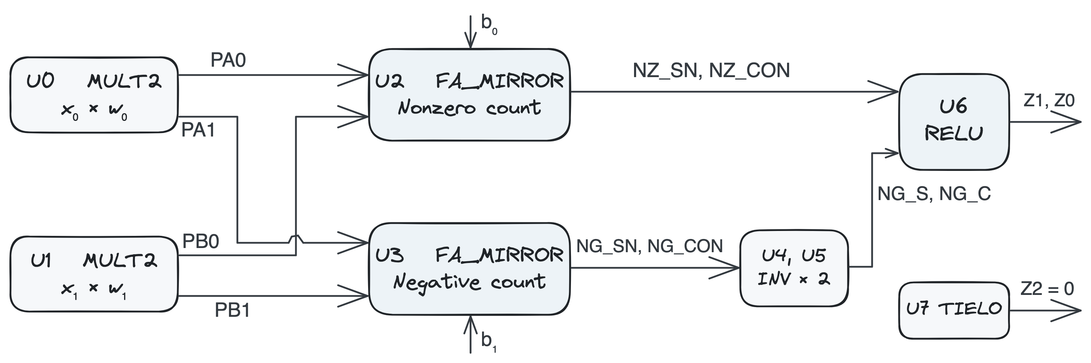
U2 counts the nonzero terms and U3 counts the negative terms, including the bias. A negative term contributes once to each count. Subtracting twice the negative count from the nonzero count gives the signed sum. The two adders can count in parallel.

Transistor count
Cell | Instances | Transistors per cell | Total
MULT2 | 2 | 22 | 44
FA_MIRROR | 2 | 24 | 48
INV | 2 | 2 | 4
RELU | 1 | 14 | 14
TIELO | 1 | 2 | 2
Neuron |  |  | 112

Device sizing
All cells use ASAP7 RVT devices with a 20 nm gate length. Each NMOS has 2 fins (54 nm) and each PMOS has 3 fins (81 nm). PMOS bodies connect to VDD and NMOS bodies to VSS.

Top-level NEURON schematic
U0 and U1 produce PA and PB. U2 takes the low bits of PA, PB and the bias. U3 takes the high bits. Both mirror adders have inverted sum and carry outputs. U4 and U5 restore the polarity of the negative count before it reaches RELU.

Multipliers and full adders (U0–U3)
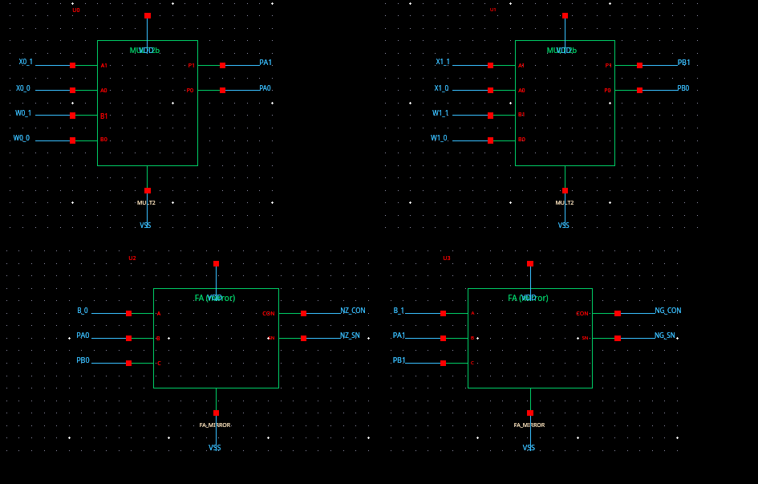

Output logic (U4–U7)
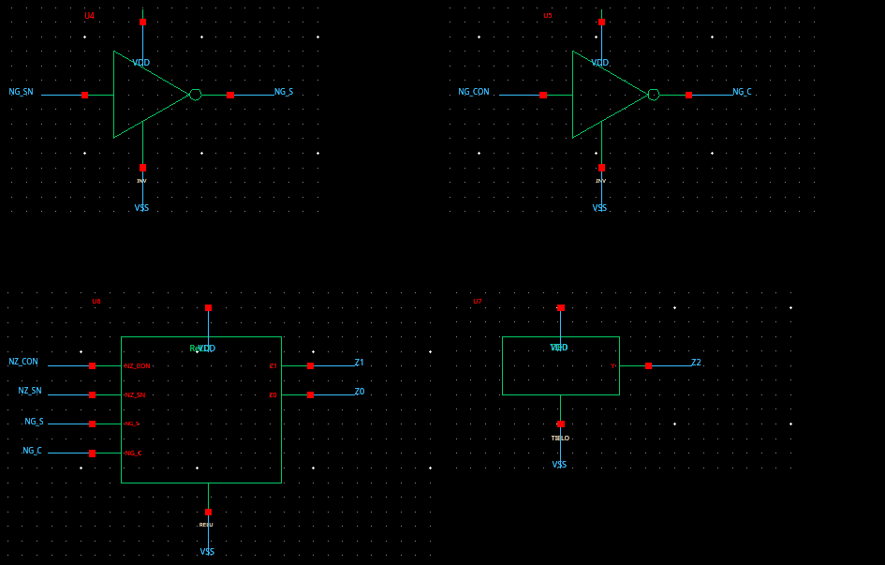

Instance connections
Inst. | Cell | Input connections | Output connections
U0 | MULT2 | A1=X0_1, A0=X0_0, B1=W0_1, B0=W0_0 | P1=PA1, P0=PA0
U1 | MULT2 | A1=X1_1, A0=X1_0, B1=W1_1, B0=W1_0 | P1=PB1, P0=PB0
U2 | FA_MIRROR | A=B_0, B=PA0, C=PB0 | CON=NZ_CON, SN=NZ_SN
U3 | FA_MIRROR | A=B_1, B=PA1, C=PB1 | CON=NG_CON, SN=NG_SN
U4 | INV | A=NG_SN | Y=NG_S
U5 | INV | A=NG_CON | Y=NG_C
U6 | RELU | NZ_CON=NZ_CON, NZ_SN=NZ_SN, NG_S=NG_S, NG_C=NG_C | Z1=Z1, Z0=Z0
U7 | TIELO |  | Y=Z2
Matching net names in the schematics indicate a connection. The largest sum is 3 (011), so U7 holds Z2 low. U6 drives Z1 and Z0.

Two-bit multiplier

MULT2 schematic
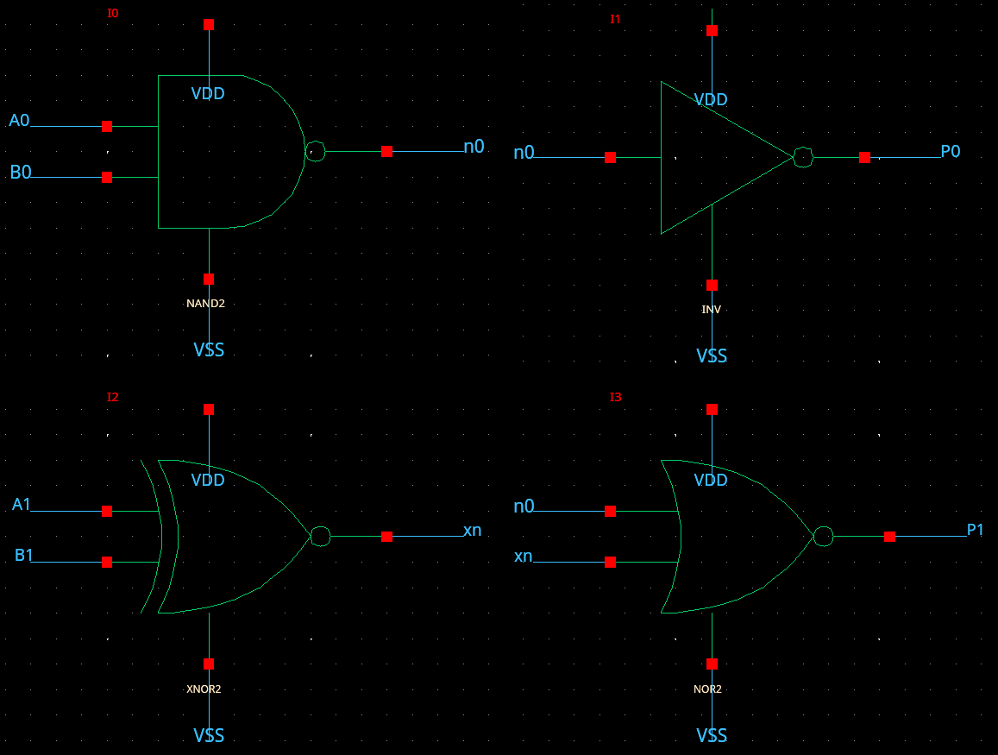
P0 is high when both operands are nonzero. P1 is high when P0 is high and the signs differ. I0 and I1 form P0. I2 compares the sign bits, and I3 combines its output with the NAND output to form P1.
Inst. | Cell | Input connections | Output connections
I0 | NAND2 | A=A0, B=B0 | Y=n0
I1 | INV | A=n0 | Y=P0
I2 | XNOR2 | A=A1, B=B1 | Y=xn
I3 | NOR2 | A=n0, B=xn | Y=P1

Product truth table
A ∖ B | 11 (−1) | 00 (0) | 01 (+1)
11 (−1) | 01 | 00 | 11
00 (0) | 00 | 00 | 00
01 (+1) | 11 | 00 | 01

XNOR2 schematic
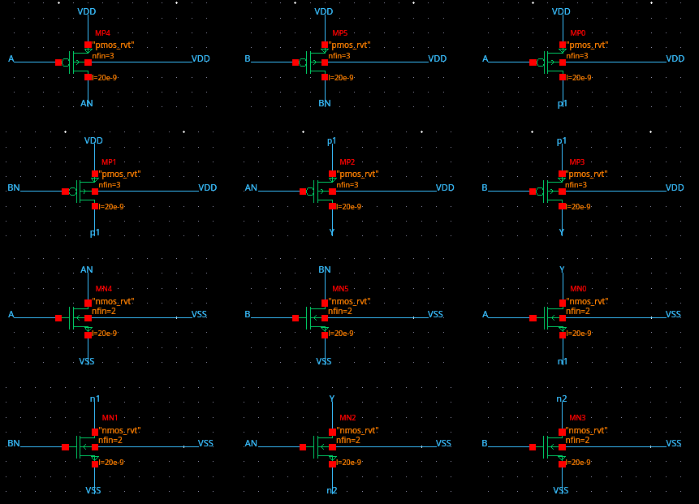
XNOR2 uses two input inverters and an eight-transistor AOI22 core. The output is high for equal signs. The NOR2 in MULT2 then forces P1 low.

Mirror full adder
FA_MIRROR uses 24 transistors. CON goes low when at least two inputs are high. The sum network uses CON and the three inputs to produce SN, the complement of the sum bit.

FA_MIRROR schematic
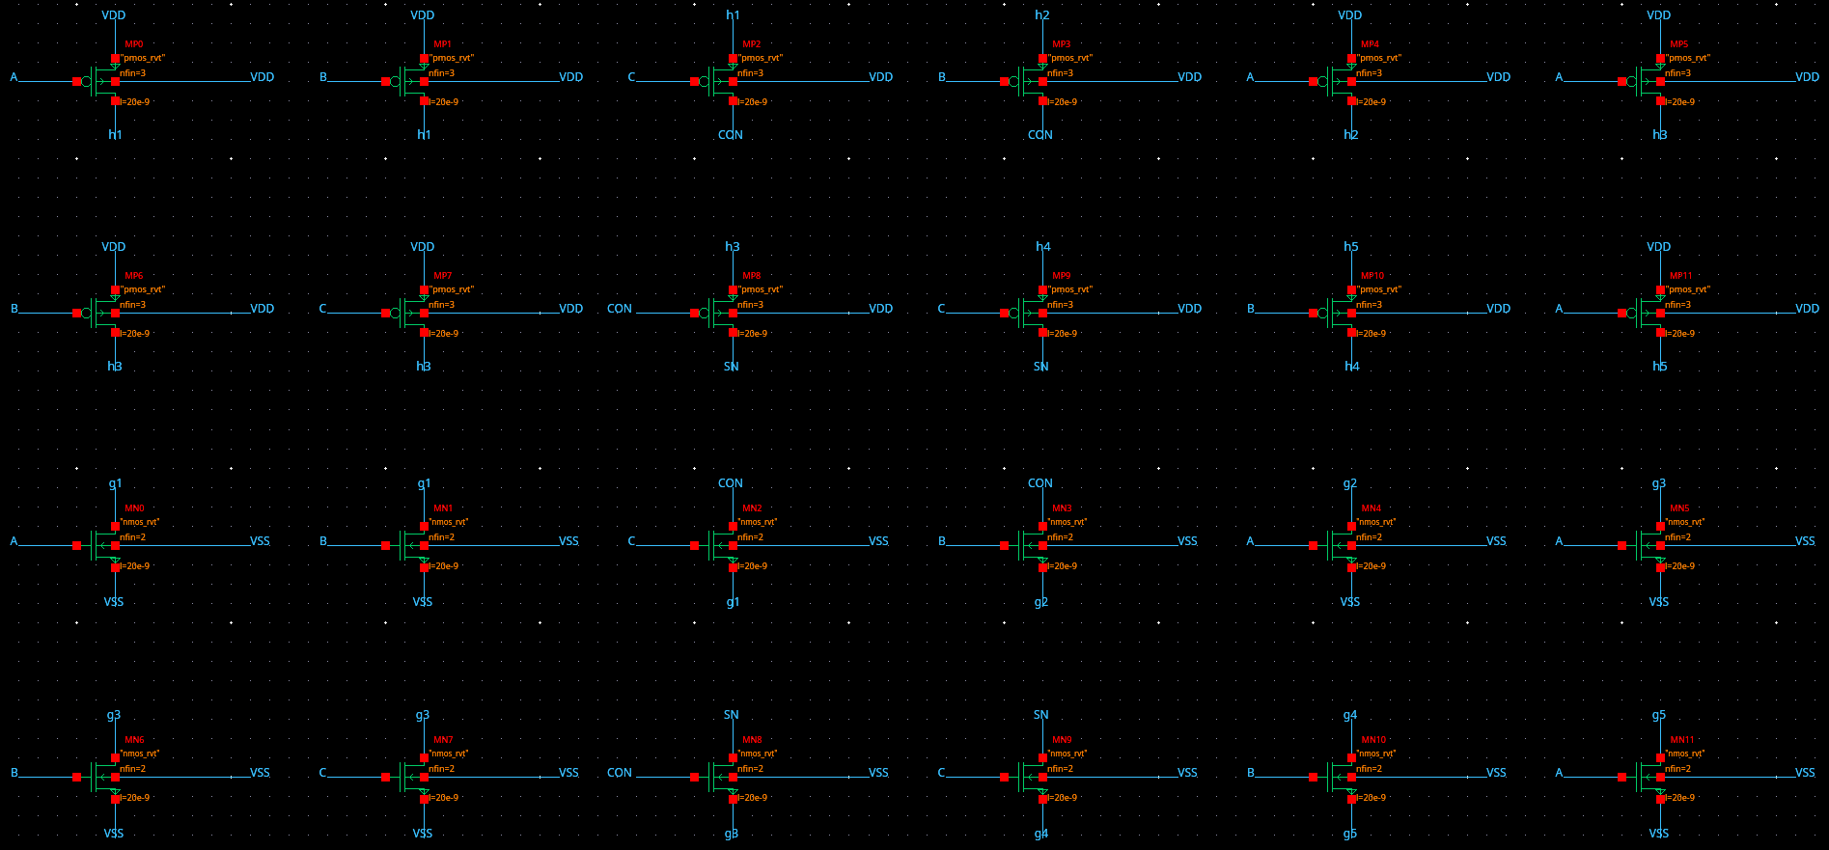

Transistor connections
CON drives MP8 and MN8 in the sum network. Each PMOS/NMOS pair in the table shares its gate net.
PMOS / NMOS | Gate | PMOS drain | PMOS source | NMOS drain | NMOS source
MP0 / MN0 | A | h1 | VDD | g1 | VSS
MP1 / MN1 | B | h1 | VDD | g1 | VSS
MP2 / MN2 | C | CON | h1 | CON | g1
MP3 / MN3 | B | CON | h2 | CON | g2
MP4 / MN4 | A | h2 | VDD | g2 | VSS
MP5 / MN5 | A | h3 | VDD | g3 | VSS
MP6 / MN6 | B | h3 | VDD | g3 | VSS
MP7 / MN7 | C | h3 | VDD | g3 | VSS
MP8 / MN8 | CON | SN | h3 | SN | g3
MP9 / MN9 | C | SN | h4 | SN | g4
MP10 / MN10 | B | h4 | h5 | g4 | g5
MP11 / MN11 | A | h5 | VDD | g5 | VSS

Inverter and two-input gates

INV schematic
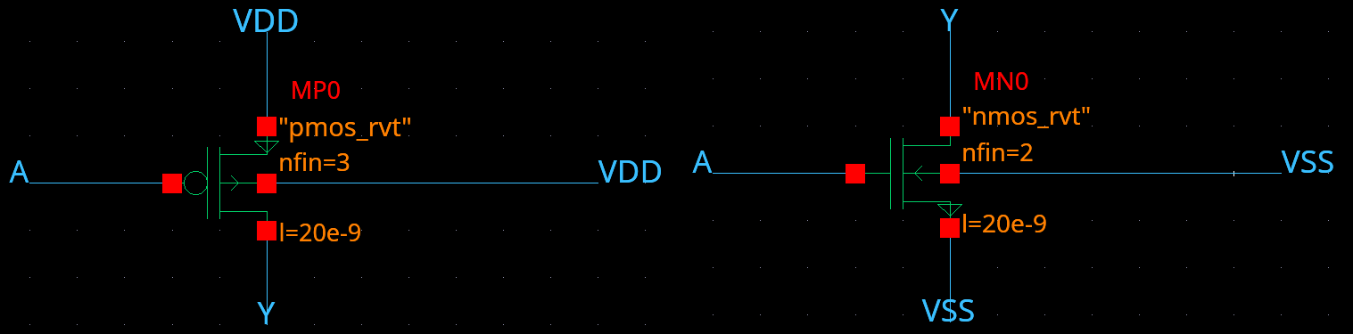
Both gates connect to A and both drains connect to Y. The PMOS pulls Y high for A = 0. The NMOS pulls Y low for A = 1.

NAND2 schematic
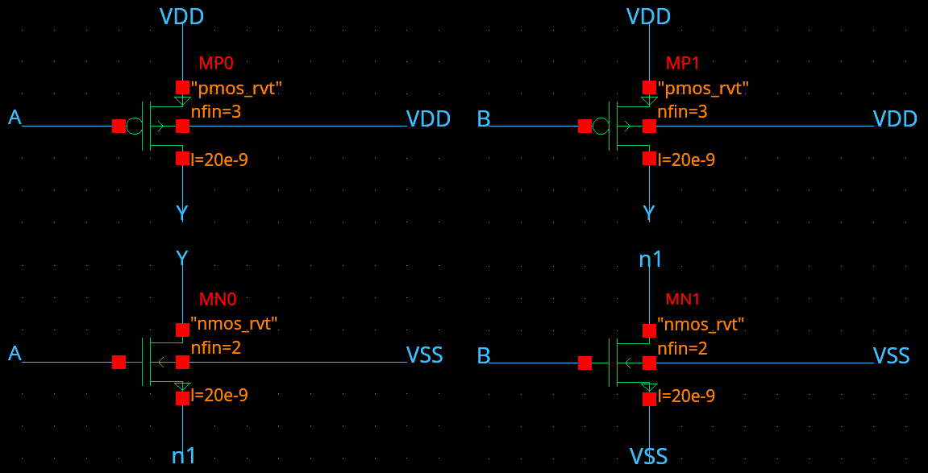
The NMOS devices meet at n1 and pull Y low only when A and B are both high. The two PMOS devices connect in parallel from VDD to Y.

NOR2 schematic
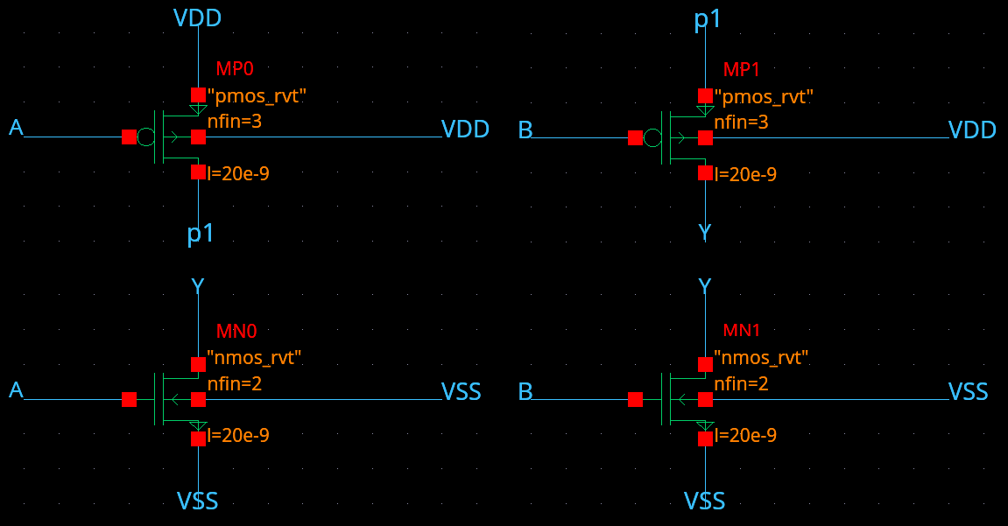
The PMOS devices meet at p1 and pull Y high only when both inputs are low. Either NMOS can discharge Y to VSS.

ReLU gates and tie-low cell

NOR3 schematic
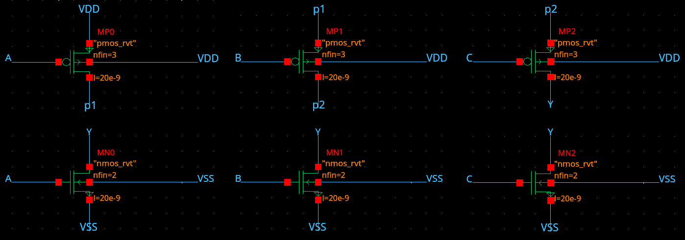
Three series PMOS devices pull Z1 high when NZ_CON, NG_S and NG_C are all low. Any high input turns on one of the parallel NMOS devices.

AOI211 schematic
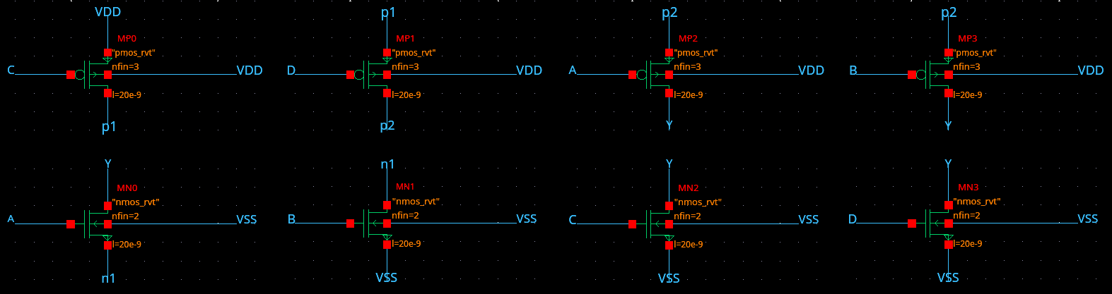
Z0 goes low when NZ_CON and NG_S are both high, or when either NZ_SN or NG_C is high. The first condition uses the series NMOS pair. Each remaining input drives a separate NMOS path to VSS.

TIELO schematic
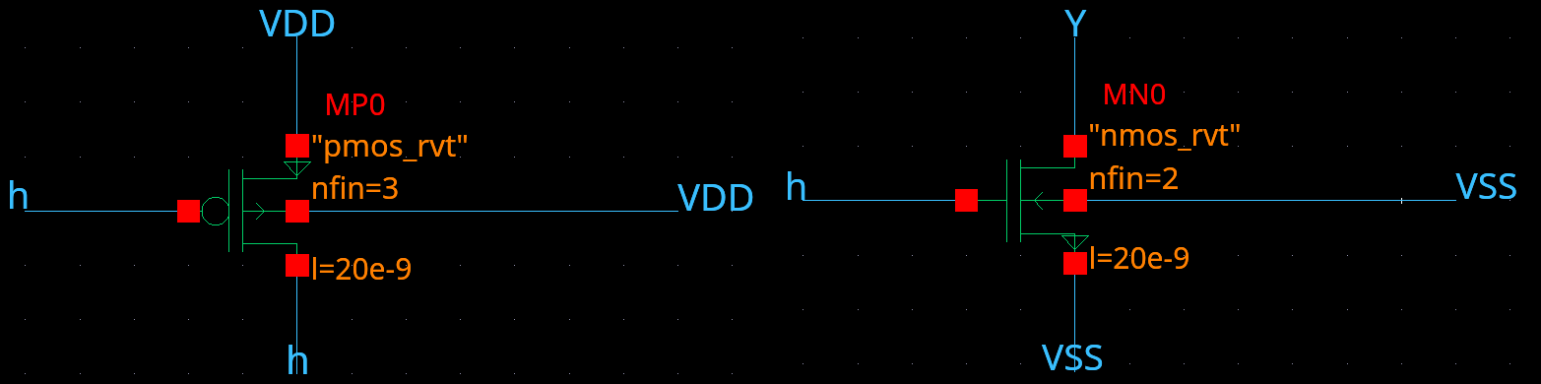
The diode-connected PMOS biases node h high. The NMOS gate connects to h and pulls its drain, Z2 at the top level, to VSS.

ReLU output logic

RELU schematic
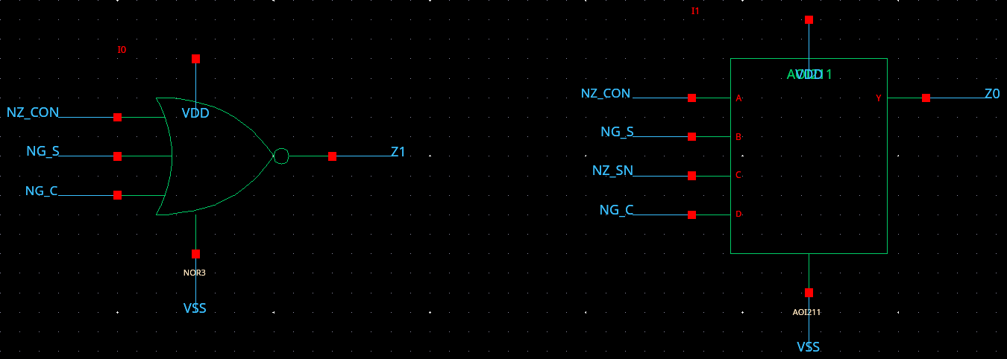
I0 drives Z1 high if at least two terms are nonzero and none are negative. I1 drives Z0 high for sums of 1 and 3. The inverted outputs from the nonzero counter feed these gates directly.
Inst. | Cell | Input connections | Output connections
I0 | NOR3 | A=NZ_CON, B=NG_S, C=NG_C | Y=Z1
I1 | AOI211 | A=NZ_CON, B=NG_S, C=NZ_SN, D=NG_C | Y=Z0

ReLU truth table
Nonzero terms | Negative terms | Signed sum | Z2 Z1 Z0
0 | 0 | 0 | 000
1 | 0 | 1 | 001
1 | 1 | -1 | 000
2 | 0 | 2 | 010
2 | 1 | 0 | 000
2 | 2 | -2 | 000
3 | 0 | 3 | 011
3 | 1 | 1 | 001
3 | 2 | -1 | 000
3 | 3 | -3 | 000

Functional verification
The switch-level check and the pre-layout HSPICE simulation each gave the expected output for all 243 input combinations (three values for each of x₀, w₀, x₁, w₁ and b). The HSPICE testbench used the TT models at 0.9 V and 25 °C with a 1 fF load on each output. It held each input combination for 400 ps and sampled 5 ps before the next input change.
Across all three outputs, logic lows reached at most 33 µV and logic highs measured at least 0.900 V at the sample time.

