Q1.

ANSWER-1.

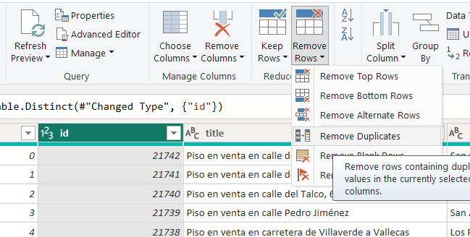 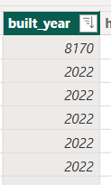

EXPLANATION:

use the id column:

• Go to Home > Remove Duplicates and select only the id column.

Keep the most recent listing:

• If there is a timestamp column, you would:

• Sort by date descending

Q2.

ANSWER-2.

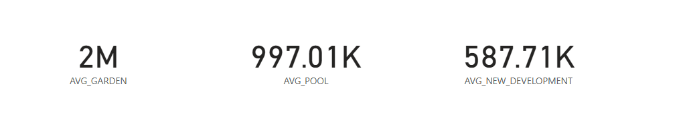

EXPLANATION:

1.In Power BI, create three DAX measures:

AvgPrice_Pool = CALCULATE(AVERAGE('Data'[price]), 'Data'[has_pool] = TRUE)

AvgPrice_Garden = CALCULATE(AVERAGE('Data'[price]), 'Data'[has_garden] = TRUE)

AvgPrice_NewDev = CALCULATE(AVERAGE('Data'[price]), 'Data'[is_new_development] = TRUE)

2.Create a bar chart or card visuals comparing these three measures.

Typically, has_garden tends to show higher average prices.

Q3.

ANSWER-3.

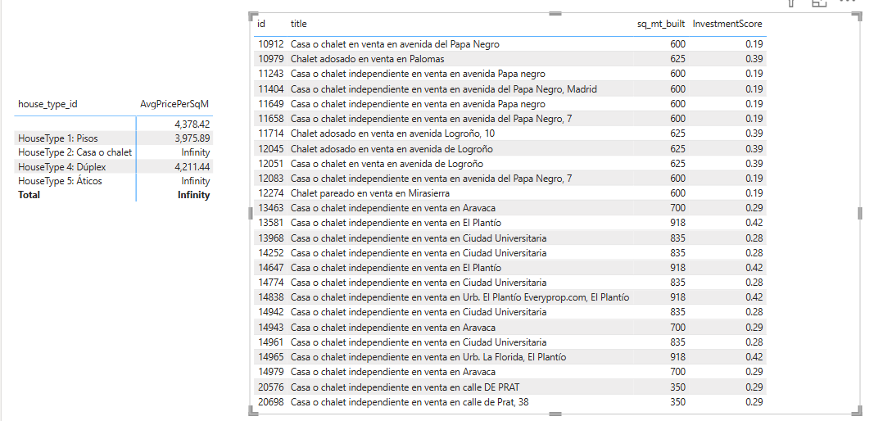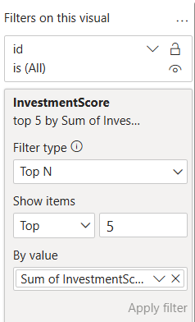

EXPLANATION:

1. Add a new DAX column:

PricePerSqM = 'Data'[price] / 'Data'[sq_mt_built]

2. Create a measure:

AvgPricePerSqM = AVERAGE('Data'[PricePerSqM])

3. Use a matrix visual:

• Rows: house_type_id

• Values: AvgPricePerSqM

4. For top 5 investments, create a measure for investment score:

InvestmentScore = 'houses_Madrid'[sq_mt_built] / 'houses_Madrid'[Pricepersqmt]

5. Use a table visual with Top N filter where InvestmentScore <= 5.

Q4.

ANSWER-4.

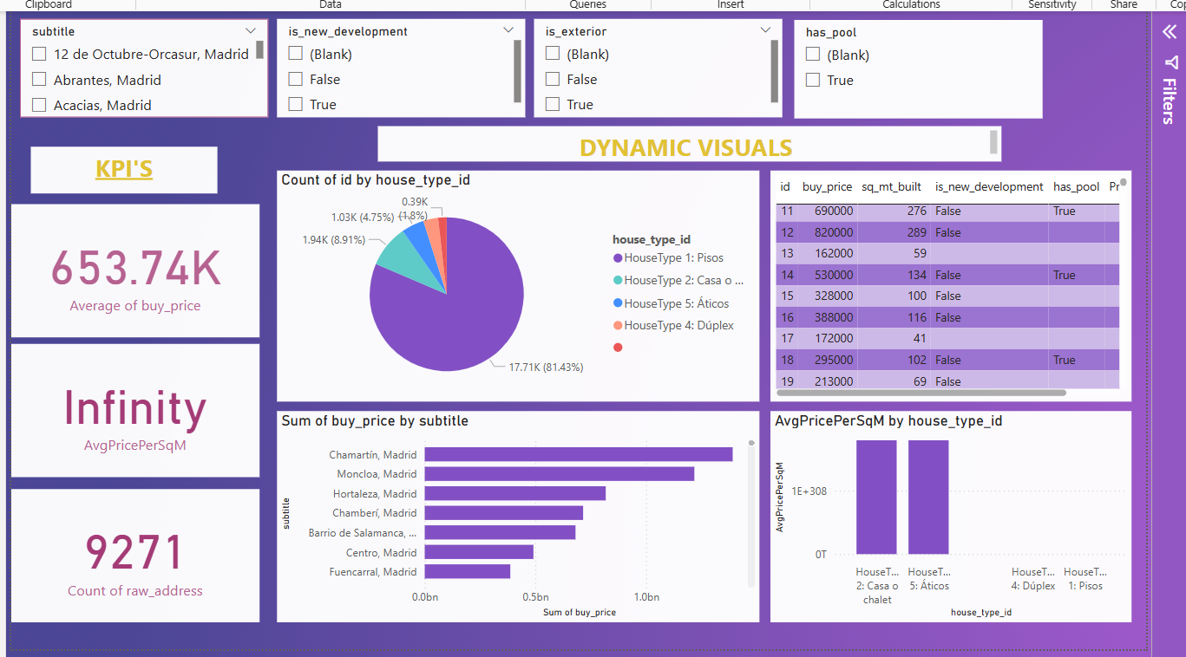

EXPLANATION:

Goal: A user-friendly dashboard with filters and dynamic visuals.

Dashboard Elements:

Filters (Slicers):

• region (or subtitle if region column missing)

• is_exterior

• has_pool

• is_new_development

Visuals:

1. Card Visuals:

• Average Price

• Total Listings

• Average Price per SqM

2. Bar/Column Chart:

• Compare prices across neighborhoods or property types.

3. Table or Matrix:

• Show top 10 listings filtered by selected criteria.

**VEDIO EXPLANATION LINK FOR THE ABOVE QUESTIONS:**

[**https://youtu.be/c9r9Ysx7szc?si=lOpT8BYlxJoHG30D**](https://youtu.be/c9r9Ysx7szc?si=lOpT8BYlxJoHG30D)