**Q1.**

**ANSWER-1.** 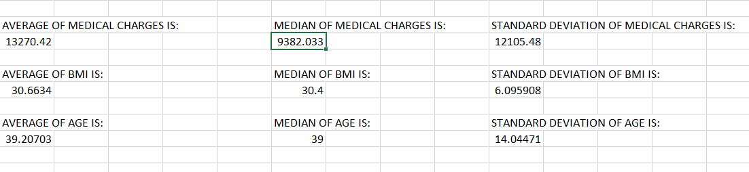

**EXPLANATION:**

Use the following Excel functions on the respective columns:

• Average: =AVERAGE(range)

• Median: =MEDIAN(range)

• Standard Deviation: =STDEV.P(range)

For example, if the charges data is in column G, use:

• =AVERAGE(G2:G1000)

• =MEDIAN(G2:G1000)

• =STDEV.P(G2:G1000)

Repeat for BMI (column C) and Age (column A).

**Q2.**

**ANSWER-2.** 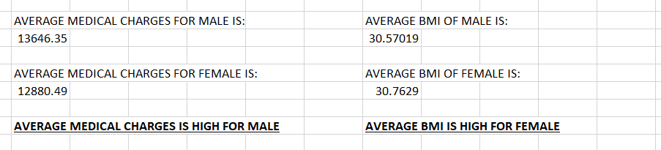

**EXPLANATION**

Use AVERAGEIF:

• Average charges for males: =AVERAGEIF(B2:B1000, "male", G2:G1000)

• Average charges for females: =AVERAGEIF(B2:B1000, "female", G2:G1000)

For BMI, replace G2:G1000 with C2:C1000.

**Q3.**

**ANSWER-3.** 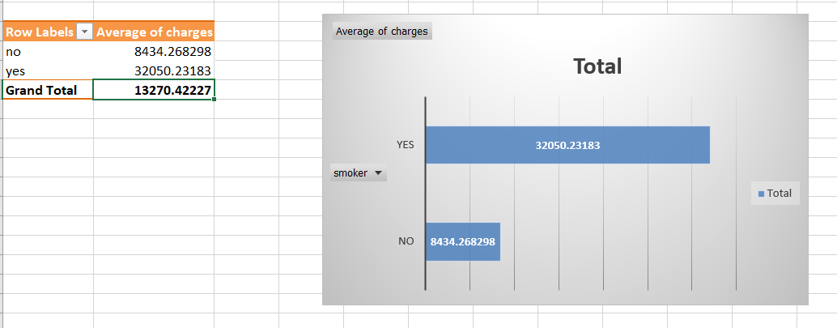

**EXPLANATION:**

We can create a Pivot Table:

1. Drag Smoking to Rows and Charges to Values.

2. Change aggregation to “Average”.

By using a Bar-Chart we can compare smokers vs. non-smokers.

**Q4.**

**ANSWER-4.** 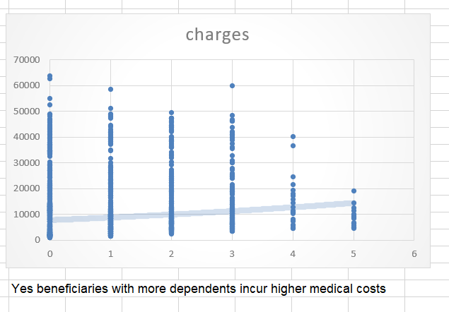

**EXPLANATION:**

Create a Scatter Plot:

1. Select Children (D column) and Charges (G column).

2. Insert → Scatter Plot.

3. Add a Trendline to see the pattern.

This shows whether having more children increases medical costs.

**Q5.**

**ANSWER-5.** 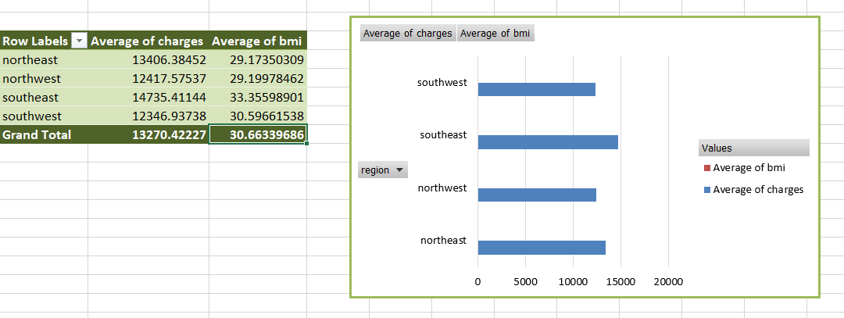

**EXPLANATION:**

use a Pivot Table:

1. Drag Region to Rows, and Charges & BMI to Values.

2. Change aggregation to “Average”.

Use a Bar Chart to visualize the regional differences.

**Q6.**

**ANSWER-6.** 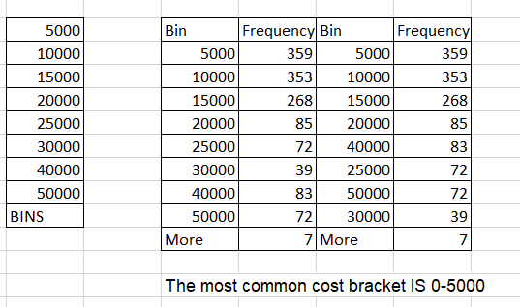

**EXPLANATION:**

1. Click on the Data tab.

2. Click Data Analysis (on the far right).

3. Select Histogram and click OK.

4. In the Input Range, select the medical charges column (e.g., G2:G1000).

5. In the Bin Range, select the bin values column (e.g., I2:I10).

6. Choose an Output Range where you want to see the results (e.g., J2).

7. Check Chart Output to generate the histogram automatically.

8. Click OK.

**Q7.**

**ANSWER-7.** 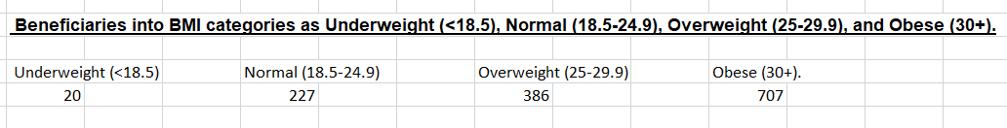

**EXPLANATION:**

Use COUNTIFS:

• Underweight: =COUNTIFS(C2:C1000, "<18.5")

• Normal: =COUNTIFS(C2:C1000, ">=18.5", C2:C1000, "<25")

• Overweight: =COUNTIFS(C2:C1000, ">=25", C2:C1000, "<30")

• Obese: =COUNTIFS(C2:C1000, ">=30")

We can also use vlookup with a category table.

**Q8.**

**ANSWER-8.** 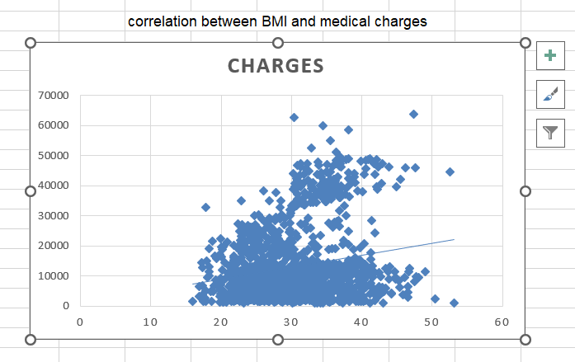

**EXPLANATION:**

Create a Scatter Plot:

1. Select BMI (C column) and Charges (G column).

2. Insert → Scatter Plot.

3. Add a Trendline and display the equation to understand the correlation.

**Q9.**

**ANSWER-9.**

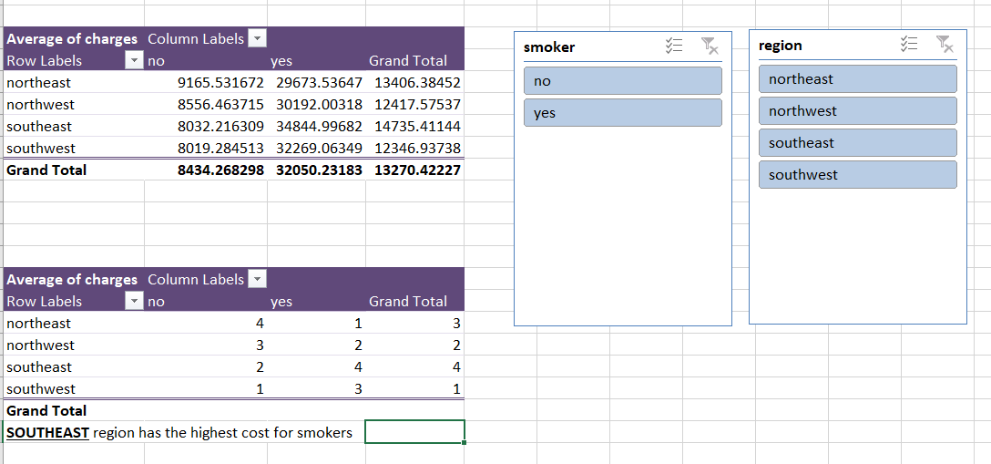

**EXPLANATION:**

Use a Pivot Table:

1. Drag Region to Rows and Smoking to Columns.

2. Drag Charges to Values and set it to “Average”.

3. Use Slicers for better filtering.

And then Find which region has the highest medical costs for smokers.

**Q10.**

**ANSWER-10.**

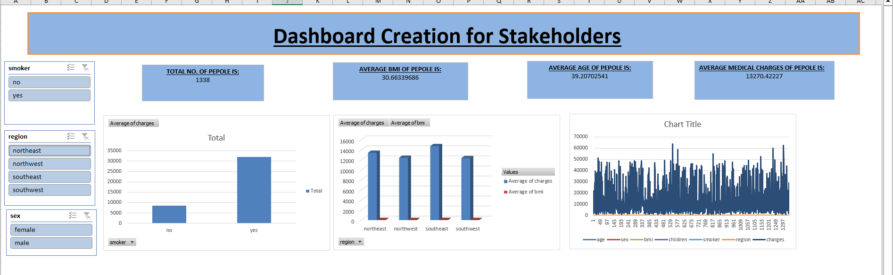

**EXPLANATION:**

Use Pivot Charts, Slicers, and Interactive Elements:

1. Insert a Pivot Table with Filters for Gender, Smoking, Region, and BMI Category.

2. Insert Pivot Charts for Costs, BMI, etc.

3. Use Slicers to allow filtering.

4. Arrange in a dashboard layout.