Cow-Dung → Compressed Biogas (CBG) in India
A decision-grade techno-economic, policy and strategic evaluation for a North-India FMCG / beverage capital allocator (10–15 year horizon).
Prepared 2026-05-31. All material claims tagged [FACT] / [INFERENCE] / [OPINION]. Indian notation (₹, lakh, crore). Figures from the committed model engine (model/cbg_model.py) and research in sources/citations.md.
CAVEAT ON RECENCY: policy and prices moved hard in the 18 months to this date. Web research indexes to ~early-mid 2026; items not re-confirmable for the current quarter are in the 'could-not-reconfirm' list. Verify live before committing capital.

Executive Verdict
A cow-dung→CBG plant built to sell gas (SATAT injection or cylinder bottling) is a NO-GO / at best a narrow CONDITIONAL-GO for this reader: subsidy-dependent, feedstock-squeezed, no contractual demand security, below the 20% hurdle even in the base case, with a ~51% modelled probability of losing money [INFERENCE]. The only version worth diligence is captive displacement (M3) at the reader's own beverage plant — and that is an infrastructure / energy-cost-hedge, not a growth bet.
Model | Verdict | Base equity IRR | Core reason
M1 SATAT injection | NO-GO (cond. only ≥10–15 TPD w/ CGD take-or-pay) | 12.6%, NPV≈0, DSCR 0.86 | No take-or-pay; CBO is aggregate not gate; dung-infeasible at scale
M2 bottled cascade | NO-GO (unconditional) | deeply negative | 2–5× capex + 250-bar compression + cascade logistics
M3 captive displacement | CONDITIONAL-GO (investigate) | swings on real avoided-fuel price | avoids OMC monopsony, offtake risk, logistics

Single biggest reason to walk away: no demand security + structurally squeezed margin. Single condition that flips it (M3 only): the beverage plant's avoided PNG/LPG/furnace-oil spend is large enough that a right-sized captive digester on cheap (<₹1,200/t, <15 km) dung/co-substrate pays back in < 5 years. Opportunity cost: ~7% modelled chance of beating the reader's 20% hurdle — capital earns more, more safely, in the existing playbook.

1. Scope & framing — three businesses, not one
"Bottling and sale" of biogas hides three structurally different businesses (see ADR-001). They are modelled and judged separately:
- M1 — CGD pipeline injection (SATAT): upgrade to >90% CH₄, sell to OMC/CGD. Volume path; near-monopsony buyer; no take-or-pay [FACT].
- M2 — Bottled / cascade CBG: fill high-pressure cascades, truck to off-grid users. Logistics-heavy; PESO-regulated; avoids OMC dependence.
- M3 — Captive displacement: burn CBG at the reader's beverage plant; value = avoided fuel cost, not a sale.
Feedstock sub-axis kept explicit: dung-only (low yield, ~15 kg CBG/t) vs dung-anchored co-digestion (press mud / napier / mandi waste) — different risk profiles [FACT].

Lens 1 — Policy & Regulatory
SATAT offtake agreements run 15 years (the '5-year' claim is a blog error) but carry no take-or-pay: OMCs 'shall try to off-take… actual off-take shall entirely depend on the actual quantity produced' [FACT, IOCL FAQ]. Price is ~₹77.4/kg ex-GST (₹1,478/MMBTU, Jun 2025), set at 85% of average CNG retail — CNG-linked, no floor [FACT]. The industry is lobbying for a fixed ₹90/kg, itself a margin-stress signal [O].
The CBO mandatory blending mandate (1%→3%→4%→5%, FY25-26→FY28-29) is an obligation on CGD entities at the national-aggregate level via a Central Repository Body — it does NOT convert into enforced offtake at an individual plant's gate [FACT/INFERENCE]. This single distinction is the crux: the policy stack creates aggregate demand *pull* but zero contractual demand security for one plant.
Subsidy: MNRE CFA up to ₹4 cr per 4,800 kg/day (cap ₹10 cr); the DPI pipeline scheme (₹994.5 cr) funds CGD tie-in (~₹9.95 cr/project) but requires a Gas Supply Agreement with the CGD carrying ≥50% take-or-pay — the *only* take-or-pay anywhere, and one you must negotiate [FACT]. Punjab has no dedicated CBG policy as of mid-2025; only generic IBDP-2022 incentives [FACT — verify PEDA].
FOM/digestate: MDA ₹1,500/t exists and FOM is now in the Fertiliser Control Order, but offtake is immature (~120 plants registered, ~44 MoUs as of Mar 2026) [FACT]. Carbon (CCTS): CBG is an approved sector but trading is not live (~late-2026 go-live); ₹600–900/tCO₂e is a forecast, not a cleared price — SPECULATIVE, exclude from base [O].
So-what for the verdict:
- Policy gives demand *pull*, not demand *security* — model offtake risk as real and uninsurable [INFERENCE].
- The only bankable take-or-pay is a CGD GSA you negotiate (M1, ≥2 TPD) — make it a precondition, not an assumption.
- FOM is upside and carbon is optionality — neither belongs in the base case.

Lens 2 — Feedstock economics (the make-or-break lens)
Collectable dung is ~5 kg/animal/day in a dairy-anchored setting (gross output ~9–10 kg, but 30–60% is dropped grazing or used as cakes) [FACT]. Wet dung's economical collection radius is <10–15 km, with ~4× requirement needed in-radius for security [FACT].
The margin vise: SATAT demand has bid feedstock up — press mud went ₹100→₹500–600/t in ~2 years [FACT]; NDDB anchors dung at ₹1/kg [FACT]. After the ₹77/kg base rate, only ~₹500–700 is left per tonne of dung to cover feedstock + debt + profit, so dung past ~₹1,000–1,500/t erases viability [FACT/INFERENCE]. Co-digestion (cheap press mud at ₹550/t, 40 kg CBG/t) lifts economics — but press mud is seasonal (sugar crush Oct–Apr) and its own price is spiralling.
Yield discipline: dung gives ~25–40 m³ biogas/t, ~60% CH₄, reconciling to ~15 kg CBG/t fresh (the widely-cited '16–20 kg/MT per IS 16087' is industry shorthand — IS 16087 is a gas-quality spec, not a yield norm) [INFERENCE]. Promoter claims of 0.45 m³ CH₄/kg dung are ~10× too high on a fresh-weight basis [FACT].
So-what for the verdict:
- Feedstock price (D1) is the #1 sensitivity; the business must outbid dung's existing manure/cake value floor [FACT].
- Dung-only cannot reach viable scale (see Lens 3 infeasibility); co-digestion is mandatory, which dilutes the 'cow-dung business' premise [INFERENCE].
- Logistics, not capex, is the binding constraint — site within a dairy cluster or don't build [OPINION].

Lens 3 — Techno-economic model
A parameterised 15-year model (model/cbg_model.py; all assumptions in drivers.py) covers 5 CBG scales × 3 models. Capex intensity ~₹40–50k/(kg·day) (5 TPD ≈ ₹22–25 cr — the prompt's ₹16 cr is ~30–45% low; a T1 parliamentary cross-check lands ~₹25 cr) [FACT]. Upgrading default = membrane (lowest capex/parasitic at small-mid scale) [FACT]. Base PLF 50% (Indian plants run 20–60% vs 80%+ in Europe) [FACT]. D:E 75:25, debt 10.5%, subsidy capped at 30% of gross (DPI off in base). Net-salary-style closure and unit checks pass the self-test.
Scale | Model | Net capex ₹cr | Proj IRR | Eq IRR | NPV ₹cr | Min DSCR | Dung feasible?
0.4 TPD | M1 injection | 1.92 | 4.2% | 0.3% | -0.63 | 0.58 | Y
0.4 TPD | M2 bottled | 6.42 | -23.1% | -53.2% | -6.79 | -0.08 | Y
0.4 TPD | M3 captive | 1.92 | -4.3% | -14.1% | -1.30 | 0.27 | Y
2.0 TPD | M1 injection | 7.33 | 10.1% | 12.6% | -0.13 | 0.86 | Y
2.0 TPD | M2 bottled | 25.33 | -16.9% | -37.6% | -24.84 | -0.01 | Y
2.0 TPD | M3 captive | 7.33 | 1.1% | -5.2% | -3.46 | 0.46 | Y
5.0 TPD | M1 injection | 18.33 | 10.1% | 12.6% | -0.33 | 0.86 | NO
5.0 TPD | M2 bottled | 63.33 | -16.9% | -37.6% | -62.11 | -0.01 | NO
5.0 TPD | M3 captive | 18.33 | 1.1% | -5.2% | -8.66 | 0.46 | NO
10.0 TPD | M1 injection | 36.67 | 10.1% | 12.6% | -0.66 | 0.86 | NO
10.0 TPD | M2 bottled | 126.67 | -16.9% | -37.6% | -124.22 | -0.01 | NO
10.0 TPD | M3 captive | 36.67 | 1.1% | -5.2% | -17.32 | 0.46 | NO
15.0 TPD | M1 injection | 57.50 | 9.4% | 11.0% | -3.18 | 0.82 | NO
15.0 TPD | M2 bottled | 192.50 | -16.8% | -37.7% | -188.51 | -0.01 | NO
15.0 TPD | M3 captive | 57.50 | 0.7% | -6.0% | -28.17 | 0.44 | NO

Dung-availability constraint (default 50% dung mix): a 5 TPD plant needs ~73,000 cattle within a 15 km radius (≈57,000 available) — infeasible at ≥5 TPD [INFERENCE]. The economics-need-scale vs can't-source-dung-at-scale vise is the model's central structural finding.
Scale | Feed/day | Dung/day | Cattle needed | Cattle in 15km | Verdict
0.4 TPD | 15 t/d | 7 t/d | 5,818 | 56,549 | FEASIBLE
2.0 TPD | 73 t/d | 36 t/d | 29,091 | 56,549 | FEASIBLE
5.0 TPD | 182 t/d | 91 t/d | 72,727 | 56,549 | INFEASIBLE
10.0 TPD | 364 t/d | 182 t/d | 145,455 | 56,549 | INFEASIBLE
15.0 TPD | 545 t/d | 273 t/d | 218,182 | 56,549 | INFEASIBLE

So-what for the verdict:
- At base assumptions, M1 returns only ~10% project / 12.6% equity IRR with DSCR 0.86 — below WACC-NPV and below the bank's 1.2 DSCR floor [INFERENCE].
- M2 (bottled) is deeply negative at every scale; M3 (captive) ~1% at generic avoided-fuel price [INFERENCE].
- The only scales that are even marginally economic (≥5 TPD) are dung-infeasible — forcing co-digestion or import [INFERENCE].

Lens 4 — Sensitivity, scenario & Monte-Carlo
Scenario | Project IRR | Equity IRR | NPV ₹cr | Min DSCR
Tailwind | 30.1% | 66.6% | 22.02 | 1.32
Base | 10.1% | 12.6% | -0.33 | 0.86
Stress | -15.8% | -33.8% | -17.76 | 0.06

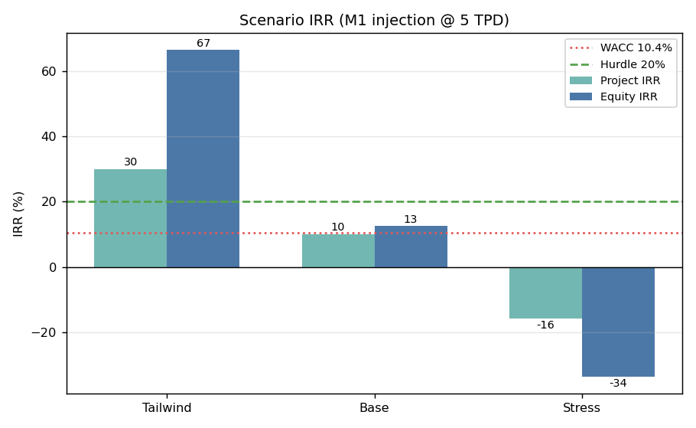
Tornado: equity-IRR swing ranks PLF > feedstock price > CBG price > capex > FOM > subsidy > cost of debt — confirming D6/D1/D4/D5 as the dominant drivers [INFERENCE].
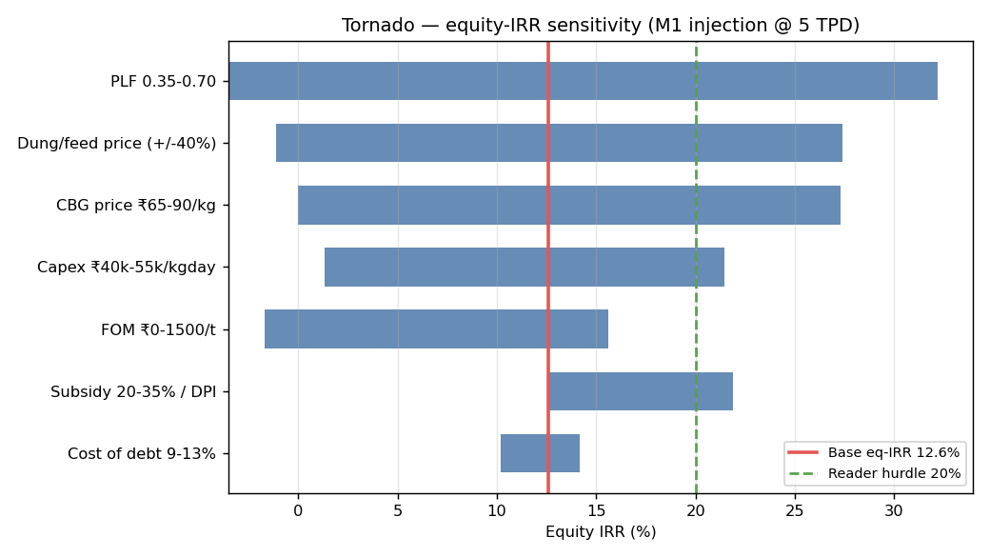
Monte-Carlo (5,000 draws) on the top drivers: P10 -15.8%, P50 -0.3%, P90 17.3%. P(IRR>WACC)=21%, P(IRR>20% hurdle)=7%, P(IRR<0)=51% [INFERENCE]. A coin-flip-to-lose-money proposition that clears the reader's hurdle 7% of the time.
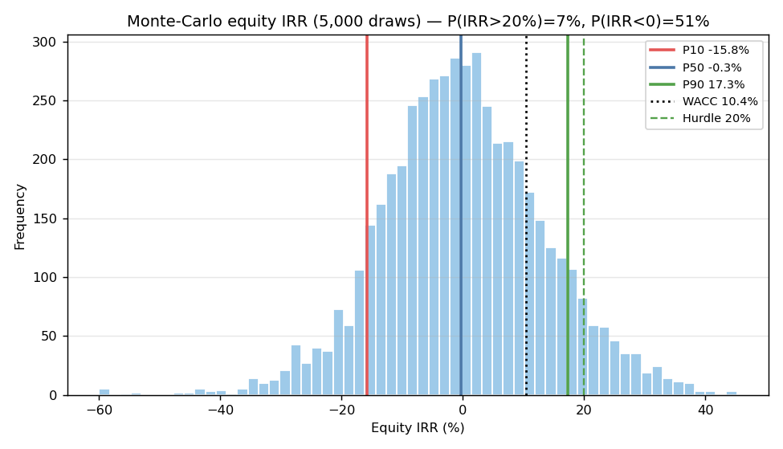
Breakeven frontier: even the favourable corner (cheap dung ₹800/t, high CBG ₹95/kg) only reaches ~21% project IRR; the base point (₹1,250/₹77) sits at WACC. Most of the plausible feedstock×price space is sub-WACC [INFERENCE].
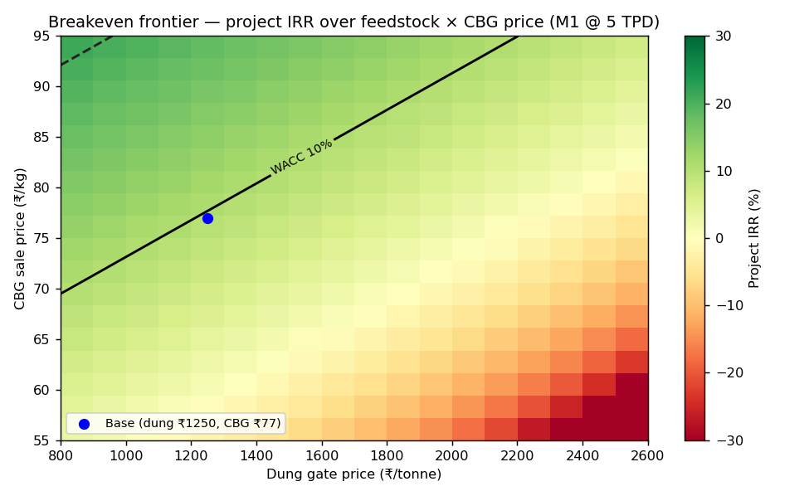
So-what for the verdict:
- Only a full policy-tailwind stack (PLF .70 + DPI + FOM clears + ₹85 + cheap dung) clears 20% [INFERENCE].
- The base case sits AT WACC with NPV≈0 — no margin of safety; the stress case is a wipeout (-34% equity IRR) [INFERENCE].
- 7% probability of beating the hurdle is the decisive number for a 20%-mandate allocator [OPINION].

Lens 5 — Competitive / strategic structure
SATAT targeted 5,000 plants by 2023-24; ~108–132 are commissioned — a ~97% shortfall, ~920 TPD output, with 1,094 LoIs that never became plants (~10% conversion) [FACT]. Failure modes, ranked: feedstock-cost squeeze > low PLF > FOM non-clearance > OMC offtake delays > financing gaps [FACT/INFERENCE].
Margin capture: the plant operator is the squeezed middle — between feedstock aggregators with pricing power in scarcity and an OMC monopsony paying an administered price. The clearer winners are feedstock aggregators and EPC/subsidy-capture players who earn on the build regardless of PLF [INFERENCE].
Exit: unlike a pure orphan asset, a live acquirer market exists — EverEnviro, GPS/ARYA ONE ($400M platform, Sojitz minority stake), Adani, Reliance, OMC JVs (IGRPL raised ₹836 cr) — but value concentrates in platforms, not single sub-scale plants, and no public plant EV/EBITDA multiple was disclosed [FACT/INFERENCE].
So-what for the verdict:
- As a single sub-scale plant you are the squeezed middle and a price-taker to a monopsony [INFERENCE].
- There is an exit, but only for platform-scale, high-PLF portfolios — not a one-off dung plant [INFERENCE].
- Late entry into a 'mandated-demand' market that 97% of intended builders never entered is a warning, not an opportunity [OPINION].

Lens 6 — Long-term viability & macro (10–15 yr)
CNG-transport demand is still growing near-term (>1M CNG cars FY26) but faces structural EV erosion in the 10–15 yr tail (EV target 30% of sales by 2030); PNG-domestic is the more durable CBG sink [FACT/INFERENCE]. India's gas import dependence is high (LNG ≈ 50% of availability); the import-substitution thesis is directionally valid (IEEFA: ~US$29bn savings FY25–30) [FACT].
The price is administered (85% of CNG), not floating — the operator captures no upside beyond the formula [FACT]. The CBO 5% is a ceiling, not an ever-rising floor: the market is genuinely undersupplied vs the mandate for ~2–3 years, but post-saturation incremental plants compete for a fixed obligated volume at an administered price. 'Mandated demand forever' is marketing that conflates the 3-year window with the 10–15 yr horizon [INFERENCE].
So-what for the verdict:
- Near-term (2–3 yr) demand cover is real; the 10–15 yr thesis the prompt asks about is not secured [INFERENCE].
- Administered, capped pricing means you bear cost inflation without price upside [FACT].
- EV erosion + a 5% ceiling cap the terminal growth story — underwrite cashflow, not perpetual demand [OPINION].

Lens 7 — ESG, optics & non-financial return
Genuine methane-abatement and dairy/agri-waste-management value is real and strategically useful for an FMCG brand's sustainability narrative [FACT]. Carbon credit economics (~$40–75/t CBG) are marginal, not a thesis-maker [O]. The credible risk is greenwashing optics if the plant chases energy crops/subsidies rather than genuine waste utilisation.
So-what for the verdict:
- The strongest non-financial case is for M3 (captive) as a credible 'cleaner manufacturing' story tied to the reader's own plant [OPINION].
- ESG value does not rescue a sub-WACC sale-of-gas business; it is a reason to do M3 well, not to do M1/M2 [OPINION].
- Rural/dairy-cluster goodwill in Punjab is a real but unquantified side-benefit [INFERENCE].

Lens 8 — Execution & operational risk
Anaerobic digestion + gas upgrading is operationally intensive: digester souring/foaming, H₂S corrosion, grit abrasion from dung, upgrading downtime, and skilled-operator scarcity [FACT]. Feedstock contracts with smallholders/dairies are hard to enforce. The reader is a solo technical/ops leader already stretched across many fronts — a feedstock-logistics-heavy biological process plant is a major, sustained bandwidth commitment, not a passive asset [OPINION].
So-what for the verdict:
- This is a hands-on operating business, not capital-light — it competes for the reader's scarcest resource (attention) [OPINION].
- PLF (the #1 driver) is precisely what weak operations destroy — the ops risk and the financial risk are the same risk [INFERENCE].
- If pursued, M3 at the existing plant at least co-locates with existing operations and staff [OPINION].

Red-team: value trap vs steel-man
The bear case (this is a value trap): subsidy-dependent; no take-or-pay; CBO is aggregate not gate; feedstock prices are spiralling toward the viability cliff; PLF chronically 20–60%; FOM revenue often doesn't clear (a real Surat plant runs at 2.9% capacity); >70% of early plants missed forecasts; base-case IRR is sub-hurdle with DSCR <1.2; 51% modelled chance of loss; no exit for a single sub-scale plant; and it consumes a stretched operator's bandwidth. For a 20%-mandate, capital-light allocator this is the opposite of the brief [OPINION].
The steel-man (the case to proceed): the sector is genuinely undersupplied vs a legislated CBO for the next 2–3 years; co-digestion with cheap press mud materially improves the math; a signed CGD GSA with ≥50% take-or-pay (DPI precondition) removes the central offtake risk and unlocks pipeline subsidy; at ≥10–15 TPD with secured feedstock the asset can reach low-teens IRR and is acquirable by a platform; and for M3, displacing dear furnace-oil/LPG at the reader's own plant can pay back fast while delivering a real ESG story [INFERENCE]. The steel-man is strongest for M3 and weakest for M2.

Verdict & decision tree
M1 (SATAT injection): NO-GO for this reader as a growth investment; CONDITIONAL-GO only if ALL hold: ≥10–15 TPD scale; a signed CGD gas-supply agreement with ≥50% take-or-pay (also unlocks DPI subsidy); co-digestion feedstock locked at <₹1,200/t within 15 km; PLF underwritten ≥60%. Even then it is a low-teens-IRR infrastructure asset below the 20% hurdle [OPINION].
M2 (bottled cascade): NO-GO (unconditional) — the 2–5× capex penalty, 250-bar compression and cascade logistics make it negative-IRR; keep it only as an emergency fallback channel if an OMC stops lifting [INFERENCE].
M3 (captive displacement): CONDITIONAL-GO — the only model to investigate. Precondition: the beverage plant's annual PNG/LPG/furnace-oil spend, divided by a right-sized captive digester fed on <₹1,200/t dung/co-substrate within 15 km, yields payback < 5 years on avoided fuel. Underwrite as a sustainability/energy-cost hedge, not against the 20% hurdle. This needs one input: driver D13 — your plant's fuel spend (₹/yr) and unit fuel price. Flex the live model/cbg_model.xlsx with your real numbers.
Single biggest walk-away reason: no demand security (no take-or-pay; CBO is aggregate, not plant-gate) combined with a feedstock price spiral → 51% modelled probability of loss, 7% of clearing the hurdle. Single condition that flips to buy: M3 with payback < 5 yr on avoided fuel at the reader's own plant.
Opportunity cost: against a 20%+ CAGR mandate met by capital-light, liquid, high-conviction bets, a CBG plant is capital-heavy (₹20–25 cr at 5 TPD), illiquid, operationally punishing, and sub-WACC in the base case. Unless the ESG/strategic value to the FMCG brand is itself the objective (M3), the capital is better deployed in the existing playbook [OPINION].
- Want to SELL gas (M1/M2)? → Walk away unless you can sign a CGD ≥50%-ToP GSA AND lock feedstock <₹1,200/t at ≥10 TPD — then a sub-hurdle infrastructure asset.
- Want to cut the plant's fuel bill / build an ESG story (M3)? → Investigate. Get D13, right-size to your gas demand + local dung, accept it only if payback < 5 yr.
- Neither? → Deploy the capital in your existing 20%+ playbook.

Sources & methods
Full dated citations with source tiers (T1 govt/peer-reviewed · T2 trade/consultancy · T3 promoter) and the complete 'could-not-reconfirm' list are in sources/citations.md. Load-bearing T1/T2 sources include: IOCL CBG FAQ; PIB CBO notifications (PRID 1979705/1989226); MoPNG/MNRE/GOBARdhan/PNGRB scheme docs; Standing Committee on Petroleum & NG (2022-23); MDPI Energies 18(24):6506 (2025); SBI Caps / Renewable Watch financing analyses; REGlobal; Down To Earth; IEEFA; PPAC; CSE; Indian Biogas Association.
Method & limitations: outputs come from a transparent 15-year model (drivers.py → cbg_model.py) cross-checked against published plant economics and the SBI Caps IRR-by-scale ladder; it passes a self-test on unit-chain reconciliation, mass-balance closure, and driver→output propagation. Known limitations: capex intensity is held flat across scale (conservative — understates large-plant scale economics); cascade logistics (M2) and the M3 avoided-fuel price (D13) are under-sourced placeholders; FOM, carbon and PLF carry wide uncertainty (reflected in the Monte-Carlo). Several primary PDFs were fetch-blocked and rest on search extraction. Verify all policy and prices live before committing capital.

