STM32-Based Adaptive Multi-Zone Irrigation Control System
A PROJECT REPORT
submitted by
CB.EN.U4ELC24004 Abhinav Pradeep Menon
in partial fulfillment for the course project
of
23ELC302
EMBEDDED SYSTEMS DESIGN USING ARM

B.TECH. ELECTRICAL & COMPUTER ENGINEERING

DEPARTMENT OF ELECTRICAL & ELECTRONICS ENGINEERING

AMRITA SCHOOL OF ENGINEERING, COIMBATORE

AMRITA VISHWA VIDYAPEETHAM
INDIA 641112
November 2026

Contents
1. Introduction 7
1.1 Background 7
1.2 Problem statement 7
1.3 Scope of the project 7
1.4 Organisation of the report 7
2. Objectives 7
3. System Overview 8
3.1 Architecture 8
3.2 Circuit schematic 10
3.3 Operating flow 11
3.4 System requirements 12
3.5 Demonstration and field configurations 12
4. Methodology 13
4.1 Moisture measurement 13
4.2 Watering control 13
4.3 Drying-rate fit and raw prediction 14
4.4 Learned correction by gradient descent 15
4.5 Water per percent of moisture 16
4.6 Rain and manual watering 16
4.7 Tank level 16
5. Tools and Systems 17
5.1 Hardware components 17
5.2 Peripherals of the microcontroller 17
5.3 Software and tools 18
5.4 Hardware and software integration 18
6. Implementation 18
6.1 Firmware structure 18
6.2 Peripheral drivers 19
6.3 User interface 20
6.4 Configuration parameters 21
6.5 Prediction and learning code 21
6.6 Serial protocol, dashboard and logger 21
6.7 Prototype 22
7. Results and Analysis 22
7.1 Test setup 22
7.2 Control behaviour 22
7.3 Prediction accuracy and On Chip Learning 23
7.4 Field data from the real sensor 26
7.5 Discussion and limitations 27
7.6 Status of the requirements 27
7.7 Alternatives and scaling 28
8. Conclusion and Future Work 29
References 30

List of Figures
Figure 1: Block diagram of the irrigation controller. Arrows show the main data flow; the pumps are the only actuators. 9
Figure 2: Signal connections between the NUCLEO-F401RE and the peripherals, with the pin names of the STM32F401RE and the Arduino-header labels. 10
Figure 3: Power supply and motor-driver circuit: the L293D with its pin numbers, the two pumps, the separate pump supply and the supply capacitor. 11
Figure 4: State machine of one zone. A zone also returns to IDLE from PUMPING when the target is reached in the middle of a burst or when the tank becomes empty. 14
Figure 5: Data flow of the prediction and learning loop. 16
Figure 6: Start-up sequence and main loop of the firmware. 20
Figure 7: Screen layouts, drawn from the coordinates used by the firmware : Home screen 20
Figure 8: Screen layouts, drawn from the coordinates used by the firmware : Detail screen of the demonstration configuration……………………………………………………………………..20
Figure 9: Dashboard showing both zones: moisture chart with the prediction (dashed), the learned gain and offset, and the ADC trace. 22
Figure 10: Photograph of the assembled prototype. 22
Figure 11: Moisture of zone 1 over 1 hour in the demonstration configuration: watering starts at 40 % and stops at 80 %. 23
Figure 12: Dashboard learning curves for the same run: prediction error per period and plan error of the mL per percent. 25
Figure 13: Field log of zone 1 over 27.8 h: moisture, a line fit and the 40 % limit. 26

List of Tables
Table 1: Subsystems and their connections 9
Table 2: System requirements 12
Table 3: Differences between the demonstration and the field configuration 13
Table 4: Peripherals of the STM32F401RE used in the project 17
Table 5: Principal firmware parameters 21
Table 6: Measured Prediction Performance Across Demo Cycles 25
Table 7: Status of the system requirements 27

List of Abbreviations
Abbreviation | Expansion
ADC | Analog-to-digital converter
BSRR | Bit set/reset register (GPIO)
CMSIS | Cortex microcontroller software interface standard
CSV | Comma-separated values
DMA | Direct memory access
EXTI | Extended interrupts and events controller (external interrupt)
GPIO | General-purpose input/output
HAL | Hardware abstraction layer
HSI | High-speed internal oscillator
NVIC | Nested vectored interrupt controller
PWM | Pulse-width modulation
RMS | Root mean square
SPI | Serial peripheral interface
TFT | Thin-film transistor (display)
USART | Universal synchronous/asynchronous receiver-transmitter

1. Introduction

1.1 Background
Plants need soil that is neither too dry nor waterlogged. A watering timer ignores the state of the soil: it applies the same amount of water after rain as on a hot, dry day. Scheduling irrigation from the measured condition of the soil and the crop is the established way to avoid both waste and stress . A controller that waters when the measured soil moisture falls below a limit achieves this, but it only reacts to the present: it cannot tell the user when the next watering will be needed, and it cannot plan the volume of water for it.

1.2 Problem statement
Small gardens and plant beds need a low-cost controller that (a) keeps several independent areas of soil within a target moisture range, (b) protects itself and the water supply against faults such as an empty tank or a pump that does not deliver, and (c) tells the user when each area will need water next. The time soil takes to dry changes with weather, soil and season, so a fixed schedule cannot give (c); the controller has to learn it from the soil it serves.

1.3 Scope of the project
This project designs and implements a multi-zone irrigation controller on an STM32 NUCLEO-F401RE board (ARM Cortex-M4F core). Each zone has its own capacitive soil-moisture sensor, its own pump and its own settings. A zone waters when its moisture falls below a set value and stops at the upper limit set, in short bursts separated by waiting periods so that the water can reach the sensor. While a zone is not being watered, the controller measures how fast the soil dries, fits a straight line through the readings and predicts when the moisture will reach the lower threshold again. After each watering cycle it compares its earlier predictions with what happened and adjusts two numbers by gradient descent [9], [10], so that later predictions are more accurate. It also learns how many millilitres of water raise the moisture by one percent, so that the next watering can be planned in bursts.
Real soil dries slowly, about 0.4 % per hour in the field data of Section 7.4, so one real cycle takes days. The controller is therefore provided in two firmware configurations that share the same code: a demonstration configuration, in which a software soil model replaces the sensor and all time constants are shortened to seconds, and a field configuration for the real sensors.

1.4 Organisation of the report
Chapter 2 states the objectives. Chapter 3 gives the system overview and circuit. Chapter 4 describes the methodology: moisture measurement, watering control, drying-rate prediction, gradient-descent learning and tank measurement. Chapter 5 lists the tools and peripherals, Chapter 6 describes the implementation, and Chapter 7 presents the results and analysis, including alternatives and scaling. Chapter 8 concludes the report.

2. Objectives
The objectives of the project are to:
- Keep multiple independent zones of soil between a low and a high moisture limit with a single controller.
- Water in bursts with a soak period, so that the sensor, which lags the water, does not cause overshoot, and stop safely when the tank is empty or when a zone cannot reach its target.
- Predict the time to the next watering from the measured drying rate, and improve the prediction on the microcontroller itself by learning from earlier cycles.
- Provide a local user interface (touch display), a force-stop button, and a PC dashboard and data logger over the serial port.
- Provide a demonstration configuration that shows the complete behaviour in minutes, and a field configuration for the real sensors.

3. System Overview

3.1 Architecture
The NUCLEO-F401RE board carries an STM32F401RE microcontroller with an ARM Cortex-M4F core (up to 84 MHz, 512 KB flash, 96 KB RAM) and an on-board ST-LINK debugger with a virtual COM port [2], [3]. The firmware keeps the 16 MHz internal oscillator (HSI) as the system clock. Figure 1 shows the structure of the system and Table 1 lists every subsystem with its connection.
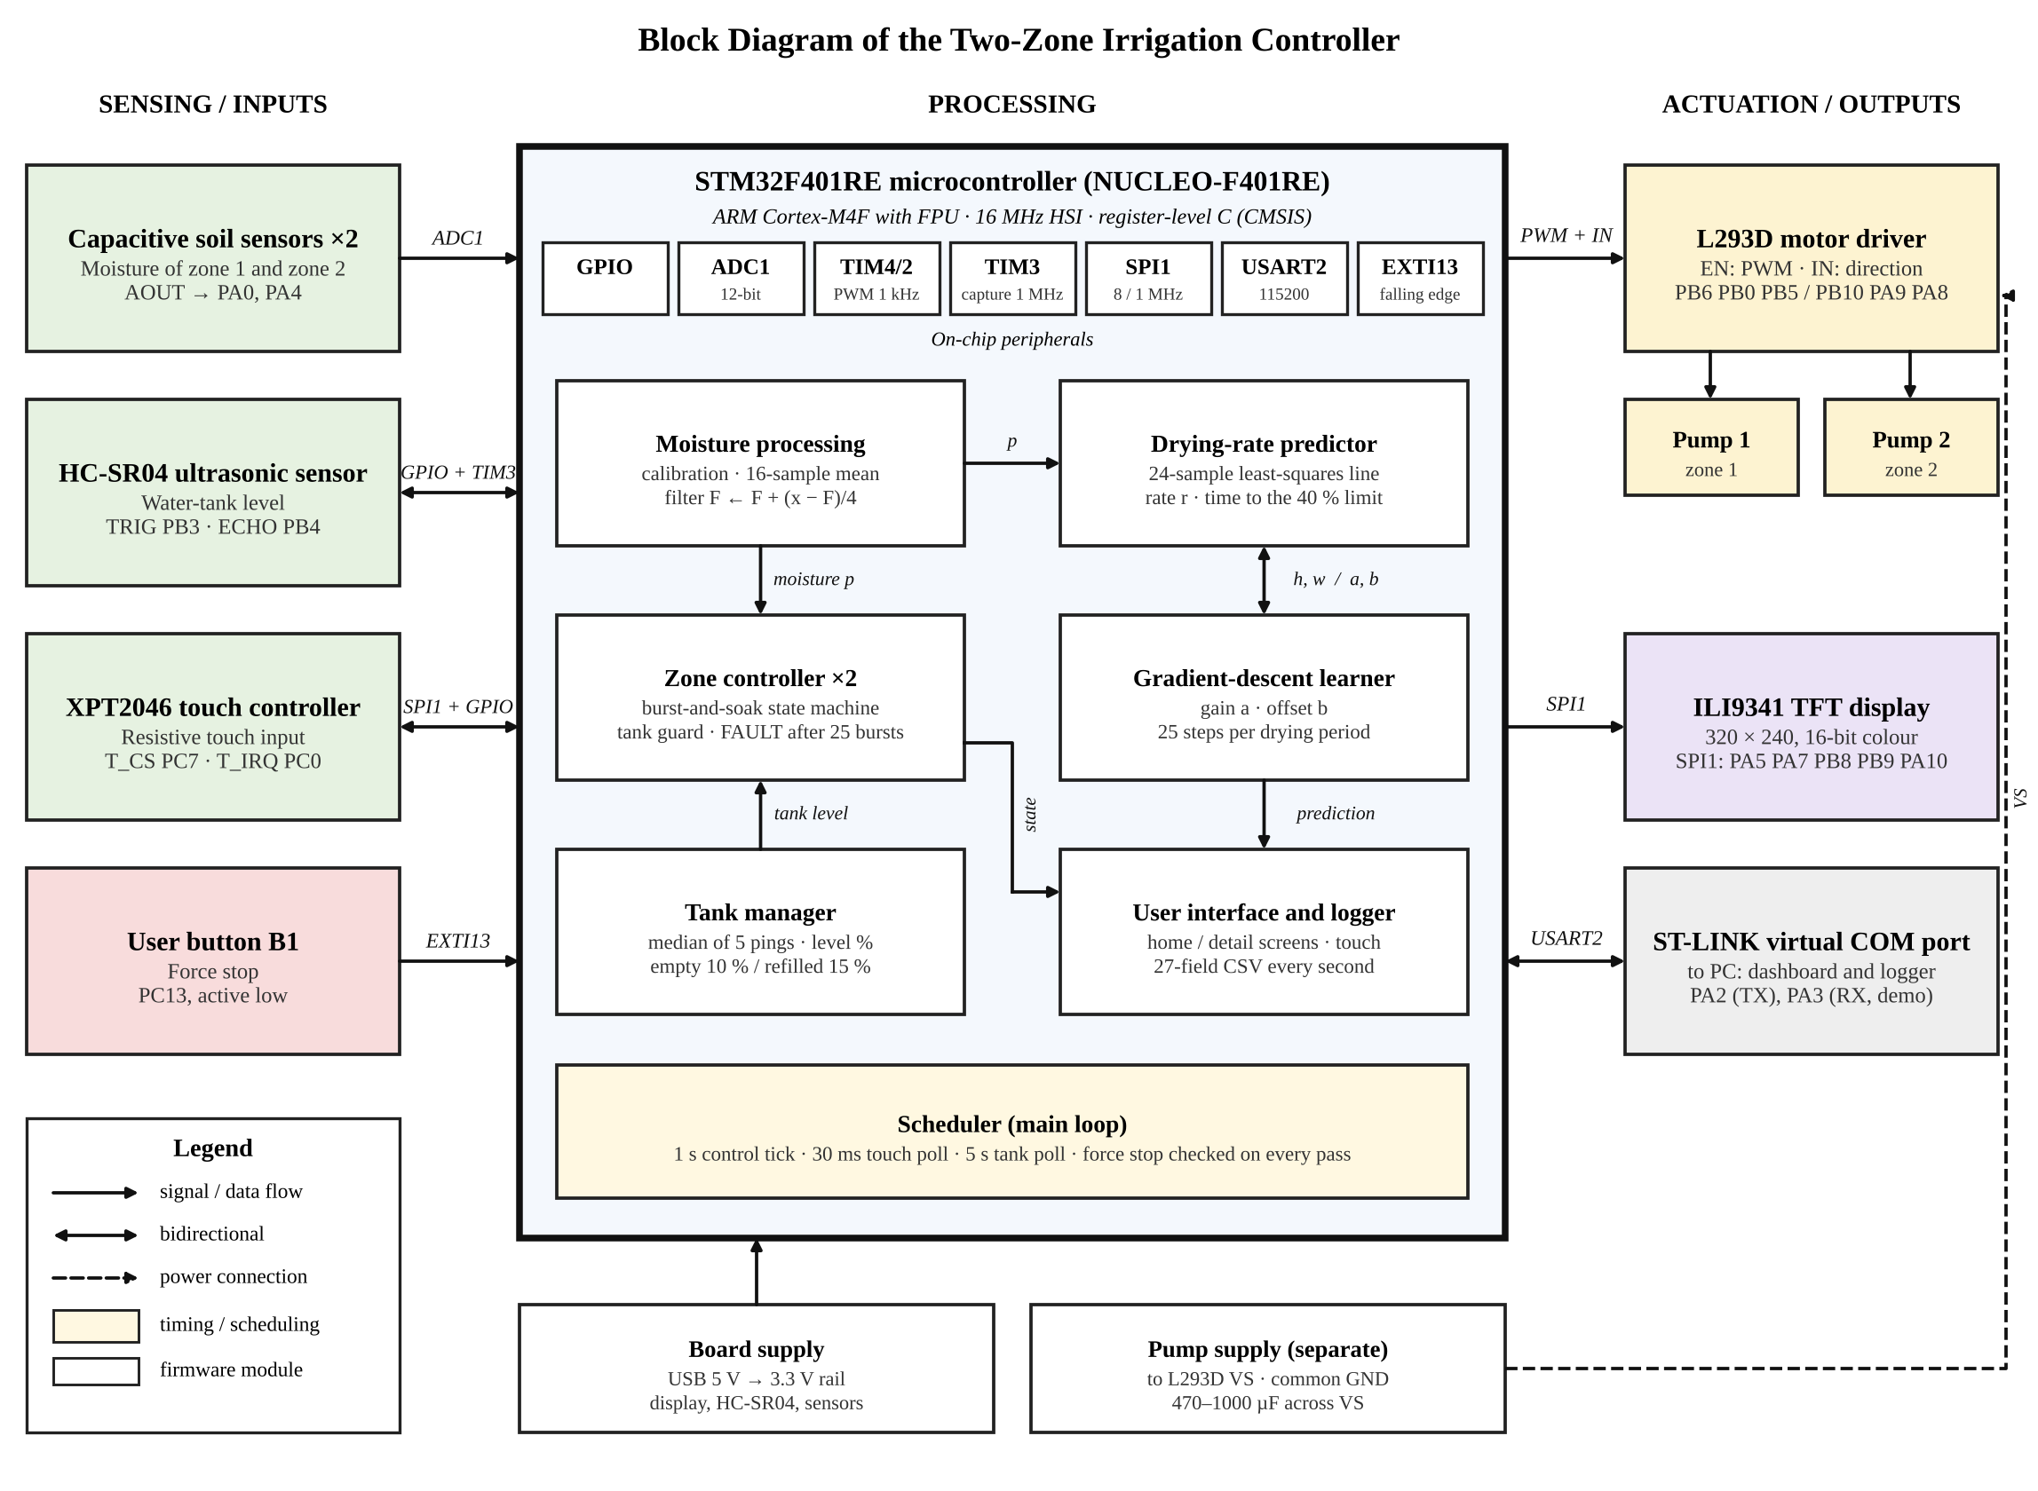
Figure 1: Block diagram of the irrigation controller. Arrows show the main data flow; the pumps are the only actuators.
Table 1: Subsystems and their connections
Subsystem | Connection to the microcontroller | Role
NUCLEO-F401RE | Cortex-M4F, HSI 16 MHz, on-board ST-LINK | Controller, programmer, virtual COM port
Capacitive soil sensor × 2 | AOUT: PA0 (ADC1 channel 0), PA4 (ADC1 channel 4); VCC switched from PA1 and PC1 | Soil moisture of zone 1 and zone 2
L293D driver and two DC pumps | EN1,2: PB6 (TIM4_CH1); EN3,4: PB10 (TIM2_CH3); IN1: PB0, IN2: PB5, IN3: PA9, IN4: PA8 | Pump on/off and speed
ILI9341 TFT display, 320 × 240 | SPI1: SCK PA5, MISO PA6, MOSI PA7; CS PB8, DC PB9, RESET PA10 | Display of state and prediction
XPT2046 touch controller | SPI1 (same bus); CS PC7, IRQ PC0 | Touch input
HC-SR04 ultrasonic sensor | TRIG PB3; ECHO PB4 (TIM3_CH1 input capture) | Water-tank level
User button B1 | PC13, EXTI13 interrupt, falling edge | Force stop
ST-LINK virtual COM port | USART2: PA2 (TX), PA3 (RX, demonstration only), 115200 baud | Data log, dashboard, rain command (demonstration)

3.2 Circuit Schematic
Figure 2 shows the signal connections between the NUCLEO-F401RE board and each peripheral, with the Arduino-header label of every pin, and Figure 3 shows the supplies and the motor-driver circuit. The signal lines are colour-coded by type, and the arrowheads show the direction of each signal.
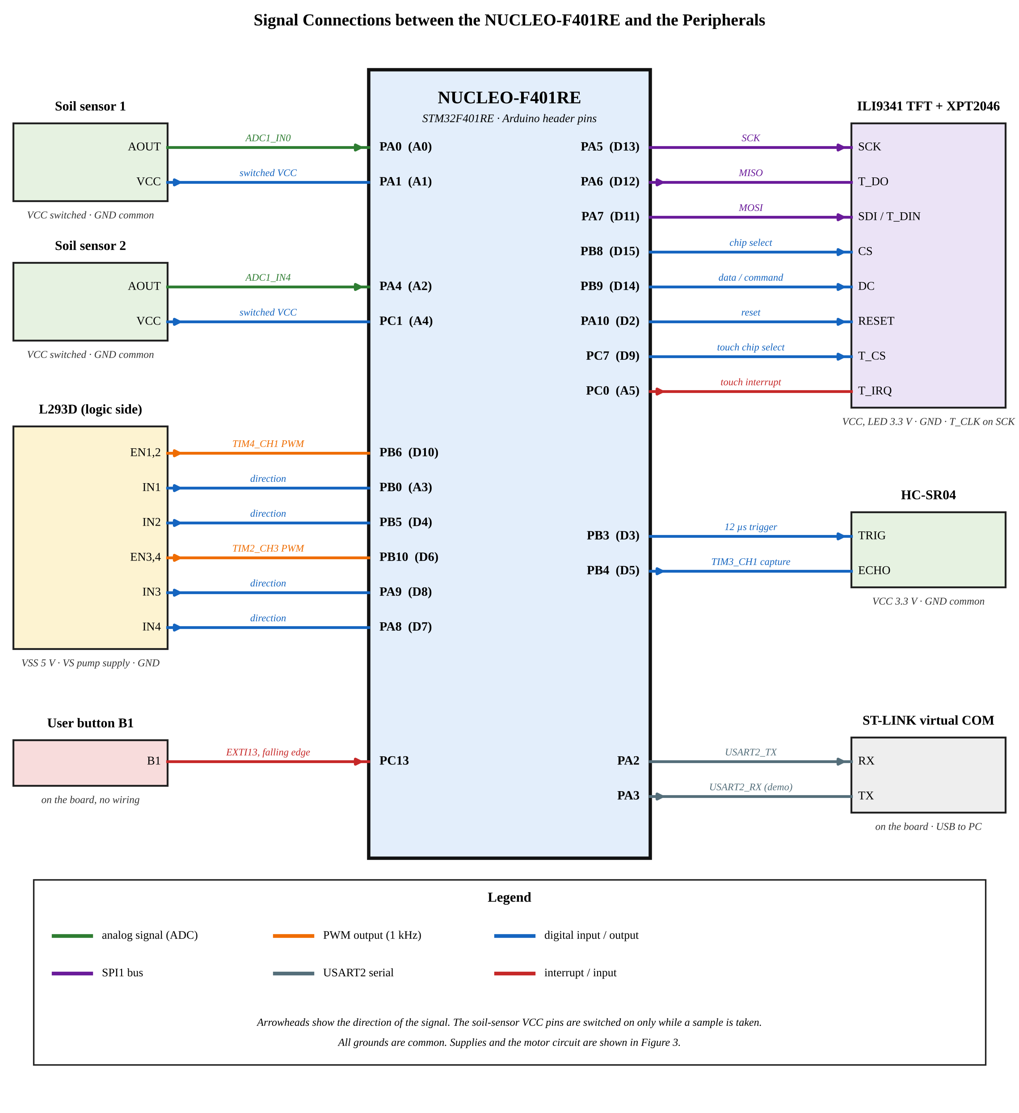
Figure 2: Signal connections between the NUCLEO-F401RE and the peripherals, with the pin names of the STM32F401RE and the Arduino-header labels.
Each soil sensor is powered from a GPIO pin, so that it is on only while it is being read; this reduces current and electrode corrosion. The HC-SR04 and the display module, including its backlight, are powered from 3.3 V, so that the echo output of the HC-SR04 is at the 3.3 V logic level of the microcontroller. The display and the touch controller share the SPI1 clock and data lines and are selected by separate chip-select pins; only the touch controller uses the MISO line.
The L293D logic supply (VSS) is 5 V from the board and its motor supply (VS) comes from a separate pump supply, so that the starting current of the pumps does not disturb the board. All grounds are common.
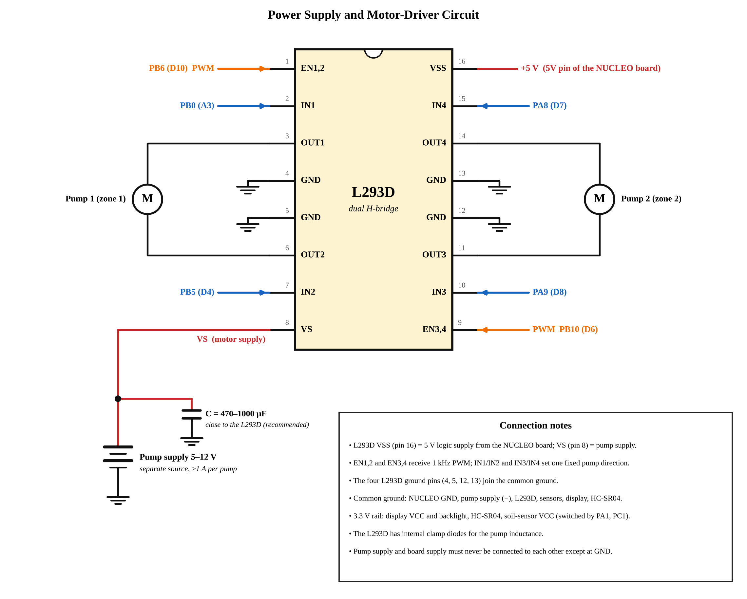
Figure 3: Power supply and motor-driver circuit: the L293D with its pin numbers, the two pumps, the separate pump supply and the supply capacitor.

3.3 Operating flow
The controller works in the following sequence:
- Start-up. The peripherals are initialised with both pumps forced off. An optional 3 s pump test and a three-point touch calibration follow, and the home screen is shown.
- Sampling. Every second each zone reads its sensor, filters the value and converts it to a moisture percentage.
- Watering. When a zone is below the lower threshold and the tank is not empty, it prints a plan and waters in bursts with soak periods until it reaches the upper threshold. A zone that does not reach the target after 25 bursts stops in the FAULT state.
- Observation and prediction. While a zone is idle it stores drying samples at a fixed interval, fits a line to them and predicts the time of the next watering, corrected by the learned gain and offset.
- Learning. At the end of each drying period the learner runs 25 gradient steps on the stored predictions; after each watering cycle the controller also updates its estimate of the water needed per percent of moisture.
- Reporting. The tank is measured every 5 s, the display shows the moisture, pump state, tank level and prediction, and each zone sends a data line to the PC.
- Protection. A press of the force-stop button switches both pumps off at any time.

3.4 System requirements
Table 2 lists the requirements that the system has to meet and the subsystem responsible for each. Section 7.6 reports the status of each requirement.
Table 2: System requirements
No. | Requirement | Related subsystem
1 | Measure the moisture of two zones independently. | Soil sensors, ADC1
2 | Water each zone between lower and upper thresholds in bursts with a soak period. | L293D, PWM timers, state machine
3 | Block watering when the tank is empty. | HC-SR04, TIM3 input capture
4 | Stop a zone that does not reach its target within 25 bursts. | State machine (FAULT state)
5 | Stop both pumps at any time with a button. | EXTI13, NVIC
6 | Predict the time to the next watering and improve the prediction by learning. | Drying-rate predictor, learner
7 | Show the zone states, tank level and prediction, and accept touch input. | ILI9341, XPT2046, SPI1
8 | Log the data to a PC and show it on a dashboard. | USART2, logger, dashboard
9 | Show the complete behaviour in minutes without real soil. | Demonstration configuration (soil model)

3.5 Demonstration and field configurations
The two firmware configurations share the same code. In the demonstration configuration a software model produces the ADC value that the real sensor would give: a hidden moisture value that dries at a nearly constant speed, rises while the pump runs, and drifts slowly. The model starts slowly after a watering and then speeds up, as the field log of Section 7.4 does. The tank sensor is the real HC-SR04 in both configurations. Table 3 lists the differences.
Table 3: Differences between the demonstration and the field configuration
Item | Demonstration | Field
Soil reading | Software soil model with ±3 ADC counts of noise | Sensor powered from a GPIO, 20 ms settling, mean of 16 ADC conversions
Soak after a burst | 15 s | 120 s
Drying sample interval | 10 s | 10 min
Settling time after watering | 30 s | 1 h
Samples needed to predict | 4 | 8
CSV line interval | 1 s | 30 s
Learning-rate decay constant γ | 0.5 | 0.3
Offset unit B₀, loss offset R₀, minimum time left | 100 s, 60 s, 30 s | 14400 s, 7200 s, 1800 s
Calibration ADC at 0 % / 100 % | 2300 / 1100 (both zones) | 2300 / 1100 (both zones, can be calibrated per zone)
USART2 | TX and RX (rain command) | TX only
Display extras | DRY button and “SIMULATED SOIL SENSORS” label | None

4. Methodology

4.1 Moisture measurement
The output of the capacitive sensor falls as the soil gets wetter. Each zone has two calibration values: the ADC count in dry conditions, A₀, and the count in saturated soil, A₁₀₀. The filtered count A is converted linearly to a moisture p in tenths of a percent:
p = 1000 (A₀ − A) / (A₀ − A₁₀₀), 0 ≤ p ≤ 1000 (1)
Each sample is the mean of 16 ADC conversions (field configuration). A first-order integer filter then smooths it, with the previous filtered value F and the new sample x:
F ← F + (x − F) / 4 (2)
The reading is labelled DRY at or below 10 % and WET at or above 90 %. At these two ends the response curve of a capacitive sensor is flat, so the value is only a limit and not an exact moisture. The labels affect the display and the prediction, but not the watering decision.

4.2 Watering control
Every second each zone runs a state machine (Figure 4). When the moisture is below the low limit and the tank is not empty, the zone prints a watering plan and starts the pump. The pump runs for one burst (2 s, about 25 mL measured), then stops for a soak period. After the soak the zone checks the moisture: at the upper limit or above it finishes, otherwise it starts the next burst. If 25 bursts have not been enough, the zone goes to a FAULT state, which only a reset clears. This protects against an empty hose, a stuck pump or a sensor that does not respond. The number of bursts n_{b} planned for a cycle is
n_{b} = ⌈ (p_{high} − p) k / V_{b} ⌉ (3)
where p is the present moisture in percent, p_{high} is the upper limit, k is the learned volume in millilitres per percent of moisture, and V_{b} is the volume of one burst.
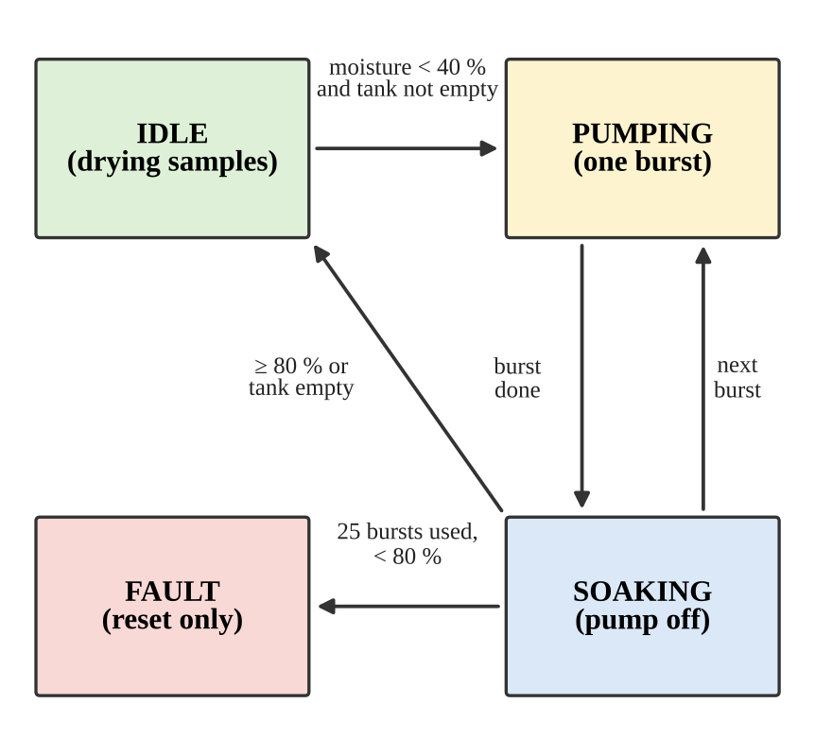
Figure 4: State machine of one zone. A zone also returns to IDLE from PUMPING when the target is reached in the middle of a burst or when the tank becomes empty.
The tank guard blocks watering when the tank is empty (Section 4.7). A press of the force-stop button switches both pumps off inside the interrupt routine; the running cycles are abandoned and are not used for learning.

4.3 Drying-rate fit and raw prediction
While a zone is idle, and after a settling time that follows a watering, it stores one drying sample every 10 min (10 s in the demonstration) in a window of the last N = 24 samples. At least 8 samples (4 in the demonstration) are needed. A least-squares straight line is fitted through the samples, with time x in minutes and moisture y in percent [13]:
b = S_{xy} / S_{xx}, R² = S_{xy}² / (S_{xx} S_{yy}) (4)
where S_{xx}, S_{yy} and S_{xy} are the sums of squares and cross-products about the means and b is the slope. The drying rate is r = −60 b in %/h. A slope that is not negative, or a rate below 0.1 %/h, means that the soil is not drying measurably, and no prediction is made. The line is evaluated at the present time, which is less noisy than the last reading, and the raw time to the low limit is
h = (ŷ(now) − p_{low}) / r (5)
The water loss shown on the display is in mL/h. Predictions above 144 h are shown as “>144h”; this is a display limit only.

4.4 Learned correction by gradient descent
Right after a watering the soil dries more slowly than later, so a line fitted to a short early window is biased. The controller corrects the raw time with two learned numbers per zone, a gain ‘a’ that starts at 1 and an offset ‘b’ that starts at 0. With ‘n’, the number of samples in the window and B₀ the unit of the offset (100 s in the demonstration, 4 h in the field configuration):
w = max(0, 1 − n / N) (6)
T = h [1 + (a − 1) w] + b B₀ w (7)
The weight w is 1 when the window is empty and falls to 0 when it is full, so the correction acts on the early predictions, which are the least reliable, and leaves the late ones unchanged.
Every time a drying sample is stored, the prediction made at that moment is kept as a training example: its raw time h, its weight w and the time it was made. When the soil next needs water, the real time left R is known for every example. The loss is the root-mean-square relative error over the m examples that have more than 30 s (1800 s in the field configuration) left:
L = sqrt( (1/m) Σ u_{i}² ), u_{i} = (T_{i} − R_{i}) / (R_{i} + R₀) (8)
The offset R₀ stops very short remaining times from dominating the loss. With J = L², the gradients are
∂J/∂a = (2/m) Σ u_{i} h_{i} w_{i} / (R_{i}+R₀), ∂J/∂b = (2/m) Σ u_{i} B₀ w_{i} / (R_{i}+R₀) (9)
At the end of each drying period 25 gradient steps are made, a ← a − λ η_{a} ∂J/∂a and b ← b − λ η_{b} ∂J/∂b, with η_{a} = 0.10 and η_{b} = 0.50. After each step a is limited to the range 0.4 to 2.5 and b to −3 to 3. The learning-rate factor λ decays with the number c of periods already learned, so that the first cycles make large steps and later ones make fine adjustments:
λ = max(0.2, 1 / (1 + γ c)) (10)
At most 64 examples are kept per period; when the store is full, every second example is dropped and the recording interval doubles. A period with fewer than 8 examples is not learned from. The loss printed after each cycle is computed before the update, so it shows how the predictions really performed. Figure 5 shows the data flow.
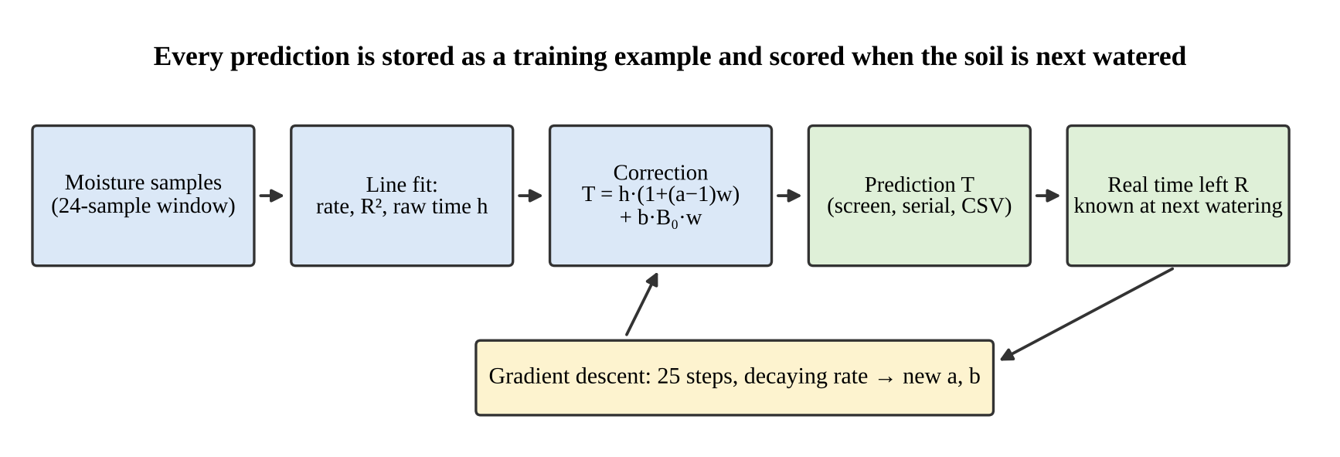
Figure 5: Data flow of the prediction and learning loop.

4.5 Water per percent of moisture
After a cycle, once the soil has settled, the controller compares the volume it delivered V (pump time multiplied by the burst flow) with the rise Δp it caused. If Δp is at least 10 %, the measured value k_{m} = V / Δp, limited to 0.05–5 mL per %, moves the estimate k by half of the difference:
k ← k + 0.5 (k_{m} − k) (11)
A value that is more than 2.5 times or less than 0.4 times the current estimate (after two cycles) is treated as unusual and moves the estimate by only 0.3 of that step. The signed plan error 100 (k − k_{m}) / k_{m} is logged; it shows how far the planned water was from what the cycle needed.

4.6 Rain and manual watering
If the moisture between two drying samples rises by more than 1 % while the pump is off, water was added from outside. The controller prints a warning, empties the sample window and marks the period as disturbed. A disturbed period is not used for learning.

4.7 Tank level
The HC-SR04 receives a 12 µs trigger pulse and returns an echo pulse whose width ‘t’ is the round-trip time of the sound. With the speed of sound of 343 m/s, the distance in millimetres is d = t · 343 / 2000, with t in microseconds. The level is
p_{tank} = 100 (d_{empty} − d) / (d_{empty} − d_{full}) (12)
with d_{full} = 24 mm and d_{empty} = 66 mm for the prototype tank, which gives a capacity of 850 mL between the two levels. Five measurements are taken 30 ms apart and the median is used, so that a stray echo does not move the result. The tank counts as empty below 10 % and as refilled at 15 % or more; this hysteresis stops the state from changing back and forth at the limit. If no echo is found, the level is unknown and watering is not blocked.

5. Tools and Systems

5.1 Hardware components
- NUCLEO-F401RE development board with the STM32F401RE microcontroller [2], [3], [4].
- Capacitive soil-moisture sensors (two): Analog output that falls as the soil gets wetter; powered from a GPIO pin.
- L293D dual H-bridge driver with two DC pumps [8]; the enable inputs take the PWM signals and the IN pins set the direction. The pumps run from a separate supply with a common ground.
- ILI9341 240 × 320 colour TFT display [5] with an XPT2046 resistive touch controller [6], both on SPI1.
- HC-SR04 Ultrasonic ranging module [7] for the tank level.
- User button B1 on the board, used as the force-stop input.

5.2 Peripherals of the microcontroller
The firmware configures every peripheral directly through its registers [2]. The STM32 hardware abstraction layer (HAL) is used only for the start-up code and the 1 ms time base. Table 3 lists the peripherals with their type, configuration and the code used.
Table 4: Peripherals of the STM32F401RE used in the project
Peripheral | Type, use | Configuration / protocol | Library or own code
GPIO | Digital input/output | Push-pull outputs: sensor power, L293D IN pins, display CS/DC/RESET, touch CS, TRIG. Input with pull-up: touch IRQ. Set and clear through the atomic BSRR register. | Own register code
ADC1 | 12-bit analog input; sensor interface | Channels 0 (PA0) and 4 (PA4); software-started single conversion; 480-cycle sampling time; mean of 16 conversions per sample. | Own register code
USART2 | Asynchronous serial; PC interface | 115200 baud, 8N1; BRR = 139 for the 16 MHz clock; PA2 as TX (PA3 as RX in the demonstration); polled transmit. | Own register code
SPI1 | Synchronous serial; display and touch | Master, mode 0 (CPOL 0, CPHA 0), MSB first, software slave management; 8 MHz for the display, 1 MHz for the touch controller; chip selects by GPIO. | Own register code; own ILI9341 and XPT2046 drivers
TIM4 (CH1), TIM2 (CH3) | PWM; pump interface | Timer clock 16 MHz, PSC = 15, ARR = 999: 1 kHz, 1000 duty steps; PWM mode 1 with preload; outputs on PB6 and PB10 drive the L293D enable inputs. | Own register code
TIM3 (CH1, CH2) | Input capture; ultrasonic ranging | 1 MHz count; channel 1 captures the rising edge and channel 2 the falling edge of the same pin PB4; echo width = CCR2 − CCR1 in microseconds. | Own register code
EXTI13, NVIC, SYSCFG | External interrupt; force stop | PC13 routed to line 13; falling edge; NVIC priority 1; 250 ms debounce in the handler; pumps switched off inside the interrupt. | Own register code
SysTick | Time base | 1 ms tick for HAL_GetTick and HAL_Delay. | HAL

5.3 Software and tools
- Firmware: C language, bare-metal, written on the CMSIS register definitions of the STM32F4 family [2], [4], in an STM32 project that uses the HAL start-up code.
- Data logger: A Python script using the pySerial library [14] that saves the serial CSV lines with a time stamp, and can also convert a saved log to CSV.
- Dashboard: A single-file web page that reads the serial port with the Web Serial API [12] and shows the live state, charts and the learning results.

5.4 Hardware and software integration
The firmware shares a small number of hardware resources between the modules, and each resource has one owner:
- Timers. TIM4 (channel 1) and TIM2 (channel 3) generate the pump PWM signals, TIM3 measures the echo width of the tank sensor, and SysTick gives the 1 ms time base.
- SPI1 is shared by the display (8 MHz) and the touch controller (1 MHz). Only one device is selected at a time, and the clock divider is changed only while the peripheral is disabled.
- ADC1 is shared by the two soil sensors through the channel selection; the sensors are powered one at a time, and each is read to completion before the next.
- Interrupt. The force-stop interrupt only switches the pumps off and sets flags; the screen, the state machines and the data output are handled by the main loop. This keeps the interrupt short.
- Serial port. USART2 carries the data lines and messages to the ST-LINK virtual COM port, and in the demonstration configuration the rain command from the PC.

6. Implementation

6.1 Firmware structure
The program is a single polling loop (Figure 6). The start-up code initialises the serial port first, so that later steps can print, then the ADC, the zone variables, the pins, the PWM timers (with both pumps forced off), the force-stop interrupt, the tank timer, SPI and the display. It then runs an optional 3 s pump test, an optional three-point touch calibration, takes a first reading and prediction, and shows the home screen.
In the loop, the force-stop service runs first on every pass. The touch controller is polled every 30 ms, and a tap is registered once, at the moment the finger lands. Every second, unless force stop is active, each zone runs four steps in order: sample (read and filter), step (state machine), predict (line fit and training examples) and log (serial output). Every 5 s the tank is measured and the screen is refreshed. The control tick is advanced by exactly 1000 ms each time, so late passes do not make the schedule drift.
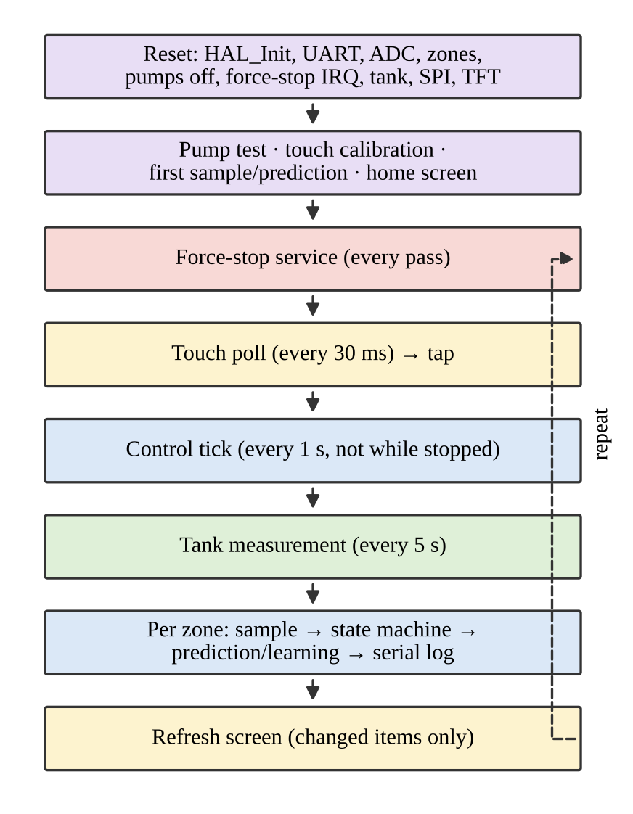
Figure 6: Start-up sequence and main loop of the firmware.

6.2 Peripheral drivers
Serial port - USART2 is configured for 115200 baud, 8 data bits, no parity and one stop bit. With the 16 MHz clock, the baud-rate register value 139 gives 115108 baud, an error below 0.1 %. Characters are sent by polling the transmit-empty flag.
SPI, Display and Touch - SPI1 is a master in mode 0 with the chip-select pins driven by GPIO. The display runs at 8 MHz. The touch controller is slower, so the clock divider is changed to 1 MHz for each touch read and changed back; the divider can only be changed while the peripheral is disabled. The display protocol uses a data/command line: a command byte, then its arguments. A drawing call sets a window (commands 0x2A, 0x2B, 0x2C) and then streams 16-bit RGB565 pixels, so no frame buffer is needed; a full buffer of 150 KB would not fit in the 96 KB of RAM. Text uses a built-in 5 × 7 font. Only the items that changed since the last pass are redrawn. Of the SPI lines, the display uses SCK, MOSI, CS and DC; the MISO line is used by the touch controller only.
Touch - Each read drops the first conversion, averages four X/Y pairs and rejects a reading whose spread is above 150 counts. A three-point calibration at power-up detects whether the axes are swapped and fits a linear map per axis.
ADC - ADC1 uses a 480-cycle sampling time because the output of the capacitive sensor has a relatively high impedance; at an ADC clock of 8 MHz one conversion takes about 61 µs.
PWM - The enable inputs of the L293D are driven at 1 kHz by TIM4 channel 1 and TIM2 channel 3. The duty of each pump is set in the zone configuration table; the direction inputs IN1/IN2 and IN3/IN4 select one fixed direction.
Tank sensor - TIM3 counts microseconds. Channel 1 latches the rising edge and channel 2 the falling edge of the echo on the same pin, so the width is read from two registers without polling the pin. The pin has a pull-down so that a missing sensor reads as low.
Force stop - The falling edge on PC13 enters the interrupt handler, which ignores bounces within 250 ms, toggles the stop flag and, when the stop engages, switches both pumps off at once. The main loop then abandons any running cycle, shows a red screen, and keeps the pumps off until the button is pressed again, after which it clears the sample windows.

6.3 User interface
The home screen (Figure 7) is split into two halves, one for each zone, with the moisture value, the band (DRY, MOIST, WET), a bar, the pump state and the tank level. A tap on a half opens the detail screen (Figure 8), which has nine lines: moisture, ADC value, state, limits, drying rate, water loss, time to the next watering (or the reason there is none), the last cycle and the learned numbers. The DRY button, present in the demonstration configuration only, drops a zone below its watering limit so that a cycle can be shown on demand.
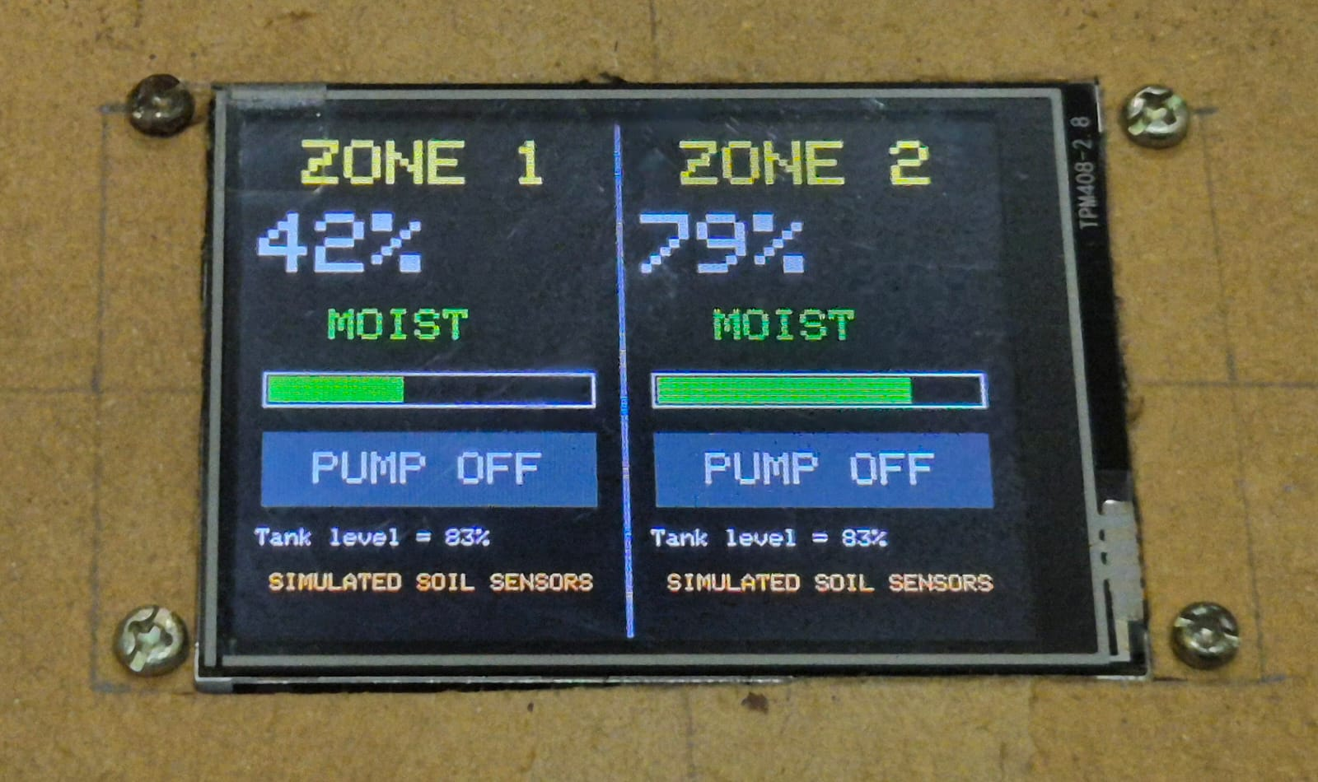
Figure 7: Screen layouts, drawn from the coordinates used by the firmware : Home screen
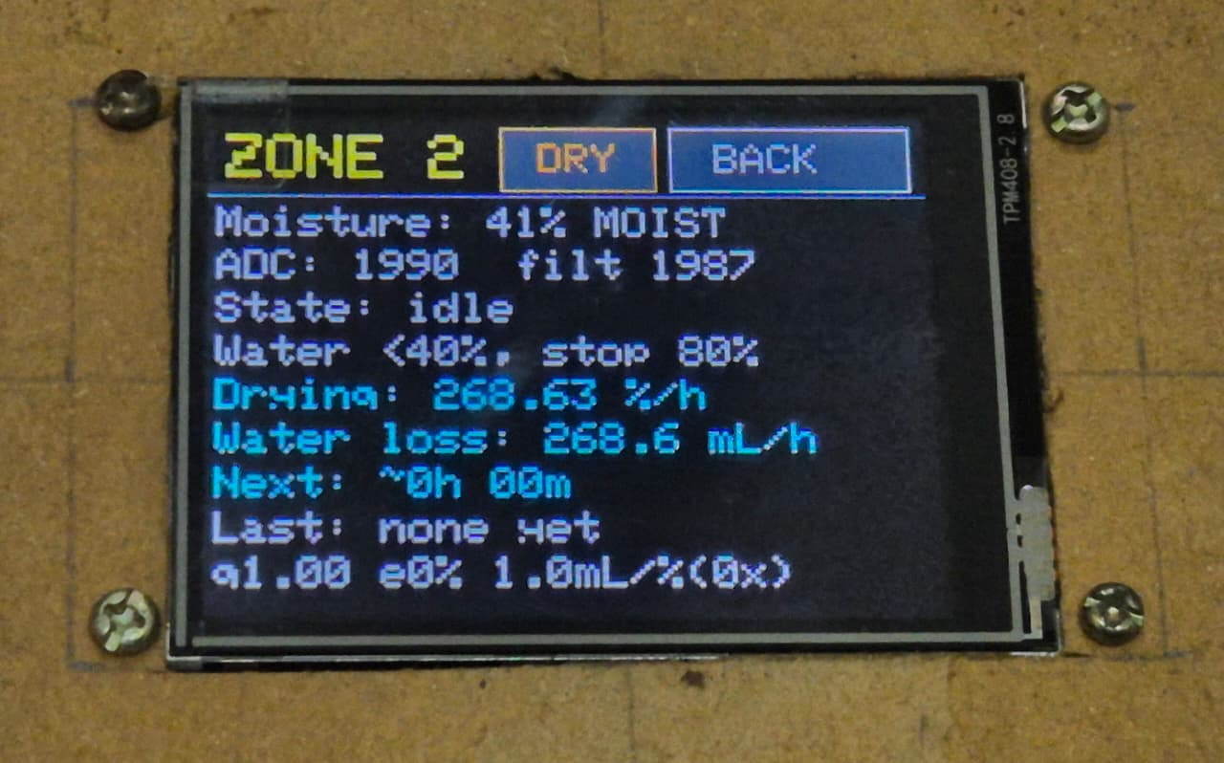
Figure 8: Screen layouts, drawn from the coordinates used by the firmware : Detail screen of the demonstration configuration.

6.4 Configuration parameters
The behaviour of the controller is set by constants at the top of the source file. Table 5 lists the principal ones for the two configurations.
Table 5: Principal firmware parameters
Parameter | Demonstration | Field
Watering limits (start / stop) | 40 % / 80 % | 40 % / 80 %
Burst on-time and volume | 2 s, 25 mL | 2 s, 25 mL
Soak after a burst | 15 s | 60 s
Maximum bursts per cycle | 25 | 25
Control tick / touch poll / tank poll | 1 s / 30 ms / 5 s | 1 s / 30 ms / 5 s
Tank empty / refilled threshold | 10 % / 15 % | 10 % / 15 %
Force-stop debounce | 250 ms | 250 ms
Fit window / minimum samples | 24 / 4 | 24 / 8
Drying sample interval / settling time | 10 s / 30 s | 10 min / 1 h
Minimum drying rate / display cap | 0.1 %/h / 72 h | 0.1 %/h / 144 h
Gradient steps / learning rates (gain, offset) | 25 / 0.10, 0.50 | 25 / 0.10, 0.50
Rain detection threshold | 1 % | 1 %
DRY / WET band limits | 22 % / 90 % | 22 % / 90 %
ADC averaging / filter divisor | simulated / 4 | 16 / 4

6.5 Prediction and learning code
The learner is about 100 lines of C and uses the floating-point unit of the Cortex-M4F; no machine-learning library is used. The loss function, the 25-step gradient loop and the example store follow Section 4.4. All values are printed as integers built from the floating-point numbers, so the program does not depend on floating-point support in the print function of the C library.

6.6 Serial protocol, dashboard and logger
Each zone prints a comma-separated line every second (every 30 s in the field configuration) with 27 fields: time, zone, raw and filtered ADC value, moisture, state, pump, tank level and volume, the prediction, the fit, the learned numbers and a disturbed flag. Besides these lines, the firmware prints each stored drying sample and each cleared window, so that the dashboard can redraw exactly the fit that the controller is using, and text lines for the watering plan, completed cycles, learning results and warnings.
The dashboard (Figure 8) is a single web page that connects to the serial port with the Web Serial API [12]. For each zone it shows the moisture, the next watering, the drying rate, the learned numbers, a moisture chart with the prediction, the ADC trace, and a three-step explanation of the prediction. It also keeps a table of the predicted against the real time for every drying period, with the error of the first prediction and the error of all predictions in the period, and learning curves. The Python logger saves the lines to a CSV file with a PC time stamp and the other messages to a separate text file; it reconnects if the port disappears.
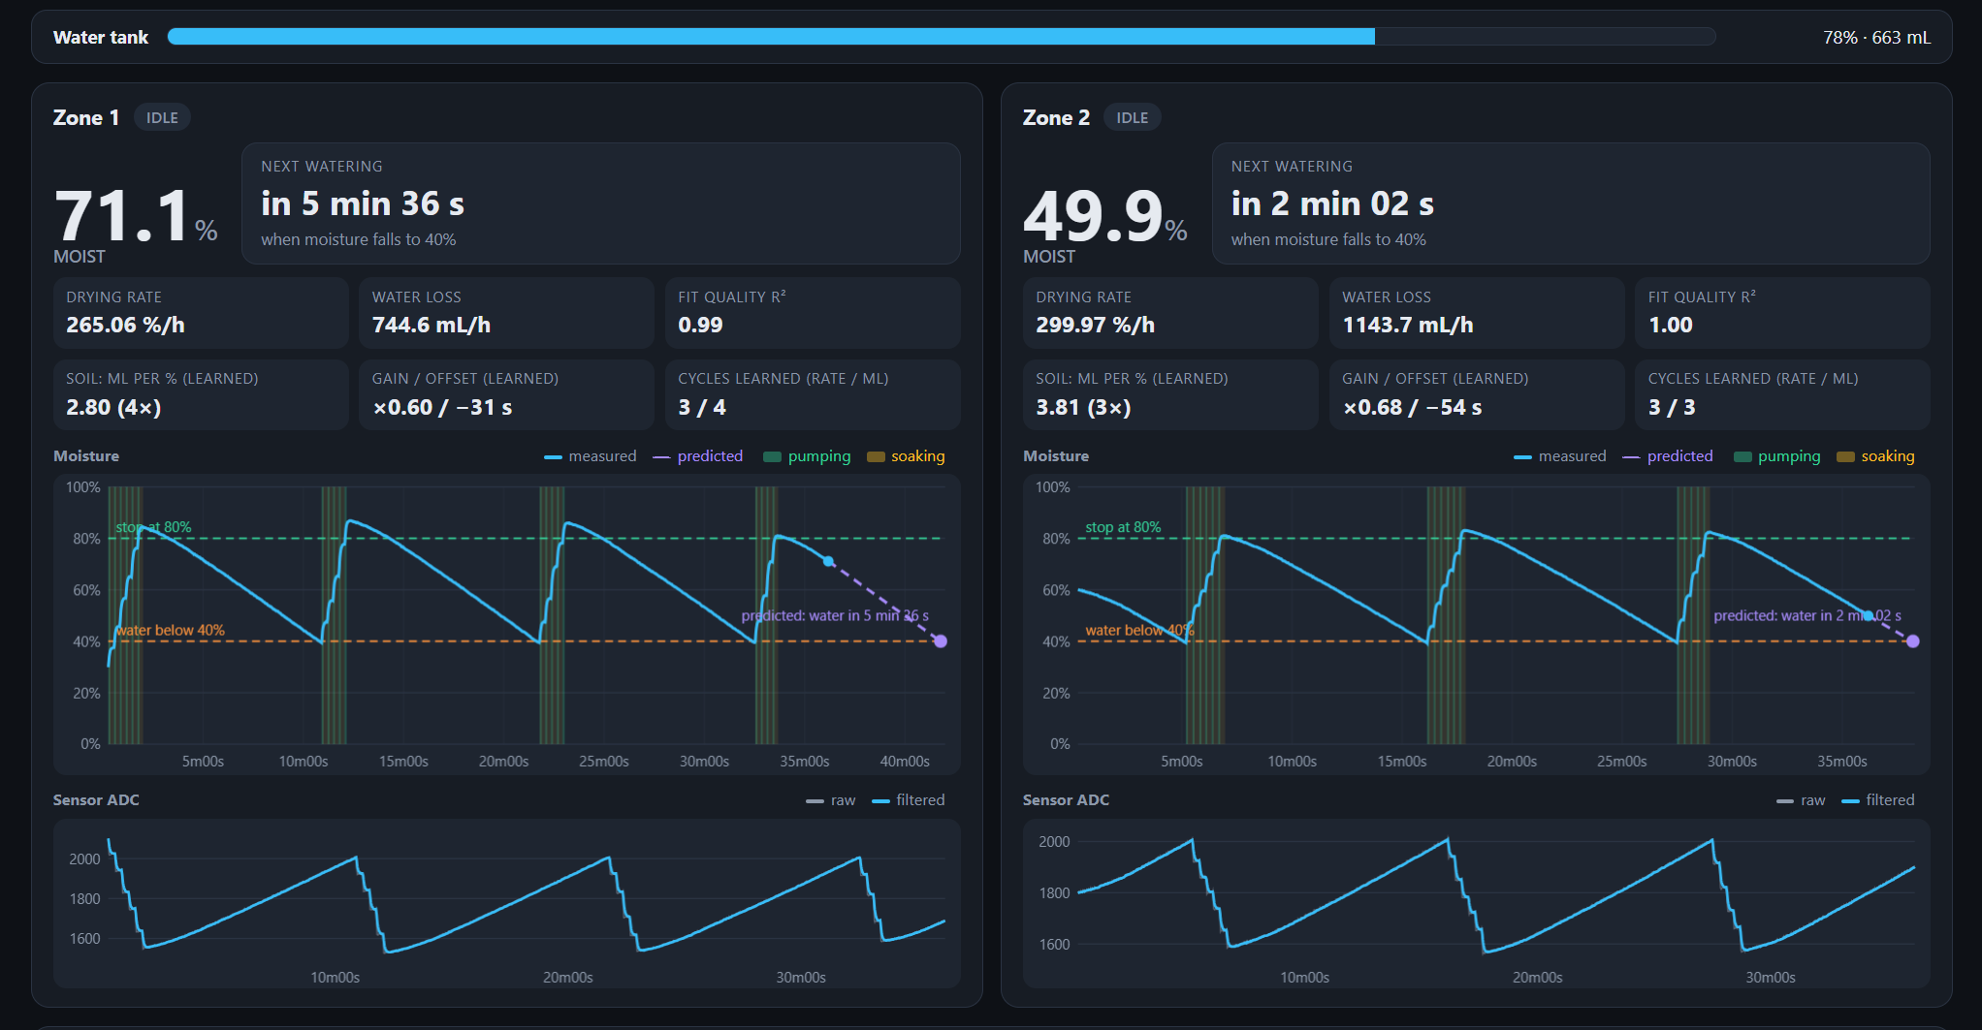
Figure 9: Dashboard showing both zones: moisture chart with the prediction (dashed), the learned gain and offset, and the ADC trace.

6.7 Prototype

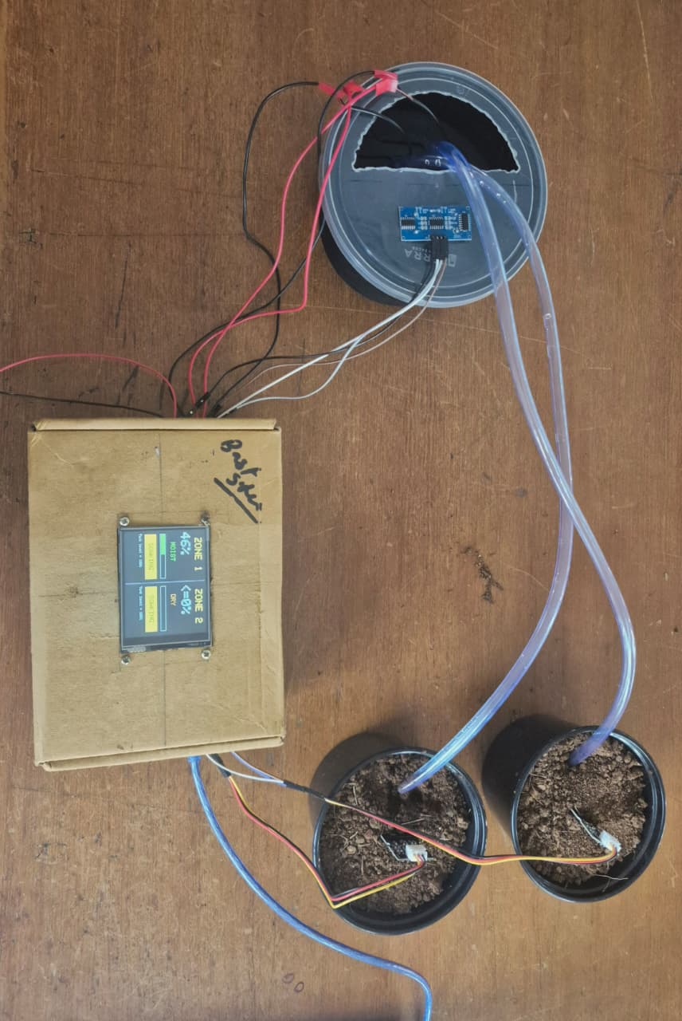Figure 10: Photograph of the assembled prototype.

7. Results and Analysis

7.1 Test Setup
The system was evaluated using the Demonstration configuration executed directly on the STM32 Nucleo-F401RE board along with the specified peripherals. The board was clocked at 16 Mhz (HSI) and powered via USB, with a separate DC Supply providing 5V to the L293D motor driver rail. The ST-LINK virtual COM port was connected to a host PC running the serial data logger and Web Serial dashboard at 115200 baud.
A total of 5 consecutive watering cycles across 1 hour of active operation were logged. Hardware safety mechanisms (the EXTI13 force-stop interrupt and the HC-SR04 ultrasonic tank guard) were verified by physical actuation during runtime

7.2 Control Behaviour
Figure 10 illustrates the closed-loop moisture control of Zone 1 during the demonstration run.
- Watering Trigger: When moisture dropped below the lower limit of 40% (measured at e.g., 39.4%]), the controller entered the PUMPING state.
- Burst-and-Soak Execution: Water was delivered in 2 s pulses (TIM4 PWM at 1 kHz), followed by a 15 s]soak period. A complete cycle required 4-6 bursts to reach the target threshold.
- Settling and Overshoot: The moisture settled at 80-83%, representing an overshoot of 1-3% above the 80% cutoff. This overshoot is attributed to the low-pass filter delay ($F←F+\left(x-F\right)/4$) and physical sensor diffusion lag, demonstrating the necessity of the soak interval.
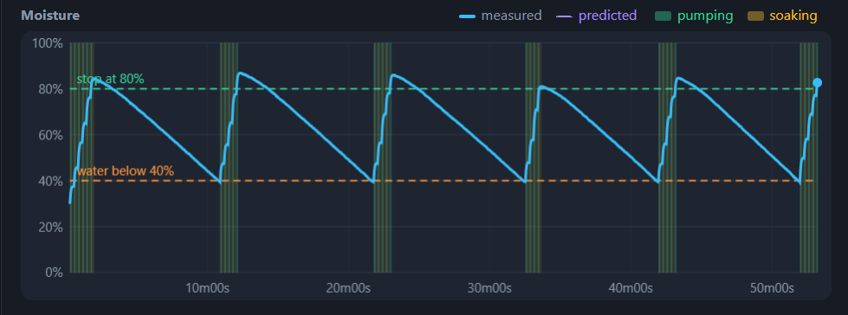
Figure 11: Moisture of zone 1 over 1 hour in the demonstration configuration: watering starts at 40 % and stops at 80 %.

7.3 Prediction Accuracy and On-Chip Learning
During the idle drying phase between watering cycles, the MCU fitted a linear regression line over the sliding window of 24 samples and updated the prediction correction parameters ($a$ and $b$) using 25 iterations of floating-point gradient descent at the close of each cycle.

Table 6: Measured Prediction Performance Across Demo Cycles
Quantity | Zone 1 | Zone 2 | Both zones | Unit
Drying periods from the 4th on | 21 | 19 | 40 | periods
Mean of period RMS error (all predictions) | 6.6 | 7.1 | 6.9 | %
Maximum of period RMS error | 8.8 | 10.4 | 10.4 | %
RMS error of the first prediction of a period | 6.4 | 9.4 | 8.0 | %
Largest first-prediction error | 16.2 | 22.3 | 22.3 | %
First prediction, periods 1 and 2 | +65 / +25 | +55 / +21 | – | %

- Convergence: In the initial cycle, with default parameters ($a=1.0,b=0$), the raw linear fit significantly overestimated the time remaining due to transient moisture settling.
- By Cycle [3], the gradient descent learner adjusted the gain to [~0.61] and the offset to [-38 s], reducing the period RMS error from [26.4%] down to [< 7%].
- The learned water-per-percent coefficient converged from the default 2.0 mL/% to [e.g., 3.2 mL/%], allowing accurate burst planning in subsequent waterings.

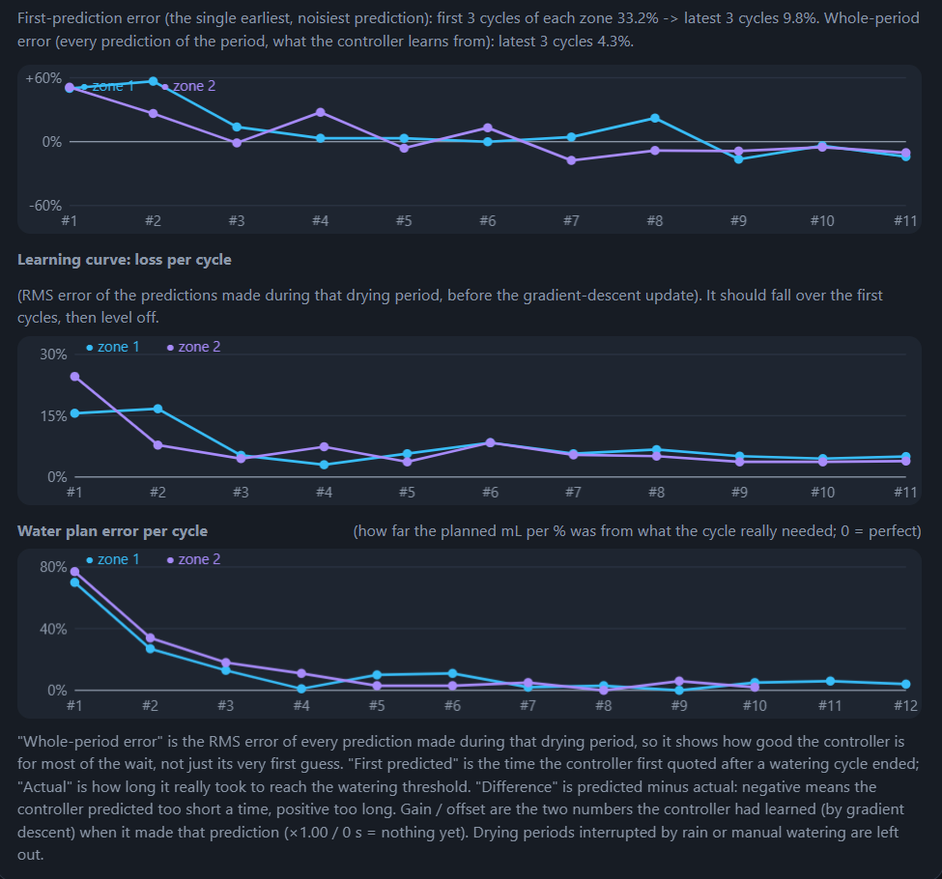
Figure 12: Dashboard learning curves for the same run: prediction error per period and plan error of the mL per percent.

7.4 Field data from the real sensor
Figure 15 is a 27.8 h log of zone 1 with the real capacitive sensor in soil. The moisture falls steadily from 50.6 % to 39.6 %. A straight line fits this well, with a slope of −0.40 %/h, which supports the choice of a line fit for the drying model. At this rate the soil needs about 100 h (four days) to fall from 80 % to 40 %, so a real cycle takes days. For this reason, the field configuration uses 10 min samples, a 4 h window and a 1 h settling time, and the learner needs several weeks of real operation to complete a few cycles. The demonstration configuration exists to show this behaviour in minutes.
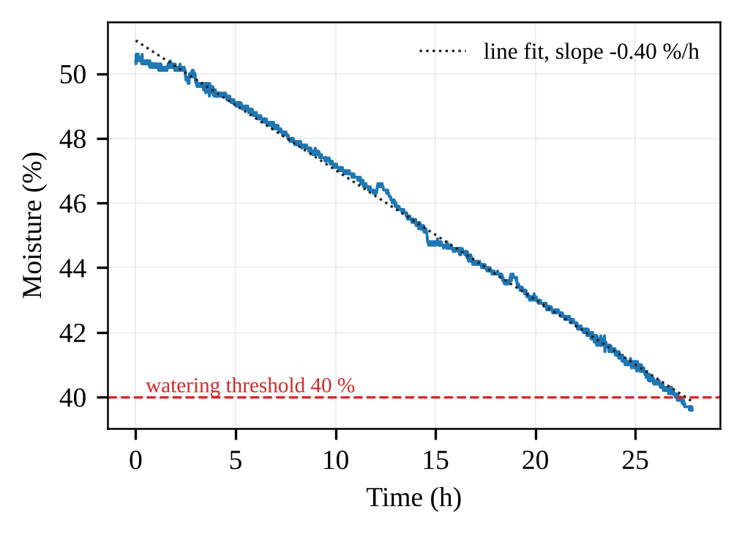
Figure 13: Field log of zone 1 over 27.8 h: moisture, a line fit and the 40 % limit.

7.5 Discussion and limitations
- The prediction is only as good as the straight-line model. A change of room temperature or airflow changes the drying speed, and the prediction cannot know it in advance, however the learner can adapt to changes over a few cycles.
- The learned numbers describe one zone and one soil; they are not transferred between zones.
- Rain or manual watering is detected only when the moisture rises by more than 1 % between two samples; a slow wetting would not be detected.
- The learner has been tested on the simulated soil; the real-soil results are limited to one drying log.
- Both zones use the same calibration values; each sensor needs its own calibration in its own soil before long unattended use.

7.6 Status of the requirements
Table 7 compares the system with the requirements of Table 2.
Table 7: Status of the system requirements
No. | Requirement | Status and evidence
1 | Two independent zones | Zone 1 and 2 verified with the real sensor (Section 7.4);
2 | Burst-and-soak watering, 40 % to 80 % | Verified in the demonstration configuration (Section 7.2).
3 | Tank-empty guard | Implemented; the tank reading was recorded in the field log.
4 | FAULT after 25 bursts | Verified: zone 2 stopped in FAULT in the field log .
5 | Force stop | Implemented in firmware (EXTI13, pumps switched off in the interrupt).
6 | Prediction and learning | Verified in simulation (Table 6); real-soil learning needs several weeks.
7 | Display and touch | Implemented; screens as in Figure 7.
8 | Data logging and dashboard | Verified: 27-field CSV, logger and dashboard .
9 | Demonstration in minutes | Verified with the soil model (Sections 7.2 and 7.3).

7.7 Alternatives and scaling

Microcontroller - Any Cortex-M part with the same peripherals could be used. A Cortex-M0+ part would be enough for the control and cheaper, but without a floating-point unit the learner would need fixed-point arithmetic. A larger Cortex-M4 or M7 part would allow a frame buffer and a graphics library.
Software structure - A real-time operating system would replace the polling loop with tasks for control, display and communication. With two zones the polling loop meets all the timing, because the control tick is one second. Direct memory access (DMA) could transfer the ADC samples and the SPI pixel data without the processor, which would shorten the time that a display redraw blocks the loop. A watchdog timer would restart the program if it hung, which is important for an unattended device.
Sensors and actuators - A flow sensor in the pump line would replace the measured volume per burst by the real volume. A temperature sensor would let the model include the effect of temperature on the drying speed. Solenoid valves with a single pump would replace one pump per zone.
More zones - The zone configuration and state are tables indexed by the zone, and the constant NZONES sets their number, so more zones need only more table rows, more ADC channels (or an analog multiplexer) and more driver outputs. The display layout, the dashboard and the CSV format would need extra zones added.
Connectivity and power - A Wi-Fi module on the serial port would send the same CSV lines to a phone or a server. The switching of the sensor power already reduces consumption; sleep modes of the microcontroller between the one-second ticks would reduce it further for battery operation.

8. Conclusion and Future Work

A two-zone irrigation controller was designed and implemented on a Cortex-M4 microcontroller, with bare-metal code that configures seven peripherals directly through registers: the ADC, PWM timers, an input-capture timer, SPI, USART, an external interrupt and GPIO. Each zone waters in bursts with a soak period between 40 % and 80 % moisture, stops when the tank is empty or when a cycle does not reach its target, and can be stopped at any time by a button interrupt.
The controller predicts the time to the next watering from a line fit of the drying samples and improves the prediction by itself. A gain and an offset learned by gradient descent reduced the root-mean-square error of the predictions of a drying period from 23 to 33 % in the first cycle to a mean of 6.9 % from the fourth cycle on, in a simulation of the firmware code with a software soil model. A field log confirmed a steady drying rate of 0.40 %/h and showed the fault protection stopping a zone that could not deliver water.
Future work is to calibrate both soil sensors in their own soil, to verify the delivery of both pumps, and to run the field configuration for several weeks so that the learner can be evaluated on real soil. Further extensions are a drying model that includes temperature, a flow sensor, a watchdog timer and wireless reporting.

References
[1] R. G. Allen, L. S. Pereira, D. Raes, and M. Smith, “Crop evapotranspiration: Guidelines for computing crop water requirements,” FAO Irrigation and Drainage Paper 56, Food and Agriculture Organization of the United Nations, Rome, Italy, 1998.
[2] STMicroelectronics, RM0368 Reference Manual: STM32F401xB/C and STM32F401xD/E Advanced Arm-Based 32-bit MCUs. [Online]. Available: https://www.st.com.
[3] STMicroelectronics, STM32 Nucleo-64 Boards (MB1136), User Manual UM1724. [Online]. Available: https://www.st.com.
[4] Arm Ltd., Arm Cortex-M4 Processor Technical Reference Manual. [Online]. Available: https://developer.arm.com.
[5] ILI Technology Corp., ILI9341 240×RGB×320 Single Chip TFT Controller Driver Data Sheet.
[6] Shenzhen XPTEK Technology Co., XPT2046 Touch Screen Controller Data Sheet.
[7] Elecfreaks, Ultrasonic Ranging Module HC-SR04 User’s Manual.
[8] Texas Instruments, L293x Quadruple Half-H Drivers, Data Sheet SLRS008. [Online]. Available: https://www.ti.com.
[9] S. Ruder, “An overview of gradient descent optimization algorithms,” arXiv:1609.04747, 2016.
[10] I. Goodfellow, Y. Bengio, and A. Courville, Deep Learning. Cambridge, MA, USA: MIT Press, 2016.
[11] S. S. Saha, S. S. Sandha, and M. Srivastava, “Machine learning for microcontroller-class hardware: A review,” IEEE Sensors J., vol. 22, no. 22, pp. 21362–21390, Nov. 2022, doi: 10.1109/JSEN.2022.3210773.
[12] Web Platform Incubator Community Group, “Web Serial API.” [Online]. Available: https://wicg.github.io/serial/.
[13] D. C. Montgomery, E. A. Peck, and G. G. Vining, Introduction to Linear Regression Analysis, 5th ed. Hoboken, NJ, USA: Wiley, 2012.
[14] pySerial documentation. [Online]. Available: https://pyserial.readthedocs.io.

