**WCF Installation Document**

Step1- First Download projects from git repository. And then save it in your system.

Step2- Now open project in visual studio.

Step3- Please Build the solution, If build is succeeded then start project in debug mode, now it will open a window.

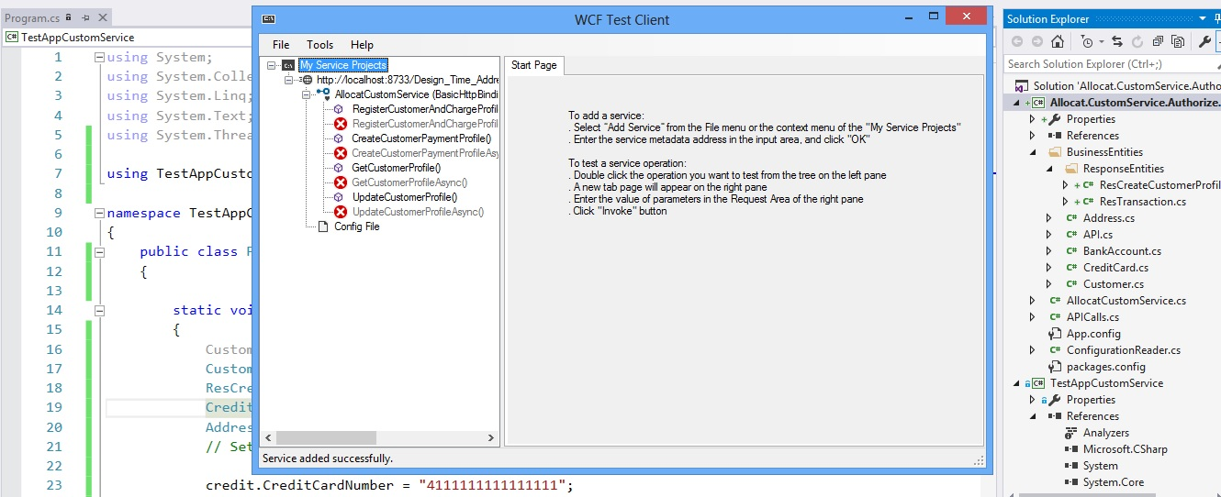

Step4-In the left side you can see different method name. Now open, RegisterCustomerAndChangeProfile()method, A window will display like this.

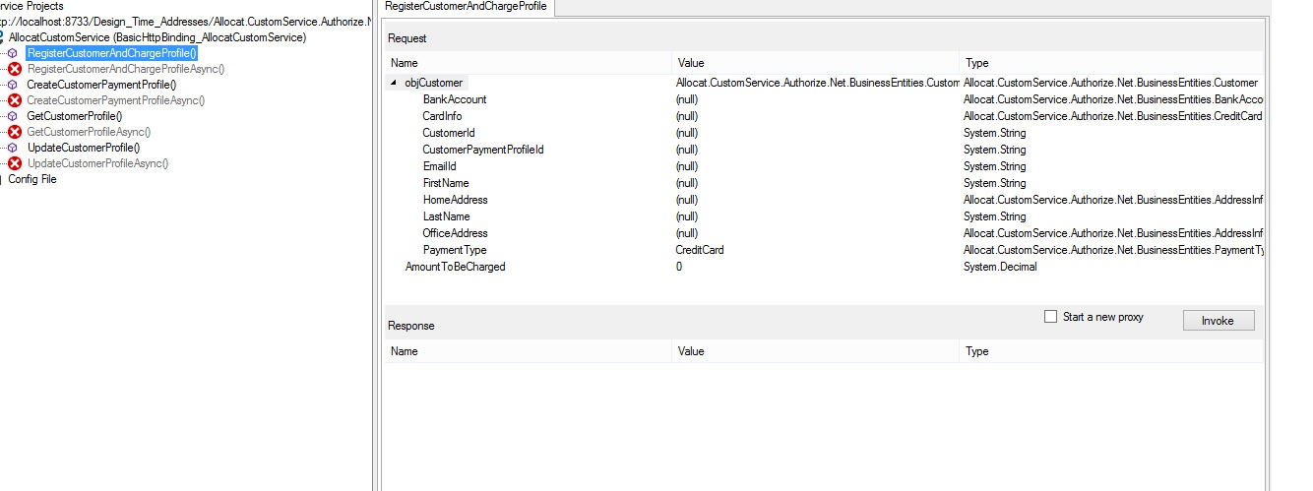

Note- Don’t use async method.

Step5- Enter Values in this table.You can see three columns –Name, Values and Type.

Step5.1-

|  |  |  |
| --- | --- | --- |
| Name | Values | Type |
| ObjCustomer- | Choose -Allocat.CustomService.Authorize.Net.BusinessEntities.Customer |  |
| BankAccount- | Choose-Allocat.CustomService.Authorize.Net.BusinessEntities.BankAccount |  |
| AccountType | NonMandatoryFiled(Don’t fill) |  |
| BankAccoutNumber | NonMandatoryFiled(Don’t fill) |  |
| BankName | NonMandatoryFiled(Don’t fill) |  |
| EcheckType | NonMandatoryFiled(Don’t fill) |  |
| NameOnAccount | NonMandatoryFiled(Don’t fill) |  |
| RoutingNumber | NonMandatoryFiled(Don’t fill) |  |
| CardInfo- | Choose-Allocat.CustomService.Authorize.Net.BusinessEntities.CreditCard |  |
| CreditCardNumber | Mandatory Field(4111111111111111) |  |
| CreditCardType | Mandatory Field (0) |  |
| ExpiryDate | Mandatory Field(mmyy)(0719) |  |
| CustomerId | Don’t Enter any thing(Generated automatically) |  |
| CustomerProfileId | Don’t Enter any thin.(Generated automatically) |  |
| EmailId | Enter emailId |  |
| FirstName | Enter name |  |
| HomeAddress- | Choose-Allocat.CustomService.Authorize.Net.BusinessEntities.AddressInfo |  |
| Address | Enter address |  |
| City | Enter City |  |
| Zipcode | Enter zipcode |  |
| LastName | Enter LastName |  |
| OfficeAddress- | Choose-Allocat.CustomService.Authorize.Net.BusinessEntities.AddressInfo |  |
| Address | Enter address |  |
| City | Enter City |  |
| Zipcode | Enter zipcode |  |
| PaymentType | Choose credit card from dropdownlist. |  |
| AmountTobecharged | Please enter amount which has to be deducted at the time of acknowledge. |  |

Now, you can see “start a new proxy text” having check box. Please check this box and press button invoke.

Step6- now you can see the response.

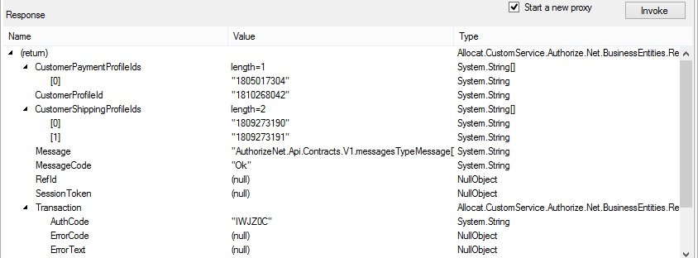



Note- If you can’t see responses. It’s not mean that it is not working. We are using sandbox environment, some times its behavior is different. So the best way is to check with test application.

Step-7 Copy the address bar from the wcf test client.

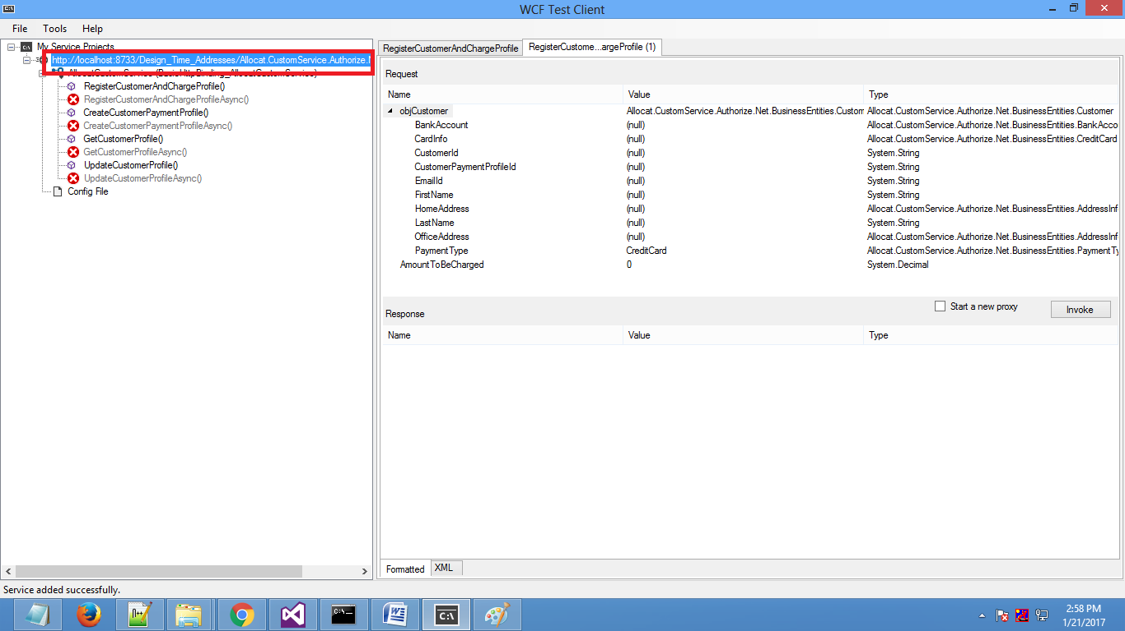

And Paste it in the browser. Like-

**http://localhost:8733/Design_Time_Addresses/Allocat.CustomService.Authorize.Net/Service1/mex**

Remove mex from the address. And press enter.

<http://localhost:8733/Design_Time_Addresses/Allocat.CustomService.Authorize.Net/Service1>/

Now it will open a window like this.

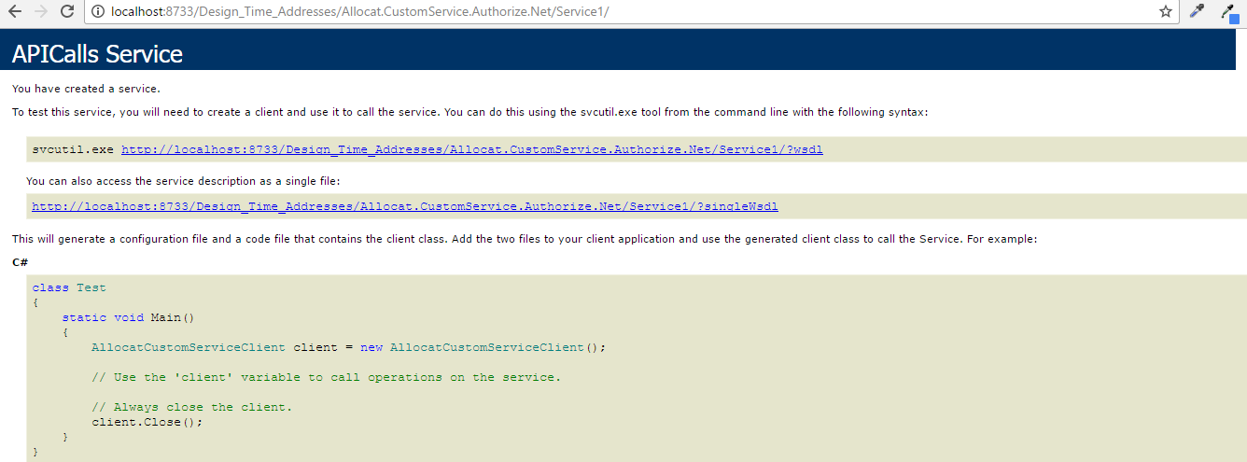

**Fields which we have to be stored in database-**

1)-CustomerPaymentProfileIds

2)-CustomerProfileIds

3)-CustomerShippingProfileIds

4)-AuthoCode

5)-MessageDescription

6)-TransactionID

**Install WCF Services**

**Step1-** Open Developer command prompt **(run as administrator).**

**Step2-** Write these steps-

**Step 2.1 : -** cd C:\Program Files (x86)\Microsoft Visual Studio 14.0

**Step 2.2 : -** C:\Program Files (x86)\Microsoft Visual Studio 14.0>where svcutil.exe

Then the output looks like this

**Step 2.3 : -** C:\Program Files (x86)\Microsoft SDKs\Windows\v10.0A\bin\NETFX 4.6.1 Tools\SvcUtil.exe

**Step : 2.4 : -** C:\Program Files (x86)\Microsoft Visual Studio 14.0>cd..

**Step 2.5 : -** C:\Program Files (x86)>cd microsoft sdks

**Step 2.6 : -** C:\Program Files (x86)\Microsoft SDKs>cd Windows

**Step 2.7 : -** C:\Program Files (x86)\Microsoft SDKs\Windows>cd v10.0A

**Step 2.8 : -** C:\Program Files (x86)\Microsoft SDKs\Windows\v10.0A>cd bin\NETFX 4.6.1 Tools

**Step 2.9 : -** C:\Program Files (x86)\Microsoft SDKs\Windows\v10.0A\bin\NETFX 4.6.1 Tools>svcutil.exe /language:cs /out:d:/proxy.cs /config:d:/output.config <http://localhost:8733/Design_Time_Addresses/Allocat.CustomService.Authorize.Net/Service1/?wsdl>

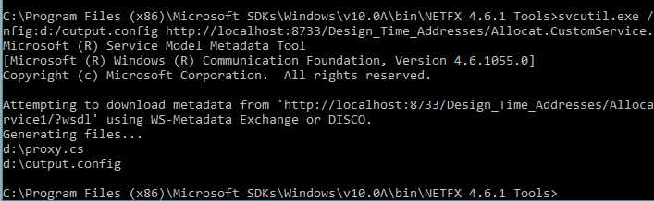

**After installing this you can see proxy.cs and output.cs in your d drive.**

**Test Application**

TestApplication- Now creates a test application. Go to reference folder then right click, choose Add service reference ,A window will open now paste this url [http://localhost:8733/Design_Time_Addresses/Allocat.CustomService.Authorize.Net/Service1](http://localhost:8733/Design_Time_Addresses/Allocat.CustomService.Authorize.Net/Service1/?wsdl)

And press go button .if the connection is successful it will display message. In the bottom, you can change your service name and press ok button.

Now you can see a service reference folder is created in your project and it is having service reference also like (CustomServiceAuNetReference)

Now create a class file and write code for checking response.

CustomServiceAuNetRefrence.AllocatCustomServiceClient obj = new AllocatCustomServiceClient();

Customer objCustomer = new Customer();

ResCreateCustomerProfile response = new ResCreateCustomerProfile();

CreditCard credit = new CreditCard();

AddressInfo address = new AddressInfo();

// Setting input data

credit.CreditCardNumber = "4111111111111111";

credit.CreditCardType = 0;

credit.ExpiryDate = "0819";

objCustomer.CardInfo = credit;

objCustomer.EmailId = "Sachan.Amita33@gmail.com";

objCustomer.FirstName = "Sachan";

objCustomer.LastName = "Am";

address.Address = "Sushant lok";

address.City = "gurgaon";

address.ZipCode = "122090";

objCustomer.HomeAddress = address;

address = null;

address = new AddressInfo();

address.Address = "Unitech sector 21";

address.City = "gurgaon";

address.ZipCode = "122089";

objCustomer.OfficeAddress = address;

objCustomer.PaymentType = PaymentType.CreditCard;

// calling service method

response = obj.RegisterCustomerAndChargeProfile(objCustomer, 25);

When you are debug your project, then you can see the response.