**WEEK 2**

**2.(a) Aim:** Program to read data from BME-280 Sensor

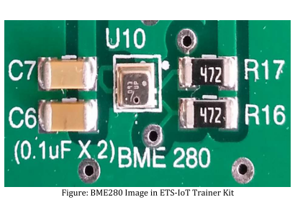

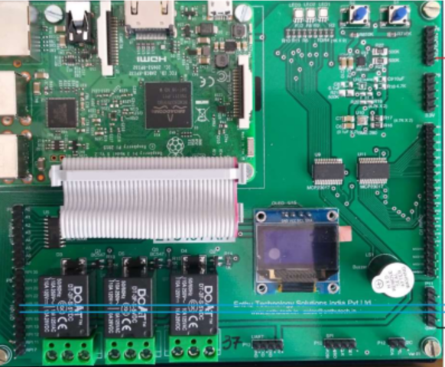

**Source Code:**

import sys

import urllib

sys.path.append('/home/pi/ETS_IoT KIT demo/DemoCode/BME280')

import BME280lib as BME

import time

while True:

(chip_id, chip_version) = BME.readBME280ID()

print "Chip ID :", chip_id

print "Version :", chip_version

temperature,pressure,humidity = BME.readBME280All()

print "Temperature : ", temperature, "C"

print "Pressure : ", pressure, "hPa"

print "Humidity : ", humidity, "%"

**Output:**

