**Experiment-7: Publishing data on to Cloud using MQTT Protocol**

**7(a) Aim:** Write a python program to publish message using MQTT protocol

**Description:** MQTT is a lightweight TCP/IP based protocol used in machine to machine communication. MQTT provides clients with a simple way to distribute telemetry information through a broker by using a publish/subscribe communication

**Source Code:**

**# Publish Code:**

import paho.mqtt.publish as publish

publish.single("TOPIC/test", "Hello", hostname="test.mosquitto.org")

print("Done")

**Output:**

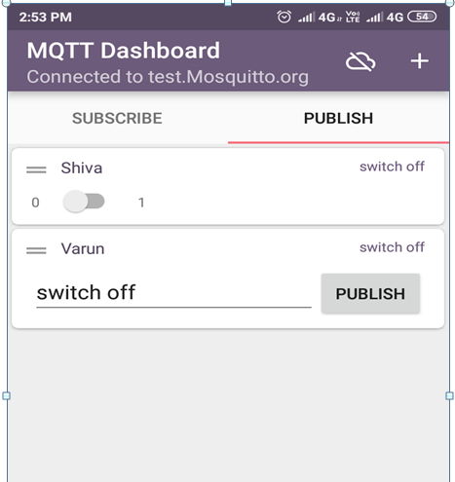

**7.(b) Aim:** Writea python program to publish sensor data (PIR – Passive Infrared) using MQTT protocol

**Description:** MQTT is a lightweight TCP/IP based protocol used in machine to machine communication. MQTT provides clients with a simple way to distribute telemetry information through a broker by using a publish/subscribe communication

**Package Installation Codes**

* sudo pip install paho-mqtt

**Source Code:**

**# Publish Code:**

import sys

sys.path.append('/home/pi/Adafruit-Raspberry-Pi-Python-Code-legacy/Adafruit_MCP230xx')

sys.path.append('/usr/local/lib/python2.7/dist-packages')

from Adafruit_MCP230XX import Adafruit_MCP230XX

import time

import paho.mqtt.publish as publish

mcp = Adafruit_MCP230XX(busnum = 1, address = 0x21, num_gpios = 16)

# Set pins 0, 1 and 2 to output (you can set pins 0..15 this way)

mcp.config(0, mcp.INPUT) # PIR

mcp.pullup(0, 1)

def motion():

print(" --------------------MOTION DETECTION PROCESS--------------------")

i = mcp.input(0)

if i == 1:

print ("person Available \n")

publish.single("SMART/PIR","Person available", hostname="test.mosquitto.org")

if i == 0:

print ("person NOT Available \n")

publish.single("SMART/PIR1","person NOT Available", hostname="test.mosquitto.org")

while (True):

motion()

time.sleep(1)

**Output:**

Data gets published in the cloud from PIR sensor.

**7.(c) Aim:** Write a python program to Subscribe message using MQTT protocol

**Description:** MQTT is a lightweight TCP/IP based protocol used in machine to machine communication. MQTT provides clients with a simple way to distribute telemetry information through a broker by using a publish/subscribe communication

**Package Installation Codes**

* sudo pip install paho-mqtt

**Source Code:**

**#Subscribe Code:**

import paho.mqtt.client as mqtt

def on_connect(client, userdata, flags, rc):

print("Connected with result code "+str(rc))

client.subscribe("TOPIC/test")

def on_message(client, userdata, msg):

print(msg.topic+" "+str(msg.payload))

if msg.payload == "Hello":

print("Received message #1, do something")

client = mqtt.Client()

client.on_connect = on_connect

client.on_message = on_message

client.connect("test.mosquitto.org", 1883, 60)

client.loop_forever()

**Output:**

Data gets published in the cloud from PIR sensor.

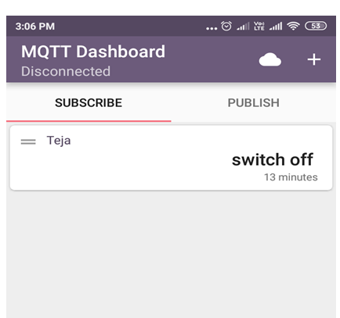

**7.(d) Aim:** Writea python program to subscribe sensor data (PIR – Passive Infrared) using MQTT protocol

**Description:** MQTT is a lightweight TCP/IP based protocol used in machine to machine communication. MQTT provides clients with a simple way to distribute telemetry information through a broker by using a publish/subscribe communication

**Package Installation Codes**

* sudo pip install paho-mqtt

**Source Code:**

**# Subscribe Code:**

import paho.mqtt.client as mqtt

import RPi.GPIO as GPIO

import time

GPIO.setwarnings(False)

GPIO.setmode(GPIO.BOARD)

GPIO.setwarnings(False)

def on_connect(client, userdata, flags, rc):

print("Connected with result code "+str(rc))

client.subscribe("SMART/PIR")

client.subscribe("SMART/PIR1")

def on_message(client, userdata, msg):

print(msg.topic+" "+str(msg.payload))

if msg.payload =="Person available":

print "PERSON AVAILABLE"

print "----------------------------------------------------"

if msg.payload =="person NOT Available":

print "PERSON NOT AVAILABLE"

print "----------------------------------------------------"

client = mqtt.Client()

client.on_connect = on_connect

client.on_message = on_message

client.connect("test.mosquitto.org", 1883, 60)

client.loop_forever()

**output:**

Data gets subscribed in the cloud from PIR sensor.