**PRELAB-03**

**1) What are the applications of buzzer and push buttons?**

**A**: Applications of buzzers: Alarm devices, timers, and confirmations of user input such as a mouse click or key stroke.

Applications of pushbuttons: calculators, push-button telephones, kitchen appliances, magnetic locks.

**2) What is the difference between a push button and a key on a keyboard?**

**A:** A push-button is a simple switch mechanism to control some aspect of a machine or a process. Buttons are typically made out of hard material, usually plastic or metal. A key on a computer keyboard that allows someone to stop an action, leave a program, or return to a previous menu. This key is usually marked 'Esc'. A special button on a computer keyboard that is used for a particular operation in a program. The keys near the top of a keyboard marked 'F1' to 'F12' are function keys.

**3)What is the range of ultrasonic sensors?**

**A:** For ultrasonic sensing, the most widely used range is 40 to 70 kHz. The frequency determines range and resolution; the lower frequencies produce the greatest sensing range.  At 58 kHz, a commonly used frequency, the measurement resolution is one centimeter (cm), and range is up to 11 meters. At 300 kHz, the resolution can be as low as one millimeter; however, range suffers at this frequency with a maximum of about 30 cm.

**4)What is the working principle of ultrasonic sensor?**

A: Ultrasonic sensors emit short, high-frequency sound pulses at regular intervals. These propagate in the air at the velocity of sound. If they strike an object, then they are reflected back as echo signals to the sensor, which itself computes the distance to the target based on the time-span between emitting the signal and receiving the echo.

**5)How does a PIR sensor work?**

A: The PIR sensor itself has two slots in it, each slot is made of a special material that is sensitive to IR. The lens used here is not really doing much and so we see that the two slots can 'see' out past some distance (basically the sensitivity of the sensor). When the sensor is idle, both slots detect the same amount of IR, the ambient amount radiated from the room or walls or outdoors. When a warm body like a human or animal passes by, it first intercepts one half of the PIR sensor, which causes a positive differential change between the two halves. When the warm body leaves the sensing area, the reverse happens, whereby the sensor generates a negative differential change. These change pulses are what is detected.

**6)List the application areas of PIR sensor.**

**A:** PIR sensors have numerous applications in different fields such as automatic switching operation of outdoor lights, lift lobby, common staircases, automatic switching operation of garden lights based on the presence of a human being, for covered parking area, automatic door operating system in shopping malls, and so on.

**7)What are the different types of motion sensors and how they work?**

**A:** Different types of motion sensors which include Passive Infrared Sensor, Ultrasonic Sensor, Microwave Sensor, Tomographic Sensor and Combined types. Active ultrasonic sensors emit ultrasonic sound waves that reflect off objects and bounce back to the original emission point. ... Motion detection cameras, lights, and sensors used in home security systems generally rely on PIR sensors. These detect infrared energy, which humans and animals release as heat. The motion sensor sends out a series of ultrasonic pulses. These pulses reflect from nearby objects and return to a detector. The computer software provides a very precise timer to measure the time elapsed between the sending of the original pulse and the detection of the reflected pulse

**8)What is the sensitivity range of PIR?**

**A:** Sensitivity range of PIR is up to 20 feet (6 meters) 110 degrees x 70 degrees detection range.

**Interfacing ultrasonic, PIR sensors to Raspberry PI**

**AIM:** Program to Interface ultrasonic sensor to Raspberry PI

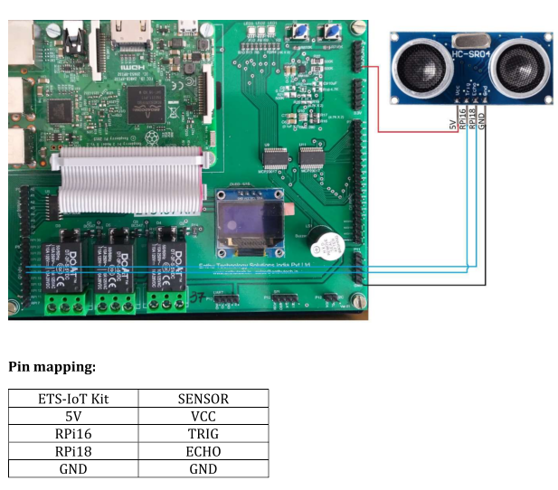

**Source Code:**

import time

import RPi.GPIO as GPIO

# Use BCM GPIO references

GPIO.setmode(GPIO.BOARD)

GPIO.setwarnings(False)

# Define GPIO to use on Pi

GPIO_TRIGGER = 16 ##connect with RPI16

GPIO_ECHO = 18 ##connect with RPI18

print "Ultrasonic Measurement"

# Set pins as output and input

GPIO.setup(GPIO_TRIGGER,GPIO.OUT) # Trigger

GPIO.setup(GPIO_ECHO,GPIO.IN) # Echo

# Set trigger to False (Low)

GPIO.output(GPIO_TRIGGER, False)

# Allow module to settle

time.sleep(0.5)

while True:

# Send 10us pulse to trigger

GPIO.output(GPIO_TRIGGER, True)

time.sleep(0.00001)

GPIO.output(GPIO_TRIGGER, False)

while GPIO.input(GPIO_ECHO)==0:

start = time.time()

while GPIO.input(GPIO_ECHO)==1:

stop = time.time()

# Calculate pulse length

elapsed = stop-start

# Distance pulse travelled in that time is time

# multiplied by the speed of sound (cm/s)

distance = elapsed * 34300

# That was the distance there and back so halve the value

distance = distance / 2

print "Distance : %.1f" % distance "cm"

time.sleep(1)

# Reset GPIO settings

#GPIO.cleanup()

**Output:**

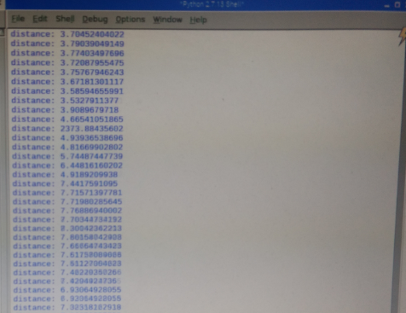

**Aim:** Program to Interface PIR sensor to Raspberry PI

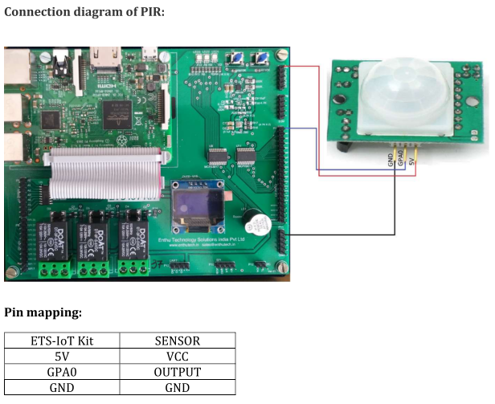

**SourceCode:**

import RPi.GPIO as GPIO

import time

GPIO.setwarnings(False)

GPIO.setmode(GPIO.BOARD)

GPIO.setup(16, GPIO.IN) #Read output from PIR motion sensor

GPIO.setup(18, GPIO.OUT) #LED output pin

while True:

i=GPIO.input(16)

if i==0: #When output from motion sensor is LOW

print "No intruders",i

GPIO.output(18, 0) #Turn OFF LED/Buzzzer

time.sleep(0.1)

elif i==1: #When output from motion sensor is HIGH

print "Intruder detected",i

GPIO.output(18, 1) #Turn ON LED/Buzzer

time.sleep(0.1)

Ouput:

