**Experiment 4**

**Interfacing Soil Moisture sensor for Agriculture based Application**

**Aim:** Program to Interface Soil Moisture sensor toRaspberry PI

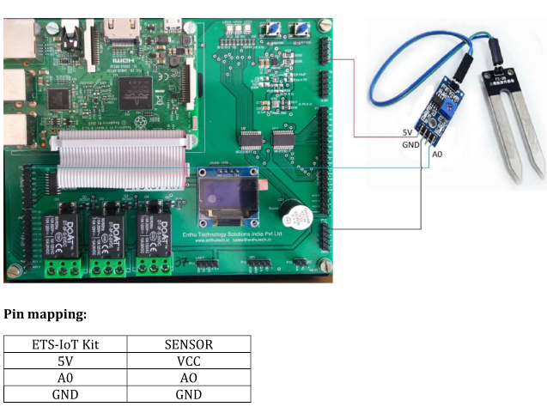

**SourceCode:**

import spidev

import time

spi = spidev.SpiDev()

spi.open(0,0)

def ReadChannel(channel):

adc = spi.xfer2([1,(8+channel)<<4,0])

data= ((adc[1]&3) << 8) + adc[2]

return data

def ConvertVolts(data,places):

volts = (data * 3.3) / float(1023)

volts = round(volts,places)

return volts

moisture_channel = 0 ##connect with A0

delay = 3

while True:

moisture_level = ReadChannel(moisture_channel)

moisture_volts = ConvertVolts(moisture_level,2)

print "____________________________________________"

print ("Moisture: {} ({}V)".format(moisture_level,moisture_volts))

time.sleep(delay)

**Output:**