**VASAVI COLLEGE OF ENGINEERING (Autonomous)**

**IBRAHIMBAGH, HYDERABAD-31**

**DEPARTMENT OF COMPUTER SCIENCE & ENGINEERING**

**INTERNET OF THINGS** **LAB**

**Prelab Questions – 2020-21 VI Semester**

T. SUBHAS

1602-18-733-303

CSE-A

1. Draw the architecture of Raspberry PI3

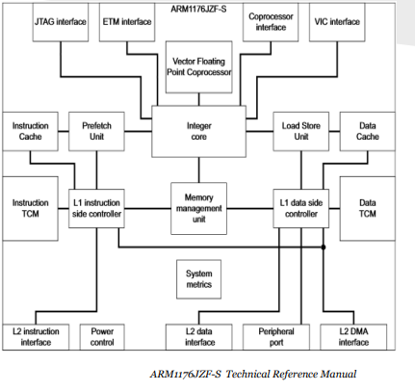

1. Draw the high level architecture of IoT.

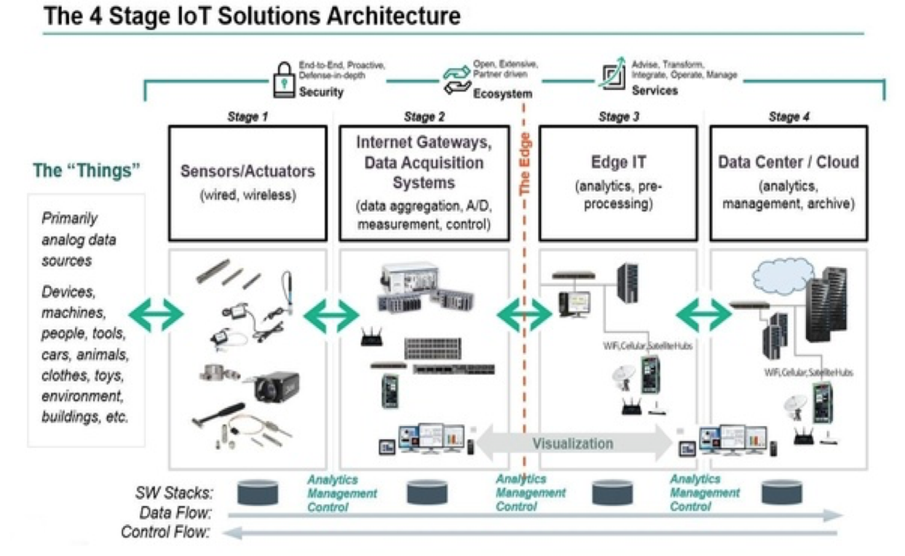

1. Write about I2C and SPI protocol.

SPI

SPI was developed in the 1980s by Motorola as a way to communicate between their early microcontrollers and onboard peripherals, such as EEPROM. Motorola, nor any other organization, maintains any sort of standardization of the SPI protocol. As a result of this "de facto" standard, implementations can vary from manufacturer to manufacturer. Make sure you read the datasheet for each SPI-enabled part very carefully!

SPI uses four active signal lines (which do not include power and ground lines) to communicate between parts. These lines include:

* SCLK: Serial Clock (controlled by master)
* MOSI: Master Out Slave In (controlled by master)
* MISO: Master In Slave Out (controlled by slave device)
* SS: Slave Select (controlled by master)

I2C

Philips Semiconductors (now known as NXP Semiconductors) created the I2C specification in 1982 to help standardize communication between chips on the same board. NXP does not charge anyone to use or implement I2C, but they do charge a fee if you would like to register a device address.

I2C uses 2 lines (not including power and ground) for communication:

* SDA: Serial Data
* SCL: Serial Clock

Any number of master devices and any number of slave devices can theoretically be attached to the same bus. Both SDA and SCL lines are required to be open-drain lines. As a result, devices can only pull each line low. A pull-up resistor is required on each line to pull the line back up to high.

1. What is the significance of Board mode and BCM mode in Raspberry PI?

**GPIO BOARD**– This type of pin numbering refers to the number of the pin in the plug, i.e, the numbers printed on the board, for example, P1. The advantage of this type of numbering is, it will not change even though the version of board changes.

**GPIO BCM**– The BCM option refers to the pin by “Broadcom SOC Channel. They signify the Broadcom SOC channel designation. The BCM channel changes as the version number changes.

1. What is the role of MCP3008?

The **MCP3008** is an 8-Channel 10-bit ADC IC, so it can measure 8 different analog voltage with a resolution of 10-bit. It measures the value of analog voltage from 0-1023 and sends the value to a microcontroller or microprocessor through SPI communication.