**DOS – PROJECT 2 REPORT**

STEPS TO RUN

1. Please set the AKKA_HOME variable in the shell. Which points to the root of akka package.
   1. Steps to get AKKA Dist.: wget <http://downloads.typesafe.com/akka/akka_2.10-2.3.6.zip>
   2. unzip akka_2.10-2.3.6.zip
   3. export AKKA_HOME=<path to akka root>
2. Unzip the project folder project2.zip
3. Go to src/
4. Run the shell script start.sh <# of nodes, topology, algorithm> to start. (This internally references scala 2.11 which is bundled with the project)

5. Run the shell script startBonus.sh <# of nodes, topology, algorithm> to start with nodeFailure.

**GOSSIP ALGORITHM RESULTS**

|  |  |  |  |  |  |
| --- | --- | --- | --- | --- | --- |
| # Nodes | 1000 | 5000 | 10000 | 30000 | 50000 |
| Full | 422 | 1002 | 2191 | 10550 | 49818 |
| imp2D | 185 | 628 | 1154 | 7508 | 21432 |
| 2D | 500 | 1000 | 1560 | 6565 | 11783 |
| Line | 300 | 680 | 1228 | 12472 | 83037 |

Time to Converge (ms)

Count before a node stops= 10

HeartBeat = 5 ms

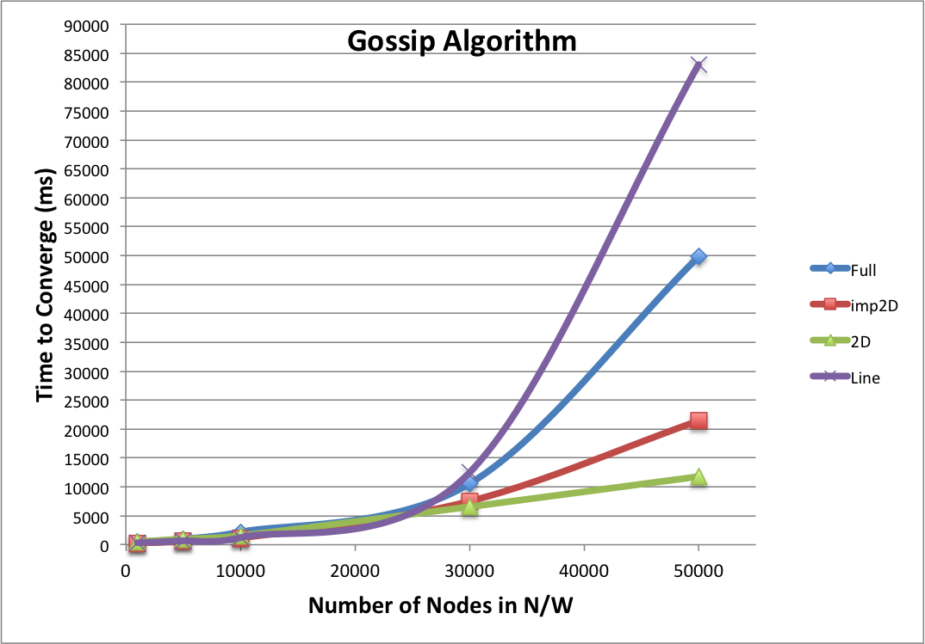

**PUSH SUM ALGORITHM RESULTS**

|  |  |  |  |  |  |
| --- | --- | --- | --- | --- | --- |
|  | 1000 | 5000 | 10000 | 30000 | 50000 |
| Full | 552 | 1085 | 1811 | 8249 | 29645 |
| imp2D | 942 | 1509 | 2324 | 11902 | 33960 |
| 2D | 902 | 2288 | 3154 | 4869 | 8181 |
| Line | 650 | 2800 | 5043 | 25770 |  |

Time to Converge (ms)

Termination Condition for a node: 3 consecutive push sums < 0.0000000001

HeartBeat = 5 ms

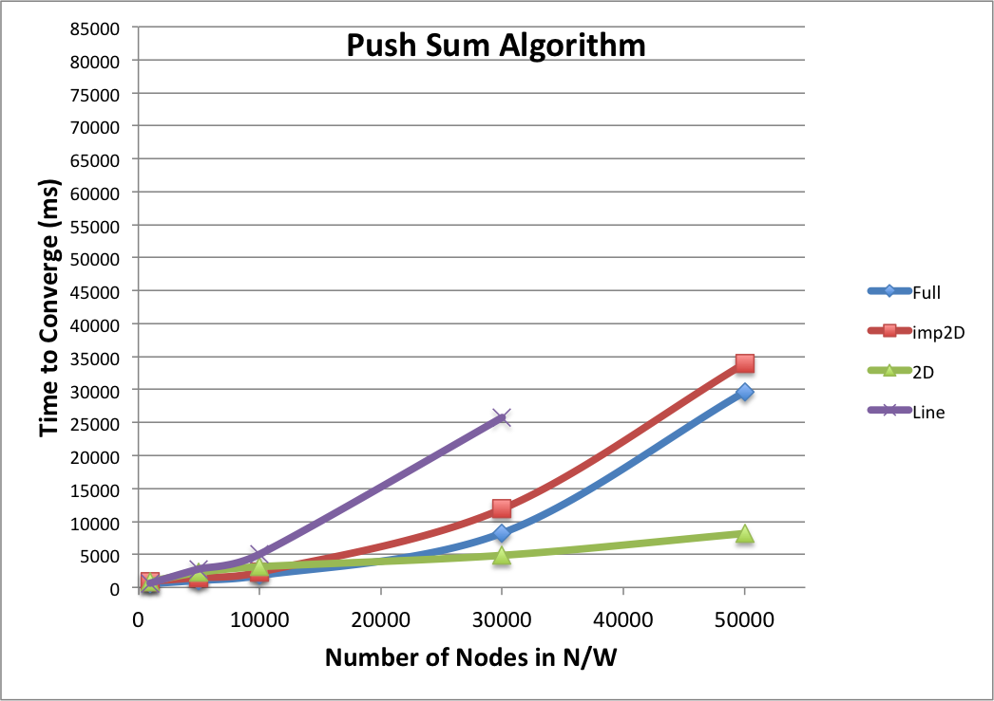

**OBSERVATIONS**

**Line Topology**

**Gossip Algorithm**: Line Topology takes exponential time to propagate Gossip as the network size grows. After a certain number, it may even require to increase the number of rounds from 10 to higher number to ensure propagation of the gossip.

**Push Sum Algorithm**: Line Topology takes the most time to compute push-sum. The calculated values are not close to the expected value. As the network size increases, many a times, we do not get convergence, even when termination condition is delayed.

**2D Topology**

**Gossip Algorithm**: 2D Topology takes least time to propagate Gossip as the network size grows. Time to propagate gossip is almost linear.

**Push Sum Algorithm**: 2D Topology takes the least time to propagate information through the network and terminate, but the computed push-sum is not close to the expected value. It points to the fact that computation in a 2D grid is localized.

**Imperfect 2D Topology**

**Gossip Algorithm**: Imperfect 2D Topology takes more time than a 2D topology but less than a full n/w topology to propagate Gossip as the network size grows. Increasing the number of rounds increases the diffusion speeds.

**Push Sum Algorithm**: Imperfect 2D Topology gives the most accurate result of all the 4 topologies. Interestingly it takes more time than a full n/w topology to converge when doing push-sum as opposed to the behavior seen in gossip propagation. It points to the fact that it takes more rounds to converge in this topology as compared to full n/w.

**Full N/W Topology**

**Gossip Algorithm**: Full n/w topology takes more time than Imp2D topology to propagate gossip and terminate. Interestingly when doing computation it converges faster than Imp2D topology. It might point to the fact that there is more duplication in a full n/w topology.

**Push Sum Algorithm**: Full n/w topology converges faster than Imp2D topology but gives comparatively poorer results than Imp2D topology.

**General Observations:**

* Diffusion speeds can be increased to an extent by doing more rounds of gossip propagation as the n/w size increases.
* Generally in a full n/w, number of rounds required to propagate gossip is comparatively less.
* Some of the topologies like the line topology show random behavior when it comes to diffusion speeds with the minimum and maximum time varying a lot.

**BONUS QUESTION**

* In general node failure causes delay in information dissemination and convergence.
* In some topologies like the line topology it might even become impossible to propagate information due to broken chains and isolated points.
* In Some other topologies we might be able to propagate to almost all nodes except a few in almost same time.
* The only n/w that will converge in all probability is the full n/w.
* As can be seen below, resilience to node failure is in the following order Full > Imp2D > 2D > Line.

#Non- Converging Nodes in a sample data of 5000 Nodes

|  |  |  |  |  |  |
| --- | --- | --- | --- | --- | --- |
| Failure Rate | 1% | 5% | 10% | 20% | 30% |
| Gossip - Full | 0 | 0 | 0 | 0 | 0 |
| Gossip - imp2D | 2 | 0 | 5 | 10 | 41 |
| Gossip - 2D | 0 | 1 | 2 | 17 | 151 |
| PushSum - Full | 0 | 0 | 0 | 0 | 0 |
| PushSum - imp2D | 4 | 4 | 15 | 25 | 87 |
| PushSum - 2D | 1 | 1 | 21 | 68 | 305 |
| Line | 4886 | 4721 | 4497 | 3995 |  |

