**Skill Gap Assessment**



**In 5th Year of (M.C.A. Integrated)**

**Gujarat Technological University (2018)**

**L.J. INSTITUTE OF COMPUTER APPLICATIONS**

**Developed By:**

Abhinav Shah (Enr.No:135170686032)

**External Guide: Mr. Nitin Shah**

**Internal Guide: Dr. Jignesh Doshi**

**L.J. INSTITUTE OF COMPUTER APPLICATIONS**

Near Nagdev Kalyan Mandir, Near Sanand Cross Roads,

Serkhej-Gandhinagr Highway Ahmedabad - 382481  
Ph. No. : 079 29296364



**CERTIFICATE**

**Enrollment No:** _______________

This is to certify that Mr./Ms.________________________________________ studying in 5 years Integrated - Master of Computer Applications, Semester X,

Roll No________ has satisfactorily completed his/her Project Titled ______________________________________________ under the supervision of

**Internal Guide Name Signature**

**Date of Submission:**

**Director**

**Index**

**1.** **Introduction** 4

**1.1** **Existing System** 5

**1.2** **Need for the New System** 5

**1.3** **Objective of the New System** 6

**1.4** **Problem Definition** 7

**1.5** **Scope of the Project and Core Components** 7

**1.6** **Project Profile** 9

**1.7** **Advantages of the Proposed System** 10

**2.** **Requirement Determination & Analysis** 11

**2.1** **Requirement Determination** 11

**2.2** **Targeted Users** 11

**3.** **System Design** 12

**3.1** **Use Case Diagram** 12

**3.2** **Class Diagram** 13

**3.3** **Activity Diagram** 14

**3.4** **Sequence Diagram** 15

**3.5** **Data Dictionary** 16

**4.** **Development** 21

**4.1** **Coding Standards** 21

**4.2** **Screenshots** 22

**5.** **Agile Documentation** 28

**5.1** **Agile Project Charter** 28

**5.2** **Agile Roadmap** 29

**5.3** **Agile Project Plan** 30

**5.4** **Agile User Story** 32

**5.5** **Agile Release Plan** 33

**5.6** **Agile Sprint Backlog** 35

**5.7** **Agile Test Plan** 37

**6.** **Proposed Enhancement** 40

**7.** **Conclusion** 40

**8.** **Bibliography** 41

# **Introduction**

* With a rapid growth in the field of Information Technology it is becoming necessary for an organization to cope up with the upcoming technologies in the market.
* Many multinational companies and organizations are looking for an employees who can cope with the upcoming technology.
* Day by day the employees are getting hired by an organization or companies. Every employee have some good skills in their particular subject or field.
* But according to the current situation in many organizations or multinational companies the major problem which is being faced is the skill gap.
* So to avoid such problem we have developed a system which will help the organizations and companies to find an employee according to their need.
* We have developed a system **“Skill Gap Assessment”**.
* **“Skill Gap Assessment”** provides the organization and multinational companies to evaluate employees according to their need.
* With the help of this tool it will be helpful to the organizations to manage their employee skills.

## **Existing System**

* There is no such existing system which gives skill gap analysis from various perspectives.

## **Need for the New System**

* The main purpose of this system is to assess and measure an individual’s skill in an organizations.
* When used by an organizations, it can support employee’s performance improvement plan to identify the gaps and define action plans for resolution.
* The system is developed keeping in mind to do end to end skill management for an organization.
* The **“Skill Gap Assessment”** can be used in conjunction with an Organizational Assessment to help assess the current state of Organizational Project Management Maturity.
* A **“Skill Gap Assessment”** is a tool that can provide insight on how and where an employee can improve their knowledge and skills.

## **Objective of the New System**

* The main objective of the system to manage skills of an employee in an organization or a multinational company.
* The system helps the organization to refine and define the skills now and in the future.
* The system also helps the employees know what critical skills they will need to grow.
* It also helps the organization in reducing efforts for recruiting employees for a specific skills.
* System generates different variety of reports so that the organizations can easily manage employee skills.

## **Problem Definition**

* The Skill Gap Assessment is used to provide a brief overview of employee’s skills to promote shared understanding of it before a more detailed plan.
* The purpose of this system is to do end to end skill management for the organization.
* The goal of this project is to use latest open source technologies and develop following modules.

1. Skill Assessment
2. Executive Dashboard

## **Scope of the Project and Core Components**

* **Scope**

The main scope of **“Skill Gap Assessment”** is to manage employee’s skill in an organization. The system has an admin login who can add question or a set of questions for a particular skill. Each skill can be categorize into different sub categories. Each skill can have multiple questions. Each question may have a single answer or a multiple answer. Admin can assign rating (in simple term marks) for each question and each group of questions. Further there will be a manager login in which he can assess employee on a particular skill. Manager can also approve the assessment done by the employee. Further there will be an employee login who can assess himself on a particular questionnaire.

* **Core Components**

1. **Admin Panel**

* Login
* Manage Category
* Manage Sub Category
* Manage Skills
* Manage Forms
* Generate Report
* View Response

1. **Manager Panel**

* Login
* Add Assessment
* Approve Employee Assessment

1. **Employee Panel**

* Login
* Self-Assessment

1. **Client Panel**

* Login
* Employee Assessment

## **Project Profile**

|  |  |
| --- | --- |
| Project Name | Skill Gap Assessment |
| Organization | Prazo Solutions |
| Project Type | Web Application |
| Team Member | Abhinav Shah(135170686032) |
| Front End | Angular 5, Bootstrap 4.0, Php 7.0.10, Node JS(npm) 8.9.4 |
| Back End | MySQL 5.7.14 |
| Other Tools/Technology | Visual Studio Code, Postman, Dia, SmartGit |

## **Advantages of the Proposed System**

* Employee’s skill can be easily figured out.
* Employees can be evaluated differently for different project parameters.
* As employees are assessed from different parameters the organization can easily figure out skill gap of each employee or a group of employees.
* Reports can be generated from different perspectives.
* Brief overview of employee’s skills to promote shared understanding of it before a more detailed plan.

# **Requirement Determination & Analysis**

## **Requirement Determination**

* Requirement of this system is collected from the head of the company and other superior executives.

## **Targeted Users**

* **Admin**
* Admin can manage category, manage sub category, manage skills and can manage questions.
* Admin can generate different questionnaire.
* Admin can view reports and responses.
* **Employee**
* Employee can assess himself on the questionnaire generated by admin.
* **Manager**
* Manager can approve or disapprove employee’s assessment.
* Manager can also update employee’s assessment.
* **Client**
* Client can assess the project team.

# **System Design**

## **Use Case Diagram**

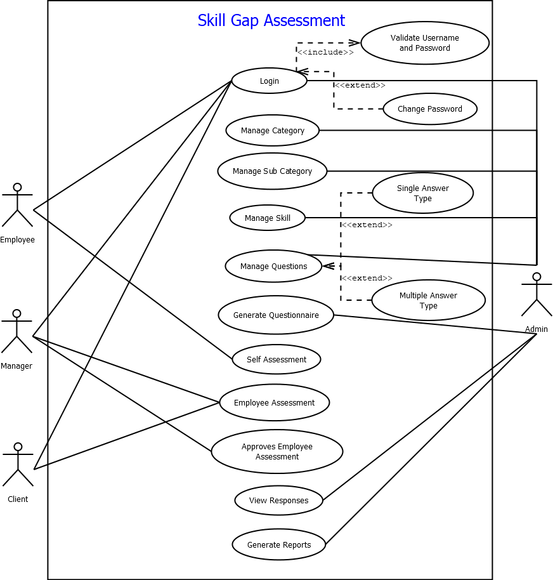

## **Class Diagram**

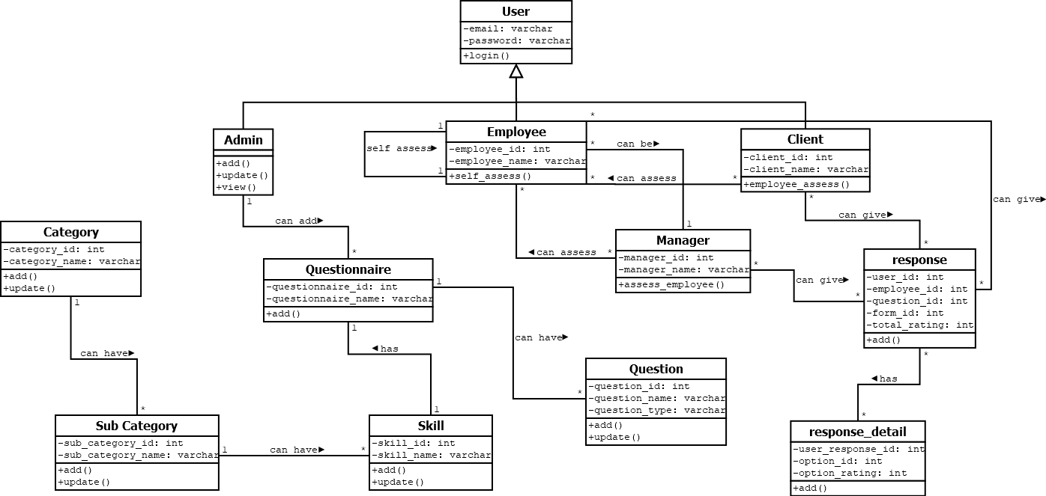

## **Activity Diagram**

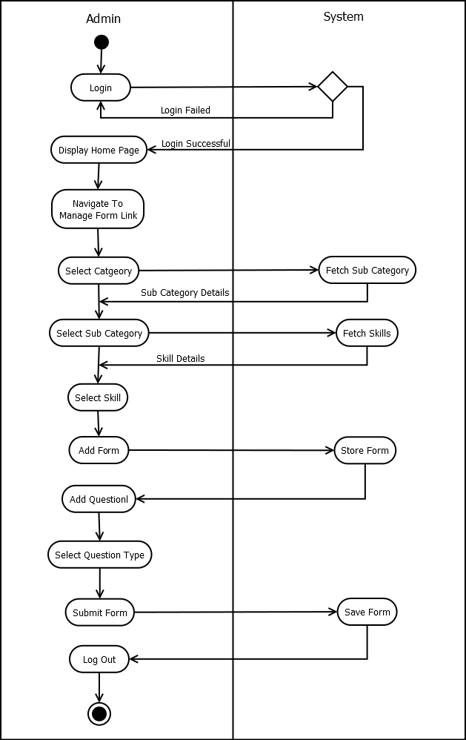

## **Sequence Diagram**

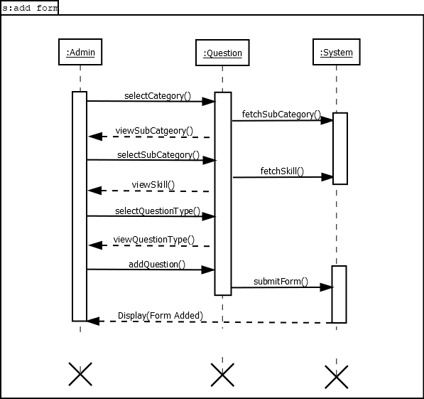

## **Data Dictionary**

**Table Name:** user_master

**Table Description:** Includes the details of the user.

|  |  |  |  |  |
| --- | --- | --- | --- | --- |
| Field Name | Data Type | Constraint | Description | Sample Data |
| User_id | Int | Primary Key | User Id | 1 |
| First_name | Varchar(30) | Not null | First name | Abhinav |
| Middle_name | Varchar(30) | Null | Middle name | Kiran |
| Last_name | Varchar(30) | Not null | Last name | Shah |
| Gender | Enum(‘Male’,’Female’) | Null | Gender | Male |
| Email | Varchar(100) | Unique Not Null | Email id | [abhi@gmail.com](mailto:abhi@gmail.com) |
| Passwd | Varchar(255) | Not null | Password | Encrypted |
| Contact | Varchar(15) | Uunique Not null | Contact no | 9427021031 |
| User_type | Enum(‘Admin’, ’Employee’, ’Manager’, ’Client’) | Not null | User type | Admin |

**Table Name:** employee_master

**Table Description:** Includes the details of different employees.

|  |  |  |  |  |
| --- | --- | --- | --- | --- |
| Field Name | Data Type | Constraint | Description | Sample Data |
| Employee_id | Int | Primary key | Employee id | 1 |
| User_id | Int | Foreign key | User id | 1 |

**Table Name:** manager_master

**Table Description:** Includes the details of different managers.

|  |  |  |  |  |
| --- | --- | --- | --- | --- |
| Field Name | Data Type | Constraint | Description | Sample Data |
| Manager_id | Int | Primary key | Manager id | 1 |
| User_id | Int | Foreign key | User id | 1 |

**Table Name:** category_master

**Table Description:** Includes the details of different categories.

|  |  |  |  |  |
| --- | --- | --- | --- | --- |
| Field Name | Data Type | Constraint | Description | Sample Data |
| Category_id | Int | Primary key | Category id | 1 |
| Category_description | Varchar(50) | Unique Not null | Category description | Technical Skills |

**Table Name:** sub_category_master

**Table Description:** Includes the details of different sub category.

|  |  |  |  |  |
| --- | --- | --- | --- | --- |
| Field Name | Data Type | Constraint | Description | Sample Data |
| Sub_category_id | Int | Primary key | Sub category id | 1 |
| Category_id | Int | Foreign key | Category id | 1 |
| Sub_category_description | Varchar(50) | Unique Not null | Sub category description | Web Technologies |

**Table Name:** skill_master

**Table Description:** Includes the details of different skills of each sub category.

|  |  |  |  |  |
| --- | --- | --- | --- | --- |
| Field Name | Data Type | Constraint | Description | Sample Data |
| Skill_id | Int | Primary key | Skill id | 1 |
| Sub_category_id | Int | Foreign key | Sub category id | 1 |
| Skill_description | Varchar(50) | Unique Not null | Skill description | Php |

**Table Name:** form_master

**Table Description:** Includes the details of different forms.

|  |  |  |  |  |
| --- | --- | --- | --- | --- |
| Field Name | Data Type | Constraint | Description | Sample Data |
| Form_id | Int | Primary key | Form id | 1 |
| Skill_id | Int | Foreign key | Skill id | 1 |
| Form_name | Varchar(30) | Unique Not Null | Form Name | Php Form |

**Table Name:** question_master

**Table Description:** Includes the details of different questions of each skill.

|  |  |  |  |  |
| --- | --- | --- | --- | --- |
| Field Name | Data Type | Constraint | Description | Sample Data |
| Question_id | Int | Primary key | Question id | 1 |
| Form_id | Int | Foreign key | Form id | 1 |
| Question_type | Enum(‘Single Option’,  ’Multiple Option’) | Null | Question type | Multiple Choice |
| Question_description | Varchar(255) | Not null | Question description | What is php? |
| Total_rating | Int | Not null | Rating | 10 |

**Table Name:** question_option_master

**Table Description:** Includes the details of different options of each question.

|  |  |  |  |  |
| --- | --- | --- | --- | --- |
| Field Name | Data Type | Constraint | Description | Sample Data |
| Question_id | Int | Primary key | Question id | 1 |
| Option_id | Int | Primary Key | Option id | 1 |
| Option_description | Varchar(50) | Not null | Option description | Option1 |
| Correct_option | Enum(‘True’,’False’) | Null | Correct answer | True |

**Table Name:** user_response

**Table Description:** Includes the details of reponse given by user.

|  |  |  |  |  |
| --- | --- | --- | --- | --- |
| Field Name | Data Type | Constraint | Description | Sample Data |
| User_id | Int | Primary key | User id | 1 |
| Employee_id | Int | Primary Key | Employee id | 1 |
| Question_id | Int | Primary Key | Question id | 1 |
| Form_id | Int | Foreign Key | Form id | 1 |
| Question_total_rating | Varchar(100) | Not null | Question Total Rating | 10 |

**Table Name:** user_response_option

**Table Description:** Includes the details of detailed reponse given by user.

|  |  |  |  |  |
| --- | --- | --- | --- | --- |
| Field Name | Data Type | Constraint | Description | Sample Data |
| User_response_id | Int | Primary key | User response id | 1 |
| Option_id | Int | Primary Key | Option id | 1 |
| Option_rating | Int | Not null | Option rating | 5 |

# **Development**

## **Coding Standards**

## **Screenshots**

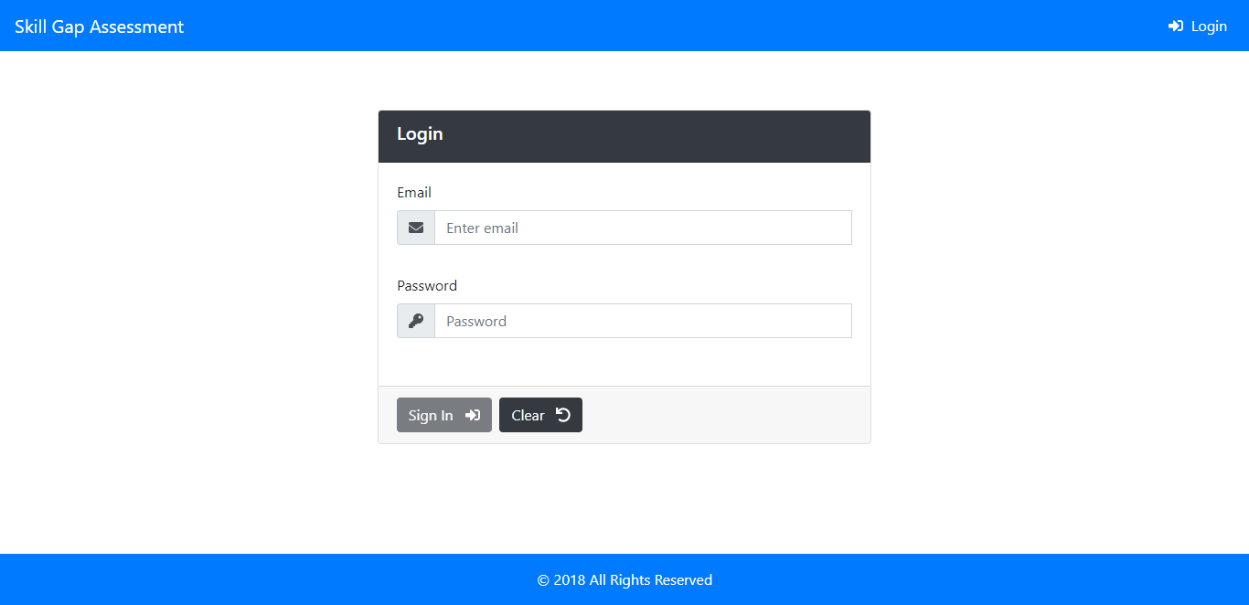

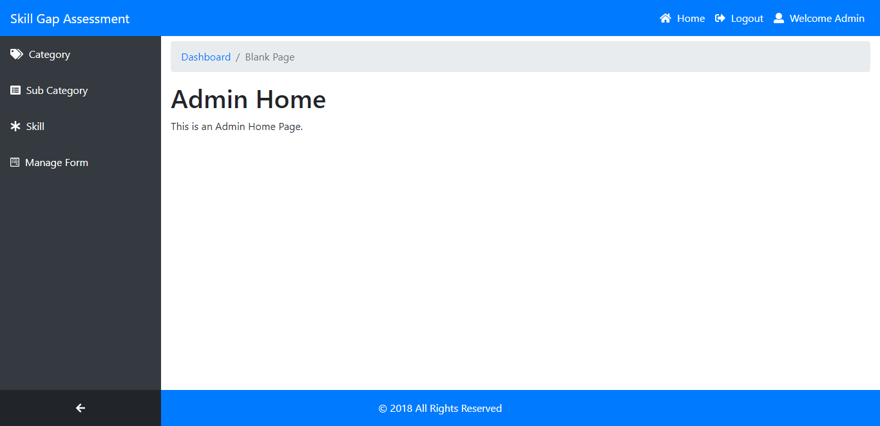

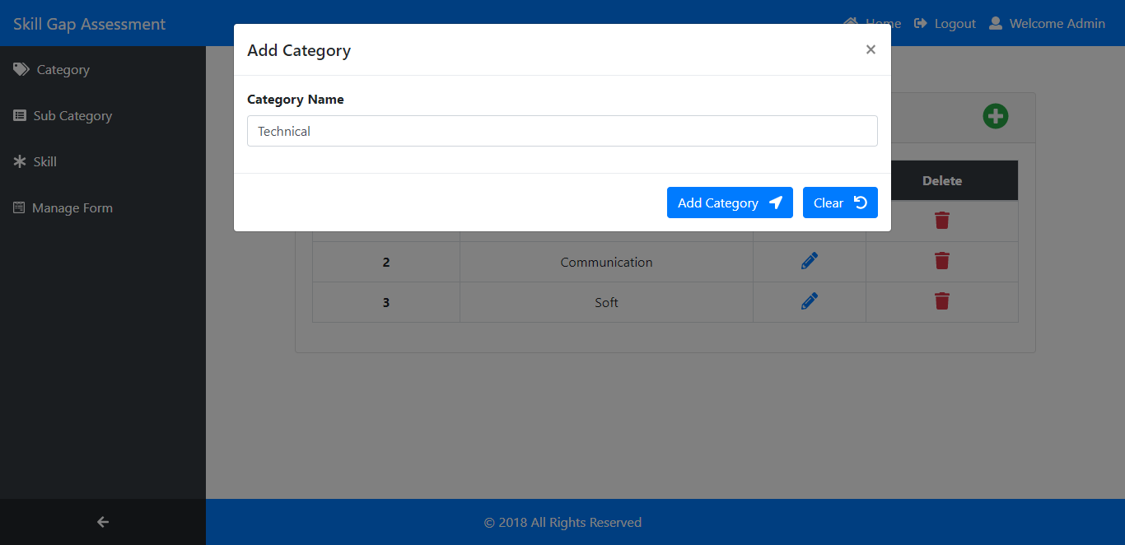

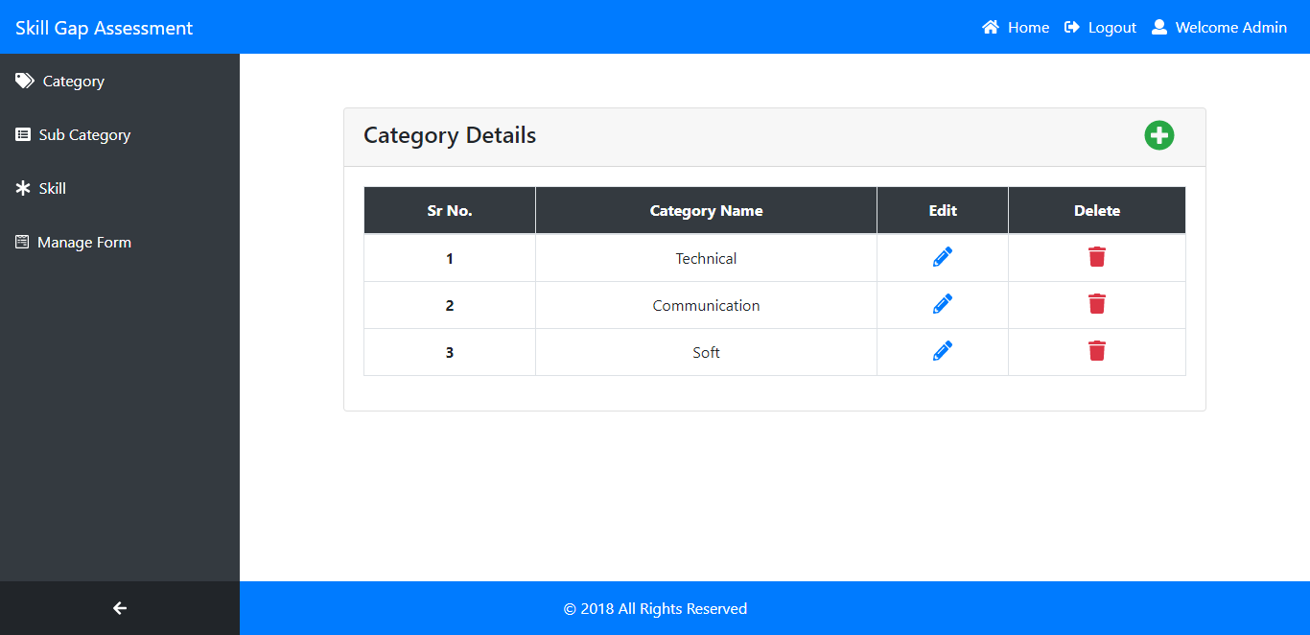

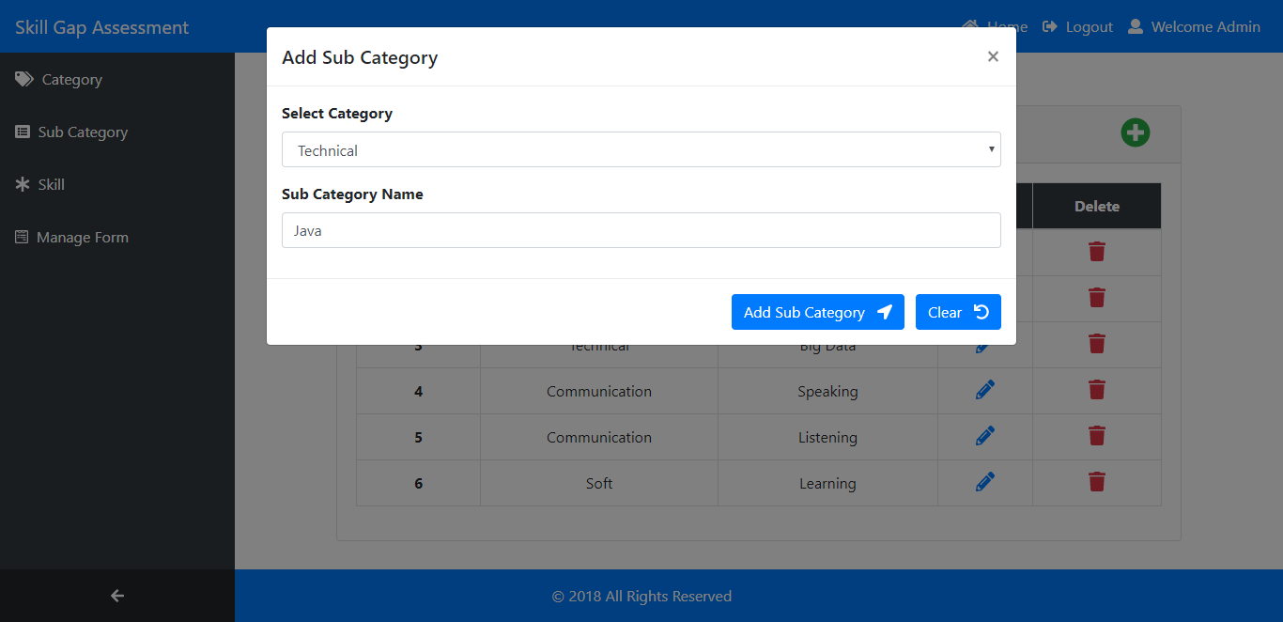

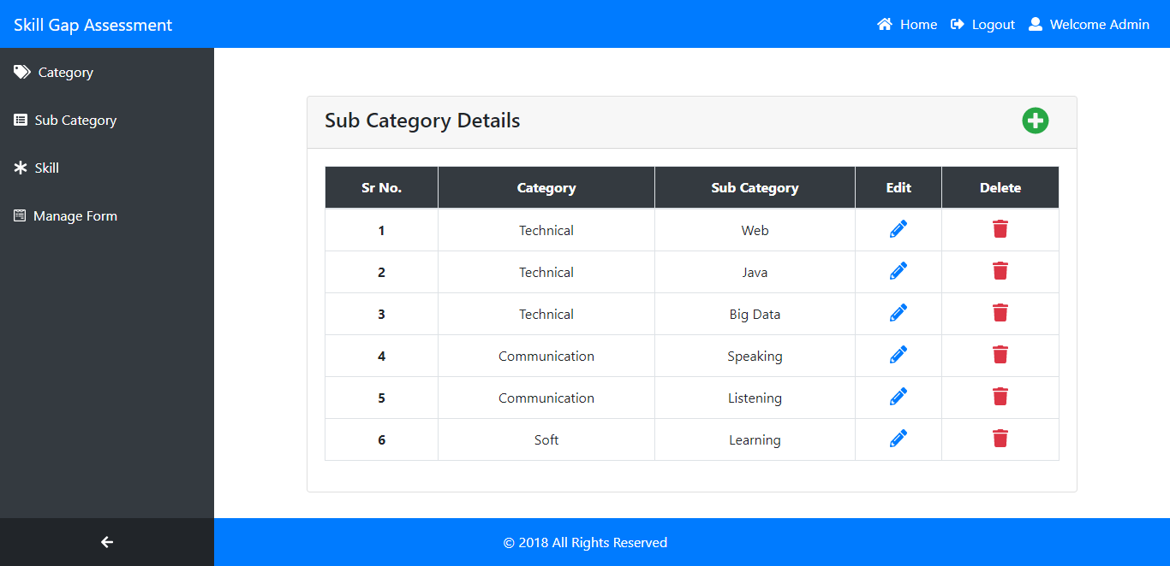

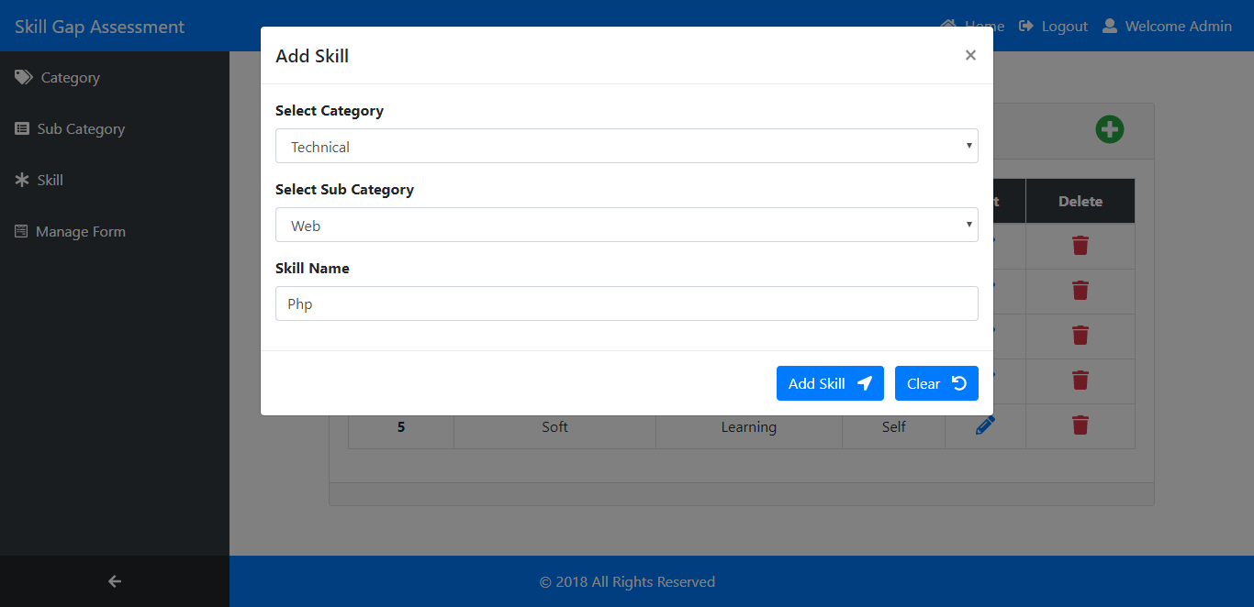

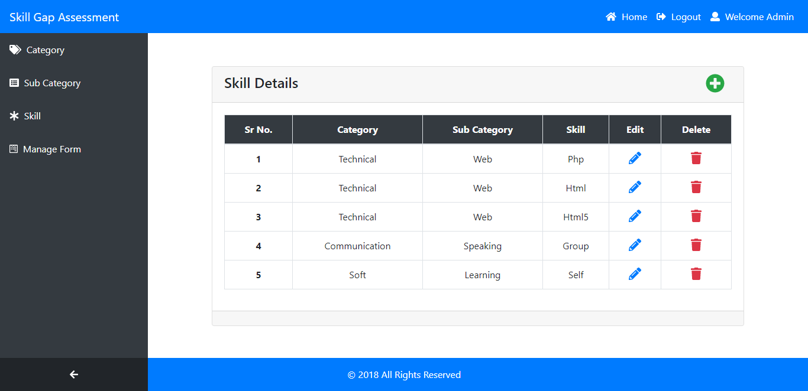

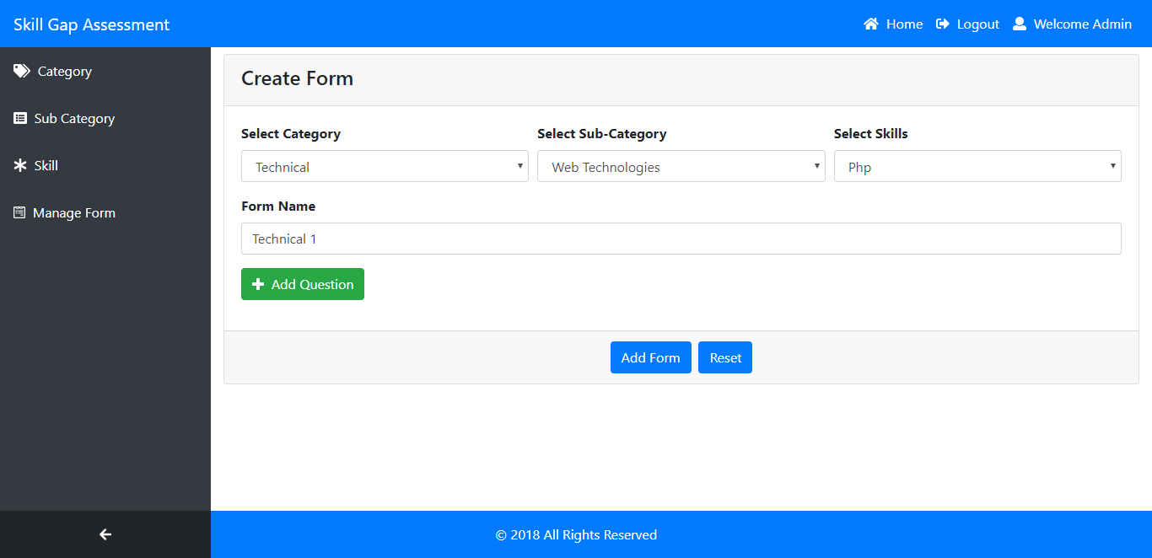

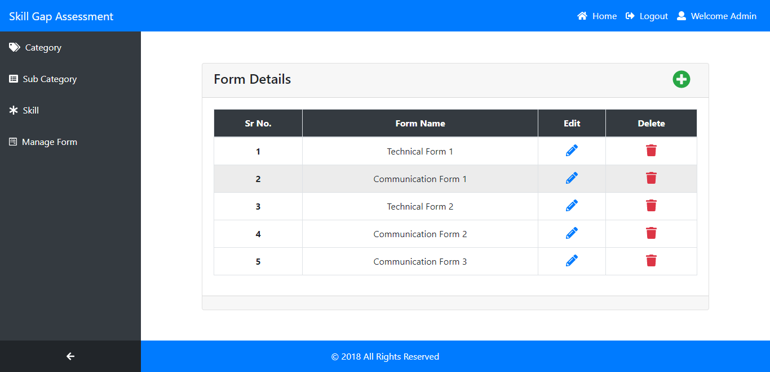

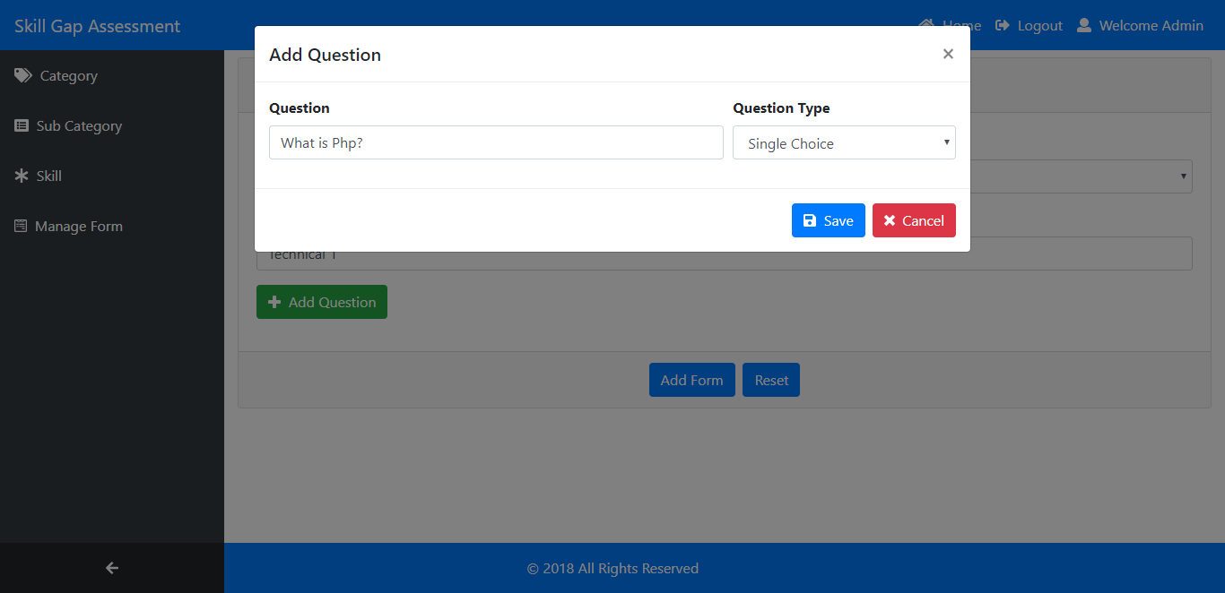

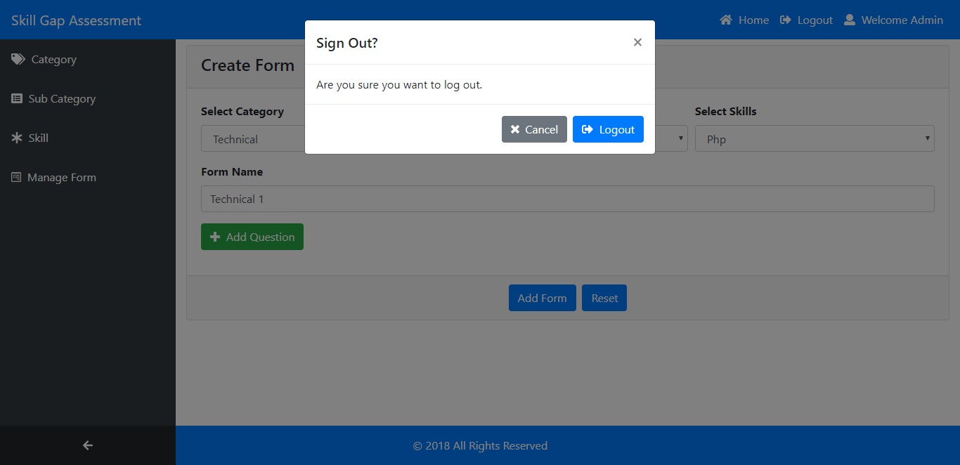

# **Agile Documentation**

## **Agile Project Charter**

|  |  |
| --- | --- |
| General Project Information | |
| Project Name | Skill Gap Assessment |
| Project Champion | Mr. Nitin Shah |
| Project Sponsor | Prazo Solutions |
| Project Manager | Mr. Nitin Shah |
| Stakeholders | Prazo Solutions |
| Expected Start Date | 05-02-2018 |
| Expected Completion Date* | 05-06-2018 |
| Project Details | |
| Mission | To build an application to do end to end skill management for the organization. |
| Vision | To provide a brief overview of Skill Gap Assessment to promote a shared understanding of it before a more detailed plan. |
| Scope | The main scope of **“Skill Gap Assessment”** is to manage employee’s skill in an organization. The system has an admin login who can add question or a set of questions for a particular skill. Each skill can be categorize into different sub categories. Each skill can have multiple questions. Each question may have a single answer or a multiple answer. Admin can assign rating (in simple term marks) for each question and each group of questions. Further there will be a manager login in which he can assess employee on a particular skill. Manager can also approve the assessment done by the employee. Further there will be an employee login who can assess himself on a particular questionnaire. |
| Date: | 05-06-2018 |

## **Agile Roadmap**



## **Agile Project Plan**

|  |  |
| --- | --- |
| Project Name | Skill Gap Assessment |
| Project Manager | Mr. Nitin Shah |
| Project Deliverable | Yes |
| Scope Statement | Refer Introduction Section |
| Start Date | 05-02-2018 |
| End Date* | 05-06-2018 |

|  |  |  |  |  |  |
| --- | --- | --- | --- | --- | --- |
| Task Name | Responsible | Start Date | End Date | Days | Status |
| Sprint 1 | **Abhinav Shah** | **15-02-2018** | **25-02-2018** | **10** | **Completed** |
| Login | Abhinav Shah | 15-02-2018 | 25-02-2018 | 10 | Completed |
| Sprint 2 | **Abhinav Shah** | **28-02-2018** | **16-03-2018** | **16** | **Completed** |
| Manage Category | Abhinav Shah | 28-02-2018 | 04-03-2018 | 5 | Completed |
| Manage Sub Category | Abhinav Shah | 05-03-2018 | 09-03-2018 | 5 | Completed |
| Manage Skill | Abhinav Shah | 10-03-2018 | 16-03-2018 | 6 | Completed |
| Sprint 3 | **Abhinav Shah** | **18-03-2018** | **30-03-2018** | **12** | **Completed** |
| Add Form | Abhinav Shah | 18-03-2018 | 25-03-2018 | 7 | Completed |
| View/Update Form | Abhinav Shah | 26-03-2018 | 30-03-2018 | 4 | Completed |
| Sprint 4 | **Abhinav Shah** | **02-04-2018** | **12-04-2018** | **10** | **Completed** |
| Add Question | Abhinav Shah | 02-04-2018 | 04-04-2018 | 3 | Completed |
| View Question | Abhinav Shah | 05-04-2018 | 08-04-2018 | 4 | Completed |
| Update Question | Abhinav Shah | 09-04-2018 | 12-04-2018 | 3 | Completed |
| Sprint 5 | **Abhinav Shah** | **14-04-2018** | **24-04-2018** | **10** | **Pending** |
| Manager Assessment | Abhinav Shah | 14-04-2018 | 20-04-2018 | 6 | Pending |
| Approve Employee Assessment | Abhinav Shah | 21-04-2018 | 24-04-2018 | 4 | Pending |
| Sprint 6 | **Abhinav Shah** | **26-04-2018** | **05-05-2018** | **10** | **Not Started** |
| Employee Add Assessment | Abhinav Shah | 26-04-2018 | 30-04-2018 | 5 | Not Started |
| View Assessment | Abhinav Shah | 01-05-2018 | 05-05-2018 | 5 | Not Started |
| Sprint 7 | **Abhinav Shah** | **08-05-2018** | **15-05-2018** | **8** | **Not Started** |
| Customer Assessment | Abhinav Shah | 08-05-2018 | 15-05-2018 | 8 | Not Started |
| Sprint 8 | **Abhinav Shah** | **18-05-2018** | **28-05-2018** | **10** | **Not Started** |
| Admin View Response | Abhinav Shah | 18-05-2018 | 23-05-2018 | 6 | Not Started |
| Generate Report | Abhinav Shah | 24-05-2018 | 28-05-2018 | 4 | Not Started |
| Sprint 9 | **Abhinav Shah** | **29-05-2018** | **05-06-2018** | **8** | **Not Started** |
| Manage Dashboard | Abhinav Shah | 29-05-2018 | 05-06-2018 | 8 | Not Started |

## **Agile User Story**

|  |  |  |  |  |
| --- | --- | --- | --- | --- |
| User Story ID | As a <type of user> | I want to <perform some task> | So that I can <achieve some goal> | Priority |
| 1 | Admin | Enter email and password | Admin logs into the system. | High |
| 2 | Admin | Adds category | All the classes are added. | Medium |
| 3 | Admin | Adds sub category | All the sub category are added for each category. | Medium |
| 4 | Admin | Adds skill | All the skill are added for each sub category. | Medium |
| 5 | Admin | Add form | Form is created for each specific skill | High |
| 6 | Admin | Add question | Questions are added for a specific form | High |
| 7 | Admin | Manage dashboard | Admin manages dashboard | High |
| 8 | Admin | View responses | Admin views responses | Medium |
| 9 | Manager | Approve assessment | Manager approves employee’s assessment | High |
| 10 | Manager | Update employee assessment | Manager can update employee’s assessment | Medium |
| 11 | Manager | Assess employee | Manager can assess employee | medium |
| 12 | Employee | Self-assessment | Employee can assess himself | Medium |
| 13 | Employee | View response | Employee can view his response | low |
| 14 | Customer | Asses project team | Customer can assess project team | medium |

## **Agile Release Plan**

|  |  |  |  |  |  |  |  |
| --- | --- | --- | --- | --- | --- | --- | --- |
| Sprint | Task | Start | End | Days | Status | Release Date | Goal |
| 1 | Login | 15-02-2018 | 25-02-2018 | 10 | Released | 26-02-2018 | Create Login Module |
| 2 | Manage Category | 28-02-2018 | 04-03-2018 | 5 | Released | 04-03-2018 | Manage Category Details |
| Manage Sub Category | 05-03-2018 | 09-03-2018 | 5 | Released | 09-03-2018 | Manage Sub Category Details |
| Manage Skill | 10-03-2018 | 16-03-2018 | 6 | Released | 17-03-2018 | Manage Skill Details |
| 3 | Add Form | 18-03-2018 | 25-03-2018 | 7 | Released | 25-03-2018 | Add Form Details |
| View/Update Form | 26-03-2018 | 30-03-2018 | 4 | Released | 01-04-2018 | View/Update Form Details |
| 4 | Add Question | 02-04-2018 | 04-04-2018 | 3 | Released | 04-04-2018 | Add Question Detail |
| View Question | 05-04-2018 | 08-04-2018 | 4 | Released | 08-04-2018 | View Questions |
| Update Question | 09-04-2018 | 12-04-2018 | 3 | Released | 13-04-2018 | Update Question Details |
| 5 | Manager Assessment | 14-04-2018 | 20-04-2018 | 6 | Not Released | 20-04-2018 | Manager Assess Employee |
| Approve Employee Assessment | 21-04-2018 | 24-04-2018 | 4 | Not Released | 25-04-2018 | Manager Approve Employee Assessment |
| 6 | Employee Add Assessment | 26-04-2018 | 30-04-2018 | 5 | Not Released | 30-04-2018 | Employee Assessment |
| View Assessment | 01-05-2018 | 05-05-2018 | 5 | Not Released | 05-05-2018 | Employee Can View His Assessment |
| 7 | Customer Assessment | 08-05-2018 | 15-05-2018 | 8 | Not Released | 15-05-2018 | Customer Can Assess Team |
| 8 | Admin View Response | 18-05-2018 | 23-05-2018 | 6 | Not Released | 23-05-2018 | Admin Can View All Response |
| Generate Report | 24-05-2018 | 28-05-2018 | 4 | Not Released | 28-05-2018 | Admin Can Generate Report |
| 9 | Manage Dashboard | 29-05-2018 | 05-06-2018 | 8 | Not Released | 05-06-2018 | Admin Can Manage Dashboard |

## **Agile Sprint Backlog**

|  |  |  |  |  |  |  |
| --- | --- | --- | --- | --- | --- | --- |
| Task Name | Story | Sprint Ready | Priority | Status | Story Points | Assigned to Sprint |
| Sprint 1 | Yes | Yes | High | Complete | 8 | Yes |
| Login | Yes | Yes | High | Complete | 8 | Yes |
| Sprint 2 | Yes | Yes | Medium | Complete | 24 | Yes |
| Manage Category | Yes | Yes | Medium | Complete | 8 | Yes |
| Manage Sub Category | Yes | Yes | Medium | Complete | 8 | Yes |
| Manage Skill | Yes | Yes | Medium | Complete | 8 | Yes |
| Sprint 3 | Yes | Yes | High | Complete | 32 | Yes |
| Add Form | Yes | Yes | High | Complete | 16 | Yes |
| View/Update Form | Yes | Yes | High | Complete | 16 | Yes |
| Sprint 4 | Yes | Yes | High | Complete | 48 | Yes |
| Add Question | Yes | Yes | High | Complete | 16 | Yes |
| View Question | Yes | Yes | High | Complete | 16 | Yes |
| Update Question | Yes | Yes | High | Complete | 16 | Yes |
| Sprint 5 | Yes | Yes | High | Pending | 16 | Yes |
| Manager Assessment | Yes | Yes | Medium | Pending | 8 | Yes |
| Approve Employee Assessment | Yes | Yes | High | Pending | 8 | Yes |
| Sprint 6 | Yes | Yes | High | Not Started | 8 | Yes |
| Employee Add Assessment | Yes | Yes | Medium | Not Started | 4 | Yes |
| View Assessment | Yes | Yes | Low | Not Started | 4 | Yes |
| Sprint 7 | Yes | Yes | High | Not Started | 4 | Yes |
| Customer Assessment | Yes | Yes | Medium | Not Started | 4 | Yes |
| Sprint 8 | Yes | Yes | High | Not Started | 20 | Yes |
| Admin View Response | Yes | Yes | Low | Not Started | 4 | Yes |
| Generate Report | Yes | Yes | High | Not Started | 16 | Yes |
| Sprint 9 | Yes | Yes | High | Not Started | 20 | Yes |
| Manage Dashboard | Yes | Yes | High | Not Started | 20 | Yes |

## **Agile Test Plan**

|  |  |
| --- | --- |
| Project Name: Skill Gap Assessment | |
| Test Case ID: T1 | **Test Designed by:** Abhinav Shah |
| Test Priority (Low/Medium/High): Med | **Test Designed date:** 04/03/2018 |
| Module Name: Admin Add Category | **Test Executed by:** Abhinav Shah |
| Test Title: Add Category Details | **Test Execution date:** 04/03/2018 |
| Description: Admin Adds The Category |  |
| Pre-conditions: Admin Should Be Logged In | |
| Dependencies: | |

|  |  |  |  |  |  |
| --- | --- | --- | --- | --- | --- |
| Step | Test Steps | Test Data | Expected Result | Actual Result | Status |
| 1 | Navigate To Add Category Page | Click On Add | Allow | Pass | Pass |
| 2 | Enter Category Details | Add Category Details | Allow | Pass | Pass |
| 3 | Add Button | Click On Add Button | Allow | Pass | Pass |

|  |  |
| --- | --- |
| Project Name: Skill Gap Assessment | |
| Test Case ID: T2 | **Test Designed by:** Abhinav Shah |
| Test Priority (Low/Medium/High): Med | **Test Designed date:** 09/03/2018 |
| Module Name: Admin Add Sub Category | **Test Executed by:** Abhinav Shah |
| Test Title: Add Sub Category Details | **Test Execution date:** 09/03/2018 |
| Description: Admin Adds The Sub Category |  |
| Pre-conditions: Admin Should Be Logged In | |
| Dependencies: | |

|  |  |  |  |  |  |
| --- | --- | --- | --- | --- | --- |
| Step | Test Steps | Test Data | Expected Result | Actual Result | Status |
| 1 | Navigate To Add Sub Category Page | Click On Add | Allow | Pass | Pass |
| 2 | Enter Sub Category Details | Add Sub Category Details | Allow | Pass | Pass |
| 3 | Add Button | Click On Add Button | Allow | Pass | Pass |

|  |  |
| --- | --- |
| Project Name: Skill Gap Assessment | |
| Test Case ID: T3 | **Test Designed by:** Abhinav Shah |
| Test Priority (Low/Medium/High): Med | **Test Designed date:** 16/03/2018 |
| Module Name: Admin Add Skill | **Test Executed by:** Abhinav Shah |
| Test Title: Add Skill Details | **Test Execution date:** 16/03/2018 |
| Description: Admin Adds The Skill |  |
| Pre-conditions: Admin Should Be Logged In | |
| Dependencies: | |

|  |  |  |  |  |  |
| --- | --- | --- | --- | --- | --- |
| Step | Test Steps | Test Data | Expected Result | Actual Result | Status |
| 1 | Navigate To Add Skill Page | Click On Add | Allow | Pass | Pass |
| 2 | Enter Skill Details | Add Skill Details | Allow | Pass | Pass |
| 3 | Add Button | Click On Add Button | Allow | Pass | Pass |

# **Proposed Enhancement**

* There are some point features that we will do in future as proposed enhancement.
  + Planned to make use of this system in other organizations.
  + Priority based approved system.
  + Tracking of complaints schedule.

# **Conclusion**

* We have made **“Skill Gap Assessment”** application where admin is able to manage category, sub category, skills, forms, questions and all the activities based on their roles and permissions.
* Use of Angular 5 and Bootstrap 4 technology would make the application more interactive.
* This application is simple for our organization to use. The whole data will be containing in the database so that user get the data easily without more effort.

# **Bibliography**

* Search Engine
  + www.google.com
* Sites
  + angular.io
  + getbootstrap.com
  + github.com
  + w3schools.com
  + tutorialspoint.com
  + typescriptlang.org
  + stackoverflow.com