INT333 : DEVOPS ADVANCE CONFIGURATION MANAGEMENT
Project
On
Student Attendance Tracker
Submitted by | Registration No | Section | Roll Number
ABHINAV | 12300709 | K4O2315 | 34



Lovely Professional University, Jalandhar, Punjab, India
In partial fulfillment for the requirements of the award
of the Degree of

BTECH
NAME OF THE SCHOOL - SCHOOL OF COMPUTER SCIENCE & INFORMATION TECHNOLOGY

Lovely Professional University
Phagwara, Punjab

Report Contents
Abstract
1 Introduction
2 DevOps Architecture
3 Ansible Automation
4 Automated Application Deployment
5 Nagios Monitoring Implementation
6 Failure Detection and Recovery
7 Security, Reliability, and Maintainability
8 Results and Evaluation
9 Limitations and Future Enhancements
10 Conclusion
References
Appendix A Operational Command Reference

Abstract
This project implements a reproducible DevOps environment for the Student Attendance Tracker. Rather than treating deployment and monitoring as manual afterthoughts, the solution uses two Ubuntu Server virtual machines with separate application and operations responsibilities. Ansible automates Docker installation, application deployment, NRPE configuration, and Nagios setup, while Nagios continuously verifies host reachability, resource utilization, container health, frontend availability, and API correctness.
The main engineering focus is repeatability and operational visibility. Configuration is organized as inventory, variables, roles, handlers, templates, and playbooks. Re-running the same playbooks produces no unnecessary changes when the machines already match the declared state. Monitoring is validated through a controlled backend failure: the application host remains reachable, while the API and Docker stack checks become critical. After recovery, all eight service checks return to OK. This demonstrates that the environment can be rebuilt, verified, diagnosed, and recovered using documented automation instead of undocumented manual steps.

Project Outcomes
• A two-VM lab with isolated application and monitoring responsibilities.
• Passwordless SSH and Ansible inventory for repeatable controller-to-target administration.
• Role-based deployment of Docker Engine and a three-container application stack.
• Idempotent Ansible runs with zero failed or unreachable hosts.
• Authenticated Nagios Core monitoring with eight meaningful service checks.
• A tested incident scenario that detects backend failure and verifies recovery.

1 Introduction
A working web application is only one part of a dependable software system. The operating system must be prepared consistently, application dependencies must be installed in the correct order, services must restart when configuration changes, and failures must be visible before users report them. Manual administration makes these tasks slow to repeat and difficult to audit. This project therefore places configuration management and monitoring at the centre of the implementation.
Ansible was selected as the configuration-management layer because it provides agentless, declarative automation over SSH. Nagios Core and NRPE were selected for operational monitoring because they can combine network checks, local operating-system plugins, custom application checks, and Docker-aware health checks in one dashboard. Docker Compose supplies a consistent runtime for the frontend, backend, and MongoDB services.

1.1 Objectives
• Build a reproducible local DevOps laboratory on VirtualBox.
• Separate the managed application node from the automation and monitoring node.
• Automate installation and configuration with reusable Ansible roles.
• Deploy the application without exposing the backend or database directly to the host network.
• Monitor infrastructure, containers, HTTP availability, and API health.
• Demonstrate detection and recovery through a controlled service failure.

1.2 Scope
The implementation is a local, two-node environment intended for coursework and repeatable practical demonstration. It covers provisioning after Ubuntu installation, deployment, service verification, monitoring, troubleshooting, and recovery. Public-cloud provisioning, production TLS certificates, external alert delivery, and high availability are identified as future enhancements.

2 DevOps Architecture
The environment runs on a Windows host with VirtualBox. Each virtual machine has a NAT adapter for package downloads and a host-only adapter for stable management traffic. The host-only network keeps the lab reachable from Windows while preventing the internal services from being directly exposed to the wider physical network.
Component | Address / Port | Primary responsibility
Windows host | 192.168.56.1/24 | VirtualBox host and browser access
attendance-app VM | 192.168.56.10 | Docker Engine and application containers
devops-monitor VM | 192.168.56.20 | Ansible controller, Nagios Core, and Apache
Frontend | 192.168.56.10:5173 | User interface and reverse proxy to the API
Nagios dashboard | 192.168.56.20/nagios4/ | Authenticated monitoring interface
NRPE | 192.168.56.10:5666 | Remote execution of approved local checks

2.1 Responsibility Flow
The DevOps VM connects to the application VM through SSH and applies Ansible playbooks. Those playbooks install packages, render configuration files, synchronize application content, and invoke handlers only when required. Nagios runs independently after deployment: it checks the application over ICMP and HTTP, and uses NRPE for resource and container checks that must execute locally on the application VM.
Windows host
|-- browser --> Nagios (192.168.56.20)
|-- browser --> Frontend (192.168.56.10:5173)
devops-monitor -- SSH / Ansible --> attendance-app
devops-monitor -- NRPE / HTTP ---> attendance-app

3 Ansible Automation
The devops-monitor VM acts as the Ansible control node. An ED25519 key was generated for the devops user and copied to the app user on attendance-app. This enables non-interactive Ansible connections while sudo remains protected through Ansible privilege escalation. Connectivity was verified with the Ansible ping module before configuration playbooks were executed.
ssh-keygen -t ed25519
ssh-copy-id app@192.168.56.10
ansible -i inventory.ini app_servers -m ping

3.1 Inventory and Role Design
The inventory separates app_servers from monitoring_servers. Group variables are stored below the inventory directory so that Ansible loads them automatically. Implementation tasks are divided into four roles; each role owns the files, templates, variables, and handlers for one responsibility.
Role | Purpose | Important effect
docker | Install Docker Engine and Compose | Creates a repeatable container runtime
application | Deploy source and Compose stack | Starts frontend, backend, and MongoDB
monitoring_agent | Install NRPE and local plugins | Exposes approved host and Docker checks
nagios_server | Install Nagios, Apache, checks, and host definitions | Builds the monitoring dashboard

3.2 Playbook Sequence
Order | Playbook | Target
1 | playbooks/install_docker.yml | attendance-app
2 | playbooks/deploy_application.yml | attendance-app
3 | playbooks/configure_monitoring_agent.yml | attendance-app
4 | playbooks/install_nagios.yml | devops-monitor

3.3 Idempotence
Idempotence means that repeated execution converges on the same declared state. The second Docker role run completed with changed=0 and failed=0. This is significant because a recovery or rebuild command can be re-run safely without reinstalling healthy components or causing avoidable service interruptions.
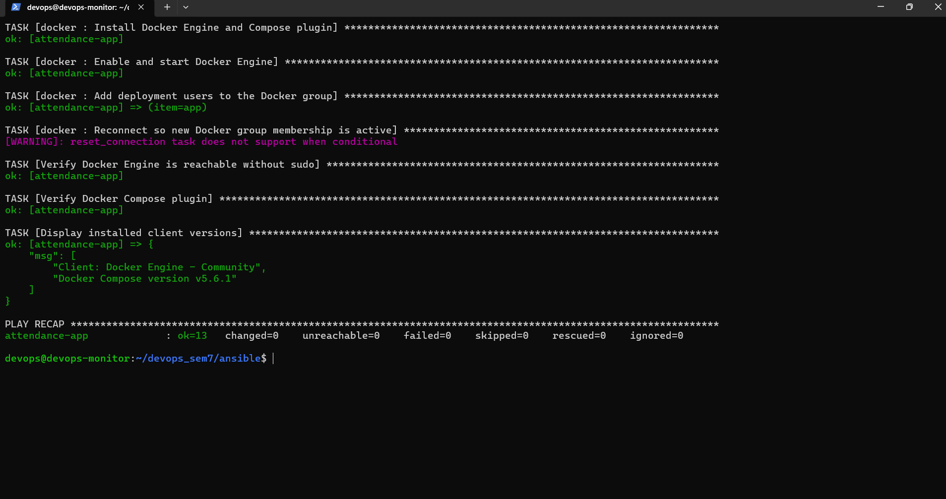
Figure 1. Ansible Docker role re-run: 13 tasks OK, 0 changed, 0 failed.

4 Automated Application Deployment
The application role deploys the project to /opt/student-attendance-tracker and starts the stack with Docker Compose. The composition contains frontend, backend, and MongoDB services. Startup ordering and health checks prevent the application from being considered ready before its dependencies are usable. Only the frontend port is published to the host-only network; backend and MongoDB remain on the private Compose network.

4.1 Deployment Verification
The playbook verifies both process state and application behaviour. It confirms that all three containers are running, then requests /api/v1/health through the published frontend endpoint. A valid response must contain status=ok and identify the student-attendance-tracker API. The recorded run completed with changed=0 on a repeated execution, confirming application-role idempotence.
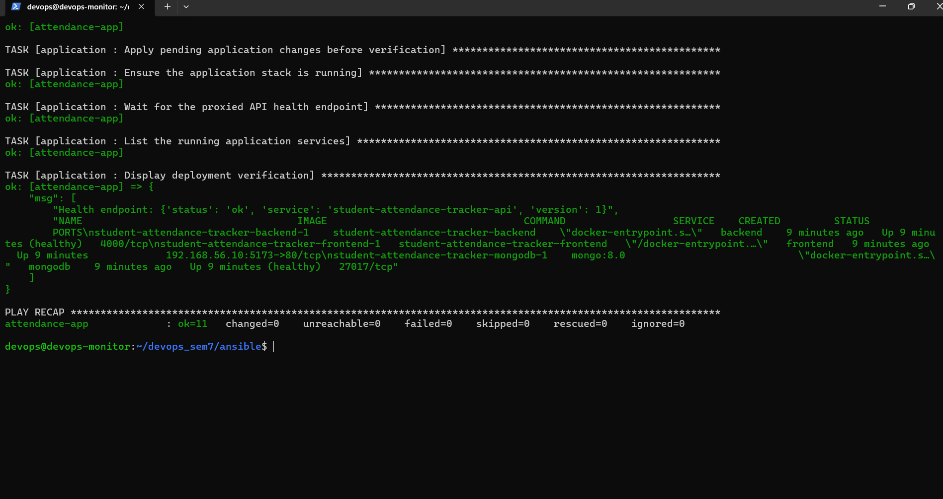
Figure 2. Application deployment verification and idempotent play recap.

4.2 Runtime Verification Commands
cd /opt/student-attendance-tracker
docker compose ps
curl -fsS http://192.168.56.10:5173/api/v1/health
For local HTTP testing, SESSION_COOKIE_SECURE is disabled because browsers do not send secure cookies over plain HTTP. A public deployment must instead use HTTPS and secure cookies.

5 Nagios Monitoring Implementation
Nagios Core runs on devops-monitor and serves its dashboard through Apache at http://192.168.56.20/nagios4/. The dashboard and command CGIs use HTTP Basic Authentication. The nagiosadmin password is generated outside the project repository and stored only at /home/devops/.ansible/nagios/admin_password. CGI authentication remains enabled so unauthenticated users cannot submit operational commands.

5.1 NRPE Agent
The NRPE service runs on attendance-app, binds only to 192.168.56.10:5666, and accepts requests from localhost and 192.168.56.20. This restricts remote plugin execution to the monitoring VM. NRPE executes approved commands for CPU, memory, disk, Docker stack, and MongoDB health. A 20-second client timeout allows container-aware checks to complete without generating avoidable socket-timeout alarms.

5.2 Monitored Services
Service | Method | Operational meaning
Host Ping | ICMP | The application VM is reachable
Frontend HTTP | check_http on port 5173 | The web interface returns HTTP 200
API Health and Response Time | Custom HTTP/JSON plugin | The backend responds correctly and promptly
CPU Usage | NRPE | CPU utilization is below warning/critical thresholds
Memory Usage | NRPE | Memory utilization is within thresholds
Root Disk Usage | NRPE | Root filesystem has sufficient free space
Docker Application Stack | NRPE custom plugin | Required containers are running and healthy
MongoDB Container Health | NRPE custom plugin | MongoDB is specifically running and healthy

5.3 Automated Nagios Deployment
The nagios_server role installs the packages, deploys custom plugins and object definitions, creates the authenticated administrator, validates Nagios configuration, and restarts services through handlers. It also executes a live NRPE memory check and verifies the authenticated dashboard before reporting success.
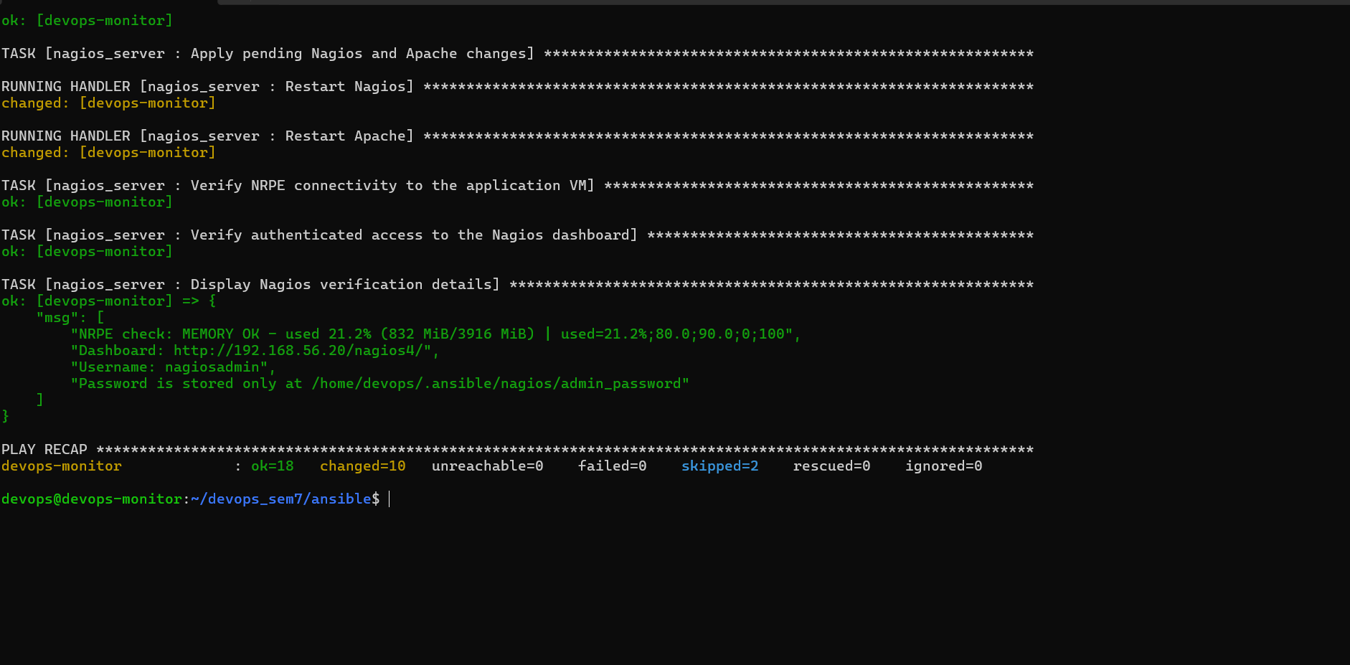
Figure 3. Ansible completes Nagios deployment, NRPE verification, and dashboard verification.

5.4 Healthy Baseline
The baseline dashboard shows the attendance-app host Up and all eight service checks OK. This provides a known-good state before failure testing. The checks cover multiple layers so that a green host ping alone cannot hide an unavailable API or failed container.
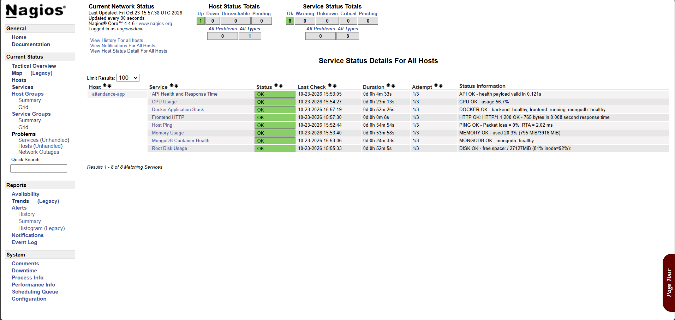
Figure 4. Nagios healthy baseline: one host Up and all eight application services OK.

6 Failure Detection and Recovery
A controlled incident was introduced by stopping only the backend container. This test was chosen because it distinguishes service-level monitoring from simple host availability. The VM, frontend, and database continue running, but API requests cannot be completed.
cd /opt/student-attendance-tracker
docker compose stop backend
docker compose ps
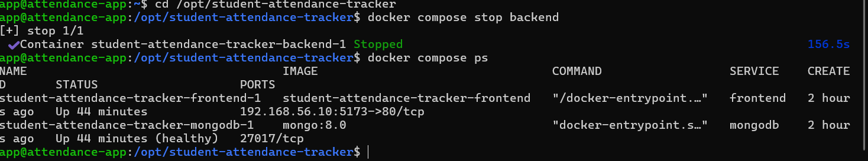
Figure 5. Controlled incident: the backend is stopped while frontend and MongoDB remain active.

6.1 Monitoring Response
Nagios correctly retained the host, frontend, MongoDB, CPU, memory, and disk checks as OK. The API check became CRITICAL because requests timed out, and the Docker Application Stack check became CRITICAL because the required backend container was not running. This isolates the fault to the application layer and avoids a misleading full-host outage diagnosis.
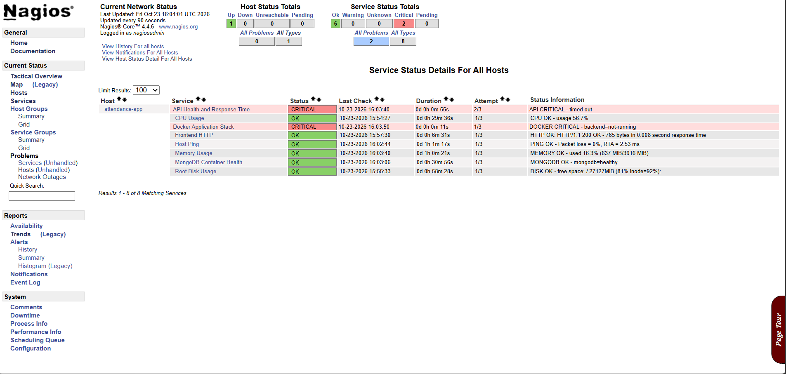
Figure 6. Nagios detects the backend incident: API and Docker stack are critical while the host remains Up.

6.2 Recovery Procedure
The backend is recreated from the existing Compose declaration. The frontend is then restarted because its Nginx process may retain the address of the replaced backend container. The health endpoint is queried immediately, followed by Nagios observation until the next active-check cycle returns every service to OK.
cd /opt/student-attendance-tracker
docker compose up -d backend
docker compose restart frontend
curl -fsS http://192.168.56.10:5173/api/v1/health

6.3 Troubleshooting Lessons
Observed issue | Root cause | Resolution
Incorrect sudo password | Invalid Ansible become password | Re-run with the app user's correct sudo password
Variables not loaded | group_vars placed outside the inventory hierarchy | Move variables below inventory/group_vars
NRPE memory check failed | Plugin access differed under the NRPE account | Grant the service account required read/execute access
NRPE socket timeout | Agent or connection was not ready | Verify binding/allowed_hosts, restart NRPE, and retry
Frontend check used port 80 | Packaged command wrapper ignored the intended port | Deploy a custom command that explicitly uses port 5173
API returned 502 after recovery | Frontend retained the replaced backend address | Restart frontend after recreating backend

7 Security, Reliability, and Maintainability

7.1 Security Controls
• Host-only addressing limits management and dashboard access to the local lab network.
• The backend and MongoDB ports are not published directly to the Windows host.
• NRPE binds to the application host-only address and trusts only the monitoring VM and localhost.
• Nagios CGI authentication remains enabled, including authorization for operational commands.
• The generated Nagios password is stored outside the Git repository.
• SSH keys enable automation without embedding a login password in the inventory.

7.2 Reliability Controls
• Container health checks and dependency ordering reduce false-ready application states.
• Ansible validates configuration and service state before declaring playbook success.
• Handlers restart services only when relevant files change.
• Nagios checks both infrastructure symptoms and application behaviour.
• Idempotent playbooks provide a safe mechanism for drift correction and rebuilding.

7.3 Maintainability
The role-based repository separates common system preparation, application deployment, monitoring-agent configuration, and monitoring-server configuration. Variables such as addresses, ports, thresholds, and credentials can be changed without rewriting task logic. Templates keep the generated configuration consistent, and the screenshots plus operational commands in this report provide evidence that the automation was executed successfully.

8 Results and Evaluation
Evaluation criterion | Evidence | Result
Controller connectivity | Ansible ping returned SUCCESS and pong | Passed
Docker configuration | Second playbook run: ok=13, changed=0, failed=0 | Passed
Application deployment | Three services active; health payload valid | Passed
Application idempotence | Second run: ok=11, changed=0, failed=0 | Passed
Monitoring deployment | Nagios role completed with no failed hosts | Passed
Healthy-state coverage | One host Up and eight services OK | Passed
Failure detection | Backend stop produced API and stack critical alerts | Passed
Recovery | Health endpoint and dashboard returned to OK | Passed

The results show that the project achieves its main DevOps goals. The same repository can configure the target machines repeatedly, and the monitoring design distinguishes a complete host outage from a single application-component failure. The evidence also confirms that deployment verification is behavioural, not limited to checking whether processes exist.

9 Limitations and Future Enhancements
The present environment is intentionally sized for a single-machine academic lab. Its architecture demonstrates configuration management and monitoring clearly, but it does not yet provide the redundancy, external alerting, and security controls expected from an internet-facing production service.
Enhancement | DevOps value
CI/CD pipeline | Automatically lint, test, build images, and run playbooks after approved changes
TLS termination | Protect credentials, cookies, dashboard traffic, and API data in transit
Email or chat alerts | Deliver critical Nagios events without requiring continuous dashboard viewing
Database backups and restore tests | Protect attendance records and prove recoverability
Versioned immutable images | Make rollback and environment consistency easier
Metrics retention and graphing | Add capacity trends and historical performance analysis
Multi-node deployment | Introduce redundancy and test failover behaviour

10 Conclusion
The Student Attendance Tracker has been converted into a practical DevOps project rather than only a web-application demonstration. Ansible expresses the desired state of the Docker host, the application stack, the NRPE agent, and the Nagios server as repeatable code. Successful second runs with zero changes demonstrate idempotence and make the playbooks suitable for rebuilds and drift correction.
Nagios supplies continuous evidence that the deployed system is usable. Its eight checks cover the host, operating-system resources, container runtime, database, frontend, and API. The controlled backend failure proved that monitoring can identify a partial application outage even while the VM remains online. The documented recovery restored service and returned the dashboard to a fully healthy state. Together, these features demonstrate the core DevOps principles of automation, observability, repeatability, security, and operational feedback.

References
• Ansible Community Documentation. https://docs.ansible.com/
• Docker Documentation, Install Docker Engine on Ubuntu. https://docs.docker.com/engine/install/ubuntu/
• Docker Documentation, Compose. https://docs.docker.com/compose/
• Nagios Core Documentation. https://www.nagios.org/documentation/
• Nagios Remote Plugin Executor (NRPE). https://github.com/NagiosEnterprises/nrpe
• Ubuntu Server Documentation. https://documentation.ubuntu.com/server/

Appendix A Operational Command Reference

A.1 Ansible Controller
cd ~/devops_sem7/ansible
ansible -i inventory.ini app_servers -m ping
ansible-playbook playbooks/install_docker.yml
ansible-playbook playbooks/deploy_application.yml
ansible-playbook playbooks/configure_monitoring_agent.yml
ansible-playbook playbooks/install_nagios.yml

A.2 Application VM
cd /opt/student-attendance-tracker
docker compose ps
docker compose logs --tail=100 backend
curl -fsS http://192.168.56.10:5173/api/v1/health
sudo systemctl status nagios-nrpe-server

A.3 Monitoring VM
/usr/lib/nagios/plugins/check_http -H 192.168.56.10 -p 5173
/usr/lib/nagios/plugins/check_nrpe -H 192.168.56.10 -t 20 -c check_cpu
/usr/lib/nagios/plugins/check_nrpe -H 192.168.56.10 -t 20 -c check_mongodb
sudo nagios4 -v /etc/nagios4/nagios.cfg
sudo systemctl restart nagios4

A.4 Access Details
Resource | Location
Application | http://192.168.56.10:5173
Health endpoint | http://192.168.56.10:5173/api/v1/health
Nagios dashboard | http://192.168.56.20/nagios4/
Nagios username | nagiosadmin
Nagios password file | /home/devops/.ansible/nagios/admin_password
GitHub repository | https://github.com/abhinavshiv7/Student-Attendance-Tracker

