Smart Attendance Management System Using Real-Time Face Recognition
An integrity-oriented prototype using embedding-based matching, temporal confirmation, database-enforced idempotency, blink liveness and centralized administration

MINI PROJECT SYNOPSIS
Submitted in partial fulfillment of the requirement for the award of the degree of
Bachelor of Technology
in
Computer Science & Engineering
Submitted to
DR. A.P.J. ABDUL KALAM TECHNICAL UNIVERSITY, UTTAR PRADESH, LUCKNOW


Submitted by  Stud Name: Abhinav Shukla  Roll No: 2401530100006  Section: 3A | Under the Supervision of  Mr. Himanshu Tiwari  Assistant Professor



Department of Computer Science & Engineering
Lloyd Institute of Engineering & Technology
Plot No. 3, Knowledge Park II, Greater Noida, Uttar Pradesh 201306
Session: 2026–27

INDEX
Sr. No. | Topic | Page No.
01 | Introduction | 3-4
02 | Statement of Problem with Objective | 5
03 | System Architecture and Proposed Methodology | 6-8
04 | Literature Survey (incl. Research Gap & Relevance) | 9-11
05 | Expected Outcome / Scope of the Project | 12-14
06 | Tentative Work Plan (mapped to the 10-week timeline) | 15
07 | Software/Hardware required for the development of the project | 16
08 | References | 17

Student’s Signature Guide’s Signature

(i)

1. INTRODUCTION

1.1 Real-world context
Attendance is a routine administrative record, but many decisions depend on it: eligibility for examinations, payroll, safety rosters and audit trails. Common collection methods each have a weakness. Manual roll call consumes teaching time and is open to proxy responses. RFID cards can be handed to another person. Fingerprint scanners prevent card-sharing but require physical contact with shared hardware and create queues. A camera-based method is attractive because it is contactless and can run while people do something else.

1.2 The technical problem behind "face attendance"
"Face recognition can automate attendance" is the starting point, not the contribution. Several distinct technical problems sit inside it:
- Detection versus recognition. Finding a face in a frame and deciding whose face it is are separate tasks with separate error modes.
- Open-set decisions. A room contains enrolled people and non-enrolled people. The system must accept the first group and reject the second, which depends entirely on a distance threshold. A threshold that is too strict produces missed marks; one that is too loose produces wrong marks, which are worse because they attribute presence to the wrong person.
- Temporal reliability. Individual video frames are affected by motion blur, partial occlusion and lighting changes. A decision based on one frame is fragile.
- Record integrity. Even a correct recogniser can write the same person twice, or write an entry when it should not, if the storage layer is not designed carefully.
- Presentation attacks. A printed photograph or a phone screen can be held up to a camera. A recogniser that only measures identity similarity will accept it.
- Privacy. A face template is a biometric identifier. How it is stored and under what consent is part of the system, not an afterthought.

1.3 Proposed project in brief
This project builds and evaluates a working prototype in which a webcam observes a room, enrolled faces are matched using 128-dimensional deep embeddings, a person is marked present only after consistent matches across consecutive processed frames, and the record is written to a SQLite database whose schema forbids a second entry for the same person on the same date. An administrator uses a login-protected Flask dashboard to manage a generic people roster, guide face enrollment, monitor the live annotated feed, review a monthly attendance register, correct authorized entries and export CSV reports. The liveness-detection module is implemented as a lightweight blink gate. The project keeps recognition parameters configurable, but it does not claim a face-recognition accuracy percentage without a labelled evaluation dataset.
This project builds and evaluates a working prototype in which a webcam observes a room, enrolled faces are matched using 128-dimensional deep embeddings, a person is marked present only after consistent matches across consecutive processed frames, and the record is written to a SQLite database whose schema forbids a second entry for the same person on the same date. An administrator uses a login-protected Flask dashboard to manage a generic people roster, guide face enrollment, monitor the live annotated feed, review a monthly attendance register, correct authorized entries and export CSV reports. The liveness-detection module is implemented as a lightweight blink gate. The project keeps recognition parameters configurable, but it does not claim a face-recognition accuracy percentage without a labelled evaluation dataset.

1.4 Key technical concepts
- Face embedding: a fixed-length vector produced by a deep network such that vectors of the same person lie close together and those of different people lie far apart.
- Distance threshold (tolerance): the maximum Euclidean distance at which a probe is accepted as a known identity.
- False accept / false reject: accepting the wrong or a non-enrolled person, versus rejecting an enrolled person.
- Idempotent write: a write that has the same effect whether it is performed once or many times; here, "mark present today" must not create a second record.
- Presentation attack detection (liveness): determining whether the face in front of the camera is a live person rather than a reproduction.

2. STATEMENT OF PROBLEM AND OBJECTIVES

2.1 Problem statement
To design and implement a low-cost, CPU-oriented face-recognition attendance prototype whose recorded entries are accurate enough to be reviewed by an administrator, complete within the tested operating conditions, unique at most once per person per day through the data layer, and protected against a static-photo attempt through an implemented blink-based liveness gate. Recognition accuracy remains an empirical quantity to be measured with a labelled evaluation set rather than assumed from the threshold value.

2.2 Research motivation
The motivation arises from three observations.
An early prototype in this project used Haar-cascade detection with raw-pixel k-nearest-neighbour matching. Informal testing confused two enrolled people, which motivated the current HOG-based detection and learned-embedding pipeline. This observation is anecdotal and is not reported as a benchmark result.
The recogniser depends on a distance tolerance. During development, a value of 0 rejected every face and a value of 0.45 separated the available test individuals. This was manual tuning, not a statistically valid calibration; the final project therefore documents the setting and retains tolerance evaluation as future measured work.
The final register is affected by more than recognition: temporal confirmation, liveness, duplicate prevention, roster correctness and administrator review also matter. The project therefore evaluates database correctness directly and describes a proper future protocol for recognition accuracy.

2.3 Objectives
To implement an enrollment and recognition pipeline based on deep face embeddings, with a configurable HOG detector and tolerance.
To document the operating threshold and define a labelled evaluation protocol for future false-accept and false-reject measurement, without inventing unsupported accuracy results.
To implement temporal confirmation and use it to reduce isolated-frame decisions before liveness and attendance marking.
To enforce one record per person per day at the database level and verify it under concurrent write attempts.
To deliver an authenticated dashboard with a live feed, people roster, guided enrollment workflow, date-wise attendance table, monthly register and CSV exports.
To implement and document a landmark-based blink liveness check, including its limitation against replayed video.
To document privacy, biometric-data, fairness and deployment limitations.
3. SYSTEM ARCHITECTURE AND PROPOSED METHODOLOGY

3.1 Overall architecture
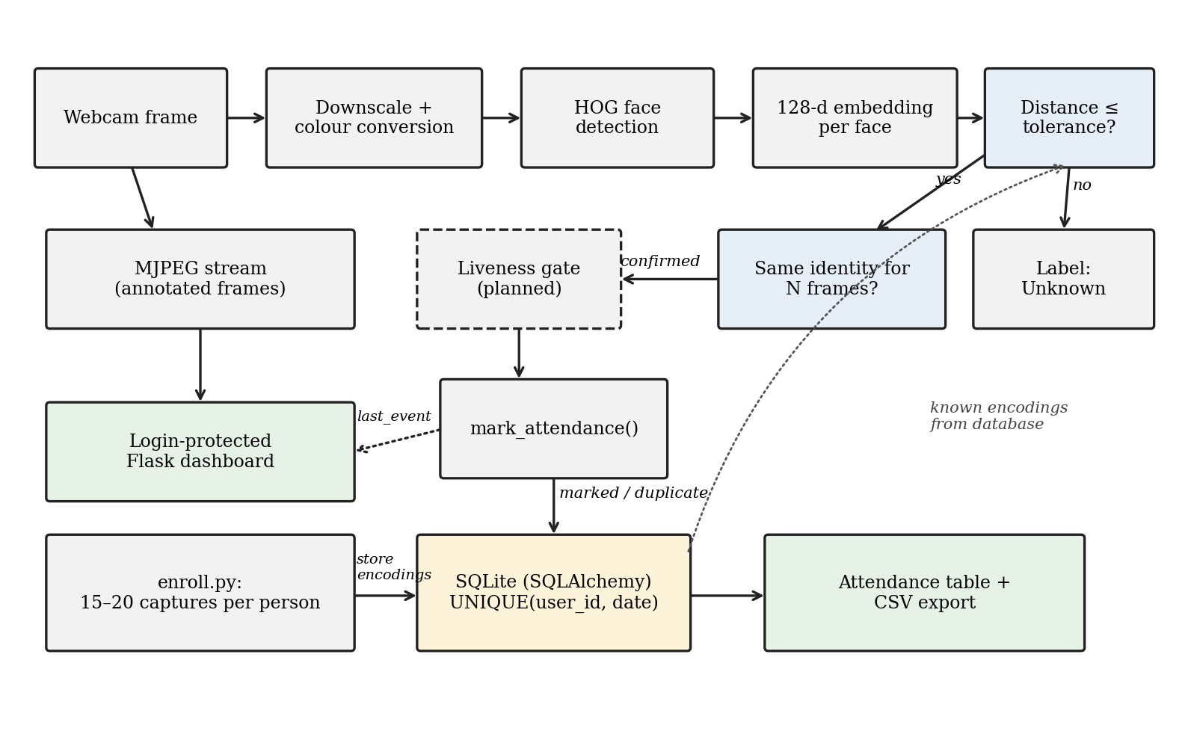
Figure 1: Final system architecture and decision chain. The final architecture includes the implemented dashboard, roster, monthly register and blink liveness gate.
Reading the diagram: the browser controls the Flask application; the runtime path passes from camera capture through recognition, temporal confirmation and the implemented liveness gate before the database write. The database is the source of truth for profiles and attendance. The dashboard renders the live feed, roster, register and reports.
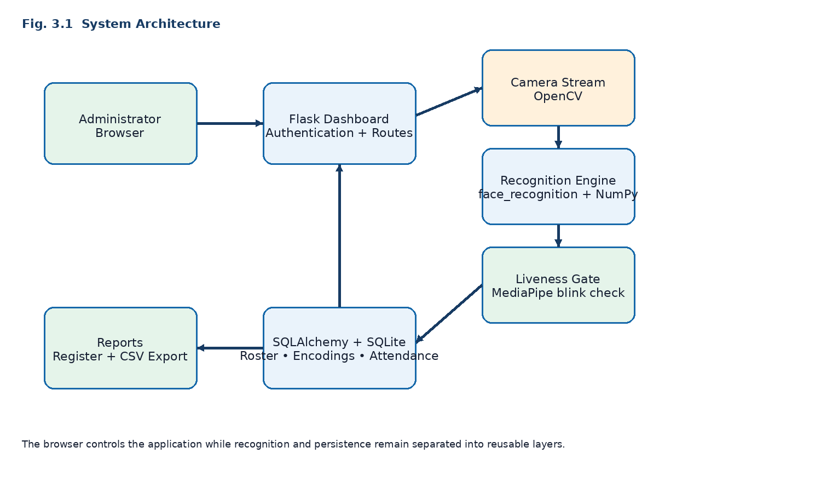
Figure 1: Final system architecture and decision chain.
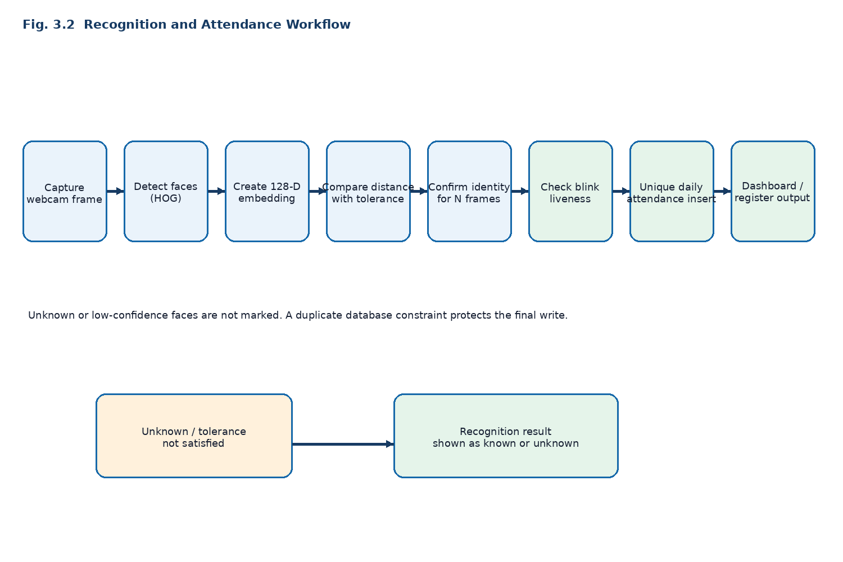
Figure 2: Recognition, liveness and attendance workflow.
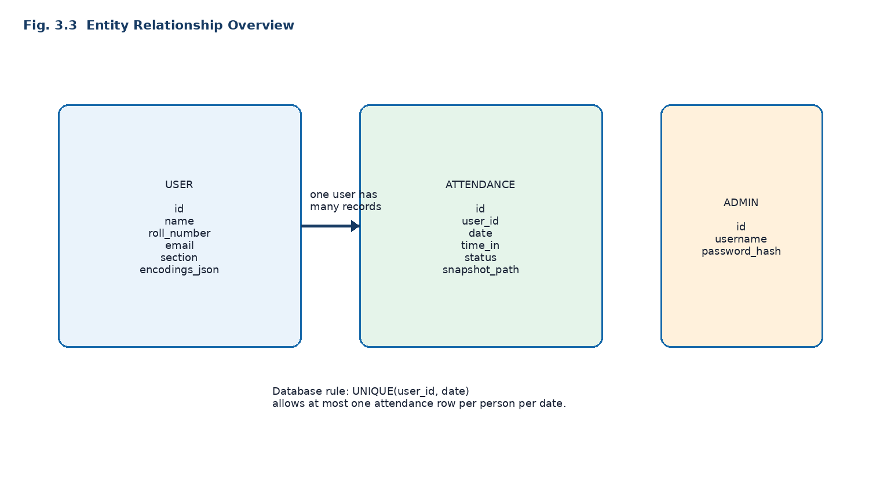
Figure 3: User, attendance and admin entity relationship overview.
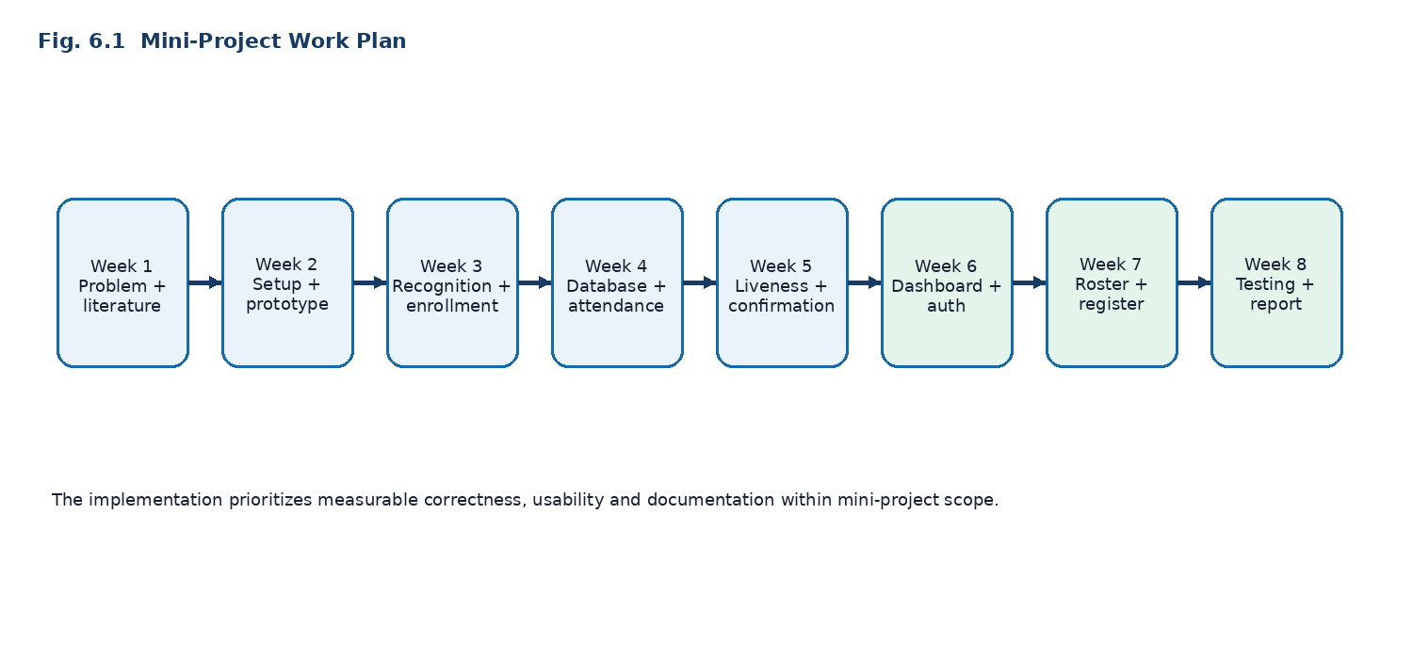
Figure 4: Project work plan aligned with the implemented mini-project.

3.2 Major components and why each exists
Component | Problem it addresses | Choice made | Reason | How it will be evaluated
Detection | Locate faces cheaply on a CPU | HOG detector (dlib, via face_recognition), frames downscaled to 0.25 | Gradient-histogram features are efficient and do not need a GPU [3][6] | Operationally validated in the prototype; formal detection-rate/FPS measurement remains future work
Representation | Make identity comparison robust to pose and illumination | 128-d deep embeddings from the dlib model | Learned embeddings were shown to outperform earlier handcrafted representations on unconstrained benchmarks [4][5] | Formal baseline comparison remains future work; embeddings are used in the implemented pipeline
Decision | Separate enrolled from non-enrolled | Euclidean distance with configurable tolerance (currently 0.45) | Embedding distance is the natural similarity measure for such models [4] | Current tolerance is 0.45; formal FAR/FRR sweep remains future work
Temporal confirmation | One bad frame should not write a record | N consecutive matches (default 3) on processed frames | Averages out transient errors without a heavier model | Wrong marks and latency vs N (E4)
Idempotent storage | Duplicates and race conditions | UNIQUE(user_id, date) constraint; IntegrityError mapped to "duplicate" | The guarantee lives in the data layer, so it cannot be bypassed by application bugs | Repeat and concurrent write tests (E6)
Delivery | Long-running, product-like use | Flask with a shared camera singleton and MJPEG stream; session login | One camera handle for many requests; browser needs no plug-in | Stability over long runs, response time
Liveness (implemented) | Photo/screen spoofing | Landmark-based blink check using MediaPipe Face Mesh | Landmark geometry gives low-cost motion cues without a depth sensor [9][10] | Static-photo mitigation is implemented; APCER/BPCER evaluation remains future work (E7)

3.3 Data flow
During enrollment, multiple frames per person are captured with exactly one face per frame; their embeddings are stored with the person record in the User table as a JSON list, while the captured images are retained under the local faces directory for enrollment reference. During operation, each processed frame yields zero or more faces; each face is matched to the nearest enrolled embedding; the streak counter advances only if the same identity is returned consecutively; the liveness state requires a blink when enabled; and the database layer returns either "marked" or "duplicate". The result is shown on the dashboard and in the register.

3.4 Core algorithm
For a probe embedding p and the set of stored embeddings for each enrolled person, the matcher computes Euclidean distances and takes the nearest enrolled identity. If that minimum is at most the tolerance τ, the identity is proposed; otherwise, the face is "Unknown". Detection and embedding are performed only on every second frame (configurable); the most recent results are cached and drawn on all frames, so the display remains smooth.

3.5 Decision and processing pipeline
proposed identity → streak update → implemented liveness check → database write → human-readable event → dashboard/register. Each stage can reject, so the stages together define the system error profile. The database uniqueness constraint protects the final write even when concurrent attempts occur.

3.6 Evaluation status and proposed measurement
The implemented prototype has been validated for Python syntax, template parsing, application initialization, SQLite foreign-key configuration and concurrent attendance uniqueness. A general face-recognition accuracy percentage has not been measured because the repository does not contain a labelled evaluation dataset. The proposed E1–E7 protocol remains the correct next step for empirical recognition and liveness measurements.
Evaluation status | Question / activity | Current project status | Evidence or next step | Metrics when evaluated
E1: embedding vs raw-pixel baseline | Proposed evaluation | Configured/implemented; formal measurement pending | Source settings and test protocol | Accuracy/FAR/FRR/time-to-mark
E2: tolerance selection | Proposed evaluation | Configured/implemented; formal measurement pending | Source settings and test protocol | Accuracy/FAR/FRR/time-to-mark
E3: lighting/pose robustness | Proposed evaluation | Configured/implemented; formal measurement pending | Source settings and test protocol | Accuracy/FAR/FRR/time-to-mark
E4: temporal confirmation | Implemented pipeline | Configured/implemented; formal measurement pending | Source settings and test protocol | Accuracy/FAR/FRR/time-to-mark
E5: throughput | Proposed evaluation | Configured/implemented; formal measurement pending | Source settings and test protocol | Accuracy/FAR/FRR/time-to-mark
E6: concurrent uniqueness | Implemented pipeline | Verified | 20 concurrent attempts: 1 marked, 19 duplicate, 1 row | Marked/duplicate counts and final row count
E7: blink liveness | Implemented pipeline | Configured/implemented; formal measurement pending | Source settings and test protocol | Accuracy/FAR/FRR/time-to-mark

4. LITERATURE SURVEY

4.1 Foundational research: from holistic faces to detectable features
Early computer face recognition treated the face as a two-dimensional pattern. Turk and Pentland's eigenfaces projected face images onto the principal components of a training set and recognised people by comparing their coordinates in this "face space", enabling near-real-time operation in 1991 [1]. The approach is compact but depends on controlled conditions, because pixel-level variance contains lighting and pose as well as identity.
For finding faces, Viola and Jones introduced an integral-image representation, AdaBoost feature selection and a cascade that rejects background quickly; it reached about 15 frames per second on a 700 MHz processor, which made real-time face detection practical [2]. Dalal and Triggs later showed that grids of locally normalised histograms of oriented gradients, paired with a linear SVM, were a strong feature set for detection (their test case was pedestrians) [3]. The HOG-plus-linear-classifier pattern underlies the CPU-friendly face detector available in dlib [6].
Relevance: the project's rejected prototype combined the Viola–Jones family of detectors with raw-pixel matching; its production pipeline retains efficient gradient-based detection but replaces the matching stage.

4.2 Modern approaches: learned embeddings
FaceNet trained a convolutional network to map a face directly to a compact Euclidean space in which distance corresponds to similarity, so that verification becomes thresholding, recognition becomes nearest-neighbour search and clustering uses standard methods; it used 128 bytes per face and reported a then-record 99.63% on the Labeled Faces in the Wild benchmark [4]. A comprehensive survey by Wang and Deng reviews how deep architectures and loss functions reshaped face recognition from 2014 onward and also catalogues the remaining difficulty in cross-factor and industrial scenes [5]. Importantly for this project, such benchmark numbers describe controlled evaluation protocols; they do not predict error rates in a particular classroom with a particular webcam, which is why local measurement (E1–E4) is proposed.
Relevance: the dlib-based face_recognition library gives the project a pre-trained 128-dimensional embedding without training data of its own. This justifies the earlier decision not to train a custom classifier (e.g. in Keras) on a few photographs per person.

4.3 Application-specific research: face-based attendance
Published attendance systems illustrate the range of designs. Cao and Li proposed a classroom attendance system built from face detection and face recognition stages and reported that it was efficient [11]. Son et al. built an attendance-taking support system that attaches to existing CCTV and uses deep face recognition, as a case study at FPT Polytechnic College [12]. Qiang improved an automatic classroom attendance system by combining facial recognition with behavioural recognition so that late arrivals and early departures can be identified, and reports 96% accuracy for the resulting system [13].
Observed pattern: in the sources reviewed for this synopsis, results are presented mainly as recognition accuracy or system feasibility. Questions such as how often a wrong person is written into the register, how the tolerance was chosen, what prevents a duplicate row, and what happens when a photograph is shown are either not the focus or not reported in the abstracts examined. This synopsis does not claim an exhaustive survey of the field; it reports what the sources consulted emphasise.

4.4 Presentation attacks and liveness
Face anti-spoofing protects recognition systems from presentation attacks such as printed photos and replayed video. A comprehensive survey by Yu et al. reports that deep-learning methods now dominate the field, and it identifies generalisation to unseen attack types and datasets, and the use of extra sensors, as open issues [8]. A lighter, motion-based family of cues relies on facial landmarks: Soukupová and Čech showed that the eye aspect ratio derived from landmarks can be used to detect blinks in real time from a standard camera [9], and MediaPipe's face-mesh model estimates 468 facial landmarks quickly enough for real-time use, even on mobile hardware [10].
Relevance and honesty about limits: a blink or head-turn challenge is inexpensive and requires no new hardware, but it is a deliberately modest defence. A pre-recorded video of a blinking person may defeat a naive blink check, which is why the plan combines a randomised challenge with explicit testing against screen-replay (E7), and reports where it fails, rather than claiming spoof-proofing.

4.5 Privacy, fairness and regulation
NIST's large-scale evaluation of demographic effects found that contemporary face-recognition algorithms exhibit demographic differentials of varying magnitude [7]. For a small institutional deployment this implies that error rates measured on one cohort should not be assumed to transfer to another, and that the evaluation cohort should be described. Biometric templates are also personal data. India's Digital Personal Data Protection Act, 2023 became operational through the DPDP Rules notified in November 2025, which emphasise a clear standalone consent notice and principles such as purpose limitation, data minimisation and security safeguards [14]; the Rules phase in over about eighteen months, so the exact obligations applicable to an institution should be confirmed at deployment time. The prototype currently stores embeddings as unencrypted JSON text and has no consent screen, which is recorded as a limitation (Section 5.6).

4.6 Comparative analysis
Approach | Strength | Limitation relevant here
Manual / RFID / fingerprint | Simple, familiar | Time cost, proxy marking, physical contact
Eigenfaces [1] | Compact, fast | Sensitive to illumination and pose
Haar cascade + raw pixels | Very cheap | Detection-only strength; raw-pixel matching confused two people in this project's informal test
Deep embeddings [4][5] | Robust, compact | Benchmark accuracy does not transfer automatically; threshold choice is critical
Published attendance systems [11][12][13] | Show practical feasibility | Evaluation usually at recognition level; integrity and spoofing less emphasised in sources consulted
Liveness research [8][9][10] | Techniques exist | Usually studied separately from attendance pipelines

4.7 Research gap
Research has established that deep embeddings represent identity far more robustly than raw pixels or eigenfaces [1][4][5]. Separate studies have built classroom attendance systems with detection and recognition stages [11][12][13], and others have developed liveness and anti-spoofing methods [8][9][10]. However, in the sources examined, these threads are not usually evaluated together as a single attendance pipeline: the choice of tolerance, the number of confirming frames, the guarantee of one record per day and the spoofing defence are not studied as interacting parameters whose joint effect on the final register can be measured.
The proposed project addresses this gap, at B.Tech scale, by building the whole chain on commodity hardware and measuring the quantities a register's user cares about: wrong entries, missed entries, duplicate entries, spoof acceptance, time-to-mark and throughput.

4.8 Real-world impact
If future labelled evaluation shows that the pipeline reaches acceptable error rates within a defined environment, it could reduce time spent on roll call and make proxy attendance harder in small classrooms, offices or laboratories within the tested conditions. Equally important, the evaluation will document where it does not work, including lighting, distance and spoofing conditions, before an institution relies on the system.

5. EXPECTED OUTCOME AND SCOPE OF THE PROJECT

5.1 Scope
In scope: a single webcam and small local deployment; enrollment through the existing guided command-line tool; real-time recognition; temporal confirmation; implemented blink liveness; database-backed attendance with date-level uniqueness; authenticated dashboard; generic people roster; guided enrollment command; live feed; date-filtered table; monthly spreadsheet-like register; manual correction; daily CSV and monthly register CSV export; and the concurrent-write correctness test.
Out of scope and future work: multi-camera deployment, mobile app, cloud hosting, fully browser-native camera enrollment, model training or fine-tuning, stronger replay-resistant anti-spoofing, privacy-consent workflow and large-cohort recognition benchmarking.

5.2 Expected outcomes
The following outcomes are now implemented unless explicitly marked as evaluation work: a functional recognition and attendance prototype; database-backed profiles and encodings; authenticated admin dashboard; people roster; monthly register; manual correction; CSV exports; liveness gate; and verified one-record-per-person-per-day behavior under concurrent writes. A labelled recognition dataset and numerical accuracy analysis remain future evaluation work.
- Functional prototype: implemented and integrated across the recognition loop, Flask dashboard, roster, register and database.
- Evaluation dataset and test protocol: not included in the repository; proposed as the next accuracy-validation activity.
- Baseline-versus-embedding comparison: not measured in the final repository; retain as future experimental work.
- Tolerance and confirmation-depth curves: settings are configurable, but formal error trade-off curves are not yet measured.
- Throughput measurements: frame resizing and frame skipping are implemented; formal hardware-specific FPS benchmarking remains future work.
- Uniqueness guarantee under concurrent writes: verified with one marked result, nineteen duplicate results and one final database row from twenty attempts.
- Liveness gate: implemented as blink detection; static-photo mitigation is supported, while replay-video resistance is not claimed.
- Limitations: documented in the synopsis and source comments.

5.3 Key features implemented
Webcam enrollment; embedding-based recognition; configurable tolerance; N-frame confirmation; database as the source of truth for enrolled faces; unique-per-day attendance; MJPEG browser stream; hashed-password session login; people roster; guided enrollment command; monthly register; manual correction; date-filtered attendance table; daily CSV export; monthly register CSV export; implemented blink liveness; and isolated concurrency validation.

5.4 Intended users
Administrators or faculty running attendance for a small group; office, classroom, workshop or laboratory operators; enrolled students, employees, trainees or members; and evaluators who need a configurable academic prototype.

5.5 Applications and use cases
Tier | Setting | Who uses it | Problem solved | Capability used | Needed for real deployment | Status
Primary | Classroom or lab attendance | Faculty, students | Roll-call time, proxy marking | Recognition, confirmation, unique record, CSV export | Consent notice, encrypted templates, larger-cohort testing | Implemented for current small local scope
Secondary | Small office or library entry logging | Administrators | Contactless presence log | Same pipeline, camera at entrance | Multiple people at once, privacy policy, retention rules | Partly applicable; future privacy and multi-person testing
Secondary | Workshop or seminar check-in | Organisers | Queue-free registration | Enrolment + recognition | Fast onboarding of many people (web enrolment) | Future scope: browser-native enrollment and larger onboarding
Extension | Examination-hall presence verification | Invigilators | Candidate impersonation | Recognition + liveness | Much stricter FAR, liveness against stronger attacks, institutional approval | Research extension
Extension | Late/early-arrival analytics | Faculty | Punctuality records | Timestamps, status field | Schedule/cutoff configuration | Future scope (field exists, logic does not)

The prototype is not presented as production-ready for any setting. It is suitable for a controlled mini-project demonstration and small local evaluation, subject to consent, privacy safeguards, calibration and performance testing.

5.7 Future scope and research directions
1. Build a consented, labelled evaluation dataset and report accuracy, precision, recall, false-accept rate and false-reject rate across tolerance values.
2. Add encrypted or otherwise protected biometric-template storage, retention/deletion controls and a recorded-consent workflow.
3. Improve replay-resistant presentation-attack detection beyond the current blink gate.
4. Compare alternative embedding models and a GPU/CNN detector against the current CPU HOG pipeline.
5. Add browser-native enrollment and stronger roster editing/deletion controls.
6. Support larger cohorts, multiple cameras or a service architecture after benchmarking the current prototype.
7. Add attendance analytics such as late arrivals, per-person trends and group summaries.
8. Add database migrations, deployment hardening and role-based administration.

6. TENTATIVE WORK PLAN (10 WEEKS)
Week | Activity | Output
1 | Literature study; define metrics and test protocol; obtain volunteer consent | Evaluation protocol and project requirements
2 | Recognition engine: detection, embeddings, tolerance configuration | Working recogniser
3 | Enrolment tool and database schema (users, attendance, admin) | Enrolment + DB layer
4 | Recognition-to-database integration; N-frame confirmation; uniqueness constraint | End-to-end marking
5 | Flask backend, MJPEG stream, authentication | Authenticated live feed
6 | Attendance table, date filter, CSV export; dashboard polish | Attendance table, dashboard polish and register output
7 | Data collection and experiments E1–E4 | Baseline comparison; tolerance and N analysis
8 | Liveness module (blink / head-turn) and experiments E5–E7 | Concurrency correctness validation and report-ready evidence
9 | System testing: multiple users, varied lighting, concurrency; bug fixing | Concurrency correctness validation and report-ready evidence
10 | Analysis, limitations, documentation, final demonstration | Report and demo

7. SOFTWARE AND HARDWARE REQUIREMENTS
Hardware Requirements:
Component | Minimum Requirements
Processor | Intel Core i5 /equivalent or above [Multi-Core CPU] [HOG pipeline is designed to run on the CPU, so no GPU is required]
RAM | 16GB or above
Storage | Minimum 15GB available space
Display | Standard Display
Internet | Required for development and installing packages
Keyboard/Mouse | Standard Keyboard and Mouse

Packages: Python 3.10 / OpenCV / face_recognition (dlib) / NumPy / Flask (with Werkzeug) / SQLAlchemy ≥ 2.0 with SQLite / MediaPipe (implemented for blink liveness)
Component | Requirement
Operating System | Linux, Windows or macOS with camera access
Packages | Python 3.10 / OpenCV / face_recognition (dlib) / NumPy / Flask (Werkzeug) / SQLAlchemy ≥ 2.0 with SQLite / MediaPipe Face Mesh (implemented for blink liveness)
IDE | Open-Source IDE like VS Code
Version Control | Git And GitHub
Browser | Google Chrome/Mozilla Firefox/Safari/Brave [Any moder browser ]

8. REFERENCES

[1] Turk, M. and Pentland, A., "Eigenfaces for Recognition," Journal of Cognitive Neuroscience, vol. 3, no. 1, pp. 71–86, 1991. doi:10.1162/jocn.1991.3.1.71
[2] Viola, P. and Jones, M., "Rapid Object Detection using a Boosted Cascade of Simple Features," in Proc. IEEE CVPR, 2001. doi:10.1109/CVPR.2001.990517
[3] Dalal, N. and Triggs, B., "Histograms of Oriented Gradients for Human Detection," in Proc. IEEE CVPR, 2005. doi:10.1109/CVPR.2005.177
[4] Schroff, F., Kalenichenko, D. and Philbin, J., "FaceNet: A Unified Embedding for Face Recognition and Clustering," in Proc. IEEE CVPR, 2015, pp. 815–823. doi:10.1109/CVPR.2015.7298682
[5] Wang, M. and Deng, W., "Deep Face Recognition: A Survey," Neurocomputing, vol. 429, pp. 215–244, 2021.
[6] King, D. E., "Dlib-ml: A Machine Learning Toolkit," Journal of Machine Learning Research, vol. 10, pp. 1755–1758, 2009.
[7] Grother, P., Ngan, M. and Hanaoka, K., "Face Recognition Vendor Test (FRVT) Part 3: Demographic Effects," NISTIR 8280, National Institute of Standards and Technology, 2019. doi:10.6028/NIST.IR.8280
[8] Yu, Z., Qin, Y., Li, X., Zhao, C., Lei, Z. and Zhao, G., "Deep Learning for Face Anti-Spoofing: A Survey," IEEE Transactions on Pattern Analysis and Machine Intelligence, vol. 45, no. 5, pp. 5609–5631, 2023. doi:10.1109/TPAMI.2022.3215850
[9] Soukupová, T. and Čech, J., "Real-Time Eye Blink Detection using Facial Landmarks," in Proc. 21st Computer Vision Winter Workshop, Rimske Toplice, Slovenia, 2016.
[10] Kartynnik, Y., Ablavatski, A., Grishchenko, I. and Grundmann, M., "Real-time Facial Surface Geometry from Monocular Video on Mobile GPUs," CVPR Workshop on Computer Vision for Augmented and Virtual Reality, 2019. arXiv:1907.06724
[11] Cao, W. and Li, B., "Attendance System Applied in Classroom Based on Face Image," in Proc. 2015 International Symposium on Computers & Informatics, Atlantis Press, 2015. doi:10.2991/isci-15.2015.218
[12] Son, N. T., Anh, B. N., Ban, T. Q., Chi, L. P., Chien, B. D., Hoa, D. X., Thanh, L. V., Huy, T. Q., Duy, L. D. and Khan, M. H. R., "Implementing CCTV-Based Attendance Taking Support System Using Deep Face Recognition: A Case Study at FPT Polytechnic College," Symmetry, vol. 12, no. 2, art. 307, 2020. doi:10.3390/sym12020307
[13] Qiang, S., "Towards the Classroom of the Future: Improvement Strategies for Automatic Attendance Systems Using Facial Recognition Combining Behavioral Recognition," in Proc. 2024 International Conference on Artificial Intelligence and Communication (ICAIC 2024), Atlantis Press, 2024.
[14] Government of India, Ministry of Electronics and Information Technology, Digital Personal Data Protection Act, 2023 and Digital Personal Data Protection Rules, 2025 (notified 14 November 2025); see also PIB backgrounder "DPDP Rules, 2025 Notified," 17 November 2025.

