Coffee Shop Revenue Prediction
Full-Stack ML Project | Flask Backend + Streamlit Frontend
Generated: September 23, 2026

1. Executive Summary
This project builds a full-stack machine learning application that predicts the daily total revenue for a coffee shop store location. The business problem — forecasting day-level revenue — helps operations teams with staffing, inventory, and promotions planning. A Linear Regression model is trained on 543 daily aggregated records derived from 149,116 raw transactions across three New York City stores (Jan–Jun 2023). The trained model achieves an R² of 0.6942 with a Mean Absolute Error of $172.45 per day.

2. Project Structure
File / Folder | Description
coffee_shop_project/ | Project root
data/Coffee_Shop_Sales.csv | 149,116 raw transactions: store, product, qty, price
model/model.pkl | Trained LinearRegression artefact
model/scaler.pkl | StandardScaler fitted on training data
model/le_store.pkl | LabelEncoder for store locations
model/metrics.json | Saved evaluation metrics and revenue summaries
model/diagnostics.png | Actual vs Predicted + Residual plots
backend/app.py | Flask REST API (port 5000)
frontend/ui.py | Streamlit frontend (port 8501)
train_model.py | Training script – full ML pipeline
generate_report.py | This report generator
requirements.txt | All Python dependencies
README.md | Run instructions

3. Dataset Analysis
The Coffee Shop Sales dataset contains 149,116 transactions from three NYC locations across January–June 2023. It was sourced from Kaggle (srisyra02/coffee-shop-sales-dataset). For modelling, transactions are aggregated to 543 daily store-level records.

3.1 Raw Data Sample (first 8 rows)
Transaction Date | Store Location | Product Category | Transaction Qty | Unit Price | Revenue
2023-01-01 | Lower Manhattan | Coffee | 2 | 3.0 | 6.0
2023-01-01 | Lower Manhattan | Tea | 2 | 3.1 | 6.2
2023-01-01 | Lower Manhattan | Drinking Chocolate | 2 | 4.5 | 9.0
2023-01-01 | Lower Manhattan | Coffee | 1 | 2.0 | 2.0
2023-01-01 | Lower Manhattan | Tea | 2 | 3.1 | 6.2
2023-01-01 | Lower Manhattan | Bakery | 1 | 3.0 | 3.0
2023-01-01 | Lower Manhattan | Coffee | 1 | 2.0 | 2.0
2023-01-01 | Lower Manhattan | Coffee | 2 | 2.0 | 4.0

3.2 Revenue by Store Location
Total revenue summed across all 181 trading days per store:
Store Location | Total Revenue (USD)
Astoria | $232,243.91
Hell's Kitchen | $236,511.17
Lower Manhattan | $230,057.25

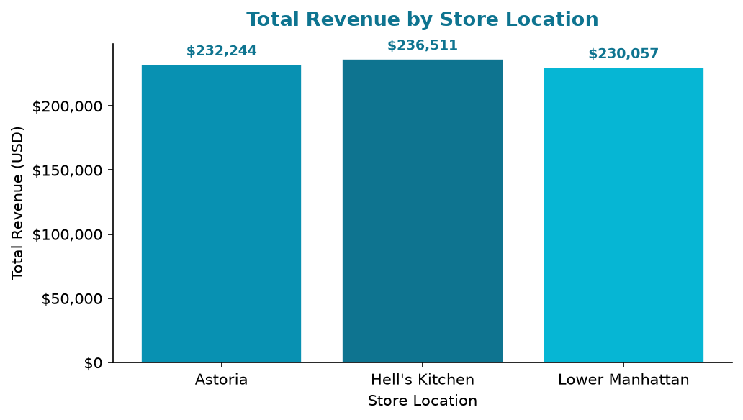

3.3 Monthly Revenue Trend
Month | Total Revenue (USD)
Jan | $81,677.74
Feb | $76,145.19
Mar | $98,834.68
Apr | $118,941.08
May | $156,727.76
Jun | $166,485.88

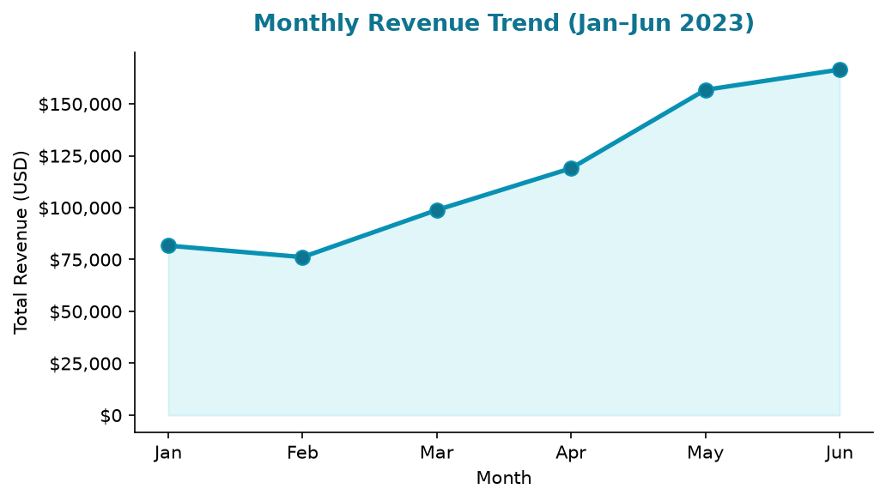

4. Machine Learning Model
A Linear Regression model was trained using scikit-learn. Features were normalised using StandardScaler (fit only on training data). An 80/20 train-test split was used with random_state=42 for reproducibility.

4.1 Model Pipeline
- Load CSV → pandas DataFrame
- Aggregate transactions → daily revenue per store
- Extract features: store_enc, day_of_week, month, week_of_year
- Train/test split: 80% train / 20% test (random_state=42)
- Feature scaling: StandardScaler.fit_transform(X_train), .transform(X_test)
- Model fitting: LinearRegression().fit(X_train_scaled, y_train)
- Evaluation: R², MAE, RMSE on test set
- Persistence: joblib.dump(model, scaler, le_store)

4.2 Model Equation
Daily Revenue = 1303.29 + -5.2636 * store_enc + -2.1031 * day_of_week + 333.8445 * month + 39.1426 * week_of_year

4.3 Evaluation Metrics
Metric | Value | Interpretation
R² Score | 0.6942 | Proportion of variance explained (0–1, higher is better)
MAE | $172.45 | Average absolute prediction error in USD per day
RMSE | $219.51 | Root mean squared error – penalises large errors

Note: The R² of 0.6942 is moderate. With only 4 calendar features (store, day of week, month, week of year), the model captures broad seasonal and location trends. Adding product-mix or weather data would improve accuracy.
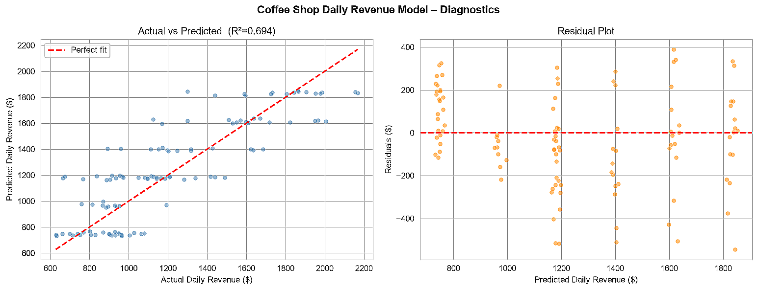

5. API Endpoints (Flask)
The Flask backend runs on port 5000 and exposes four REST endpoints.
Method | Endpoint | Description
GET | /health | Service health check
POST | /predict | Predict daily store revenue from store + date features
GET | /dataset | Dataset summary, revenue breakdowns, sample records
GET | /model_info | Model coefficients, evaluation metrics, sample predictions

POST /predict – Example Request
{
"store_location": "Astoria",
"day_of_week": 0,
"month": 3,
"week_of_year": 13
}

POST /predict – Example Response
{
"predicted_daily_revenue": 1318.42,
"historical_avg_same_weekday": 1285.60,
"inputs": { "store_location": "Astoria", "day_name": "Monday", ... }
}

6. Frontend UI (Streamlit)
The Streamlit frontend runs on port 8501 and consists of three navigable pages, all communicating with the Flask backend API in real time.

6.1 Page 1 – Predict Revenue
Accepts store location, day of week, month, and week of year as inputs, sends a POST request to /predict, and displays the predicted daily revenue via a gauge chart. A comparison table shows predictions for all three stores under the same conditions.

6.2 Page 2 – Dataset Explorer
Fetches /dataset and displays KPI metric cards (total transactions, total revenue, mean daily revenue), a bar chart of revenue by store, a line chart of monthly revenue trends, a day-of-week bar chart, and a store-share pie chart. The aggregated daily records table is shown at the bottom.

6.3 Page 3 – Model Insights
Fetches /model_info and displays R², MAE, and RMSE metric cards, the model equation, a feature coefficients bar chart, the diagnostics PNG, and a table of sample predictions across five representative store/day/month combinations.

7. Sample Prediction Results
The following table shows model predictions for a range of store and date configurations:
Store | Day | Month | Week | Predicted Daily Revenue (USD)
Astoria | Monday | Jan | 1 | $747.23
Hell's Kitchen | Friday | Mar | 13 | $1,188.85
Lower Manhattan | Saturday | May | 20 | $1,608.62
Astoria | Sunday | Jun | 26 | $1,846.82
Hell's Kitchen | Wednesday | Feb | 8 | $969.78
Lower Manhattan | Tuesday | Apr | 16 | $1,396.67

7.1 Revenue Heatmap – Store vs Day of Week
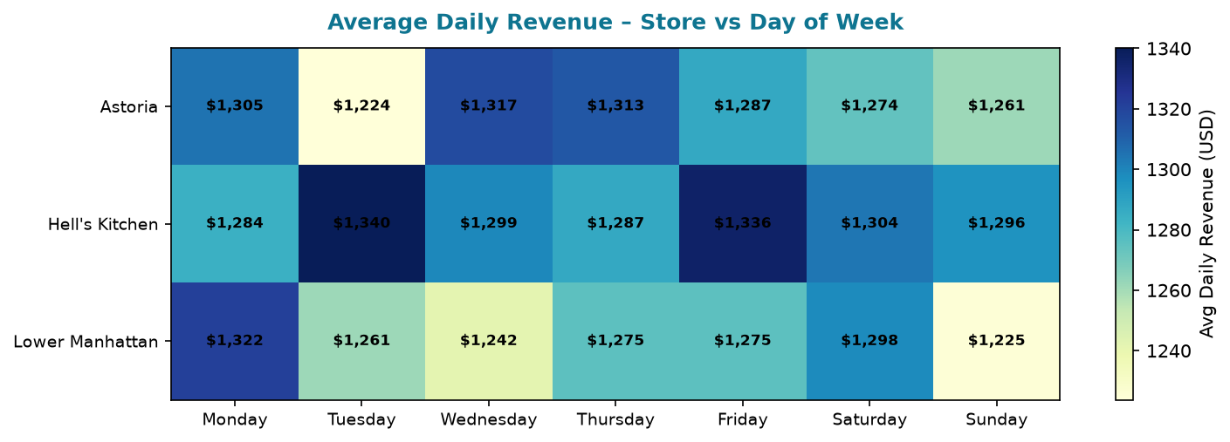

8. How to Run the Project
Step 1: Install Dependencies
pip install -r requirements.txt
Step 2: Place the Dataset
Copy Coffee_Shop_Sales.csv into the data/ folder
Step 3: Train the Model
python train_model.py
Step 4: Start Flask Backend (Terminal 1)
python backend/app.py # runs on http://localhost:5000
Step 5: Launch Streamlit Frontend (Terminal 2)
streamlit run frontend/ui.py # opens http://localhost:8501
Step 6: Generate Report (optional)
python generate_report.py

Generated by IBM Bob | Coffee Shop Revenue Prediction Project

