SOCIAL MEDIA DATABASE
MANAGEMENT SYSTEM
A DBMS Mini Project Report

Submitted as part of the Database Management Systems course
Database Engine: MySQL / PostgreSQL
Backend: Python (Flask) or Node.js (Express)

Table of Contents
1. Introduction 3
1.1 Objectives 3
1.2 Scope 3
2. System Requirements 3
2.1 Functional Requirements 3
2.2 Non-Functional Requirements 3
2.3 Tools & Technology Stack 4
3. Entity-Relationship (ER) Diagram 5
3.1 Relationship Summary 5
4. Entity & Attribute Description 7
4.1 Users 7
4.2 Posts 7
4.3 Comments 7
4.4 Likes (junction table) 8
4.5 Follows (self-referencing junction table) 8
4.6 Notifications 8
5. Normalization 10
5.1 First Normal Form (1NF) 10
5.2 Second Normal Form (2NF) 10
5.3 Third Normal Form (3NF) 10
5.4 A Deliberate Denormalization 10
6. Relational Schema (DDL) 11
7. Sample Queries 12
7.1 Personalized Feed 12
7.2 Top 10 Most-Liked Posts This Week 12
7.3 Suggested Users to Follow 12
7.4 Mutual Followers of Two Users 12
7.5 Engagement Summary per User 13
8. Triggers, Views & Stored Procedures 14
8.1 Trigger: Keep like_count in Sync 14
8.2 Trigger: Auto-generate a Notification on Like 14
8.3 View: User Feed 14
8.4 Stored Procedure: Mutual Followers 15
9. Indexing Strategy 16
10. Application Architecture 17
11. Future Enhancements 17
12. Conclusion 17

1. Introduction
This project designs and implements the backend database for a simplified social media platform, similar in spirit to Twitter or Instagram. The goal is to demonstrate practical database design skills — entity-relationship modeling, normalization, schema creation, and the use of advanced SQL features such as views, triggers, and stored procedures — on a dataset that has realistic, non-trivial relationships (self-referencing follows, many-to-many likes, cascading notifications).

1.1 Objectives
- Design a normalized relational schema for a social media application.
- Model one-to-many, many-to-many, and self-referencing relationships correctly.
- Implement referential integrity using primary and foreign key constraints.
- Use triggers to maintain derived data (e.g., like counts) automatically.
- Use views and stored procedures to simplify common, repeated queries.
- Apply indexing to optimize the queries the application runs most frequently.
- Connect the database to a small backend application to demonstrate real usage.

1.2 Scope
The project covers user accounts, posts, comments, likes, follower relationships, and notifications. It intentionally excludes features such as direct messaging, media transcoding, and recommendation algorithms, which are outside the scope of a database-focused project and can be listed as future enhancements.

2. System Requirements

2.1 Functional Requirements
- Users can register, log in, and edit their profile.
- Users can create, edit, and delete posts.
- Users can comment on posts.
- Users can like/unlike posts.
- Users can follow/unfollow other users.
- Users receive notifications for likes, comments, and new followers.
- Users can view a personalized feed made up of posts from people they follow.

2.2 Non-Functional Requirements
- Data integrity: no orphaned rows (e.g., a comment referencing a deleted post).
- Performance: feed and like-count queries should remain fast as data grows, via indexing.
- Consistency: like/follow counts must always match the underlying rows (enforced by triggers, not application code).

2.3 Tools & Technology Stack
Attribute | Data Type | Key | Description
Database | MySQL 8 / PostgreSQL 14+ | — | Stores all relational data
Backend language | Python 3 / Node.js | — | Connects to DB, exposes REST API
Backend framework | Flask / Express | — | Routes for register, post, like, follow, feed
DB connector | mysql-connector-python / psycopg2 / Sequelize | — | Executes parameterized SQL
Diagramming | MySQL Workbench / dbdiagram.io | — | ER modeling
Version control | Git + GitHub | — | Source and schema history

3. Entity-Relationship (ER) Diagram
The diagram below shows all six entities, their key attributes, and the relationships between them. Primary keys are marked PK and foreign keys FK. Likes and Follows are junction (bridge) tables that resolve the two many-to-many relationships in the system.
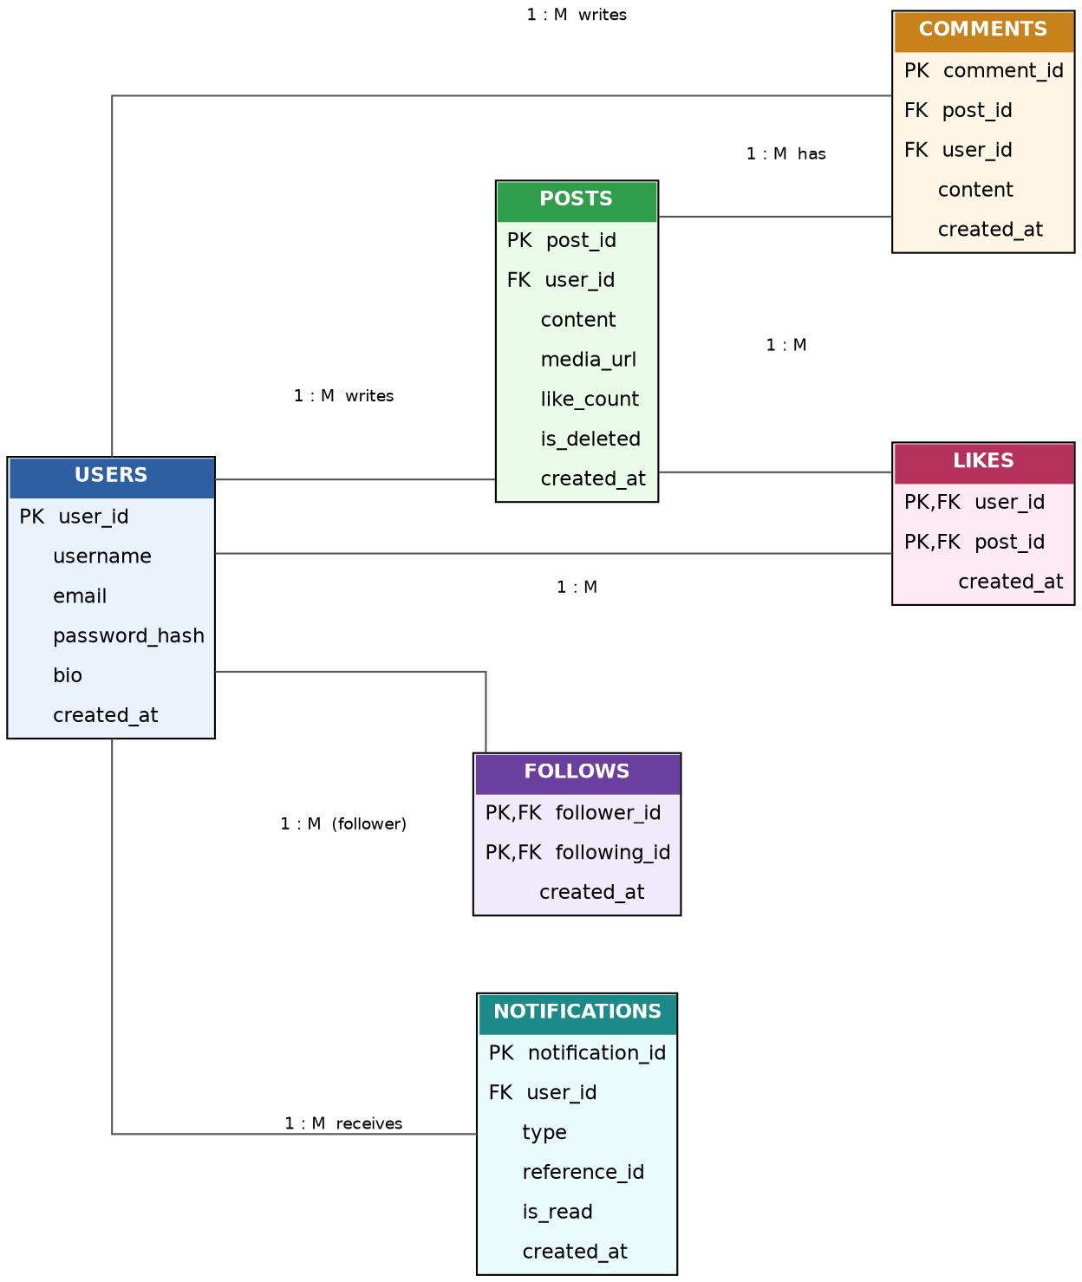
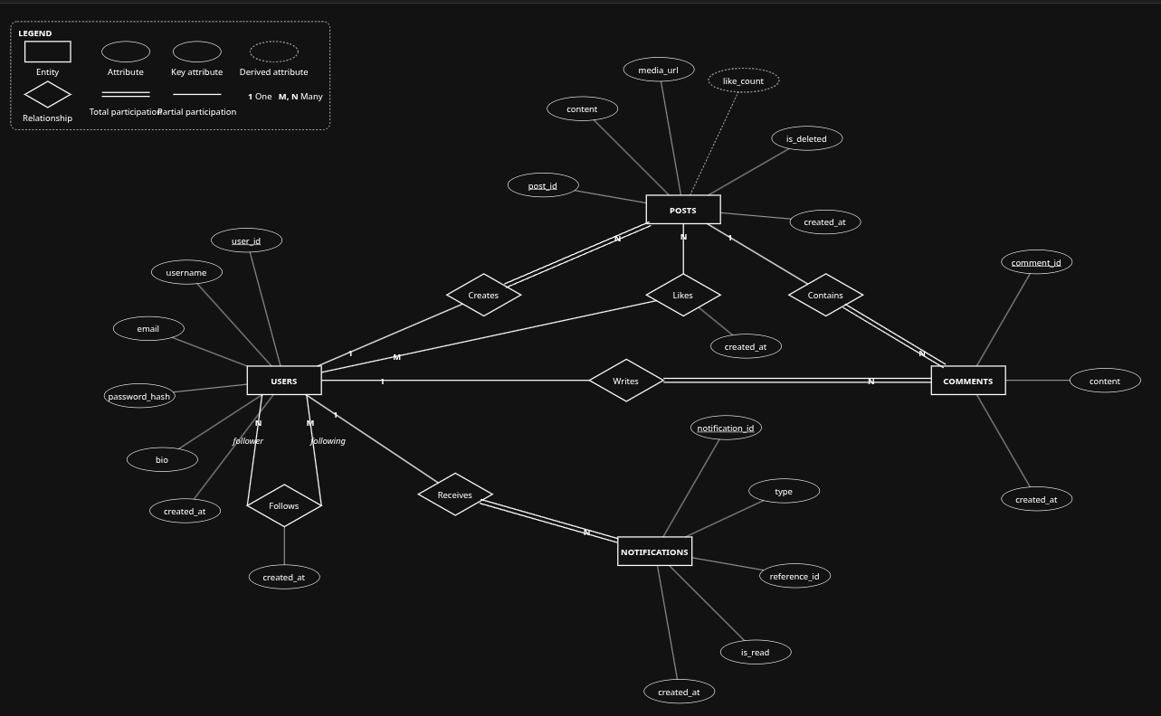

3.1 Relationship Summary
Attribute | Data Type | Key | Description
Users → Posts | 1 : M | — | A user can write many posts; each post belongs to exactly one user
Users → Comments | 1 : M | — | A user can write many comments
Posts → Comments | 1 : M | — | A post can have many comments
Users ↔ Posts (Likes) | M : N | via Likes | A user can like many posts; a post can be liked by many users
Users ↔ Users (Follows) | M : N | via Follows, self-referencing | A user can follow many users and be followed by many users
Users → Notifications | 1 : M | — | A user can receive many notifications

4. Entity & Attribute Description

4.1 Users
Stores account information for every registered user of the platform.
Attribute | Data Type | Key | Description
user_id | INT / SERIAL | PK | Unique identifier, auto-incremented
username | VARCHAR(30) | UNIQUE, NOT NULL | Public handle shown on posts and profile
email | VARCHAR(255) | UNIQUE, NOT NULL | Login credential and contact address
password_hash | VARCHAR(255) | NOT NULL | Hashed password — never stored in plain text
bio | TEXT | NULL | Optional short profile description
created_at | TIMESTAMP | DEFAULT NOW() | Account creation time

4.2 Posts
Stores every post created by a user, including a denormalized like counter for fast reads.
Attribute | Data Type | Key | Description
post_id | INT / SERIAL | PK | Unique identifier
user_id | INT | FK → Users | Author of the post
content | VARCHAR(2200) | NOT NULL | Post text
media_url | VARCHAR(500) | NULL | Optional image/video attachment link
like_count | INT | DEFAULT 0 | Denormalized count, maintained by trigger
is_deleted | BOOLEAN | DEFAULT FALSE | Soft-delete flag
created_at | TIMESTAMP | DEFAULT NOW() | Post creation time

4.3 Comments
Stores replies made by users on posts.
Attribute | Data Type | Key | Description
comment_id | INT / SERIAL | PK | Unique identifier
post_id | INT | FK → Posts | Post being commented on
user_id | INT | FK → Users | Author of the comment
content | VARCHAR(500) | NOT NULL | Comment text
created_at | TIMESTAMP | DEFAULT NOW() | Comment creation time

4.4 Likes (junction table)
Resolves the many-to-many relationship between Users and Posts. The combination of user_id and post_id is unique — a user can like a given post only once.
Attribute | Data Type | Key | Description
user_id | INT | PK, FK → Users | The user who liked the post
post_id | INT | PK, FK → Posts | The post that was liked
created_at | TIMESTAMP | DEFAULT NOW() | When the like was made

4.5 Follows (self-referencing junction table)
Resolves the many-to-many relationship of Users following other Users. Both columns reference the Users table.
Attribute | Data Type | Key | Description
follower_id | INT | PK, FK → Users | The user who initiates the follow
following_id | INT | PK, FK → Users | The user being followed
created_at | TIMESTAMP | DEFAULT NOW() | When the follow happened
A CHECK constraint (follower_id <> following_id) prevents a user from following themselves.

4.6 Notifications
Stores alerts generated when another user likes, comments, or follows. reference_id points at the row (post, comment, or follow) that triggered the notification; type distinguishes how to interpret it.
Attribute | Data Type | Key | Description
notification_id | INT / SERIAL | PK | Unique identifier
user_id | INT | FK → Users | Recipient of the notification
type | VARCHAR(20) | NOT NULL | 'like', 'comment', or 'follow'
reference_id | INT | NOT NULL | ID of the related post / comment / follow row
is_read | BOOLEAN | DEFAULT FALSE | Whether the user has seen it
created_at | TIMESTAMP | DEFAULT NOW() | When the notification was generated

5. Normalization
Normalization removes redundancy and update anomalies by progressively splitting data into related tables. Below is the reasoning applied to this schema.

5.1 First Normal Form (1NF)
Every column holds a single atomic value — e.g., a post has one content field rather than a comma-separated list of hashtags, and there are no repeating groups (a user is never given post1, post2, post3 columns). All tables satisfy 1NF.

5.2 Second Normal Form (2NF)
2NF requires that non-key attributes depend on the whole primary key, which only matters for composite keys. In Likes (PK: user_id + post_id) and Follows (PK: follower_id + following_id), the only non-key column is created_at, which depends on the combination of both keys together — not on either key alone — so 2NF holds.

5.3 Third Normal Form (3NF)
3NF requires that non-key attributes depend only on the primary key, not on other non-key attributes (no transitive dependencies). For example, Posts does not store the author's username or email — those live only in Users and are retrieved via a join. This avoids the anomaly where changing a username would require updating every post row.

5.4 A Deliberate Denormalization
Posts.like_count is a deliberate exception: it duplicates information that could be derived with COUNT(*) FROM Likes WHERE post_id = ?. It is kept as a maintained column because feeds display like counts on every post, and recomputing that with a COUNT() on every read does not scale. A trigger (Section 8.1) keeps it consistent with the Likes table, so the denormalization never drifts out of sync.

6. Relational Schema (DDL)
The following CREATE TABLE statements implement the design above in standard SQL (MySQL/PostgreSQL compatible with minor type adjustments).
CREATE TABLE Users (
user_id INT AUTO_INCREMENT PRIMARY KEY,
username VARCHAR(30) UNIQUE NOT NULL,
email VARCHAR(255) UNIQUE NOT NULL,
password_hash VARCHAR(255) NOT NULL,
bio TEXT,
created_at TIMESTAMP DEFAULT CURRENT_TIMESTAMP
);

CREATE TABLE Posts (
post_id INT AUTO_INCREMENT PRIMARY KEY,
user_id INT NOT NULL,
content VARCHAR(2200) NOT NULL,
media_url VARCHAR(500),
like_count INT DEFAULT 0,
is_deleted BOOLEAN DEFAULT FALSE,
created_at TIMESTAMP DEFAULT CURRENT_TIMESTAMP,
FOREIGN KEY (user_id) REFERENCES Users(user_id) ON DELETE CASCADE
);

CREATE TABLE Comments (
comment_id INT AUTO_INCREMENT PRIMARY KEY,
post_id INT NOT NULL,
user_id INT NOT NULL,
content VARCHAR(500) NOT NULL,
created_at TIMESTAMP DEFAULT CURRENT_TIMESTAMP,
FOREIGN KEY (post_id) REFERENCES Posts(post_id) ON DELETE CASCADE,
FOREIGN KEY (user_id) REFERENCES Users(user_id) ON DELETE CASCADE
);

CREATE TABLE Likes (
user_id INT NOT NULL,
post_id INT NOT NULL,
created_at TIMESTAMP DEFAULT CURRENT_TIMESTAMP,
PRIMARY KEY (user_id, post_id),
FOREIGN KEY (user_id) REFERENCES Users(user_id) ON DELETE CASCADE,
FOREIGN KEY (post_id) REFERENCES Posts(post_id) ON DELETE CASCADE
);

CREATE TABLE Follows (
follower_id INT NOT NULL,
following_id INT NOT NULL,
created_at TIMESTAMP DEFAULT CURRENT_TIMESTAMP,
PRIMARY KEY (follower_id, following_id),
FOREIGN KEY (follower_id) REFERENCES Users(user_id) ON DELETE CASCADE,
FOREIGN KEY (following_id) REFERENCES Users(user_id) ON DELETE CASCADE,
CHECK (follower_id <> following_id)
);

CREATE TABLE Notifications (
notification_id INT AUTO_INCREMENT PRIMARY KEY,
user_id INT NOT NULL,
type VARCHAR(20) NOT NULL,
reference_id INT NOT NULL,
is_read BOOLEAN DEFAULT FALSE,
created_at TIMESTAMP DEFAULT CURRENT_TIMESTAMP,
FOREIGN KEY (user_id) REFERENCES Users(user_id) ON DELETE CASCADE
);

7. Sample Queries

7.1 Personalized Feed
Posts from everyone a given user follows, most recent first.
SELECT p.post_id, u.username, p.content, p.like_count, p.created_at
FROM Posts p
JOIN Users u ON u.user_id = p.user_id
JOIN Follows f ON f.following_id = p.user_id
WHERE f.follower_id = ?
AND p.is_deleted = FALSE
ORDER BY p.created_at DESC
LIMIT 20 OFFSET 0;

7.2 Top 10 Most-Liked Posts This Week
SELECT p.post_id, u.username, p.content, p.like_count
FROM Posts p
JOIN Users u ON u.user_id = p.user_id
WHERE p.created_at >= NOW() - INTERVAL 7 DAY
ORDER BY p.like_count DESC
LIMIT 10;

7.3 Suggested Users to Follow
Users followed by people you follow, excluding those you already follow and yourself — a classic 'friends of friends' self-join.
SELECT DISTINCT u.user_id, u.username
FROM Follows f1
JOIN Follows f2 ON f1.following_id = f2.follower_id
JOIN Users u ON u.user_id = f2.following_id
WHERE f1.follower_id = ? -- the current user
AND f2.following_id <> ? -- exclude self
AND f2.following_id NOT IN (
SELECT following_id FROM Follows WHERE follower_id = ?
);

7.4 Mutual Followers of Two Users
SELECT u.username
FROM Follows f1
JOIN Follows f2 ON f1.follower_id = f2.follower_id
JOIN Users u ON u.user_id = f1.follower_id
WHERE f1.following_id = ? -- user A
AND f2.following_id = ?; -- user B

7.5 Engagement Summary per User
SELECT u.username,
COUNT(DISTINCT p.post_id) AS total_posts,
COALESCE(SUM(p.like_count), 0) AS total_likes_received,
COUNT(DISTINCT c.comment_id) AS total_comments_written
FROM Users u
LEFT JOIN Posts p ON p.user_id = u.user_id
LEFT JOIN Comments c ON c.user_id = u.user_id
GROUP BY u.user_id, u.username
ORDER BY total_likes_received DESC;

8. Triggers, Views & Stored Procedures

8.1 Trigger: Keep like_count in Sync
Rather than trusting the application layer to update the counter, the database enforces consistency itself.
DELIMITER $$
CREATE TRIGGER trg_like_insert
AFTER INSERT ON Likes
FOR EACH ROW
BEGIN
UPDATE Posts SET like_count = like_count + 1
WHERE post_id = NEW.post_id;
END$$

CREATE TRIGGER trg_like_delete
AFTER DELETE ON Likes
FOR EACH ROW
BEGIN
UPDATE Posts SET like_count = like_count - 1
WHERE post_id = OLD.post_id;
END$$
DELIMITER ;

8.2 Trigger: Auto-generate a Notification on Like
DELIMITER $$
CREATE TRIGGER trg_notify_on_like
AFTER INSERT ON Likes
FOR EACH ROW
BEGIN
INSERT INTO Notifications (user_id, type, reference_id)
SELECT p.user_id, 'like', NEW.post_id
FROM Posts p
WHERE p.post_id = NEW.post_id
AND p.user_id <> NEW.user_id; -- don't notify yourself
END$$
DELIMITER ;

8.3 View: User Feed
CREATE VIEW user_feed AS
SELECT f.follower_id AS viewer_id,
p.post_id, p.content, p.like_count, p.created_at,
u.username AS author
FROM Follows f
JOIN Posts p ON p.user_id = f.following_id
JOIN Users u ON u.user_id = p.user_id
WHERE p.is_deleted = FALSE;

-- Usage:
SELECT * FROM user_feed WHERE viewer_id = 7 ORDER BY created_at DESC;

8.4 Stored Procedure: Mutual Followers
DELIMITER $$
CREATE PROCEDURE get_mutual_followers(IN user_a INT, IN user_b INT)
BEGIN
SELECT u.user_id, u.username
FROM Follows f1
JOIN Follows f2 ON f1.follower_id = f2.follower_id
JOIN Users u ON u.user_id = f1.follower_id
WHERE f1.following_id = user_a
AND f2.following_id = user_b;
END$$
DELIMITER ;

-- Usage:
CALL get_mutual_followers(3, 9);

9. Indexing Strategy
Indexes are added on columns that are filtered or joined on frequently, since these are exactly the queries above (feed generation, like counting, follow lookups).
Attribute | Data Type | Key | Description
idx_posts_user_created | Posts(user_id, created_at) |  | Speeds up fetching a user's own posts, newest first
idx_follows_following | Follows(following_id) |  | Speeds up 'who follows user X' and feed joins
idx_follows_follower | Follows(follower_id) |  | Speeds up 'who does user X follow'
idx_likes_post | Likes(post_id) |  | Speeds up counting/listing likers of a post
idx_comments_post | Comments(post_id) |  | Speeds up loading a post's comment thread
idx_notifications_user_read | Notifications(user_id, is_read) |  | Speeds up 'unread notifications for user X'
Recommended validation: run EXPLAIN (MySQL) or EXPLAIN ANALYZE (PostgreSQL) on the feed query before and after adding idx_follows_following, and record the change in estimated rows scanned in the project report — this is a query performance comparison that evaluators specifically look for.

10. Application Architecture
The database sits behind a thin REST API so the project can be demonstrated live rather than through raw SQL alone.
Attribute | Data Type | Key | Description
POST | /register |  | Create a new user (hash password before insert)
POST | /login |  | Authenticate and return a session/token
POST | /posts |  | Create a post
GET | /feed |  | Return the caller's personalized feed (uses user_feed view)
POST | /posts/:id/like |  | Insert a row into Likes (trigger updates like_count)
DELETE | /posts/:id/like |  | Remove a row from Likes
POST | /users/:id/follow |  | Insert a row into Follows
GET | /notifications |  | Return unread notifications for the caller
Passwords are hashed (e.g., bcrypt) before insertion — the database never stores plain-text credentials. All queries from the API layer use parameterized statements to prevent SQL injection.

11. Future Enhancements
- Direct messaging between users (would need a Messages table with sender/receiver).
- Hashtags and search (tag extraction + full-text index on Posts.content).
- Media table separate from Posts to support multiple images/videos per post.
- Basic recommendation logic using engagement history.
- Partitioning Posts by date once data volume grows large enough to matter.

12. Conclusion
This project applies core DBMS concepts — ER modeling, normalization, constraints, triggers, views, stored procedures, and indexing — to a realistic, multi-relationship domain. The schema enforces integrity at the database layer rather than relying solely on application code, which is the central lesson the project is meant to demonstrate: a well-designed database should be correct and consistent even if the application code above it has bugs.

