A DBMS MINI PROJECT REPORT

SOCIAL MEDIA
DATABASE MANAGEMENT SYSTEM
Design, Implementation and Performance Evaluation of a Relational Database for a Social Networking Platform
Submitted in partial fulfilment of the requirements of the course
Database Management Systems

Submitted by | [Student name(s)]
Enrollment No. | [Enrollment number(s)]
Program / Semester | [Program, Semester]
Under the guidance of | [Guide name, designation]
Department / Institute | [Department, Institute name]
Academic year | [2026–27]
Database engine | MySQL / PostgreSQL
Backend | Python (Flask) / Node.js (Express)

Certificate
This is to certify that the project report entitled “Social Media Database Management System”, submitted by [Student name(s)] (Enrollment No. [Enrollment number(s)]) in partial fulfilment of the requirements of the course Database Management Systems for [Program, Semester] at [Institute name], is a record of bona fide work carried out under my guidance and supervision.
To the best of my knowledge, the work reported here has not been submitted elsewhere for the award of any other degree or diploma.
[Guide name] [Head of Department]
Project Guide Head of Department
Date: [DD/MM/YYYY] Place: [City]
Acknowledgement
I would like to express my sincere gratitude to my project guide, [Guide name], for the guidance, encouragement and constructive feedback received throughout this project. The discussions on database design and query optimization shaped many of the decisions documented in this report.
I am also thankful to [Head of Department] and the faculty of the [Department name] for providing the facilities and the academic environment needed to complete this work, and to my family and friends for their continued support.
[Student name(s)]
Abstract
Social media platforms depend on databases that store highly connected data (users, posts, comments, likes, follower relationships and notifications) while staying consistent and responsive as usage grows. This project designs and implements the relational database backend of a simplified social networking platform.
The work covers requirement analysis, entity-relationship modelling, normalization to Boyce–Codd Normal Form, and implementation in MySQL-compatible SQL. Integrity is enforced inside the database through primary and foreign keys, CHECK constraints and cascading deletes, while triggers keep the derived like counter consistent and generate notifications automatically. Views and stored procedures encapsulate frequently used operations such as the personalised feed and the mutual-follower lookup, and a targeted indexing strategy supports the most common access paths.
The schema was tested with a seed dataset and with a synthetic dataset of 300,000 posts, 247,000 follow relationships and 600,000 notifications. Added indexes reduced the execution time of the heaviest query from about 416 ms to under 8 ms. Testing also exposed two defects in the initial design, a row-multiplication error in an aggregate query and counter drift caused by cascaded deletes, both of which were corrected and are documented in this report.
Keywords: DBMS, social media, ER model, normalization, SQL, triggers, views, indexing, MySQL.
Table of Contents
1. Introduction 1
1.1 Background and Motivation 1
1.2 Problem Statement 1
1.3 Objectives 1
1.4 Scope and Limitations 1
1.5 Organization of the Report 2
2. System Requirements 3
2.1 Functional Requirements 3
2.2 Non-Functional Requirements 3
2.3 Tools and Technology Stack 4
3. System Design 5
3.1 Conceptual Design: Entity-Relationship Diagram 5
3.2 Relational Schema Diagram 5
3.3 Relationship Summary 6
3.4 Key Design Decisions 6
4. Data Dictionary 8
4.1 Users 8
4.2 Posts 8
4.3 Comments 9
4.4 Likes (junction table) 9
4.5 Follows (self-referencing junction table) 9
4.6 Notifications 10
5. Normalization 11
5.1 First Normal Form (1NF) 11
5.2 Second Normal Form (2NF) 11
5.3 Third Normal Form (3NF) 11
5.4 Boyce–Codd Normal Form (BCNF) 11
5.5 A Deliberate Denormalization 12
6. Database Implementation (DDL) 13
6.1 Creating the Tables 13
6.2 Integrity Constraints Implemented 14
6.3 Portability: MySQL and PostgreSQL 14
7. Sample Queries 16
7.1 Personalized Feed 16
7.2 Top 10 Most-Liked Posts of the Past Week 16
7.3 Suggested Users to Follow 17
7.4 Followers Common to Two Users 17
7.5 Engagement Summary per User 18
8. Triggers, Views and Stored Procedures 19
8.1 Triggers: Keep like_count in Sync 19
8.2 Triggers: Automatic Notifications 20
8.3 View: User Feed 20
8.4 Stored Procedure: Mutual Followers 21
8.5 Stored Procedure: Recount Likes (Maintenance) 21
9. Indexing Strategy 22
9.1 Index Design 22
9.2 Indexes on Foreign-Key Columns 22
9.3 Performance Evaluation 23
10. Application Architecture 25
10.1 Overview 25
10.2 REST API Endpoints 25
10.3 Security Considerations 26
11. Testing and Results 27
11.1 Test Environment 27
11.2 Integrity and Trigger Tests 27
11.3 Defects Found and Corrected 27
12. Limitations and Future Enhancements 29
12.1 Limitations 29
12.2 Future Enhancements 29
13. Conclusion 30
References 31
Appendix A: Sample Data Script 32
Appendix B: Test Script 33
Appendix C: Performance Test Data Generation 35
List of Figures
Figure 3.1: Entity-Relationship diagram of the social media database (Chen notation) 5
Figure 3.2: Relational schema with primary keys, foreign keys and cardinalities 6
Figure 9.1: Mean execution time per query before and after indexing (logarithmic scale) 24
Figure 10.1: Three-tier architecture of the demonstration application 25
List of Tables
Table 2.1: Functional requirements and the database objects that support them 3
Table 2.2: Non-functional requirements and how each is addressed 3
Table 2.3: Tools and technologies 4
Table 3.1: Relationships in the schema 6
Table 4.1: Users 8
Table 4.2: Posts 8
Table 4.3: Comments 9
Table 4.4: Likes 9
Table 4.5: Follows 9
Table 4.6: Notifications 10
Table 4.7: Interpretation of Notifications.reference_id 10
Table 5.1: Functional dependencies and normal form of each relation 11
Table 6.1: Constraints and the rules they enforce 14
Table 6.2: Differences between MySQL and PostgreSQL 14
Table 7.1: Result for user 1 (asha) 16
Table 7.2: Result on the seed data (seven posts qualify) 16
Table 7.3: Result on the seed data 18
Table 8.1: Triggers, view and procedures 19
Table 9.1: Indexes added beyond the primary and foreign keys 22
Table 9.2: Query plans and execution times before and after indexing 23
Table 10.1: Endpoints and the database operations behind them 25
Table 11.1: Test cases and outcomes 27

1. Introduction

1.1 Background and Motivation
Platforms such as Twitter (X) and Instagram are, at their core, large relational data sets: people who follow people, people who write posts, and people who react to those posts. Every screen of such an application, from the home feed to the notification bell, is the result of a query over these relationships. A database that is poorly designed produces duplicated data, inconsistent counters and slow pages; a well-designed one remains correct even when the application code above it contains bugs.
This project designs and implements the backend database of a simplified social media platform. It demonstrates practical database design skills (entity-relationship modelling, normalization, schema creation, and the use of advanced SQL features such as views, triggers and stored procedures) on a data set that has realistic, non-trivial relationships: self-referencing follows, many-to-many likes and cascading notifications.

1.2 Problem Statement
To design a relational database for a social networking application that (a) stores user accounts, posts, comments, likes, follower relationships and notifications; (b) guarantees data integrity at the database layer rather than relying on application code; and (c) answers the application's most frequent queries, in particular the personalised feed, quickly as the data grows.

1.3 Objectives
- Design a normalized relational schema for a social media application.
- Model one-to-many, many-to-many and self-referencing relationships correctly.
- Implement referential integrity using primary key, foreign key, UNIQUE and CHECK constraints.
- Use triggers to maintain derived data (such as like counts) and to generate notifications automatically.
- Use views and stored procedures to simplify common, repeated queries.
- Apply indexing to the queries the application runs most frequently, and measure its effect.
- Connect the database to a small backend application (REST API) to demonstrate real usage.

1.4 Scope and Limitations
The project covers user accounts, posts, comments, likes, follower relationships and notifications. It intentionally excludes direct messaging, media transcoding and recommendation algorithms, which fall outside a database-focused project and are listed as future enhancements in Chapter 12. Performance experiments were run on a single-node database with synthetic data; they demonstrate the effect of the chosen indexes but are not a substitute for load testing a production deployment.

1.5 Organization of the Report
Chapter 2 lists the functional and non-functional requirements and the technology stack. Chapters 3 and 4 present the conceptual design, the relational schema and the data dictionary. Chapter 5 verifies the design through normalization. Chapters 6 to 9 describe the implementation: DDL, queries, triggers, views, procedures and indexes, including a performance evaluation. Chapter 10 outlines the application architecture. Chapter 11 reports the tests carried out and the defects they revealed, and Chapters 12 and 13 discuss limitations, future work and conclusions.

2. System Requirements
This chapter states what the system must do and how well it must do it. Each requirement is traced to the database objects that satisfy it.

2.1 Functional Requirements
Table 2.1: Functional requirements and the database objects that support them
ID | Requirement | Supporting database objects
FR1 | Users can register, log in and edit their profile. | Users table; UNIQUE username and email; hashed password
FR2 | Users can create, edit and delete posts. | Posts table; is_deleted soft-delete flag
FR3 | Users can comment on posts. | Comments table with foreign keys to Posts and Users
FR4 | Users can like and unlike posts. | Likes junction table; triggers maintaining like_count
FR5 | Users can follow and unfollow other users. | Follows self-referencing junction table; CHECK against self-follow
FR6 | Users receive notifications for likes, comments and new followers. | Notifications table; three notification triggers
FR7 | Users can view a personalised feed of posts from people they follow. | user_feed view; indexes on Posts and Follows

2.2 Non-Functional Requirements
Table 2.2: Non-functional requirements and how each is addressed
ID | Requirement | How it is addressed
NFR1 | Data integrity: no orphaned rows, for example a comment referencing a deleted post. | Foreign keys with ON DELETE CASCADE; NOT NULL, UNIQUE and CHECK constraints
NFR2 | Performance: feed and like-count queries remain fast as data grows. | Targeted indexes (Chapter 9); stored like_count instead of COUNT(*) on every read
NFR3 | Consistency: like and follow counts always match the underlying rows, enforced by the database rather than application code. | Triggers on Likes; recount_likes() procedure as a repair tool (Section 8.5)
NFR4 | Security: no plain-text credentials; no SQL injection. | password_hash column (bcrypt); parameterized statements in the API layer
NFR5 | Portability: runs on MySQL 8 and PostgreSQL 14+ with minor changes. | Standard SQL types and constraints; differences listed in Section 6.3

2.3 Tools and Technology Stack
Table 2.3: Tools and technologies
Component | Technology | Purpose
Database | MySQL 8 / PostgreSQL 14+ | Stores all relational data
Backend language | Python 3 / Node.js | Connects to the database and exposes a REST API
Backend framework | Flask / Express | Routes for register, post, like, follow and feed
DB connector | mysql-connector-python / psycopg2 / Sequelize | Executes parameterized SQL
Diagramming | MySQL Workbench / dbdiagram.io / Graphviz | ER and schema modelling
Version control | Git and GitHub | Source code and schema history

3. System Design

3.1 Conceptual Design: Entity-Relationship Diagram
Figure 3.1 shows the conceptual model in Chen notation. Rectangles are entities, ellipses are attributes (underlined for key attributes, dashed for derived attributes) and diamonds are relationships. A double line indicates total participation: every post must have an author, every comment must belong to a post and a user, and every notification must have a recipient. The derived attribute like_count on Posts is discussed in Section 5.5.
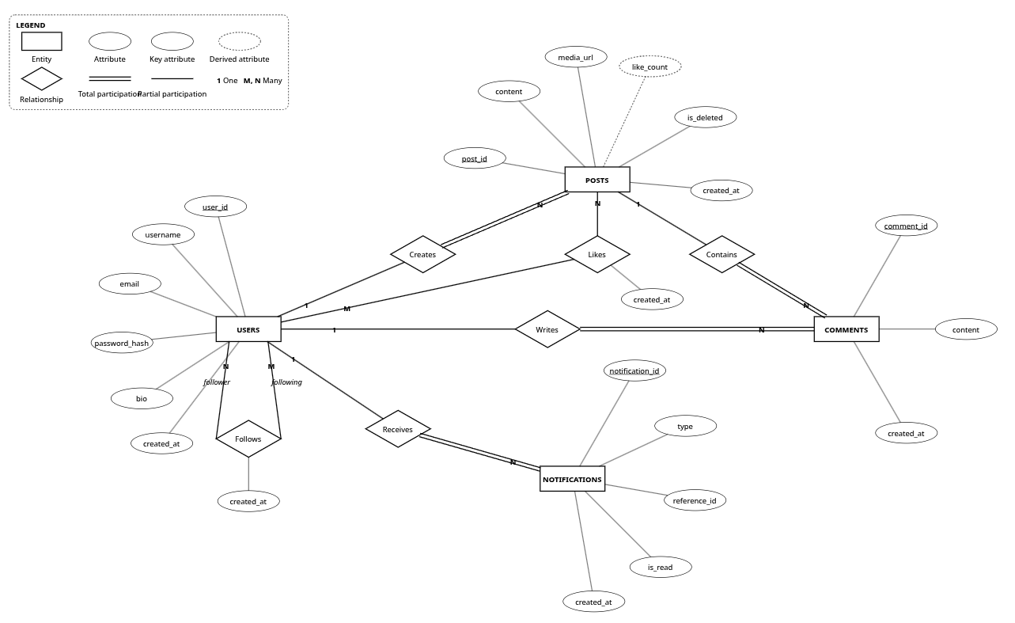
Figure 3.1: Entity-Relationship diagram of the social media database (Chen notation)

3.2 Relational Schema Diagram
Figure 3.2 shows the same design after mapping to relational tables. Primary keys are marked PK and foreign keys FK. Likes and Follows are junction (bridge) tables that resolve the two many-to-many relationships in the system; Follows references the Users table twice. Each arrow runs from the referenced (one) side to the referencing (many) side.
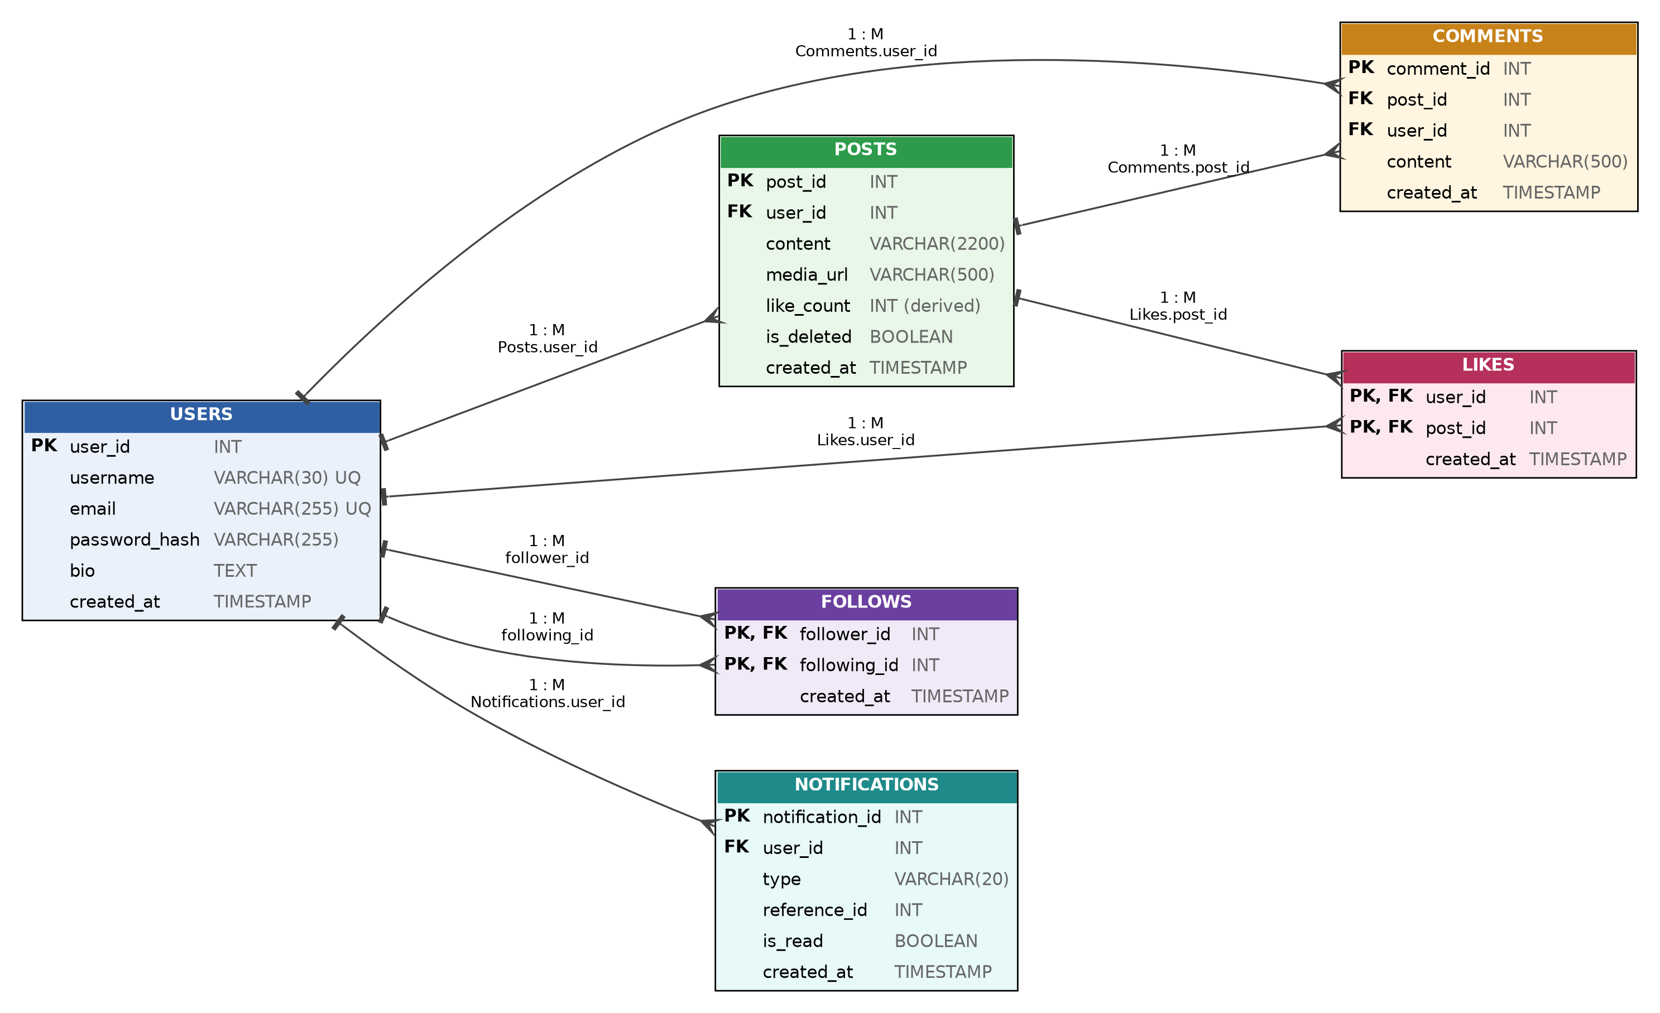
Figure 3.2: Relational schema with primary keys, foreign keys and cardinalities

3.3 Relationship Summary
Table 3.1: Relationships in the schema
Relationship | Cardinality | Implemented by | Meaning
Users → Posts | 1 : M | Posts.user_id (FK) | A user can write many posts; each post belongs to exactly one user.
Users → Comments | 1 : M | Comments.user_id (FK) | A user can write many comments.
Posts → Comments | 1 : M | Comments.post_id (FK) | A post can have many comments.
Users ↔ Posts (likes) | M : N | Likes junction table | A user can like many posts; a post can be liked by many users.
Users ↔ Users (follows) | M : N | Follows junction table, self-referencing | A user can follow many users and be followed by many users.
Users → Notifications | 1 : M | Notifications.user_id (FK) | A user can receive many notifications.

3.4 Key Design Decisions
- Surrogate keys and composite keys. Entity tables use auto-incremented integer keys. Junction tables use the composite key of the two columns they link, so a duplicate like or follow is impossible at the database level.
- Cascading deletes. Deleting a user removes their posts, comments, likes, follows and notifications; deleting a post removes its comments and likes. No orphaned rows can remain.
- Soft delete for posts. The is_deleted flag lets a post be hidden from feeds without destroying its engagement history. Queries that serve users filter on it.
- A typed reference in Notifications. type tells the application how to interpret reference_id (Table 4.7). This keeps one notification table for three event kinds, at the cost of a foreign key on that column (see Chapter 12).
- One deliberate redundancy. Posts.like_count duplicates information derivable from Likes; it is kept in step by triggers (Section 5.5 and Section 8.1).

4. Data Dictionary
This chapter describes every table and column. Data types are given for MySQL; PostgreSQL equivalents are listed in Section 6.3.

4.1 Users
Stores account information for every registered user of the platform.
Table 4.1: Users
Attribute | Data type | Constraints | Description
user_id | INT | PK, AUTO_INCREMENT | Unique identifier
username | VARCHAR(30) | UNIQUE, NOT NULL | Public handle shown on posts and profile
email | VARCHAR(255) | UNIQUE, NOT NULL | Login credential and contact address
password_hash | VARCHAR(255) | NOT NULL | Hashed password, never stored in plain text
bio | TEXT | NULL | Optional short profile description
created_at | TIMESTAMP | DEFAULT NOW() | Account creation time

4.2 Posts
Stores every post created by a user, including a denormalized like counter for fast reads.
Table 4.2: Posts
Attribute | Data type | Constraints | Description
post_id | INT | PK, AUTO_INCREMENT | Unique identifier
user_id | INT | FK → Users, NOT NULL | Author of the post
content | VARCHAR(2200) | NOT NULL | Post text
media_url | VARCHAR(500) | NULL | Optional image or video link
like_count | INT | NOT NULL, DEFAULT 0 | Denormalized count, maintained by triggers
is_deleted | BOOLEAN | NOT NULL, DEFAULT FALSE | Soft-delete flag
created_at | TIMESTAMP | DEFAULT NOW() | Post creation time

4.3 Comments
Stores replies made by users on posts.
Table 4.3: Comments
Attribute | Data type | Constraints | Description
comment_id | INT | PK, AUTO_INCREMENT | Unique identifier
post_id | INT | FK → Posts, NOT NULL | Post being commented on
user_id | INT | FK → Users, NOT NULL | Author of the comment
content | VARCHAR(500) | NOT NULL | Comment text
created_at | TIMESTAMP | DEFAULT NOW() | Comment creation time

4.4 Likes (junction table)
Resolves the many-to-many relationship between Users and Posts. The combination of user_id and post_id is the primary key, so a user can like a given post only once.
Table 4.4: Likes
Attribute | Data type | Constraints | Description
user_id | INT | PK, FK → Users | The user who liked the post
post_id | INT | PK, FK → Posts | The post that was liked
created_at | TIMESTAMP | DEFAULT NOW() | When the like was made

4.5 Follows (self-referencing junction table)
Resolves the many-to-many relationship of users following other users. Both key columns reference the Users table. A CHECK constraint (follower_id <> following_id) prevents a user from following themselves.
Table 4.5: Follows
Attribute | Data type | Constraints | Description
follower_id | INT | PK, FK → Users | The user who initiates the follow
following_id | INT | PK, FK → Users | The user being followed
created_at | TIMESTAMP | DEFAULT NOW() | When the follow happened

4.6 Notifications
Stores alerts generated when another user likes a post, comments on a post, or follows the recipient. The meaning of reference_id depends on type, as shown in Table 4.7.
Table 4.6: Notifications
Attribute | Data type | Constraints | Description
notification_id | INT | PK, AUTO_INCREMENT | Unique identifier
user_id | INT | FK → Users, NOT NULL | Recipient of the notification
type | VARCHAR(20) | NOT NULL, CHECK | One of 'like', 'comment' or 'follow'
reference_id | INT | NOT NULL | ID of the related post, comment or user (Table 4.7)
is_read | BOOLEAN | NOT NULL, DEFAULT FALSE | Whether the user has seen it
created_at | TIMESTAMP | DEFAULT NOW() | When the notification was generated

Table 4.7: Interpretation of Notifications.reference_id
type | reference_id refers to | Generated by
like | Posts.post_id of the liked post | trg_notify_on_like
comment | Comments.comment_id of the new comment | trg_notify_on_comment
follow | Users.user_id of the new follower (the Follows table has a composite key and no single row id) | trg_notify_on_follow

5. Normalization
Normalization removes redundancy and update anomalies by progressively splitting data into related tables. This chapter applies the normal forms to the schema and records the one place where redundancy is introduced on purpose.

5.1 First Normal Form (1NF)
Every column holds a single atomic value. A post has one content field rather than a comma-separated list of hashtags, and there are no repeating groups: a user is never given post1, post2, post3 columns. All tables satisfy 1NF.

5.2 Second Normal Form (2NF)
2NF requires that non-key attributes depend on the whole primary key, which only matters for composite keys. In Likes (key: user_id, post_id) and Follows (key: follower_id, following_id) the only non-key column is created_at, which depends on the combination of both key columns together and not on either one alone. All other tables have single-column keys, so 2NF holds throughout.

5.3 Third Normal Form (3NF)
3NF requires that non-key attributes depend only on the primary key and not on other non-key attributes (no transitive dependencies). For example, Posts does not store the author's username or email: those live only in Users and are retrieved with a join. This avoids the update anomaly in which changing a username would require updating every post row.

5.4 Boyce–Codd Normal Form (BCNF)
BCNF requires every determinant of a non-trivial functional dependency to be a candidate key. Table 5.1 lists the dependencies of each relation; in every case the left-hand side is a candidate key, so all six relations are in BCNF.
Table 5.1: Functional dependencies and normal form of each relation
Relation | Candidate key(s) | Functional dependencies | Normal form
Users | user_id; username; email | user_id → all other attributes; username → user_id; email → user_id | BCNF
Posts | post_id | post_id → user_id, content, media_url, like_count, is_deleted, created_at | BCNF
Comments | comment_id | comment_id → post_id, user_id, content, created_at | BCNF
Likes | (user_id, post_id) | (user_id, post_id) → created_at | BCNF
Follows | (follower_id, following_id) | (follower_id, following_id) → created_at | BCNF
Notifications | notification_id | notification_id → user_id, type, reference_id, is_read, created_at | BCNF

5.5 A Deliberate Denormalization
Posts.like_count is a deliberate exception. It duplicates information that could be derived with SELECT COUNT(*) FROM Likes WHERE post_id = ?. Within the Posts relation it does not break a functional dependency, but it is redundant across relations: the same fact is stored in two places. It is kept as a maintained column because feeds display a like count on every post, and recomputing it with COUNT(*) on every read does not scale. Triggers (Section 8.1) keep it consistent with the Likes table, and a repair procedure (Section 8.5) restores it in the one situation where triggers cannot, described in Chapter 11.

6. Database Implementation (DDL)

6.1 Creating the Tables
The following statements implement the design in MySQL 8 syntax. They were executed without modification on the test database used in Chapter 11. Compared with the initial draft, like_count, is_deleted and is_read are declared NOT NULL, and a CHECK constraint restricts Notifications.type to the three valid values.
CREATE TABLE Users (
user_id INT AUTO_INCREMENT PRIMARY KEY,
username VARCHAR(30) NOT NULL UNIQUE,
email VARCHAR(255) NOT NULL UNIQUE,
password_hash VARCHAR(255) NOT NULL,
bio TEXT,
created_at TIMESTAMP DEFAULT CURRENT_TIMESTAMP
);

CREATE TABLE Posts (
post_id INT AUTO_INCREMENT PRIMARY KEY,
user_id INT NOT NULL,
content VARCHAR(2200) NOT NULL,
media_url VARCHAR(500),
like_count INT NOT NULL DEFAULT 0,
is_deleted BOOLEAN NOT NULL DEFAULT FALSE,
created_at TIMESTAMP DEFAULT CURRENT_TIMESTAMP,
FOREIGN KEY (user_id) REFERENCES Users(user_id) ON DELETE CASCADE
);

CREATE TABLE Comments (
comment_id INT AUTO_INCREMENT PRIMARY KEY,
post_id INT NOT NULL,
user_id INT NOT NULL,
content VARCHAR(500) NOT NULL,
created_at TIMESTAMP DEFAULT CURRENT_TIMESTAMP,
FOREIGN KEY (post_id) REFERENCES Posts(post_id) ON DELETE CASCADE,
FOREIGN KEY (user_id) REFERENCES Users(user_id) ON DELETE CASCADE
);

CREATE TABLE Likes (
user_id INT NOT NULL,
post_id INT NOT NULL,
created_at TIMESTAMP DEFAULT CURRENT_TIMESTAMP,
PRIMARY KEY (user_id, post_id),
FOREIGN KEY (user_id) REFERENCES Users(user_id) ON DELETE CASCADE,
FOREIGN KEY (post_id) REFERENCES Posts(post_id) ON DELETE CASCADE
);

CREATE TABLE Follows (
follower_id INT NOT NULL,
following_id INT NOT NULL,
created_at TIMESTAMP DEFAULT CURRENT_TIMESTAMP,
PRIMARY KEY (follower_id, following_id),
FOREIGN KEY (follower_id) REFERENCES Users(user_id) ON DELETE CASCADE,
FOREIGN KEY (following_id) REFERENCES Users(user_id) ON DELETE CASCADE,
CHECK (follower_id <> following_id)
);

CREATE TABLE Notifications (
notification_id INT AUTO_INCREMENT PRIMARY KEY,
user_id INT NOT NULL,
type VARCHAR(20) NOT NULL,
reference_id INT NOT NULL,
is_read BOOLEAN NOT NULL DEFAULT FALSE,
created_at TIMESTAMP DEFAULT CURRENT_TIMESTAMP,
FOREIGN KEY (user_id) REFERENCES Users(user_id) ON DELETE CASCADE,
CHECK (type IN ('like', 'comment', 'follow'))
);

6.2 Integrity Constraints Implemented
Table 6.1: Constraints and the rules they enforce
Constraint | Where used | Rule enforced
PRIMARY KEY | All tables; composite on Likes and Follows | Every row is uniquely identifiable; no duplicate likes or follows
FOREIGN KEY … ON DELETE CASCADE | Posts, Comments, Likes, Follows, Notifications | No orphaned rows; deleting a parent removes its children
UNIQUE | Users.username, Users.email | Handles and e-mail addresses are not reused
CHECK | Follows (follower_id <> following_id); Notifications.type | No self-follows; only valid notification types
NOT NULL / DEFAULT | Mandatory columns; counters and flags | Required data is present; sensible initial values

6.3 Portability: MySQL and PostgreSQL
The schema uses standard SQL types so that it ports to PostgreSQL with the adjustments in Table 6.2. The test results in this report were obtained on a MySQL-compatible server; the PostgreSQL column describes the required changes and was not exercised in testing.
Table 6.2: Differences between MySQL and PostgreSQL
Feature | MySQL 8 | PostgreSQL 14+
Auto-increment key | INT AUTO_INCREMENT | SERIAL or GENERATED ALWAYS AS IDENTITY
Trigger definition | Trigger body written inline | A trigger function (RETURNS TRIGGER) plus CREATE TRIGGER … EXECUTE FUNCTION
DELIMITER command | Needed in the mysql client for multi-statement bodies | Not needed; use $$ dollar quoting
Date arithmetic | NOW() - INTERVAL 7 DAY | NOW() - INTERVAL '7 days'
Indexes on foreign keys | Created automatically by InnoDB | Not created automatically; must be added by hand (Section 9.2)
Stored routines | CREATE PROCEDURE … CALL | CREATE PROCEDURE (v11+) or CREATE FUNCTION … RETURNS TABLE

7. Sample Queries
The queries below are the ones the application runs most often. A ? is a parameter supplied by the API layer. The result tables were produced by running each query against the seed data in Appendix A (six users, ten posts, 18 likes, 13 follows and eight comments).

7.1 Personalized Feed
Posts from everyone a given user follows, most recent first, excluding soft-deleted posts. post_id is added as a tie-breaker so that pages are stable.
SELECT p.post_id, u.username, p.content, p.like_count, p.created_at
FROM Posts p
JOIN Users u ON u.user_id = p.user_id
JOIN Follows f ON f.following_id = p.user_id
WHERE f.follower_id = ?
AND p.is_deleted = FALSE
ORDER BY p.created_at DESC, p.post_id DESC
LIMIT 20 OFFSET 0;

Table 7.1: Result for user 1 (asha)
post_id | username | content | like_count
7 | karan | What a match! | 2
3 | ravi | Shipped my first Flask API | 2
5 | meera | Three days in Pachmarhi | 3
6 | meera | Packing list for the monsoon | 0
4 | ravi | Debugging at 2 AM again | 0

7.2 Top 10 Most-Liked Posts of the Past Week
Posts created in the last seven days, ordered by like count. The query reads the stored like_count and therefore needs no join to Likes.
SELECT p.post_id, u.username, p.content, p.like_count
FROM Posts p
JOIN Users u ON u.user_id = p.user_id
WHERE p.created_at >= NOW() - INTERVAL 7 DAY
AND p.is_deleted = FALSE
ORDER BY p.like_count DESC, p.created_at DESC
LIMIT 10;

Table 7.2: Result on the seed data (seven posts qualify)
post_id | username | content | like_count
1 | asha | Sunrise over the Upper Lake | 6
5 | meera | Three days in Pachmarhi | 3
7 | karan | What a match! | 2
3 | ravi | Shipped my first Flask API | 2
8 | neha | Currently reading: Godan | 2
2 | asha | New lens day! | 1
6 | meera | Packing list for the monsoon | 0

7.3 Suggested Users to Follow
Users followed by people you follow, excluding yourself and those you already follow: a classic “friends of friends” self-join.
SELECT DISTINCT u.user_id, u.username
FROM Follows f1
JOIN Follows f2 ON f1.following_id = f2.follower_id
JOIN Users u ON u.user_id = f2.following_id
WHERE f1.follower_id = ? -- the current user
AND f2.following_id <> ? -- exclude self
AND f2.following_id NOT IN (
SELECT following_id FROM Follows WHERE follower_id = ?
);

For user 5 (neha) the query returns karan (user 4) and ravi (user 2), both followed by people whom neha follows.

7.4 Followers Common to Two Users
The users who follow both user A and user B. The same logic is packaged as a stored procedure in Section 8.4.
SELECT u.username
FROM Follows f1
JOIN Follows f2 ON f1.follower_id = f2.follower_id
JOIN Users u ON u.user_id = f1.follower_id
WHERE f1.following_id = ? -- user A
AND f2.following_id = ?; -- user B

For users 1 (asha) and 3 (meera) the result is ravi, neha and imran.

7.5 Engagement Summary per User
Total posts, likes received and comments written by each user. Posts and comments are aggregated in separate derived tables before being joined to Users.
SELECT u.username,
COALESCE(p.total_posts, 0) AS total_posts,
COALESCE(p.likes_received, 0) AS total_likes_received,
COALESCE(c.total_comments, 0) AS total_comments_written
FROM Users u
LEFT JOIN (SELECT user_id, COUNT(*) AS total_posts,
SUM(like_count) AS likes_received
FROM Posts WHERE is_deleted = FALSE
GROUP BY user_id) p ON p.user_id = u.user_id
LEFT JOIN (SELECT user_id, COUNT(*) AS total_comments
FROM Comments GROUP BY user_id) c ON c.user_id = u.user_id
ORDER BY total_likes_received DESC, u.username;

Table 7.3: Result on the seed data
username | total_posts | total_likes_received | total_comments_written
asha | 2 | 7 | 4
neha | 2 | 4 | 0
meera | 2 | 3 | 2
karan | 1 | 2 | 1
ravi | 2 | 2 | 1
imran | 0 | 0 | 0
Correction to the initial draft. The first version of this query joined Users to both Posts and Comments in a single statement and then grouped. Each post row was repeated once for every comment written by the same user, so SUM(p.like_count) was inflated. On the seed data it reported 28 likes received for asha instead of the correct 7, and it also counted a soft-deleted post. Aggregating each table separately before joining avoids this “fan-out” error.

8. Triggers, Views and Stored Procedures
Placing business rules in the database means they hold regardless of which application, script or administrator modifies the data. Table 8.1 summarizes the objects created in this chapter.
Table 8.1: Triggers, view and procedures
Object | Type | Fires on / input | Purpose
trg_like_insert | Trigger | AFTER INSERT on Likes | Increment Posts.like_count
trg_like_delete | Trigger | AFTER DELETE on Likes | Decrement Posts.like_count
trg_notify_on_like | Trigger | AFTER INSERT on Likes | Notify the post author
trg_notify_on_comment | Trigger | AFTER INSERT on Comments | Notify the post author
trg_notify_on_follow | Trigger | AFTER INSERT on Follows | Notify the followed user
user_feed | View | viewer_id | Posts from followed users
get_mutual_followers | Procedure | user_a, user_b | Followers common to two users
recount_likes | Procedure | none | Rebuild all like counters

8.1 Triggers: Keep like_count in Sync
Rather than trusting the application layer to update the counter, the database enforces consistency itself. One trigger handles likes and one handles unlikes.
DELIMITER $$

CREATE TRIGGER trg_like_insert
AFTER INSERT ON Likes
FOR EACH ROW
BEGIN
UPDATE Posts SET like_count = like_count + 1
WHERE post_id = NEW.post_id;
END$$

CREATE TRIGGER trg_like_delete
AFTER DELETE ON Likes
FOR EACH ROW
BEGIN
UPDATE Posts SET like_count = like_count - 1
WHERE post_id = OLD.post_id;
END$$

DELIMITER ;

8.2 Triggers: Automatic Notifications
Three triggers generate notifications. Each one skips the case where the actor and the recipient are the same user, so liking or commenting on your own post produces no alert.
DELIMITER $$

CREATE TRIGGER trg_notify_on_like
AFTER INSERT ON Likes
FOR EACH ROW
BEGIN
INSERT INTO Notifications (user_id, type, reference_id)
SELECT p.user_id, 'like', NEW.post_id
FROM Posts p
WHERE p.post_id = NEW.post_id
AND p.user_id <> NEW.user_id; -- do not notify yourself
END$$

CREATE TRIGGER trg_notify_on_comment
AFTER INSERT ON Comments
FOR EACH ROW
BEGIN
INSERT INTO Notifications (user_id, type, reference_id)
SELECT p.user_id, 'comment', NEW.comment_id
FROM Posts p
WHERE p.post_id = NEW.post_id
AND p.user_id <> NEW.user_id;
END$$

CREATE TRIGGER trg_notify_on_follow
AFTER INSERT ON Follows
FOR EACH ROW
BEGIN
INSERT INTO Notifications (user_id, type, reference_id)
VALUES (NEW.following_id, 'follow', NEW.follower_id);
END$$

DELIMITER ;

8.3 View: User Feed
The view packages the join behind the personalized feed so that the application can issue a single, simple statement.
CREATE VIEW user_feed AS
SELECT f.follower_id AS viewer_id,
p.post_id, p.content, p.like_count, p.created_at,
u.username AS author
FROM Follows f
JOIN Posts p ON p.user_id = f.following_id
JOIN Users u ON u.user_id = p.user_id
WHERE p.is_deleted = FALSE;

-- Usage:
SELECT * FROM user_feed WHERE viewer_id = 7 ORDER BY created_at DESC;

8.4 Stored Procedure: Mutual Followers
DELIMITER $$

CREATE PROCEDURE get_mutual_followers(IN user_a INT, IN user_b INT)
BEGIN
SELECT u.user_id, u.username
FROM Follows f1
JOIN Follows f2 ON f1.follower_id = f2.follower_id
JOIN Users u ON u.user_id = f1.follower_id
WHERE f1.following_id = user_a
AND f2.following_id = user_b;
END$$

DELIMITER ;

-- Usage:
CALL get_mutual_followers(3, 9);

8.5 Stored Procedure: Recount Likes (Maintenance)
MySQL does not fire triggers for rows deleted by a foreign-key cascade. When a user account is deleted, that user's rows in Likes disappear through ON DELETE CASCADE, but trg_like_delete does not run, so the stored like_count of the posts they had liked becomes too high (test T10 in Chapter 11 demonstrates this). The procedure below rebuilds every counter from the Likes table and is intended to be run after account deletions or on a schedule.
DELIMITER $$

CREATE PROCEDURE recount_likes()
BEGIN
UPDATE Posts p
LEFT JOIN (SELECT post_id, COUNT(*) AS n FROM Likes GROUP BY post_id) l
ON l.post_id = p.post_id
SET p.like_count = COALESCE(l.n, 0);
END$$

DELIMITER ;

9. Indexing Strategy
Indexes are added on columns that are filtered, joined or sorted on frequently, since these are exactly the queries of Chapter 7: feed generation, like counting, follow lookups and notification retrieval.

9.1 Index Design
Table 9.1: Indexes added beyond the primary and foreign keys
Index | Columns | Supports
idx_posts_user_created | Posts(user_id, created_at) | A user's own posts, newest first, without a sort step; also the feed join
idx_posts_created | Posts(created_at) | Time-window queries such as the weekly top posts (Section 7.2)
idx_notifications_user_read | Notifications(user_id, is_read) | “Unread notifications for user X”

CREATE INDEX idx_posts_user_created
ON Posts (user_id, created_at);
CREATE INDEX idx_posts_created
ON Posts (created_at);
CREATE INDEX idx_notifications_user_read
ON Notifications (user_id, is_read);

9.2 Indexes on Foreign-Key Columns
Several access paths depend on foreign-key columns that are not the leading column of any primary key: who liked a post (Likes.post_id), who follows a user (Follows.following_id) and the comments on a post (Comments.post_id). MySQL's InnoDB engine creates an index on every foreign-key column automatically, which was confirmed by listing the indexes of the test database. PostgreSQL does not, so on that engine they must be created explicitly:
-- PostgreSQL only (InnoDB creates these automatically)
CREATE INDEX idx_likes_post ON Likes (post_id);
CREATE INDEX idx_follows_following ON Follows (following_id);
CREATE INDEX idx_comments_post ON Comments (post_id);
CREATE INDEX idx_posts_user ON Posts (user_id);
CREATE INDEX idx_notif_user ON Notifications (user_id);

Correction to the initial draft. An index on Follows(follower_id) was originally proposed. It is redundant: follower_id is the leading column of the primary key (follower_id, following_id), which already serves every lookup by follower. It has been removed to avoid extra write cost.

9.3 Performance Evaluation

Method
To measure the effect of the indexes, a synthetic data set was generated with authorship skewed towards a few prolific users, as on a real platform: 5,000 users, 300,000 posts (the most active user has 581), about 247,000 follow relationships and 600,000 notifications of which roughly 10 % are unread. Four representative queries were run first with only the primary-key and automatic foreign-key indexes, and again after creating the three indexes of Table 9.1. For each run EXPLAIN was recorded, and execution time was taken as the best of two batches of 30 repeated executions, with client connection overhead subtracted. The experiments ran on MariaDB 10.11, a MySQL-compatible server, on a single node with default settings, so absolute times are indicative only; the relative changes are what matter. The data-generation script is in Appendix C.

Results
Table 9.2: Query plans and execution times before and after indexing
Query | Plan before | Plan after | Before (ms) | After (ms) | Speed-up
QA latest 20 posts of a prolific user | FK index user_id; filesort | idx_posts_user_created; no filesort | 0.88 | 0.06 | ≈ 15×
QB personalised feed (52 followed users) | PK on Follows, then FK index on Posts; temp table and filesort | Same shape; composite index used | 13.29 | 13.27 | none
QC unread notifications (user with 130) | FK index user_id; ≈ 1,149 rows estimated | idx_notifications_user_read; ≈ 130 rows | 1.60 | 0.25 | ≈ 6×
QD top posts, past 7 days | Index scan of Users, then lookup of each user's posts (≈ whole table) | Range scan on idx_posts_created (≈ 5,770 rows) | 415.83 | 7.70 | ≈ 54×

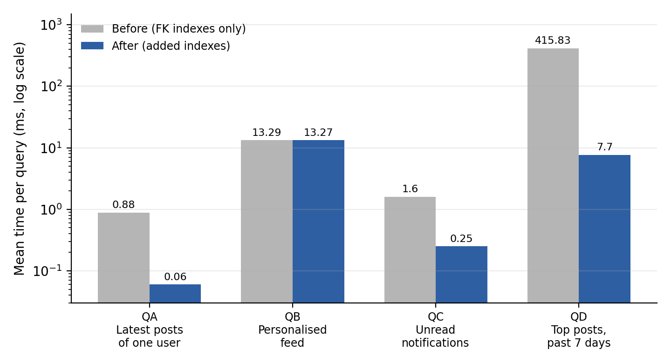
Figure 9.1: Mean execution time per query before and after indexing (logarithmic scale)

Interpretation
- QD shows the largest gain. Without an index on created_at the optimizer had to visit essentially every post to find those from the last seven days; the range scan reads only about 2 % of them.
- QA and QC gain by narrowing the rows examined (QC) and removing the sort (QA), since the composite index returns rows already in created_at order.
- QB, the feed, does not improve. The feed needs the newest posts across about 50 different authors, roughly 1,600 rows in all, and no B-tree index can return rows pre-ordered across several authors, so a sort of the merged set is unavoidable. The index therefore helps profile pages but not the feed itself. Scaling the feed further requires a different technique, such as keyset pagination, caching, or a precomputed timeline table (Chapter 12).
This result is worth stating plainly: an index is justified by measurement, and the initial expectation that the follower and post indexes would speed up the feed was not borne out by the plan.

10. Application Architecture

10.1 Overview
The database sits behind a thin REST API so that the project can be demonstrated live rather than through raw SQL alone. The client talks only to the API; the API is the only component with database credentials.
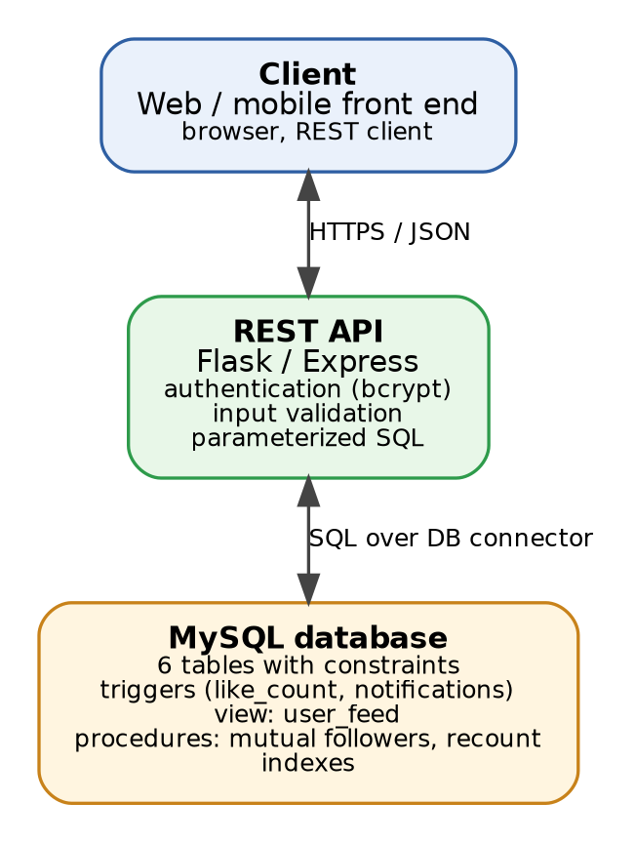
Figure 10.1: Three-tier architecture of the demonstration application

10.2 REST API Endpoints
Table 10.1: Endpoints and the database operations behind them
Method | Endpoint | Description | Database operation
POST | /register | Create a new user | INSERT into Users (password hashed first)
POST | /login | Authenticate; return a session token | SELECT password_hash from Users
POST | /posts | Create a post | INSERT into Posts
DELETE | /posts/:id | Delete own post (soft) | UPDATE Posts SET is_deleted = TRUE
GET | /feed | Caller's personalized feed | SELECT from user_feed
POST | /posts/:id/comments | Comment on a post | INSERT into Comments; trigger notifies author
POST | /posts/:id/like | Like a post | INSERT into Likes; triggers update like_count and notify
DELETE | /posts/:id/like | Remove a like | DELETE from Likes; trigger decrements like_count
POST | /users/:id/follow | Follow a user | INSERT into Follows; trigger notifies
DELETE | /users/:id/follow | Unfollow a user | DELETE from Follows
GET | /notifications | Unread notifications for the caller | SELECT from Notifications where is_read = FALSE
PATCH | /notifications/:id/read | Mark a notification as read | UPDATE Notifications SET is_read = TRUE

10.3 Security Considerations
- Passwords are hashed (for example with bcrypt) before insertion; the database never stores plain-text credentials.
- All queries issued by the API layer use parameterized statements, which prevents SQL injection.
- The API connects with a dedicated database account that has only the privileges it needs (no DROP or ALTER).
- Ownership checks (for example, only an author may delete a post) are enforced in the API using the authenticated user's id.

11. Testing and Results

11.1 Test Environment
The schema, triggers, view and procedures were loaded into a MariaDB 10.11 server (MySQL-compatible) and populated with the seed script in Appendix A. The test script is reproduced in Appendix B. Each data-modifying test was run inside a transaction and rolled back so that tests did not affect one another.

11.2 Integrity and Trigger Tests
Table 11.1: Test cases and outcomes
ID | Scenario | Expected / observed result | Outcome
T1 | A user follows themselves | Rejected by the CHECK constraint | Pass
T2 | A user likes the same post twice | Rejected: duplicate primary key | Pass
T3 | Insert a notification of type poke | Rejected by the CHECK constraint | Pass
T4 | Create a post for a non-existent user | Rejected: foreign-key violation | Pass
T5 | Register a username that already exists | Rejected: unique violation | Pass
T6 | Remove a like from a post with 6 likes | like_count changes from 6 to 5 | Pass
T7 | Another user likes karan's post | Karan's like notifications go from 2 to 3 | Pass
T8 | A user likes their own post | No notification created (4 stays 4) | Pass
T9 | Delete a post with 6 likes and 3 comments | Likes and comments both drop to 0 | Pass
T10 | Delete a user who had liked posts | like_count of those posts left too high (6 stored, 5 actual); corrected by recount_likes() | Defect found, mitigated

In addition, after loading the seed data every one of the ten posts had a stored like_count equal to the number of rows in Likes for that post. The 18 likes produced 16 like-notifications (two self-likes correctly produced none), the eight comments produced seven comment-notifications (one self-comment), and the 13 follows produced 13 follow-notifications.

11.3 Defects Found and Corrected
Testing and review of the first draft of the design revealed two genuine defects, both now corrected in this report:
- Row multiplication in the engagement query (Section 7.5). The single-statement version inflated like totals whenever a user had written several comments. It was rewritten with separate derived tables.
- Counter drift after cascaded deletes (T10, Section 8.5). Foreign-key cascades do not fire triggers in MySQL, so deleting a user leaves like_count stale on other users' posts. The recount_likes() procedure was added as the repair mechanism; the alternative is to soft-delete user accounts instead of removing them.
Two further inaccuracies in the initial draft were also corrected: the follow-notification trigger and the comment-notification trigger were missing even though requirement FR6 calls for them, and the index on Follows(follower_id) was redundant (Section 9.2).

12. Limitations and Future Enhancements

12.1 Limitations
- Notifications do not identify the actor. A like or comment notification stores the post or comment id, so the interface must look up who acted. Adding an actor_id column would remove that extra join.
- The notification reference has no foreign key. Because reference_id points at different tables depending on type, the database cannot guarantee it still resolves; a deleted post leaves a dangling reference.
- Unliking does not retract the notification that the like generated.
- The feed is computed at read time. As Section 9.3 showed, its cost grows with the number of people a user follows.
- `OFFSET` pagination slows down on deep pages; keyset pagination (WHERE created_at < ?) is preferable at scale.
- Single-node, synthetic-data evaluation. The performance results were not measured under concurrent load.

12.2 Future Enhancements
- Direct messaging between users (a Messages table with sender and receiver).
- Hashtags and search (tag extraction and a full-text index on Posts.content).
- A separate Media table to support several images or videos per post.
- Basic recommendation logic using engagement history.
- A precomputed timeline table, or caching, to make the feed scale independently of follow counts.
- Partitioning Posts by date once data volume grows large enough to matter.

13. Conclusion
This project applied the core concepts of a database course (ER modelling, normalization, constraints, triggers, views, stored procedures and indexing) to a realistic, multi-relationship domain. The resulting six-table schema is in Boyce–Codd Normal Form apart from one documented, trigger-maintained denormalization, and it enforces integrity inside the database rather than relying on application code.
Testing was as valuable as design. It confirmed that the constraints and triggers behave as intended, showed that well-chosen indexes can cut the cost of a query by more than fifty times, and also exposed limits: a query that appeared correct but multiplied rows, a trigger gap around cascaded deletes, and a feed query that indexing alone cannot speed up. Recording these findings, rather than only the successes, is part of the result.
The central lesson is the one the project set out to demonstrate: a well-designed database should remain correct and consistent even if the application code above it has bugs.

References
[1] R. Elmasri and S. B. Navathe, Fundamentals of Database Systems, 7th ed. Pearson, 2016.
[2] A. Silberschatz, H. F. Korth and S. Sudarshan, Database System Concepts, 7th ed. McGraw-Hill, 2019.
[3] R. Ramakrishnan and J. Gehrke, Database Management Systems, 3rd ed. McGraw-Hill, 2003.
[4] P. P. Chen, “The Entity-Relationship Model: Toward a Unified View of Data,” ACM Transactions on Database Systems, vol. 1, no. 1, pp. 9–36, 1976.
[5] E. F. Codd, “A Relational Model of Data for Large Shared Data Banks,” Communications of the ACM, vol. 13, no. 6, pp. 377–387, 1970.
[6] Oracle Corporation, MySQL 8.0 Reference Manual. https://dev.mysql.com/doc/refman/8.0/en/
[7] The PostgreSQL Global Development Group, PostgreSQL Documentation. https://www.postgresql.org/docs/
[8] Pallets Projects, Flask Documentation. https://flask.palletsprojects.com/

Appendix A: Sample Data Script
Seed data used for the examples in Chapter 7 and the tests in Chapter 11. Load it after the schema, triggers and view; the triggers populate like_count and Notifications automatically.
INSERT INTO Users (username, email, password_hash, bio) VALUES
('asha', 'asha@example.com', '$2b$12$hashAsha', 'Photographer from Bhopal'),
('ravi', 'ravi@example.com', '$2b$12$hashRavi', 'Coffee and code'),
('meera', 'meera@example.com', '$2b$12$hashMeera', 'Travel blogger'),
('karan', 'karan@example.com', '$2b$12$hashKaran', 'Cricket fan'),
('neha', 'neha@example.com', '$2b$12$hashNeha', 'Book lover'),
('imran', 'imran@example.com', '$2b$12$hashImran', NULL);

INSERT INTO Follows (follower_id, following_id) VALUES
(1,2),(1,3),(1,4),
(2,1),(2,3),
(3,1),
(4,1),(4,2),(4,5),
(5,1),(5,3),
(6,3),(6,1);

INSERT INTO Posts (user_id, content, created_at) VALUES
(1, 'Sunrise over the Upper Lake', NOW() - INTERVAL 1 DAY),
(1, 'New lens day!', NOW() - INTERVAL 3 DAY),
(2, 'Shipped my first Flask API', NOW() - INTERVAL 2 DAY),
(2, 'Debugging at 2 AM again', NOW() - INTERVAL 10 DAY),
(3, 'Three days in Pachmarhi', NOW() - INTERVAL 4 DAY),
(3, 'Packing list for the monsoon', NOW() - INTERVAL 6 DAY),
(4, 'What a match!', NOW() - INTERVAL 5 HOUR),
(5, 'Currently reading: Godan', NOW() - INTERVAL 2 DAY),
(5, 'Library haul', NOW() - INTERVAL 12 DAY),
(1, 'Old draft post (deleted)', NOW() - INTERVAL 7 DAY);
UPDATE Posts SET is_deleted = TRUE WHERE post_id = 10;

INSERT INTO Likes (user_id, post_id) VALUES
(2,1),(3,1),(4,1),(5,1),(6,1),
(1,3),(4,3),
(1,5),(2,5),(6,5),
(1,7),(2,7),
(3,8),(1,8),
(1,2),(1,9),(2,9),
(1,1); -- asha likes her own post (no notification expected)

INSERT INTO Comments (post_id, user_id, content) VALUES
(1, 2, 'Stunning shot!'),
(1, 3, 'Which camera?'),
(3, 1, 'Congrats!'),
(5, 1, 'Adding this to my list'),
(5, 4, 'Great write-up'),
(7, 1, 'Unreal finish'),
(8, 3, 'Classic'),
(1, 1, 'Thanks everyone!'); -- self-comment (no notification expected)

Appendix B: Test Script
Integrity and trigger tests T1 to T10. The first five statements are expected to fail with constraint errors; the remaining tests are wrapped in transactions that are rolled back.
SELECT 'T1 self-follow rejected' AS test;
INSERT INTO Follows (follower_id, following_id) VALUES (1,1);
SELECT 'T2 duplicate like rejected' AS test;
INSERT INTO Likes (user_id, post_id) VALUES (2,1);
SELECT 'T3 invalid notification type rejected' AS test;
INSERT INTO Notifications (user_id,type,reference_id) VALUES (1,'poke',1);
SELECT 'T4 post for non-existent user rejected' AS test;
INSERT INTO Posts (user_id, content) VALUES (999,'ghost');
SELECT 'T5 duplicate username rejected' AS test;
INSERT INTO Users (username,email,password_hash) VALUES ('asha','x@example.com','h');

SELECT 'T6 unlike decrements like_count' AS test;
START TRANSACTION;
SELECT like_count AS before_unlike FROM Posts WHERE post_id=1;
DELETE FROM Likes WHERE user_id=2 AND post_id=1;
SELECT like_count AS after_unlike FROM Posts WHERE post_id=1;
ROLLBACK;

SELECT 'T7 new like creates one notification for the author' AS test;
START TRANSACTION;
SELECT COUNT(*) AS notifs_before FROM Notifications WHERE user_id=4 AND type='like';
INSERT INTO Likes (user_id, post_id) VALUES (3,7);
SELECT COUNT(*) AS notifs_after FROM Notifications WHERE user_id=4 AND type='like';
ROLLBACK;

SELECT 'T8 self-like creates no notification' AS test;
START TRANSACTION;
SELECT COUNT(*) AS notifs_before FROM Notifications WHERE user_id=4;
INSERT INTO Likes (user_id, post_id) VALUES (4,7);
SELECT COUNT(*) AS notifs_after FROM Notifications WHERE user_id=4;
ROLLBACK;

SELECT 'T9 deleting a post cascades to likes and comments' AS test;
START TRANSACTION;
SELECT (SELECT COUNT(*) FROM Likes WHERE post_id=1) AS likes_before,
(SELECT COUNT(*) FROM Comments WHERE post_id=1) AS comments_before;
DELETE FROM Posts WHERE post_id=1;
SELECT (SELECT COUNT(*) FROM Likes WHERE post_id=1) AS likes_after,
(SELECT COUNT(*) FROM Comments WHERE post_id=1) AS comments_after;
ROLLBACK;

SELECT 'T10 deleting a user: cascaded deletes vs like_count' AS test;
START TRANSACTION;
SELECT post_id, like_count AS stored_like_count,
(SELECT COUNT(*) FROM Likes l WHERE l.post_id = p.post_id) AS actual
FROM Posts p WHERE post_id IN (1,5);
DELETE FROM Users WHERE user_id=2;
SELECT post_id, like_count AS stored_like_count,
(SELECT COUNT(*) FROM Likes l WHERE l.post_id = p.post_id) AS actual
FROM Posts p WHERE post_id IN (1,5);
ROLLBACK;

Appendix C: Performance Test Data Generation
The script below generated the data set used in Section 9.3. It uses MariaDB's built-in sequence tables (seq_1_to_N); on MySQL 8, replace each with a recursive common table expression that counts from 1 to N. Authorship, follow targets and notification recipients are skewed towards low user ids with RAND() * RAND().
INSERT INTO Users (username, email, password_hash)
SELECT CONCAT('u', seq), CONCAT('u', seq, '@x.com'), 'h'
FROM seq_1_to_5000;

INSERT INTO Posts (user_id, content, like_count, created_at)
SELECT 1 + FLOOR(RAND() * RAND() * 5000), CONCAT('post ', seq),
FLOOR(RAND() * RAND() * 500),
NOW() - INTERVAL FLOOR(RAND() * 365 * 24 * 60) MINUTE
FROM seq_1_to_300000;

CREATE TEMPORARY TABLE pairs (a INT, b INT);
INSERT INTO pairs
SELECT 1 + FLOOR(RAND() * 5000), 1 + FLOOR(RAND() * RAND() * 5000)
FROM seq_1_to_250000;
DELETE FROM pairs WHERE a = b;
INSERT INTO Follows (follower_id, following_id)
SELECT DISTINCT a, b FROM pairs;

INSERT INTO Notifications (user_id, type, reference_id, is_read, created_at)
SELECT 1 + FLOOR(RAND() * RAND() * 5000),
ELT(1 + FLOOR(RAND() * 3), 'like', 'comment', 'follow'),
1 + FLOOR(RAND() * 300000), RAND() < 0.9,
NOW() - INTERVAL FLOOR(RAND() * 365 * 24 * 60) MINUTE
FROM seq_1_to_600000;

