**Lead_scoring_data_pipeline**

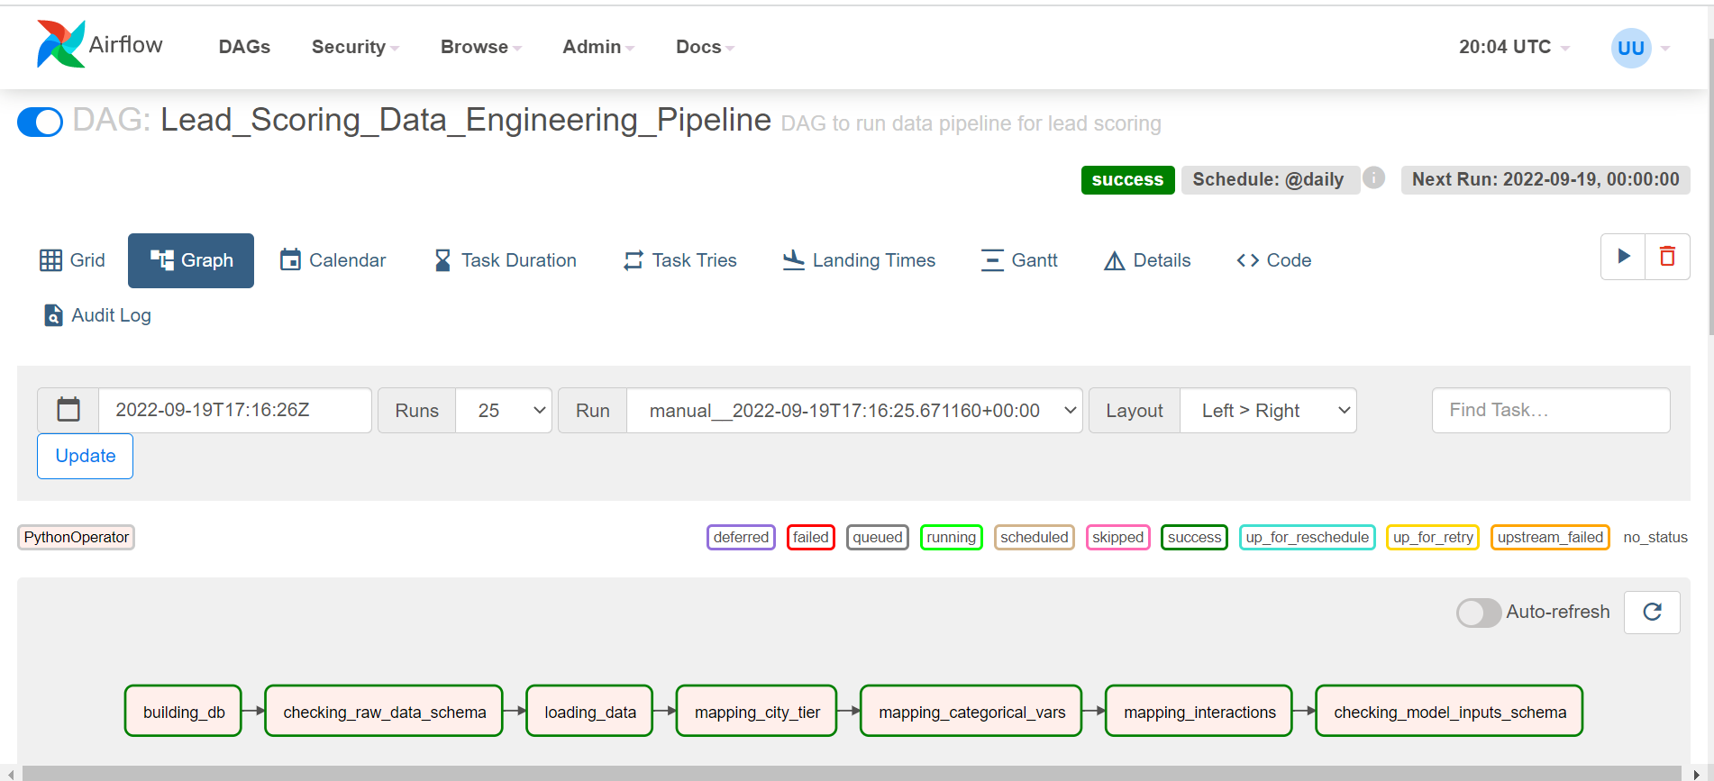

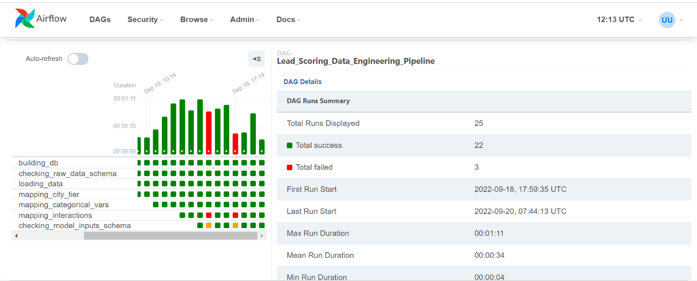

**Lead_scoring_training_pipeline**

**Lead_scoring_inference_pipeline**

**ML FLOW:**

Model Parameters

**LGBM Model (in Production)**

