A MINI PROJECT REPORT ON
CUSTOMER CHURN PREDICTION USING MACHINE LEARNING
Submitted in partial fulfilment of the internal assessment for the course
MACHINE LEARNING
Submitted by
Name | Register Number
Abhinav Tiwari | Register No.
Student 2 Name | Register No.
Student 3 Name | Register No.

Under the guidance of
Title Ramani
Designation, Department of ___
DEPARTMENT NAME
COLLEGE / UNIVERSITY NAME
City
October 2026

ABSTRACT
Customer churn — the loss of existing customers — is one of the most expensive problems in the telecommunications industry, because acquiring a new customer costs several times more than retaining an existing one. This project builds a machine-learning system that predicts which customers are likely to churn, so that a company can target them with retention offers before they leave.
The study uses the publicly available Telco Customer Churn dataset from Kaggle (originally released by IBM), containing 7,043 customers and 21 attributes covering demographics, subscribed services, contract and billing details. 1,869 customers (26.54%) churned, so the data is imbalanced. After data cleaning, exploratory data analysis and feature engineering, the class imbalance was handled with SMOTE (Synthetic Minority Over-sampling Technique) applied only to the training folds.
Eleven classification algorithms were trained and compared — Logistic Regression, K-Nearest Neighbours, Decision Tree, Naive Bayes, Support Vector Machine, Random Forest, AdaBoost, Gradient Boosting, XGBoost, LightGBM and CatBoost — using accuracy, precision, recall, F1-score and ROC-AUC on a held-out 20 % test set, along with 5-fold cross-validation. The three strongest models were tuned with randomized hyper-parameter search, and the decision threshold of the final model was optimised for F1-score.
The tuned XGBoost classifier gave the best result, with a test ROC-AUC of 0.844. At the optimised threshold of 0.44 it identifies 74.9% of churners (recall) with an accuracy of 76.7%. Feature-importance analysis shows that contract type, tenure, internet service type, online security and tech support are the strongest drivers of churn. Based on these findings, the report recommends concrete retention strategies such as converting month-to-month customers to longer contracts and promoting auto-pay and security add-ons.
Keywords: Customer churn, classification, XGBoost, SMOTE, ensemble learning, imbalanced data, telecom analytics.

TABLE OF CONTENTS
Abstract 2
1. Introduction 4
2. Literature Survey 5
3. Dataset Description 5
4. Methodology 6
5. Exploratory Data Analysis 8
6. Model Implementation 9
7. Results and Discussion 11
8. Business Insights and Recommendations 13
9. Conclusion and Future Scope 13
References 14

List of key figures: workflow diagram (Fig. 4.1), churn distribution (Fig. 5.1), numeric distributions (Fig. 5.2), churn rate by category (Fig. 5.3), correlation (Fig. 5.4), model comparison & ROC (Fig. 7.1), confusion matrix & threshold (Fig. 7.2), feature importance (Fig. 7.3).

1. INTRODUCTION

1.1 Background
In subscription businesses such as telecommunications, banking and streaming, revenue depends on customers staying over many months. Churn refers to customers who cancel or do not renew their service. Telecom markets are saturated and highly competitive: customers can switch provider easily, and every lost customer takes away a stream of monthly revenue. Studies of the telecom sector consistently report that retaining an existing customer is far cheaper than acquiring a new one, which makes early identification of at-risk customers commercially valuable.
Telecom companies already hold rich data about each customer — how long they have been with the company, which services they use, how they pay and how much they are billed. Machine learning can learn the patterns in this historical data that separate customers who left from those who stayed, and then score current customers by their risk of leaving.

1.2 Problem Statement
Given a customer's demographic information, subscribed services, contract and billing details, predict whether the customer will churn (Yes / No). This is a binary classification problem on imbalanced data: only about one customer in four churns, so a naive model that predicts "No churn" for everyone would already be 73 % accurate while being useless to the business. The model must therefore be judged on its ability to find churners (recall, F1-score, ROC-AUC), not on accuracy alone.

1.3 Objectives
- Clean and explore the Telco Customer Churn dataset to understand which factors are associated with churn.
- Engineer useful features and prepare the data with proper encoding, scaling and imbalance handling.
- Train and compare at least ten classification algorithms on the same train/test split.
- Tune the best models and optimise the decision threshold for the business goal of catching churners.
- Interpret the final model and translate the results into actionable retention recommendations.

1.4 Scope of the Project
The project covers the complete supervised-learning pipeline — from raw CSV data to a saved, reusable model that outputs a churn probability for any new customer record. It is limited to the static customer snapshot available in the dataset; it does not use time-series usage logs, call-centre transcripts or real-time deployment, which are discussed under future scope.

2. LITERATURE SURVEY
Customer churn prediction is a well-studied application of data mining. Key works that shaped this project are summarised below.
- Huang, Kechadi and Buckley (2012) studied churn prediction for land-line telecom customers and compared Logistic Regression, Decision Trees, Naive Bayes, SVM and neural networks. They showed that the choice of input features matters as much as the choice of algorithm.
- Verbeke et al. (2012) argued that churn models should be evaluated by the profit they generate rather than by accuracy alone. They proposed a profit-driven evaluation framework, which motivates this project's focus on recall and threshold selection.
- Ahmad, Jafar and Aljoumaa (2019) built a churn system for a large telecom operator on a big-data platform and found that tree-based ensembles (Random Forest, Gradient Boosted Trees, XGBoost) clearly outperformed single models.
- Chawla et al. (2002) introduced SMOTE, which creates synthetic minority-class samples by interpolating between neighbouring examples. It is one of the most widely used remedies for class imbalance and is applied in this project.
- Breiman (2001) proposed Random Forests, and Friedman (2001) formalised gradient boosting machines. Their modern, efficient implementations are XGBoost (Chen & Guestrin, 2016), LightGBM (Ke et al., 2017) and CatBoost (Prokhorenkova et al., 2018), all of which are compared in this study.
Research gap addressed: many student and online implementations on this dataset report only accuracy with the default 0.5 threshold and apply oversampling before the train/test split, which leaks information into the test set. This project applies SMOTE inside a cross-validation pipeline, compares eleven algorithms under identical conditions and selects the decision threshold on training data only, so the reported test scores are an honest estimate.

3. DATASET DESCRIPTION
Source: Kaggle — "Telco Customer Churn" (blastchar/telco-customer-churn), originally published in the IBM Sample Data Sets. The data describes a fictional telecom company providing home phone and internet services in California. It contains 7,043 rows (one per customer) and 21 columns: 19 input features, one identifier and the target Churn.
Table 3.1: Attributes of the Telco Customer Churn dataset
Group | Attributes | Type
Identifier | customerID | Text (dropped)
Demographics | gender, SeniorCitizen, Partner, Dependents | Categorical / binary
Account | tenure (months), Contract, PaperlessBilling, PaymentMethod | Numeric + categorical
Charges | MonthlyCharges, TotalCharges | Numeric
Phone services | PhoneService, MultipleLines | Categorical
Internet services | InternetService, OnlineSecurity, OnlineBackup, DeviceProtection, TechSupport, StreamingTV, StreamingMovies | Categorical
Target | Churn (Yes / No) | Binary

Data quality observations: there are no missing values in the raw file, but TotalCharges is stored as text. Converting it to numbers exposes 11 blank entries, all for customers with tenure = 0 who joined in the current month and have not yet been billed, so they are filled with 0. There are 22 rows with identical attribute values; because each has a different customer ID they represent real, distinct customers and are kept. The target is imbalanced: 5,174 customers stayed (73.46 %) and 1,869 churned (26.54 %).

4. METHODOLOGY
The project follows the standard machine-learning workflow shown in Figure 4.1. All work was done in Python 3 in a Jupyter Notebook using pandas, NumPy, Matplotlib, Seaborn, scikit-learn, imbalanced-learn, XGBoost, LightGBM and CatBoost.
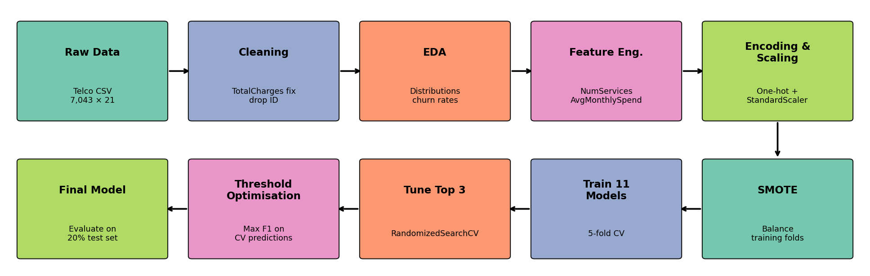
Figure 4.1: Project workflow

4.1 Data Pre-processing
- Cleaning: convert TotalCharges to numeric, fill the 11 blanks with 0, and drop customerID.
- Feature engineering: NumServices counts the optional add-ons (online security, backup, device protection, tech support, streaming TV, streaming movies) a customer uses, and AvgMonthlySpend = TotalCharges / tenure gives the customer's real average bill.
- Encoding: categorical columns are one-hot encoded (binary columns become a single 0/1 column), giving 42 model inputs.
- Scaling: numeric columns are standardised to zero mean and unit variance, which distance- and margin-based models (KNN, SVM, Logistic Regression) need.
- Train/test split: 80 % training (5,634 customers) and 20 % testing (1,409 customers), stratified so both keep the 26.5 % churn rate.

4.2 Handling Class Imbalance — SMOTE
SMOTE generates new synthetic churn examples along the lines joining each minority-class sample to its nearest minority neighbours, until both classes are equal in the training data. To avoid data leakage, SMOTE is placed inside an imblearn pipeline, so it runs only on the training portion of each cross-validation fold and is never applied to validation or test data.

4.3 Evaluation Metrics
With TP, TN, FP and FN denoting true/false positives/negatives (positive = churn):
- Accuracy = (TP + TN) / (TP + TN + FP + FN) — overall correctness; misleading on imbalanced data.
- Precision = TP / (TP + FP) — of the customers flagged as churners, how many really churn.
- Recall = TP / (TP + FN) — of the real churners, how many the model catches. This is the key business metric.
- F1-score = 2 × Precision × Recall / (Precision + Recall) — balance of precision and recall.
- ROC-AUC — the probability that the model ranks a random churner above a random non-churner. It does not depend on the threshold and is used as the primary metric for selecting the model.

5. EXPLORATORY DATA ANALYSIS
EDA was carried out to understand how each attribute relates to churn before modelling. Figure 5.1 confirms the imbalance and shows the single strongest pattern in the data: customers on month-to-month contracts churn at 42.7 %, against 11.3 % for one-year and only 2.8 % for two-year contracts.
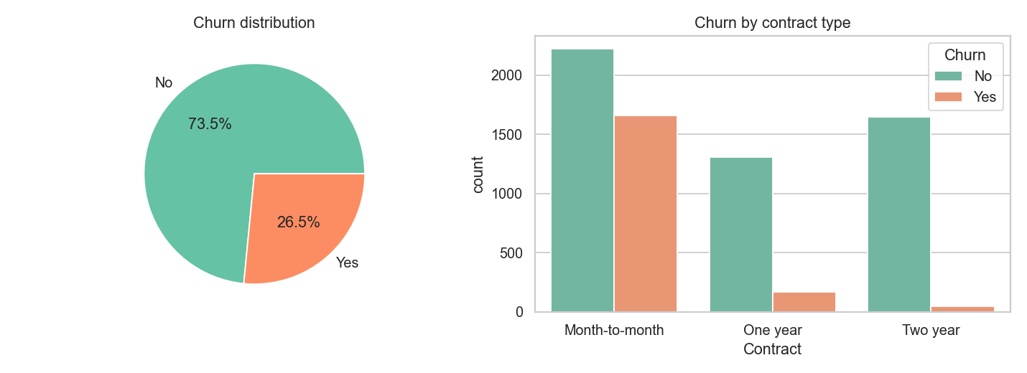
Figure 5.1: Overall churn distribution and churn by contract type
Figure 5.2 compares the distributions of the numeric features. Churners have a much shorter tenure (mean 18.0 months vs 37.6 months for customers who stayed), and 55 % of all churners leave within their first 12 months. Churners also pay more each month (mean monthly charge $74.44 vs $61.27), while their total charges are lower because they leave early.
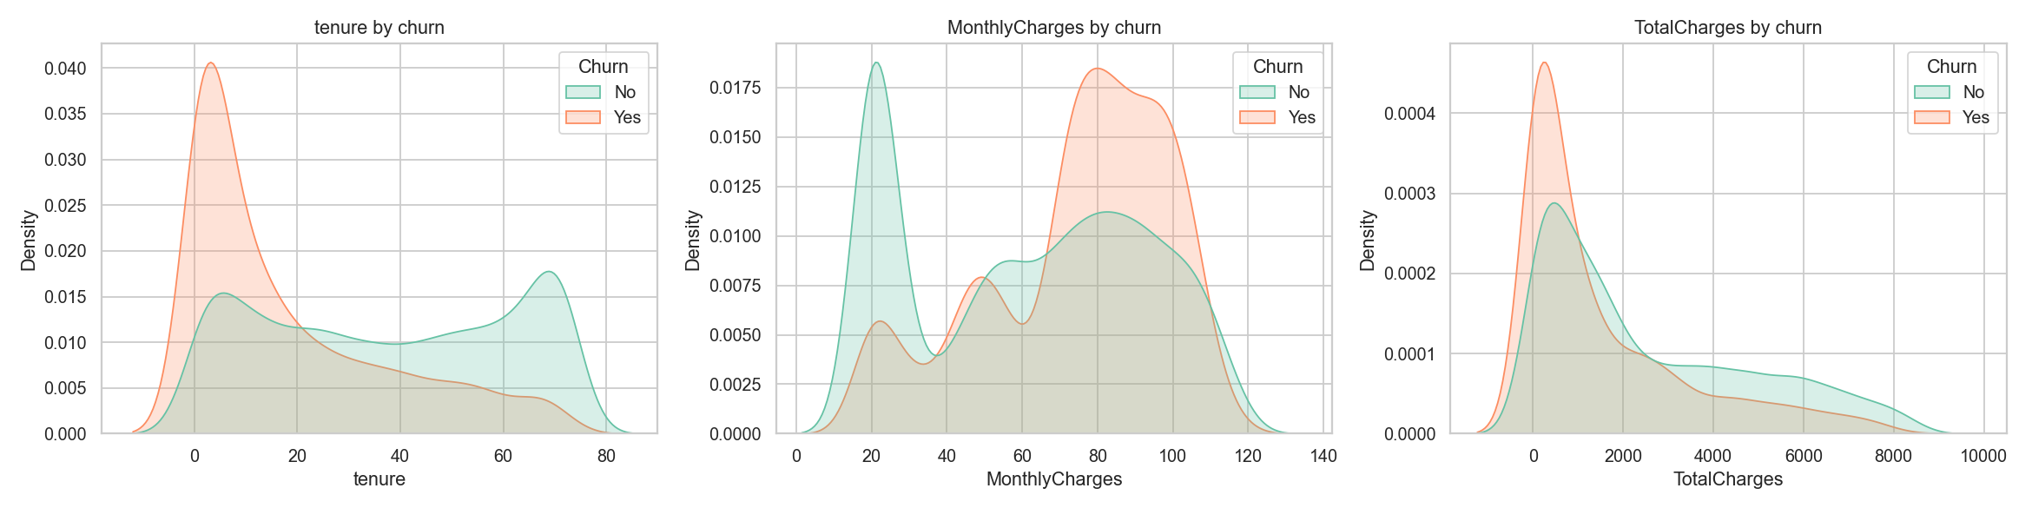
Figure 5.2: Distribution of tenure, monthly charges and total charges by churn status
Figure 5.3 shows churn rates across key categorical attributes:
- Internet service: fibre-optic customers churn at 41.9 %, compared with 19.0 % for DSL and 7.4 % for customers without internet. This suggests price or service-quality issues with the fibre product.
- Payment method: electronic-check users churn at 45.3 %, about three times the rate of automatic bank-transfer (16.7 %) or credit-card (15.2 %) users.
- Add-on services: customers without Online Security churn at 41.8 % against 14.6 % with it, and the pattern for Tech Support is almost identical (41.6 % vs 15.2 %).
- Demographics: senior citizens churn at 41.7 % against 23.6 % for others. Customers without a partner or dependents also churn more. Gender has no visible effect.
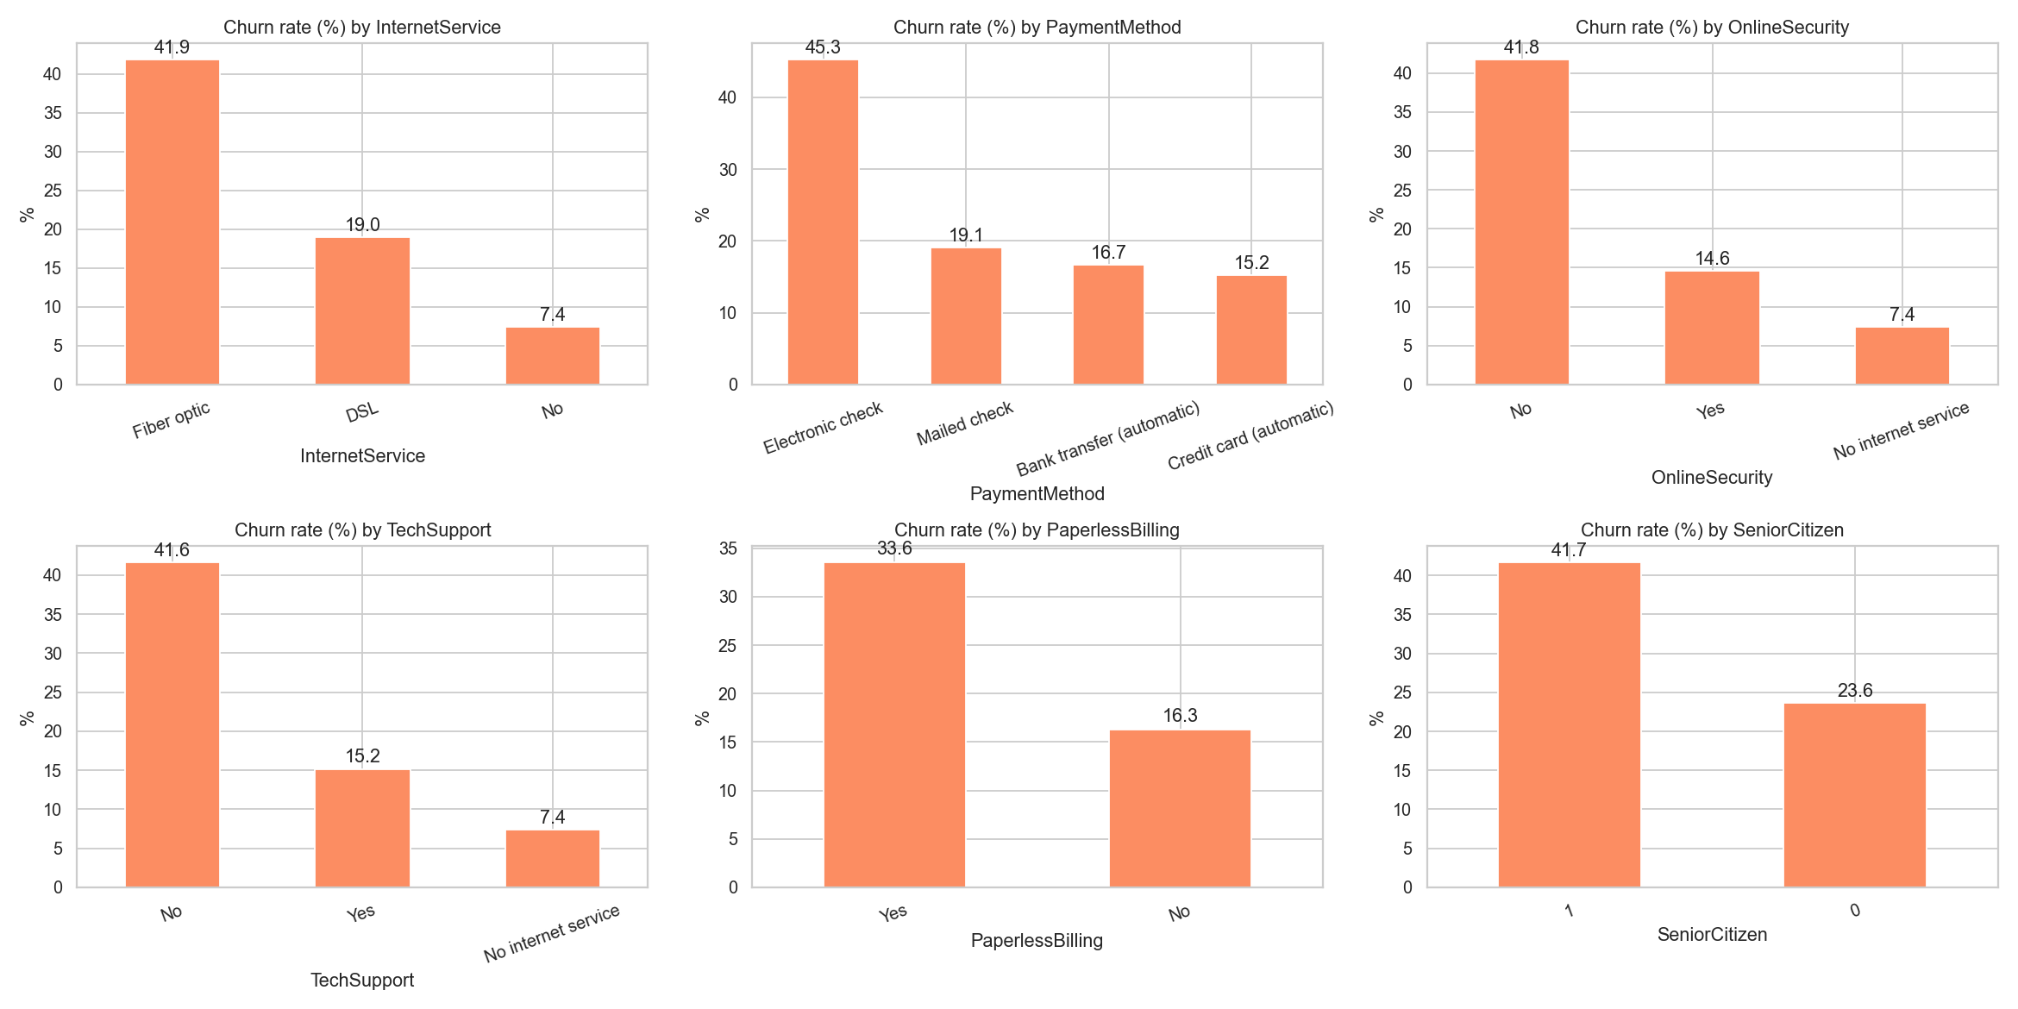
Figure 5.3: Churn rate (%) across key categorical attributes
Figure 5.4 shows the correlations among the numeric features. Tenure has the strongest (negative) correlation with churn (−0.35). TotalCharges is highly correlated with tenure (0.83) because it is approximately tenure × monthly charge. Tree-based models handle this redundancy well.
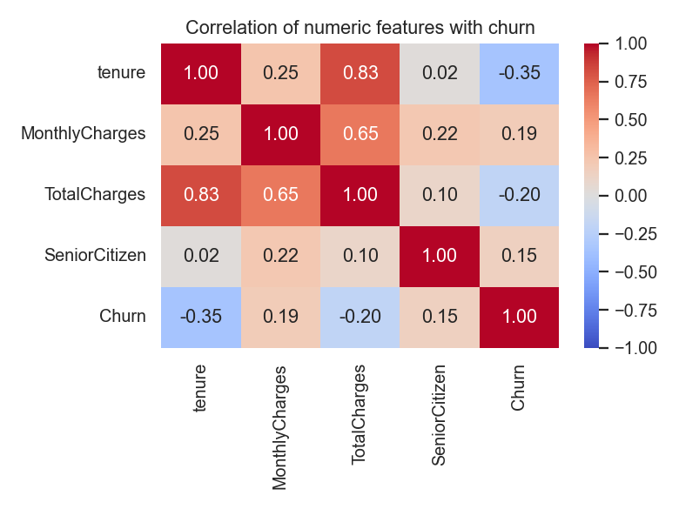
Figure 5.4: Correlation heat-map of numeric features and churn

6. MODEL IMPLEMENTATION
Eleven classifiers from four families were trained on exactly the same pre-processed, SMOTE-balanced training data, so that the comparison is fair:
Table 6.1: Algorithms compared and their initial settings
Family | Algorithm | Key settings
Linear | Logistic Regression | L2 penalty, max_iter = 2000
Instance-based | K-Nearest Neighbours | k = 15
Probabilistic | Gaussian Naive Bayes | default
Kernel | Support Vector Machine | RBF kernel, probability outputs
Tree | Decision Tree | max_depth = 6
Bagging ensemble | Random Forest | 300 trees, max_depth = 10
Boosting ensemble | AdaBoost | 200 estimators
Boosting ensemble | Gradient Boosting | 100 trees, depth 3, lr = 0.1
Boosting ensemble | XGBoost | 300 trees, depth 4, lr = 0.05
Boosting ensemble | LightGBM | 300 trees, 15 leaves, lr = 0.05
Boosting ensemble | CatBoost | 500 iterations, depth 5, lr = 0.05

6.1 Hyper-parameter Tuning
The three models with the highest test ROC-AUC (XGBoost, Gradient Boosting and AdaBoost) were tuned with RandomizedSearchCV. Each search tried 30 parameter combinations, scored by 5-fold cross-validated ROC-AUC on the training set. The search covered the number of trees, learning rate, tree depth, row sub-sampling and (for XGBoost) column sub-sampling.

6.2 Decision-threshold Optimisation
Classifiers output a probability, and by default a customer is labelled a churner when this exceeds 0.5. In churn prevention, a missed churner (false negative) costs a lost customer, while a false alarm costs only a discount offer. The threshold was therefore re-chosen to maximise F1-score. To keep the test set untouched, this was done on out-of-fold cross-validated predictions on the training data.

7. RESULTS AND DISCUSSION

7.1 Comparison of All Algorithms
Table 7.1: Test-set performance of all algorithms (sorted by ROC-AUC)
Algorithm | Accuracy | Precision | Recall | F1-Score | ROC-AUC | CV AUC
XGBoost | 0.7771 | 0.5732 | 0.6283 | 0.5995 | 0.8420 | 0.8417
Gradient Boosting | 0.7821 | 0.5763 | 0.6765 | 0.6224 | 0.8417 | 0.8450
AdaBoost | 0.7779 | 0.5673 | 0.6872 | 0.6215 | 0.8415 | 0.8451
Logistic Regression | 0.7402 | 0.5068 | 0.7995 | 0.6203 | 0.8405 | 0.8447
LightGBM | 0.7878 | 0.5984 | 0.6096 | 0.6040 | 0.8386 | 0.8378
CatBoost | 0.7857 | 0.5957 | 0.5989 | 0.5973 | 0.8380 | 0.8397
Random Forest | 0.7608 | 0.5394 | 0.6765 | 0.6002 | 0.8371 | 0.8405
SVM (RBF) | 0.7523 | 0.5234 | 0.7487 | 0.6161 | 0.8186 | 0.8266
Decision Tree | 0.7615 | 0.5411 | 0.6684 | 0.5981 | 0.8113 | 0.8165
Naive Bayes | 0.6941 | 0.4580 | 0.8316 | 0.5907 | 0.8074 | 0.8217
K-Nearest Neighbours | 0.6870 | 0.4514 | 0.8316 | 0.5851 | 0.8028 | 0.8100

The boosting ensembles and Logistic Regression form a clear top group (ROC-AUC ≈ 0.84), with the four best models within 0.002 of each other. Single models that rely on local neighbourhoods or strong independence assumptions — KNN, Naive Bayes and a single Decision Tree — perform worst (ROC-AUC ≈ 0.80–0.81). KNN and Naive Bayes reach high recall only by flagging many loyal customers (precision ≈ 0.45). The close 5-fold CV and test scores show that the models are not over-fitting.
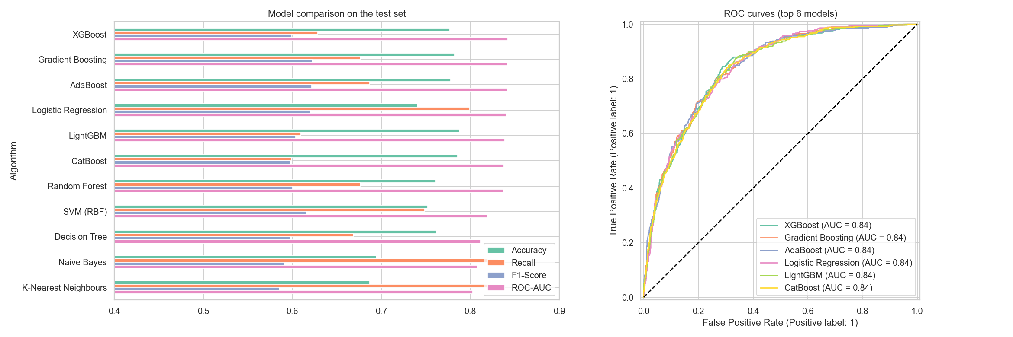
Figure 7.1: Metric comparison of all models (left) and ROC curves of the top six (right)

7.2 Tuned Models
Table 7.2: Performance after hyper-parameter tuning
Model | CV ROC-AUC | Test ROC-AUC | Accuracy | Recall | F1-Score
XGBoost (tuned) | 0.8473 | 0.8437 | 0.7807 | 0.7005 | 0.6291
Gradient Boosting (tuned) | 0.8471 | 0.8429 | 0.7743 | 0.7005 | 0.6223
AdaBoost (tuned) | 0.8478 | 0.8398 | 0.7757 | 0.7353 | 0.6351

Tuning raised XGBoost's recall from 0.628 to 0.701 and its F1-score from 0.600 to 0.629, while ROC-AUC rose slightly to 0.844. The best XGBoost settings (300 shallow trees of depth 2, learning rate 0.05, 70 % row and 60 % column sampling) favour many simple, strongly regularised trees, which suits a small tabular dataset. XGBoost has the highest test ROC-AUC and is selected as the final model.

7.3 Final Model with Optimised Threshold
Table 7.3: Final tuned XGBoost — effect of the decision threshold
Setting | Accuracy | Precision | Recall | F1-Score | ROC-AUC
Threshold 0.50 (default) | 0.7807 | 0.5708 | 0.7005 | 0.6291 | 0.8437
Threshold 0.44 (optimised) | 0.7672 | 0.5447 | 0.7487 | 0.6306 | 0.8437

Lowering the threshold to 0.44 raises recall from 70.0% to 74.9%, at a small cost in precision. On the 1,409 unseen test customers the final model correctly flags 280 of 374 churners and misses only 94. It also correctly clears 801 of 1035 loyal customers, raising 234 false alarms (Figure 7.2). For a retention campaign this is the right balance: a false alarm costs only a small incentive, while each caught churner preserves months of revenue.
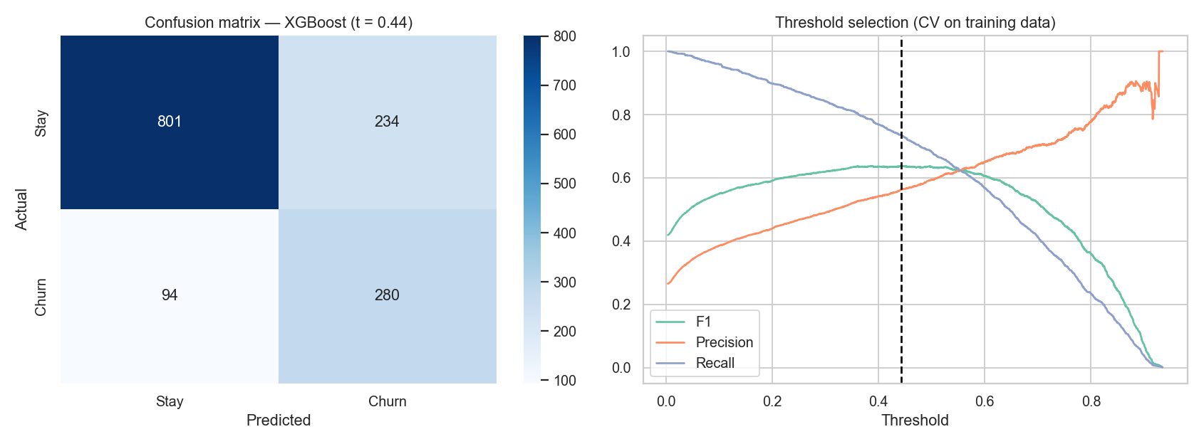
Figure 7.2: Confusion matrix of the final model (left) and threshold selection curve (right)

7.4 Feature Importance
Permutation importance measures how much the test ROC-AUC falls when one original column is randomly shuffled. Figure 7.3 shows that Contract (0.060), tenure (0.049), InternetService (0.011), OnlineSecurity (0.007) are the most influential features. This agrees closely with the EDA. Gender, partner status and the streaming services contribute almost nothing.
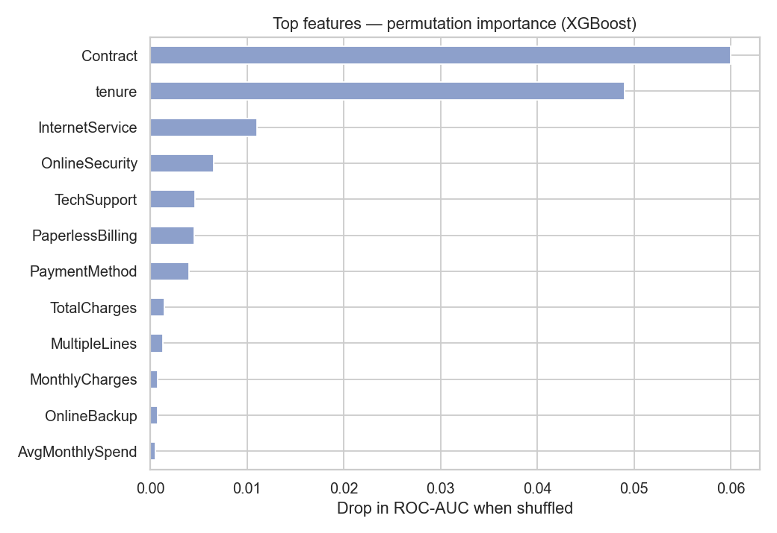
Figure 7.3: Top features by permutation importance (final XGBoost model)

8. BUSINESS INSIGHTS AND RECOMMENDATIONS
The model is useful only if it changes decisions. Combining the EDA and the feature importance, the following actions are recommended:
- Lock in month-to-month customers. They churn at 42.7 % against 2.8 % on two-year plans. Offer a discount or bonus data for switching to a 12- or 24-month contract, prioritising customers the model scores above the 0.44 threshold.
- Focus on the first year. 55 % of churners leave within 12 months. An onboarding programme with welcome calls, setup help and a 3-month check-in should target new customers.
- Fix the fibre-optic experience. Fibre customers churn at 41.9 % despite paying the most. The company should investigate fibre pricing and service quality, and bundle security and support add-ons into fibre plans.
- Bundle Online Security and Tech Support. Customers with these add-ons churn about 2.8× less. Free trials of these services for high-risk customers are a low-cost retention lever.
- Move customers to automatic payment. Electronic-check users churn at 45.3 %. A small incentive to switch to auto-pay reduces both churn and payment friction.
- Deploy the model as a monthly risk score. Score every customer each month and pass the top-risk list, with the main risk factors, to the retention team.

9. CONCLUSION AND FUTURE SCOPE

9.1 Conclusion
This project built a complete machine-learning pipeline to predict customer churn on the Kaggle Telco Customer Churn dataset. After cleaning, EDA and feature engineering, eleven algorithms were compared under identical conditions, with SMOTE applied correctly inside cross-validation. Gradient-boosting ensembles and Logistic Regression performed best. After tuning and threshold optimisation, the final XGBoost model achieved a test ROC-AUC of 0.844, recall of 74.9% and F1-score of 0.631, so it identifies three out of every four customers who are about to leave. The analysis also showed that churn is driven mainly by contract type, tenure, fibre-optic internet, the absence of security and support add-ons, and electronic-check payment. These insights translate directly into retention actions.

9.2 Limitations
- The dataset is a single static snapshot of a fictional company. Real churn depends on behaviour over time, such as falling usage or complaints.
- There is no cost information, so the threshold was optimised for F1 rather than for actual profit.

9.3 Future Scope
- Add time-series usage, complaint and customer-care data to capture behaviour that comes before churn.
- Use SHAP values to explain each individual prediction to the retention team.
- Optimise the threshold with a profit-based cost matrix (retention-offer cost vs customer lifetime value).
- Deploy the model as a web application or REST API (e.g., Flask/Streamlit) with monthly re-training and drift monitoring.

REFERENCES
[1] Kaggle. Telco Customer Churn dataset (blastchar). https://www.kaggle.com/datasets/blastchar/telco-customer-churn
[2] Huang, B., Kechadi, M. T., & Buckley, B. (2012). Customer churn prediction in telecommunications. Expert Systems with Applications, 39(1), 1414–1425.
[3] Verbeke, W., Dejaeger, K., Martens, D., Hur, J., & Baesens, B. (2012). New insights into churn prediction in the telecommunication sector: A profit driven data mining approach. European Journal of Operational Research, 218(1), 211–229.
[4] Ahmad, A. K., Jafar, A., & Aljoumaa, K. (2019). Customer churn prediction in telecom using machine learning in big data platform. Journal of Big Data, 6, 28.
[5] Chawla, N. V., Bowyer, K. W., Hall, L. O., & Kegelmeyer, W. P. (2002). SMOTE: Synthetic Minority Over-sampling Technique. Journal of Artificial Intelligence Research, 16, 321–357.
[6] Breiman, L. (2001). Random Forests. Machine Learning, 45(1), 5–32.
[7] Friedman, J. H. (2001). Greedy function approximation: A gradient boosting machine. Annals of Statistics, 29(5), 1189–1232.
[8] Chen, T., & Guestrin, C. (2016). XGBoost: A scalable tree boosting system. Proceedings of the 22nd ACM SIGKDD Conference, 785–794.
[9] Ke, G., et al. (2017). LightGBM: A highly efficient gradient boosting decision tree. Advances in Neural Information Processing Systems 30.
[10] Prokhorenkova, L., et al. (2018). CatBoost: Unbiased boosting with categorical features. Advances in Neural Information Processing Systems 31.
[11] Pedregosa, F., et al. (2011). Scikit-learn: Machine learning in Python. Journal of Machine Learning Research, 12, 2825–2830.

