**CSE 4004 DAY-1**

**Task-1**

<!DOCTYPE html>

<html>

<head>

<title> Resume </title>

</head>

<body>

<center>

<h1 style = "color: red;"> RESUME</h1> </center>

<center><h1 style="color: blue;"> <u>

P.Sai Uttej 19BCE7163</u></h1>

</center>

<b>Objective: </b>

<object>To work in an organization which helps to explore and an environment to grow.</object>

<ol>

<li><a style ="color: red;"> Educational Qualifications :</a><br>

<ul><li>a.Btech</li>

<li>b.Masters in AI</li></ul>

</li>

<li><a style ="color: red;"> Hobbies :</a> <br>

<ul><li>a.Reading Books</li>

<li>b.Playing Badminton</li></ul>

</li>

<li><a style ="color: red;"> Personal Details : </a><br>

<ul><li>Father Name:Santosh</li>

<li>Address : Nizamabad</li>

<li>Email-id :psaiuttej@gmail.com</li></ul>

</li>

</ol><br>

<b>Singnature :19BCE7163</b>

</body>

</html>>

OUTPUT :

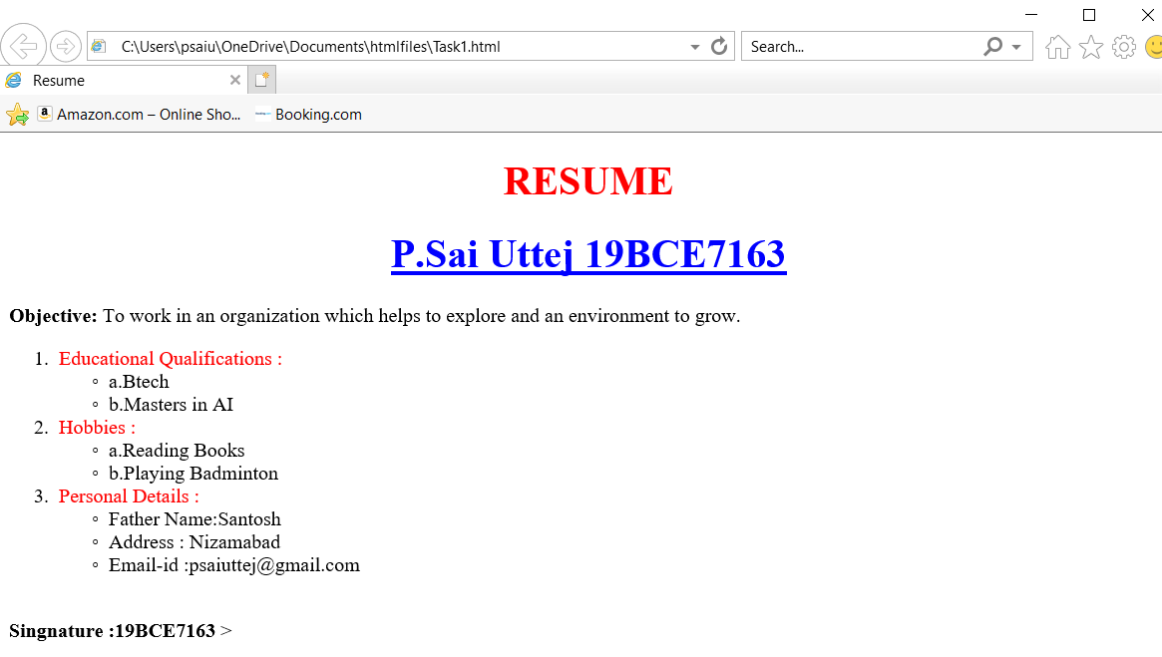

TASK - 2:

<!DOCTYPE html>

<html>

<head>

<title> Resume </title>

</head>

<body>

<center><h1 style="color: blue;"> <u>

P.Sai Uttej</u></h1>

</center>

<b>Objective: </b>

<object>To work in an organization which helps to explore and an environment to grow.</object>

<style>

table,th,td{

background-color: #f1f1c1;

}

</style>

<table border="2">

<tr>

<th>Sl.no:</th>

<th>Educational Qualifications</th>

</tr>

<tr><td>1.</td>

<td>Btech</td>

</tr>

<tr>

<td>2.</td>

<td>Masters in AI</td>

</tr>

</table>

<br>

<table border="2">

<tr>

<th>Sl.no:</th>

<th>Hobbies :</th>

</tr>

<tr><td>1.</td>

<td>Reading Books</td>

</tr>

<tr>

<td>2.</td>

<td>Playing Badminton</td>

</tr>

</table>

<br>

<table border="2">

<tr>

<th>Sl.no</th>

<th>Personal Details :</th>

</tr>

<tr><td>Father Name:</td>

<td>Santosh</td>

</tr>

<tr>

<td>Address : </td>

<td>Nizamabad</td>

</tr>

<tr>

<td>Email id :</td>

<td>psaiuttej@gmail.com</td>

</tr>

</table>

<br>

<b>Singnature : 19BCE7163</b>

</body>

</html>>

OUTPUT :

