AN INTERNSHIP PROJECT REPORT
ON
Predictive Insights for Collections Strategy
Geldium Collections Strategy – Job Simulation Project

Submitted To
School of Computer Science and Engineering
IILM University, Greater Noida, U.P.
In partial fulfilment of the requirement of degree of
B-Tech (CSE)


By
Admission Number: 2410031511
Name of Student: ABHINAV KUMAR TRIPATHI
Batch: 2026–2027

CANDIDATE'S DECLARATION
I, ABHINAV KUMAR TRIPATHI, hereby declare that the project report titled “Predictive Insights for Collections Strategy” has been prepared as part of my academic internship/project documentation in the field of predictive analytics and collections strategy. This report is based on the provided Geldium Collections Strategy job-simulation materials and the accompanying reference/template documents. I have presented the source-supported findings faithfully and have not knowingly introduced unsupported numerical results, model-performance claims, credentials, or organizational facts.
I further declare that this report is intended for academic submission and that any external material, where used, is identified in the references. I accept responsibility for the accuracy of the student details stated in this report.
Signature: __________________________
Student Name: ABHINAV KUMAR TRIPATHI
Admission No.: 2410031511

ACKNOWLEDGEMENT
I sincerely express my gratitude to everyone who supported me in completing this academic project report. I am thankful for the guidance, encouragement, and constructive support that helped me understand the practical application of data analytics to business decision-making.
I would also like to acknowledge the learning materials and case-study documentation provided for the Geldium Collections Strategy job simulation. The project provided an opportunity to study predictive insights, identify high-risk customer segments, formulate a SMART collections intervention, and consider fairness, explainability, responsible use, transparency, and accountability.
I am grateful to IILM University, Greater Noida, and the School of Computer Science and Engineering for providing an academic environment in which such practical work could be documented and evaluated. Finally, I express my gratitude to my parents and everyone who encouraged me throughout the work.
Signature: __________________________
Student Name: ABHINAV KUMAR TRIPATHI
Admission No.: 2410031511

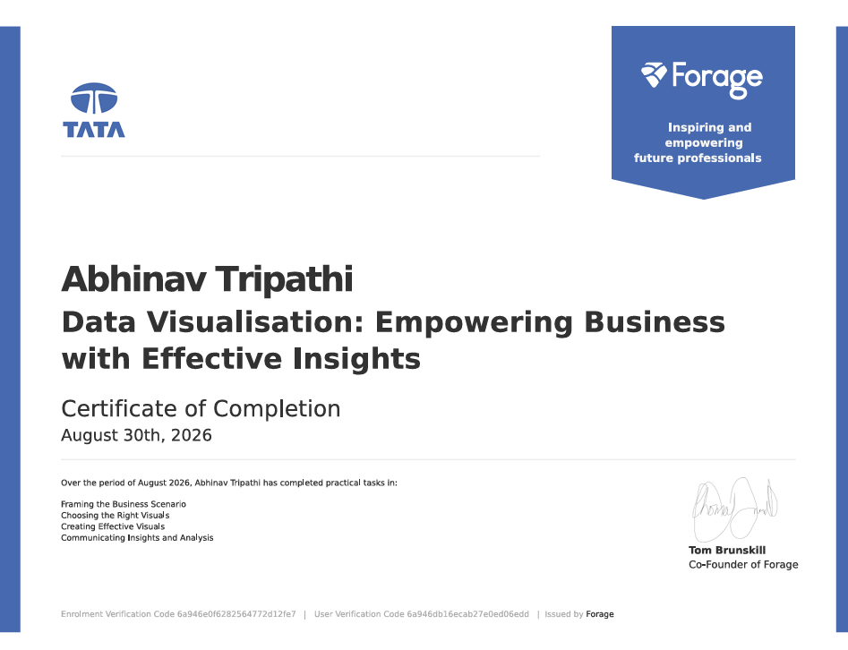

TABLE OF CONTENTS
1. Executive Summary
2. Project Introduction
3. Organization / Case Context
4. Problem Statement
5. Project Objectives
6. Scope of the Project
7. Data and Predictive Insights
8. Key Insights Summary
9. Recommended Collections Intervention
10. Methodology and Decision Framework
11. Ethical and Responsible AI Considerations
12. Limitations and Source Boundaries
13. Expected Business Outcomes
14. Conclusion
15. Evidence and Supporting Documents
16. Bibliography / References

1. EXECUTIVE SUMMARY
This project, titled “Predictive Insights for Collections Strategy”, examines how predictive insights can support a collections team in identifying customers who may be at elevated risk of delinquency and in moving from reactive recovery toward earlier, more supportive intervention.
The provided business report identifies three variables or variable groups that consistently separate customers who fall behind on payments from those who do not: high credit utilization, repeated missed payments, and the combination of lower income with shorter account tenure. Among these, repeated missed payments are described as the strongest predictor of future default, while utilization above roughly 70% is highlighted as an important early-warning signal.
The recommended intervention is a proactive outreach program for customers whose credit utilization exceeds 70% for two consecutive billing cycles. Such customers would be routed to an early-engagement queue and offered a check-in call plus optional repayment or credit-limit counselling. The proposed pilot should compare the flagged group with a comparable unflagged control group for one quarter and consider broader rollout if delinquency in the flagged group falls by at least 10% relative to the control.
Responsible AI is treated as a core requirement rather than an afterthought. Income and account tenure may correlate with protected characteristics, so the source recommends avoiding protected attributes, monitoring outcomes across demographic groups, and emphasizing behavioral variables such as utilization and payment history.
Important source boundary: the supplied materials do not specify the dataset size, exact predictive algorithm, model accuracy/AUC, feature-importance values, train/test split, or actual pilot results. Accordingly, this report does not invent those details.

2. PROJECT INTRODUCTION
The project is centered on the practical use of predictive analytics in collections strategy. Traditional collections processes may begin after a payment becomes overdue. Predictive collections seeks to identify signals that appear earlier, allowing a business to prioritize attention and offer appropriate support before delinquency becomes more difficult or costly to resolve.
The supplied Geldium business report states that exploratory analysis and the predictive model point to a small set of variables that consistently distinguish customers who fall behind on payments from those who do not. These findings form the analytical basis for the intervention proposed in this report.

2.1 Project Theme
Predictive risk identification → customer segmentation → proactive outreach → controlled measurement → responsible AI review.

2.2 Academic Relevance
The project connects data analysis with a concrete business decision: deciding which customers should receive early collections attention and what type of intervention is appropriate. It also demonstrates why model outputs must be translated into understandable business rules rather than treated as opaque scores.

3. ORGANIZATION / CASE CONTEXT
The case materials identify Geldium as the business context for the collections strategy exercise. The supplied report is specifically framed around “Predictive Insights for Collections Strategy” and focuses on using customer and payment-related variables to improve collections prioritization.

3.1 Business Context
The collections function has to balance two objectives: reducing losses caused by delinquency while maintaining a fair and constructive relationship with customers. The source materials therefore emphasize early intervention, tailored repayment plans, and supportive outreach instead of relying only on post-due-date recovery.

3.2 Analytical Context
The supplied analysis identifies credit utilization, outstanding balance, credit limit, missed-payment count, days past due, payment-history trend, income level, employment status, and account age as relevant variables. The report does not provide the underlying raw dataset or a complete statistical model specification.
Therefore, this project report documents the decision logic and business recommendations supported by the provided materials rather than presenting fabricated model-development metrics.

4. PROBLEM STATEMENT
Collections teams need an effective way to distinguish customers who may require early attention from customers who can continue through normal servicing. Waiting until a payment is missed can reduce the available options for preventive support. The project therefore addresses the problem of identifying early-warning indicators of delinquency and converting those indicators into a practical, measurable, and responsible collections intervention.

4.1 Core Business Question
Which observable customer behaviors and account characteristics can be used to prioritize proactive collections outreach, and how should the resulting intervention be measured without creating unfair or unnecessary customer harm?

4.2 Decision Challenge
The key challenge is not simply prediction. The prediction must lead to an operational action: a customer is flagged, routed to an early-engagement queue, contacted through existing channels, and offered appropriate support. The intervention must then be evaluated against a comparable control group.

5. PROJECT OBJECTIVES
- Identify the major factors associated with future delinquency in the supplied analysis.
- Translate predictive findings into clear customer segments for collections prioritization.
- Design a proactive intervention based on an early-warning threshold.
- Define measurable success criteria using a flagged group and a comparable control group.
- Ensure the recommendation is specific, actionable, relevant, and time-bound.
- Address fairness, explainability, responsible use, transparency, accountability, and data privacy.
- Clearly distinguish source-supported facts from information not supplied in the case materials.

5.1 Primary Deliverable
The primary deliverable is a structured predictive-collections strategy that converts the identified risk factors into a prioritized outreach framework and a one-quarter pilot evaluation plan.

6. SCOPE OF THE PROJECT
The project covers predictive insight interpretation, customer segmentation, collections prioritization, recommendation design, measurement planning, and responsible-AI considerations. It is focused on the business use of the provided predictive findings rather than on rebuilding the underlying model.

6.1 Included
- Interpretation of the three major risk-factor findings.
- Identification of the highest-risk intersection: high utilization, a recent missed payment, and limited income cushion.
- Design of proactive outreach for customers crossing the utilization threshold.
- SMART measurement and pilot framework.
- Ethical review of income, tenure, behavioral variables, explainability, human review, and data use.

6.2 Not Included / Not Supplied
- Raw customer-level dataset.
- Exact predictive algorithm or hyperparameters.
- Model accuracy, precision, recall, AUC, confusion matrix, or calibration results.
- Actual pilot outcomes or verified reduction in delinquency.
- Customer-level personally identifiable information.

7. DATA AND PREDICTIVE INSIGHTS
The source analysis identifies a small set of variables that consistently separate customers who fall behind on payments from those who do not. The following findings are reproduced as business interpretations rather than new statistical calculations.
Key Insight | Customer Segment | Influencing Variables | Potential Impact
High utilization drives delinquency | Customers using more than 70% of available credit | Credit utilization ratio; outstanding balance; credit limit | Early-warning flag for proactive outreach before delinquency
Repeated missed payments predict future default | Customers with 2 or more missed payments in the last 6 months | Missed payment count; days past due; payment-history trend | Highest-priority group for immediate collections contact
Income and tenure lower resilience | Lower-income customers with shorter account tenure | Income level; employment status; account age | Tailored, lower-cost repayment plans rather than standard collections

7.1 Highest-Risk Intersection
The source identifies the highest-risk segment as the intersection of high utilization, a recent missed payment, and limited income cushion. This group should be prioritized for early, proactive intervention rather than standard post-due-date collections.

7.2 Interpretation
Utilization is useful as an early signal because it may rise before a payment is missed. Missed-payment history provides a stronger behavioral warning because repeated missed payments reflect observed repayment behavior. Income and tenure can indicate resilience, but they require additional fairness safeguards.

8. RECOMMENDED COLLECTIONS INTERVENTION

8.1 Restated Insight
High credit utilization—balances above approximately 70% of the credit limit—is identified as one of the strongest early predictors of delinquency and may appear before a payment is missed.

8.2 Proposed Recommendation
Launch a proactive outreach program that flags customers crossing the 70% utilization threshold and offers a check-in call together with optional repayment or credit-limit counselling before a payment is missed.
Specific: Target customers whose credit utilization exceeds 70% for two consecutive billing cycles.
Measurable: Track the delinquency rate of the flagged group against a comparable unflagged control group each quarter.
Actionable: Route flagged accounts to the collections team's early-engagement queue using existing call, SMS, and email channels.
Relevant: The intervention directly addresses the model's leading early-warning predictor and supports earlier loss prevention.
Time-bound: Run the pilot for one quarter and review results; expand to eligible accounts if delinquency in the flagged group drops by at least 10% relative to the control group.

8.3 Justification and Business Rationale
Acting on utilization data rather than waiting for a missed payment shifts collections from reactive recovery toward preventive engagement. The source rationale is that earlier intervention can be cheaper to operate and less damaging to the customer relationship than late-stage recovery.

9. METHODOLOGY AND DECISION FRAMEWORK
Step 1 – Identify predictive signals: Use the supplied analysis to identify variables that distinguish higher-risk customers.
Step 2 – Define segments: Convert the signals into operational groups such as >70% utilization, 2+ missed payments, and lower income/shorter tenure.
Step 3 – Prioritize: Give highest attention to the intersection of high utilization, recent missed payment, and limited income cushion.
Step 4 – Trigger intervention: For the primary pilot, flag >70% utilization for two consecutive billing cycles.
Step 5 – Engage supportively: Use call, SMS, or email for a check-in and offer optional repayment or credit-limit counselling.
Step 6 – Measure: Compare delinquency outcomes between the flagged intervention group and a comparable control group.
Step 7 – Review responsible-AI impacts: Monitor demographic outcomes, human-review decisions, explainability, and privacy.
Step 8 – Decide on scale-up: Use the one-quarter results and the 10% relative delinquency-reduction criterion to inform expansion.

9.1 Decision Flow
Predictive signals → Risk segment → Early-warning trigger → Supportive outreach → Control-group measurement → Ethical review → Scale / refine

10. ETHICAL AND RESPONSIBLE AI CONSIDERATIONS
Fairness: Income and account tenure can correlate with protected characteristics such as age and socioeconomic background. Direct use can therefore risk disadvantaging otherwise creditworthy customers. Mitigation includes excluding protected attributes, monitoring outcomes by demographic group, and emphasizing behavioral variables.
Explainability: Predictions should be communicated using plain-language drivers—for example, explaining that utilization crossed the threshold and that a payment was missed—rather than exposing stakeholders only to opaque model scores.
Responsible use: The model should flag customers for supportive outreach and counselling rather than automatic penalties. A false positive should result in a helpful check-in, not punitive treatment.
Transparency and accountability: Model performance and flagged segments should be reviewed regularly. Decisions affecting customers should remain subject to human review.
Data privacy: Customer information should be used only for the stated collections purpose and handled with appropriate access and governance controls.

10.1 Practical Safeguard Checklist
- Use behavioral indicators as primary decision drivers where possible.
- Test for disparate outcomes across relevant demographic groups.
- Maintain human review for customer-impacting decisions.
- Document threshold changes and intervention rules.
- Explain why a customer was flagged in plain language.
- Use customer data only for the stated collections purpose.

11. LIMITATIONS AND SOURCE BOUNDARIES
To keep this report academically and factually defensible, the following limitations are explicitly recorded.
- The supplied business report describes predictive-model findings but does not provide the underlying dataset.
- The exact machine-learning algorithm and model-development procedure are not specified in the supplied report.
- No numerical model-performance metrics are supplied; therefore no accuracy, precision, recall, AUC, or lift values are claimed.
- The 10% figure is a proposed pilot decision threshold from the recommendation, not an observed result.
- No evidence is supplied showing that the intervention has already been deployed in live production.
- The case materials support a business recommendation but do not establish customer-level outcomes.
These boundaries do not weaken the strategic value of the project; instead, they ensure that the report does not present assumptions as verified facts.

12. EXPECTED BUSINESS OUTCOMES
- Earlier identification of customers showing elevated delinquency risk.
- More efficient allocation of collections-team time through prioritized early-engagement queues.
- Potential reduction in delinquency if the intervention performs as hypothesized and meets the proposed pilot criterion.
- More tailored repayment support for customers who may have lower resilience.
- Improved explainability because operational decisions are tied to understandable behavioral signals.
- Stronger governance through control-group measurement, human review, fairness monitoring, and privacy safeguards.

12.1 Success Measurement
The source recommendation specifies delinquency-rate comparison between the flagged group and a comparable unflagged control group over a quarter. The proposed expansion criterion is a delinquency reduction of at least 10% relative to the control group. This should be treated as a decision threshold, not as a guaranteed outcome.

13. CONCLUSION
This project demonstrates how predictive insights can be translated into a practical collections strategy. The supplied analysis highlights high credit utilization, repeated missed payments, and lower income combined with shorter tenure as meaningful risk signals. Repeated missed payments are described as the strongest predictor, while utilization above approximately 70% provides an actionable early-warning trigger.
The recommended approach is preventive and measurable: identify customers above the utilization threshold for two consecutive billing cycles, route them to early engagement, provide supportive options, and evaluate the result against a comparable control group over one quarter. The strategy is strengthened by explicit fairness, explainability, responsible-use, transparency, accountability, and privacy safeguards.
Overall, the project shows that the value of predictive analytics is not limited to generating a risk signal. Its real business value comes from converting that signal into a carefully governed decision process that is measurable, explainable, customer-aware, and aligned with organizational objectives.

14. EVIDENCE AND SUPPORTING DOCUMENTS
The supplied reference internship report demonstrates a formal academic structure containing a declaration, acknowledgement, project description, methodology, expected outcomes, supporting-document section, and references. This report follows that structure while adapting the substantive project content to the Geldium Collections Strategy materials.

14.1 Documents Used for This Report
- Geldium_Collections_Business_Report.docx – completed predictive-insights business report.
- Updated_Business_Summary_Report_Template.docx – business-summary structure and required recommendation/ethics prompts.
- reference internship report document – reference format and academic-report organization.
- reference internship presentation – reference presentation structure and slide flow.

14.2 Credential / Certificate Handling
No certificate, offer letter, certificate ID, or other personal credential belonging to Abhinav Kumar Tripathi was supplied in the current materials. Therefore, none has been fabricated or copied from the reference student's documents. If an official certificate or offer letter is required by the university, it should be inserted only from Abhinav Kumar Tripathi's own original document.

15. BIBLIOGRAPHY / REFERENCES
1. Geldium, “Predictive Insights for Collections Strategy,” provided business report.
2. Geldium, “Business Summary Report: Predictive Insights for Collections Strategy,” provided template.
3. Internship Report (the reference student), provided reference document.
4. Internship Report PPT (the reference student), provided reference presentation.

Note: This report intentionally does not add unsupported external facts about Geldium, the underlying dataset, or predictive-model performance.

END OF PROJECT REPORT
ABHINAV KUMAR TRIPATHI
Admission No.: 2410031511
IILM University, Greater Noida, U.P.

