

21AIE101

Elements of Computing - 1

Term Project Report

Group members:

Abhinav Vura - CB.EN.U4.

Sai Praneeth Reddy - CB.EN.U4.

Sanjay Chidambaram - CB.EN.U4.

Kishoar Hari - CB.EN.U4.

Acknowledgment

We would like to express our gratitude to our teacher Dr. Jyotish Lal sir who gave us the valuable opportunity to do the term project on Hack computer and Carry look-ahead adder. This also helped us in doing a lot of research and we can come t know about so many new things this semester. We are thankful for the opportunity given to us.

Declaration

*We declare that the Submitted Report is our original work and no values and context of it has been copy-pasted from anywhere else. We take full responsibility, that if in future, the report is found invalid or copied, the last decision will be of the Faculty concerned. Any form of plagiarism will lead to the disqualification of the report.*

Abstract

In this report, we are going to say how we have implemented CPU as a part of hack computer and tested with various hack programs. We will also see how we have implemented a 16-bit parallel adder/subtractor.

Part A :

Implementing a CPU as a part of hack computer and testing with various hack programs.

Procedure :

**Step 1**

Understand the logic circuit of the CPU

**Step 2**

Build the basic chips in the CPU using NAND gates

**Step 3**

After building we have to make use of all these in a single HDL file name CPU

**Step 4**

By seeing the connectivity from the logic circuit diagram, we will make the HDL file.

**Step 5**

After saving the HDL file we will load this chip into the simulator and test it with various examples.

**Step 6**

After building the CPU we will build RAM and ROM HDL files.

**Step 7**

Now we will combine CPU, RAM, ROM into a single HDL file named Computer.

**Step 8**

After saving the HDL file we will load it into the hardware simulator and test it with various hack file programs

*CPU logic Circuit :*

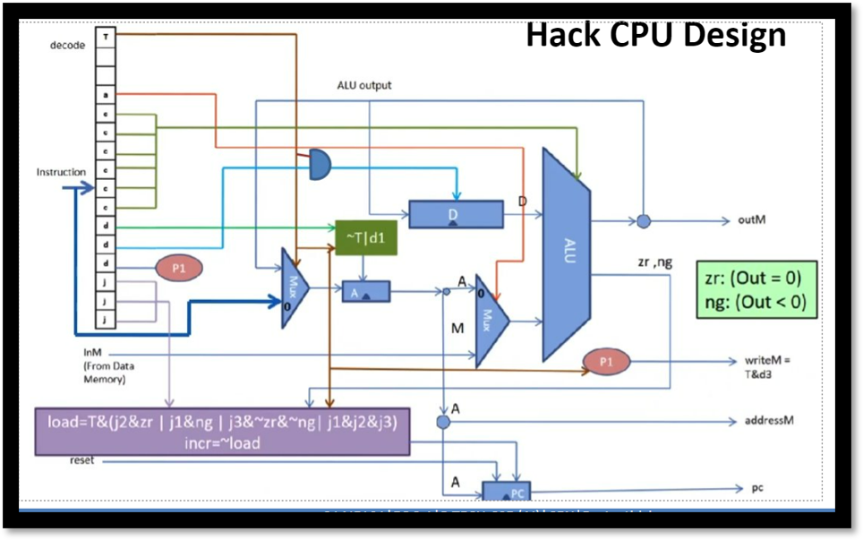

So by following the Logic circuit we will develop a HDL file and run it in simulator.

CPU HDL file :

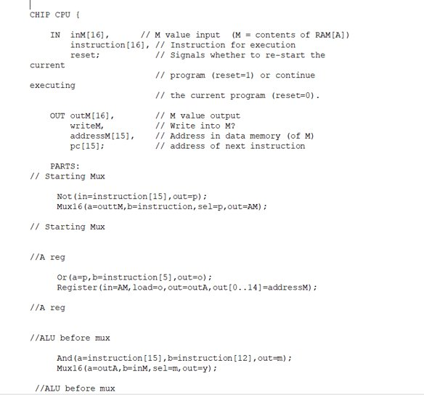

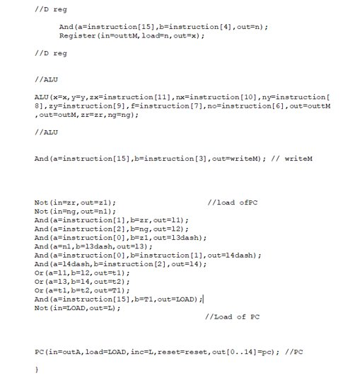

Internal Gates in CPU

Program Counter HDL file

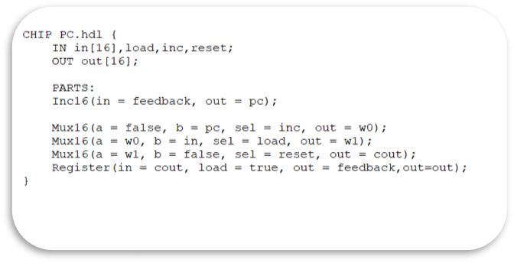

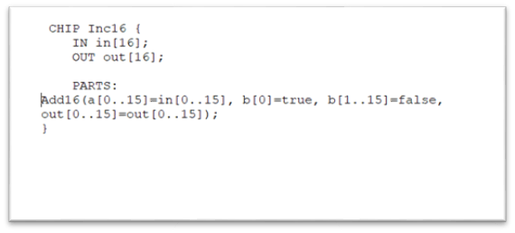

A and D registers HDL file : 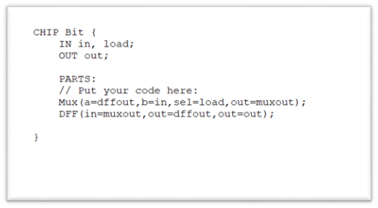

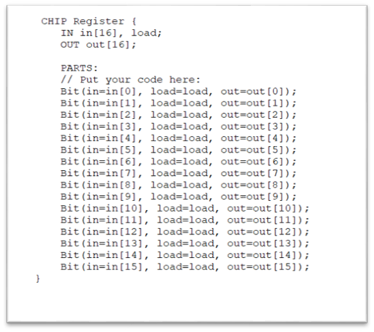

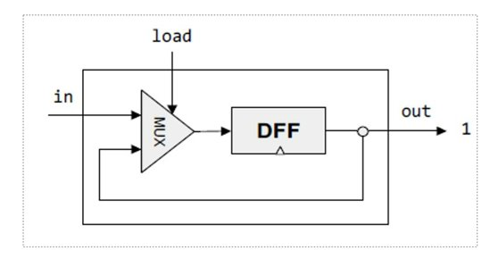

ALU HDL file :

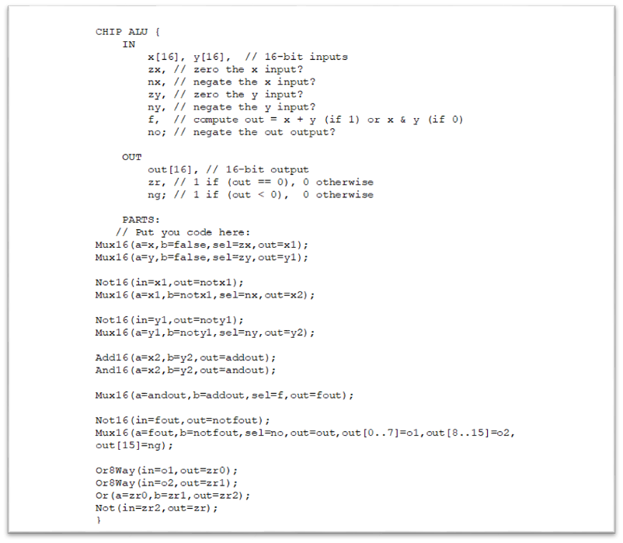

Internal chips in ALU

And 16

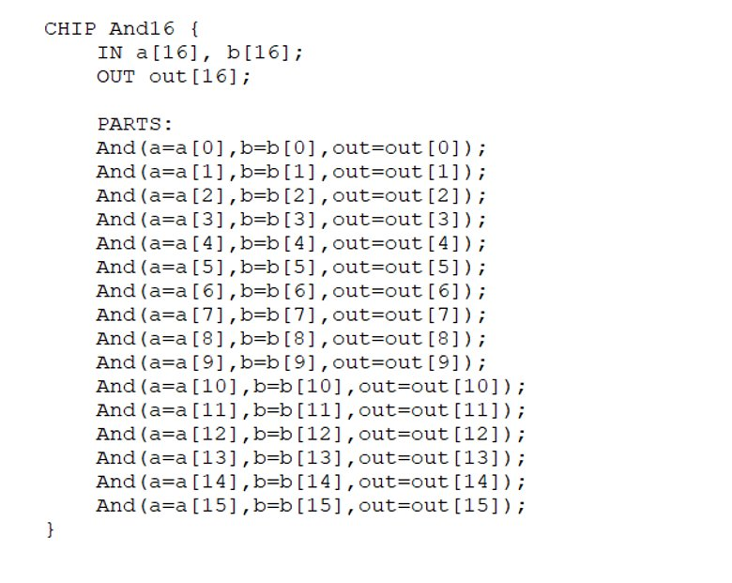

Add 16

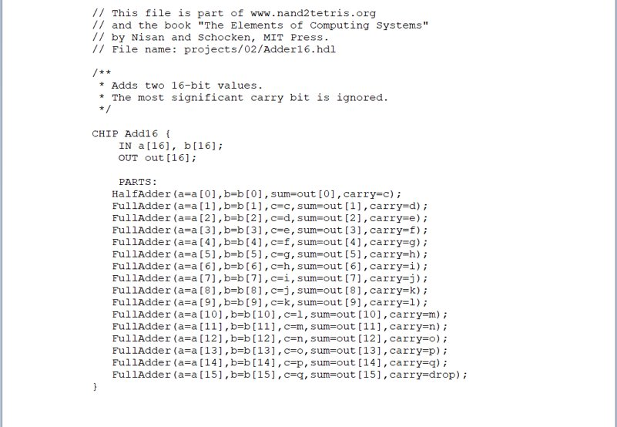

Not 16 Or 8 Way

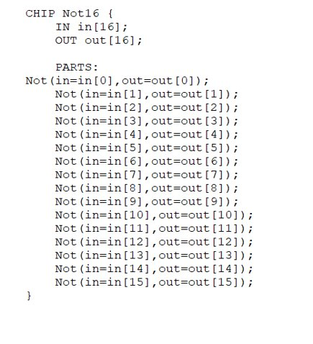  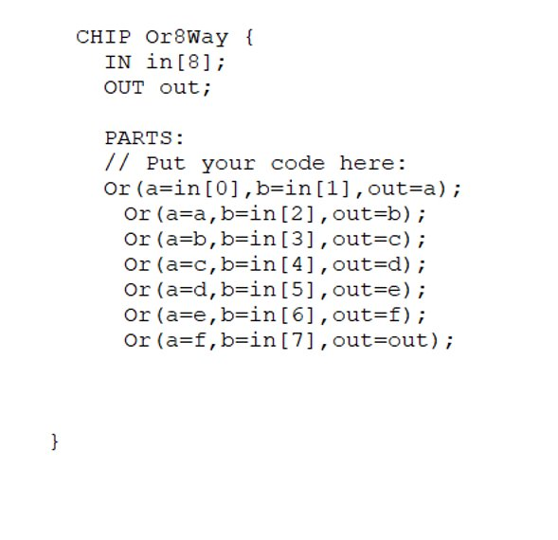

Mux 16

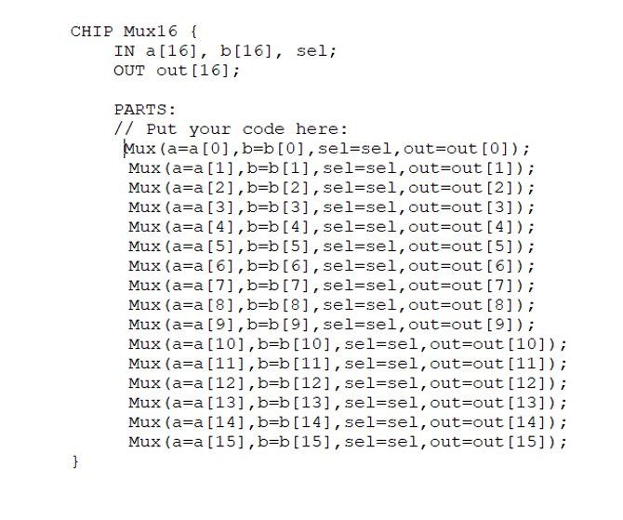

Data Memory:

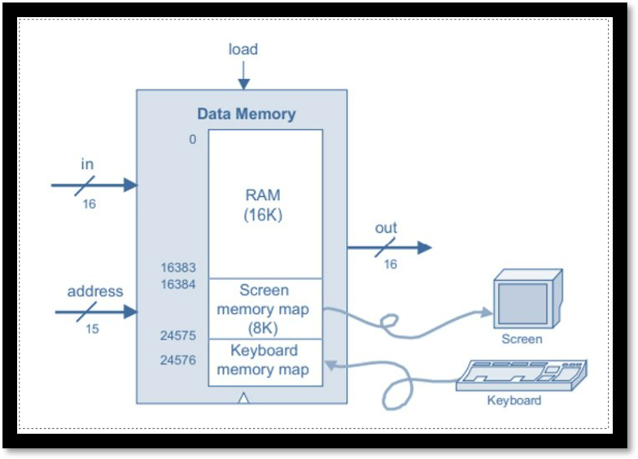  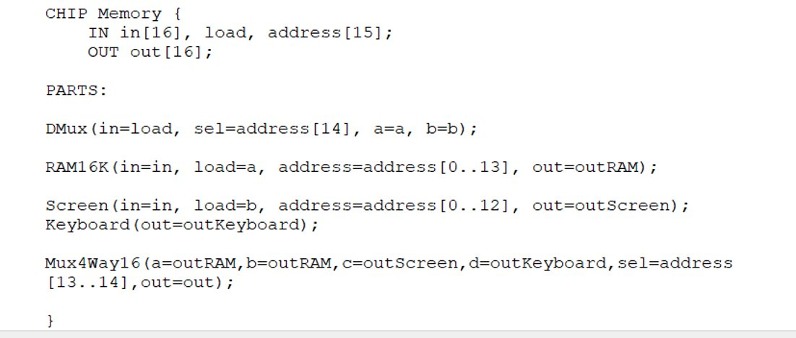

Hack Computer

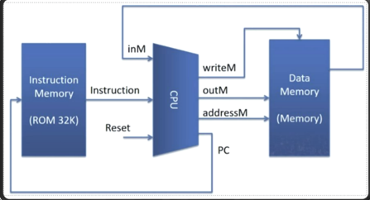  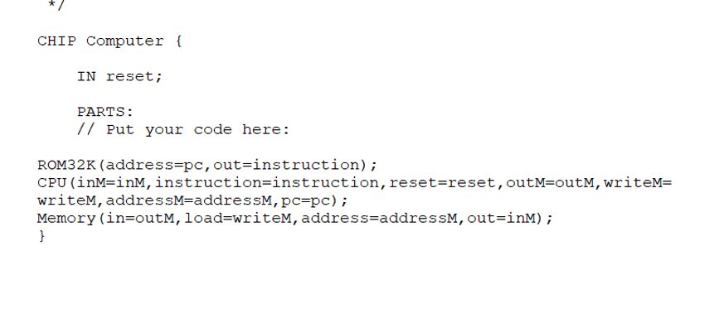

Hardware Simulator:

CPU

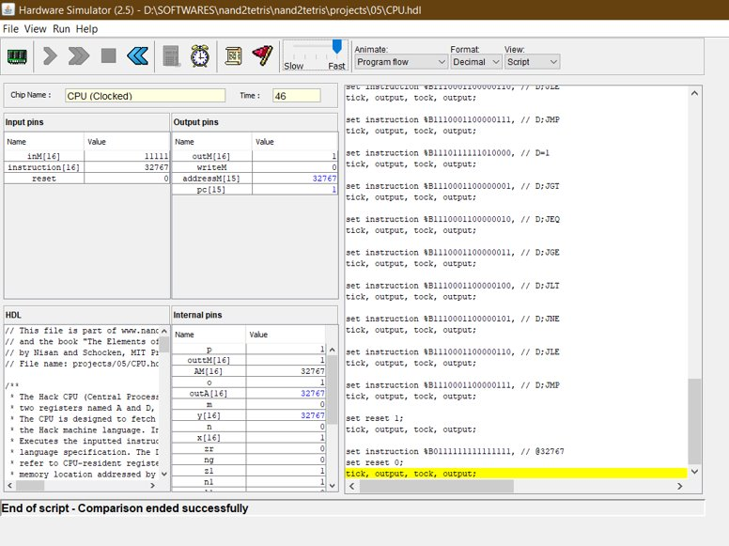

Computer

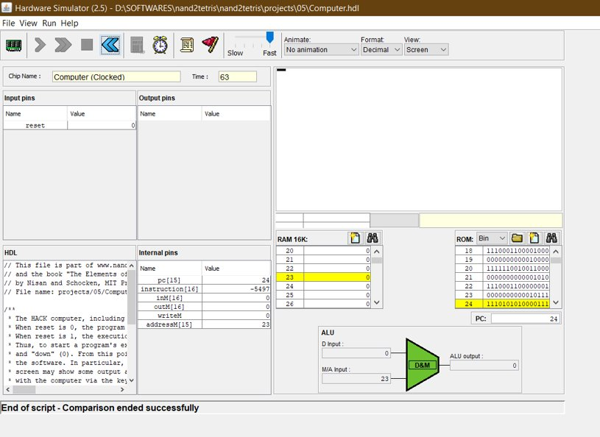

**Part B:**

Implementation of a 16 Bit Carry look-ahead adder : (add / sub)

Procedure :

**Step 1**

Understanding the logic circuit diagram of the chip

**Step 2**

Building the basic chips using NAND gates

**Step 3**

Making the logic circuit diagram as simple as possible to code it easily

**Step 4**

By following the logic circuit, we will develop a code in the respective HDL file.

**Step 5**

We will make sure that the code is with proper syntax, adding comments where it is required for a better understanding of the code.

**Step 6**

After saving the HDL file, we will load this chip into the Hardware Simulator

**Step 7**

Now we will give the input for the 2 numbers and the carry (c0) in the input pins section

**Step 8**

After running the code we will get the required output in the output pins section.

4 bit Carry look-ahead logic circuit :

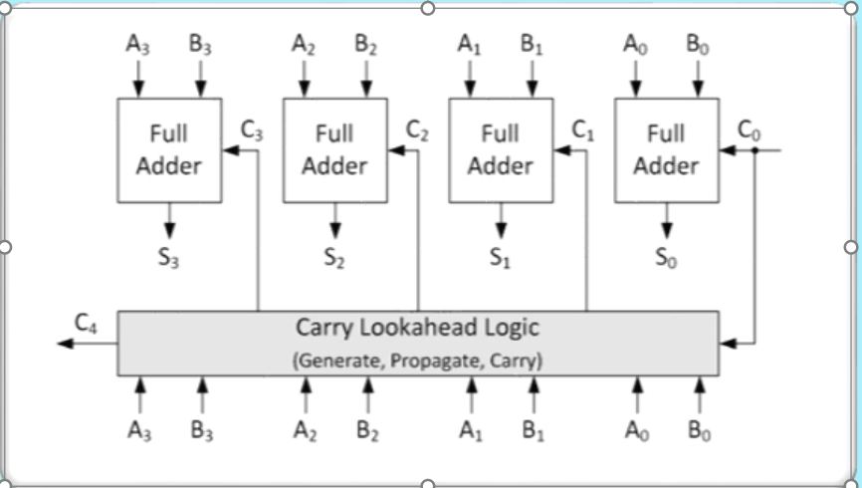

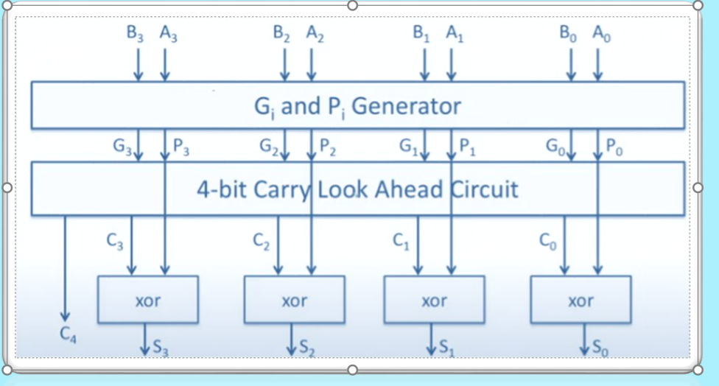

By seeing the logic circuit we have to find the carry by using carry ahead logic ​  
​  
So we will find Gi and Pi and will evaluate the carry. Like this we will do for each 16 bit​  
​  
After finding carry we will find the final sum using the below formula

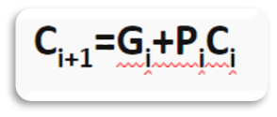  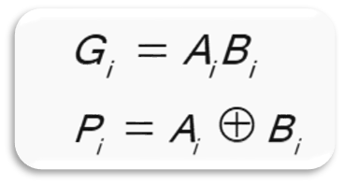

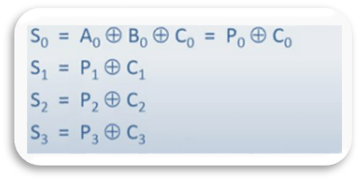

So we can find sum by using above formula.

Internal Gates :

Nand Not gate :

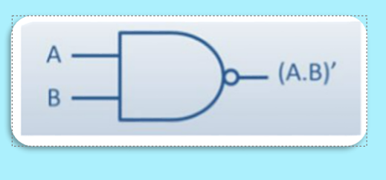 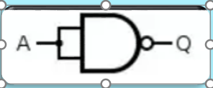

And gate : Or gate : Xor gate:

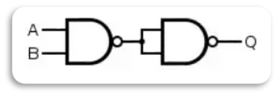   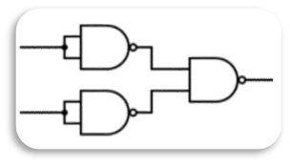  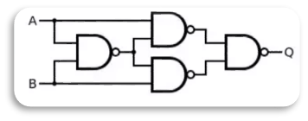

HDL file :

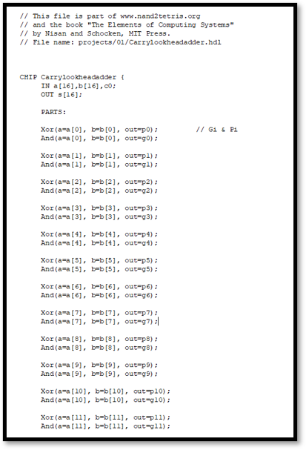  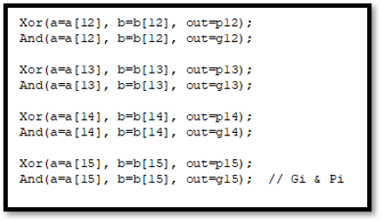 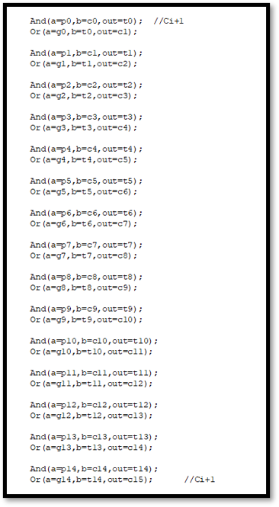  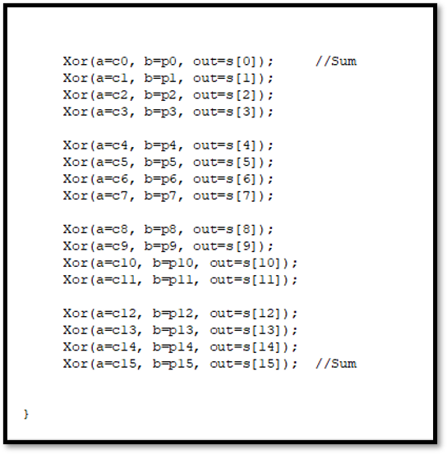

**Hardware Simulator :**

Addition :

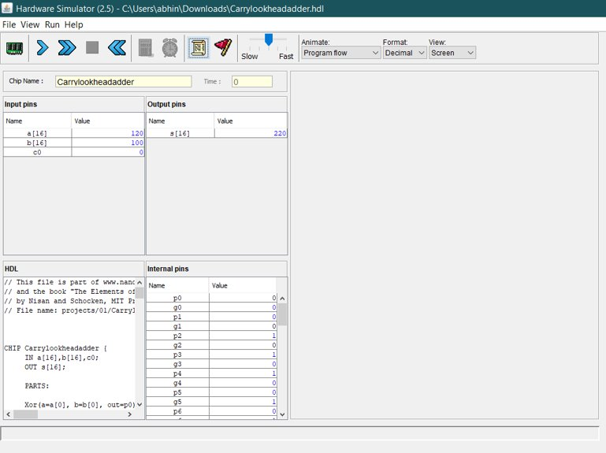

Subtraction :

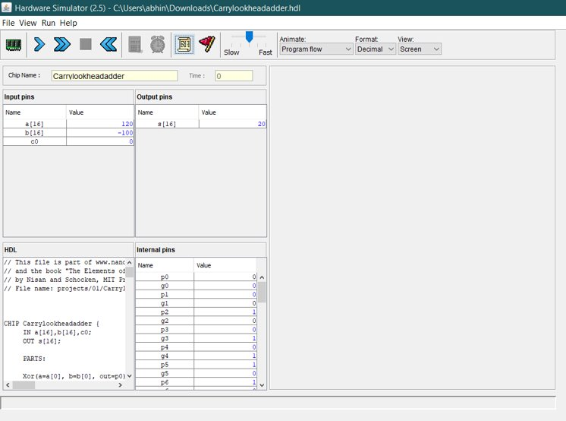

**References**

1. **Video Lectures and PPT’s of Dr.Jyotish Lal sir’s recordings.**