Lazy-loading feature modules

***By default, NgModules are eagerly loaded, which means that as soon as the app loads, so do all the NgModules, whether or not they are immediately necessary. For large apps with lots of routes, consider lazy loading—a design pattern that loads NgModules as needed. Lazy loading helps keep initial bundle sizes smaller, which in turn helps decrease load times***

***Step1:: Create Project ng new AngularLazyLoading***

***ng for angular***

***new to create new project***

***AngularLazyLoading is name of the project***

***Step 2: To Separate the Components we should create the folder in the app as***

***Components***

***Step3:: To create components***

***(I) ng g c home***

***(ii) ng g c customers***

***(iii) ng g c orders***

***ng for angular***

***g for generate***

***c for component***

***orders,customers,home are the components name***

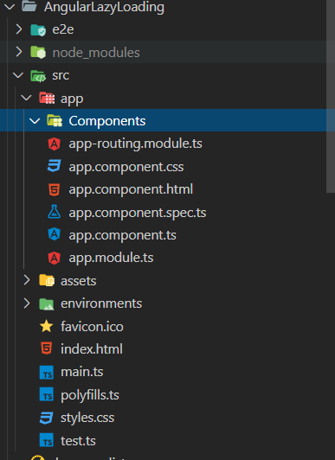

**Right click on the app folder=>create Folder=>name as Components=>hit Enter**

**Component Generation using CLI**

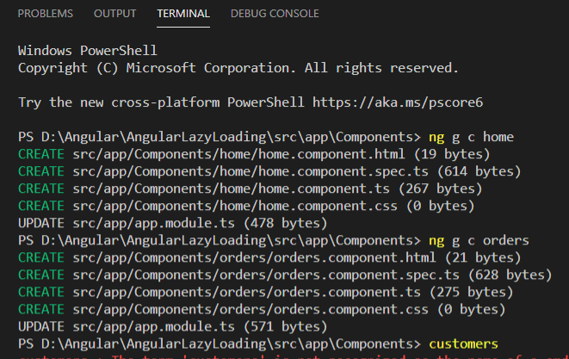

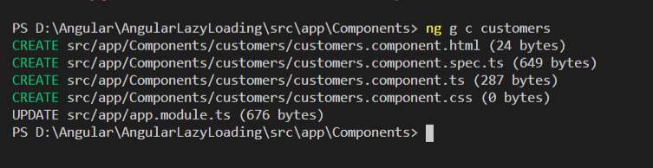

**Create Module For which component should be lazy loaded**

**ng g m orders –routing**

**ng for angular**

**g generate**

**m module**

**orders name of the module**

**-- routing is to generate the routing file**

**app.routing.module.ts**

**step 4::To define routes**

import { OrdersModule } from './Components/orders/orders.module';

import { NgModule } from '@angular/core';

import { Routes, RouterModule } from '@angular/router';

import { CustomersComponent } from './Components/customers/customers.component';

import { HomeComponent } from './Components/home/home.component';

const routes: Routes = [

{ path:'',component:HomeComponent },

{ path:'home',component:HomeComponent},

{ path:'customers',component:CustomersComponent},

{

  path:'orders',loadChildren:()=>import('./Components/orders/orders.module').then(m => m.OrdersModule)

}

];

@NgModule({

  imports: [RouterModule.forRoot(routes)],

  exports: [RouterModule]

})

export class AppRoutingModule { }

**Lazy Loaded Component**

{

  path:'orders',loadChildren:()=>import('./Components/orders/orders.module').then(m => m.OrdersModule)

}

***The loadChildren property is used to specify the module that needs to be lazy-loaded when it is first navigated to.***

***Configure route for lazy loaded component***

***orders-routing.module.ts***

import { NgModule } from '@angular/core';

import { Routes, RouterModule } from '@angular/router';

import { OrdersComponent } from './orders.component';

const routes: Routes = [

  { path:'',component:OrdersComponent },

  { path:'orders',component:OrdersComponent }

];

@NgModule({

  imports: [RouterModule.forChild(routes)],

  exports: [RouterModule]

})

export class OrdersRoutingModule { }

***app.module.ts***

import { BrowserModule } from '@angular/platform-browser';

import { NgModule } from '@angular/core';

import { AppRoutingModule } from './app-routing.module';

import { AppComponent } from './app.component';

import { HomeComponent } from './Components/home/home.component';

import { CustomersComponent } from './Components/customers/customers.component';

import { OrdersComponent } from './Components/orders/orders.component';

@NgModule({

  declarations: [

    AppComponent,

    HomeComponent,

    CustomersComponent,

    OrdersComponent

  ],

  imports: [

    BrowserModule,

    AppRoutingModule

  ],

  providers: [],

  bootstrap: [AppComponent]

})

export class AppModule { }

***app.component.css***

a{

    margin-right: 12px;

}

body{

    background-color:cyan;

    height: 1000px;

  }

***app.component.html***

<!DOCTYPE html>

<html lang="en">

  <head>

    <meta charset="UTF-8" />

    <meta name="viewport" content="width=device-width, initial-scale=1.0" />

    <title>index</title>

  </head>

  <body>

    <h1 style="color: red; text-align: center">Lazy Loading</h1>

    <div class="container" style="text-align: center">

      <a routerLink="/home">Home</a>

      <a routerLink="/customers">Customers</a>

      <a routerLink="/orders">Orders</a>

    </div>

    <div>

      <router-outlet></router-outlet>

    </div>

  </body>

</html>

***Output::***



***Default Home ,Customers are eagrly loaded***

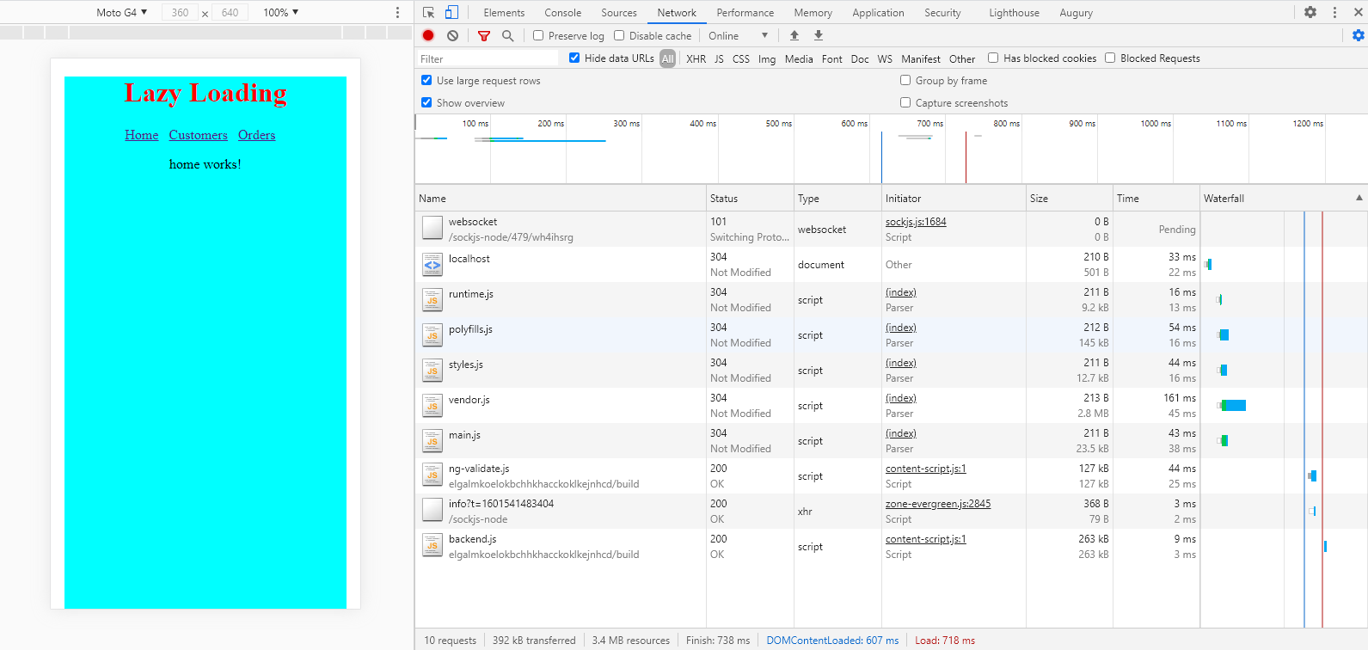

***Eagerly loaded files***

***Lazy loaded component***



