GHG Emission Prediction Project

Day 3 - Understanding Step 2 Code for Week 01

Date - 19 June 2025 (Week 1)

Internship Name - Edunet-Shell Skills4Future AICTE Internship

Intern Name: Abhinay Singh

✅ Tasks Completed:
1. Executed Code to Combine Datasets from All Years (2010–2016):
Standardized column names and added two new columns:
- Source: To differentiate between Industry vs Commodity.
- Year: The year of the data (added for tracking trends).
- Combined both datasets using pd.concat and appended to a list named all_data.
2. Created Final DataFrame (df)
- Used df = pd.concat(all_data, ignore_index=True) to merge all yearly data into one master dataframe.
This final df now contains:
- All 7 years' data
- Unified format and structure
- Both Industry & Commodity data in a single clean table.

3. Checked for Null/Missing Values
#Step 3: Data Preprocessing

df.columns # Checking columns
df.isnull().sum()

- Found that all columns except Unnamed: 7 are clean (i.e., 0 missing values).
- Column Unnamed: 7 has 2100+ missing values, indicating it's likely an empty or unnecessary column, probably coming from Excel formatting.
- Plan to drop it in preprocessing ( commented in code).

🧩 Key Concepts Learned Today:
- DataFrame (df): A tabular structure (rows × columns) in pandas, similar to an Excel table.
- Concatenation (pd.concat): Used to stack multiple DataFrames together (vertically).
- Missing Values (NaN): Gaps in data that need to be handled before modeling.
- Data Cleaning: Essential step before feeding data into ML models.
❓ Doubts Clarified:
- Understood the concept and structure of a pandas DataFrame.
- Understood the purpose of combining multiple Excel sheets into a single consistent dataset.
- Understood what df.isnull().sum() does and how to interpret the output.
Differentiated between:
- all_data: List containing one combined dataframe per year (7 total).
- df: Single final dataframe combining all years into one.

💭 Self-Reflection:
- “Today’s session was highly conceptual and boosted my confidence. The data merging part was very interesting. I understood how multiple datasets are brought together in real-world ML projects. I also understood how to detect and handle unnecessary columns. I feel more comfortable using pandas now and will revise this section from my handwritten notes.”
- I also attended ask me anything session taken by our mentor
Raghunandan Mysore Sreeharsha Sir, Where I asked about how to submit project code alongside daily logs maintained in the github and LMS portal.
- I also asked sir about the way we can use ChatGPT, Sir told us you can use it to understand the code, concept not just to copy.

Ask Me Anything Session:

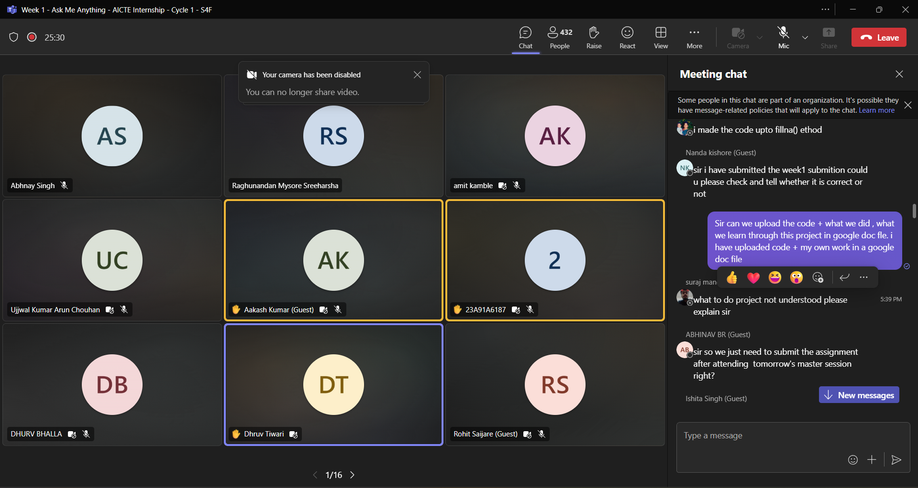
Live Session:
