NAME: ABHINAY SAMALA

PS NO: 20368668

Schematic

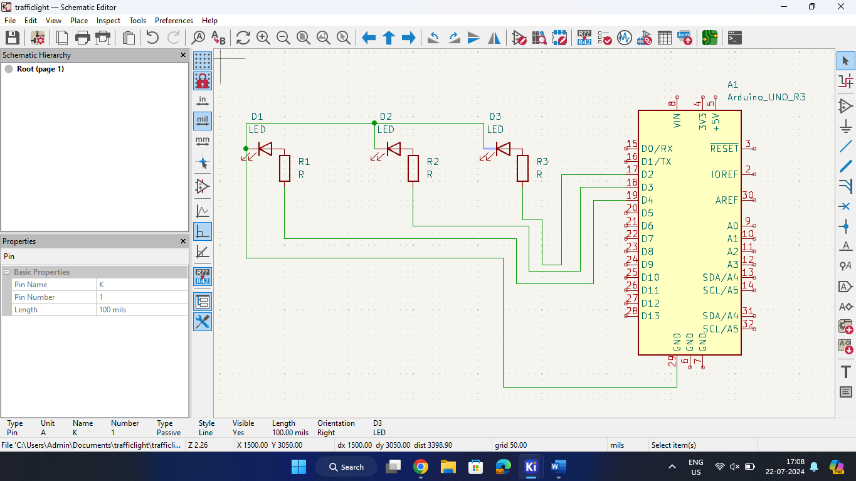

PCB Editor DRC

3D VIEW

