UNIVERSITY OF CALIFORNIA
College of Engineering
Department of Electrical Engineering and Computer Sciences
EE 130/230M Prof. Liu and Dr. Xu
Spring 2013
Solution to Homework Assignment #1

Problem 1: Miller indices and diamond lattice crystal structure
- The lattice constant of Si, a, is 5.43 Å. We have to calculate the number of atoms per unit area (cm²) on the (100), (110) and (111) planes:
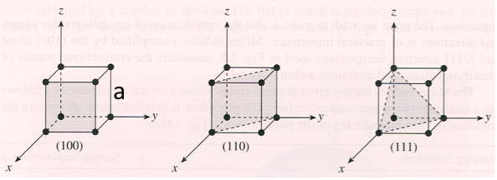
First, let’s find the unit-cell area of these planes.
The area of the square region of the (100) plane within the unit cell is A₁₀₀=a × a =a²
The area of the rectangular region of the (110) plane within the unit cell is 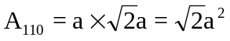
The area of the triangular region of the (111) plane within the unit cell is
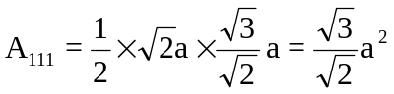
Next, let’s determine how many atoms lie on each of these planes within the unit cell.

(100): (110): (111):
a
a
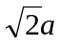

a

For the (100) plane, there are 4 atoms at the 4 corners and one atom in the middle. One fourth of each corner atom is enclosed within the unit cell, and middle atom is entirely within the unit cell, so the number of atoms on the (100) plane within the unit cell is N₁₀₀ = 4 × (1/4) + 1 × 1 = 2.
For the (110) plane, there are N₁₁₀ = 4 × (1/4) + 2 × (1/2) + 2 × 1 = 4 atoms within the unit cell.
For the (111) plane there are N₁₁₁ = 3 × (1/6) + 3 × (1/2) = 2 atoms within the unit cell.

Atomic density on the (100) plane = N₁₀₀ / A₁₀₀ =2/a² = 6.78×10¹⁴ atoms/cm²
Atomic density on the (110) plane = N₁₁₀ / A₁₁₀ =4/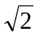a² = 9.59×10¹⁴ atoms/cm²
Atomic density on the (111) plane = N₁₁₁ / A₁₁₁ =2/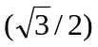a² = 7.83×10¹⁴ atoms/cm²

The (110) plane has the highest atomic density and hence is best for p-channel MOSFET performance.

- The direction that has the most number of covalent bonds is the best for hole conduction. The two illustrations below enumerate the bonds along the [110] and [111] directions. The [110] direction is the best for hole conduction.
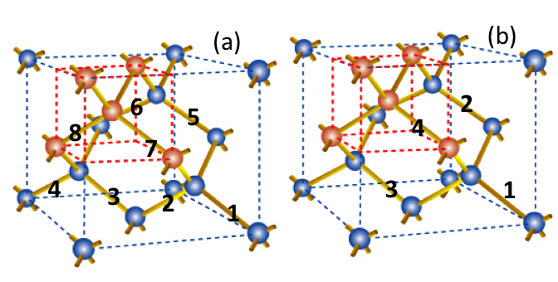

Problem 2: Intrinsic semiconductor

a) The intrinsic carrier concentration (n_{i}) is due to thermal generation of electron-hole pairs. The band gap energy (E_{G}) is the minimum energy required to generate an electron-hole pair (EHP), i.e. the minimum energy needed to free an electron from a covalent bond. The smaller E_{G} is, the easier it is to generate an EHP and the higher n_{i} is. The band gap of Ge, Si and GaAs are 0.67 eV, 1.12 eV, and 1.42 eV, respectively. Since Ge has the smallest E_{G} of the three semiconductor materials, it has the highest n_{i}; since GaAs has the largest E_{G} of the three semiconductor materials, it has the lowest n_{i}. As we have learned in Lecture 3, the intrinsic carrier concentration increases rapidly (~exponentially) with decreasing band gap.
b) The thermal energy available to excite electrons from the valence band to the conduction band (i.e. to free an electron from a covalent bond) increases with temperature. Thus, the intrinsic carrier concentration increases with increasing temperature.
c) In order for a semiconductor device to work properly, the intrinsic carrier concentration should be negligible compared to typical dopant concentration levels. Since GaAs has the lowest intrinsic carrier concentration among the three semiconductor materials, it should be the best for high-temperature device applications.

Problem 3: Doping

- If Si atoms replace Ga atoms within the GaAs lattice, the material will be n-type because Si has one more valence electron than Ga (which has three valence electrons). This “extra” valence electron can easily escape the Si atom to become a conduction electron. (The Si atom becomes positively ionized, as a result.)
- If Si atoms replace As atoms within the GaAs lattice, the material will be p-type because Si has one less valence electron than As (which has five valence electrons). An electron from a nearby covalent bond can easily move to the Si atom to fill its outmost electron shell, creating a hole. (The Si atom becomes negatively ionized, as a result.)

Problem 4: Carrier Concentrations
- Boron (B) is a Group III element with three valence electrons, which is one less than Si. When a B atom replaces a Si atom, an electron from a nearby covalent bond can easily move to the B atom to fill its outmost electron shell, creating a hole. (The B atom becomes negatively ionized, as a result.) Assuming that each B atom results in one hole, the hole concentration (p) will be 10¹⁷ cm⁻³. Since the np product is equal to n_{i}² under equilibrium conditions, the electron concentration will be n_{i}² /p = 10²⁰/10¹⁷ = 10³ cm⁻³. Since p > n, this material is p-type. The majority carrier (hole) concentration is 10¹⁷ cm⁻³ and the minority carrier (electron) concentration is 10³ cm⁻³.
- From the n_{i} vs. T plot in Lecture 1, n_{i} = 10¹⁸ cm⁻³ at T = 1000K (727⁰C).

