- Front-end Flask running status:

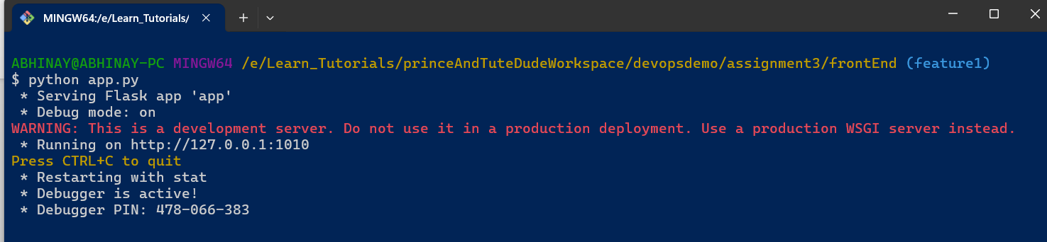

- Back-end Flask running status:

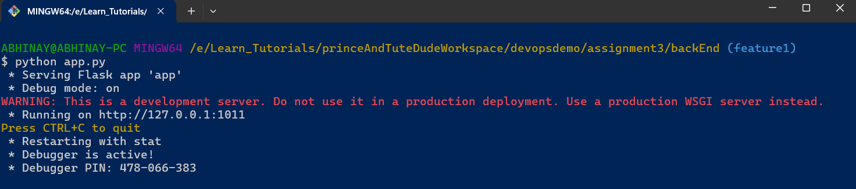

- Cloud MongoDB running status:

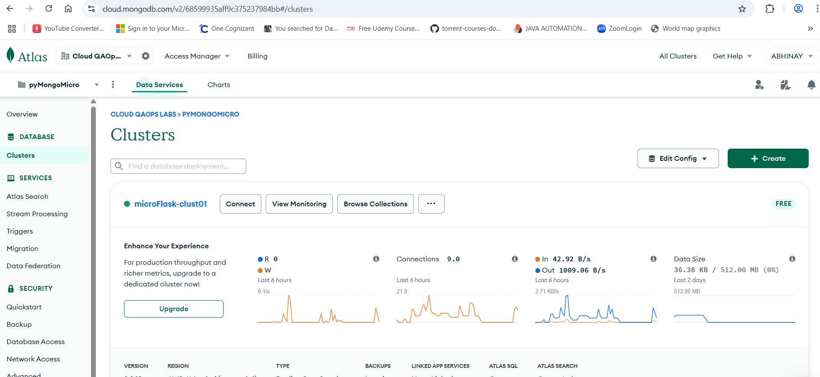

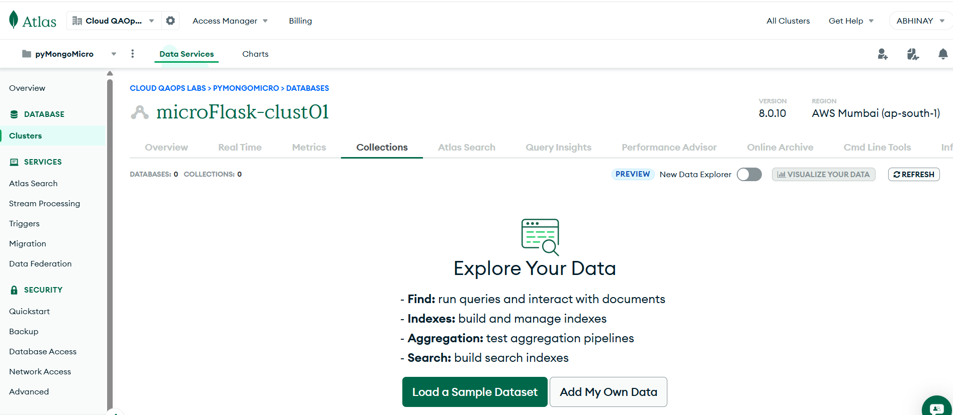
- Front-end UI View:
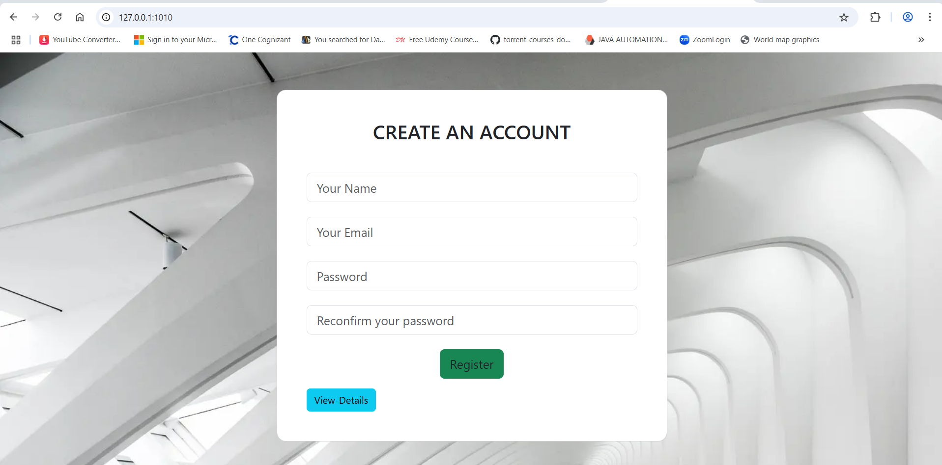

- Task-2 – Front-end to Back-end Validations:
If there's an error during submission, display the error on the same page without redirection. “Register” button click submission invalid submissions.

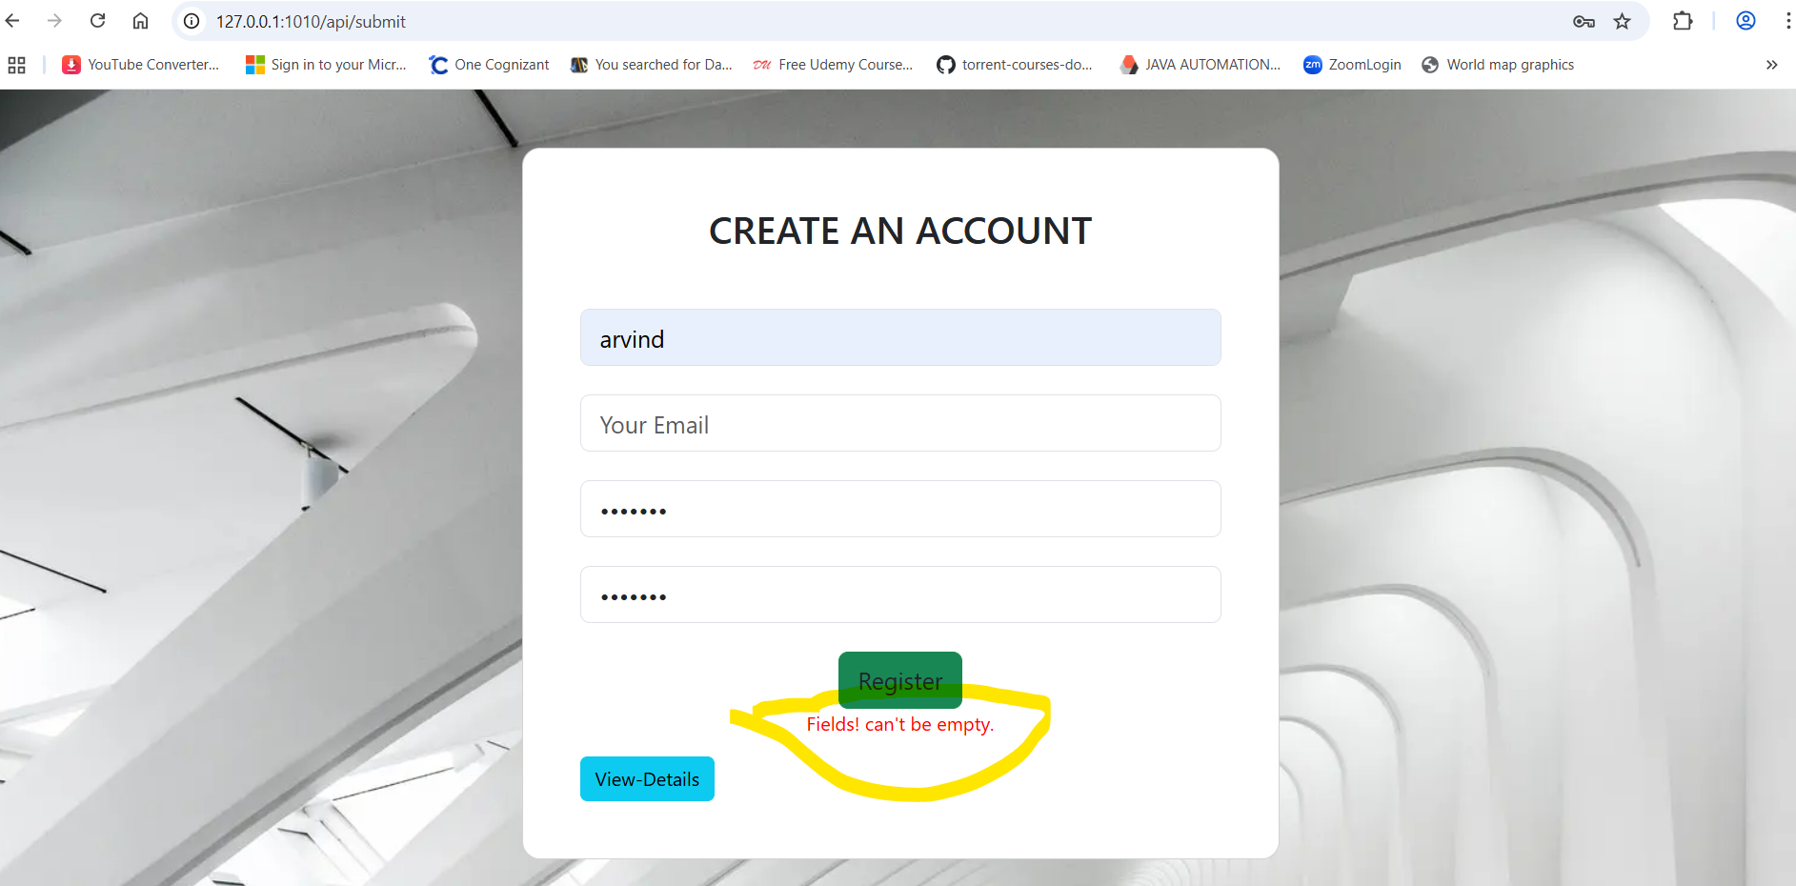

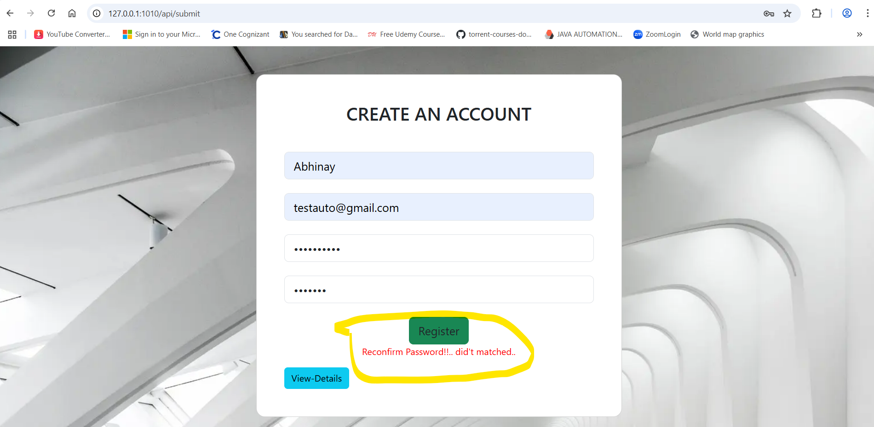
Invalid Data is not inserted to MongoDB hence list is empty:

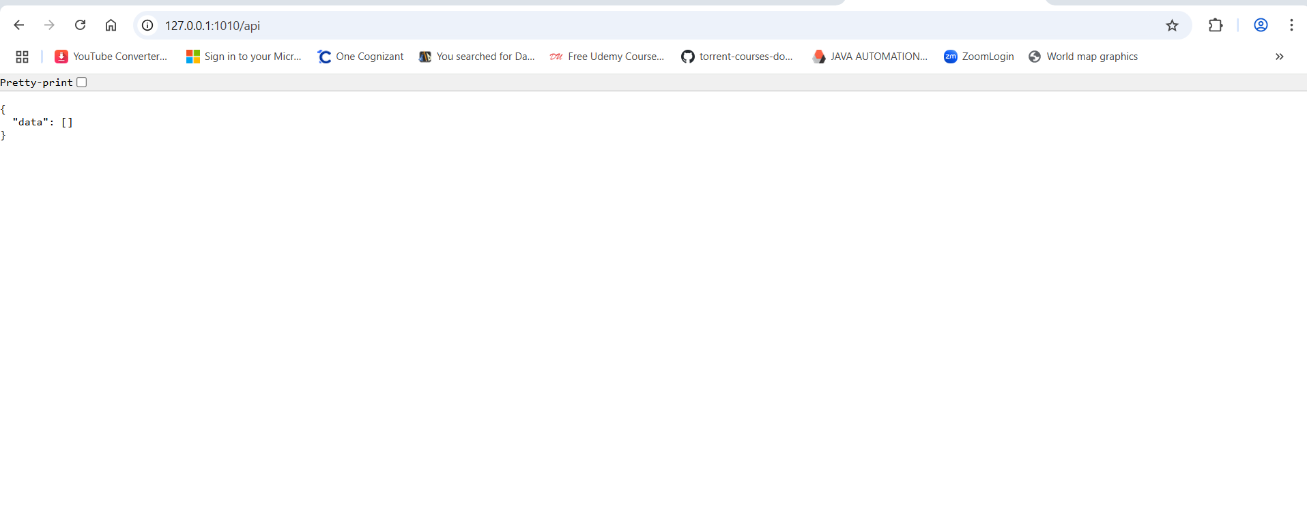



- Task-2 – Valid & successful Form Submission:

Register button click with valid input submission inserts data into MongoDB Atlas. Upon successful submission, the user should be redirected to another page displaying the message "Data submitted successfully"
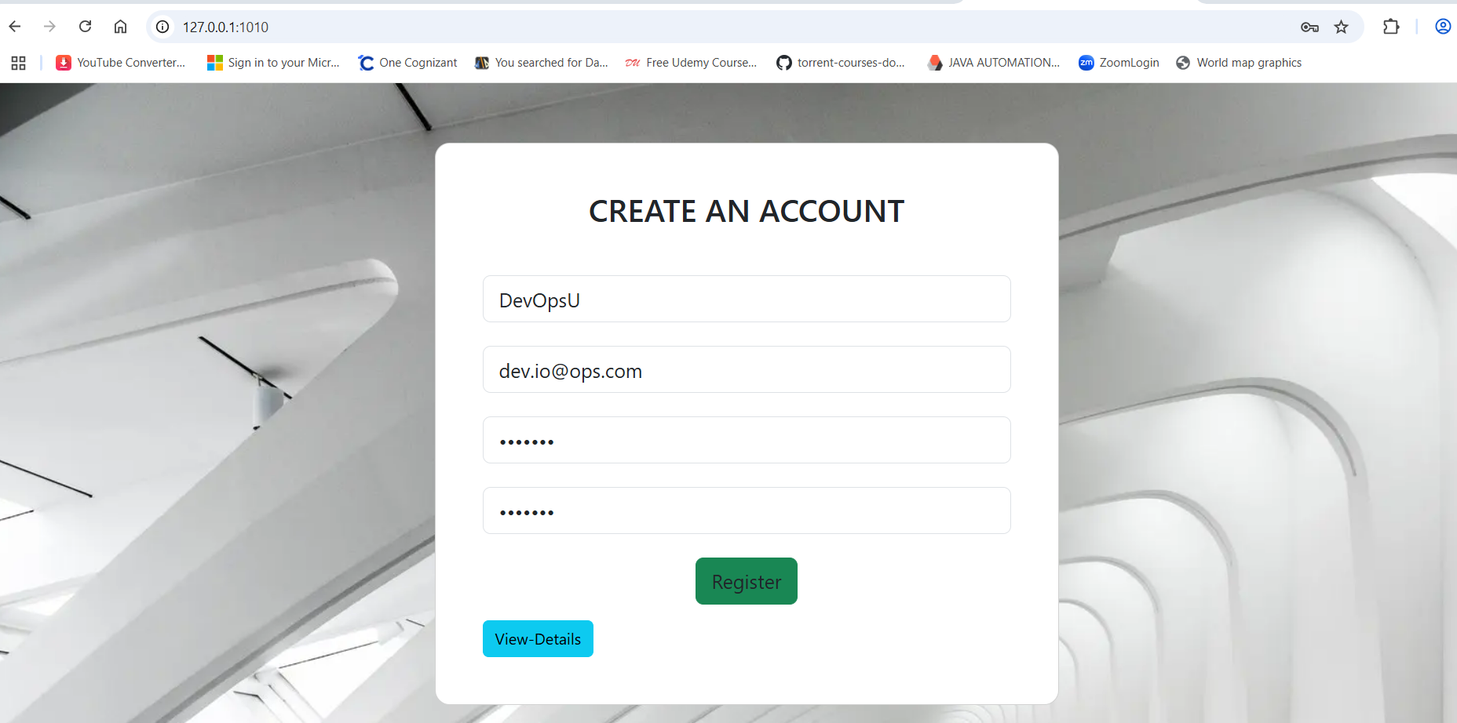
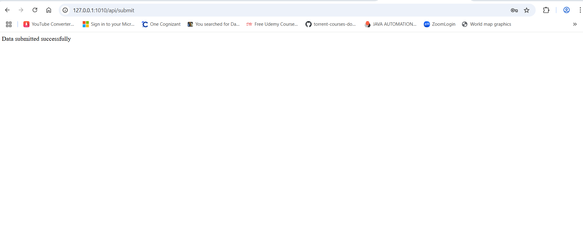

Verification of data inserted to MongoDB Atlas :
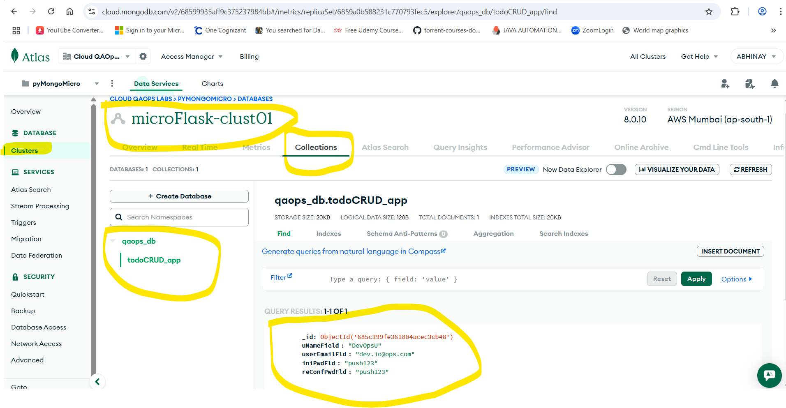

- Task-1 – “View-Details” Button Click from UI:
Create a Flask application with an /api route. When this route is accessed, it should return a JSON list. The data should be stored in a backend file, read from it, and sent as a response.

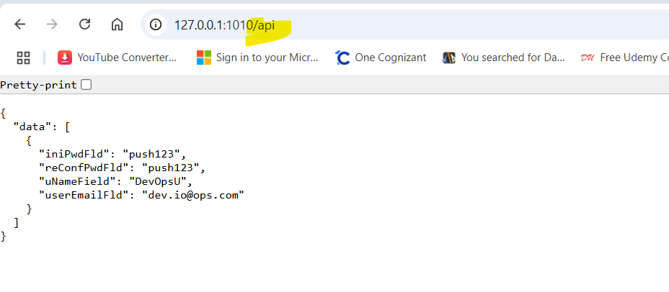
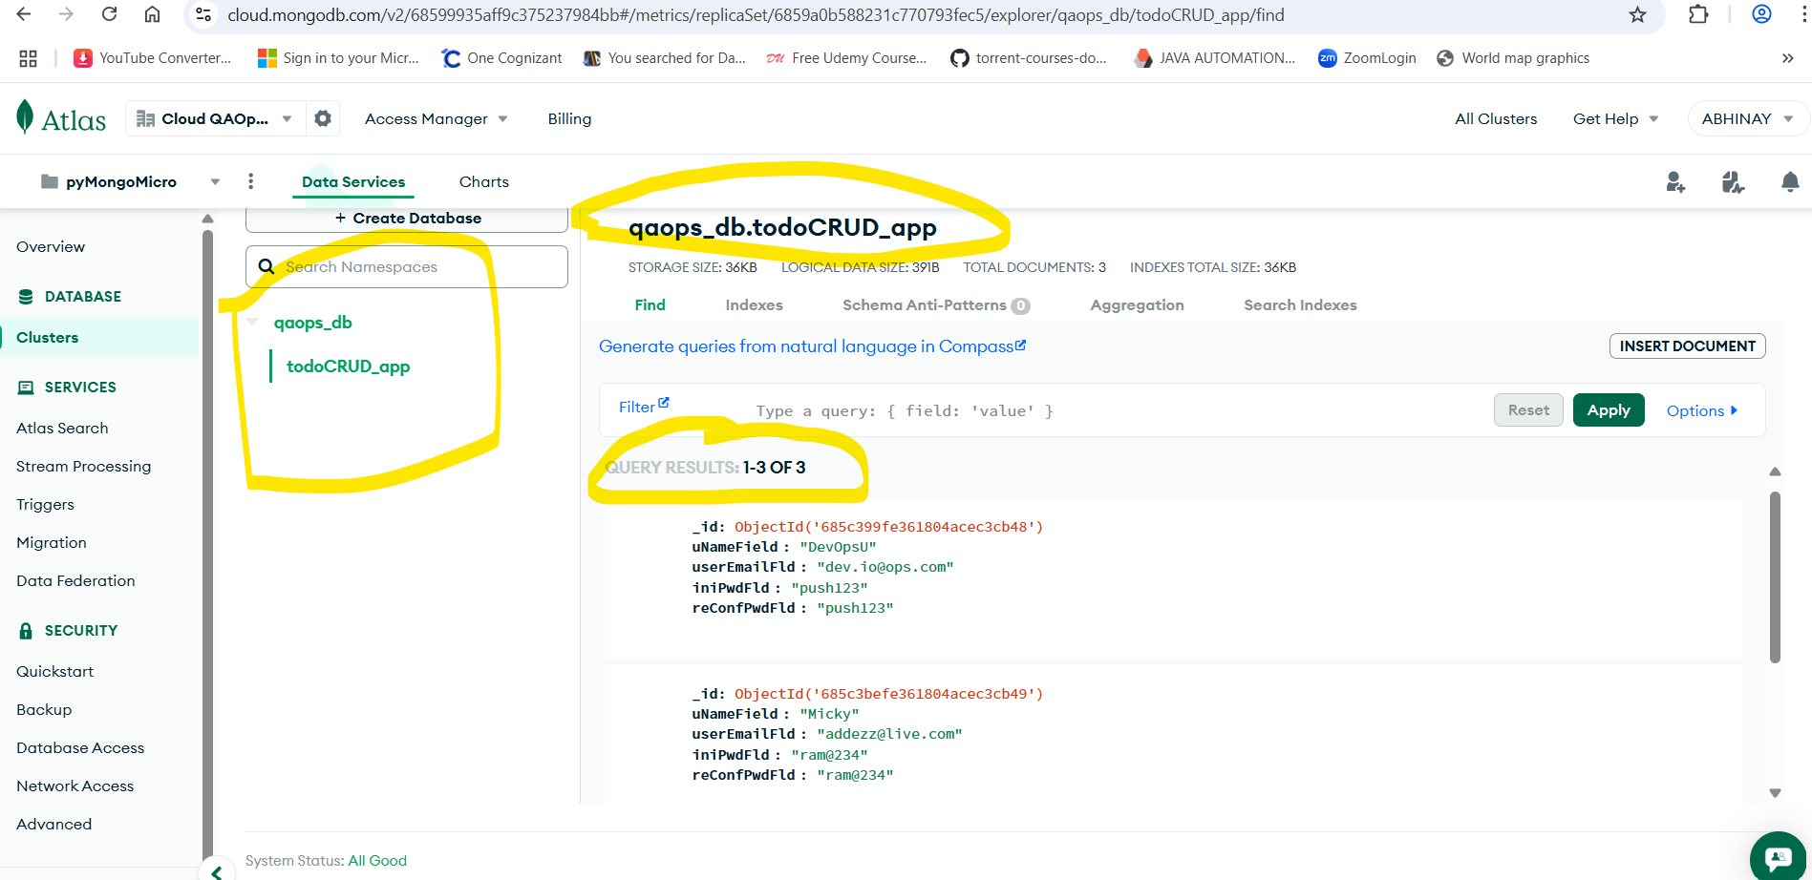

Newly Inserted 3 records with valid submissions:
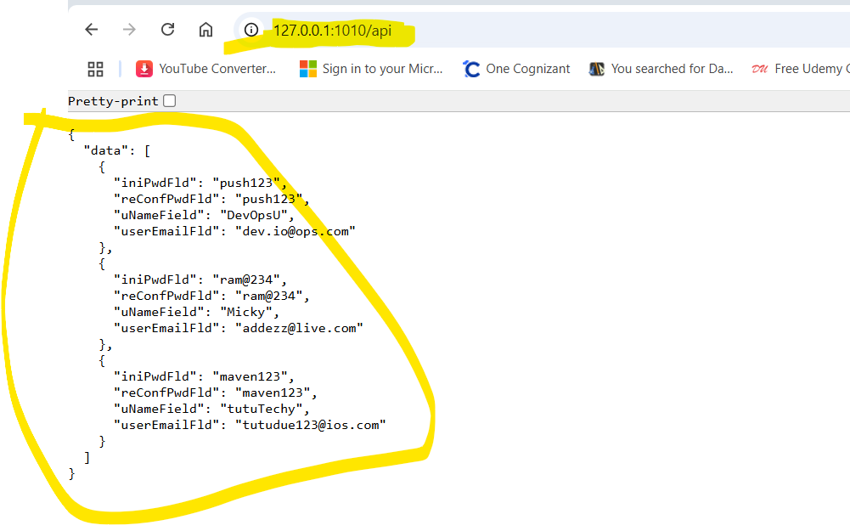

Thanks,
Abhinay Lunawat
Abhinaylunawat5993@gmail.com

