1. **Front-end Flask running status:**

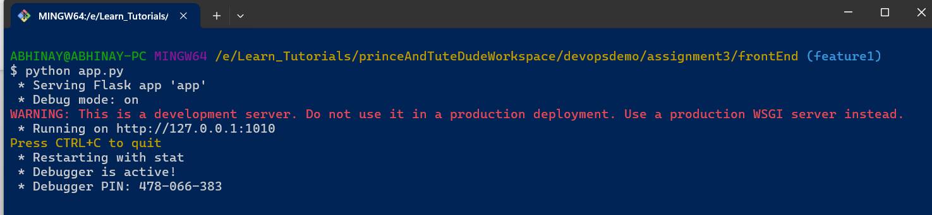

1. **Back-end Flask running status:**

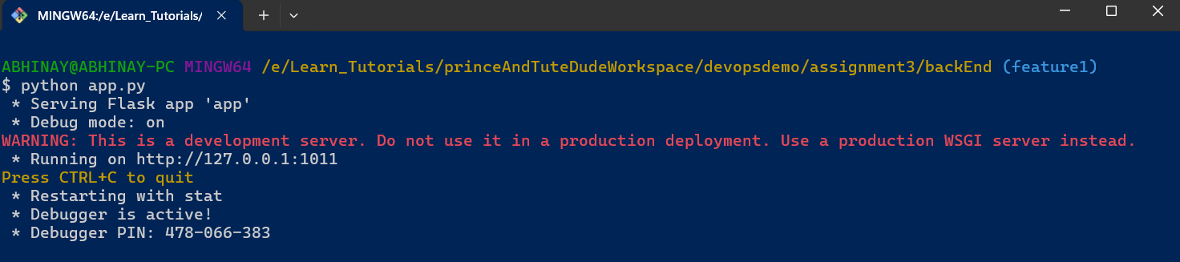

1. **Cloud MongoDB running status:**

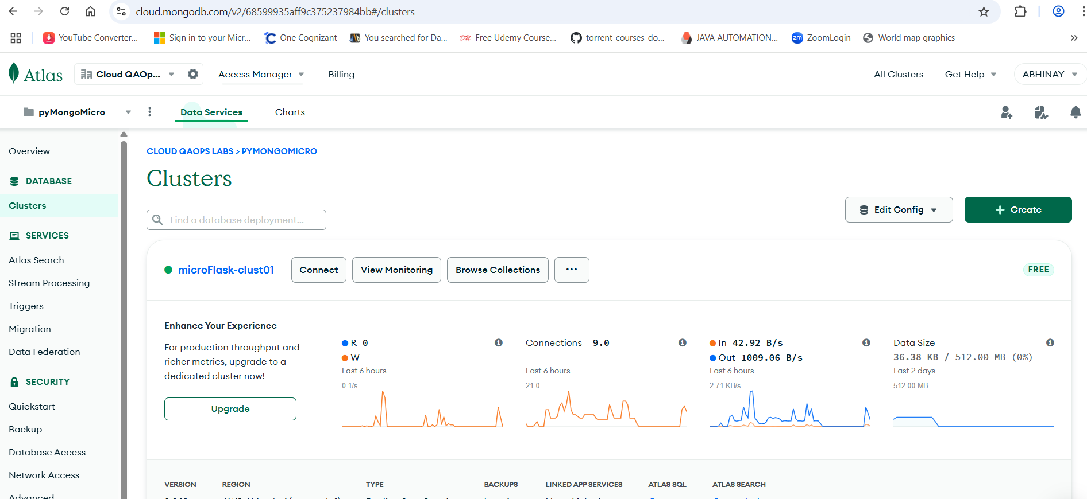

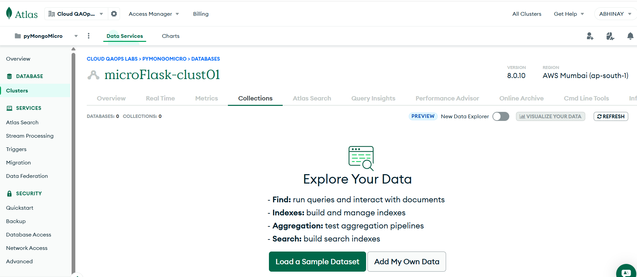

1. **Front-end UI View:**

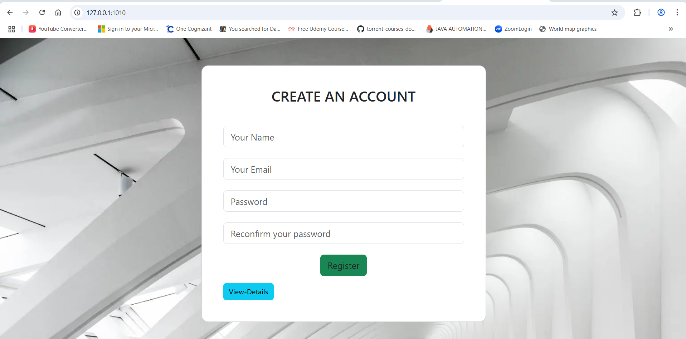

1. **Task-2 – Front-end to Back-end Validations:**

If there's an **error during submission**, display the error on the same page without redirection. “**Register**” button click submission invalid submissions.

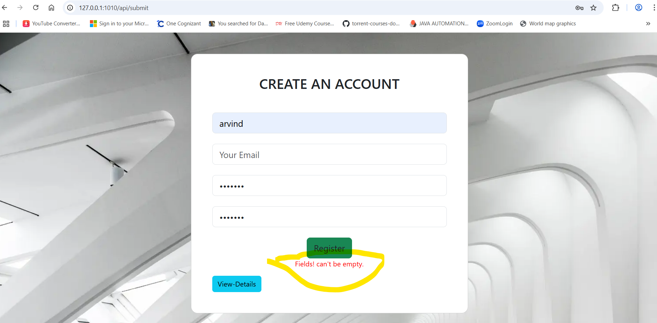

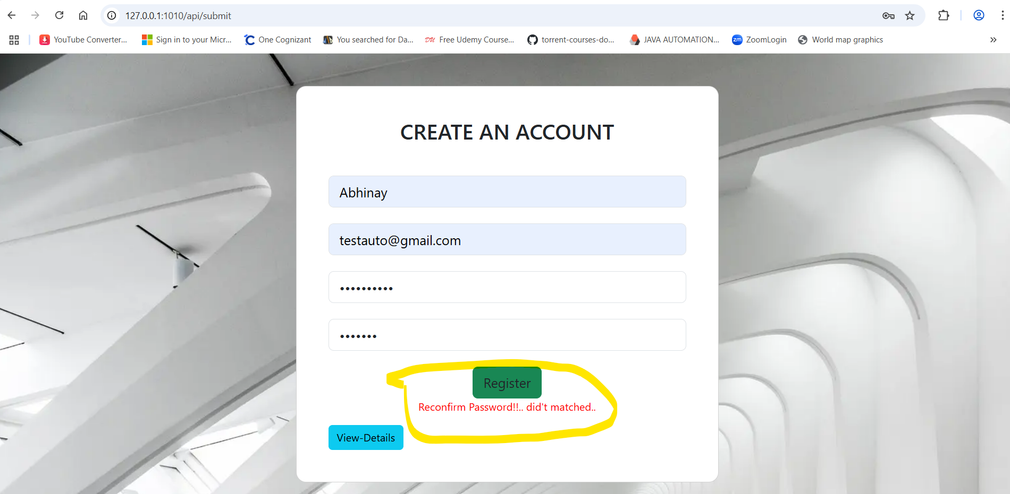

**Invalid Data is not inserted to MongoDB hence list is empty:**

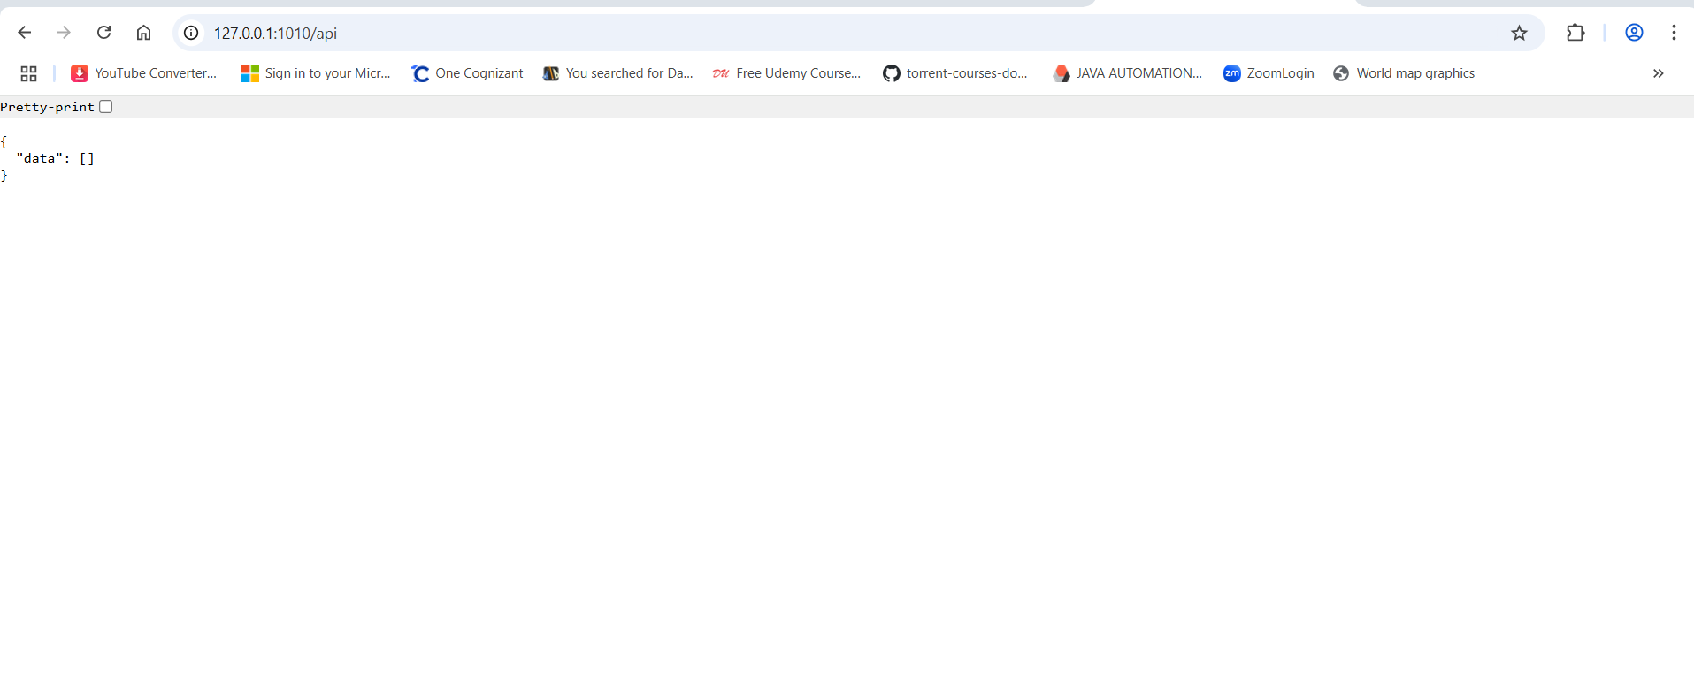



1. **Task-2 – Valid & successful Form Submission:**

**Register** button click with **valid input submission** inserts data into **MongoDB Atlas**. Upon **successful submission**, the user should be redirected to another page displaying the message "**Data submitted successfully**"

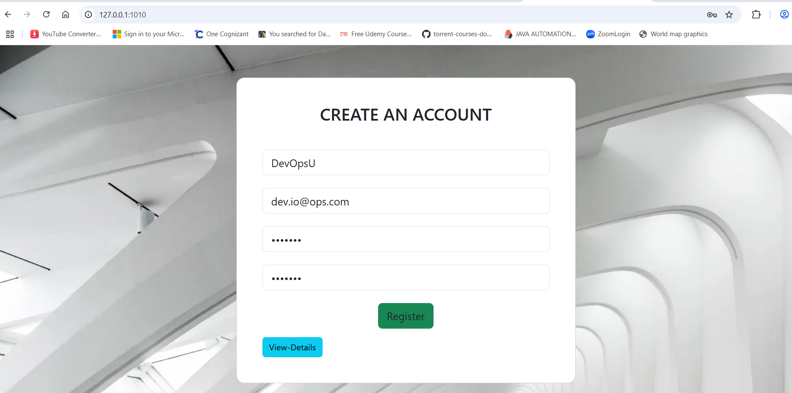

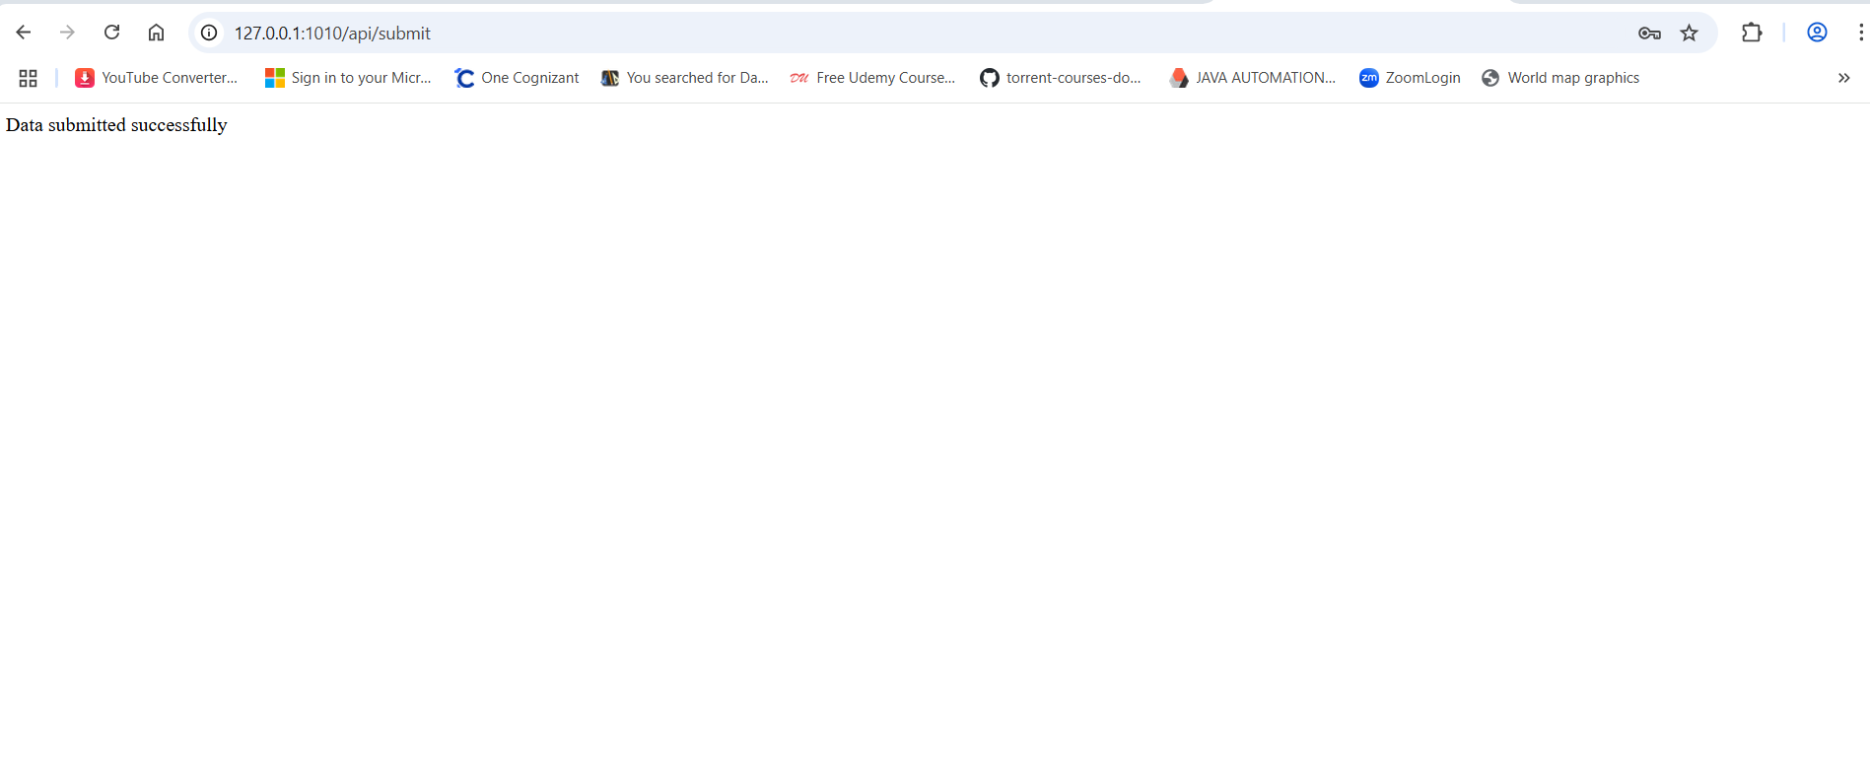

**Verification of data inserted to MongoDB Atlas :**

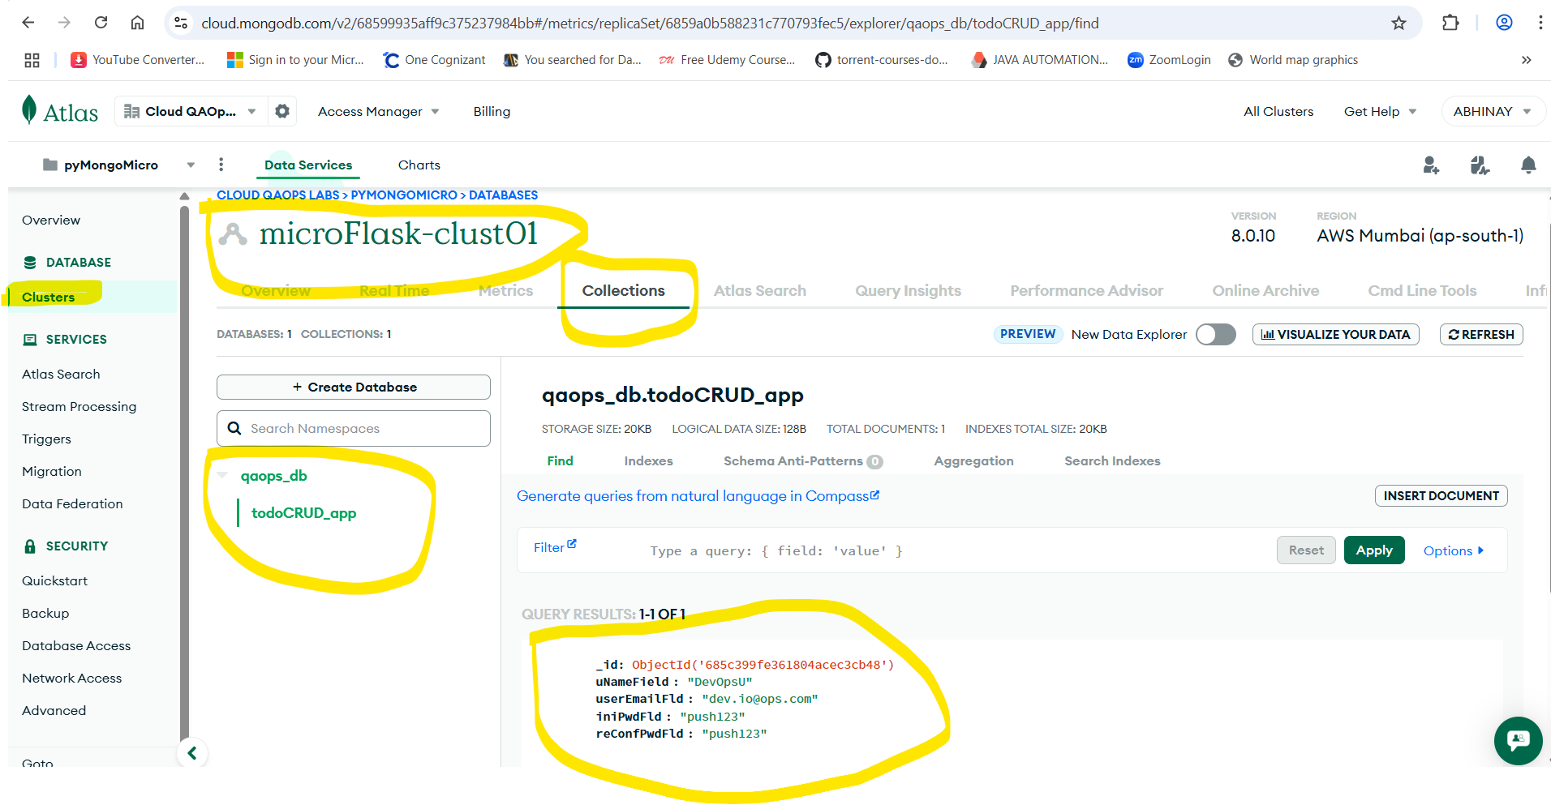

1. **Task-1 – “View-Details”** Button Click from UI**:**

Create a Flask application with an **/api route**. When this route is accessed, it should return a **JSON list**. The data should be stored in a backend file, read from it, and sent as a response.

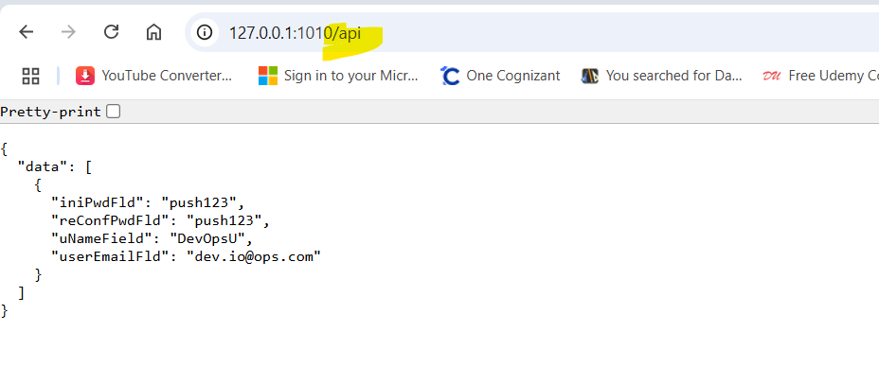

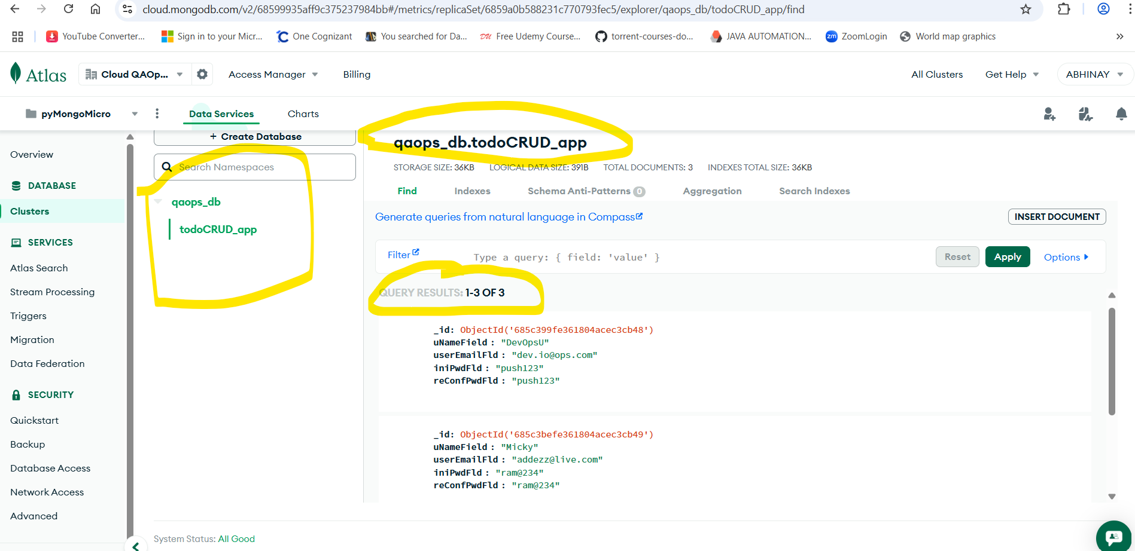

**Newly Inserted 3 records with valid submissions:**

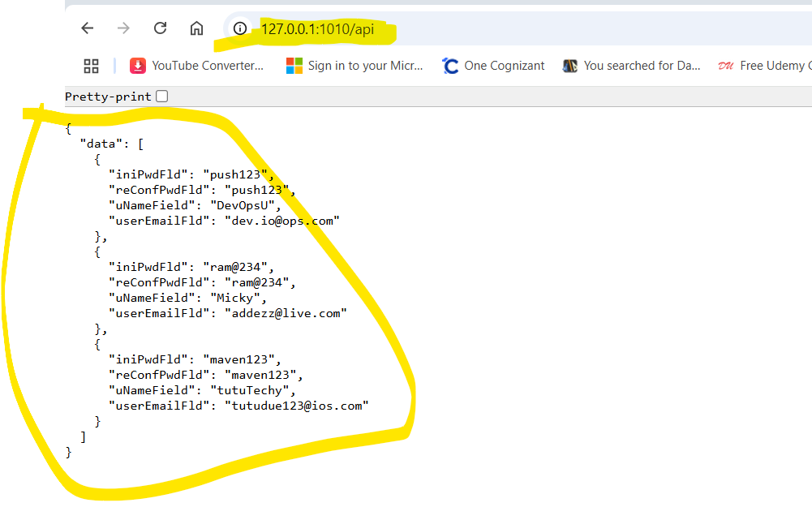

**Thanks,**

**Abhinay Lunawat**

**Abhinaylunawat5993@gmail.com**