Practical Of Numerical Method
Butwal Multiple Campus

CSIT 3rd Sem.

Submitted By:-
Abhinaya Aryal
Sec ‘A’
Roll no. :- 2
Symbol no. :- 27654/077

1. Bisection Method
#include <stdio.h>
#include <math.h>
#include <stdlib.h>

float f(float x) {
float y;
y = pow(x, 2) + x - 2;
return y;
}

int main() {
float x1, x2, x0, error = 0.0001;
int i = 0;

printf("\nEnter two initial guess:\n");
scanf("%f%f", &x1, &x2);

if (f(x1) * f(x2) > 0) {
printf("\nWrong Input !!!");
exit(0);
}
else {
do{
x0 =(x1 + x2)/2;
if (f(x0) * f(x1) > 0) {
x1 = x0;
}
else{
x2 = x0;
}
i++;
}while (fabs(f(x0)) > error);

}
printf("\nRoot = %f", x0);
printf("\nNumber of iteration = %d", i);
printf("\n\n\t\t Abhinaya Aryal\n\n\n");
return 0;
}
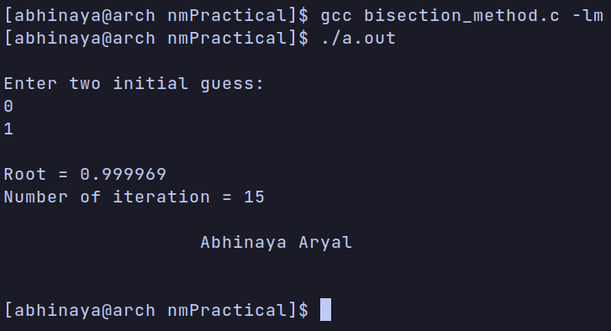

2. Secant Method
#include <stdio.h>
#include <math.h>

float f(float x) {
float y;

y = pow(x, 2) + x - 2;
return y;
}

int main() {
float x1, x2, x0, error = 0.0001;
int i = 0;

printf("\nEnter any two initial guess:\n");
scanf("%f%f", &x1, &x2);

do {
x0 = x1 - (f(x1) * (x2 - x1)) / (f(x2) - f(x1));
x2 = x1;
x1 = x0;
i++;
}while (fabs(f(x0)) > error);

printf("\nRoot = %f", x0);
printf("\nNumber of iteration = %d", i);
printf("\n\n\t\t Abhinaya Aryal\n\n\n");

return 0;
}

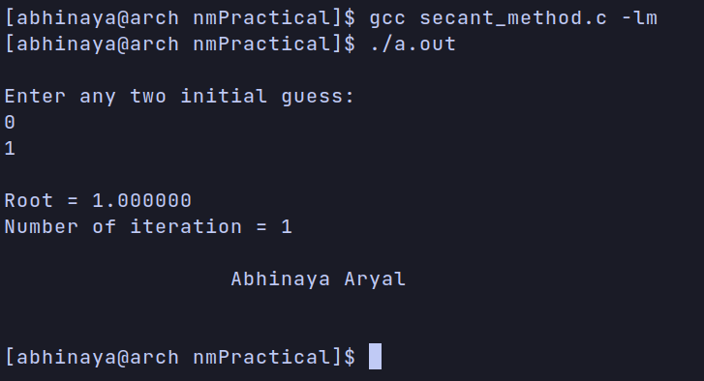

3. Newton Raphson Method
#include <stdio.h>
#include <math.h>

float f(float x) {
float y;

y = pow(x, 2) + x - 2;
return y;
}

float fd(float x) {
float y;

y = 2 * x + 1;
return y;
}

int main() {
float x0, x1, error = 0.0001;
int i = 0;

printf("\nGuess Initial Root:\n");
scanf("%f", &x1);

do {
x0 = x1 - (f(x1) / fd(x1));
x1 = x0;
i++;
}while (fabs(f(x0)) > error);

printf("\nRoot = %f", x0);
printf("\nNumber of iteration = %d", i);

printf("\n\n\t\t Abhinaya Aryal\n\n\n");

return 0;
}
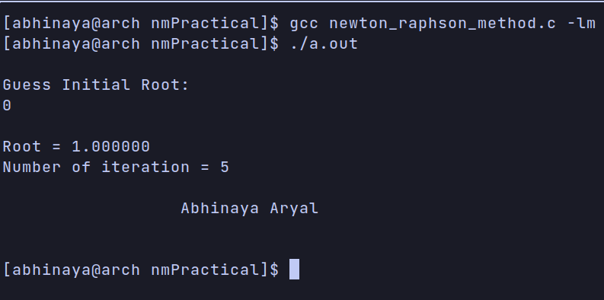

4. Fixed Point Method
#include <stdio.h>
#include <math.h>

float g(float x) {
float y;

y = 2.0 - x * x;
return y;
}

int main() {
float x0, x, error, E = 0.0001;

printf("\nInput initial guess:\n");
scanf("%f", &x0);

while (1) {
x = g(x0);
error = (x - x0) / x;

if (fabs(error) < E) {
printf("\nRoot = %f", x0);
printf("\n\n\t\t Abhinaya Aryal\n\n\n");
break;
}

x0 = x;
}

return 0;
}

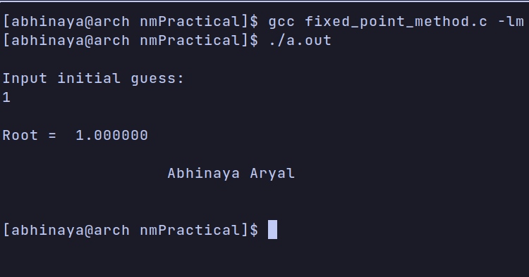

5. Lagrange Interpolation
#include <stdio.h>

int main() {
float x[10], f[10], y, l, sum = 0.0;
int n, i, j;

printf("\nInput number of data : \n");
scanf("%d", &n);
printf("\nInput data points x(i), & f(i) : \n");

for (i = 0; i < n; i++) {
printf("\nx[%d] = ", i);
scanf("%f", &x[i]);
printf("\nf[%d] = ", i);
scanf("%f", &f[i]);
}

printf("\n Functional Value: ");
scanf("%f", &y);

for (i = 0; i < n; i++) {
l = 1;

for (j = 0; j < n; j++) {
if (j != i) {
l = l * (y - x[j]) / (x[i] - x[j]);
}
}

sum = sum + l * f[i];
}

printf("\n Value at %f = %f\n", y, sum);
printf("\n\n\t\t Abhinaya Aryal\n\n\n");

return 0;
}

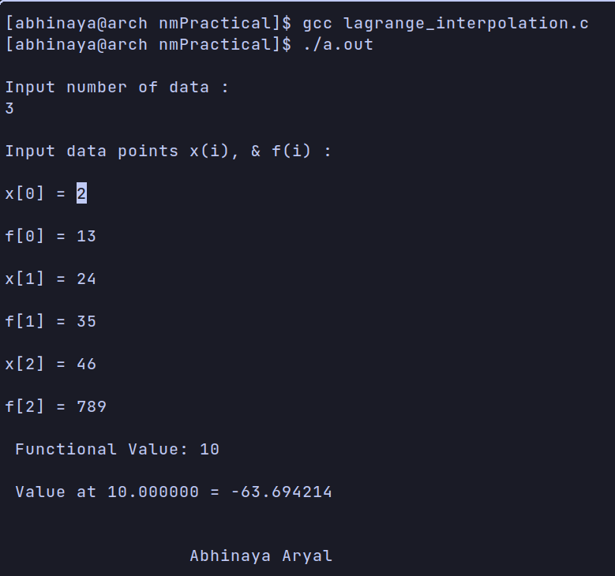

6. Curve Fitting Linear Equation
#include <stdio.h>
#include <math.h>

#define error 0.001

int main() {
int i, n;
float x[10], y[10], sumx = 0.0, sumy = 0.0;
float sumxx = 0.0, sumxy = 0.0;
float meanx, meany, denom, a, b;
printf("\nHow many element? : ");
scanf("%d", &n);

for (i = 0; i < n; i++) {
printf("\nx[%d] = ", i);
scanf("%f", &x[i]);
printf("y[%d] = ", i);
scanf("%f", &y[i]);
}

for (i = 0; i < n; i++) {
sumx += x[i];
sumy += y[i];
sumxx += x[i] * x[i];
sumxy += x[i] * y[i];
}

meanx = sumx / n;
meany = sumy / n;
denom = n * sumxx - sumx * sumx;
if (fabs(denom) > error) {

b = (n * sumxy - sumx * sumy) / denom;
a = meany - b * meanx;
printf("\ny = %fx + %f", b, a);
printf("\n\n\t\t Abhinaya Aryal\n\n\n");

}
else {
printf("\nNo solution");
printf("\n\n\t\t Abhinaya Aryal\n\n\n");

}
return 0;
}

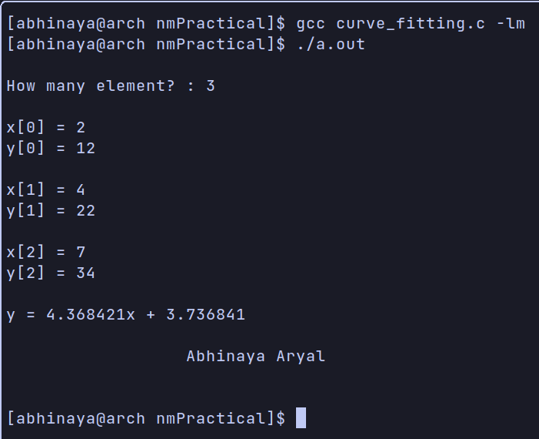

7. Trapezoidal Rule
#include <stdio.h>
#include <math.h>

float f(float x) {
return (1 - exp(-x/2.0));
}

int main() {
float a, b, h, x, sum = 0;
int n;

printf("\nEnter initial and final value of x : \n");
scanf("%f%f", &a, &b);
printf("\nNumber of segments : ");
scanf("%d", &n);
h = (b - a) / n;

for (x = a; x <= b; x = x + h) {
if (x == a) {
sum = sum + f(x);
}
else if (x == b) {
sum = sum + f(x);
}
else {
sum = sum + 2 * f(x);
}
}
sum = sum * h / 2;

printf("\nIntegral value of f(x) = %f", sum);

printf("\n\n\t\t Abhinaya Aryal\n\n");

return 0;
}
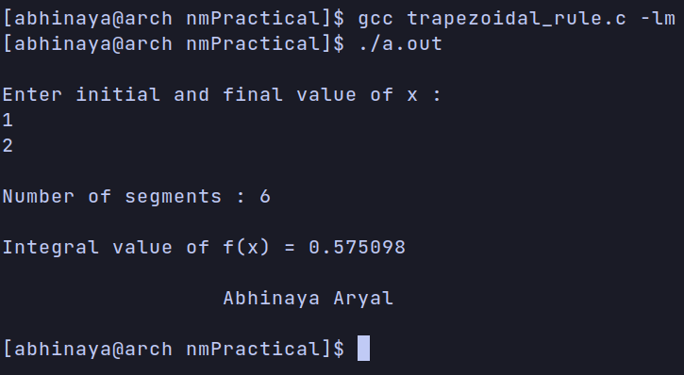

8. Simpson’s 1/3 Rule
#include <stdio.h>
#include <math.h>

float f(float x) {
return (1 - exp(-x/2.0));
}

int main() {
float a, b, h, x, ans, sum = 0;
int n, i;

printf("\nEnter initial and final value of x:\n");
scanf("%f%f", &a, &b);
printf("\nNumber of segments : ");
scanf("%d", &n);
h = (b - a) / n;

for (i = 1; i < n; i++) {
x = a + i * h;
if (i % 2 == 0) {
sum = sum + 2 * f(x);
}
else {
sum = sum + 4 * f(x);
}
}
ans = (h / 3) * (f(a) + f(b) + sum);
printf("\nIntegral value of f(x) = %f", ans);
printf("\n\n\t\t Abhinaya Aryal\n\n");
return 0;
}

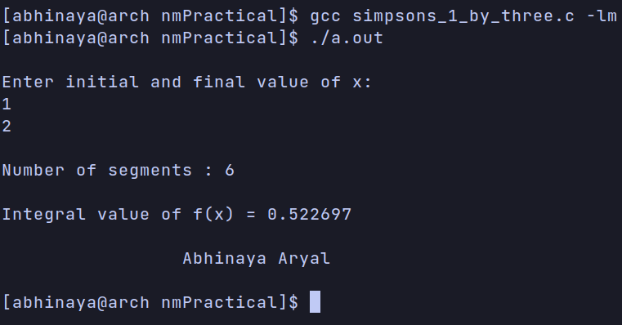

9. Simpson’s 3/8 Rule
#include <stdio.h>
#include <math.h>

float f(float x) {
return (1 - exp(-x/2.0));
}

int main() {
float a, b, h, x, ans, sum = 0;
int n, i;

printf("\nEnter intial and final value of x : \n");
scanf("%f%f", &a, &b);
printf("\nNumber of segment : ");
scanf("%d", &n);
h = (b - a) / n;

for (i = 1; i < n; i++) {
x = a + i * h;
if (i % 3 == 0) {
sum = sum + 2 * f(x);
}
else {
sum = sum + 3 * f(x);
}
}

ans = (3 * h / 8) * (f(a) + f(b) + sum);
printf("\nIntegral value of f(x) = %f", ans);
printf("\n\n\t\t Abhinaya Aryal\n\n");
return 0;
}

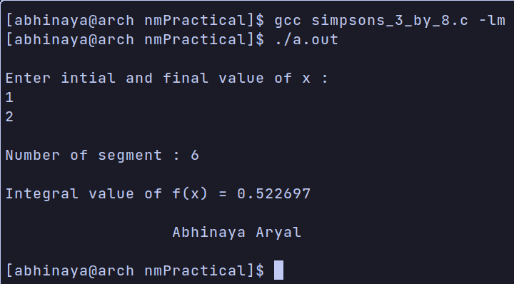

10. Euler Method
#include <stdio.h>
#include <math.h>

float fun(float x, float y) {
float f;

f = x * y;
return f;
}

int main() {
int i, n;
float x0, y0, xp, h, y;
printf("\nEnter initial value of x and y : ");
scanf("%f%f", &x0, &y0);
printf("\nEnter x at which y is required : ");
scanf("%f", &xp);
printf("\nEnter step-size, h : ");
scanf("%f", &h);

n = (xp - x0) / h;

for (i = 0; i < n; i++) {
y = y0 + h * fun(x0, y0);
x0 = x0 + h;
y0 = y;
printf("%f\t%f\n", x0, y);
}

printf("\n Value of y at x = %f is %f", x0, y0);
printf("\n\n\t\t Abhinaya Aryal\n\n");
return 0;

}

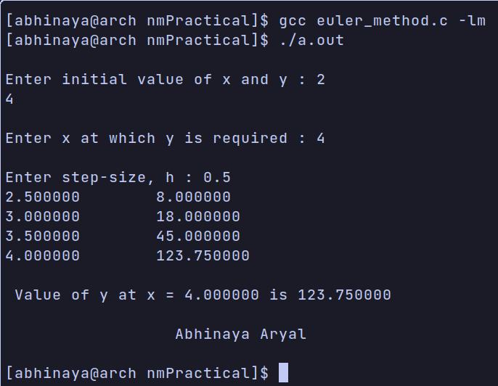

11. Heun’s Method
#include <stdio.h>
#include <math.h>

float func(float x, float y) {
float f;
f = 2.0 * y / x;
return f;
}

int main() {
int i, n;
float x0, y0, xp, h, m1, m2;
printf("Enter initial value of x and y : ");
scanf("%f%f", &x0, &y0);
printf("\n Enter x at which y is required : ");
scanf("%f", &xp);
printf("\nEnter step size, h : ");
scanf("%f", &h);
n = (xp - x0) / h;

for (i = 1; i <= n; i++) {
m1 = func(x0, y0);
m2 = func(x0 + h, y0 + m1 * h);
x0 = x0 + h;
y0 = y0 + 0.5 * h * (m1 + m2);
printf("%f\t%f\n", x0, y0);
}

printf("\nValue of y at x = %f is %f", x0, y0);
printf("\n\n\t\t Abhinaya Aryal\n\n");
return 0;
}

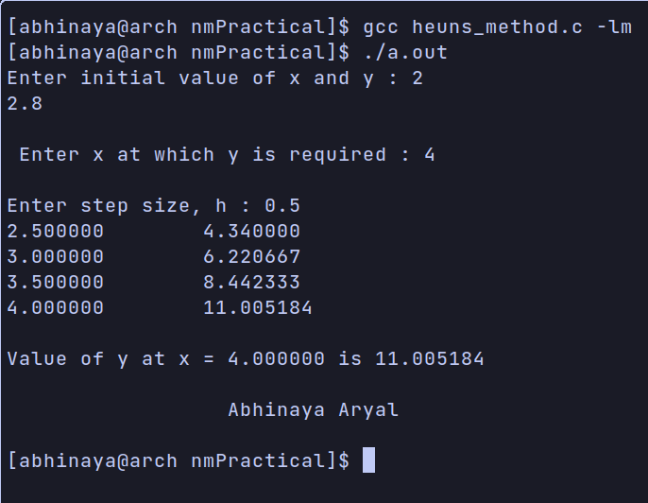

12. 4th Order Runge Kutta Method
#include <stdio.h>
#include <math.h>

float func(float x, float y) {
float f;
f = 2.0 * y / x;
return f;
}

int main() {
int i, n;
float x0, y0, xp, h, m1, m2, m3, m4;

printf("\nEnter initial value of x and y : ");
scanf("%f%f", &x0, &y0);

printf("\nEnter x at which y is required : ");
scanf("%f", &xp);

printf("\nEnter step size, h : ");
scanf("%f", &h);

n = (xp - x0) / h;

for (i = 1; i <= n; i++) {
m1 = func(x0, y0);
m2 = func(x0 + 0.5 * h, y0 + 0.5 * m1 * h);
m3 = func(x0 + 0.5 * h, y0 + 0.5 * m2 * h);
m4 = func(x0 + h, y0 + m3 * h);
x0 = x0 + h;
y0 = y0 + (m1 + 2 * m2 + 2 * m3 + m4) * h / 6;
printf("%f\t%f\n", x0, y0);

}
printf("\n Value of y at x = %f is %f", x0, y0);
printf("\n\n\t\t Abhinaya Aryal\n\n");
return 0;
}

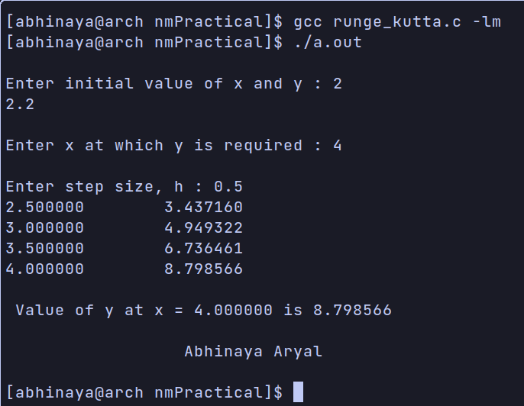

13. Gauss Elimination Method
#include <stdio.h>

int main() {
int i, j, k, n;
float A[20][20], r, x[10], sum = 0.0;

printf("\nEnter the order of matrix : ");
scanf("%d", &n);
printf("\nEnter the elements of augmented matrix row-wise : \n\n");

for (i = 1; i <= n; i++) {
for (j = 1; j <= n+1; j++) {
printf("A[%d][%d] : ", i, j);
scanf("%f", &A[i][j]);
}
}
// Generation of upper triangle matrix:
for (j = 1; j <= n; j++) {
for (i = 1; i <= n; i++) {
if (i > j) {
r = A[i][j] / A[j][j];
for (k = 1; k <= n+1; k++) {
A[i][k] = A[i][k] - r * A[j][k];
}
}
}
}
x[n] = A[n][n+1] / A[n][n];

// backward substitution

for (i = n-1; i >= 1; i--) {
sum = 0;
for (j = i+1; j <= n; j++) {
sum = sum + A[i][j] * x[j];
}
x[i] = (A[i][n+1] - sum) / A[i][i];
}
printf("\nThe solution is : \n");
for (i = 1; i <= n; i++) {
printf("\nx%d = %f\t", i, x[i]);
}
printf("\n\n\t\t Abhinaya Aryal\n\n");
return 0;
}
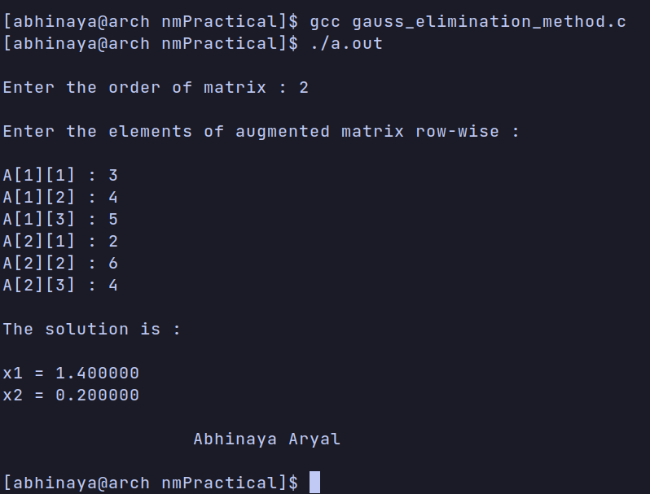

14. Gauss Jordan Method
#include <stdio.h>

int main() {
int i, j, k, n;
float A[20][20], r, x[10];
printf("\nEnter the size of matrix : ");
scanf("%d", &n);
printf("\nEnter the elements of augmented matrix row-wise : \n");

for (i = 1; i <= n; i++) {
for (j = 1; j <= n+1; j++) {
printf("A[%d][%d] : ", i, j);
scanf("%f", &A[i][j]);
}
}

// finding diaognal matrix
for (j = 1; j <= n; j++) {
for (i = 1; i <= n; i++) {
if(i != j) {
r = A[i][j] / A[j][j];
for (k = 1; k <= n + 1; k++) {
A[i][k] = A[i][k] - r * A[j][k];
}
}
}
}

printf("\nThe solution is: \n");
for (i = 1; i <= n; i++) {
x[i] = A[i][n+1] / A[i][i];
printf("\nx%d = %f", i, x[i]);

}
printf("\n\n\t\t Abhinaya Aryal\n\n");
return 0;
}

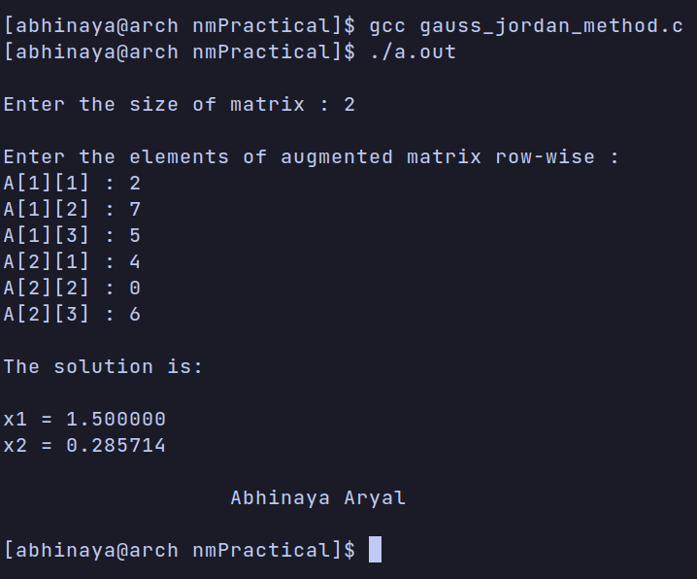

15. Gauss Jacobi Iterative Method
#include <stdio.h>
#include <math.h>

#define f1(x, y, z) (15-y-z)/10
#define f2(x, y, z) (24-x-z)/10
#define f3(x, y, z) (33-x-y)/10

int main() {
float x0 = 0, y0 = 0, z0 = 0, x1, y1, z1, e1, e2, e3, e;
int i = 1;
printf("Enter the allowed error : \n");
scanf("%f", &e);
printf("\ni\tx\ty\tz\n");

do {
x1 = f1(x0, y0, z0);
y1 = f2(x0, y0, z0);
z1 = f3(x0, y0, z0);
printf("%d\t%f\t%f\t%f\n", i, x1, y1, z1);

// error
e1 = fabs(x0 - x1);
e2 = fabs(y0 - y1);
e3 = fabs(z0 - z1);
i++;

// set value for next iteration
x0 = x1;
y0 = y1;
z0 = z1;
}while (e1 > e && e2 > e && e3 > e);

printf("\n Solution : x = %f, y = %f and z = %f \n", x1, y1, z1);
printf("\n\n\t\t Abhinaya Aryal \n\n");
return 0;
}

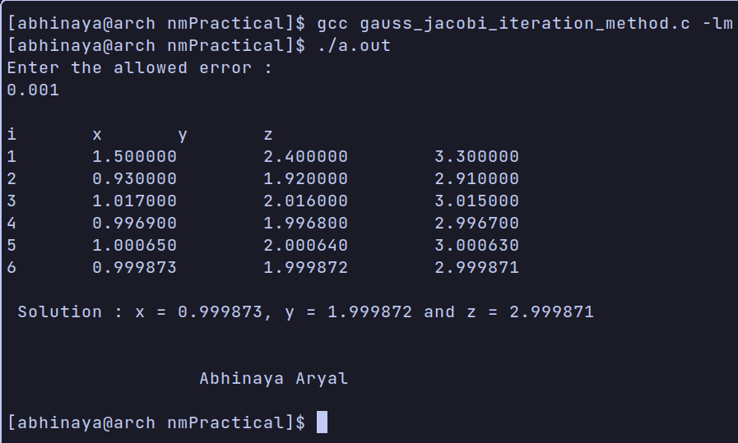

16. Gauss Seidal Iteration Method
#include <stdio.h>
#include <math.h>

#define f1(x, y, z) (15-y-z)/10
#define f2(x, y, z) (24-x-z)/10
#define f3(x, y, z) (33-x-y)/10

int main() {
float x0 = 0, y0 = 0, z0 = 0, x1, y1, z1, e1, e2, e3, e;
int i = 1;
printf("\nEnter the allowed error : ");
scanf("%f", &e);
printf("\ni\tx\ty\tz\n");
do {
x1 = f1(x0, y0, z0);
y1 = f2(x1, y0, z0);
z1 = f3(x1, y1, z0);
printf("%d\t%f\t%f\t%f\n", i, x1, y1, z1);

e1 = fabs(x0 - x1);
e2 = fabs(y0 - y1);
e3 = fabs(z0 - z1);
i++;

x0 = x1;
y0 = y1;
z0 = z1;
}while (e1 > e && e2 > e && e3 > e);

printf("\nSolution: x = %f, y = %f and z = %f \n", x1, y1, z1);
printf("\n\n\t\t Abhinaya Aryal\n\n");
return 0;

}

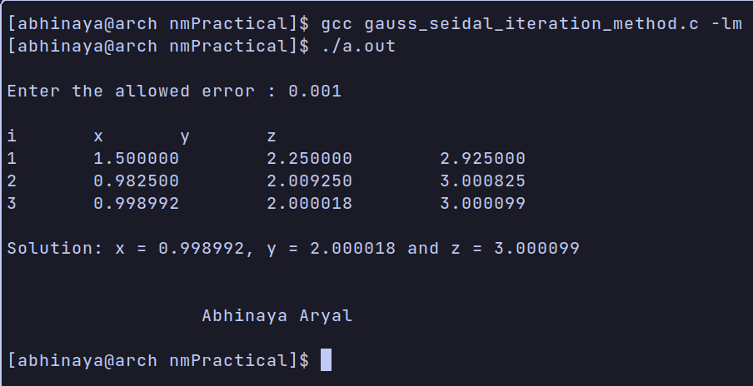

Thank You !!

