**PLOTS**

**HISTOGRAM PLOTS:**

A histogram is a graphical representation of the distribution of numerical data.It divides the range of the data into intervals and displays the frequency of observations falling into each interval with bars.

Consider the “iris” dataset.

**1.SEPAL LENGTH** :

COMMAND:

hist(iris$Sepal.Length,main="Histogram of Sepal length",xlab="sepal length")

OUTPUT:

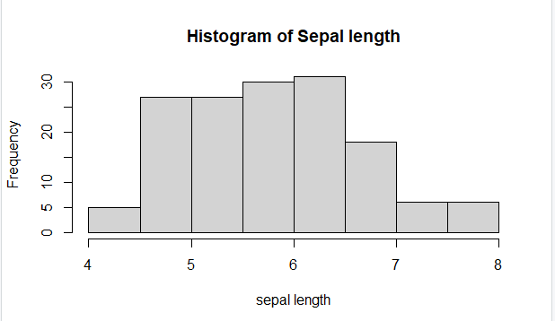

**2.SEPAL WIDTH:**

COMMAND:

hist(iris$Sepal.Width,main="Histogram of Sepal width",xlab="sepal width")

OUTPUT:

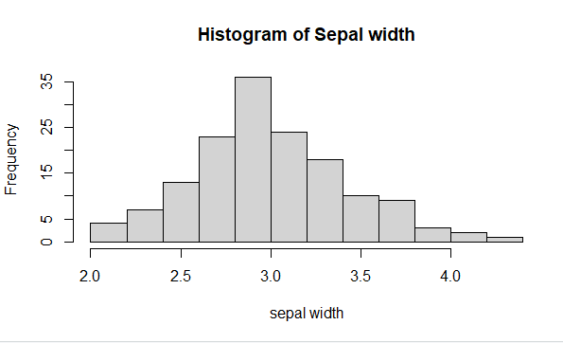

**3.PETAL LENGTH:**

COMMAND:

hist(iris$Petal.Length,main="Histogram of Petal length",xlab="petal length")

OUTPUT:

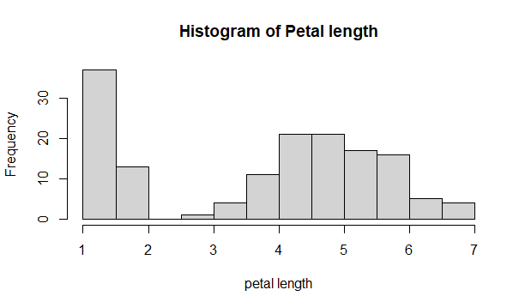

**4.PETAL WIDTH:**

COMMAND:

hist(iris$Petal.Width,main="Histogram of Petal width",xlab="petal width")

OUTPUT:

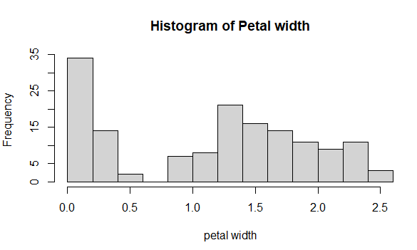

**BOXPLOTS:**

It is a type of chart that depicts a group of numerical data through their quartiles.It is a simple way to visualize the shape of our data.It makes comparing characteristics of data between categories very easy.

PETAL WIDTH:

COMMAND:

boxplot(Petal.Width ~ Species, data=iris, main="Boxplot of Petal Width by Species", xlab="Species", ylab="Petal Width")

OUTPUT:

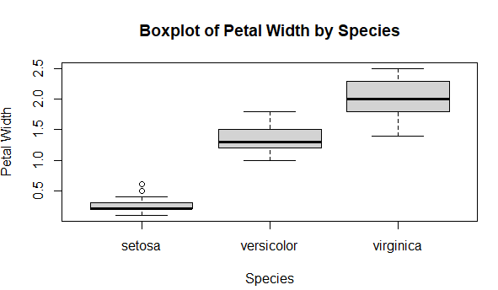

PETAL LENGTH:

COMMAND:

boxplot(Petal.Length ~ Species, data=iris, main="Boxplot of Petal Length by Species", xlab="Species", ylab="Petal Length")

OUTPUT:

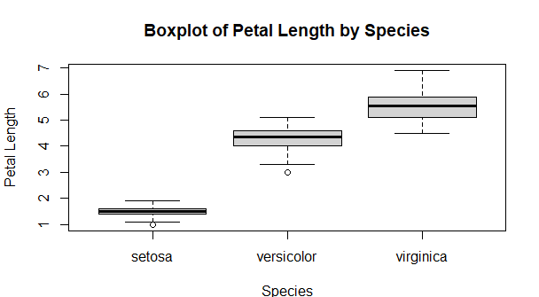

SEPAL LENGTH:

COMMAND:

boxplot(Sepal.Length ~ Species, data=iris, main="Boxplot of Sepal Length by Species", xlab="Species", ylab="Sepal Length")

OUTPUT:

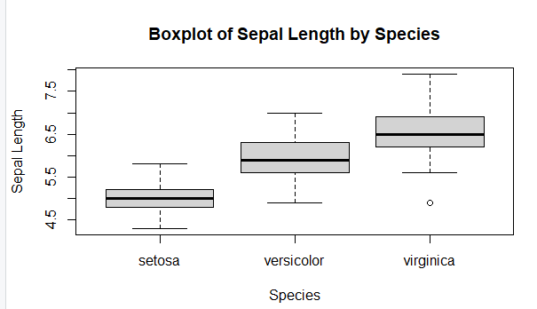

SEPAL WIDTH:

COMMAND:

boxplot(Sepal.Width ~ Species, data=iris, main="Boxplot of Sepal Width by Species", xlab="Species", ylab="Sepal Width")

OUTPUT:

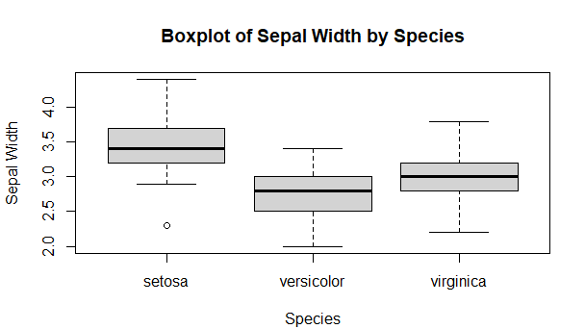

**SCATTERPLOT :**

A scatter plot (aka scatter chart, scatter graph) uses dots to represent values for two different numeric variables. The position of each dot on the horizontal and vertical axis indicates values for an individual data point. Scatter plots are used to observe relationships between variables.

SEPAL:

COMMAND:

plot(iris$Sepal.Length, iris$Sepal.Width, main="Scatter plot of Sepal Length vs. Sepal Width", xlab="Sepal Length", ylab="Sepal Width")

OUTPUT:

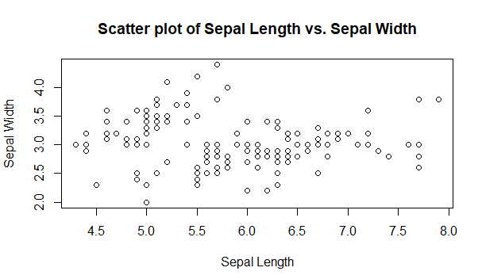

PETAL:

COMMAND:

plot(iris$Petal.Length, iris$Petal.Width, main="Scatter plot of Petal Length vs.Petal Width", xlab="Petal Length", ylab="Petal Width")

OUTPUT:

