STA380_Exercise1

Abhinaya, Jui, Sherlley

August 7, 2018

# Question 1

# Question 2

You can also embed plots, for example:

# Question 3

## Bootstrapping

First, we select the stocks that are of interest to us from the quantmod package

library(mosaic)  
library(quantmod)  
library(foreach)  
  
mystocks = c("SPY", "TLT", "LQD", "EEM", "VNQ")  
myprices = getSymbols(mystocks)  
  
for(ticker in mystocks) {  
 expr = paste0(ticker, "a = adjustOHLC(", ticker, ")")  
 eval(parse(text=expr))  
 }  
  
  
# Combine all the returns in a matrix  
all_returns = cbind(ClCl(SPYa),  
 ClCl(TLTa),  
 ClCl(LQDa),  
 ClCl(EEMa),  
 ClCl(VNQa))  
head(all_returns)

## ClCl.SPYa ClCl.TLTa ClCl.LQDa ClCl.EEMa  
## 2007-01-03 NA NA NA NA  
## 2007-01-04 0.0021221123 0.006063328 0.0075152938 -0.013809353  
## 2007-01-05 -0.0079763183 -0.004352668 -0.0006526807 -0.029238205  
## 2007-01-08 0.0046250821 0.001793566 -0.0002798843 0.007257535  
## 2007-01-09 -0.0008498831 0.000000000 0.0001866169 -0.022336235  
## 2007-01-10 0.0033315799 -0.004475797 -0.0013063264 -0.002303160  
## ClCl.VNQa  
## 2007-01-03 NA  
## 2007-01-04 0.001296655  
## 2007-01-05 -0.018518518  
## 2007-01-08 0.001451392  
## 2007-01-09 0.012648208  
## 2007-01-10 0.012880523

As we can see above, all_returns has the closing returns for the 5 stocks we want to invest in. To determine which out of these are risky and stable, we will plot their returns and check their trend

#plotting since 2007 and since 2017 to compare  
  
chartSeries(SPYa,TA='addBBands();  
 addBBands(draw="p");  
 addVo()',   
 subset='2017-01::2018',  
 theme="white"  
 )

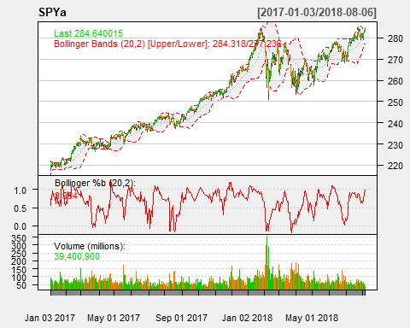

chartSeries(TLTa,TA='addBBands();  
 addBBands(draw="p");  
 addVo()',   
 subset='2017-01::2018',  
 theme="white"  
 )

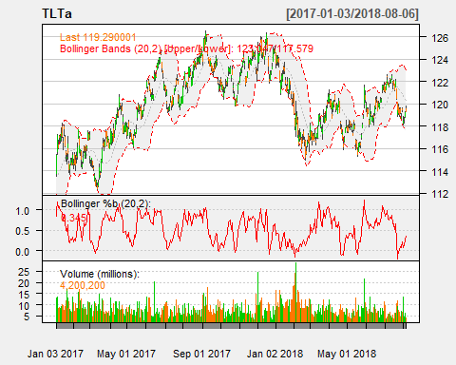

chartSeries(LQDa,TA='addBBands();  
 addBBands(draw="p");  
 addVo()',   
 subset='2017-01::2018',  
 theme="white"  
 )

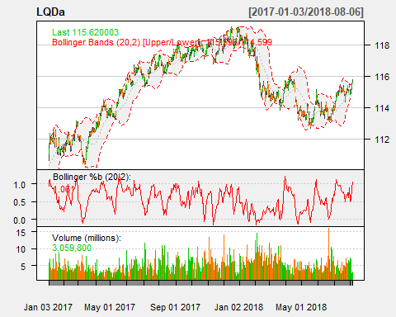

chartSeries(EEMa,TA='addBBands();  
 addBBands(draw="p");  
 addVo()',   
 subset='2017-01::2018',  
 theme="white"  
 )

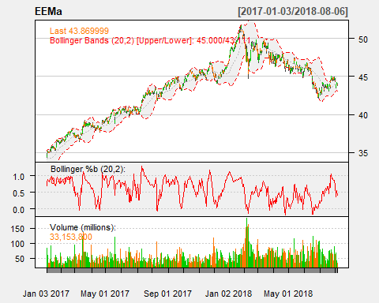

chartSeries(VNQa,TA='addBBands();  
 addBBands(draw="p");  
 addVo()',   
 subset='2017-01::2018',  
 theme="white"  
 )

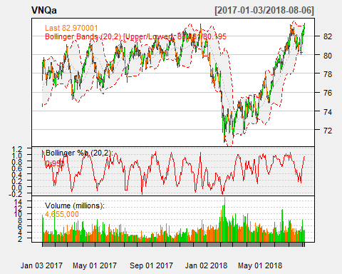

From the charts we can conclude that Emerging markets and Real estate exchange-traded funds have been rather unstable with higher returns

### (a) Simulating for even split

set.seed(12345)  
  
all_returns = as.matrix(na.omit(all_returns))  
  
n_days = 20  
initial_wealth = 100000  
sim1 = foreach(i=1:50000, .combine='rbind') %do% {  
 total_wealth = initial_wealth  
 weights = c(0.2, 0.2, 0.2, 0.2, 0.2)  
 holdings = weights * total_wealth  
 wealthtracker = rep(0, n_days)  
 for(today in 1:n_days) {  
 return.today = resample(all_returns, 1, orig.ids=FALSE)  
 holdings = holdings + holdings*return.today  
 total_wealth = sum(holdings)  
 wealthtracker[today] = total_wealth  
 holdings = total_wealth * weights  
 }  
 wealthtracker  
}  
  
# Calculate 5% value at risk  
quantile(sim1[,n_days], 0.05) - initial_wealth

## 5%   
## -6113.839

### (b) Simulating for safe split

all_returns = as.matrix(na.omit(all_returns))  
  
n_days = 20  
initial_wealth = 100000  
sim1 = foreach(i=1:50000, .combine='rbind') %do% {  
 total_wealth = initial_wealth  
 weights = c(1/3, 1/3, 1/3, 0,0)  
 holdings = weights * total_wealth  
 wealthtracker = rep(0, n_days)  
 for(today in 1:n_days) {  
 return.today = resample(all_returns, 1, orig.ids=FALSE)  
 holdings = holdings + holdings*return.today  
 total_wealth = sum(holdings)  
 wealthtracker[today] = total_wealth  
 holdings = total_wealth * weights  
 }  
 wealthtracker  
}  
  
# Calculate 5% value at risk  
quantile(sim1[,n_days], 0.05) - initial_wealth

## 5%   
## -2969.951

### (b) Simulating for aggressive split

all_returns = as.matrix(na.omit(all_returns))  
  
n_days = 20  
initial_wealth = 100000  
sim1 = foreach(i=1:50000, .combine='rbind') %do% {  
 total_wealth = initial_wealth  
 weights = c(0, 0, 0, 0.5, 0.5)  
 holdings = weights * total_wealth  
 wealthtracker = rep(0, n_days)  
 for(today in 1:n_days) {  
 return.today = resample(all_returns, 1, orig.ids=FALSE)  
 holdings = holdings + holdings*return.today  
 total_wealth = sum(holdings)  
 wealthtracker[today] = total_wealth  
 holdings = total_wealth * weights  
 }  
 wealthtracker  
}  
  
# Calculate 5% value at risk  
quantile(sim1[,n_days], 0.05) - initial_wealth

## 5%   
## -12434.07

## Question 4