- Create one VPC in N. Virginia region. 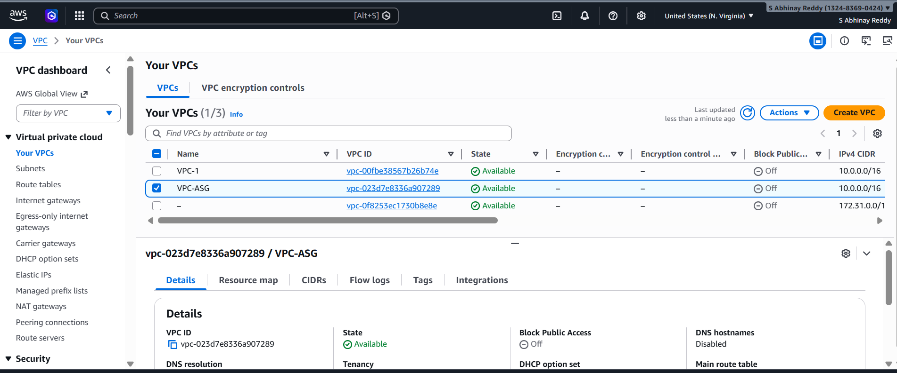
- Create two subnets: one public subnet and one private subnet. 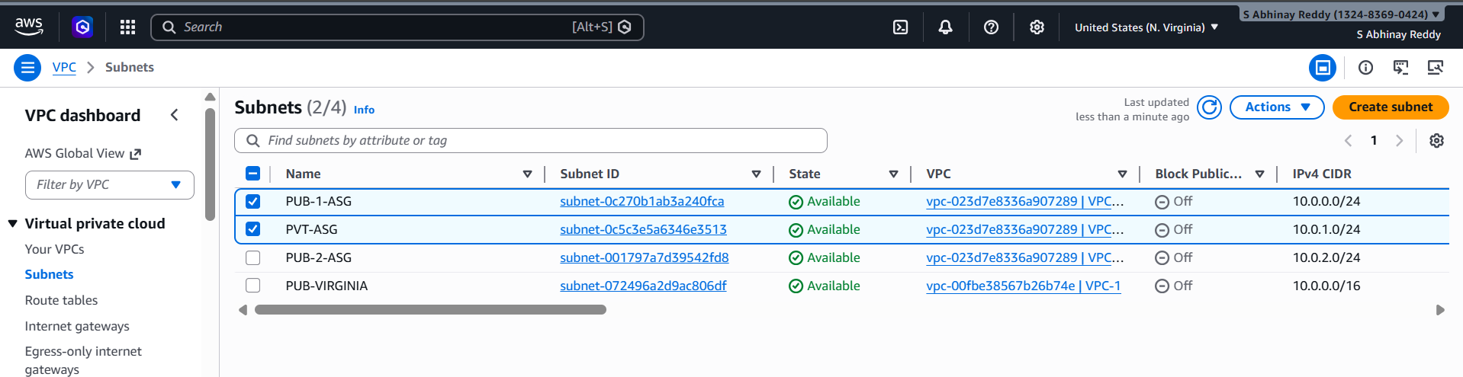
- Attach an IGW to the VPC.
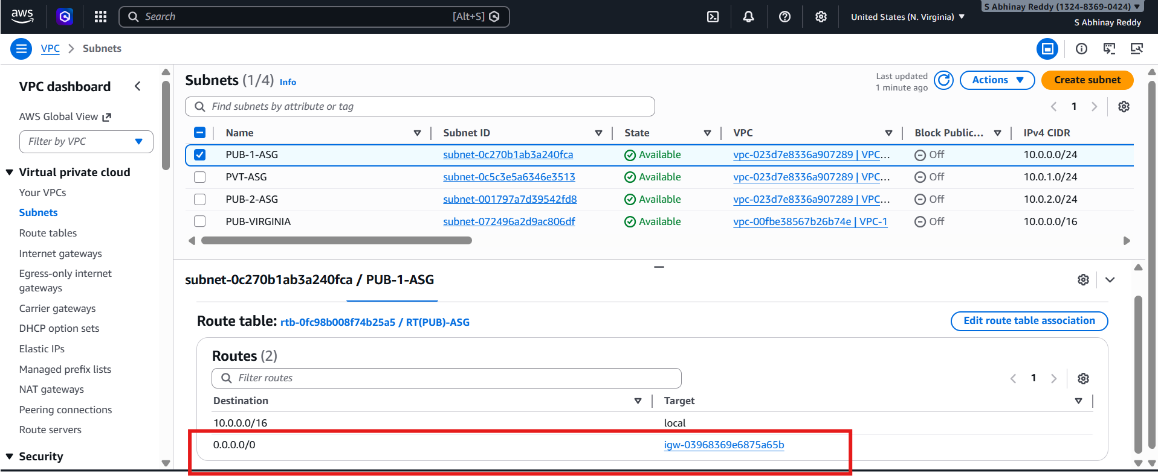
- Create one public route table (RT) and one private route table. 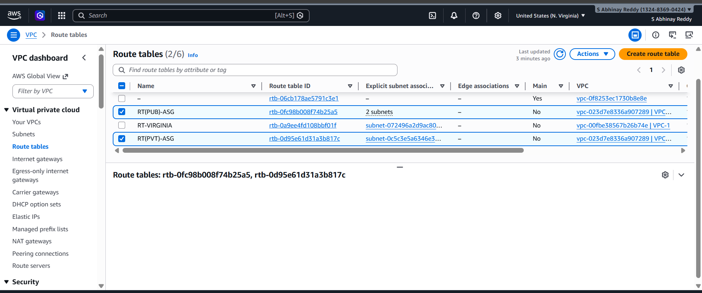
- Deploy a NAT gateway in the public subnet and attach the NAT gateway to the private subnet.
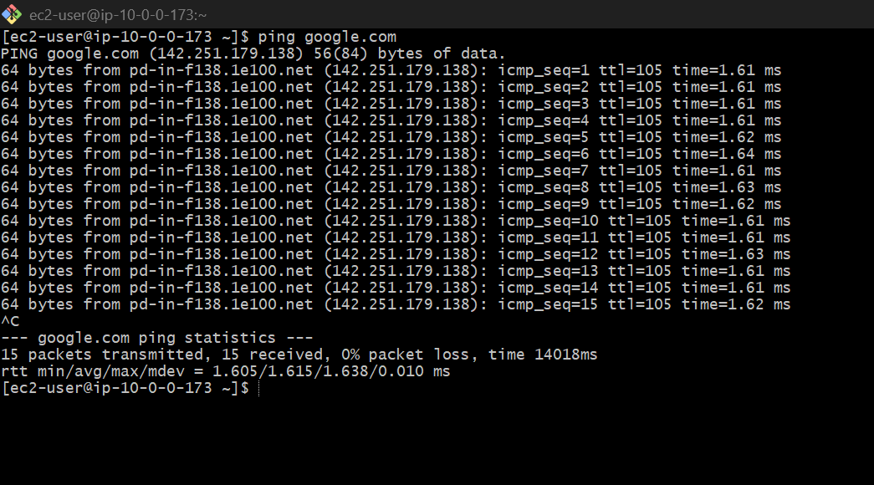
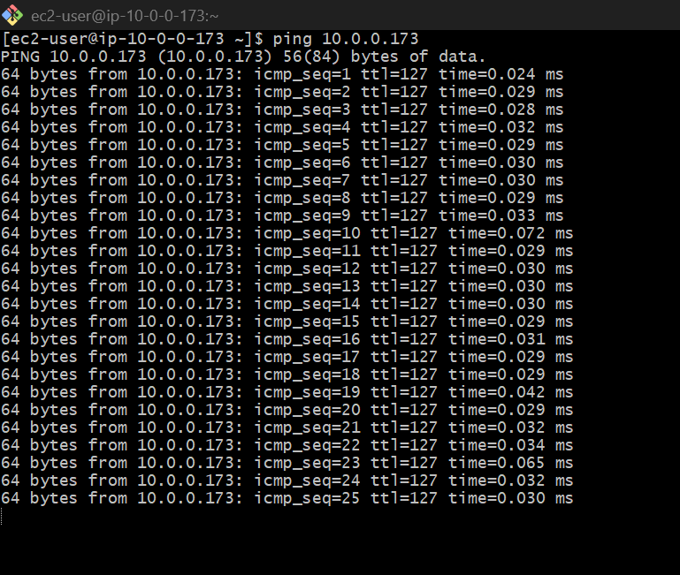

- Create two instances, one in the public subnet and one in the private subnet. 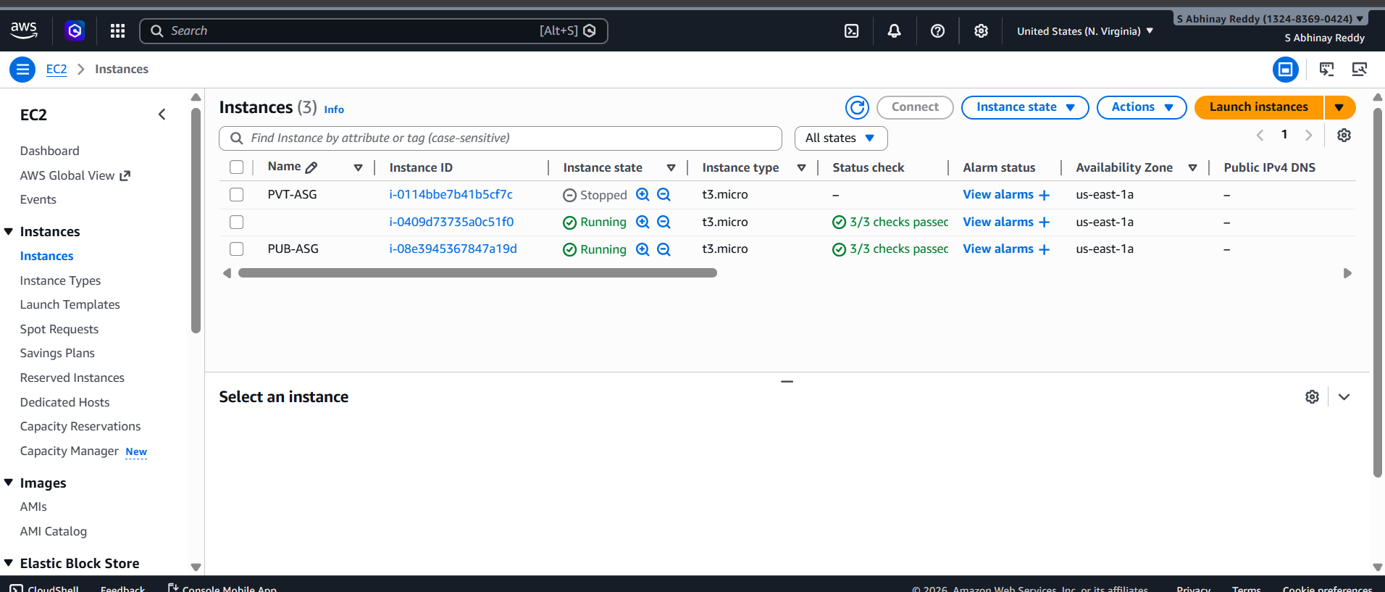

- Deploy Apache server on both EC2 instances with a sample index.html file.
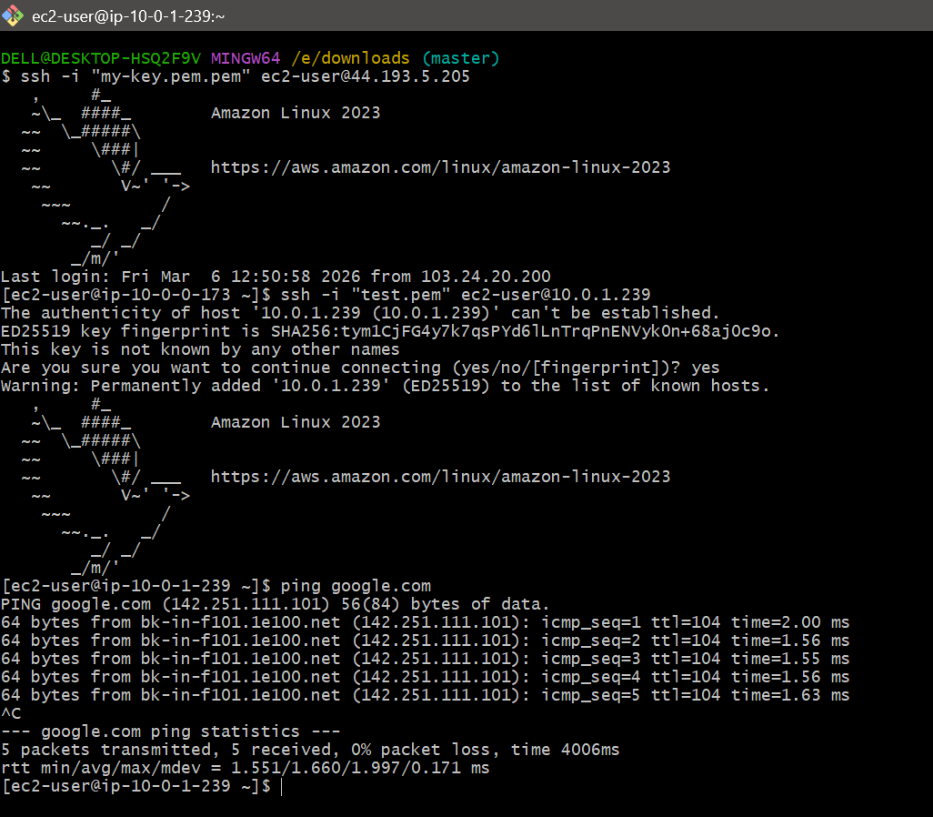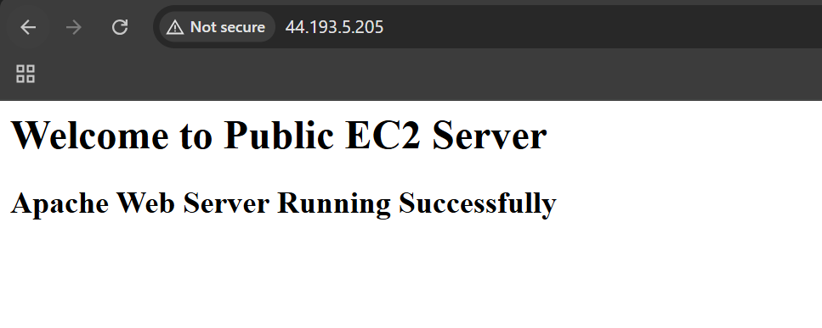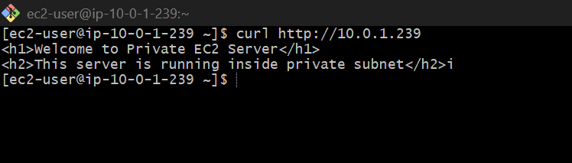
- Create one application load balancer and attach it to both EC2 instances. 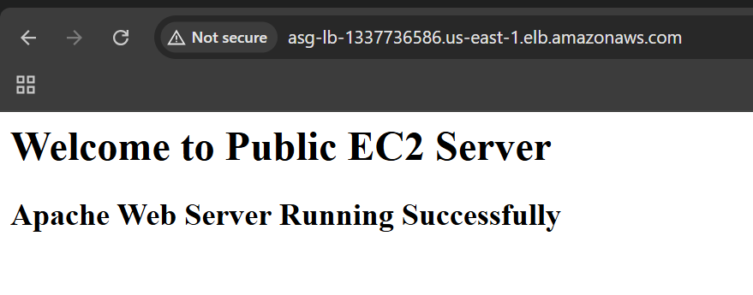
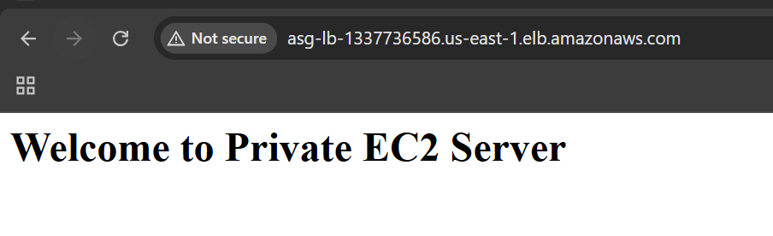

- Store application load balancer logs in S3. 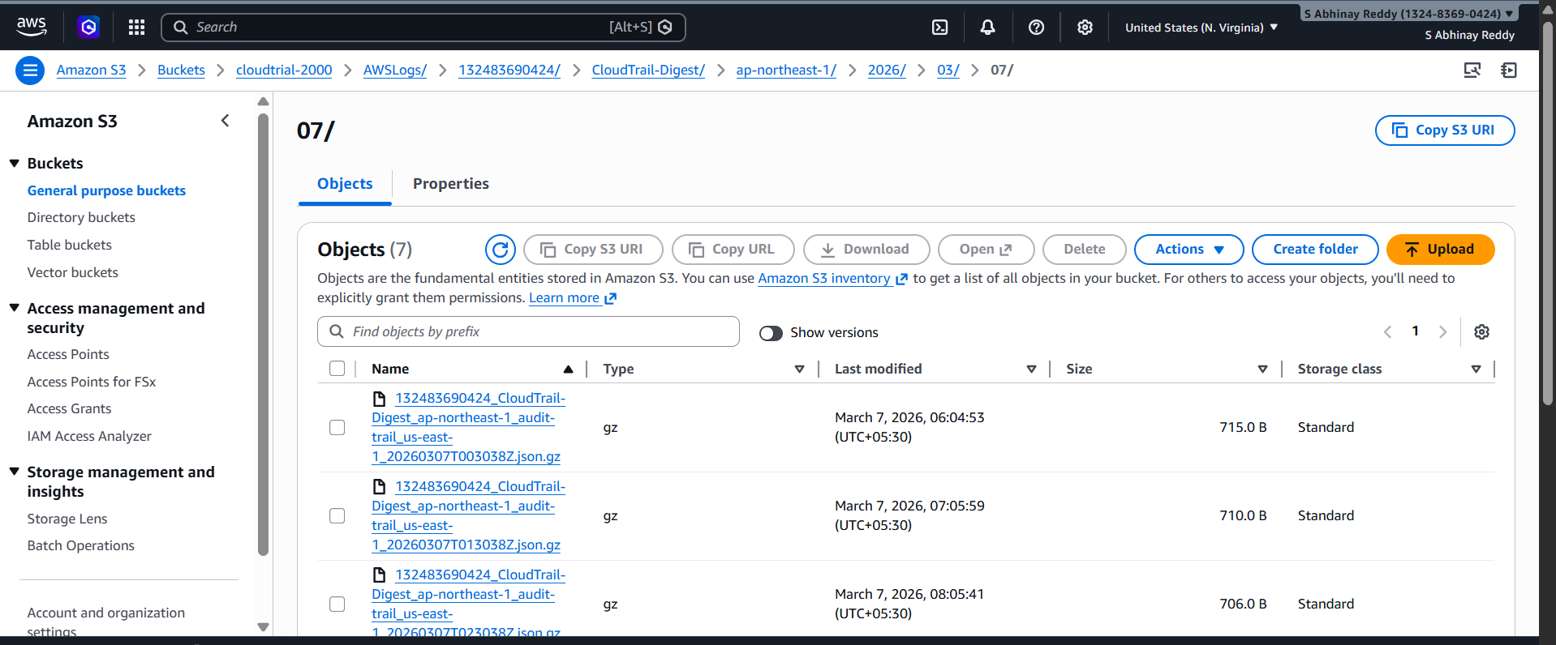
- Store the VPC flow logs in a CloudWatch log group. 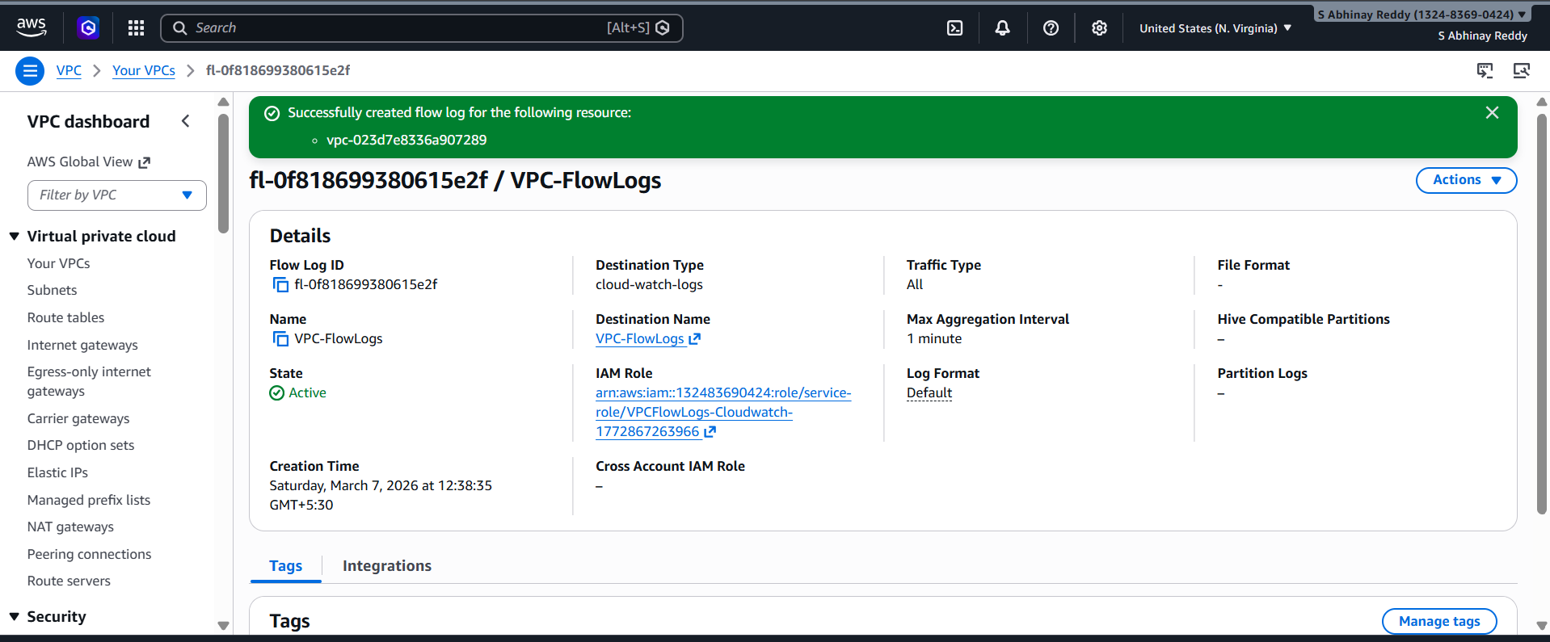 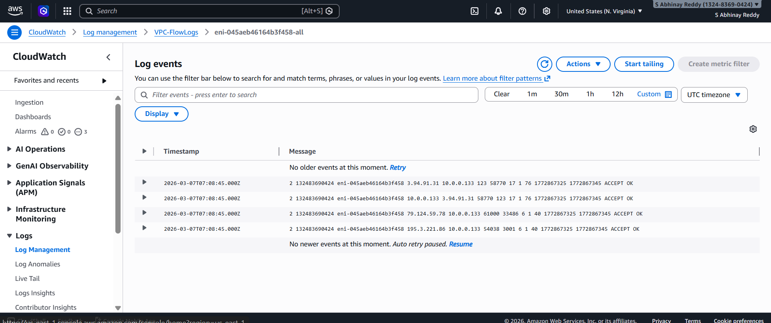

- Create monitoring dashboards to monitor CPU utilization and to monitor the Apache service. 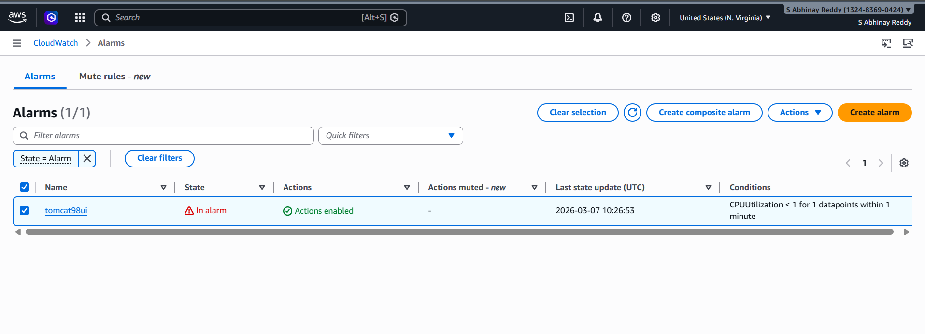 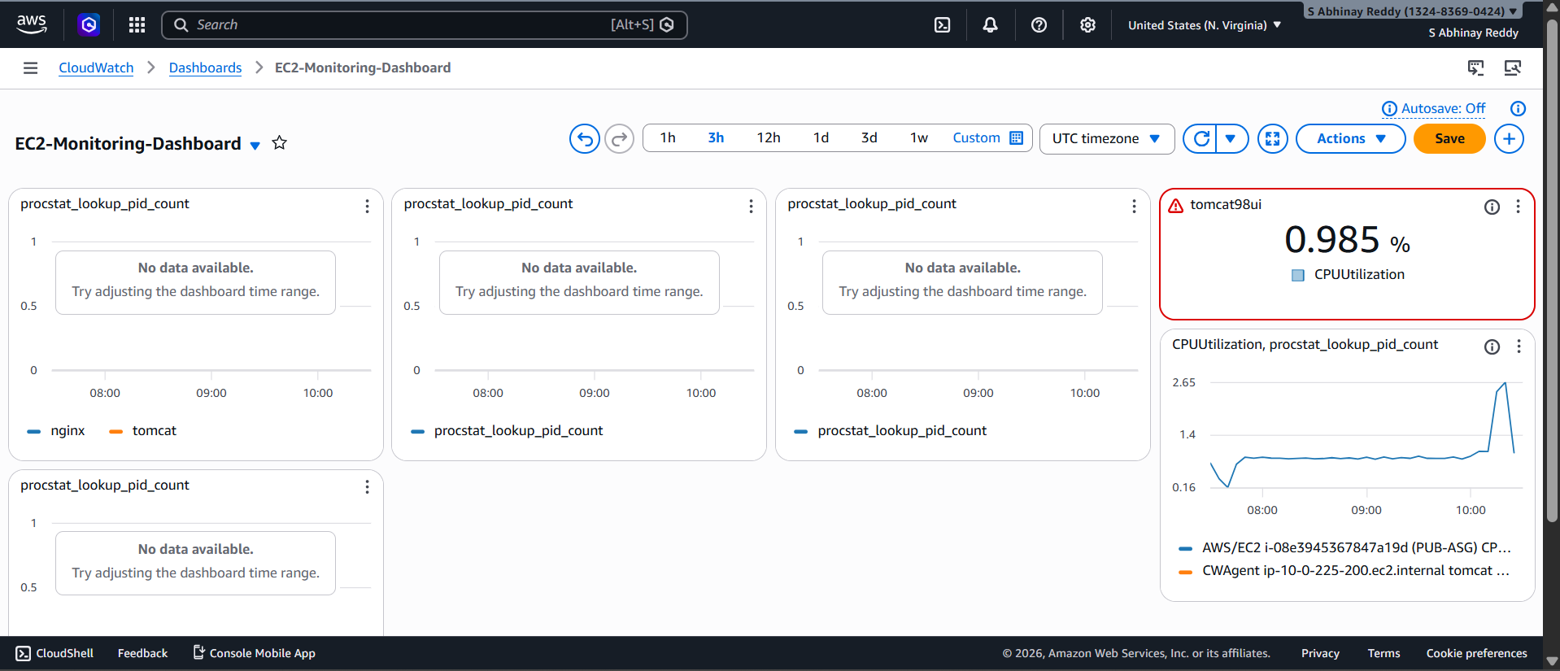

- If CPU utilization is more than 70%, then it should trigger auto scaling and launch new instance. 