- Install Jenkins and run Jenkins on port number 8081.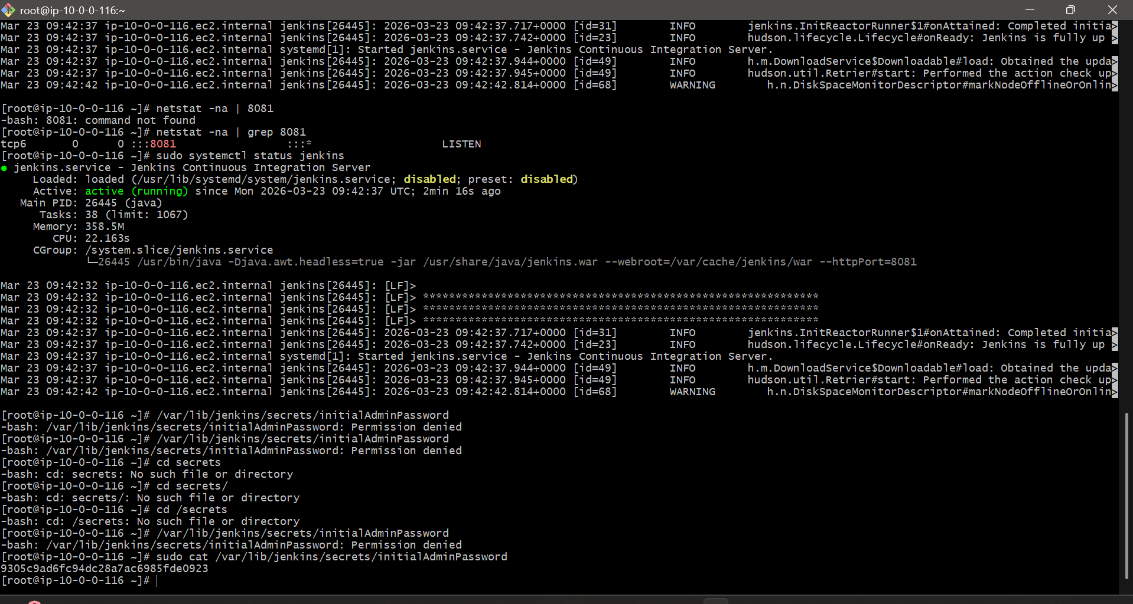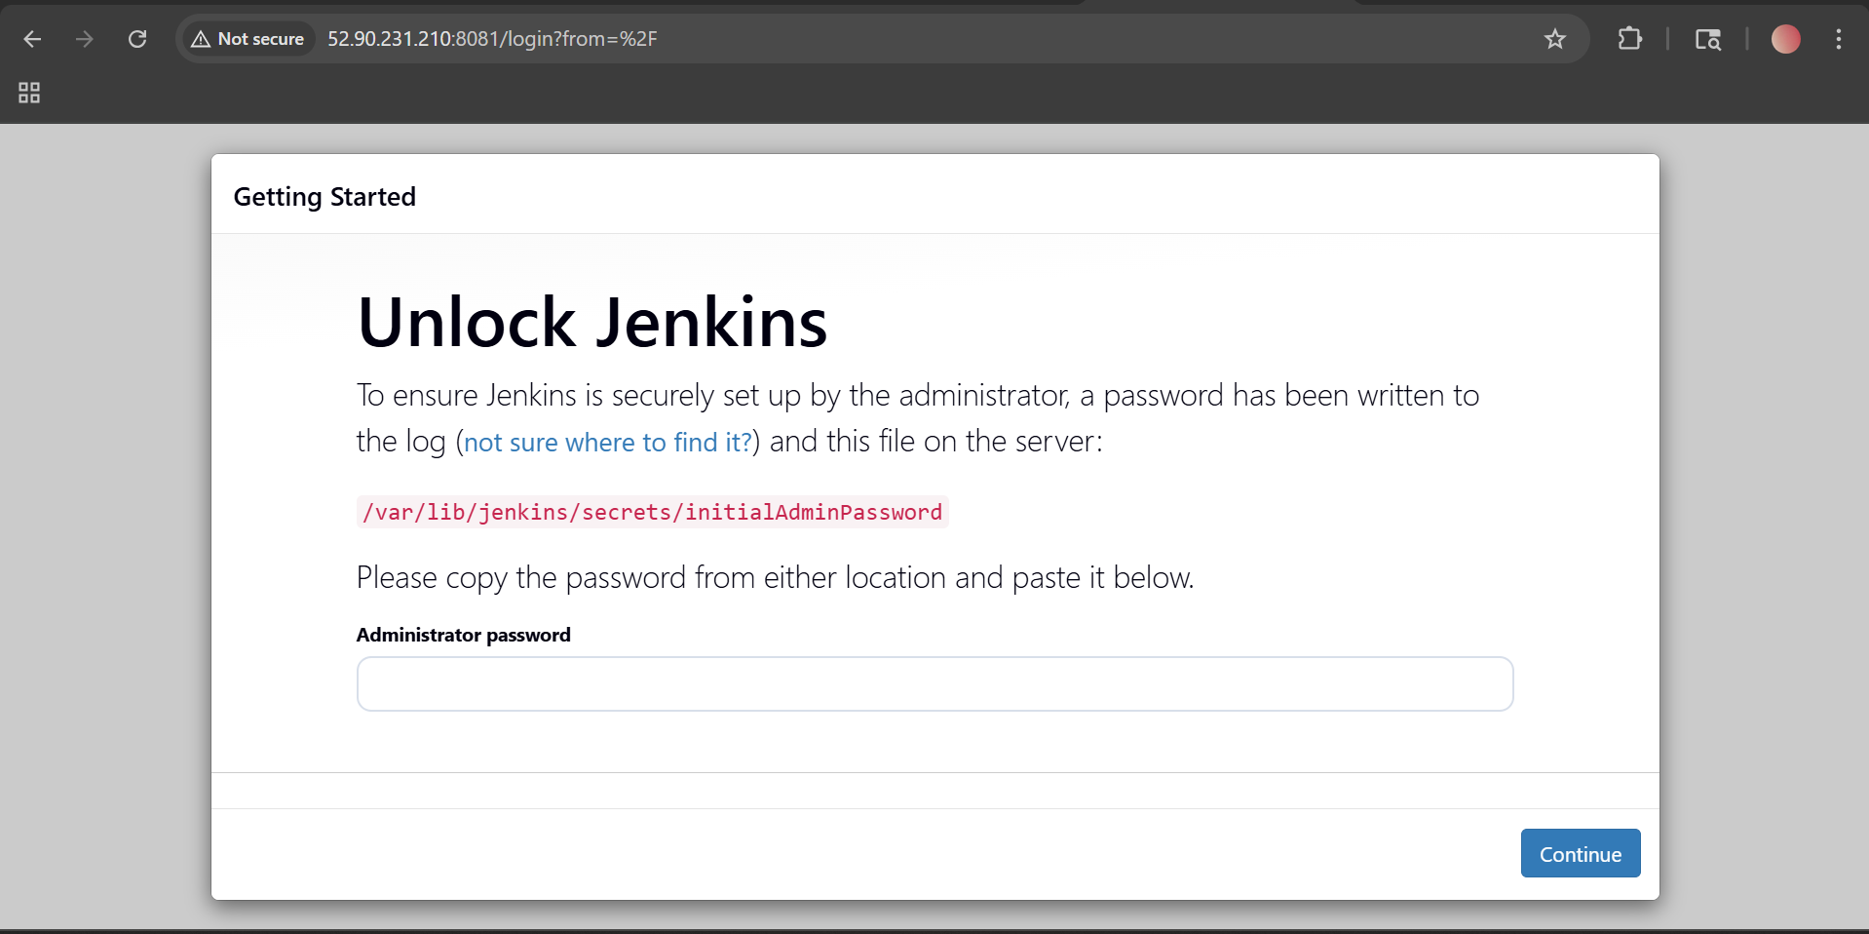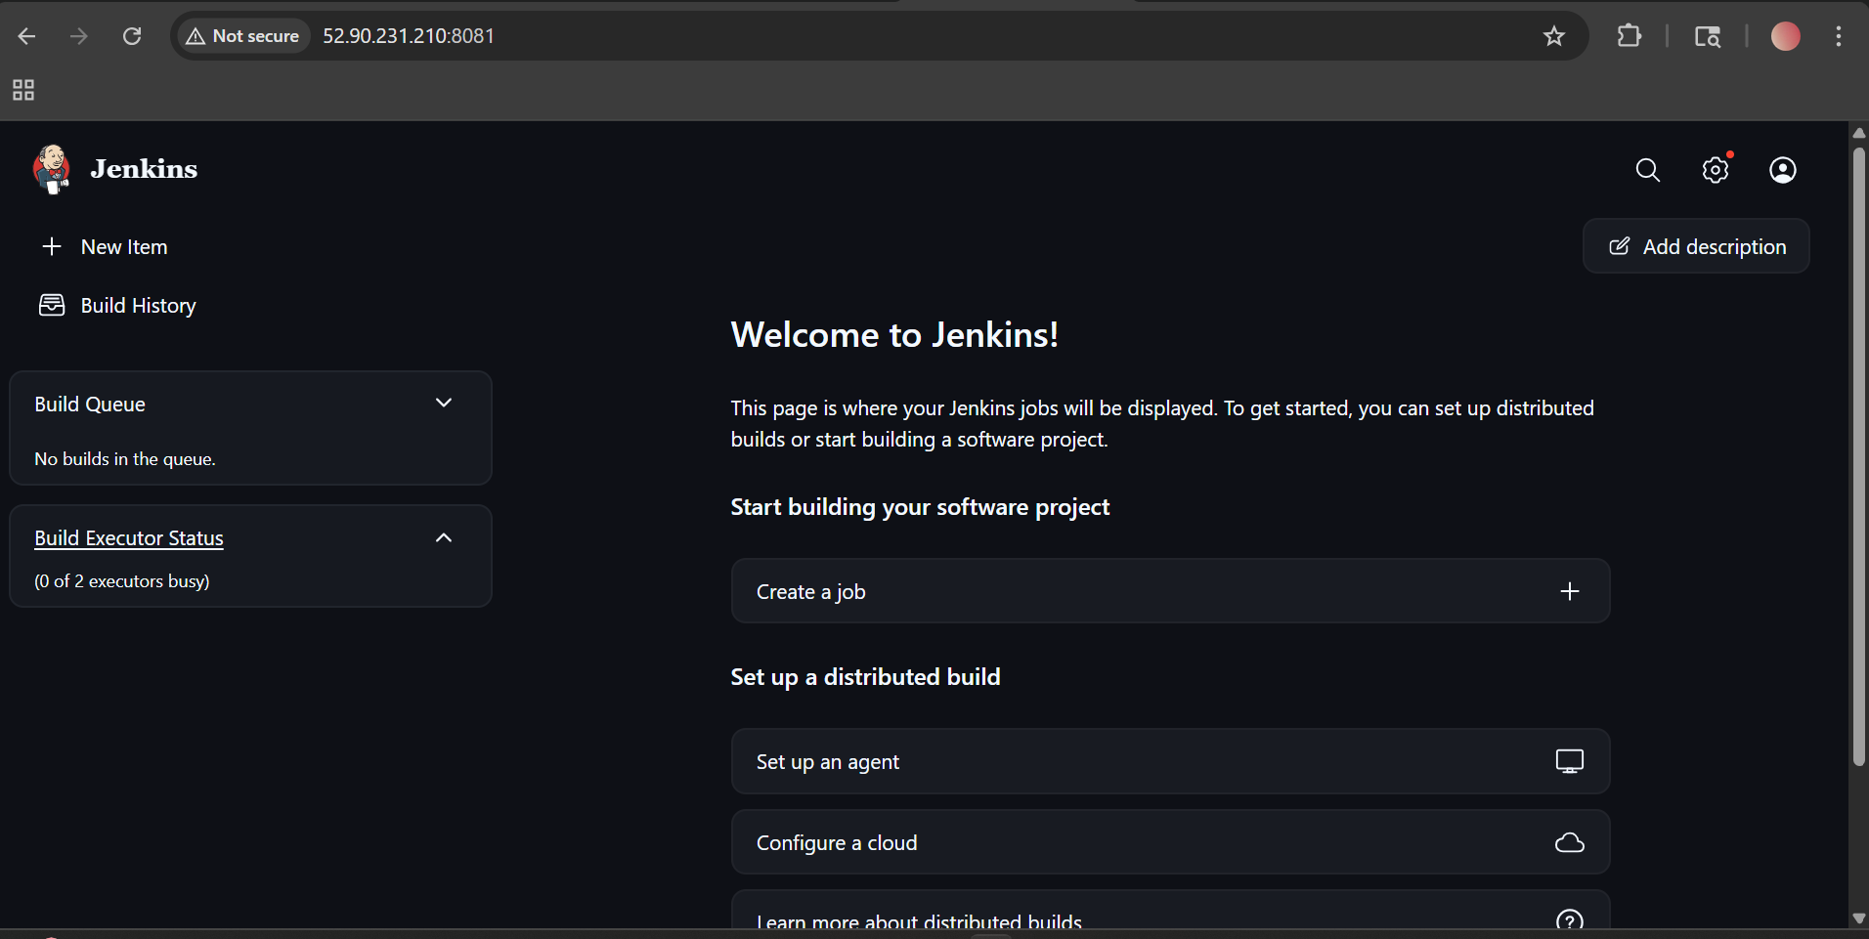
- Secure Jenkins server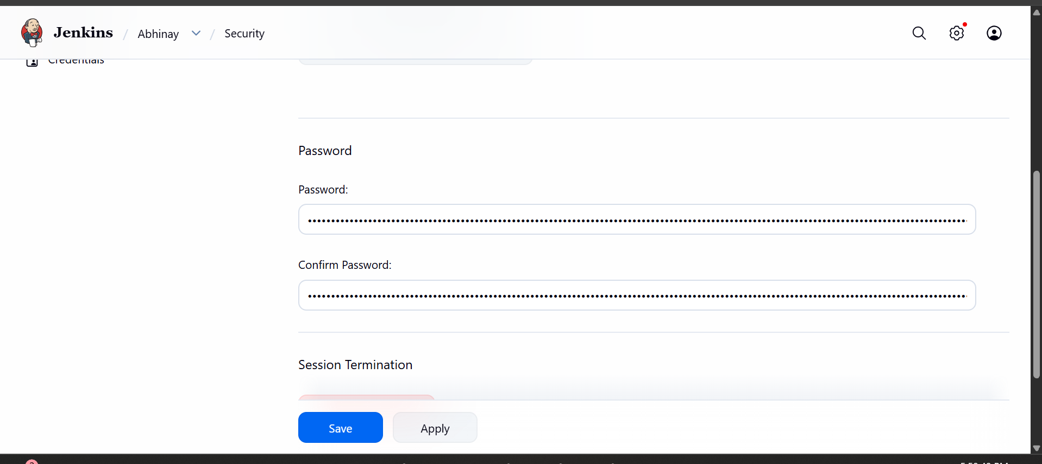

- Create users called DevOps, Testing in Jenkins with Limited access. 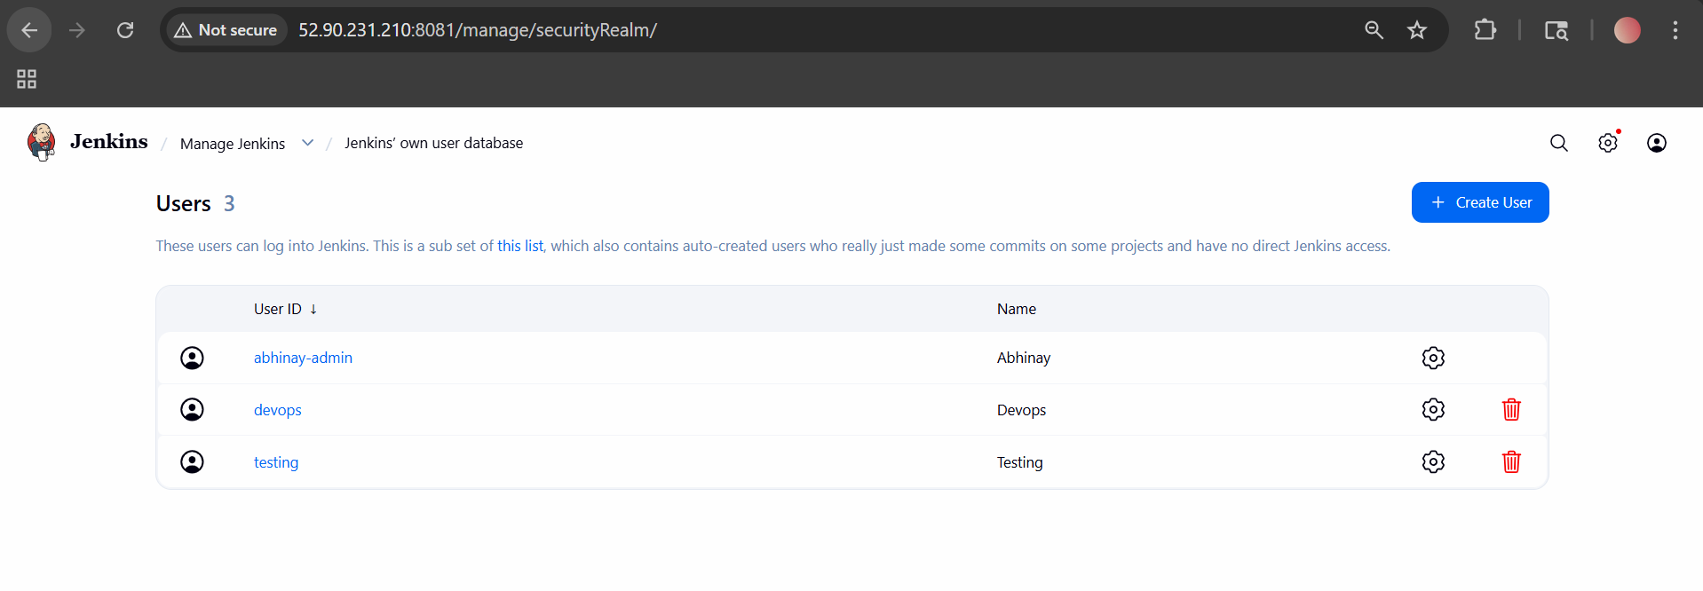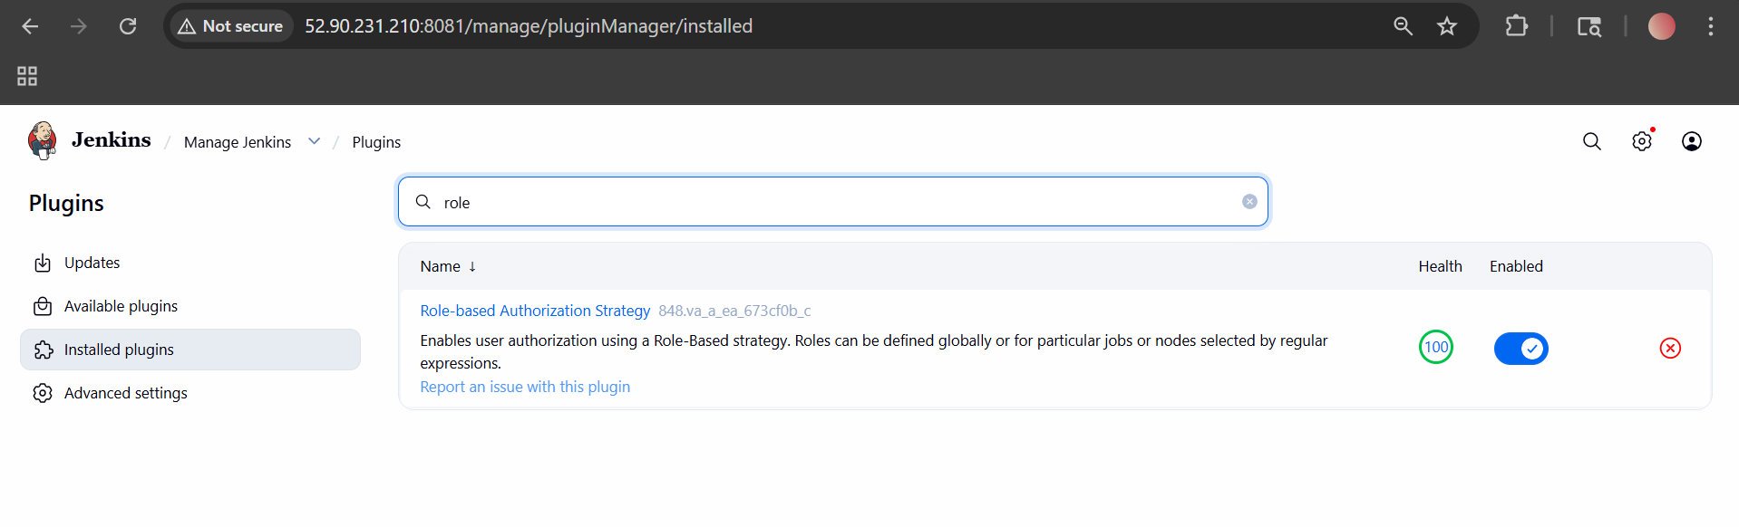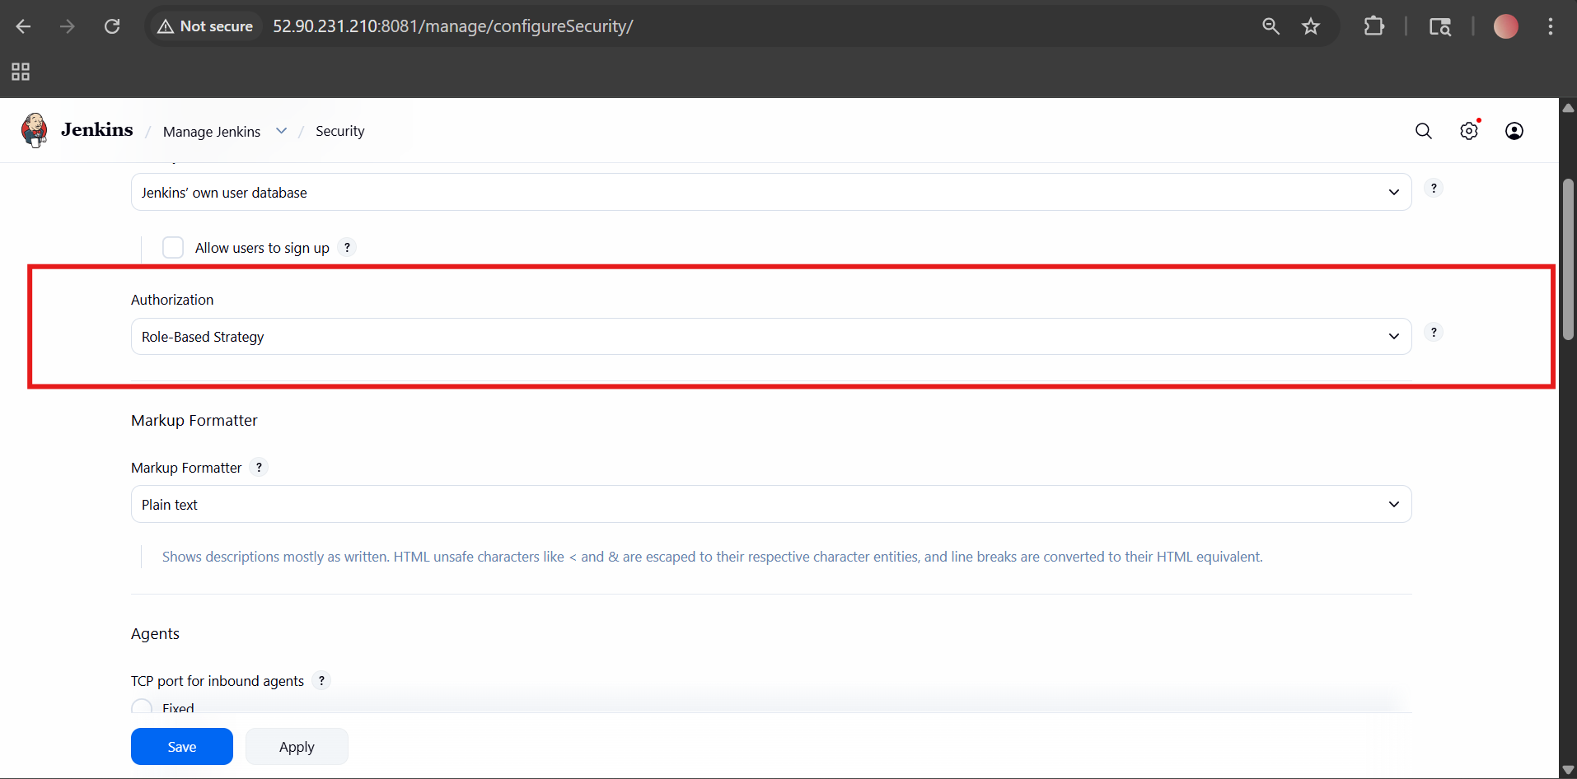
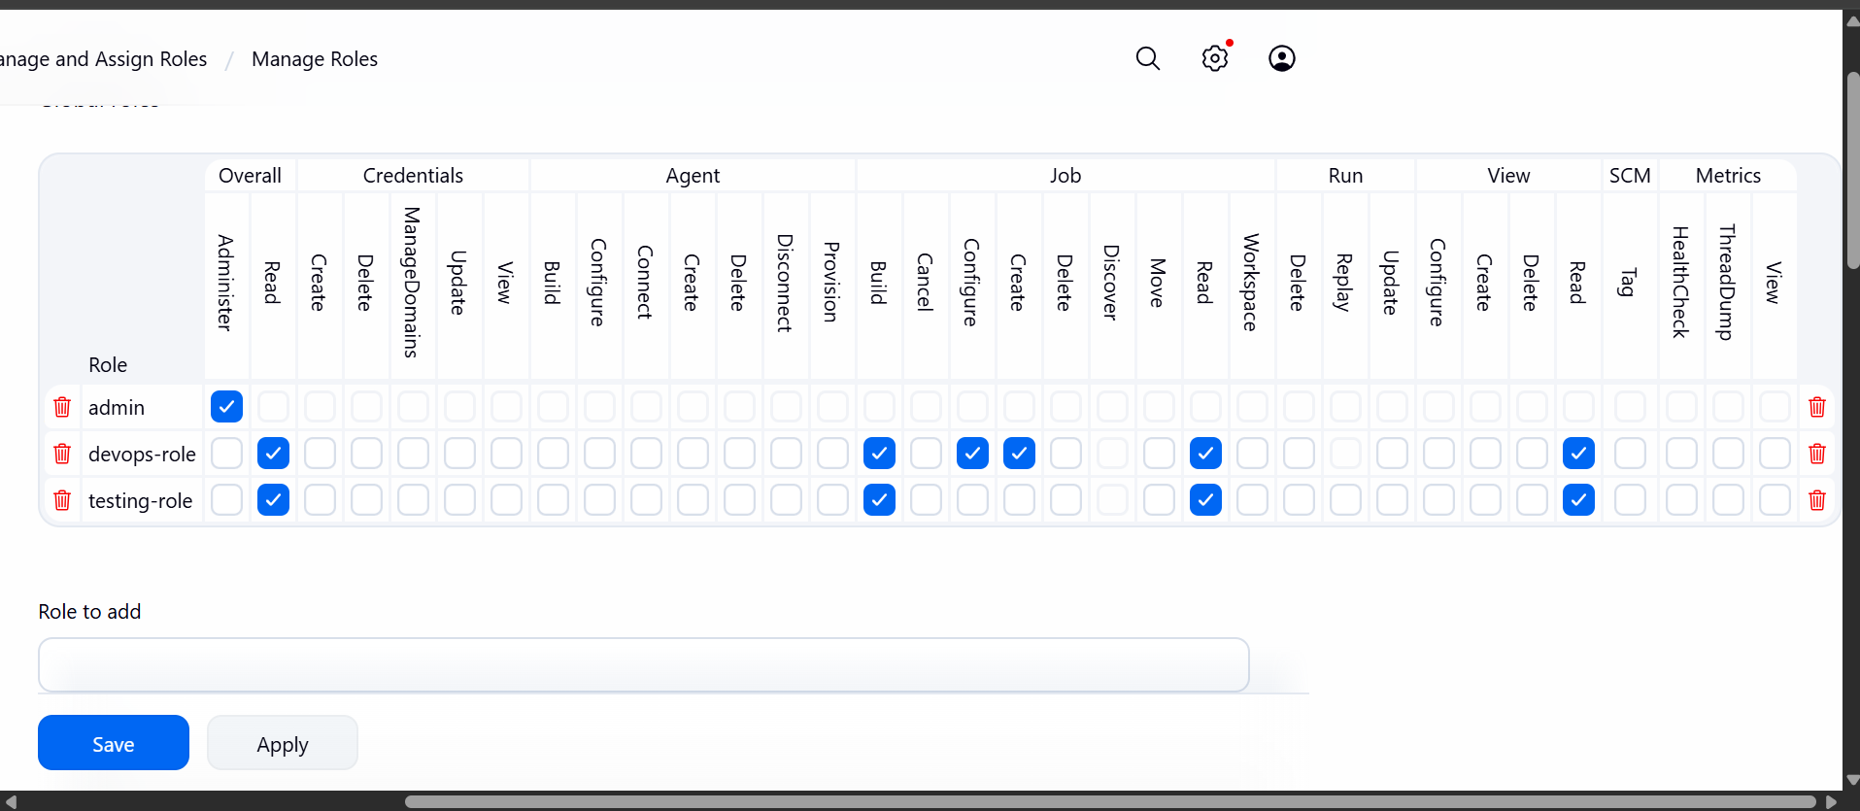

- Configure labels and restrict the jobs to execute based on label only.
What are Labels in Jenkins?
👉 Labels are tags assigned to nodes (agents)
Example:
- dev
- test
- prod
- docker
👉 Then jobs can be restricted to run only on nodes with that label
Step-by-Step Configuration

🔹 Step 1: Configure Node (Agent) Labels
📍 Go to:
👉 Manage Jenkins → Nodes → Built-in Node
(or your EC2 node)

✏️ Click:
👉 Configure

🏷️ Find:
👉 Labels
Add label like:
dev
OR
test

🔹 Step 2: Create Job (or Configure Existing Job)
👉 Go to:
New Item → Freestyle Project
(or open existing job → Configure)

🔹 Step 3: Restrict Job to Label
Find option:
✔ Restrict where this project can be run

✏️ In Label Expression:
Enter:
dev
👉 Meaning:
👉 Job will run ONLY on nodes with label dev

🔹 Step 4: Save & Build
👉 Click:
- Build Now

✅ Result
Job Label | Runs On
dev | Only dev node
test | Only test node

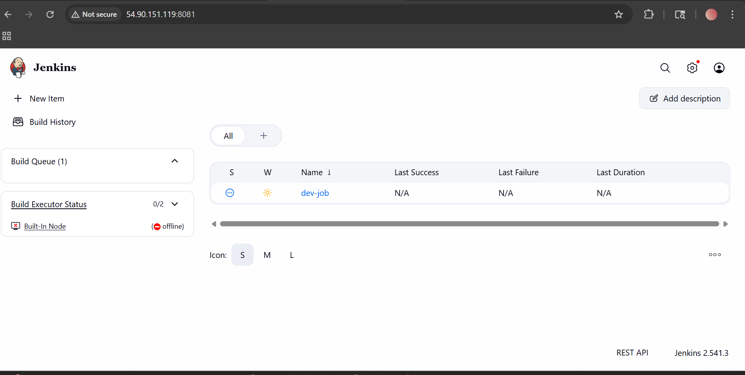
- Create Three sample jobs using the below URL.
Source Code: https://github.com/betawins/Techie_horizon_Login_app.git

Job 1: Build Job (Freestyle Project)
🔹 Purpose
Compile or prepare the application
🔹 Steps
- Go to Jenkins → New Item
- Select Freestyle Project
- Name: Build Job
- In Source Code Management
  - Choose Git
  - Paste repo URL : https://github.com/betawins/Techie_horizon_Login_app.git
- In Build Section
  - Add → Execute Shell
echo "Building the application..."

Job 2: Test Job
🔹 Purpose
Run tests on your app
🔹 Steps
- Create new job → Test Job
- Add same Git repo
- Build Step:
echo "Running tests..."

Job 3: Deployment Job
🔹 Purpose
Deploy application after build & test
🔹 Steps
- Create job → Login-App-Deploy
- Add Git repo
- Build Step:
echo "Deploying application..."

Real DevOps Flow
- Developer pushes code → GitHub
- Jenkins pulls code
- Runs:
  - Build Job
  - Test Job
  - Deploy Job
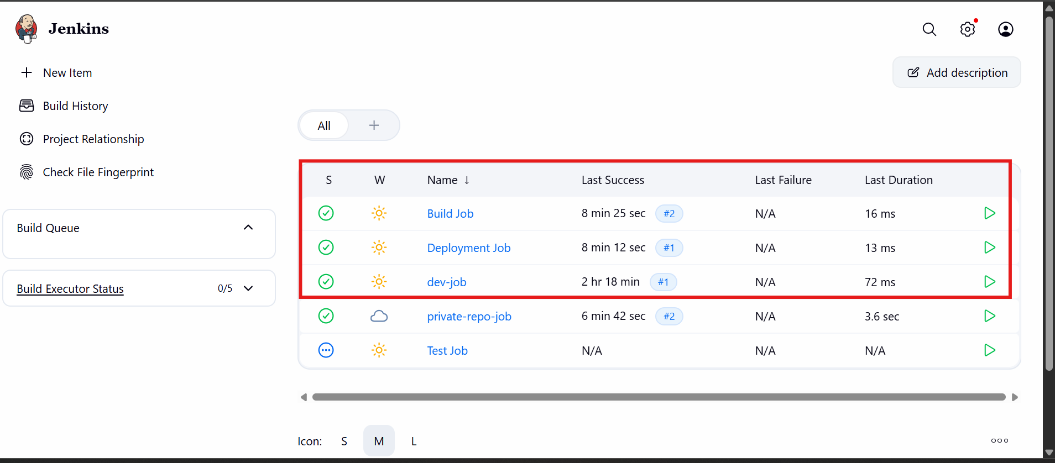

- Create one Jenkins job using GitHub Private repository.
Create a Jenkins job that pulls code from a private GitHub repo
What’s the challenge?
Private repo = 🔒 needs authentication
👉 Jenkins cannot access it without credentials
STEP 1: Generate GitHub Access Token
Go to GitHub
👉 Steps:
- Click profile → Settings
- Go to:
  - Developer settings → Personal access tokens
- Click:
  - Generate new token (classic)

✅ Select permissions:
- ✔️ repo (full control)

👉 Copy token
⚠️ IMPORTANT: Copy and save it (shown only once)

🔐 STEP 2: Add Credentials in Jenkins
📍 Go to:
👉 Jenkins Dashboard → Manage Jenkins → Credentials

👉 Click:
- (global) → Add Credentials

🧾 Fill:
- Kind: Username with password
- Username: your GitHub username
- Password: 👉 Paste token (NOT GitHub password)
- ID: github-creds
- Description: GitHub private repo access
👉 Click Create

🏗️ STEP 3: Create Jenkins Job
📍 Go to:
👉 Dashboard → New Item

👉 Enter:
- Name: github-private-job
- Type: Freestyle Project
👉 Click OK

🔗 STEP 4: Configure GitHub Repo
🔎 Find:
👉 Source Code Management
Select:
✔ Git

✏️ Enter:
Repository URL:
https://github.com/your-username/your-private-repo.git

🔐 Credentials:
👉 Select:
github-creds

🌿 STEP 5: Branch
Default:
*/main

