- Configure 2 slave machines in the Jenkins master.

Steps on Slave Machine (Agent)
These steps prepare the slave node so Jenkins can connect to it.
1. Login & switch user
- Login to slave machine
- Switch to root:
sudo su -
2. Install Java (Required for Jenkins agent)
dnf install java-17-openjdk -y
Verify Installation
java -version
3. Generate SSH Key
ssh-keygen
👉 This creates:
- Private key → id_rsa
- Public key → id_rsa.pub
4. Add Public Key to authorized_keys
cat ~/.ssh/id_rsa.pub >> ~/.ssh/authorized_keys
chmod 700 ~/.ssh/authorized_keys

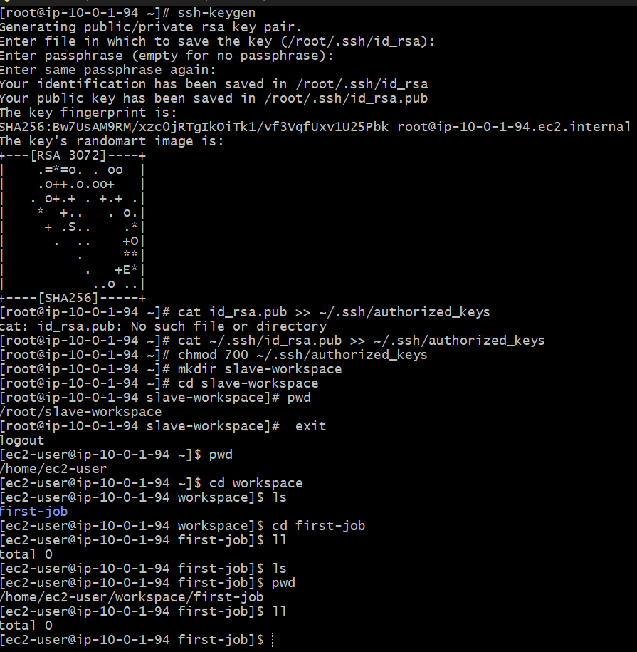
Steps on Master Machine (Jenkins Server)
1. Login & switch to root
sudo su -

2. Create Jenkins SSH directory
mkdir -p /var/lib/jenkins/.ssh
cd /var/lib/jenkins/.ssh
This is where Jenkins stores SSH configs.
3. Add Slave to known_hosts
ssh-keyscan -H 34.204.107.115 >> /var/lib/jenkins/.ssh/known_hosts
4. Fix ownership
chown jenkins:jenkins known_hosts
Because Jenkins runs as jenkins user, not root.
5. Set permissions
chmod 700 known_hosts
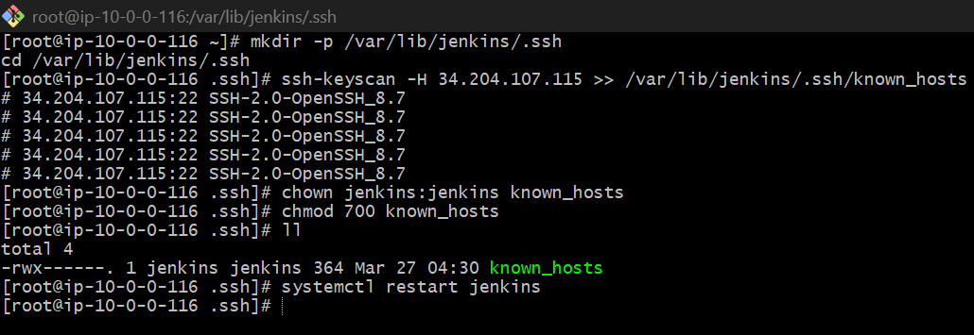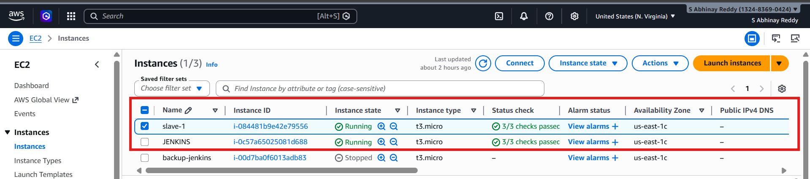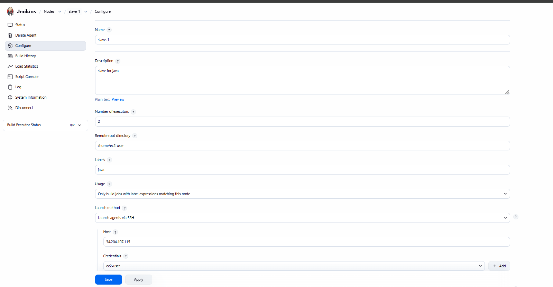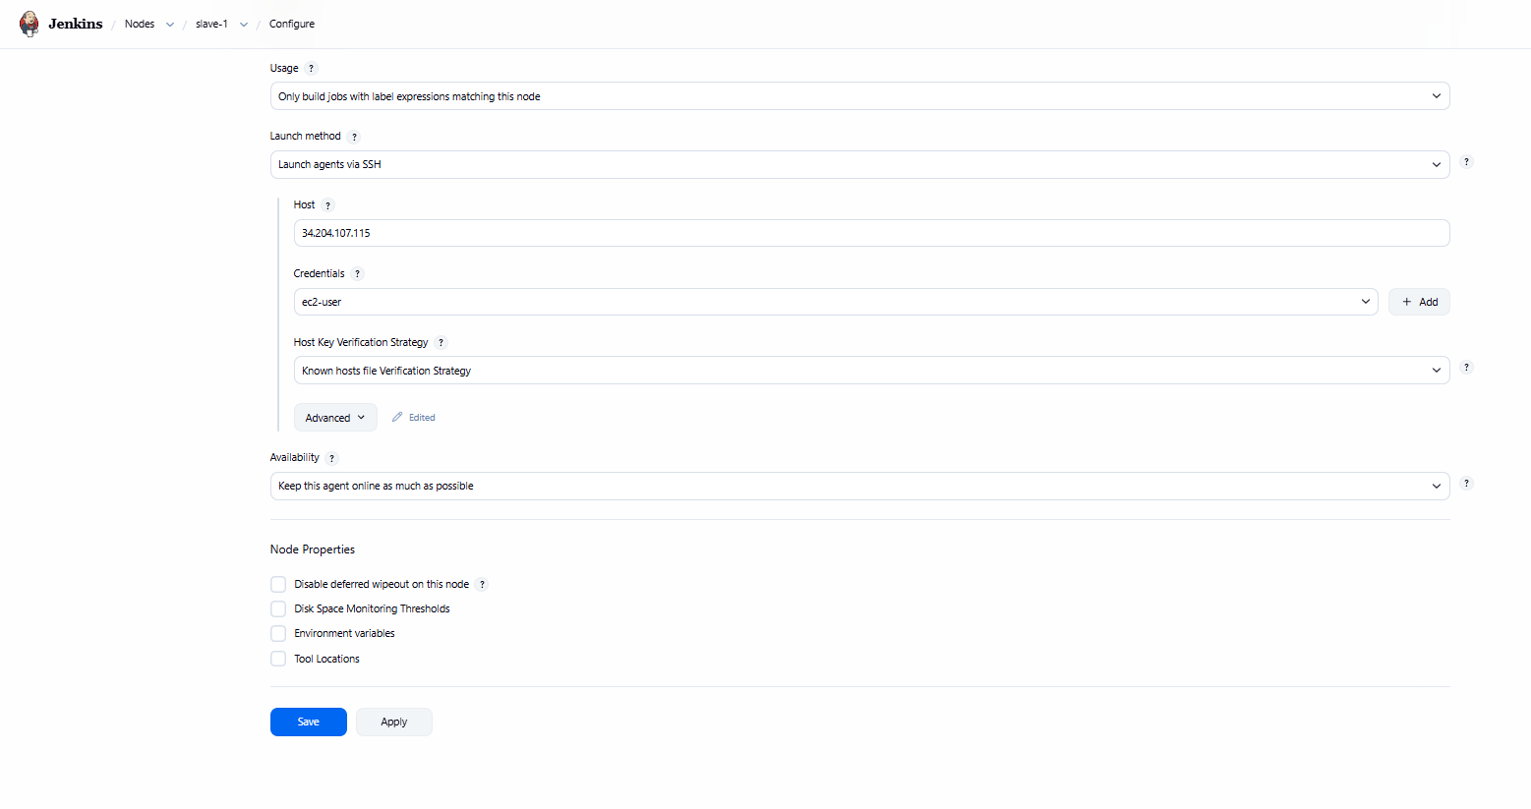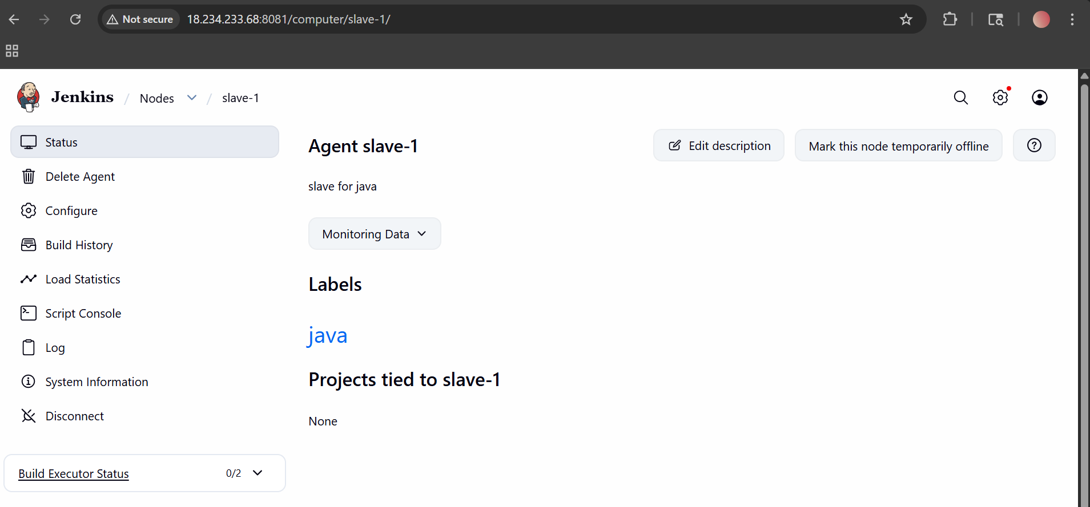
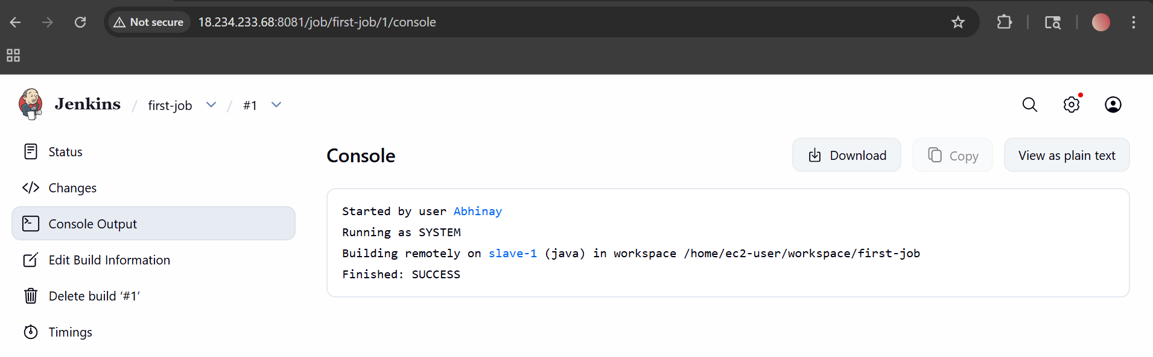

2) Configure webhooks to the Jenkins job.

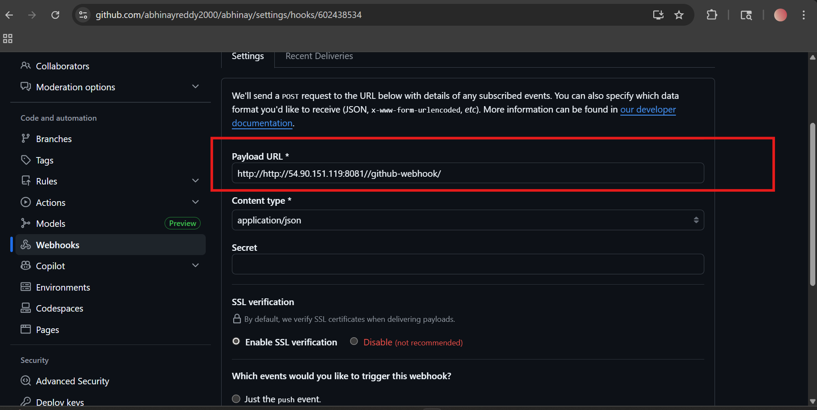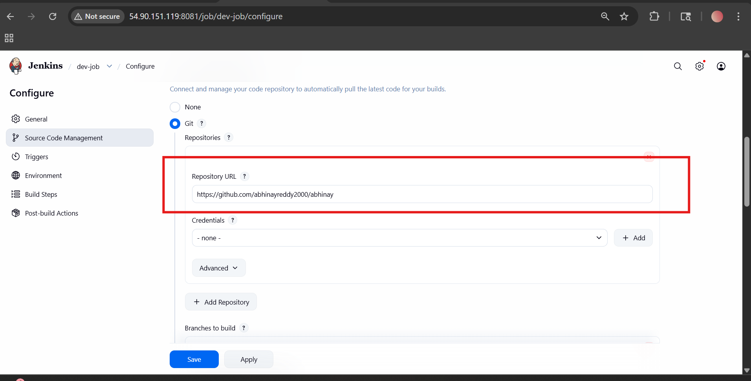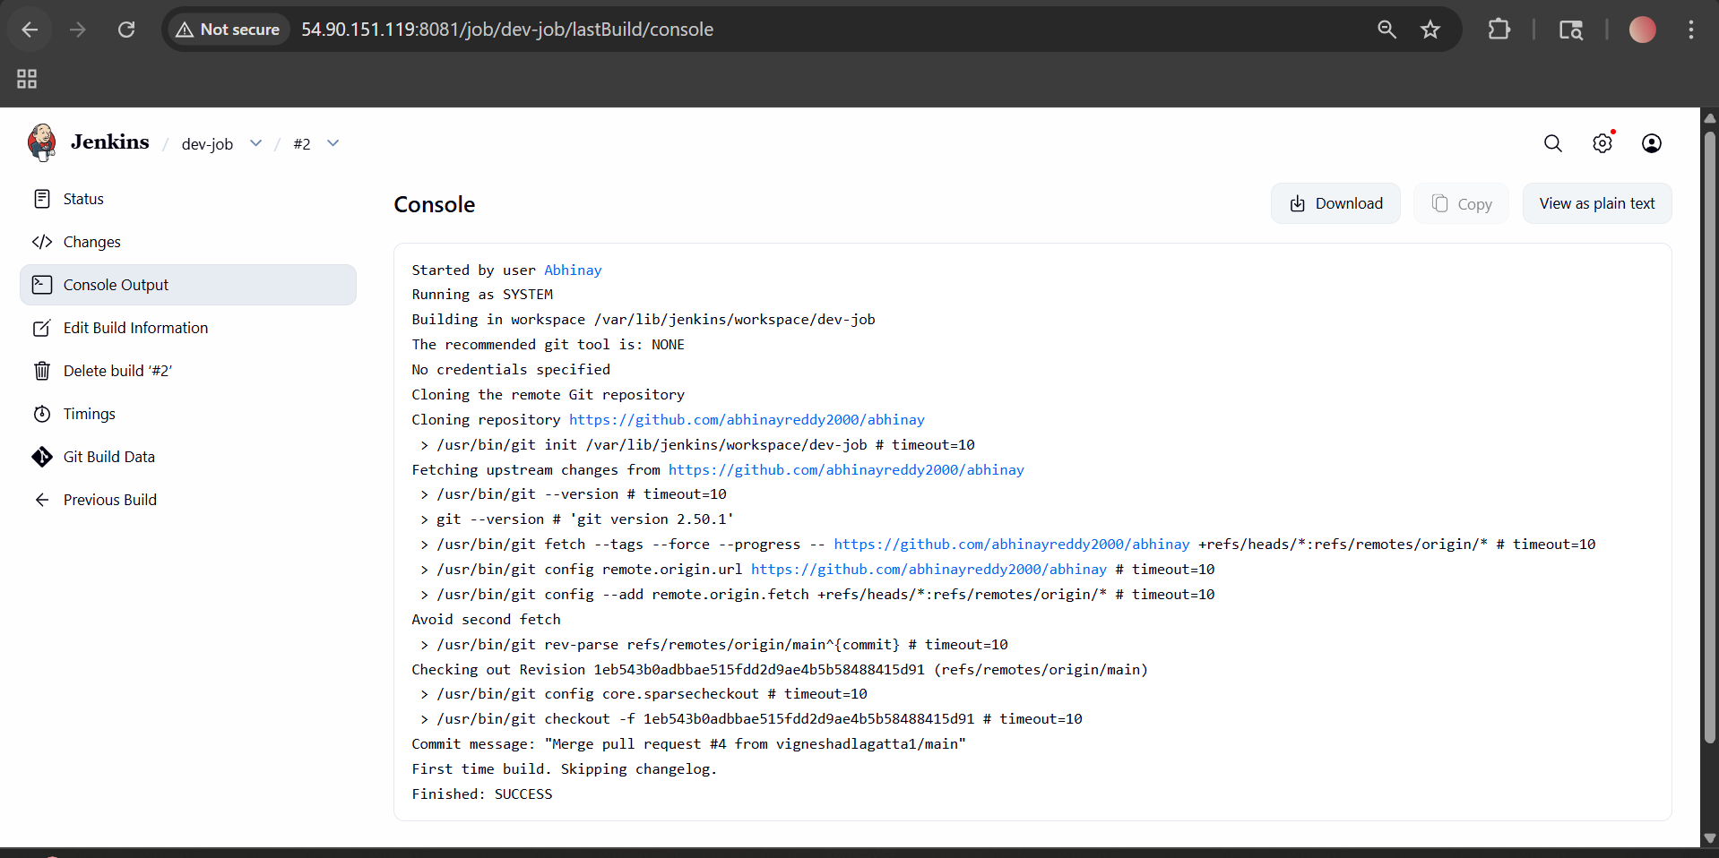
3) Configure Poll SCM and Build Periodically options in the Jenkins job.
1. Poll SCM (Source Code Management)
What it means:
- Jenkins checks your GitHub repo at regular intervals
- If it finds any new code changes, it automatically triggers a build
Example:
- You push code to GitHub
- Jenkins checks repo every minute
- If change detected → build starts
⚙️ How to Configure Poll SCM
- Go to your Jenkins Dashboard
- Click on your Job
- Click Configure
- Scroll to Build Triggers
- Select ✅ Poll SCM
- In the schedule box, enter: * * * * *

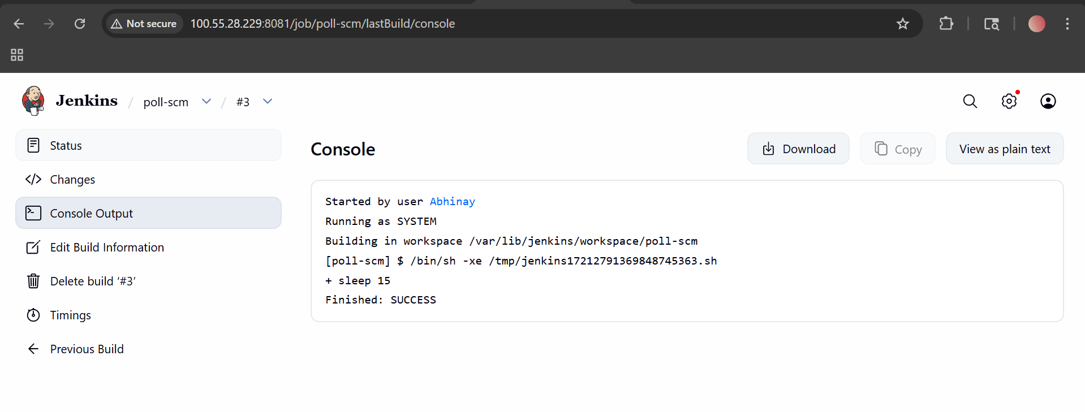

2. Build Periodically
What it means:
- Jenkins runs the job at fixed time intervals
- It does NOT check for code changes
- It builds every time based on schedule
How to Configure Build Periodically
- Go to your Jenkins Job
- Click Configure
- Scroll to Build Triggers
- Select ✅ Build periodically
- Enter schedule: * * * * *
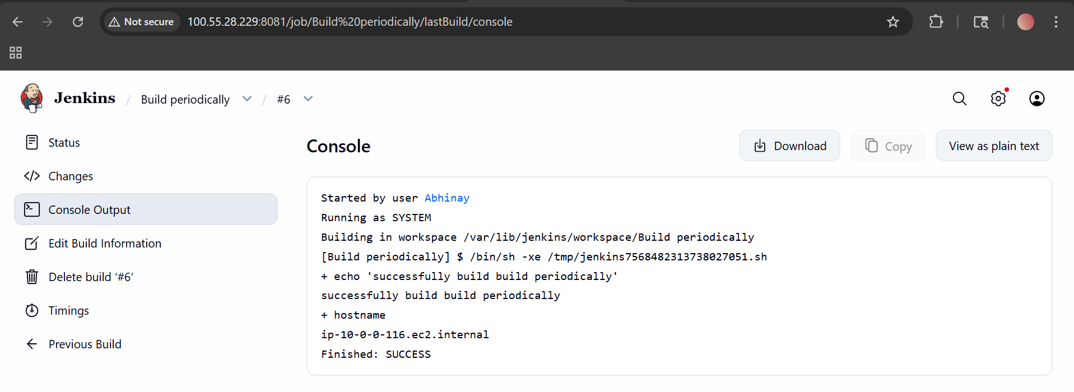

4) Take a backup of the Jenkins server using a bash-script.
Understand What to Backup
Jenkins stores all its data in:
/var/lib/jenkins
📌 This folder contains:
- Jobs
- Plugins
- User data
- Configuration files
👉 So we will backup this entire folder
Create a Backup Script File
Run:
nano jenkins_backup.sh
👉 This opens a new file
Step 3: Add Script Code
Paste this:
#!/bin/bash
JENKINS_HOME="/var/lib/jenkins"
BACKUP_DIR="/backup/jenkins"
DATE=$(date +%F)
mkdir -p $BACKUP_DIR
sudo systemctl stop jenkins
tar -czf $BACKUP_DIR/jenkins_backup_$DATE.tar.gz $JENKINS_HOME
sudo systemctl start jenkins
echo "Backup completed successfully"
Give Execute Permission : chmod +x jenkins_backup.sh
Run the Script : ./jenkins_backup.sh
Verify Backup: ls /backup/Jenkins
You will see something like: jenkins_backup_2026-03-26.tar.gz

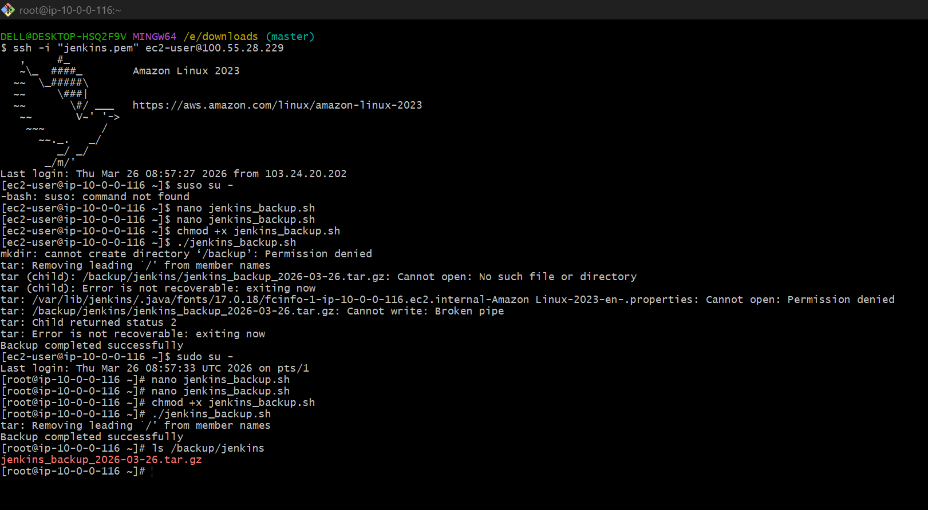
- Take a backup of Jenkins using the Thin Backup plugin.
- Set up a new Jenkins server and restore the backup taken in task 4.

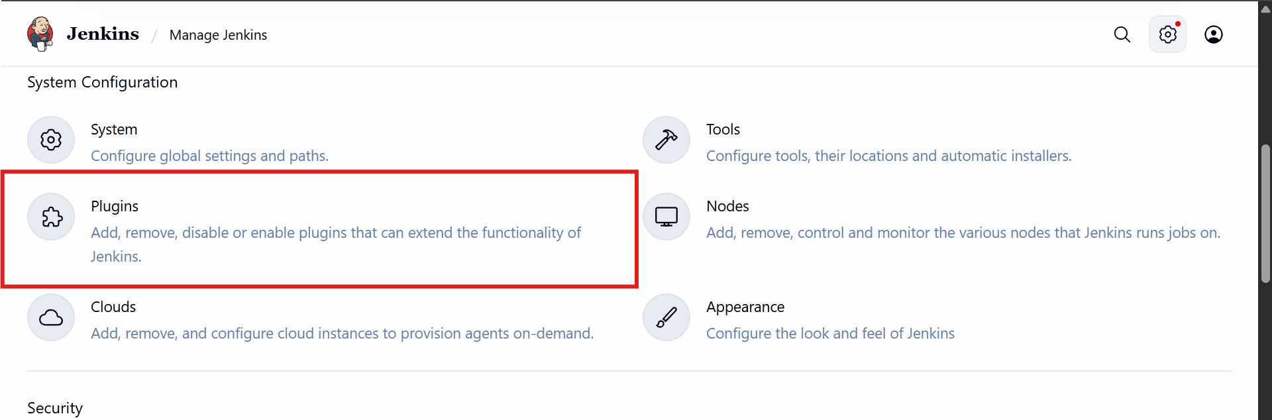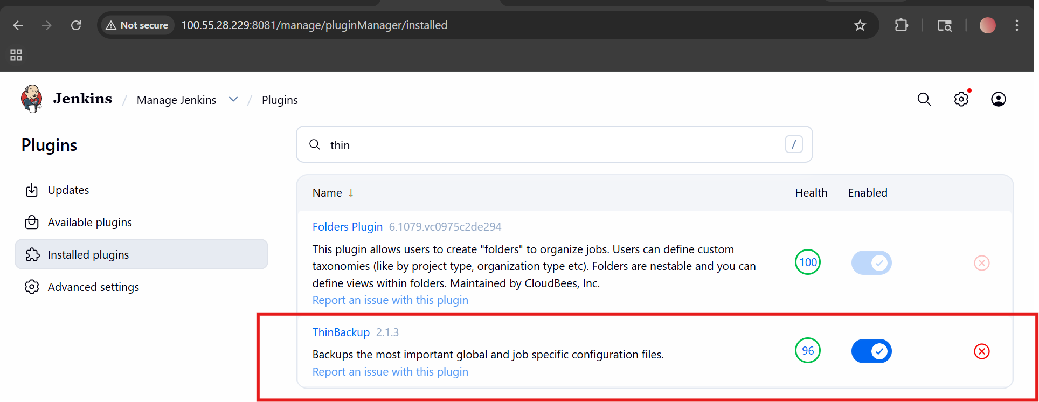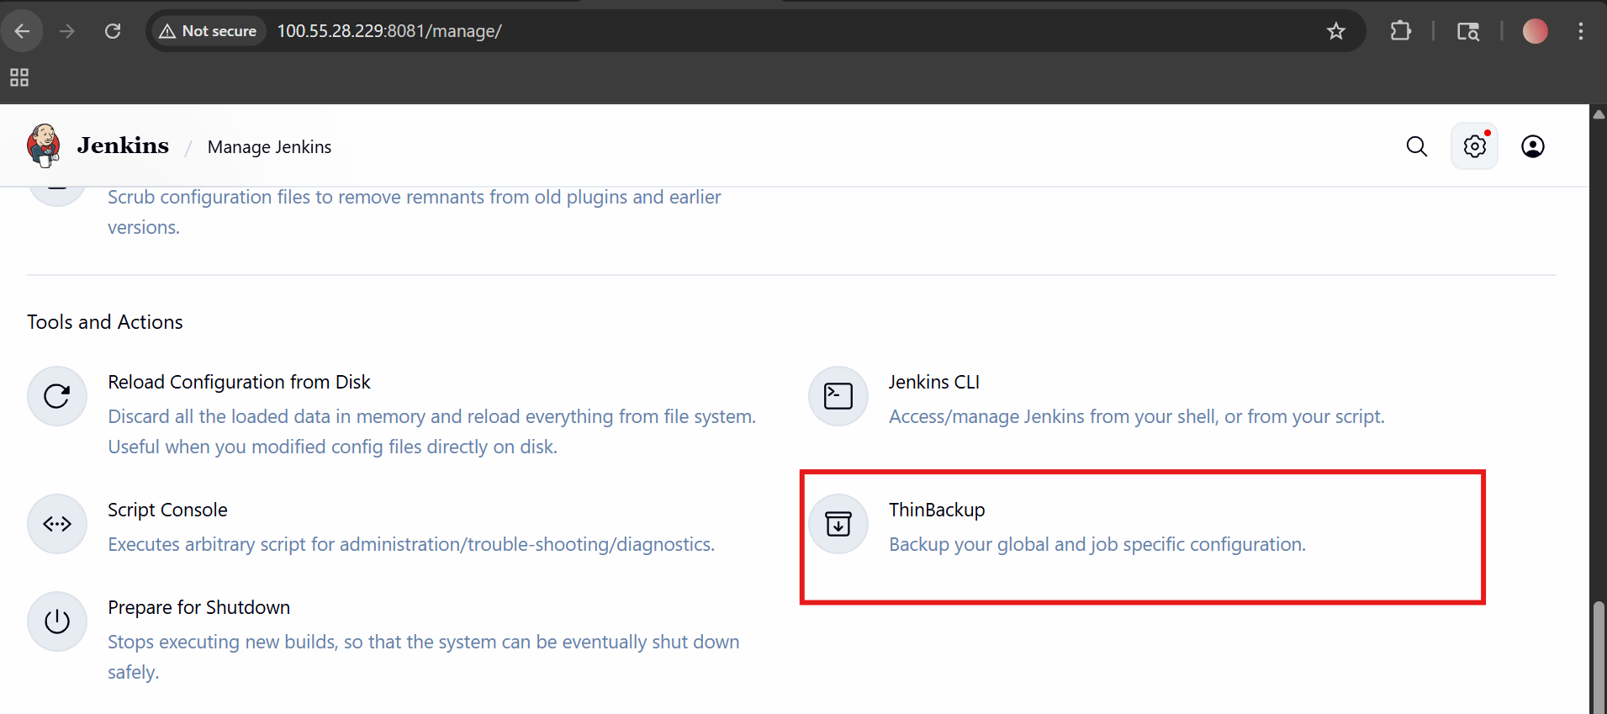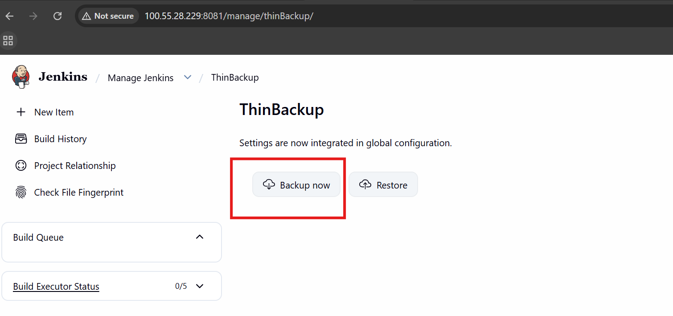

Set up a new Jenkins server and restore the backup taken in task 4.
Step 1: Setup New Jenkins Server
1. Launch a new EC2 instance
- Install Java 17 (as we did earlier)
- Then install Jenkins
sudo dnf install java-17-amazon-corretto -y
2. Install Jenkins
sudo wget -O /etc/yum.repos.d/jenkins.repo \
https://pkg.jenkins.io/redhat-stable/jenkins.repo
sudo rpm --import https://pkg.jenkins.io/redhat-stable/jenkins.io.key
sudo dnf install jenkins -y
3. Start Jenkins
sudo systemctl enable jenkins
sudo systemctl start jenkins
👉 Access in browser:
http://<EC2-PUBLIC-IP>:8080
Step 2: Install ThinBackup Plugin
- Go to:
Manage Jenkins → Plugins → Available Plugins
- Search: ThinBackup
- Install it

Step 3: Copy Backup from Old Server
- 👉 On OLD server, backup is usually here: /var/lib/jenkins/thinBackup/
cat /var/lib/jenkins/secrets/initialAdminPassword
tar xvf backup.tar /var/lib/

