Use the below code and implement our CICD stages.
- Source Code: https://github.com/betawins/hiring-app.git
- Repository contains the application code for the hiring app.
- Create one Declarative pipeline job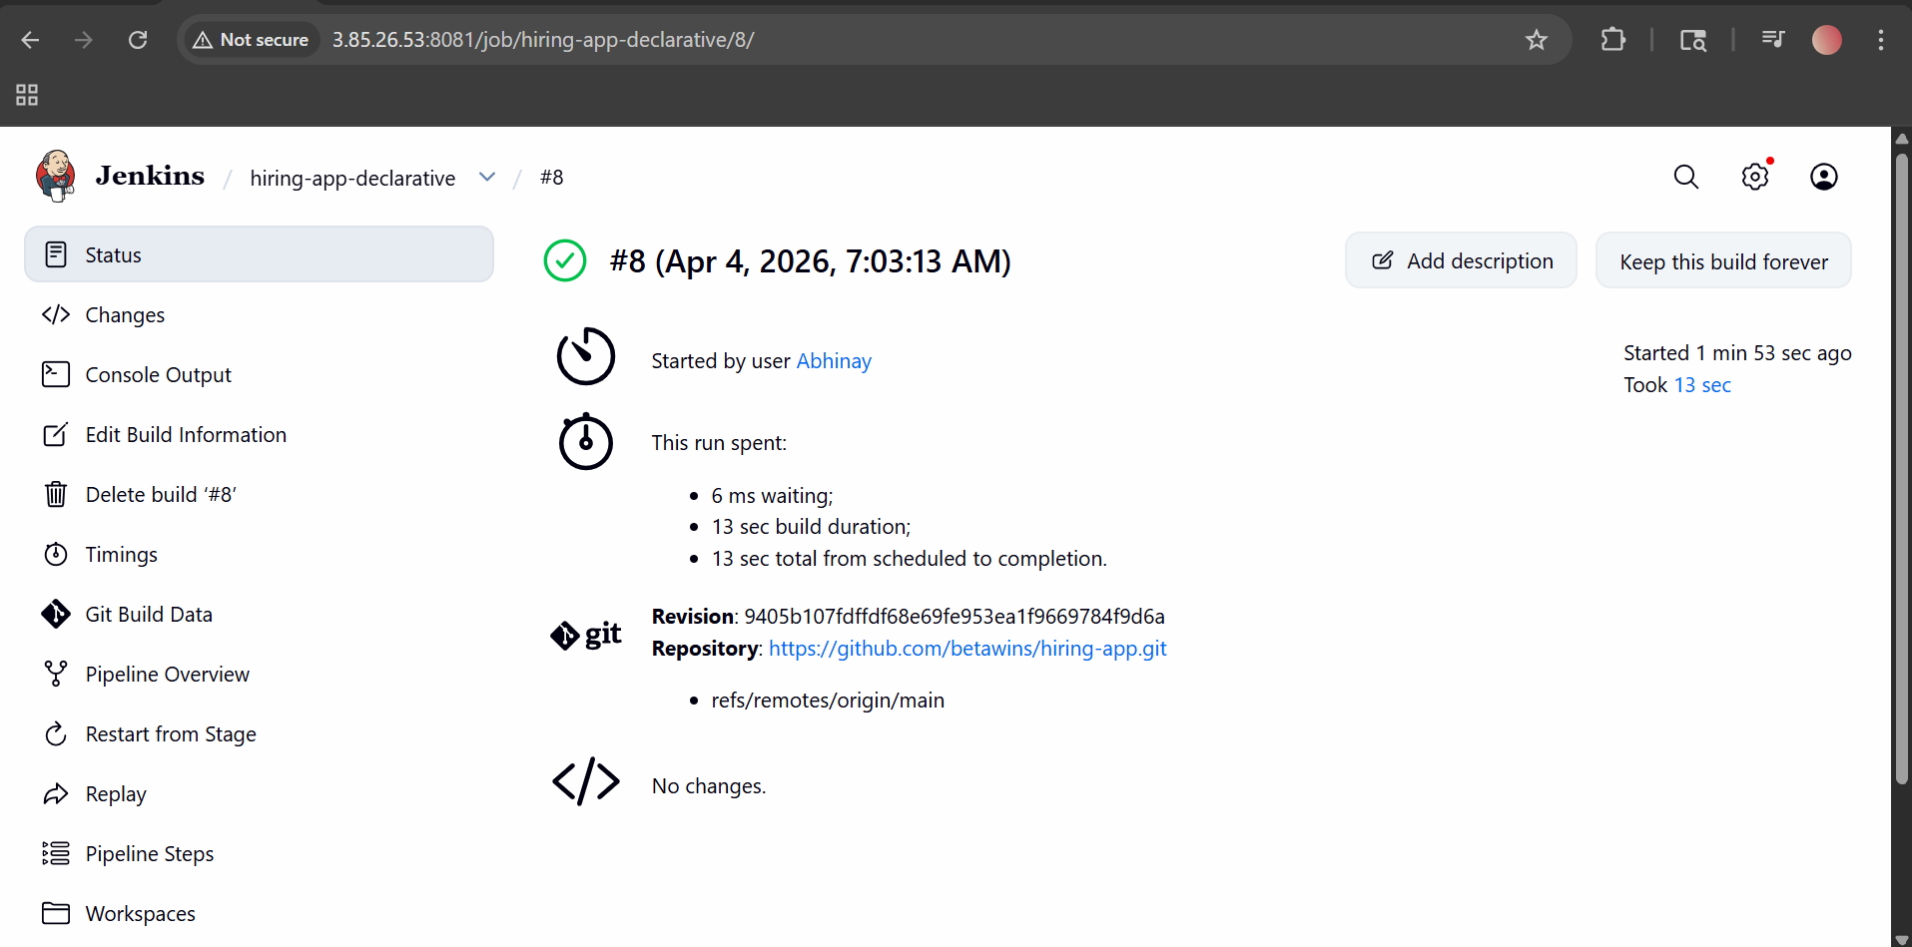
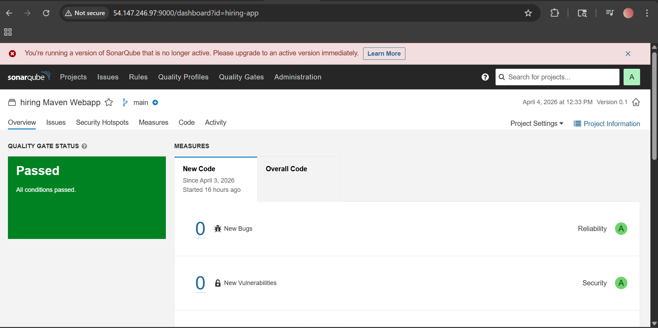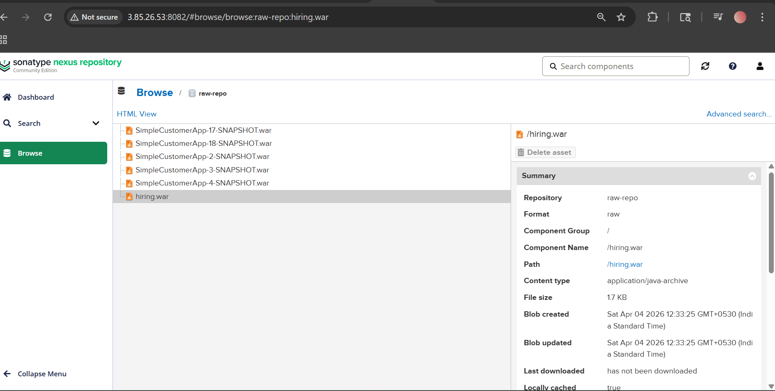
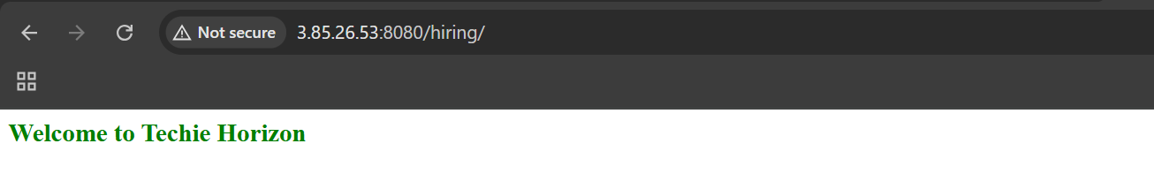

- Create one Scripted pipeline job
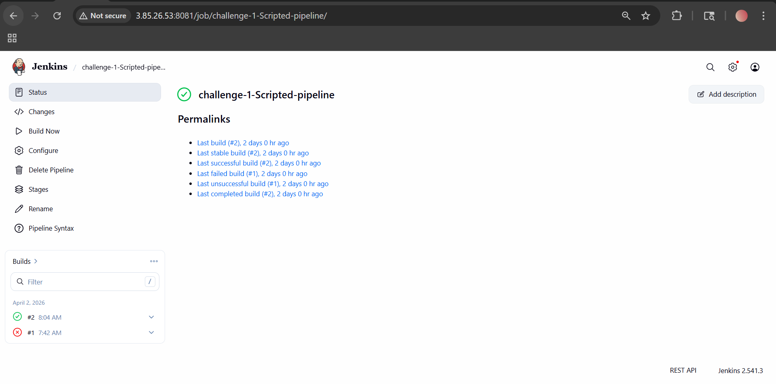
node {
try {

stage('Git Clone') {
git branch: 'main',
url: 'https://github.com/betawins/hiring-app.git'
}

stage('Build') {
sh 'mvn clean package -DskipTests'
}

stage('Test') {
sh 'mvn test'
}

stage('Deploy') {
echo 'Deploying application...'
}

currentBuild.result = 'SUCCESS'

} catch (Exception e) {
currentBuild.result = 'FAILURE'
throw e
}
}
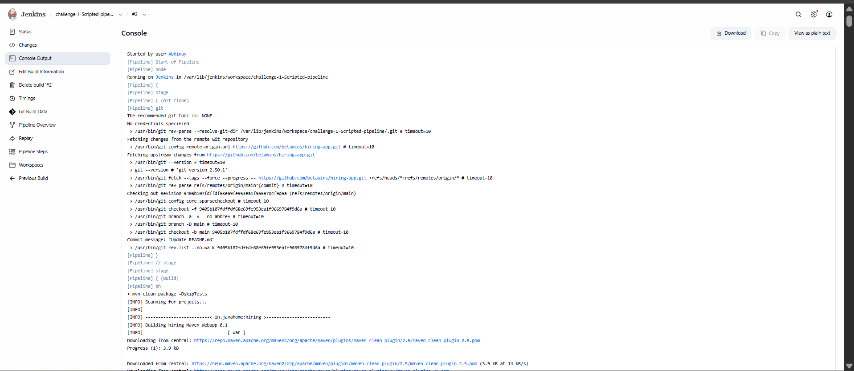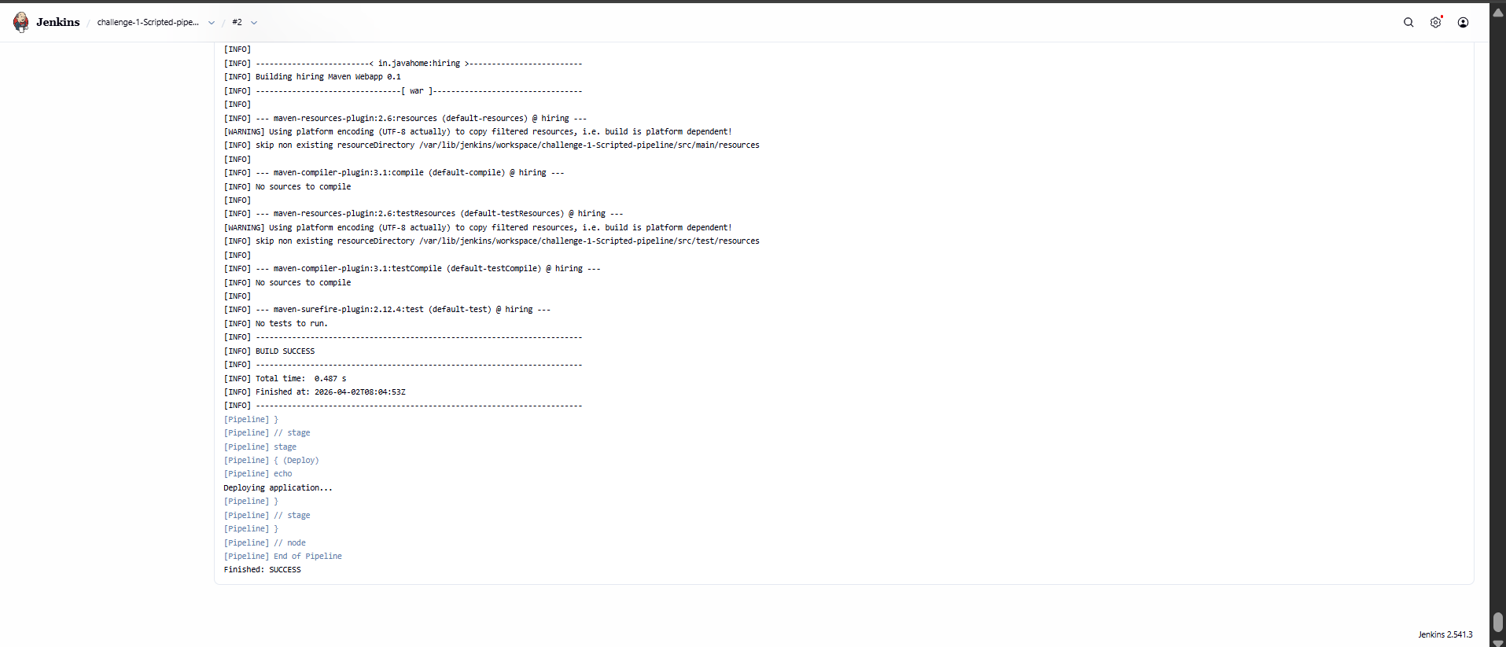

- Create one multi stage pipeline job
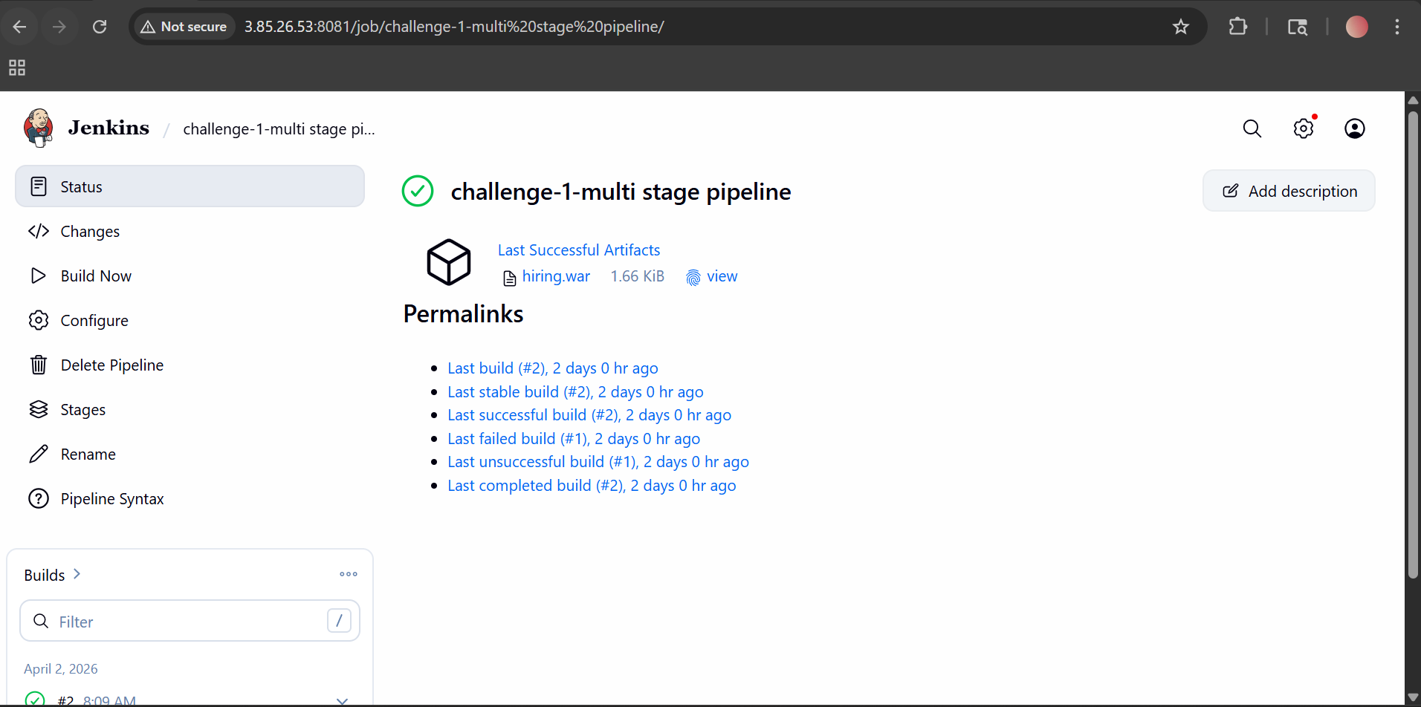
pipeline {
agent any

tools {
maven 'Maven'
}

stages {
stage('Checkout') {
steps {
git branch: 'main', url: 'https://github.com/betawins/hiring-app.git'
}
}

stage('Compile') {
steps {
sh 'mvn clean compile'
}
}

stage('Unit Test') {
steps {
sh 'mvn test'
}
}

stage('Package') {
steps {
sh 'mvn package -DskipTests'
}
}

stage('Archive Artifact') {
steps {
archiveArtifacts artifacts: 'target/*.war', fingerprint: true
}
}

stage('Deploy') {
steps {
echo 'Deployment step goes here'
}
}
}
}
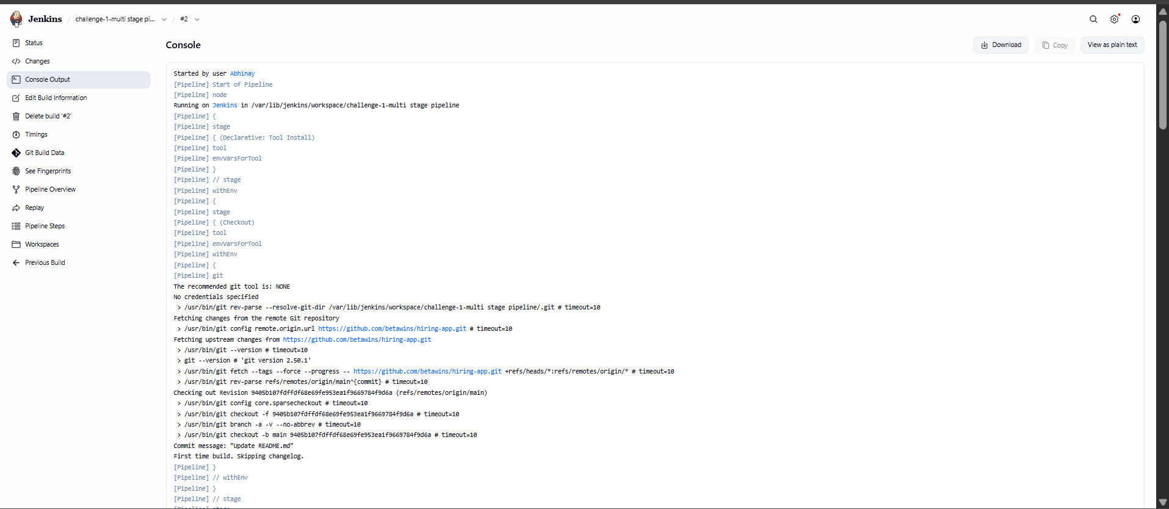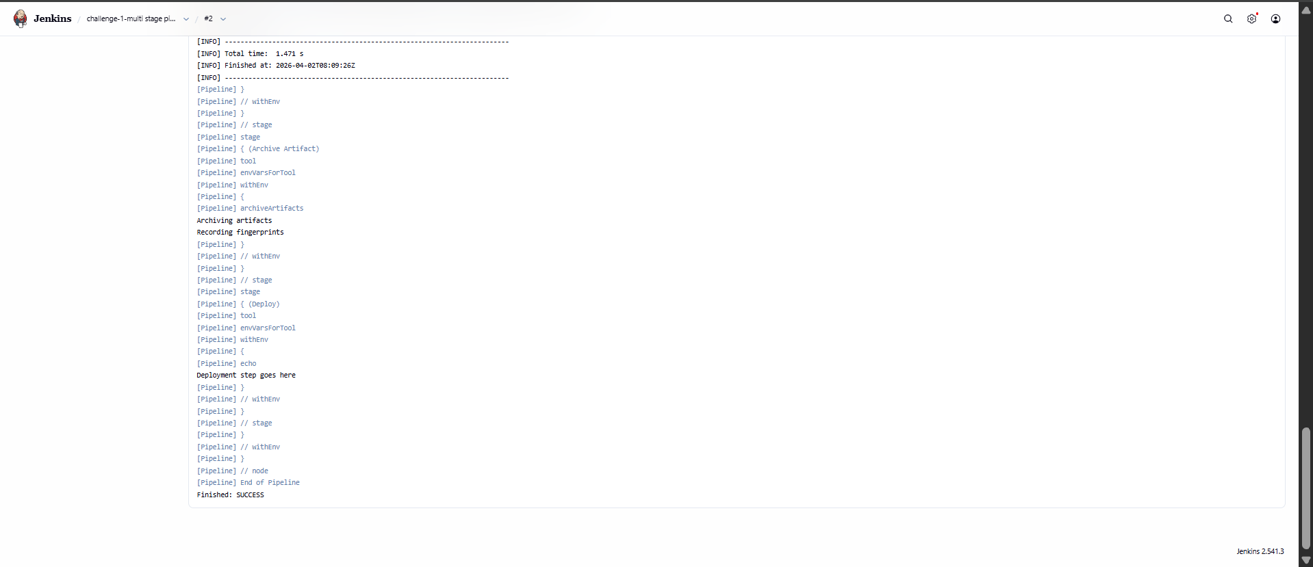

- Create one parallel stage pipeline job
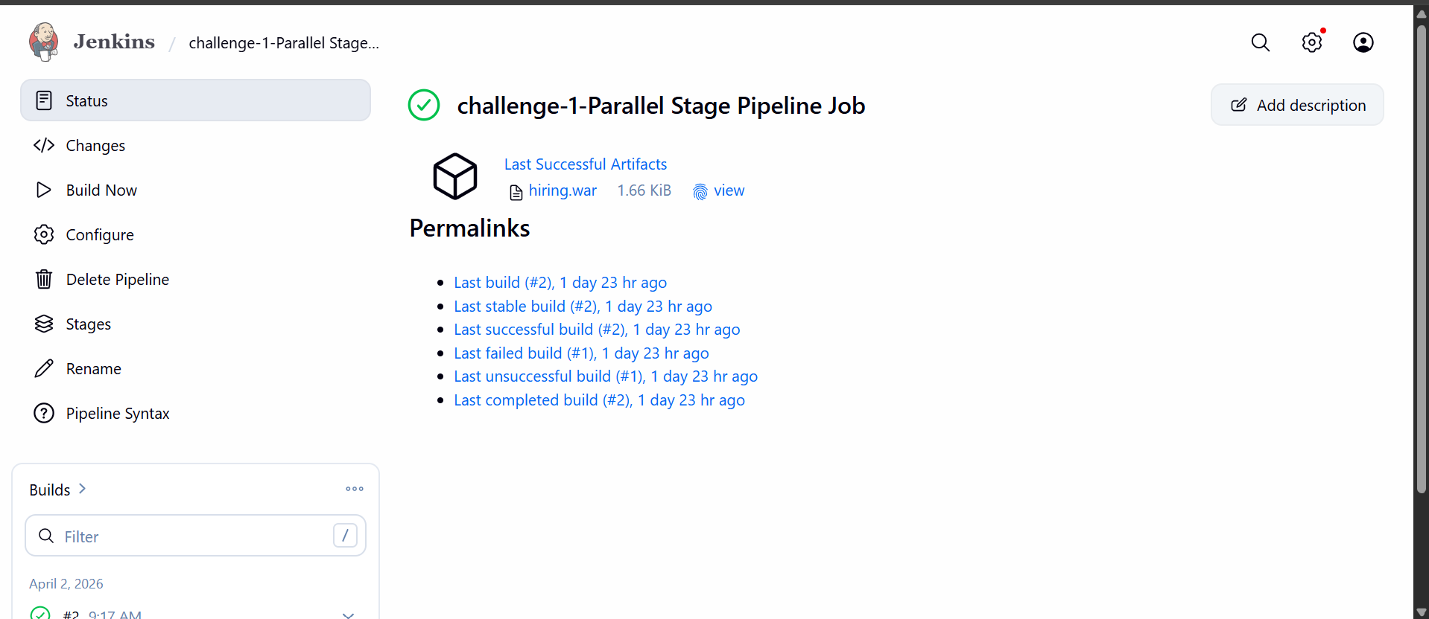
pipeline {
agent any

tools {
maven 'Maven'
}

stages {
stage('Checkout') {
steps {
git branch: 'main', url: 'https://github.com/betawins/hiring-app.git'
}
}

stage('Build & Test in Parallel') {
parallel {
stage('Compile') {
steps {
sh 'mvn clean compile -DskipTests'
}
}

stage('Validate') {
steps {
sh 'mvn validate'
}
}
}
}

stage('Package') {
steps {
sh 'mvn package -DskipTests'
}
}

stage('Archive Artifact') {
steps {
archiveArtifacts artifacts: 'target/*.war', fingerprint: true
}
}

stage('Deploy') {
steps {
echo 'Deployment stage placeholder'
}
}
}
}
