- Create one Jenkins job using the below code and create three stages.
Source Code: https://github.com/betawins/VProfile-1.git

- stage1: Git clone to download the source code. 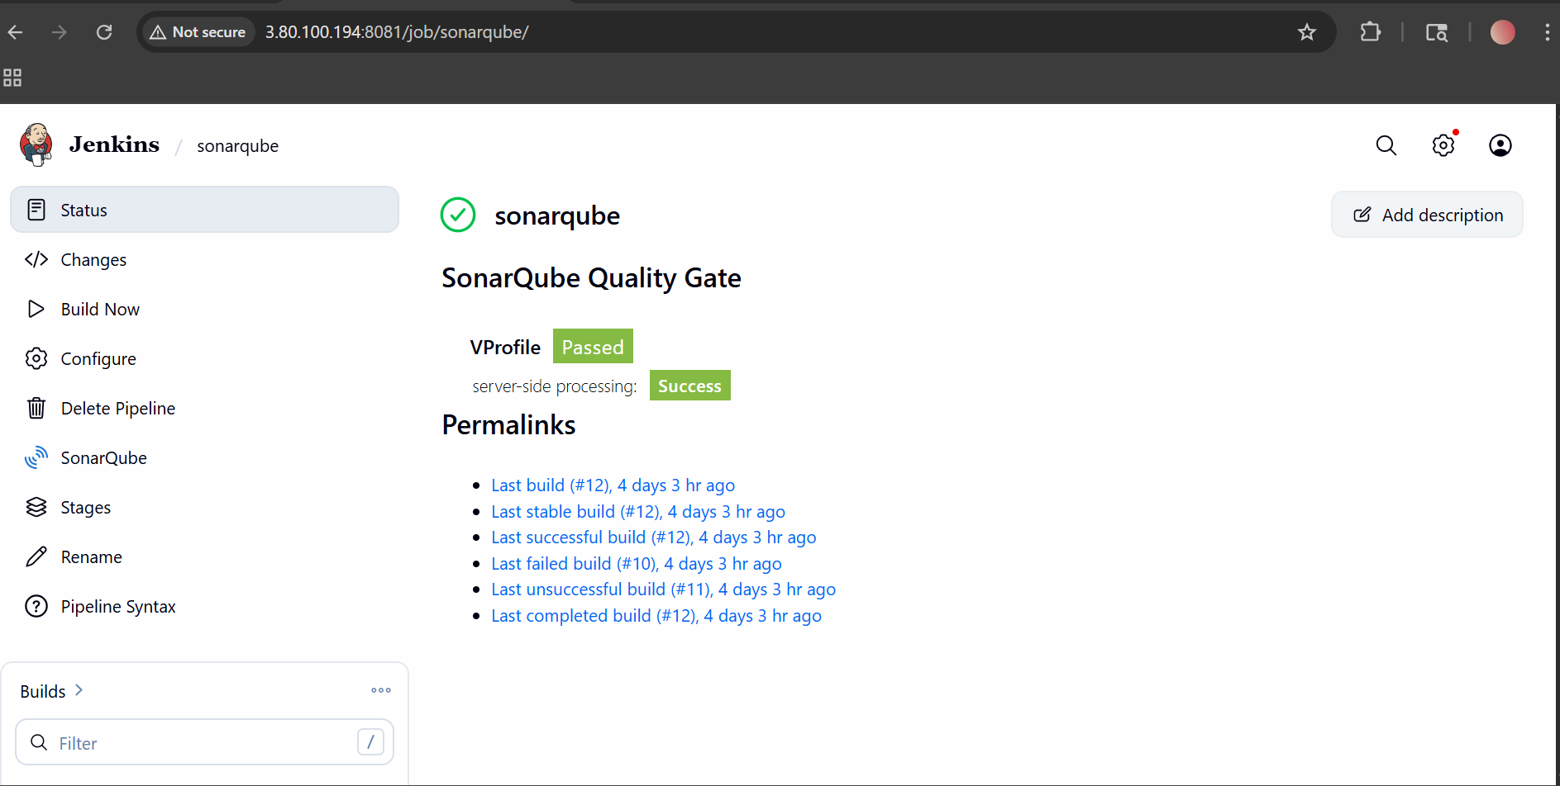
- stage2: Sonarqube Integration to check the quality of code. 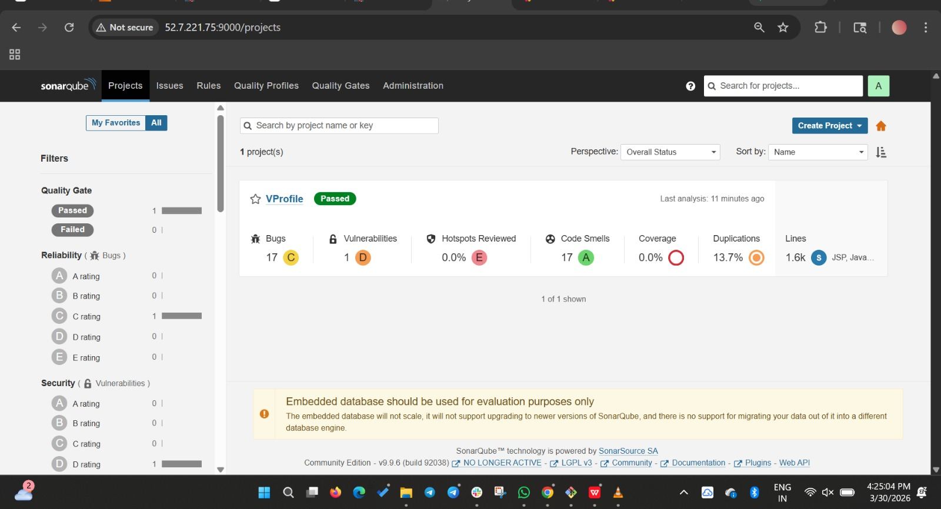
- stage3: Slack Integration to send the alerts to slack. 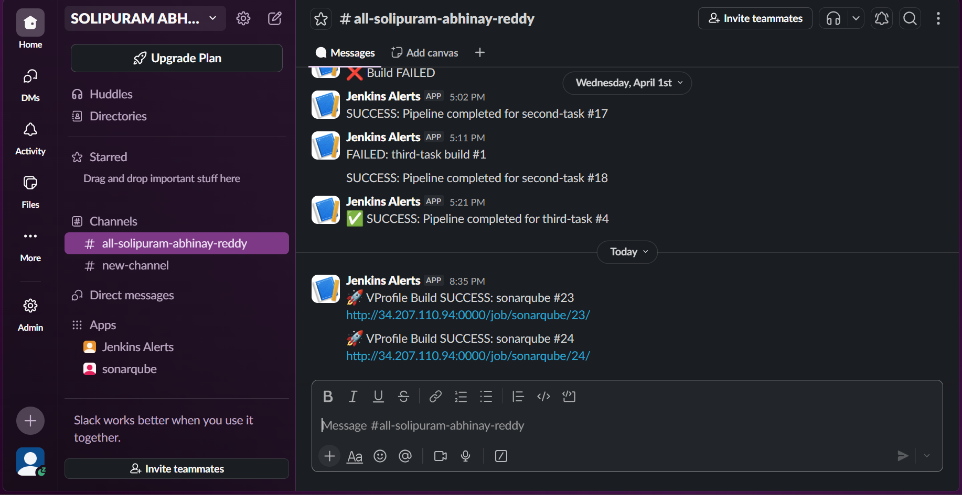

2. Create one Jenkins job using the below code and create three stages.
Source Code: https://github.com/betawins/hiring-app.git

- stage1: Git clone to download the source code.
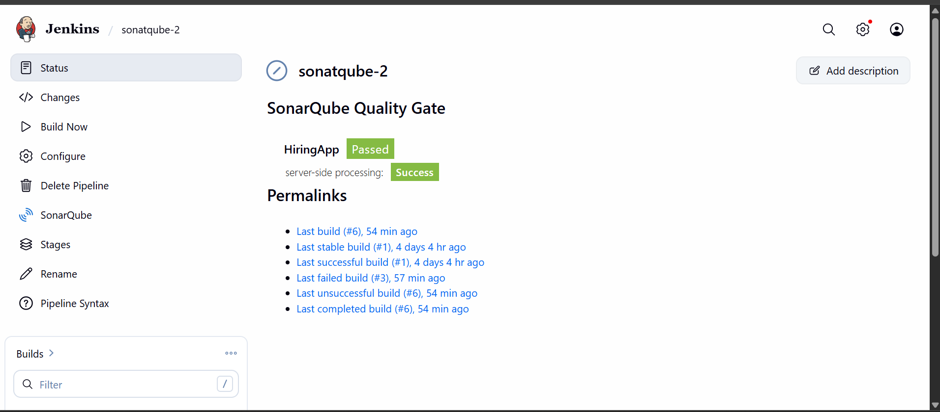
- stage2: Sonarqube Integration to check the quality of code. 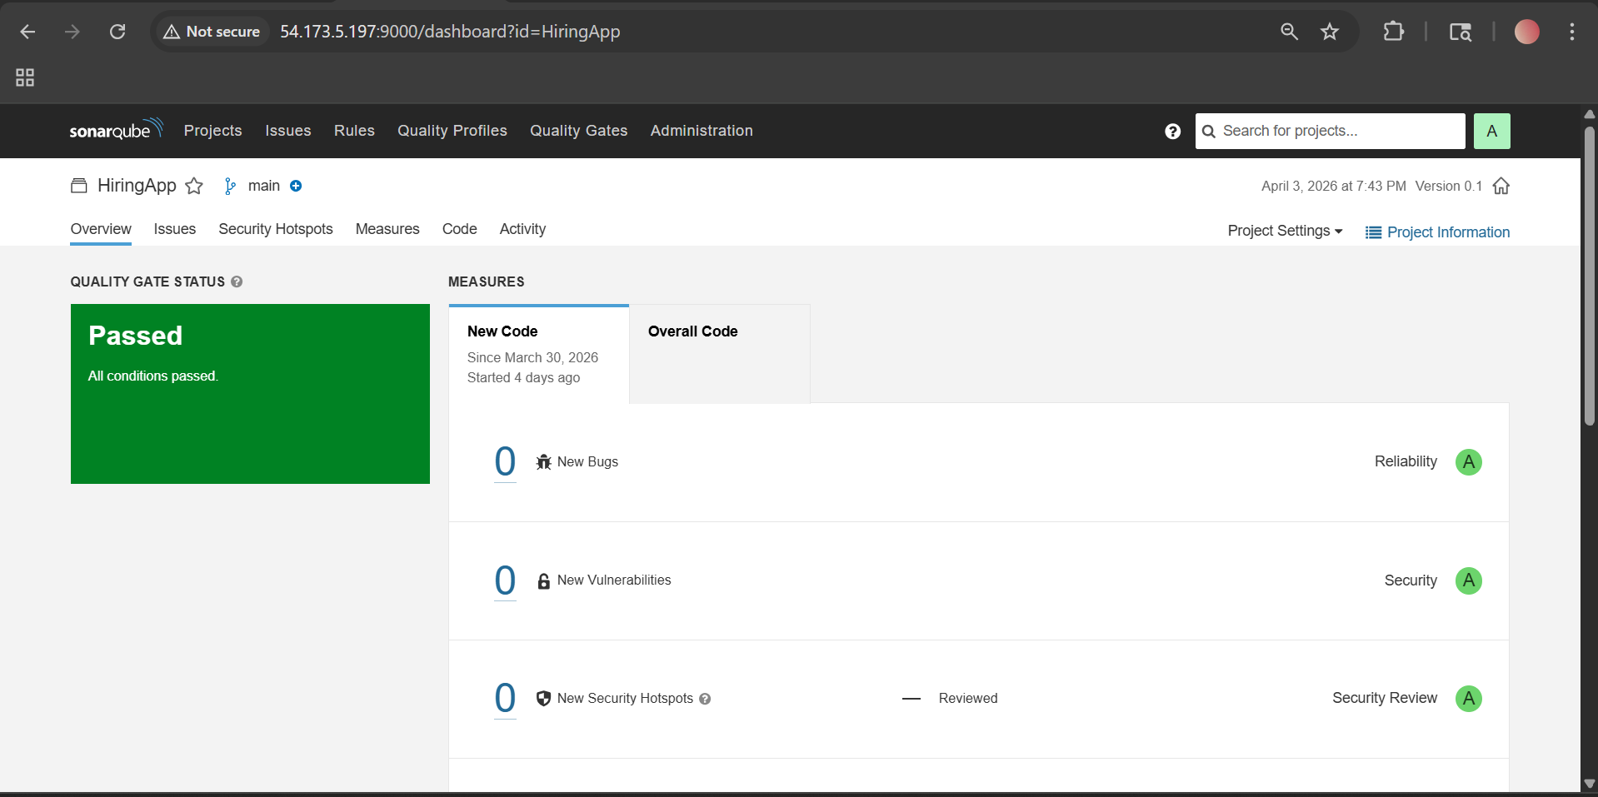

- stage3: Slack Integration to send the alerts to slack. 