1) Setup Jenkins CICD pipeline using freestyle job using Docker containers using below code.
Source Code: https://github.com/betawins/hiring-app.git
Stages:
- Git Clone
- SonarQube Integration
- Maven Compilation
- Nexus Artifactory
- Slack Notification
- Deploy On tomcat
Plugins
• Pipeline
• Git
• Maven Integration
• SonarQube Scanner for Jenkins
• Nexus Artifact Uploader
• Slack Notification
• Pipeline Utility Steps
• Workspace Cleanup
1. Create the pipeline job
• Jenkins dashboard → New Item
• Enter job name
• Select Pipeline
• Click OK
2. Add pipeline script
• Scroll to Pipeline
• Choose Pipeline script
• Paste the Jenkinsfile above
• Save

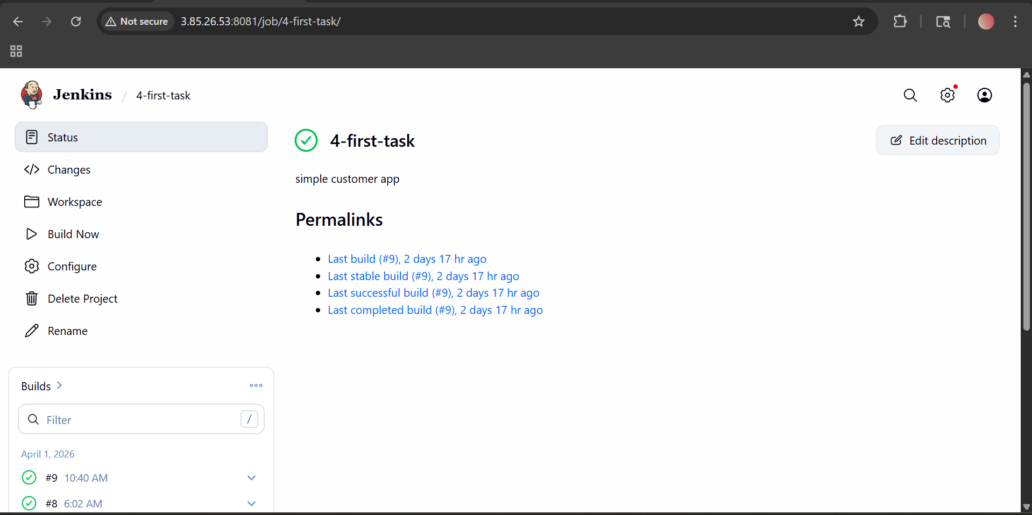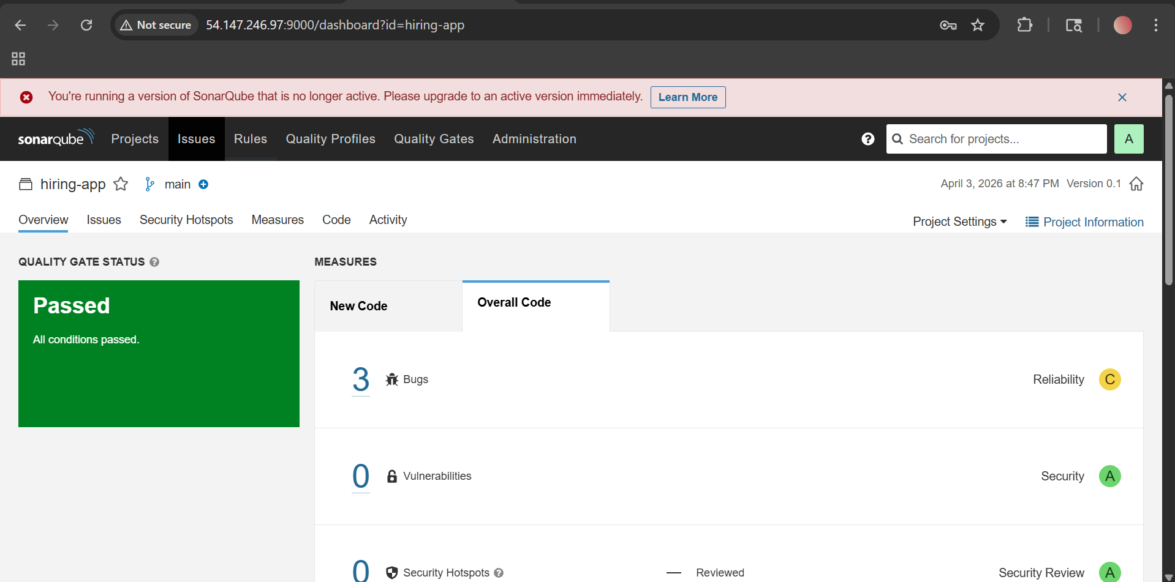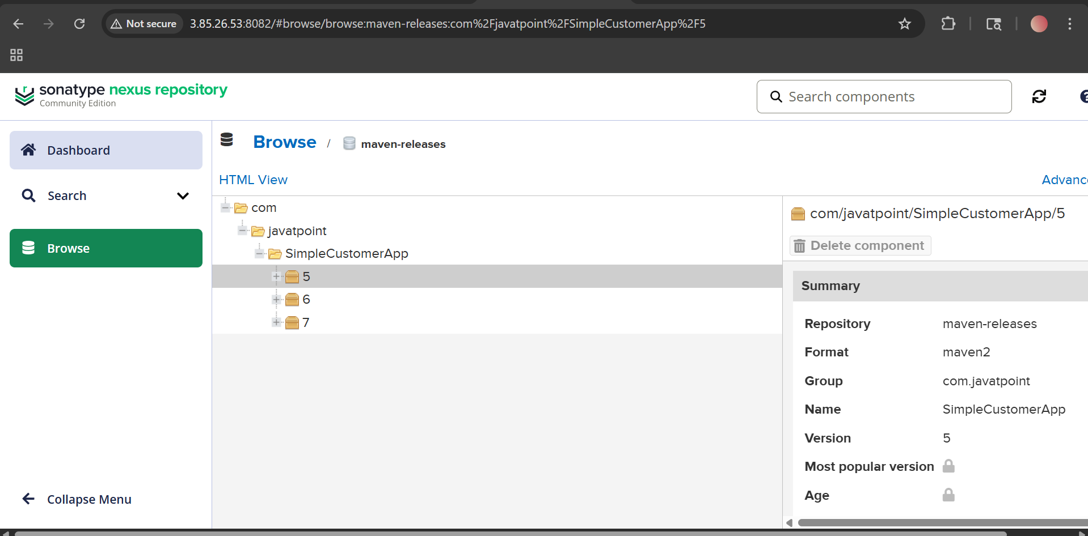
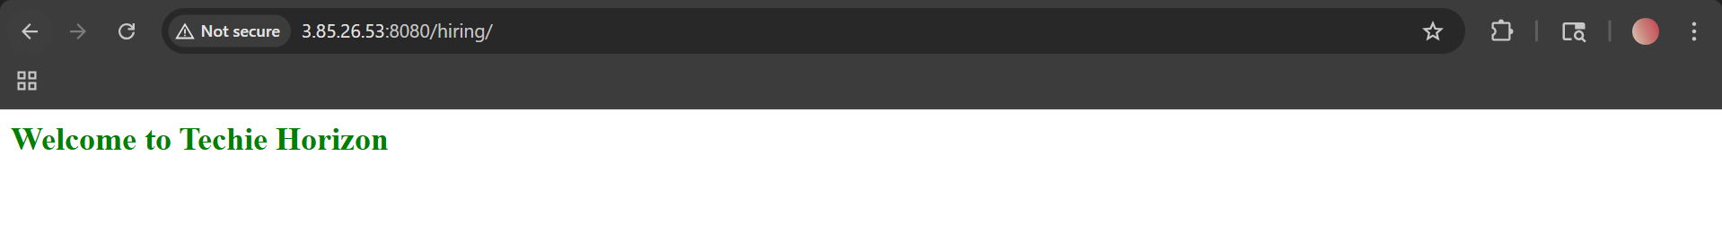

2) Setup a Jenkins CICD pipeline using Declarative pipeline using feature-1.1 branch.
Source Code: https://github.com/betawins/sabear_simplecutomerapp/tree/feature-1.1
stages:
- Git Clone
- SonarQube Integration
- Maven Compilation
- Nexus Artifactory
- Slack Notification
- Deploy On tomcat
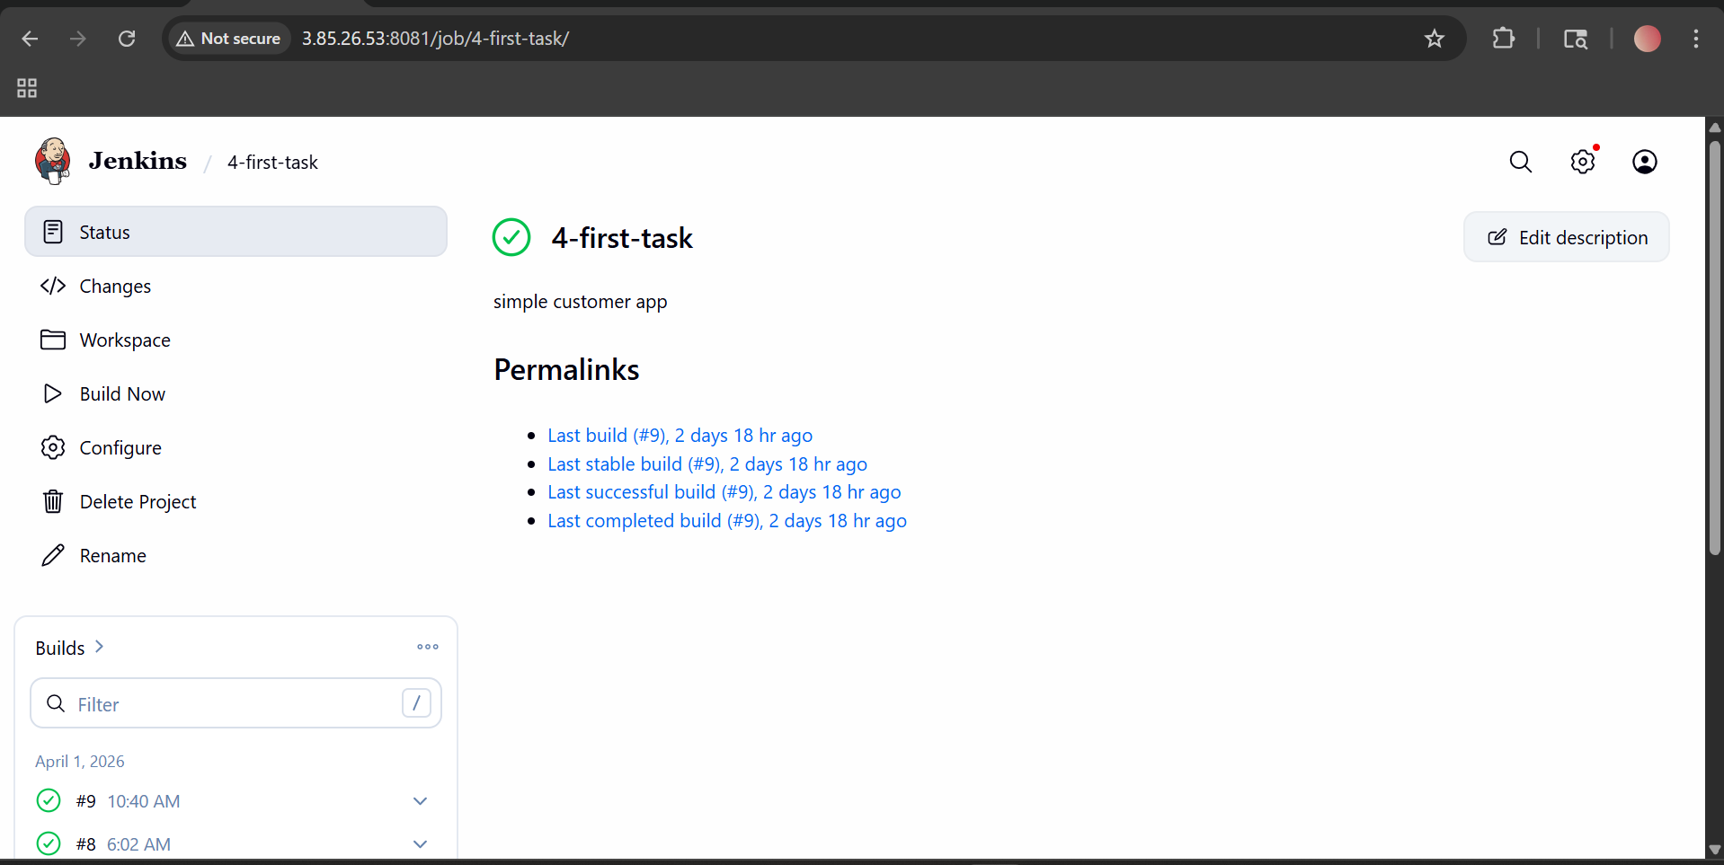
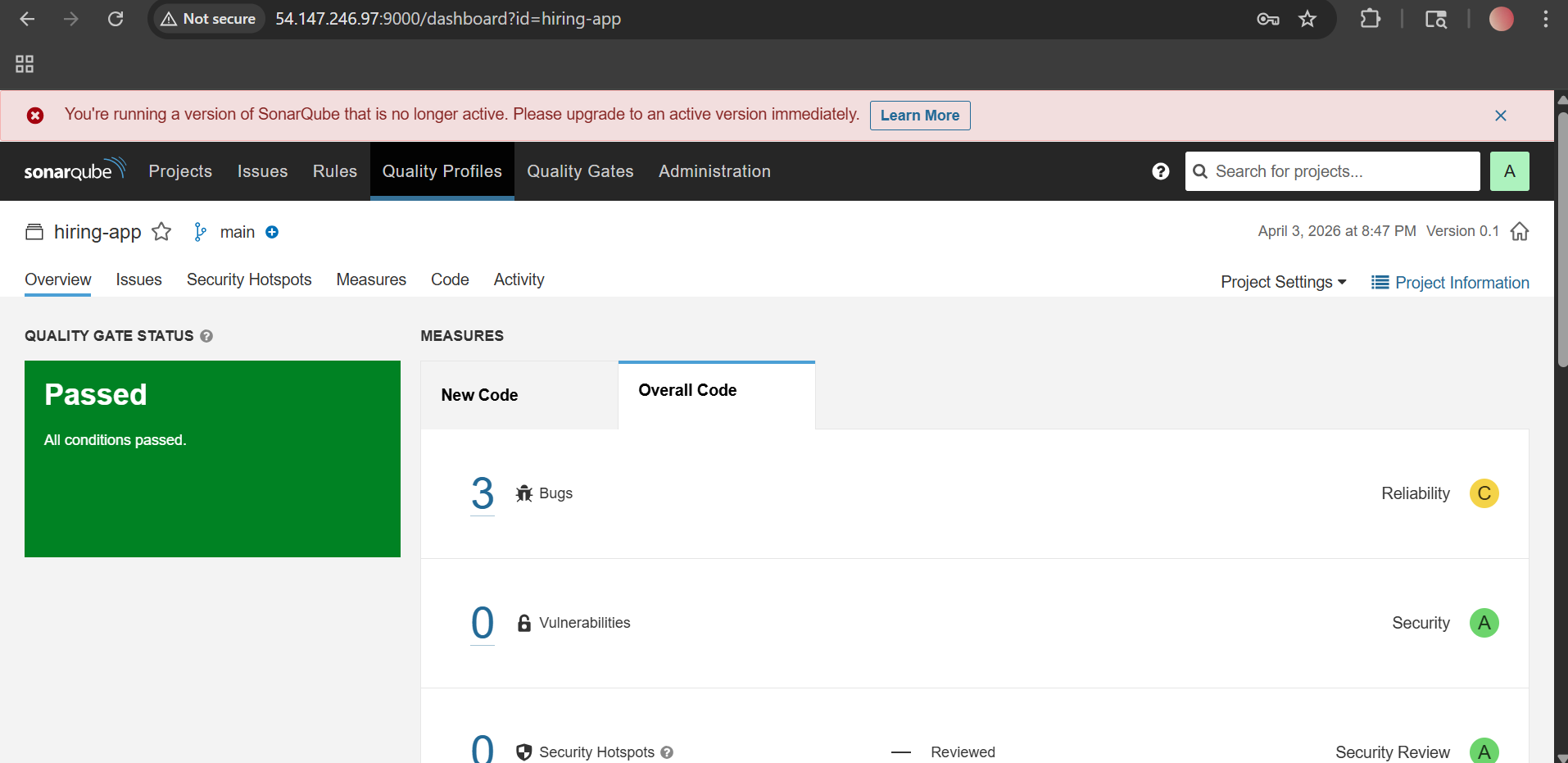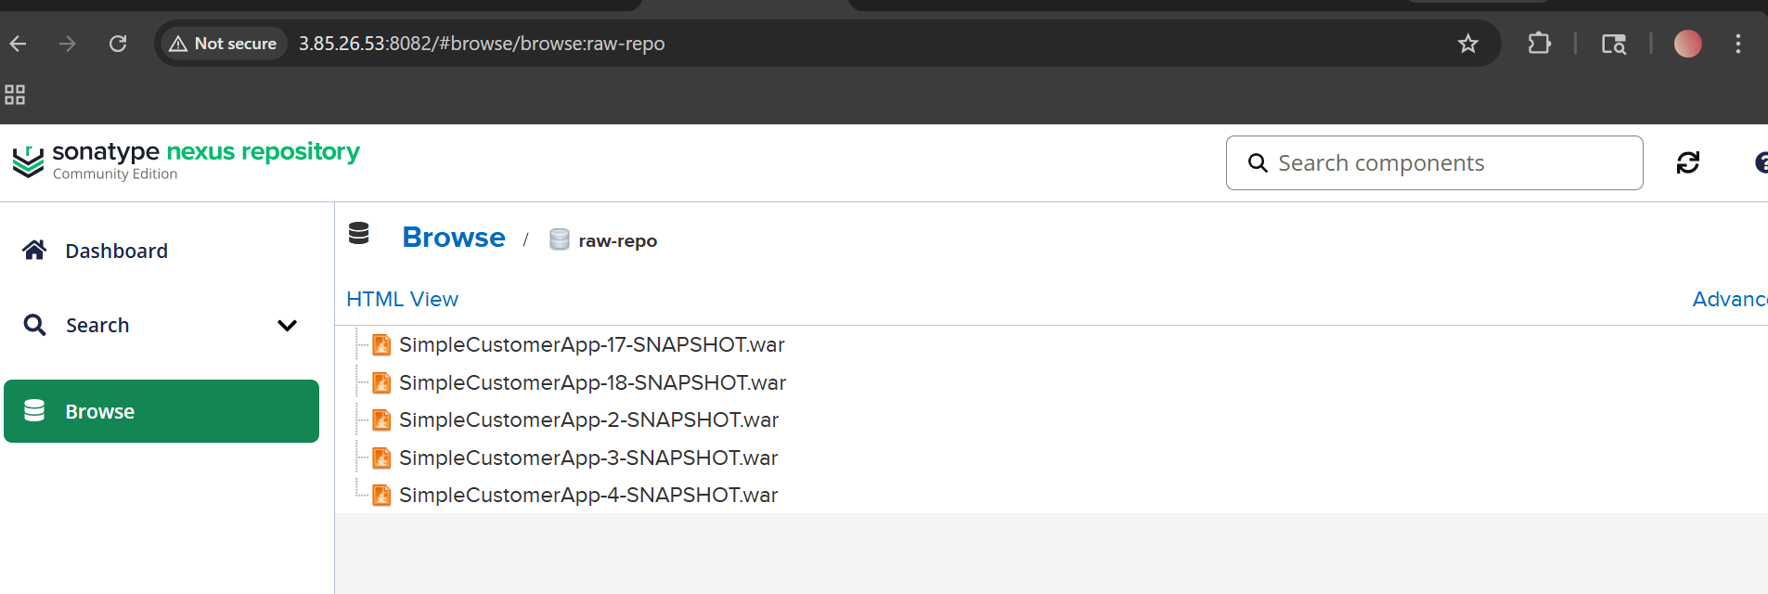
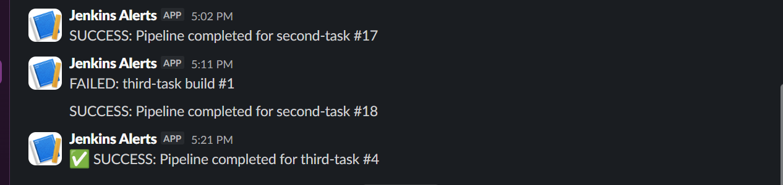

3) Setup a Jenkins CICD pipeline using Scripted pipeline using feature-1.1 branch.
Source Code: https://github.com/betawins/sabear_simplecutomerapp/tree/feature-1.1
stages:
- Git Clone
- SonarQube Integration
- Maven Compilation
- Nexus Artifactory
- Slack Notification
- Deploy On tomcat
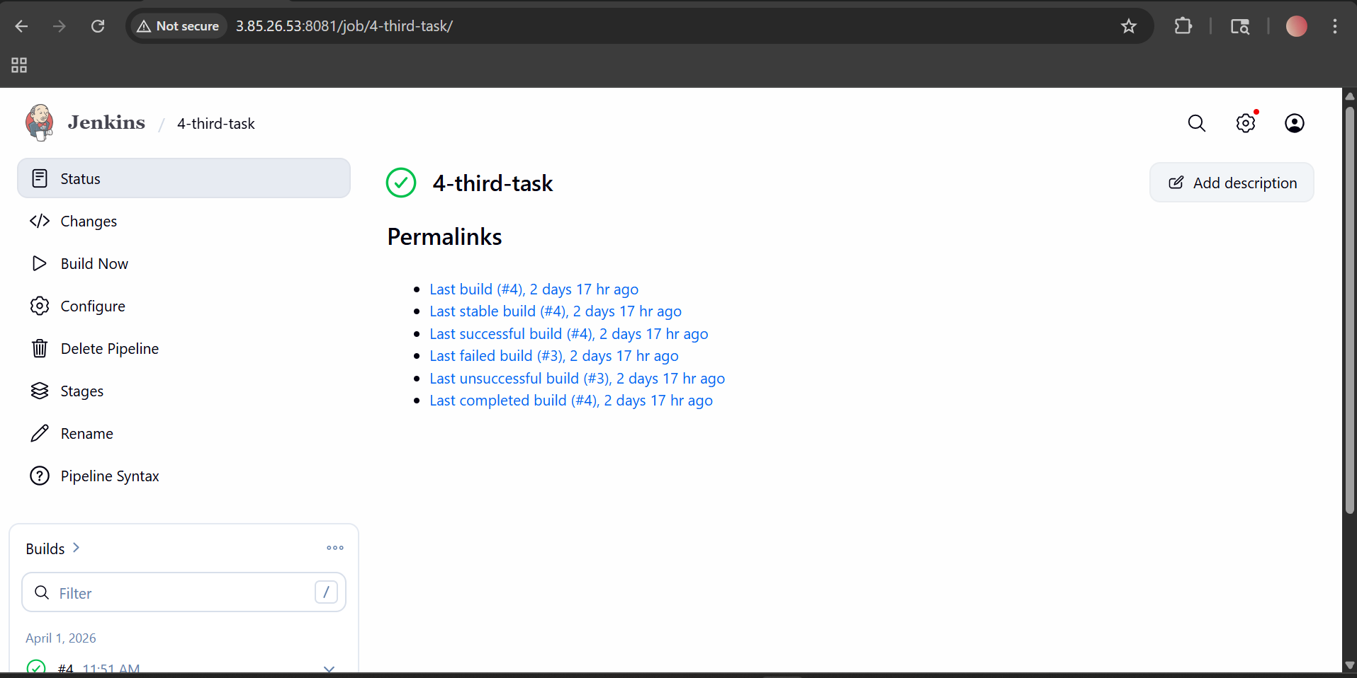

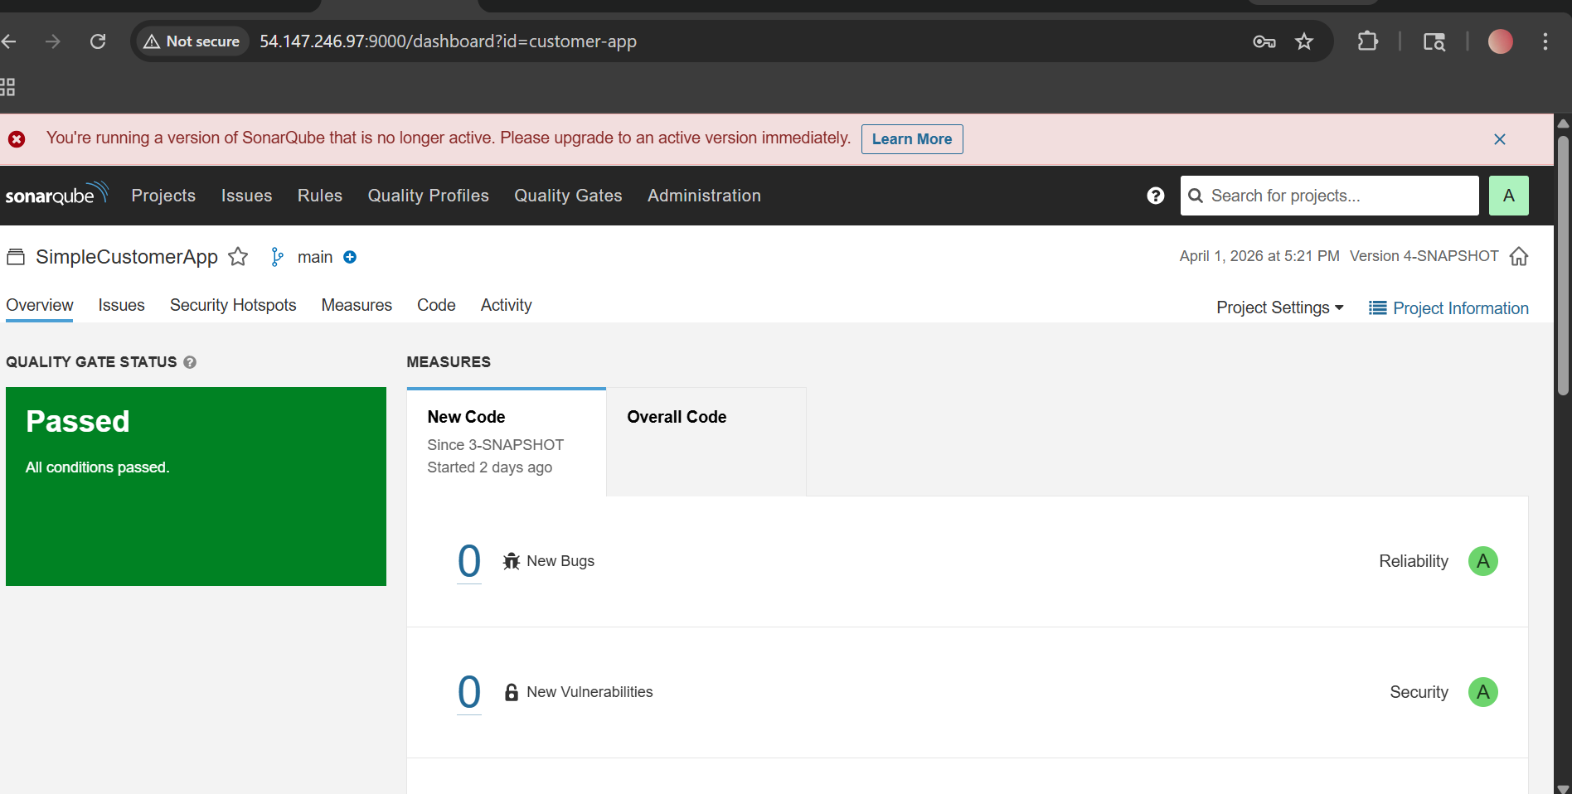
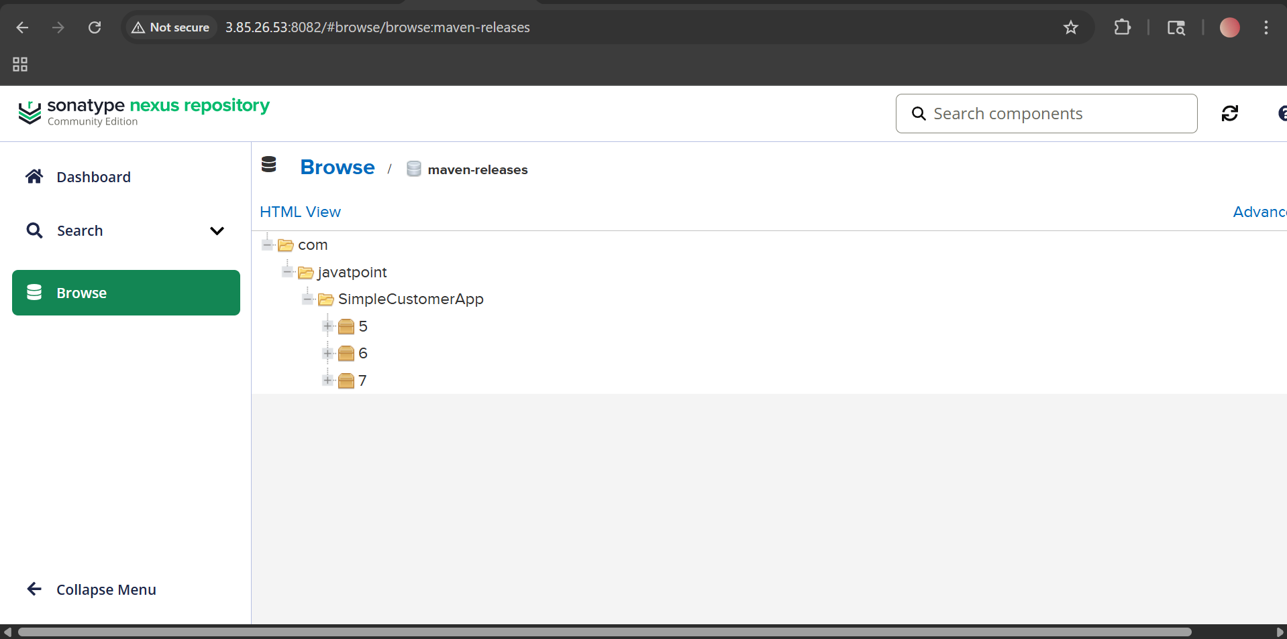

4) Write sample skeleton of pipelines.
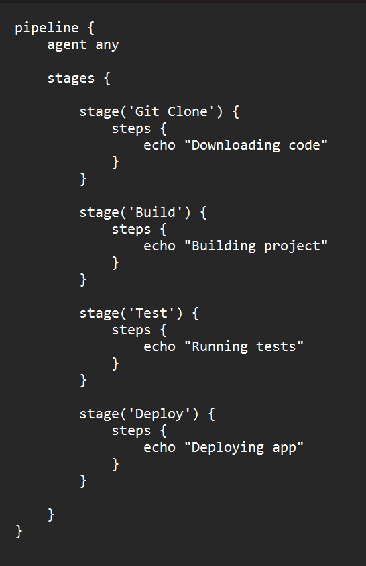
5) Create a parameterized job in Jenkins.
Source Code: https://github.com/betawins/spring3-mvc-maven-xml-hello-world-1.git
Step 1: Open Jenkins
Open Jenkins in browser.
Example:
http://3.85.26.53:8081
Login with your Jenkins username and password.

Step 2: Create a new job
On the Jenkins dashboard, click:
New Item

Step 3: Enter the job name
In the name box, type:
spring3-parameterized-job
Then select:
Freestyle project
Now click:
OK

Step 4: Enable parameterized job
In the configuration page, under General, tick this checkbox:
This project is parameterized
Now Jenkins will allow you to add parameters.

Step 5: Add parameter 1 for branch name
Click:
Add Parameter
Choose:
String Parameter
Fill the fields like this:
- Name: BRANCH_NAME
- Default Value: master
- Description: Git branch to build
You can also tick:
Trim the string

Step 6: Add parameter 2 for environment
Again click:
Add Parameter
Choose:
Choice Parameter
Fill it like this:
- Name: ENV
In Choices, type this exactly:
dev
test
prod
- Description: Select deployment environment

Step 7: Add parameter 3 for tests
Again click:
Add Parameter
Choose:
Boolean Parameter
Fill it like this:
- Name: RUN_TESTS
- Description: Run tests or skip tests
You can leave Set by Default checked or unchecked.
If checked, Jenkins will run tests by default.
If unchecked, Jenkins will skip tests unless you select it while building.

Step 8: Configure Git repository
Now go to the section:
Source Code Management
Select:
Git
In Repository URL, paste:
https://github.com/betawins/spring3-mvc-maven-xml-hello-world-1.git
Leave credentials as:
- none -
because this is a public repository.

Step 9: Configure the branch
In the Branches to build section, in Branch Specifier, enter:
*/${BRANCH_NAME}
This means Jenkins will use whatever branch name you give when you click Build with Parameters.

Step 10: Configure environment options
Go to the Environment section.
Tick:
Delete workspace before build starts
This is good because each build starts fresh.
You can also tick:
Add timestamps to the Console Output
This is optional, but useful.

Step 11: Add build step
Go to the Build Steps section.
Click:
Add build step
Choose:
Execute shell
Now paste this script:
export JAVA_HOME=/usr/lib/jvm/java-1.8.0-openjdk
export PATH=$JAVA_HOME/bin:$PATH
echo "Branch Name: $BRANCH_NAME"
echo "Environment: $ENV"
echo "Run Tests: $RUN_TESTS"
java -version
/var/lib/jenkins/tools/hudson.tasks.Maven_MavenInstallation/Maven/bin/mvn -version
if [ "$RUN_TESTS" = "true" ]; then
/var/lib/jenkins/tools/hudson.tasks.Maven_MavenInstallation/Maven/bin/mvn clean package
else
/var/lib/jenkins/tools/hudson.tasks.Maven_MavenInstallation/Maven/bin/mvn clean package -DskipTests
fi

Step 12: Save the job
Scroll down and click:
Save
Now your parameterized job is created.

Step 13: Run the job
On the left side of the job page, click:
Build with Parameters
Now Jenkins will ask for the values.
Example:
- BRANCH_NAME = master
- ENV = dev
- RUN_TESTS = checked
Then click:
Build

Step 14: Check build result
After the build starts, click the build number.
Example:
#1
Then click:
Console Output

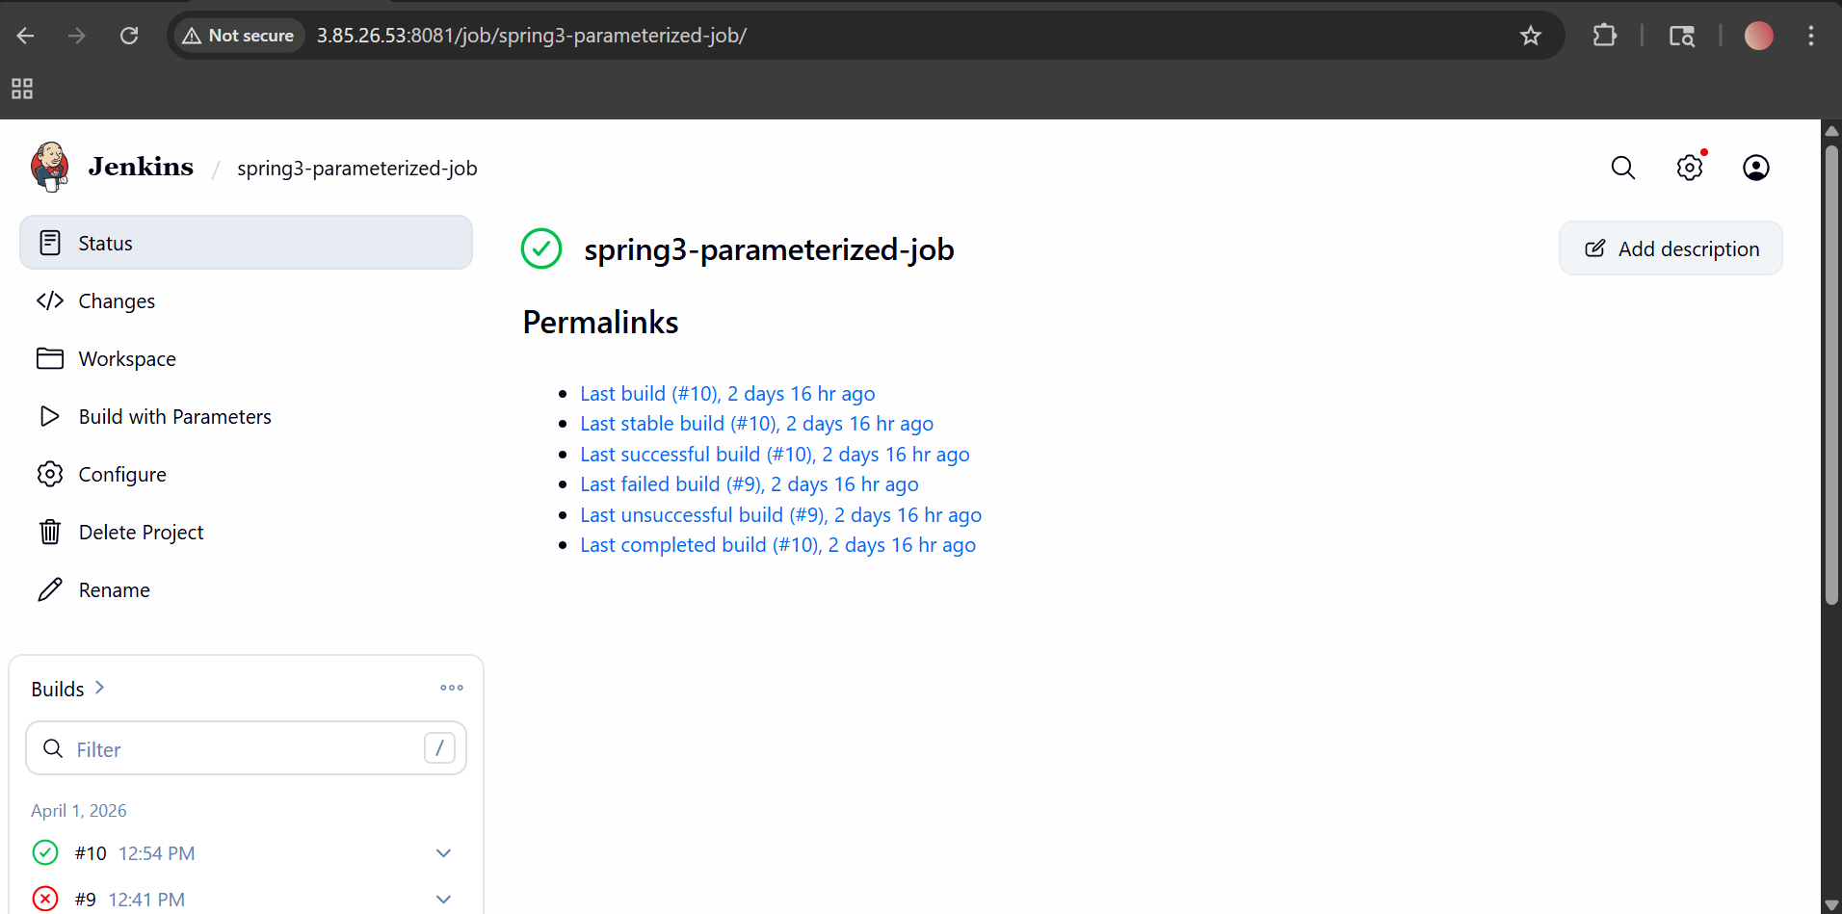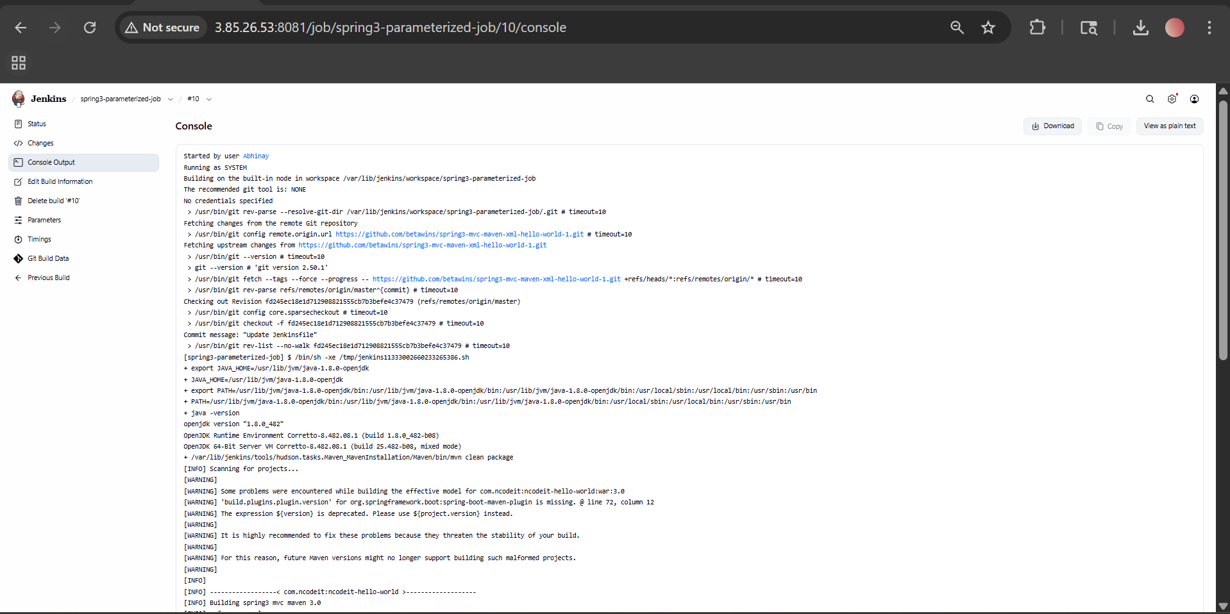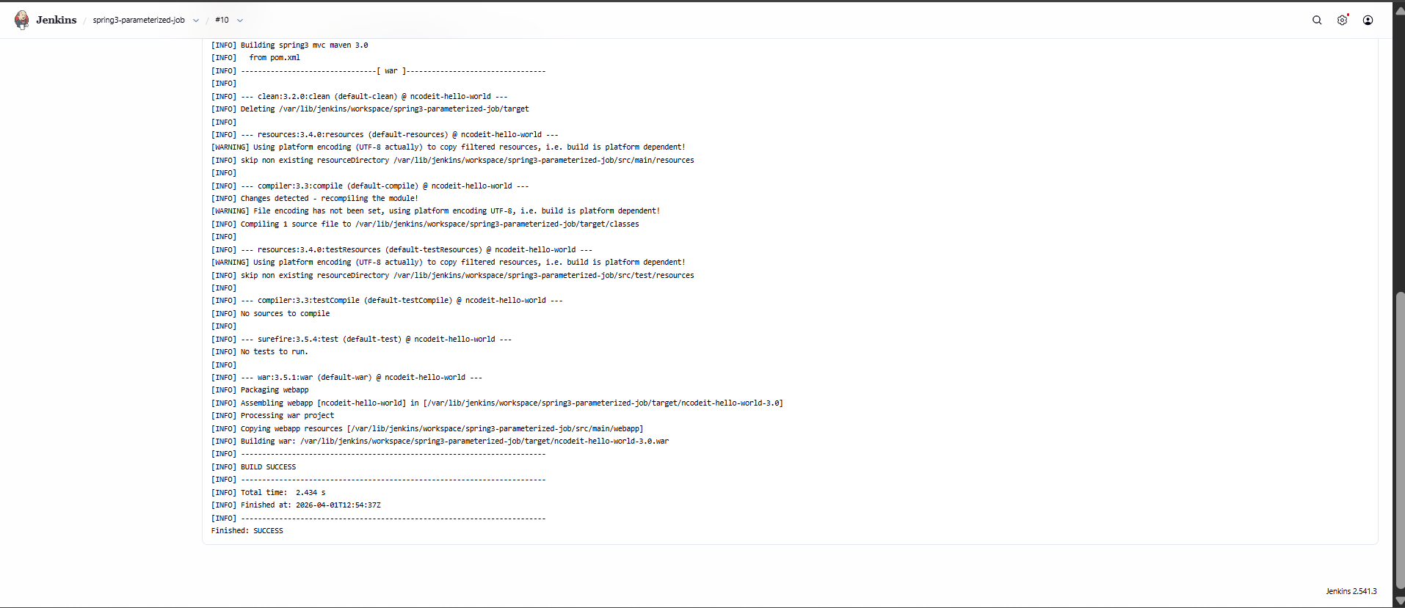

6) Setup one slave machine for Jenkins.
Steps on Slave Machine (Agent)
These steps prepare the slave node so Jenkins can connect to it.
1. Login & switch user
- Login to slave machine
- Switch to root:
sudo su -
2. Install Java (Required for Jenkins agent)
dnf install java-17-openjdk -y
Verify Installation
java -version
3. Generate SSH Key
ssh-keygen
👉 This creates:
- Private key → id_rsa
- Public key → id_rsa.pub
4. Add Public Key to authorized_keys
cat ~/.ssh/id_rsa.pub >> ~/.ssh/authorized_keys
chmod 700 ~/.ssh/authorized_keys
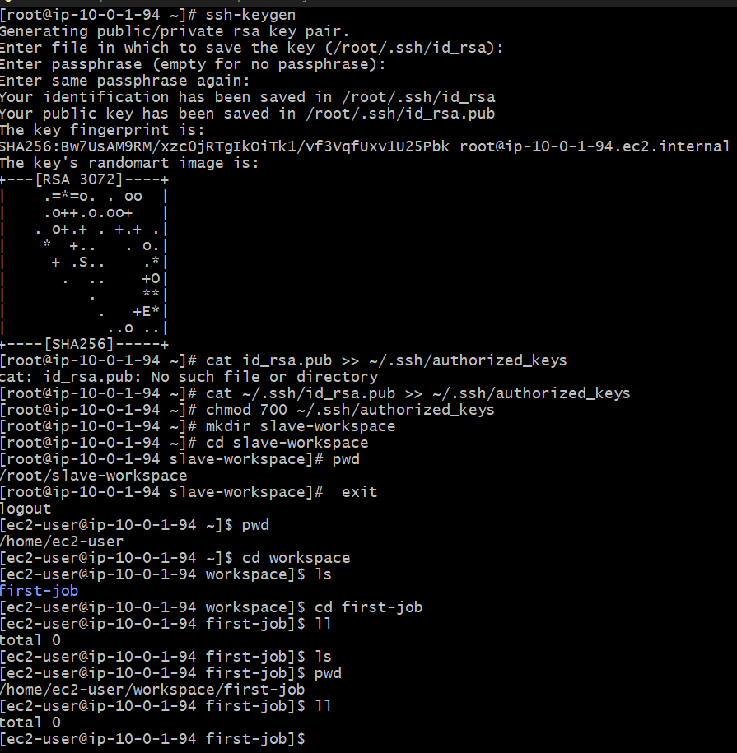 Steps on Master Machine (Jenkins Server)
1. Login & switch to root
sudo su -

2. Create Jenkins SSH directory
mkdir -p /var/lib/jenkins/.ssh
cd /var/lib/jenkins/.ssh
This is where Jenkins stores SSH configs.
3. Add Slave to known_hosts
ssh-keyscan -H 34.204.107.115 >> /var/lib/jenkins/.ssh/known_hosts
4. Fix ownership
chown jenkins:jenkins known_hosts
Because Jenkins runs as jenkins user, not root.
5. Set permissions
chmod 700 known_hosts
