Launch AWS EC2 & Install Jenkins
This section covers launching a virtual server in the cloud and setting up the Jenkins automation
server.
Step 1.1: Launch EC2 Instance
1. Log in to your AWS Management Console.
2. Navigate to EC2 > Launch Instance.
3. Name: Jenkins-Server.
4. AMI: Select Ubuntu 24.04 LTS.
5. Instance Type: t3.micro (Free Tier eligible).
6. Key Pair: Create a new one (e.g., jenkins) and download it.
7. Network Settings: * Allow SSH (Port 22).
o Allow Custom TCP (Port 8080) from "Anywhere" (0.0.0.0/0).
8. Click Launch Instance.
Step 1.2: Connect and Install Jenkins
Open your terminal (or PowerShell) and SSH into your instance:
Bash
ssh -i "my-key.pem" ubuntu@your-ec2-public-ip
Once connected, run these commands to install Java and Jenkins:
Bash
# Update system
sudo apt update && sudo apt upgrade -y
# Install OpenJDK 17 (Required for Jenkins)
sudo apt install openjdk-17-jdk -y
# Add Jenkins Repo and Key
sudo wget -O /usr/share/keyrings/jenkins-keyring.asc
https://pkg.jenkins.io/debian-stable/jenkins.io-2023.key
echo "deb [signed-by=/usr/share/keyrings/jenkins-keyring.asc] https://pkg.jenkins.io/debian-stable
binary/" | sudo tee /etc/apt/sources.list.d/jenkins.list > /dev/null
# Install Jenkins
sudo apt update
sudo apt install jenkins -y
# Start Jenkins
sudo systemctl enable jenkins
sudo systemctl start jenkins
Step 1.3: Access Jenkins UI
1. Go to http://<your-ec2-public-ip>:8080.
2. Retrieve the initial password from your terminal: sudo cat
/var/lib/jenkins/secrets/initialAdminPassword
3. Follow the wizard to install suggested plugins.
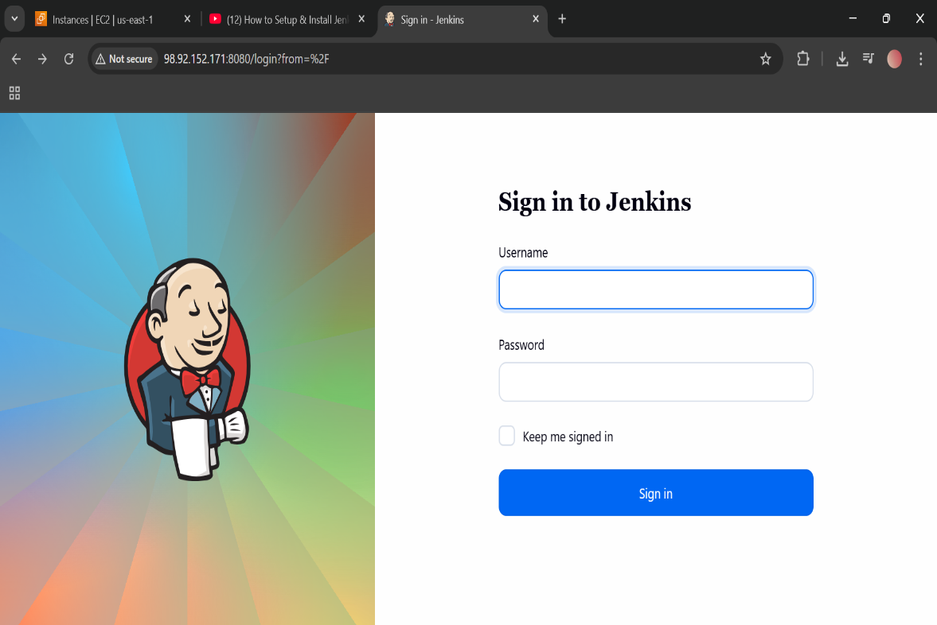 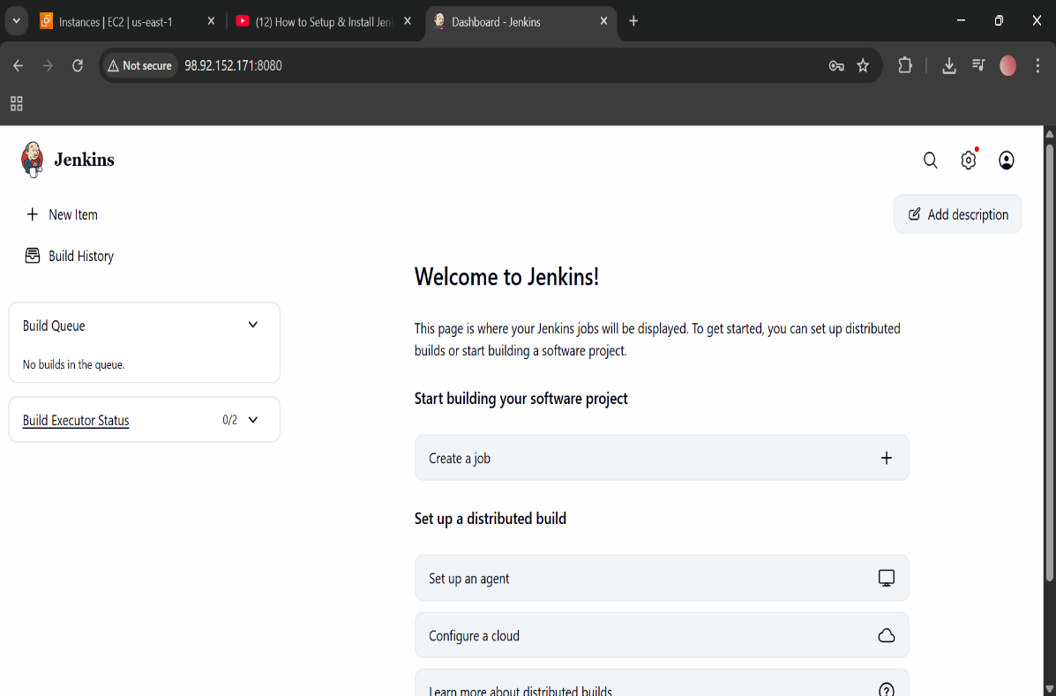 Setup Apache Tomcat on Ubuntu VM
- mkdir -p /opt/tomcat
- cd /opt
- sudo wget https://downloads.apache.org/tomcat/tomcat-9/v9.0.111/bin/apache-tomcat-9.0.111.tar.gz
- sudo tar -xzf apache-tomcat-9.0.111.tar.gz -C /opt/tomcat --strip-components=1
- sudo chmod +x /opt/tomcat/bin/*.sh
- cd /opt/tomcat/bin
- sudo ./startup.sh

- sudo snap services | grep jenkins
- sudo snap stop jenkins
- sudo snap services | grep jenkins

- cd
- cd /opt/tomcat/bin
- sudo ./startup.sh
- ps -ef | grep tomcat
- sudo ss -tulpn | grep 8080 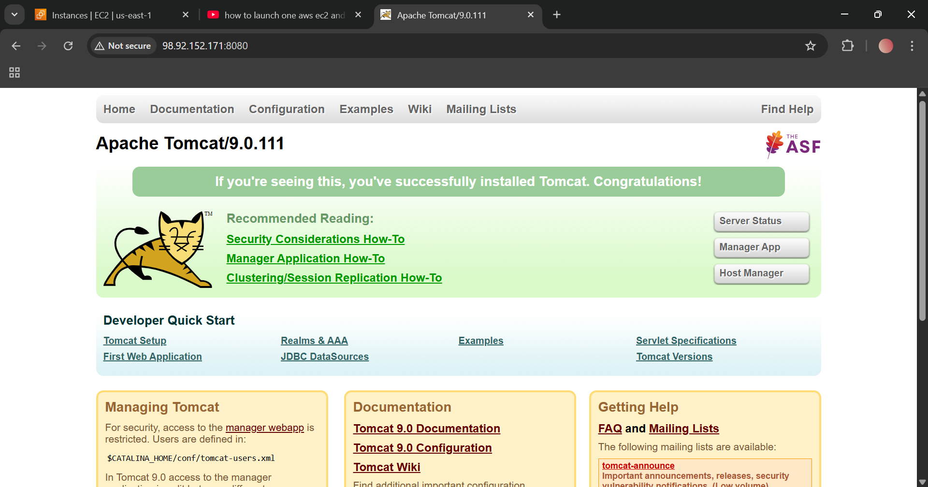
Setup Docker Desktop on Local Windows
3. Setup Docker Desktop on Local Windows
Docker allows you to package and run applications in containers.
Step 3.1: Enable WSL 2 (Prerequisite)
1. Open PowerShell as Administrator and run: wsl --install
2. Restart your computer if prompted.
Step 3.2: Install Docker Desktop
1. Download: Go to Docker's official site and click Download for Windows.
2. Run Installer: Double-click Docker Desktop Installer.exe.
3. Configuration: Ensure "Use WSL 2 instead of Hyper-V" is checked.
4. Finish: Click Ok, wait for installation, and click Close and Restart.
5. Accept Terms: Upon restart, open Docker Desktop and accept the service agreement.
Step 3.3: Verify Installation
Open a command prompt (CMD) and type:
Bash
docker --version
docker run hello-world
