- Setup eks cluster using eksctl

I’ll give you a clean step-by-step EKS setup using eksctl, including installing missing tools, configuring AWS credentials, creating the cluster, and verifying nodes.
Thought for 5s
Below commands are for Ubuntu master machine.
1. Install AWS CLI
sudo apt update -y
sudo apt install unzip curl -y
curl "https://awscli.amazonaws.com/awscli-exe-linux-x86_64.zip" -o "awscliv2.zip"
unzip awscliv2.zip
sudo ./aws/install
aws --version
2. Configure AWS
aws configure
Enter:
AWS Access Key ID
AWS Secret Access Key
Default region: ap-south-1
Default output: json
3. Install eksctl
ARCH=amd64
PLATFORM=$(uname -s)_$ARCH
curl -sLO "https://github.com/eksctl-io/eksctl/releases/latest/download/eksctl_${PLATFORM}.tar.gz"
tar -xzf eksctl_${PLATFORM}.tar.gz -C /tmp
sudo mv /tmp/eksctl /usr/local/bin
eksctl version
4. Check kubectl
You already have kubectl:
kubectl version –client

5. Create EKS Cluster
eksctl create cluster \
--name my-eks-cluster \
--region us-east-1\
--version 1.30 \
--nodegroup-name my-workers \
--node-type t3.medium \
--nodes 2 \
--nodes-min 2 \
--nodes-max 3 \
--managed
Amazon’s EKS guide says eksctl is used to create and manage EKS clusters, and AWS requires AWS CLI, kubectl, and eksctl before creating the cluster.

6. Verify Cluster
eksctl get cluster --region us-east-1
kubectl get nodes
kubectl get pods -A

7. Test with Nginx
kubectl create deployment nginx --image=nginx
kubectl expose deployment nginx --type=LoadBalancer --port=80
kubectl get svc

8. Delete Cluster Later
eksctl delete cluster \
--name my-eks-cluster \
--region us-east-1

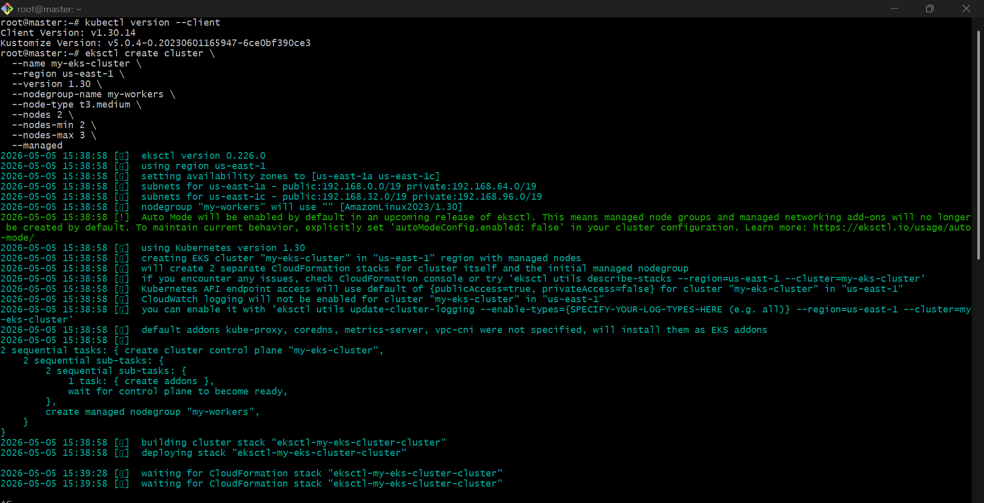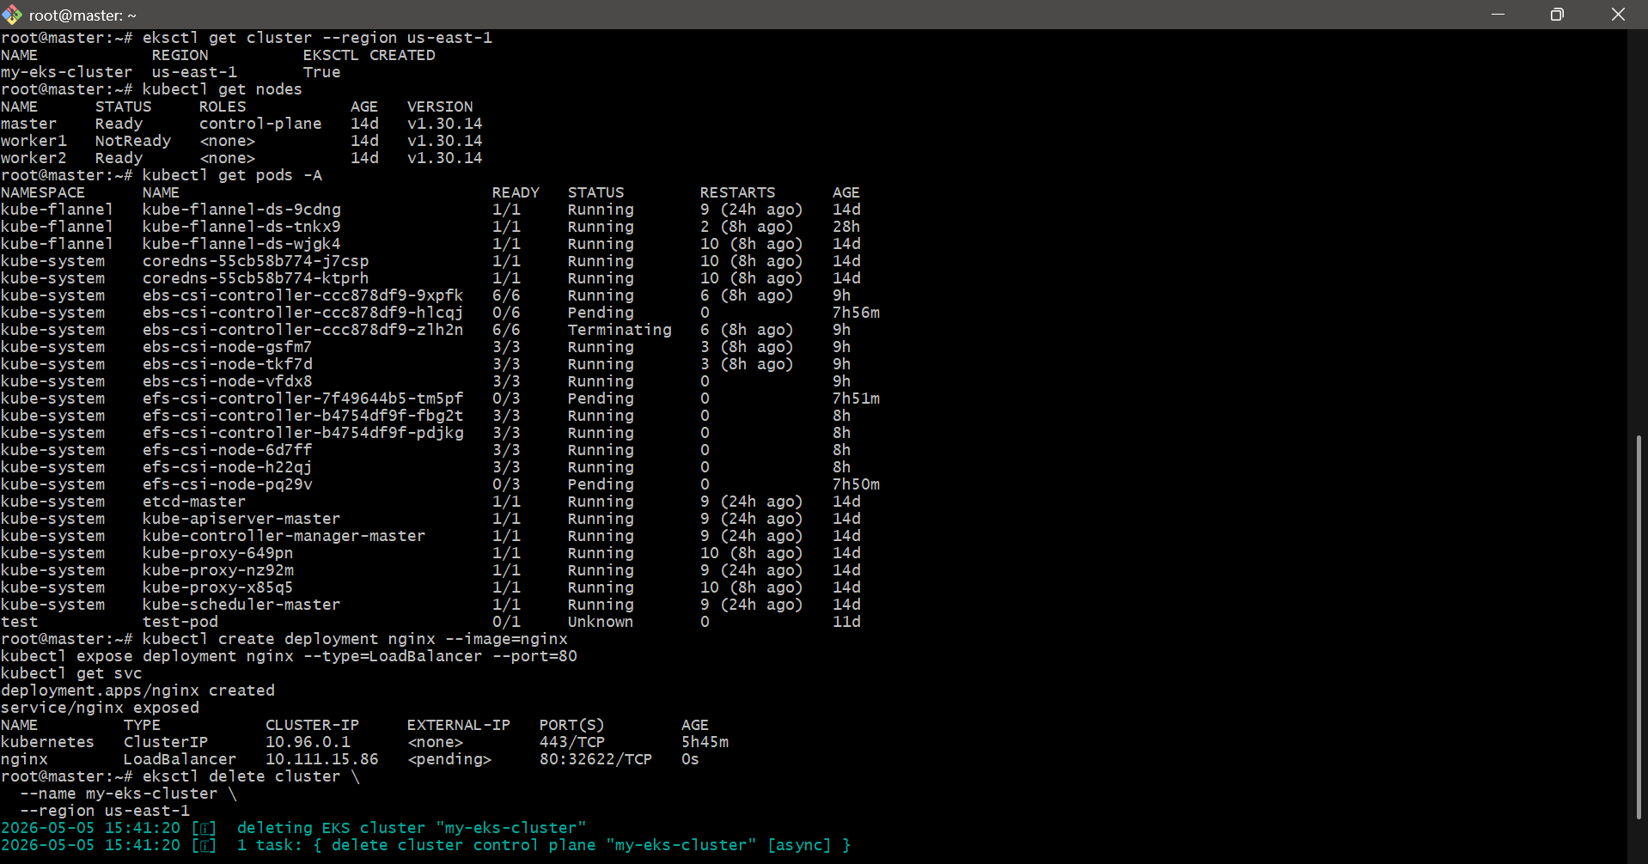

- setup eks cluster using console
Prerequisites
You should have:
- AWS Account
- IAM user with AdministratorAccess
- Ubuntu/Linux machine OR EC2 instance
- kubectl installed
- AWS CLI installed

STEP 1 — Login to AWS Console
Open:
AWS Console

STEP 2 — Change Region
Top right corner → Select:
- N. Virginia (us-east-1)

STEP 3 — Create VPC for EKS
Search:
- VPC
Open:
Amazon VPC Console

Create VPC Automatically
Go to:
- VPC Dashboard
- Click:
  - "Create VPC"

Select:
- VPC and more

Configure
Name tag
eks-vpc
IPv4 CIDR
10.0.0.0/16
Availability Zones
Select:
2
Public Subnets
2
Private Subnets
2
NAT Gateways
Select:
1 per AZ
VPC Endpoints
None

Click
Create VPC
Wait 3–5 minutes.

STEP 4 — Create EKS Cluster IAM Role
Search:
- IAM
Open:
AWS IAM Console

Create Role
Go to:
- Roles
- Create role

Trusted Entity
Select:
AWS service
Use case:
EKS
Select:
EKS - Cluster
Click:
Next

Attach Permissions
Add:
AmazonEKSClusterPolicy

Role Name
eksClusterRole
Click:
Create role

STEP 5 — Create EKS Cluster
Search:
- EKS
Open:
Amazon EKS Console

Click
Add cluster
→
Create

Cluster Configuration

Name
my-eks-cluster

Kubernetes Version
Select latest stable version.
Example:
1.30

Cluster Service Role
Select:
eksClusterRole

Networking

VPC
Select:
eks-vpc

Subnets
Select:
- 2 Public Subnets
- 2 Private Subnets

Cluster Endpoint Access
Select:
Public and Private

Logging
Enable all logs:
- API
- Audit
- Authenticator
- Controller Manager
- Scheduler

Click
Create
Wait about:
10–15 minutes

STEP 6 — Create Node Group IAM Role
Go to IAM → Roles → Create role

Trusted Entity
AWS Service
Use Case:
EC2

Attach Policies
Add ALL:
AmazonEKSWorkerNodePolicy
AmazonEC2ContainerRegistryReadOnly
AmazonEKS_CNI_Policy

Role Name
eksNodeRole
Click:
Create role

STEP 7 — Create Worker Nodes
Go back to EKS Cluster.

Open Cluster
my-eks-cluster

Go to
Compute

Click
Add Node Group

Node Group Details

Name
linux-nodes

Node IAM Role
Select:
eksNodeRole

Compute Configuration

AMI Type
Amazon Linux 2023

Capacity Type
On-Demand

Instance Type
Recommended:
t3.medium

Scaling
Desired:
2
Minimum:
2
Maximum:
3

Networking
Select:
- Private Subnets

Click
Create
Wait:
5–10 minutes

STEP 8 — Connect to Cluster
Launch Ubuntu EC2 OR use existing Linux server.

Install AWS CLI
curl "https://awscli.amazonaws.com/awscli-exe-linux-x86_64.zip" -o "awscliv2.zip"
sudo apt update -y
sudo apt install unzip -y
unzip awscliv2.zip
sudo ./aws/install
Verify:
aws --version

Configure AWS CLI
aws configure
Enter:
AWS Access Key
AWS Secret Key
Region: us-east-1
Output: json

Install kubectl
curl -LO "https://dl.k8s.io/release/$(curl -L -s https://dl.k8s.io/release/stable.txt)/bin/linux/amd64/kubectl"
chmod +x kubectl
sudo mv kubectl /usr/local/bin/
Verify:
kubectl version --client

STEP 9 — Connect kubectl to EKS
Run:
aws eks update-kubeconfig \
--region us-east-1 \
--name my-eks-cluster

STEP 10 — Verify Cluster
Check nodes:
kubectl get nodes
Expected:
NAME STATUS ROLES AGE VERSION
ip-10-0-x-x Ready <none> 5m v1.30
ip-10-0-x-x Ready <none> 5m v1.30

STEP 11 — Deploy Test Application
Create deployment:
kubectl create deployment nginx --image=nginx
Expose service:
kubectl expose deployment nginx \
--type=LoadBalancer \
--port=80
Check:
kubectl get svc

Important Components
Component | Purpose
EKS Cluster | Kubernetes Control Plane
Node Group | Worker Nodes
VPC | Networking
IAM Roles | Permissions
kubectl | Kubernetes Management
LoadBalancer | External Access

Useful Commands
Check Nodes
kubectl get nodes
Check Pods
kubectl get pods -A
Check Services
kubectl get svc
Delete Deployment
kubectl delete deployment nginx
Delete Service
kubectl delete svc nginx

Delete Entire EKS Cluster
Go to:
EKS → Cluster → Delete
Delete in order:
- Node Groups
- Cluster
- VPC
- IAM Roles

Final Result
After setup:
- EKS Control Plane running
- Worker Nodes connected
- kubectl connected
- Applications deployable
- LoadBalancer accessible from internet

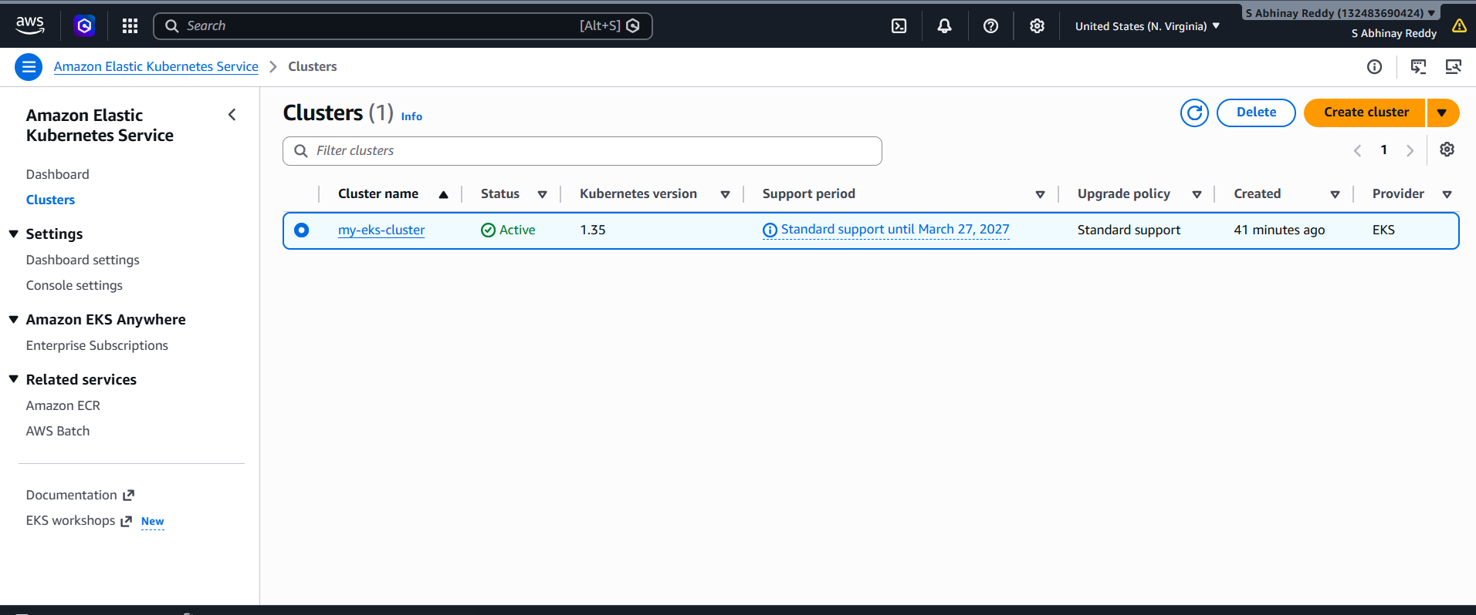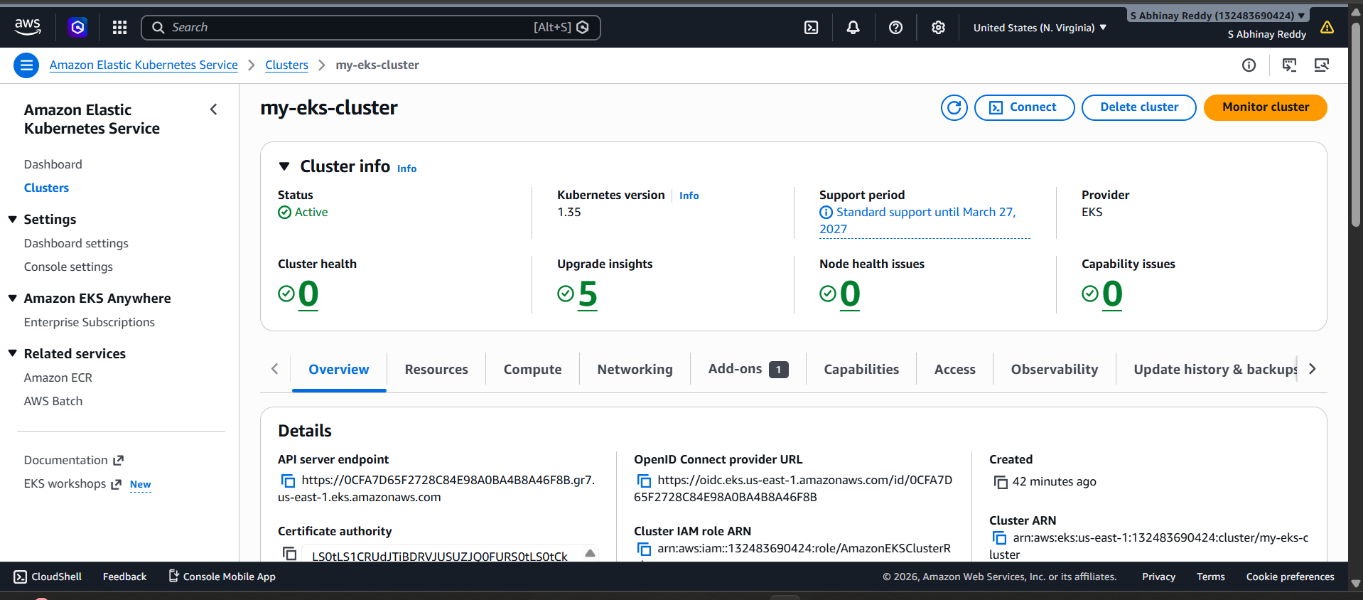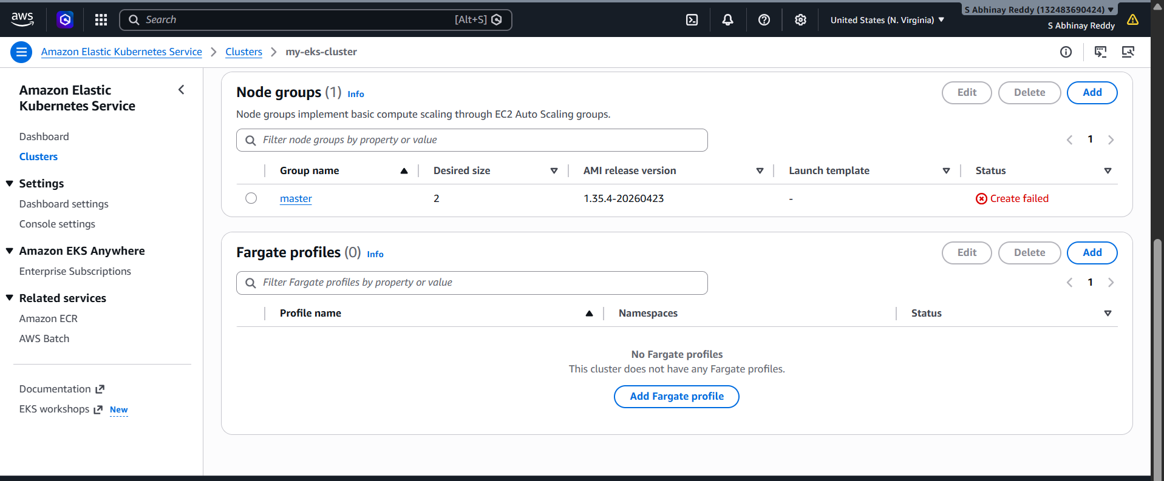

- Setup HPA

Setup HPA in Kubernetes (Horizontal Pod Autoscaler)
What is HPA?
HPA automatically increases or decreases pod count based on CPU or memory usage.
Example:
CPU > 70% → increase pods
CPU low → decrease pods

Architecture
User Traffic
↓
Deployment
↓
Pods
↓
HPA monitors CPU
↓
Automatically scales pods

Prerequisites
You need:
1. Kubernetes Cluster
2. metrics-server installed
3. Deployment running

Step 1: Verify Cluster
Check nodes:
kubectl get nodes

Step 2: Install Metrics Server
HPA requires metrics-server.
Run:
kubectl apply -f https://github.com/kubernetes-sigs/metrics-server/releases/latest/download/components.yaml

Step 3: Edit Metrics Server (Important)
For kubeadm/lab clusters usually this is needed.
Run:
kubectl edit deployment metrics-server -n kube-system
Find:
containers:
- args:
Add these lines under args:
- --kubelet-insecure-tls
- --kubelet-preferred-address-types=InternalIP
Example:
args:
- --cert-dir=/tmp
- --secure-port=10250
- --kubelet-preferred-address-types=InternalIP
- --kubelet-insecure-tls
Save and exit.

Step 4: Verify Metrics Server
Check pods:
kubectl get pods -n kube-system
Check metrics:
kubectl top nodes
kubectl top pods
If metrics appear → success.

Step 5: Create Deployment
Create nginx deployment:
kubectl create deployment nginx-hpa --image=nginx
Scale initially:
kubectl scale deployment nginx-hpa --replicas=1
Expose service:
kubectl expose deployment nginx-hpa --port=80 --type=NodePort

Step 6: Add Resource Limits
HPA works properly only with CPU requests.
Edit deployment:
kubectl edit deployment nginx-hpa
Add inside container spec:
resources:
requests:
cpu: "100m"
limits:
cpu: "200m"
Example:
containers:
- image: nginx
name: nginx
resources:
requests:
cpu: "100m"
limits:
cpu: "200m"
Save and exit.

Step 7: Create HPA
Run:
kubectl autoscale deployment nginx-hpa --cpu-percent=50 --min=1 --max=5
Meaning:
Target CPU: 50%
Minimum pods: 1
Maximum pods: 5

Step 8: Verify HPA
Check:
kubectl get hpa
Expected:
NAME REFERENCE TARGETS MINPODS MAXPODS REPLICAS
nginx-hpa Deployment/nginx-hpa 0%/50% 1 5 1

Step 9: Generate Load
Run temporary busybox pod:
kubectl run load-generator --image=busybox -- /bin/sh -c "while true; do wget -q -O- http://nginx-hpa; done"

Step 10: Watch Scaling
Open another terminal:
kubectl get hpa -w
Check pods:
kubectl get pods
You will see:
1 pod → 2 pods → 3 pods
depending on CPU usage.

Step 11: Stop Load
Delete load generator:
kubectl delete pod load-generator
After some time pods reduce automatically.

Important Commands
Check metrics
kubectl top nodes
kubectl top pods
Check HPA
kubectl describe hpa
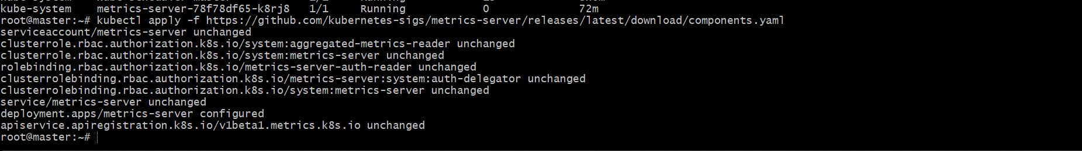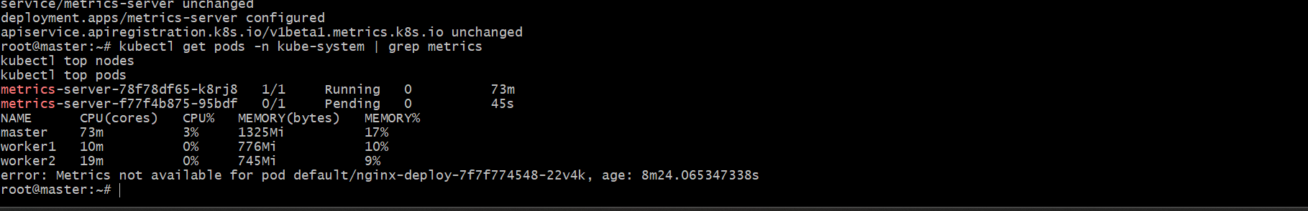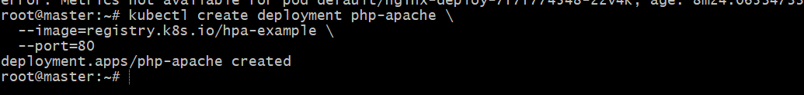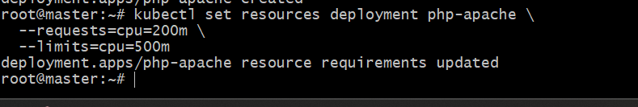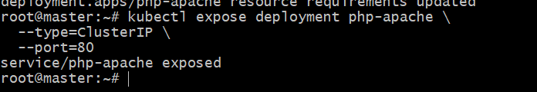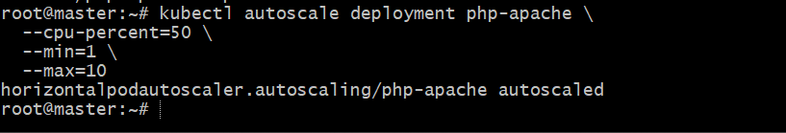

- Setup cluster autoscale

  - Enable Auto Scaling on Node Group (Console)
Go to AWS Management Console
Path:
EKS → Cluster → Compute → Node group
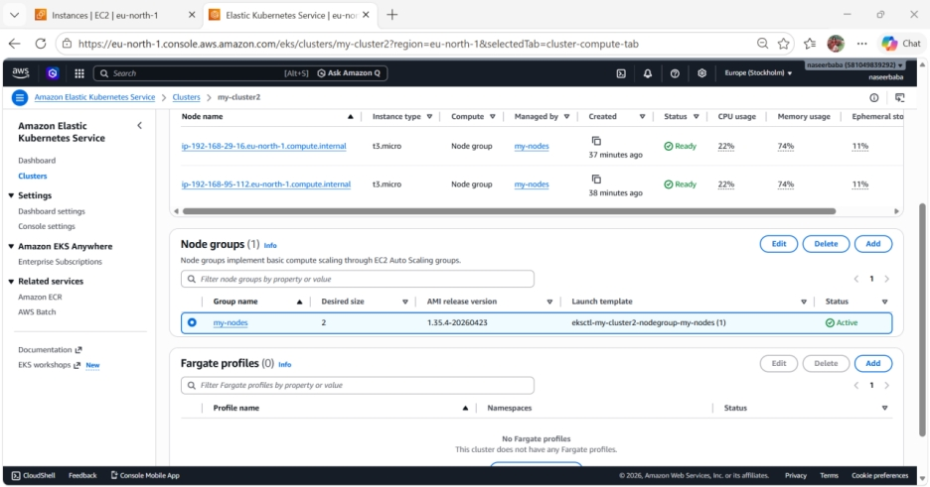
Click your node group → Edit:
Set:
• Min: 1
• Desired: 2
• Max: 3
Save
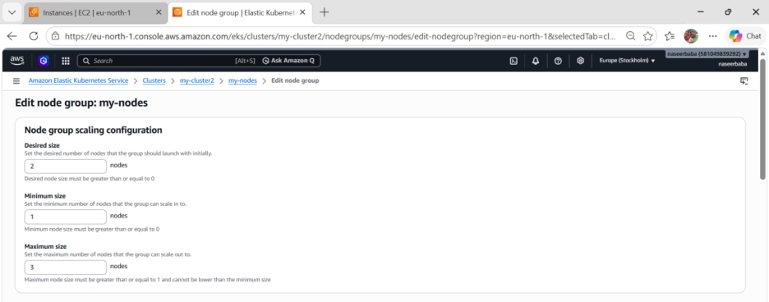
  - Attach IAM Policy (VERY IMPORTANT)
Go to: IAM → Roles → your node IAM role
Attach policy:
Create policy (JSON):
{
"Version": "2012-10-17",
"Statement": [
{
"Action": [
"autoscaling:DescribeAutoScalingGroups",
"autoscaling:DescribeAutoScalingInstances",
"autoscaling:DescribeLaunchConfigurations",
"autoscaling:SetDesiredCapacity",
"autoscaling:TerminateInstanceInAutoScalingGroup",
"ec2:DescribeLaunchTemplateVersions"
],
"Effect": "Allow",
"Resource": "*"
}
]
}
Attach this to node role.
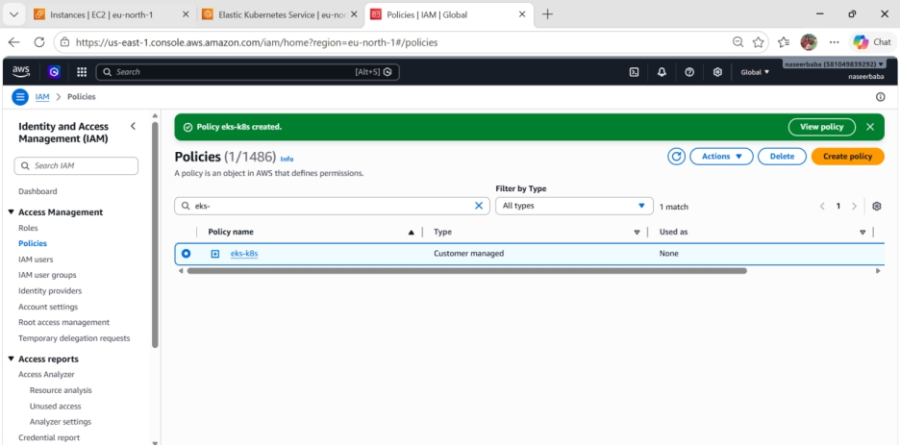

  - Add Tags to Node Group (CRITICAL)
Go to: EC2 → Auto Scaling Groups → your node group ASG
Add tags:
k8s.io/cluster-autoscaler/enabled = true
k8s.io/cluster-autoscaler/my-cluster_eks = owned
Replace cluster name correctly
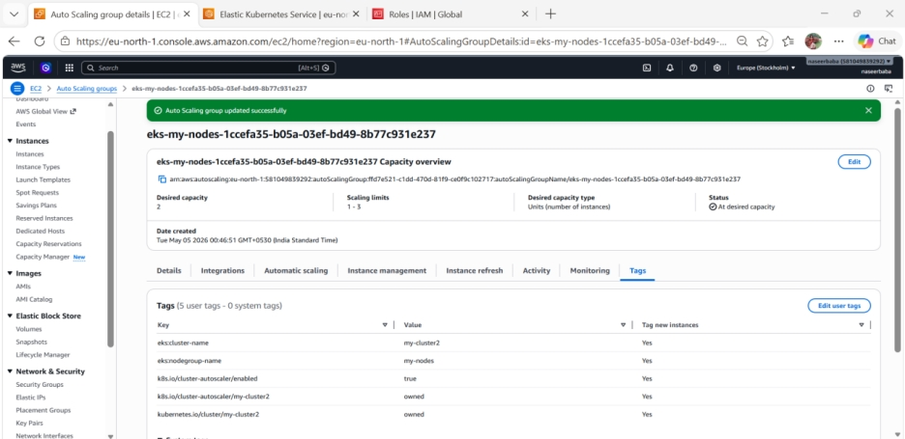
  - Deploy Cluster Autoscaler
Run this:
kubectl apply -f https://raw.githubusercontent.com/kubernetes/autoscaler/master/cluster-autoscaler/cloudprovider/aws/examples/cluster-autoscaler-autodiscover.yaml
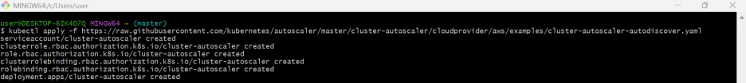
  - Edit deployment
kubectl edit deployment cluster-autoscaler -n kube-system
Find this line:
--cluster-name=<YOUR CLUSTER NAME>
Replace with:
--cluster-name=my-cluster1_eks
Add one more IMPORTANT flag
Under command: add:
--balance-similar-node-groups
--skip-nodes-with-system-pods=false
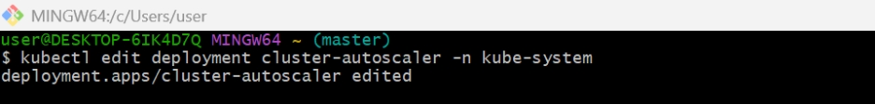
  - Verify
kubectl get pods -n kube-system
You should see:
cluster-autoscaler Running ✅
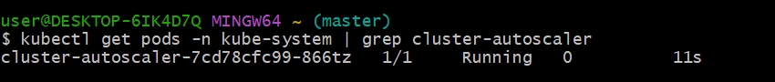
  - Test autoscaling
Create load:
Update BOTH requests + limits:
kubectl set resources deployment nginx \
--requests=cpu=1,memory=1Gi \
--limits=cpu=1,memory=1Gi
kubectl scale deployment nginx-deployment --replicas=10
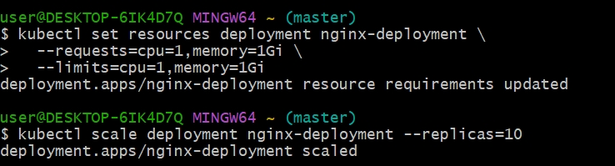
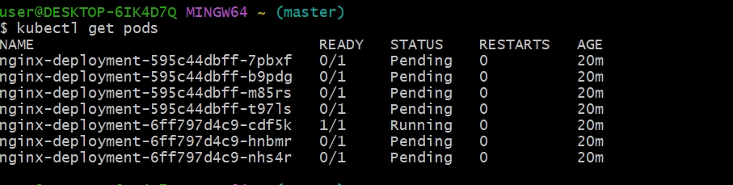

- Setup cronjob and job

  - Create one cronjob.yaml
Vi cronjob.yaml
apiVersion: batch/v1
kind: CronJob
metadata:
name: test-cronjob
namespace: default
spec:
# Cron schedule: “* * * * *” = every minute
schedule: "*/1 * * * *"
# Optional: limit number of successful/failed history
successfulJobsHistoryLimit: 3
failedJobsHistoryLimit: 1
jobTemplate:
spec:
template:
spec:
restartPolicy: OnFailure
containers:
- name: date-printer
# Lightweight image that has “date”
image: busybox:1.35
args:
- /bin/sh
- -c
- date; echo "Hello from EKS CronJob"

  - Run cronjob: kubectl apply -f cronjob.yaml
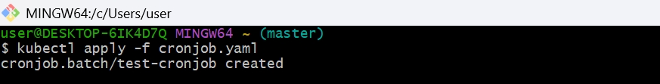
  - How to test: kubectl get cronjob
  - and check logs to see date: kubectl get pods .
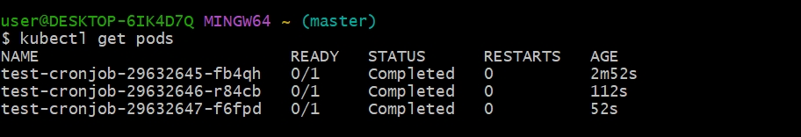
  - Kubectl get pods -w
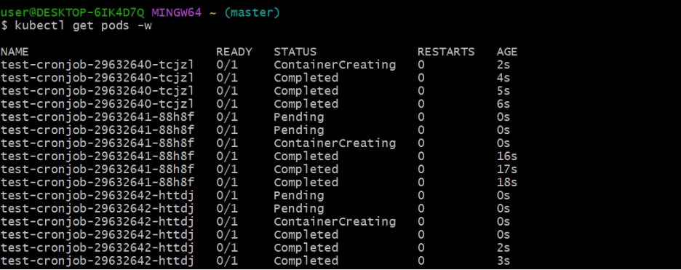
  - kubectl logs job/$(kubectl get jobs -o jsonpath='{.items[-1].metadata.name}')
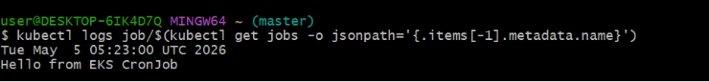

Job:
  - Create a sampleJob
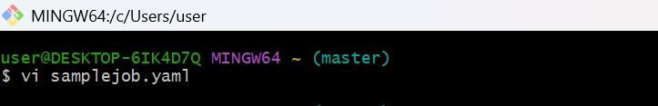
apiVersion: batch/v1
kind: Job
metadata:
name: my-job
spec:
completions: 1
parallelism: 1
template:
spec:
containers:
- name: job-container
image: busybox
command: ["sh", "-c", "echo Hello from Job && sleep 5"]
restartPolicy: Never
  - Apply
kubectl apply -f samplejob.yaml
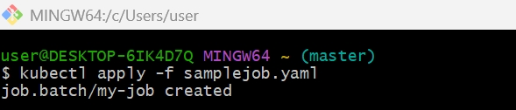
  - Check Job
kubectl get jobs
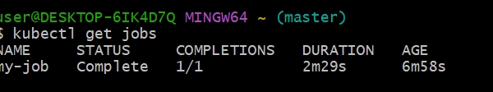
  - Check Pod
kubectl get pods
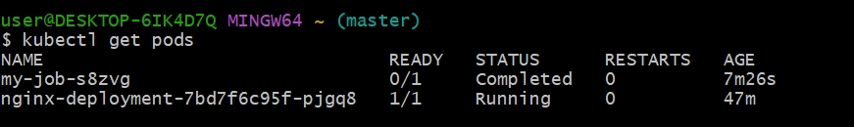
  - Check Logs
kubectl logs <job-pod-name>
kubectl logs my-job-cj26n
Output:
Hello from Job
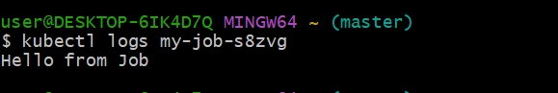

- Create secret and inject inside pod

  - Create Secret (YAML)
vi secret.yaml
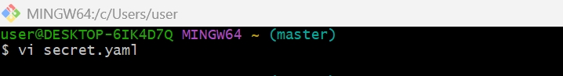
apiVersion: v1
kind: Secret
metadata:
name: my-secret
type: Opaque
data:
username: YWRtaW4= # base64 for "admin"
password: cGFzc3dvcmQ= # base64 for "password"
  - Apply it:
kubectl apply -f secret.yaml
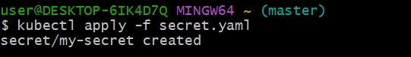
  - Verify:
kubectl get secrets
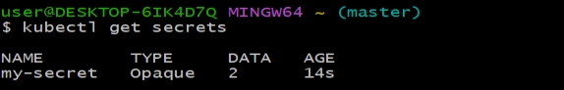
à kubectl describe secret my-secret
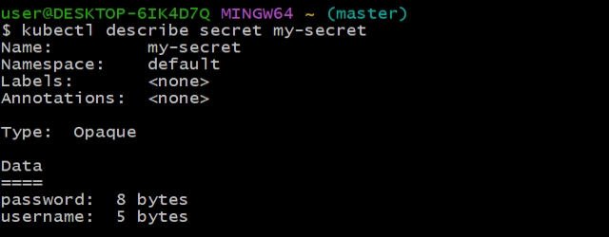
  - Inject Secret into Pod (as ENV variables)
Create pod YAML:
vi secret-pod.yaml
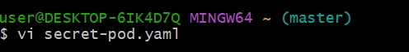
apiVersion: v1
kind: Pod
metadata:
name: secret-pod
spec:
containers:
- name: nginx
image: nginx
env:
- name: USERNAME
valueFrom:
secretKeyRef:
name: my-secret
key: username
- name: PASSWORD
valueFrom:
secretKeyRef:
name: my-secret
key: password
  - Apply:
kubectl apply -f secret-pod.yaml
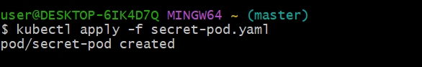
  - Verify inside Pod
kubectl exec -it secret-pod -- printenv | grep USERNAME
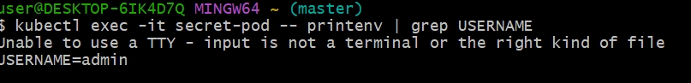
à kubectl exec -it secret-pod -- printenv | grep PASSWORD
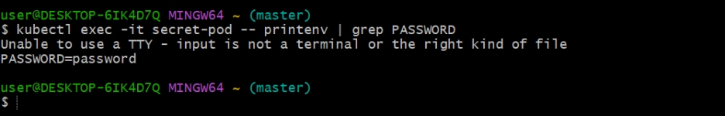

- Check differen add-ons available on eks.
  - Open your cluster
- Go to EKS → Clusters
- Click your cluster → my-cluster2
- Open Add-ons tab
  - Click “Get more add-ons”
- Scroll up and click Get more add-ons
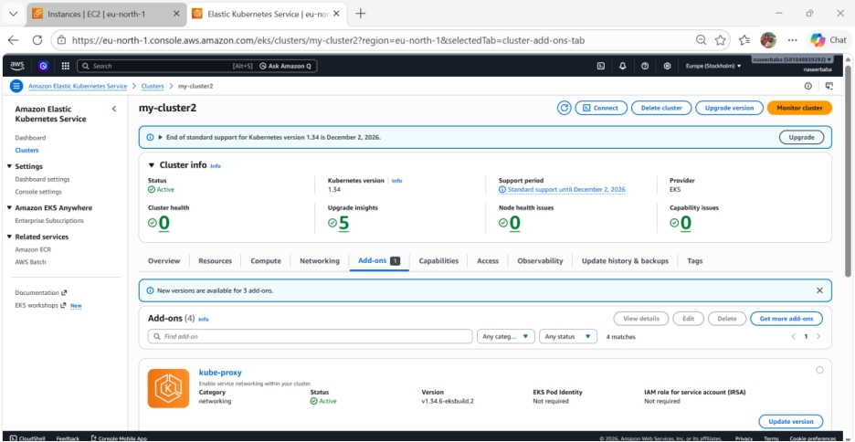
  - Select required add-ons
Search and select:
- ✔ kube-proxy
- ✔ CoreDNS
- ✔ Amazon VPC CNI
- ✔ Metrics Server
  - Configure each add-on
For each add-on:
Click Next
Basic settings:
- Version → Select latest recommended
- Most cases → leave default
IAM (Important for some add-ons):
- VPC CNI / EBS / EFS → may need IAM role
- For now:
  - Select Default (No role) OR
  - Use existing IAM role (if created earlier)
Click Next
  - Install
- Review settings
- Click Create
  - Verify
Go back to Add-ons tab
You should see:
- Status → Active
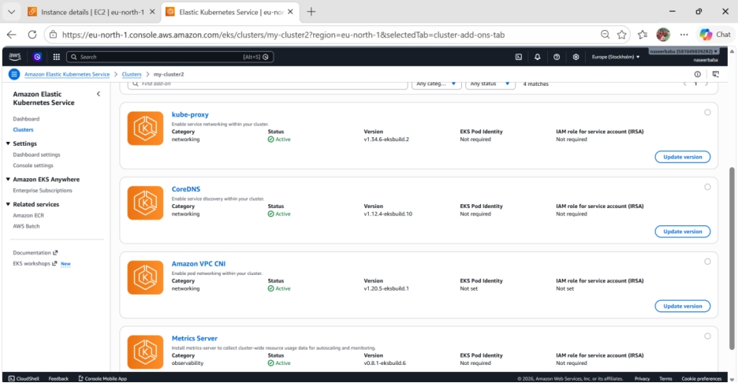
- Upgrade eks cluster
  - Check current version
aws eks describe-cluster \
--name my-cluster \
--region eu-north-1 \
--query "cluster.version"
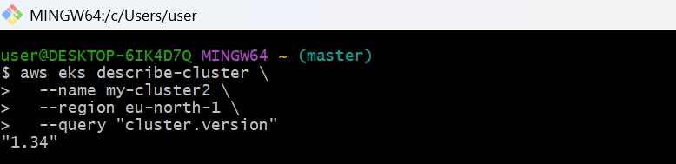
  - kubectl get nodes
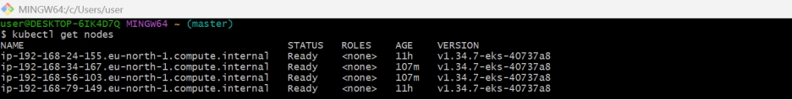 à kubectl version
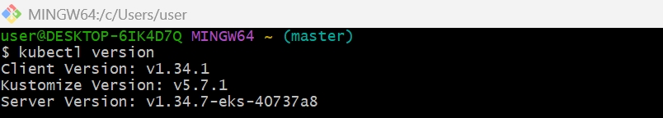
  - Check available EKS versions
aws eks describe-cluster-versions --region eu-north-1
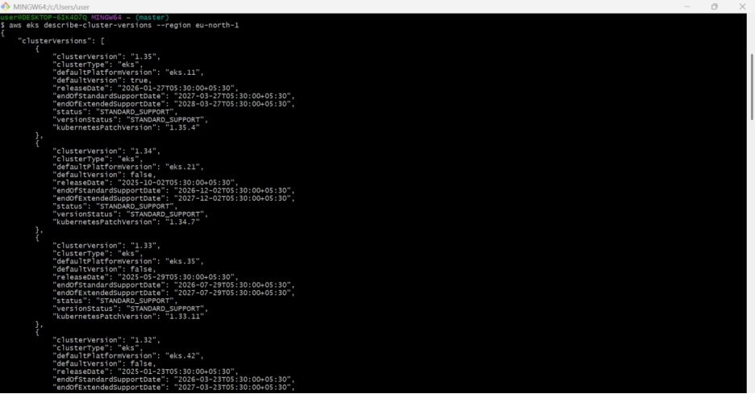
  - Check upgrade issues
In AWS Console:
EKS → Clusters → your cluster → Observability → Upgrade insights
Fix all errors before upgrade. EKS Upgrade Insights checks possible upgrade problems.
  - Upgrade EKS control plane
Example: upgrade to 1.34.
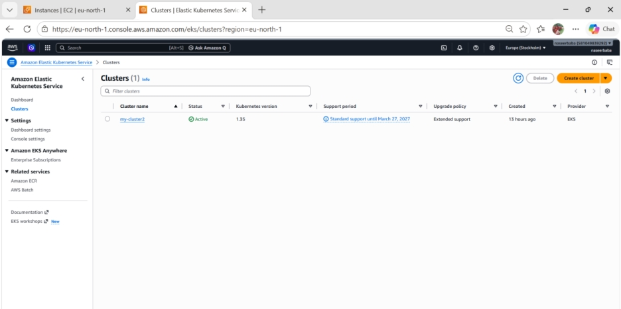
  - Upgrade EKS add-ons
Check current add-ons:
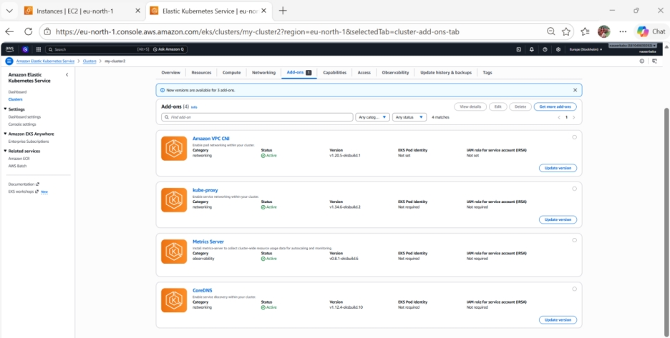
  - Upgrade managed node group
List node groups:
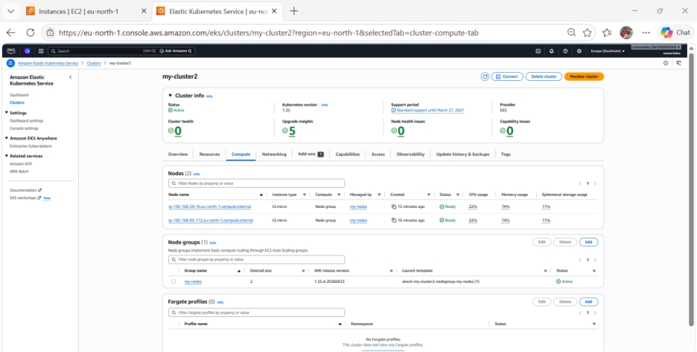
  - Verify everything
kubectl get nodes
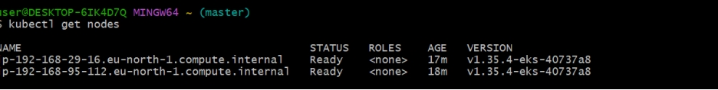
à kubectl get pods -A
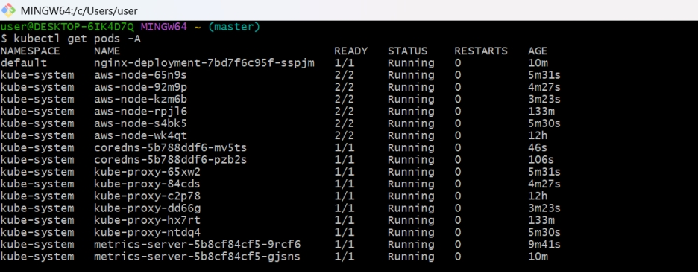

  - kubectl get deployments -A
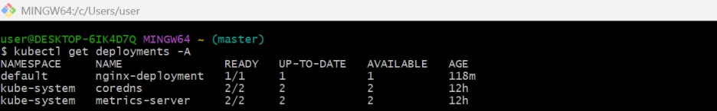
kubectl top nodes
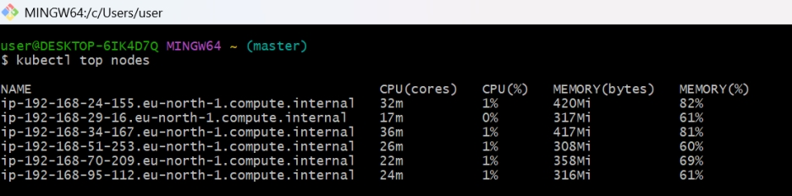
kubectl top pods -A
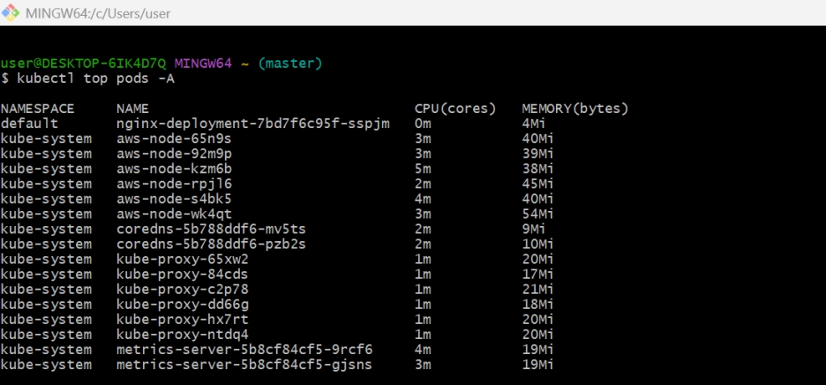
  - Check versions:
kubectl get nodes -o wide
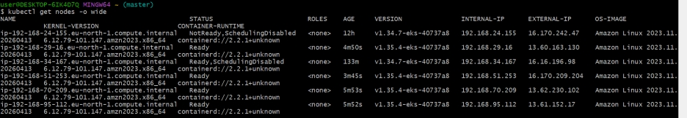
  - Quick Check (Simplest)
aws eks describe-cluster \
--name my-cluster2 \
--region eu-north-1 \
--query "cluster.status"
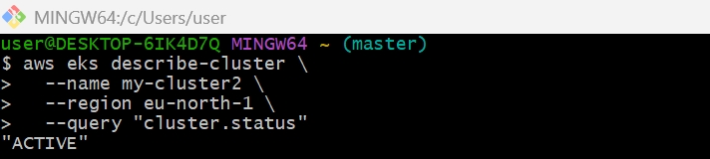
  - Check Version Change
aws eks describe-cluster \
--name my-cluster2 \
--region eu-north-1 \
--query "cluster.version"
Before:
"1.34"

After:
"1.35"
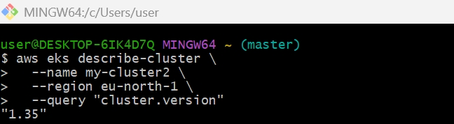
  - Verify using kubectl
kubectl version
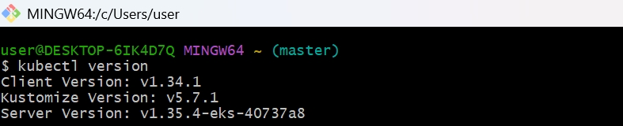
kubectl get nodes
Look for:
Server Version: v1.35.x
