- Setup Minikube in your local machine.
Step 1: Check whether WSL is already installed
Open PowerShell as Administrator and run:
wsl -l -v
If Ubuntu is already listed, good.
If not, install it:
wsl --install
Step 2: Install Docker Desktop
Install Docker Desktop for Windows and make sure:
- Docker Desktop opens successfully
- WSL 2 based engine is enabled
- Your Ubuntu distro is enabled inside Docker Desktop integration
Minikube’s WSL guide points to using Docker Desktop with WSL2 for Windows setups.
After installing, test in PowerShell:
docker version
If Docker is working, continue.
Step 3: Install kubectl
In PowerShell:
winget install Kubernetes.kubectl
Check:
kubectl version --client
Step 4: Install Minikube
In PowerShell:
winget install Kubernetes.minikube
Check:
minikube version
Minikube’s official start page documents current installation methods and verification with minikube version.
Step 5: Start Minikube
Now start the cluster with Docker driver:
minikube start --driver=docker

Step 6: Verify the cluster
Run:
kubectl get nodes
You should see one node in Ready state.
Also run:
minikube status
Step 7: Test with one nginx pod
Create a test pod:
kubectl run nginx –image=nginx –port=80
Check pod:
kubectl get pods
Expose it:
kubectl expose pod nginx –type=NodePort –port=80
Open it:
minikube service nginx

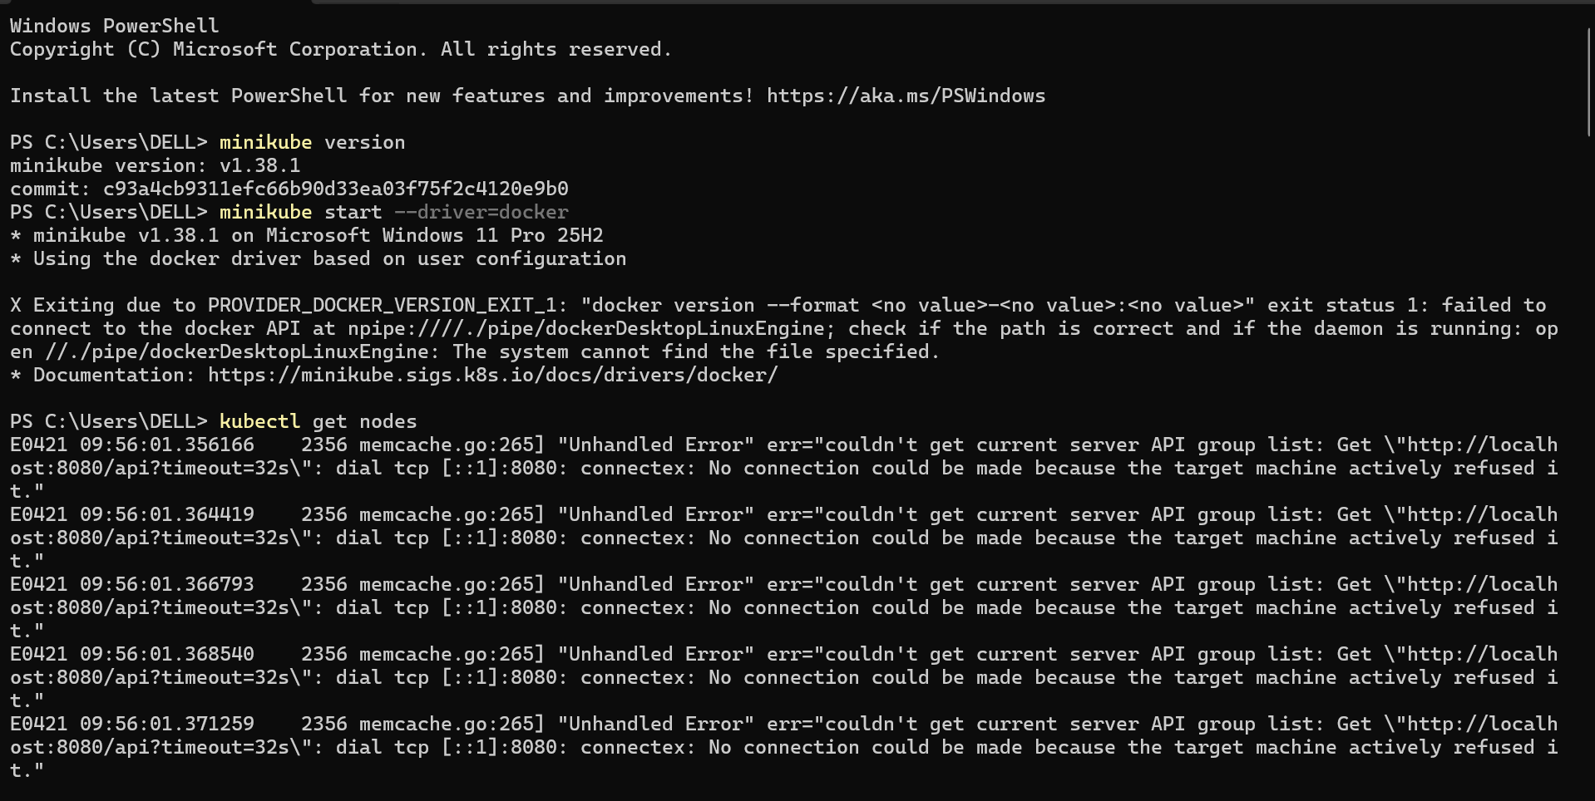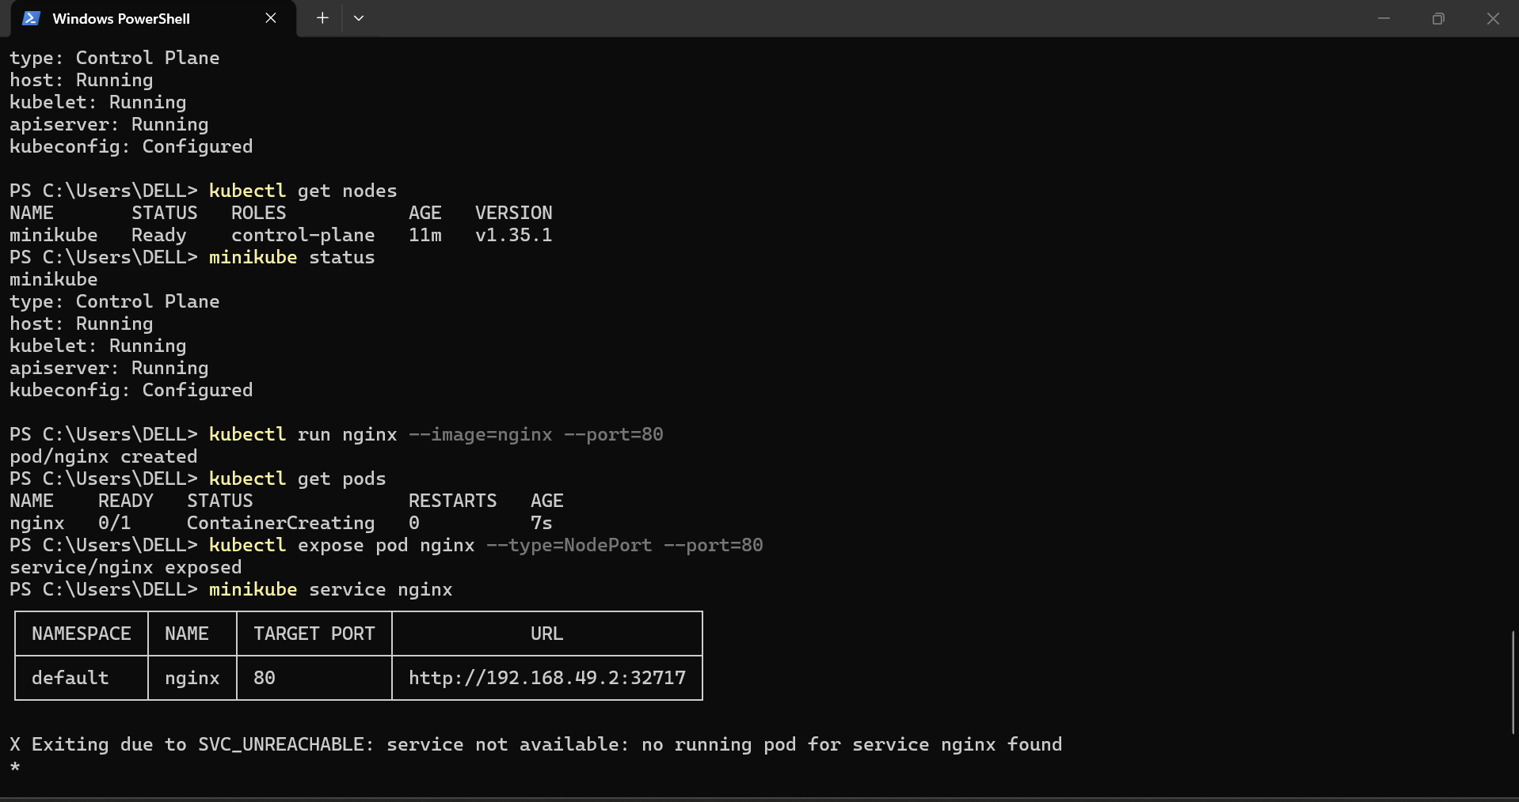

- Setup k8s master and two worker nodes on ubuntu.
Step 1: Update the system
sudo apt update && sudo apt upgrade -y
Step 2: Disable swap
sudo swapoff -a
sudo sed -i '/ swap / s/^/#/' /etc/fstab
Step 3: Load kernel modules
cat <<EOF | sudo tee /etc/modules-load.d/k8s.conf
overlay
br_netfilter
EOF
sudo modprobe overlay
sudo modprobe br_netfilter
Step 4: Set sysctl parameters
cat <<EOF | sudo tee /etc/sysctl.d/k8s.conf
net.bridge.bridge-nf-call-iptables = 1
net.bridge.bridge-nf-call-ip6tables = 1
net.ipv4.ip_forward = 1
EOF
sudo sysctl --system
Step 5: Install containerd
sudo apt install -y containerd
sudo mkdir -p /etc/containerd
containerd config default | sudo tee /etc/containerd/config.toml
sudo systemctl restart containerd
sudo systemctl enable containerd
Step 6: Install Kubernetes packages
sudo apt update
sudo apt install -y apt-transport-https ca-certificates curl gpg
curl -fsSL https://pkgs.k8s.io/core:/stable:/v1.30/deb/Release.key | sudo gpg --dearmor -o /etc/apt/keyrings/kubernetes-apt-keyring.gpg
echo 'deb [signed-by=/etc/apt/keyrings/kubernetes-apt-keyring.gpg] https://pkgs.k8s.io/core:/stable:/v1.30/deb/ /' | sudo tee /etc/apt/sources.list.d/kubernetes.list
sudo apt update
sudo apt install -y kubelet kubeadm kubectl
sudo apt-mark hold kubelet kubeadm kubectl

7. Add master node setup section
Initialize the master node
sudo kubeadm init --pod-network-cidr=10.244.0.0/16
After success, write the output join command in the document.
Configure kubectl on master
export KUBECONFIG=/etc/kubernetes/admin.conf
mkdir -p /root/.kube
cp /etc/kubernetes/admin.conf /root/.kube/config
chown root:root /root/.kube/config

8. Add CNI setup section
Since you used Flannel, write:
Install Flannel network plugin
kubectl apply -f https://github.com/flannel-io/flannel/releases/latest/download/kube-flannel.yml

9. Add worker node join section
On both worker nodes, run the join command.
Example:
kubeadm join 10.0.1.76:6443 --token 34goov.su1ts934xpv1c1yr \
--discovery-token-ca-cert-hash sha256:8ff9c944ebca9d10869d06b336d9025364c530cb90c242a2ebbaaf44a0c1f233

10. Add verification section
Write the commands used to verify.
kubectl get nodes
kubectl get pods -A
Expected result:
- master node should be Ready
- worker1 should be Ready
- worker2 should be Ready
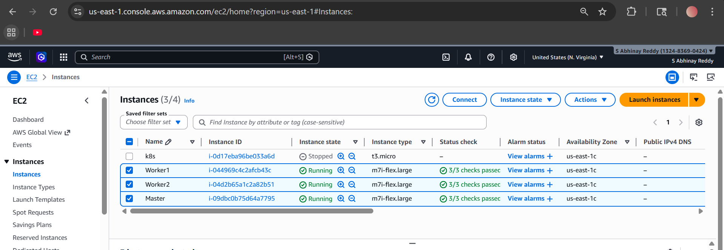
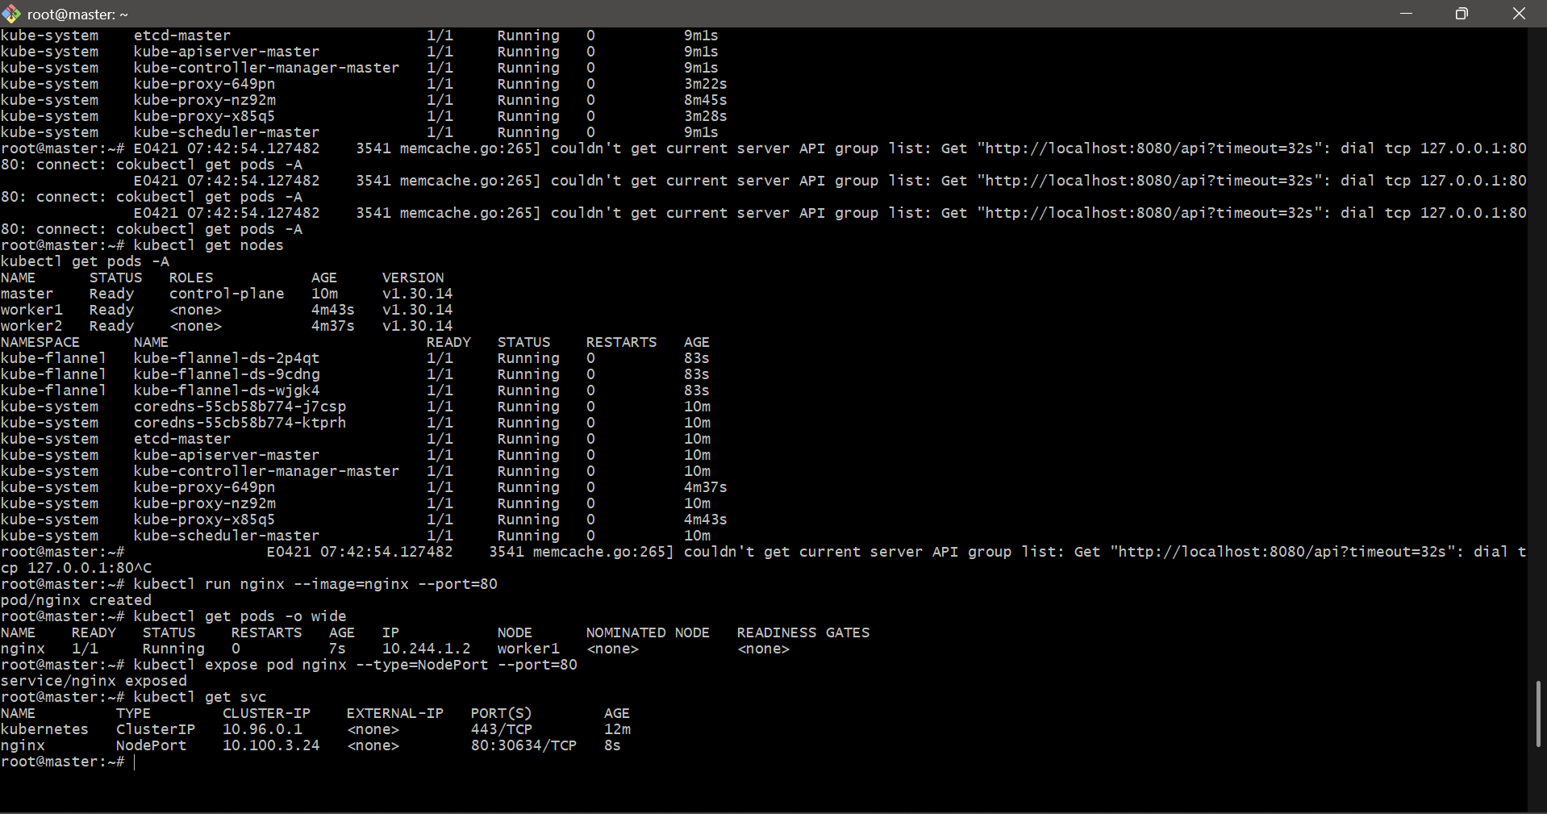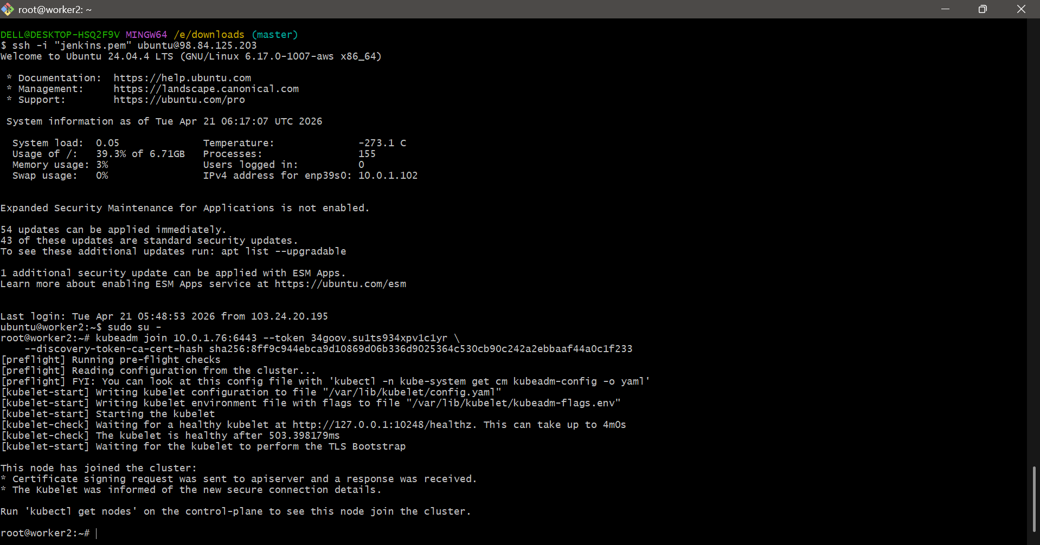
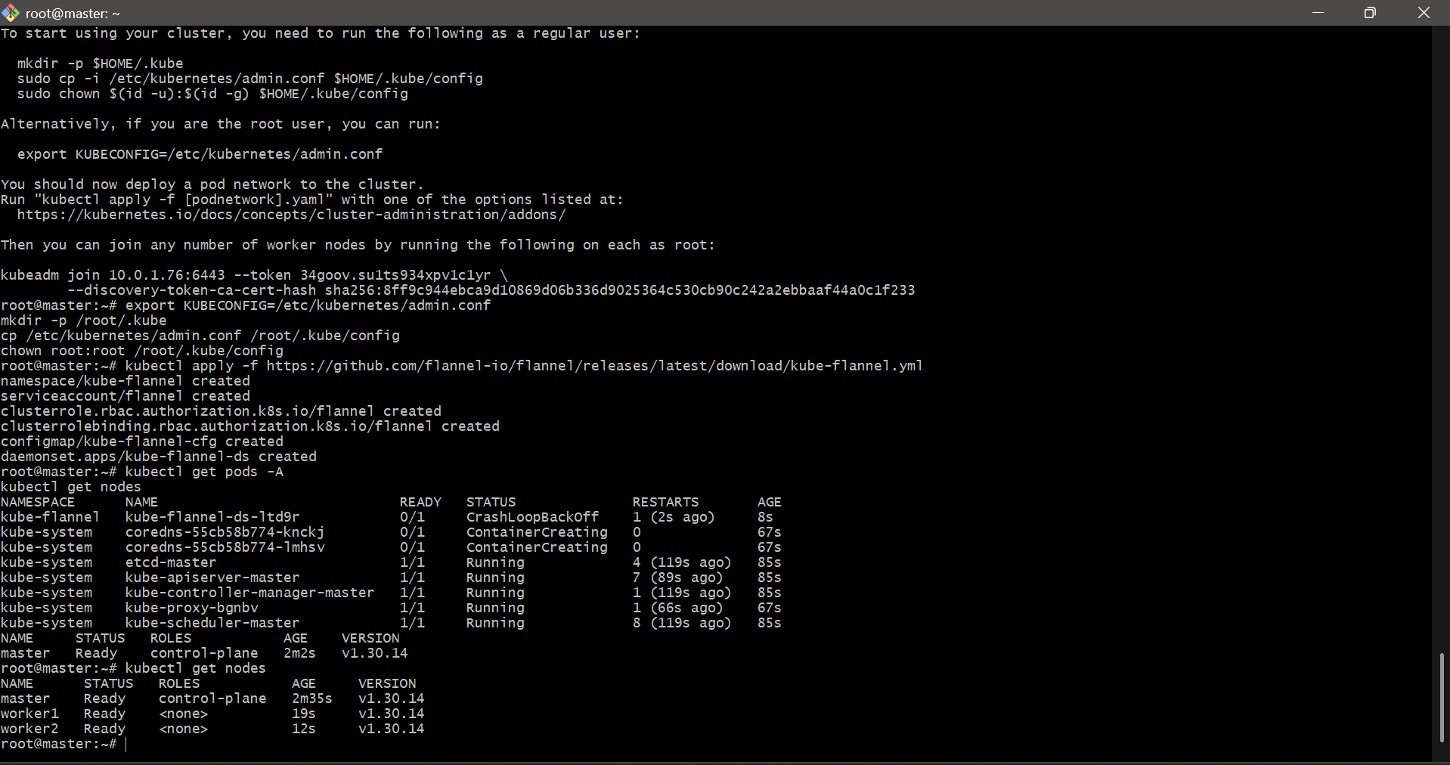

- Run one nginx pod.
Create nginx pod
kubectl run nginx --image=nginx --port=80
Verify pod
kubectl get pods -o wide
Expose pod
kubectl expose pod nginx --type=NodePort --port=80
Check service
kubectl get svc

