1. Create a Simple Pod Using YAML Task: Write a YAML file to create a Pod named firstpod with an nginx container. Verify the Pod creation using kubectl get pods and check the logs of the container using kubectl logs firstpod.
STEP 1: Create YAML file
Create a file:
vi firstpod.yaml
Paste this YAML:
apiVersion: v1
kind: Pod
metadata:
name: firstpod
spec:
containers:
- name: nginx-container
image: nginx
ports:
- containerPort: 80

STEP 2: Create Pod from YAML
Run:
kubectl apply -f firstpod.yaml
Expected output:
pod/firstpod created

STEP 3: Verify Pod Creation
Run:
kubectl get pods
You should see:
👉 If STATUS = Running → Perfect ✅

STEP 4: Check Detailed Info (Optional but important)
kubectl describe pod firstpod
👉 Shows:
- IP
- Node
- Events
- Container status

STEP 5: Check Logs of Pod
Run:
kubectl logs firstpod
👉 For nginx, logs usually show access logs when traffic comes
(Initially may be empty — this is normal ⚠️)

STEP 6 (Important): Generate Logs (Test nginx)
Since nginx logs only when requests come, test it:
Option 1: Port Forward
kubectl port-forward firstpod 8080:80
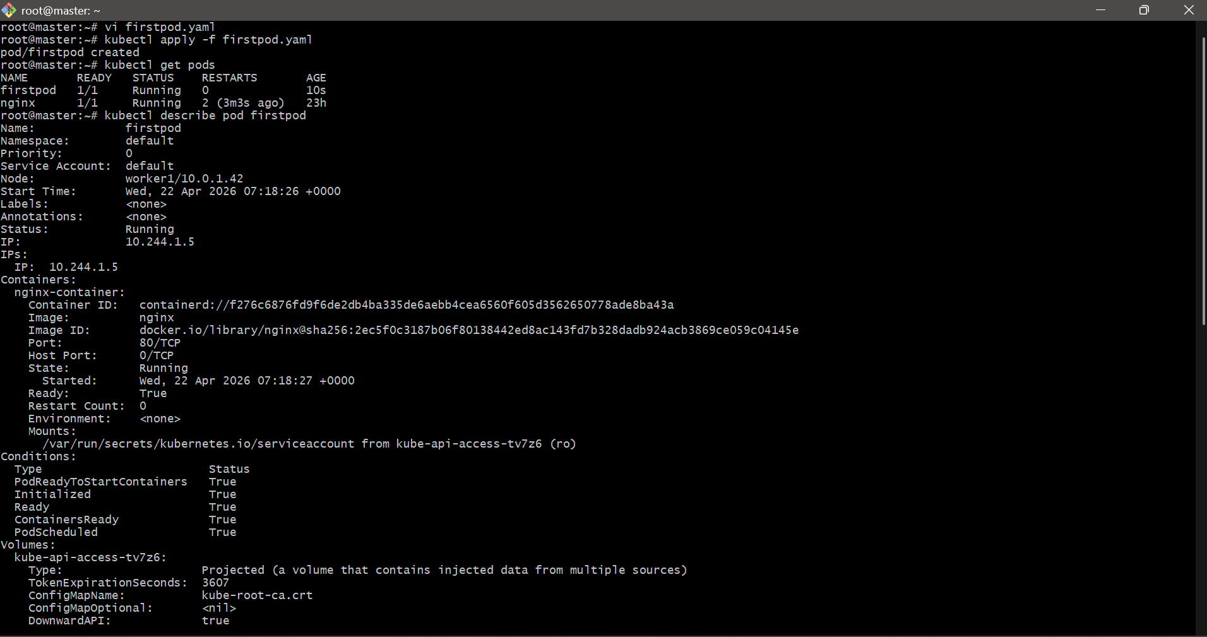

2. Set Environment Variables in a Pod Task: Modify the YAML file to include environment variables myname: sabair and City: Hyderabad. Deploy the Pod and use kubectl exec <pod_name> -- env to check if the environment variables are set properly.

STEP 1: Create YAML with Environment Variables
Edit your file:
vi firstpod.yaml
Paste this:
apiVersion: v1
kind: Pod
metadata:
name: firstpod
spec:
containers:
- name: nginx-container
image: nginx
ports:
- containerPort: 80
env:
- name: myname
value: "abhinay"
- name: City
value: "Hyderabad"
Save:
ESC → :wq → Enter

STEP 2: Delete old pod (important)
kubectl delete pod firstpod

STEP 3: Create new pod
kubectl apply -f firstpod.yaml

STEP 4: Verify pod is running
kubectl get pods
You should see:
firstpod 1/1 Running

STEP 5: Check environment variables
Run:
kubectl exec firstpod -- env | grep myname
kubectl exec firstpod -- env | grep City
Expected Output
myname=abhinay
City=Hyderabad
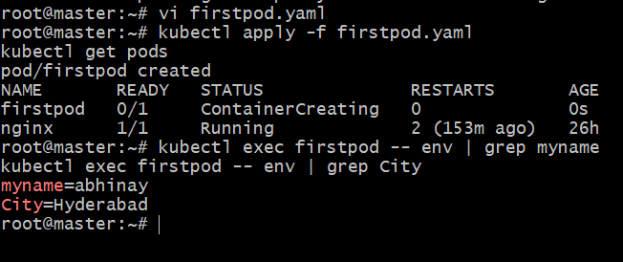

3. Deploy a Pod with Commands (Args) in YAML Task: Modify the YAML file to add args that instruct the container to sleep for 50 seconds. Deploy the Pod and use kubectl describe pod to verify the args are correctly passed to the container.
STEP 1: Create YAML with sleep command
vi firstpod.yaml
Use this clean file:
apiVersion: v1
kind: Pod
metadata:
name: sleep-pod
spec:
containers:
- name: sleep-container
image: nginx
command: ["sleep"]
args: ["50"]
STEP 2: Create Pod
kubectl apply -f firstpod.yaml
STEP 3: Check Pod status
kubectl get pods
STEP 4: Verify args using describe
kubectl describe pod sleep-pod
Look for this section:
Containers:
sleep-container:
Command:
sleep
Args:
50
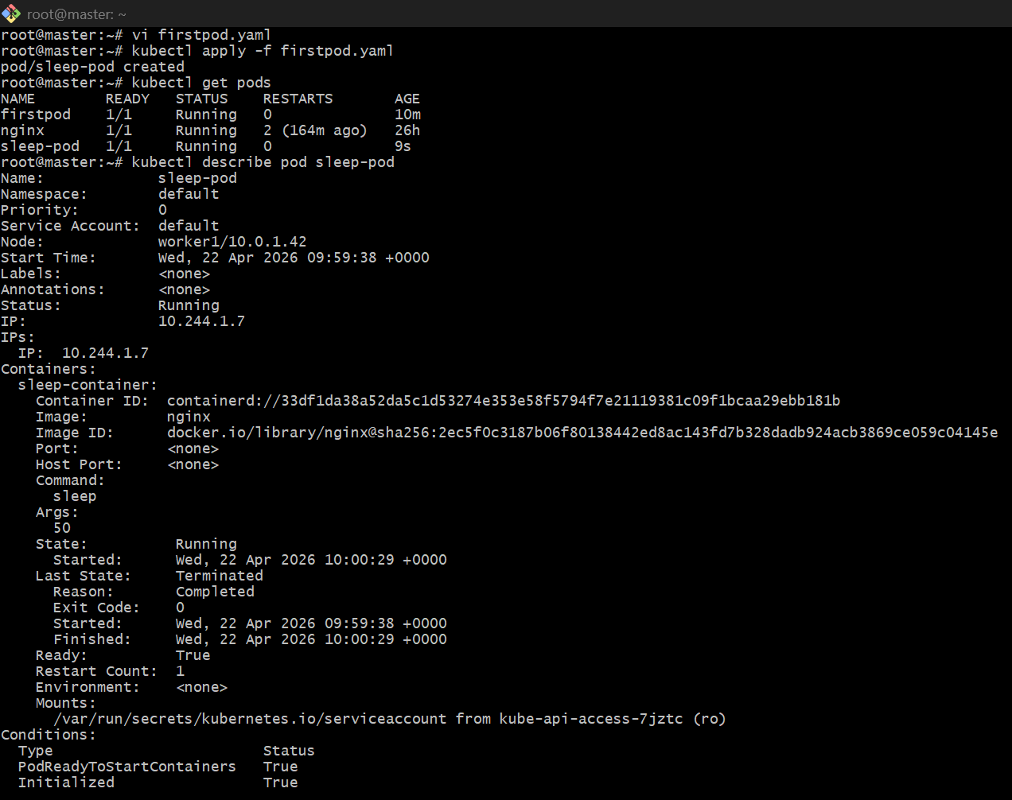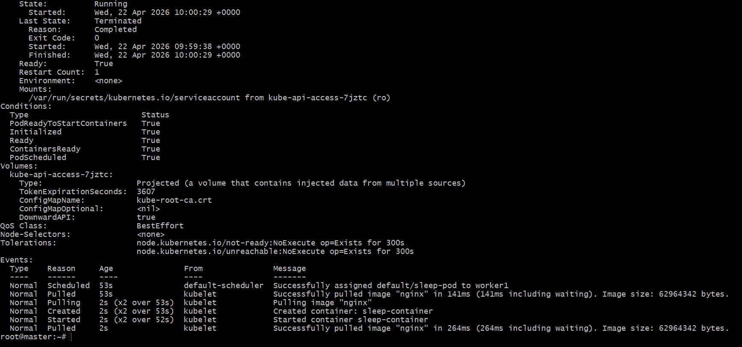

4. Create a Pod with Two Containers Task: Create a YAML file to define a Pod with two nginx containers inside. Use kubectl exec to access both containers and verify that both containers can communicate through the same network (e.g., using telnet between them).
STEP 1: Create YAML (2 nginx containers)
vi twocontainer.yaml
paste:
apiVersion: v1
kind: Pod
metadata:
name: twopod
spec:
containers:
- name: nginx1
image: nginx
ports:
- containerPort: 80

- name: nginx2
image: nginx
command: ["/bin/sh", "-c"]
args:
- sed -i 's/listen 80;/listen 81;/g' /etc/nginx/conf.d/default.conf &&
nginx -g 'daemon off;'
ports:
- containerPort: 81
STEP 2: Create Pod
kubectl apply -f twocontainer.yaml
STEP 3: Verify Pod
kubectl get pods

STEP 4: Check pod details
kubectl describe pod twopod
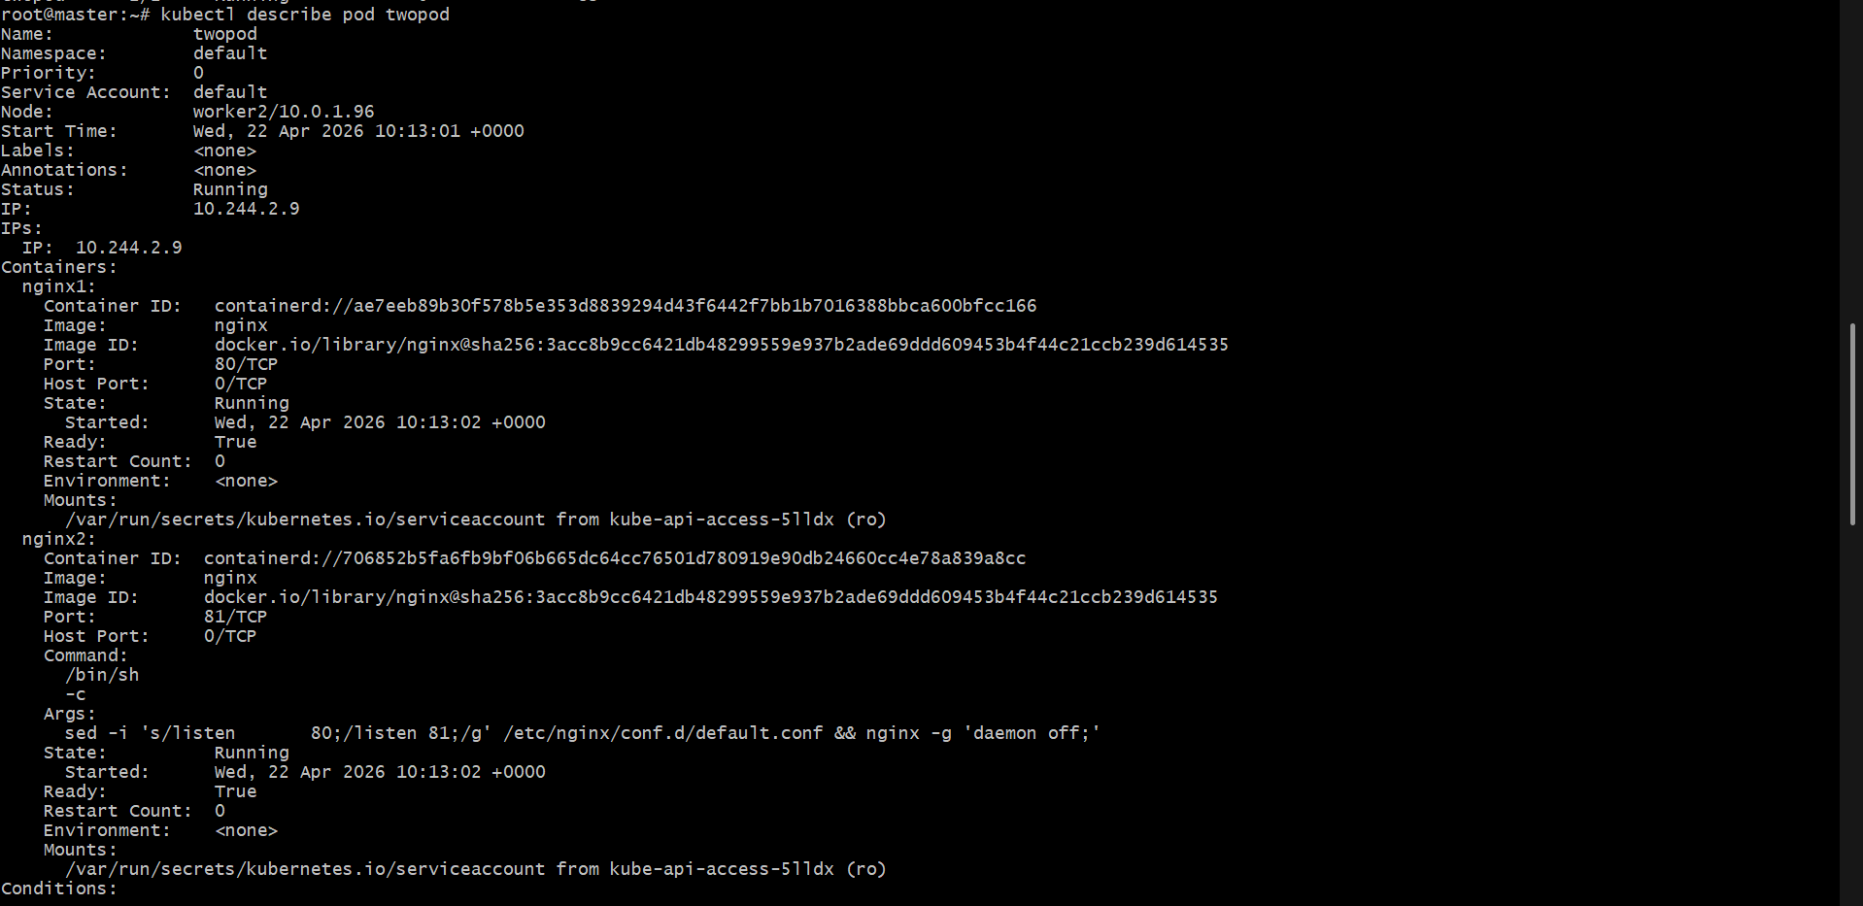
STEP 5: Check logs
kubectl logs twopod -c nginx1
kubectl logs twopod -c nginx2

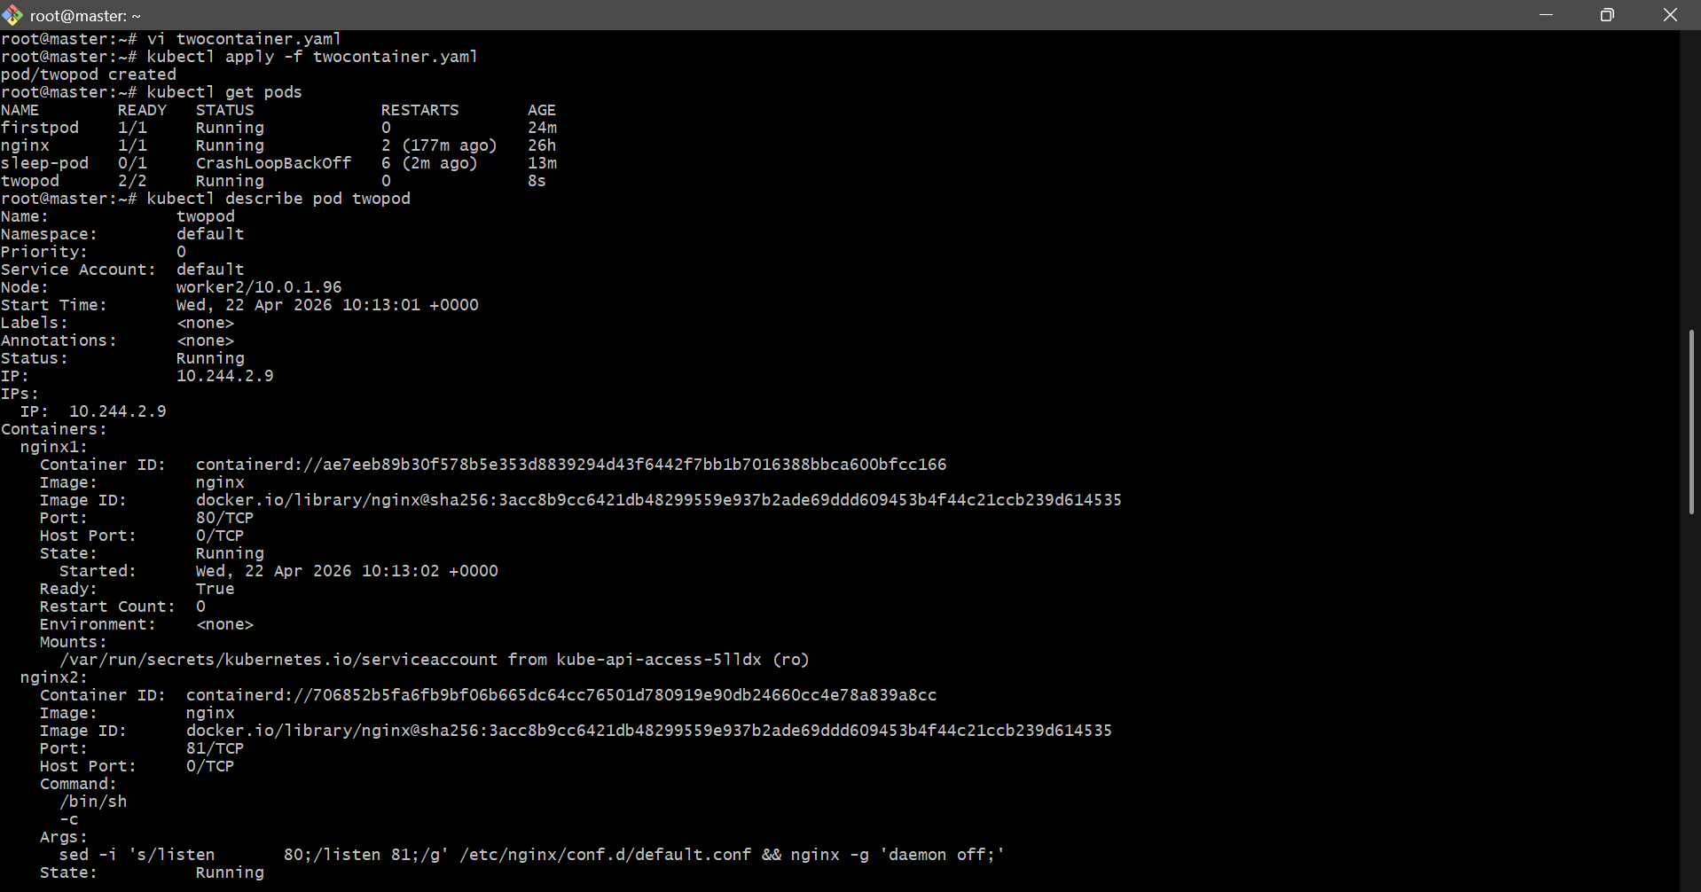
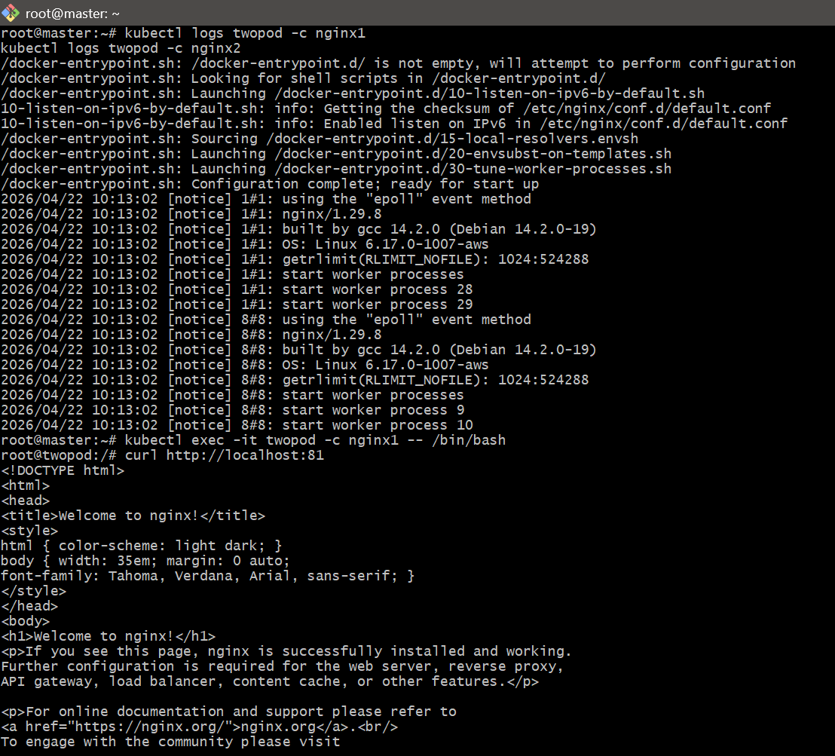

5. Set Up an Init Container in a Pod Task: Modify the YAML to include an init container that sleeps for 30 seconds before the main containers start. Verify the init container's execution using kubectl describe pod and check the logs to confirm its completion.
STEP 1: Create YAML with Init Container
vi initpod.yaml
Paste this:
apiVersion: v1
kind: Pod
metadata:
name: initpod
spec:
initContainers:
- name: init-sleep
image: busybox
command: ["sh", "-c", "echo Init started; sleep 30; echo Init completed"]
containers:
- name: nginx1
image: nginx
ports:
- containerPort: 80
- name: nginx2
image: nginx
command: ["/bin/sh", "-c"]
args:
- sed -i 's/listen 80;/listen 81;/g' /etc/nginx/conf.d/default.conf && nginx -g 'daemon off;'
ports:
- containerPort: 81
Save:
ESC → :wq

STEP 2: Create Pod
kubectl apply -f initpod.yaml

STEP 3: Watch Pod (important)
kubectl get pods -w
You will see:
initpod 0/2 Init:0/1
👉 means init container is running
After 30 sec:
initpod 2/2 Running

STEP 4: Verify using describe
kubectl describe pod initpod
Look for:
Init Containers:
init-sleep:
State: Terminated
Reason: Completed

STEP 5: Check init container logs
kubectl logs initpod -c init-sleep
Expected:
Init started
Init completed

STEP 6: Verify main containers started
kubectl get pods
Should show:
initpod 2/2 Running
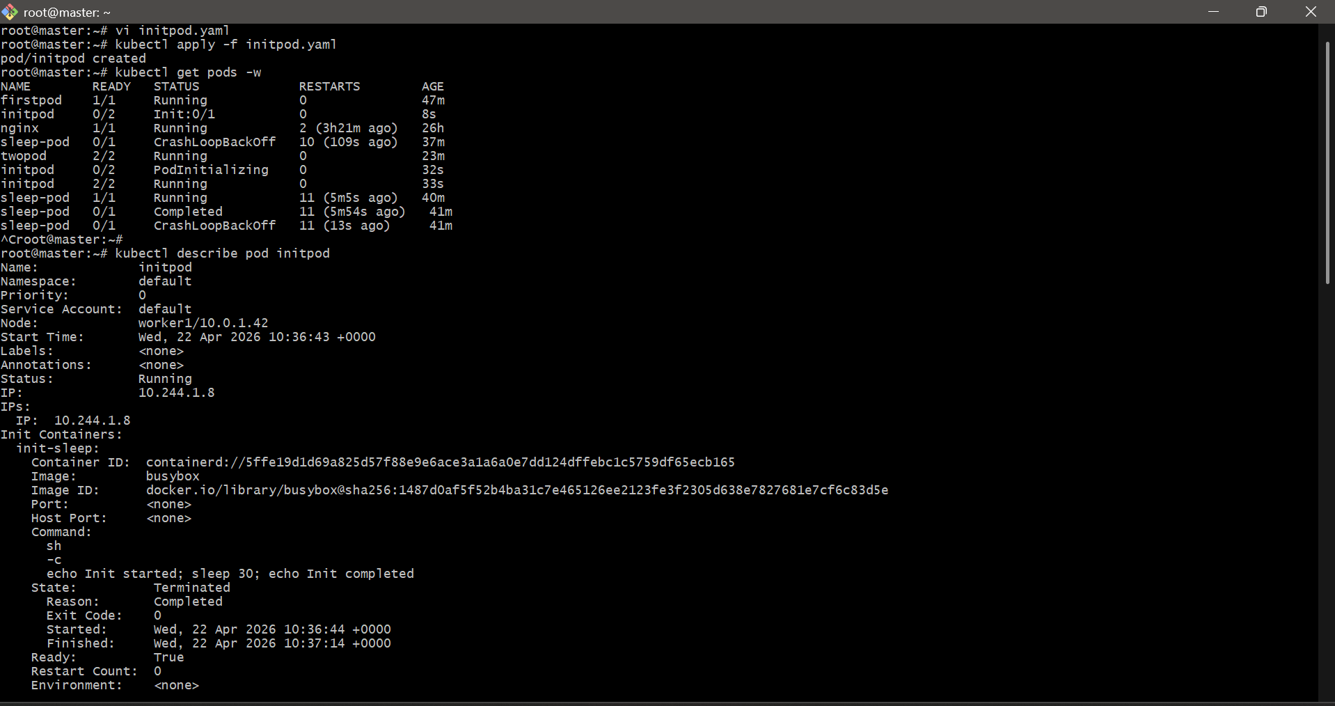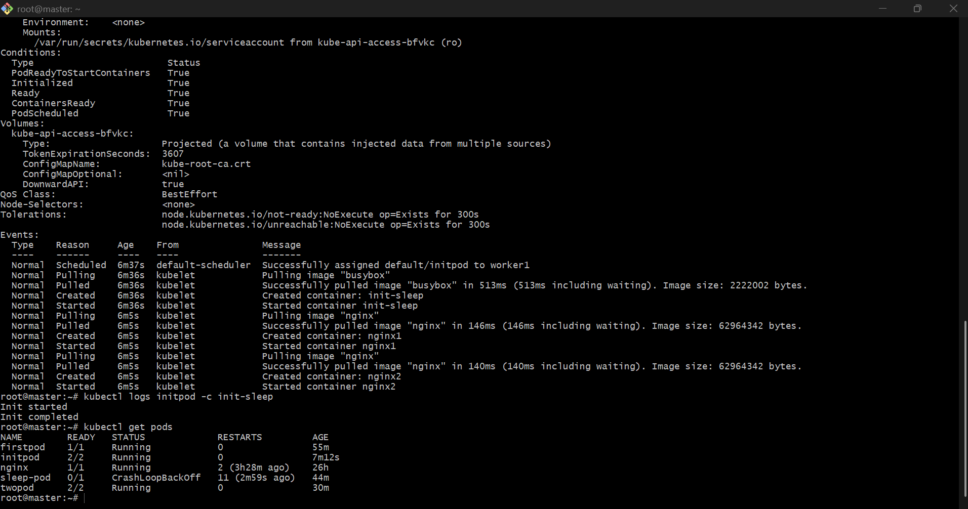

6. Run a Dry Run Command to Generate YAML Task: Use the kubectl run nginx --image=nginx --dry-run=client -o yaml command to generate a Pod YAML definition. Modify the generated YAML to suit specific requirements (e.g., labels or environment variables) and deploy it.
STEP 1: Generate YAML using dry-run
Run this:
kubectl run nginx --image=nginx --dry-run=client -o yaml > nginx.yaml
👉 This creates a file nginx.yaml

STEP 2: Check generated YAML
cat nginx.yaml
You will see something like:
apiVersion: v1
kind: Pod
metadata:
creationTimestamp: null
labels:
run: nginx
name: nginx
spec:
containers:
- image: nginx
name: nginx
resources: {}
dnsPolicy: ClusterFirst
restartPolicy: Always
status: {}

STEP 3: Modify YAML (add labels + env variables)
Edit file:
vi nginx.yaml
Update like this:
apiVersion: v1
kind: Pod
metadata:
name: nginx
labels:
app: nginx
env: dev
spec:
containers:
- name: nginx
image: nginx
ports:
- containerPort: 80
env:
- name: myname
value: "abhinay"
- name: City
value: "Hyderabad"
restartPolicy: Always
STEP 4: Deploy Pod
kubectl apply -f nginx.yaml

STEP 5: Verify Pod
kubectl get pods
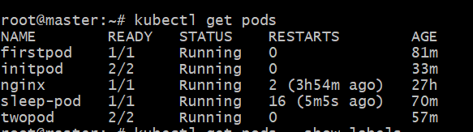

STEP 6: Verify labels
kubectl get pods --show-labels
Expected:
nginx 1/1 Running app=nginx,env=dev 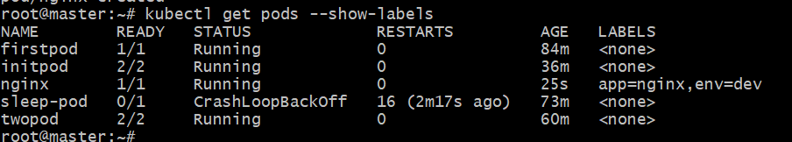

STEP 7: Verify environment variables
kubectl exec nginx -- env | grep myname
kubectl exec nginx -- env | grep City
Expected:
myname=abhinay
City=Hyderabad
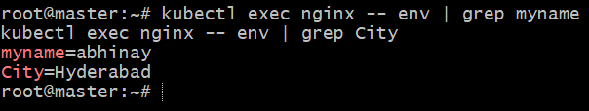

7. Use kubectl apply vs kubectl create Task: Create a YAML file to define a Pod. First, deploy it using kubectl create -f <file_name>.yml and then modify the YAML (e.g., change the image version). Use kubectl apply to redeploy and verify the difference between both commands.

STEP 1: Create YAML file
vi mypod.yaml
Paste this:
apiVersion: v1
kind: Pod
metadata:
name: mypod
spec:
containers:
- name: nginx
image: nginx:1.25
ports:
- containerPort: 80
Save:
ESC → :wq

STEP 2: Create Pod using kubectl create
kubectl create -f mypod.yaml
Check:
kubectl get pods
STEP 3: Verify image version
kubectl describe pod mypod | grep Image
Expected:
Image: nginx:1.25

STEP 4: Modify YAML (change image)
vi mypod.yaml
Change:
image: nginx:1.25
👉 to:
image: nginx:latest
Save file.

STEP 5: Try using kubectl apply
kubectl apply -f mypod.yaml
👉 You will see:
Warning: resource already exists
OR it may say configured, but Pod will NOT update properly

⚠️ Important Reality
👉 Pods are immutable
👉 Changing image does NOT update existing Pod
So you must delete and recreate:

STEP 6: Delete and apply again
kubectl delete pod mypod
kubectl apply -f mypod.yaml

STEP 7: Verify updated image
kubectl describe pod mypod | grep Image
Expected:
Image: nginx:latest
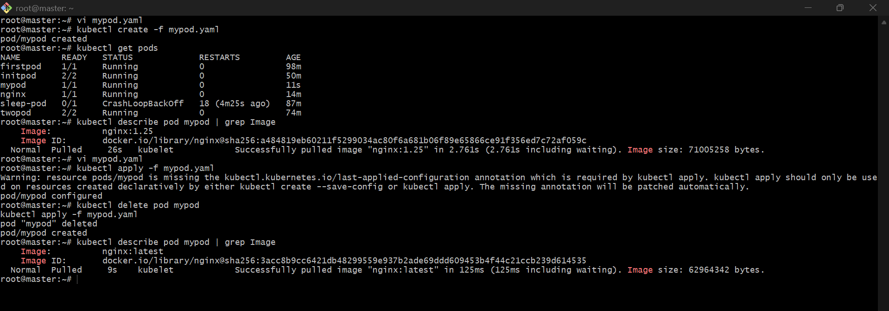

8. Edit an Existing Pod Configuration Task: Use kubectl edit pod <pod_name> to modify the running Pod's environment variables or image. After making the changes, verify if they took effect by checking the container logs or environment variables using kubectl exec.

Check Existing Pods
kubectl get pods
Edit the Pod
kubectl edit pod mypod
Modify Pod Configuration
Change Container Image
Locate:
spec:
containers:
- name: mycontainer
image: nginx:latest

Modify:
image: nginx:1.25
Save Changes
- Press ESC
- Type :wq
- Press Enter
If successful:
pod/mypod edited
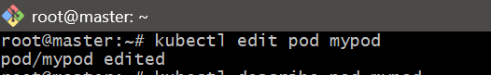
Verify Image
kubectl describe pod mypod | grep Image

9. Expose a Pod Using a Service Task: Create a YAML file to expose your firstpod using a Service (ClusterIP). Ensure that your service is exposing the Pod on port 80 and verify it using kubectl get svc.

1. Objective
The objective of this task is to expose an existing Pod (firstpod) using a Kubernetes Service of type ClusterIP and verify the service using kubectl commands.

2. Prerequisites
- Kubernetes cluster (Minikube / kubeadm)
- kubectl installed and configured
- A running Pod named firstpod

3. Verify the Pod
Check if the Pod is running:
kubectl get pods
Example Output:
NAME READY STATUS AGE
firstpod 1/1 Running 2h
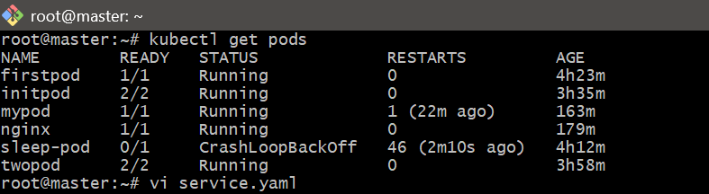

4. Create Service YAML File
Create a file named:
vi service.yaml

5. Service YAML Configuration
apiVersion: v1
kind: Service
metadata:
name: firstpod-service
spec:
type: ClusterIP
selector:
app: firstpod
ports:
- protocol: TCP
port: 80
targetPort: 80

6. Important Note (VERY IMPORTANT)
👉 The selector must match Pod labels
Check Pod labels:
kubectl describe pod firstpod
Look for:
Labels: app=firstpod
✔ If no label exists, add label to Pod:
kubectl label pod firstpod app=firstpod
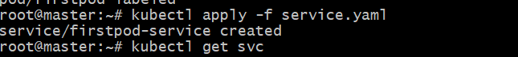

7. Apply the Service
kubectl apply -f service.yaml
Output:
service/firstpod-service created
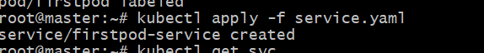

8. Verify the Service
kubectl get svc
Example Output:
NAME TYPE CLUSTER-IP PORT(S)
firstpod-service ClusterIP 10.96.0.50 80/TCP
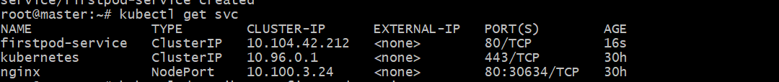

9. Detailed Verification
kubectl describe svc firstpod-service
Check:
- Cluster IP
- Port = 80
- Target Pod IP
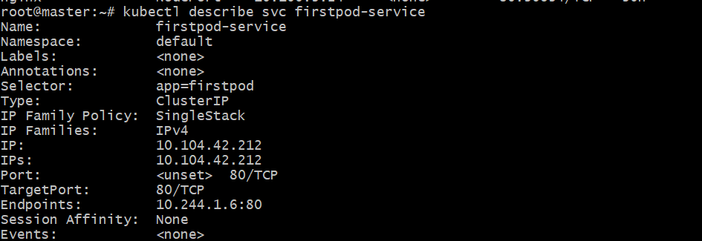

10. Test Service (Optional)
Run inside cluster:
kubectl exec -it firstpod -- curl http://firstpod-service
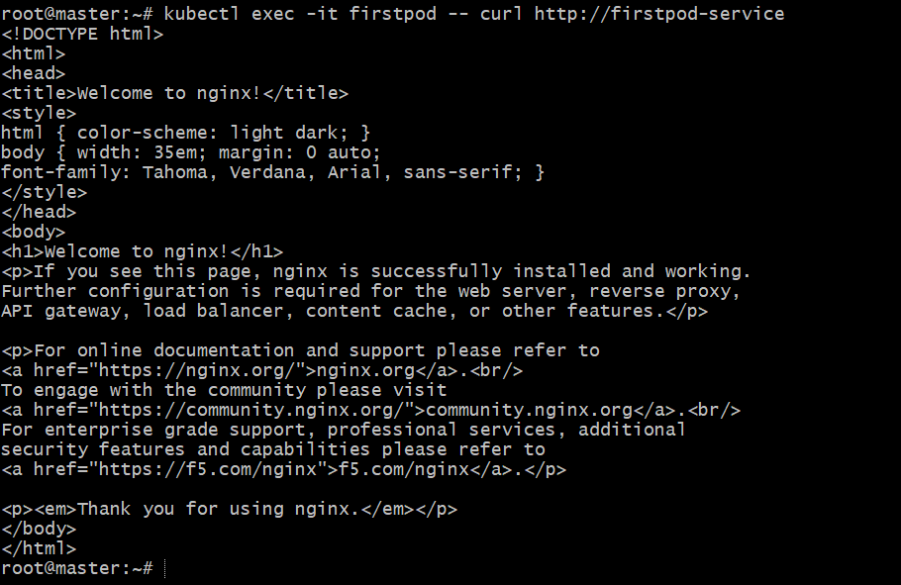

10. Pod with Resource Limits and Requests Task: Add resource requests and limits to the containers in your YAML file. Specify CPU and memory requests/limits for both containers and deploy the Pod. Use kubectl describe pod to verify if the resource configurations are correctly applied.

1. Objective
The objective of this task is to define CPU and memory resource requests and limits for containers in a Pod using a YAML file and verify the configuration using Kubernetes commands.

2. Prerequisites
- Kubernetes cluster (Minikube / kubeadm)
- kubectl configured
- Basic knowledge of YAML

3. What are Requests and Limits?
Type | Description
Requests | Minimum resources guaranteed to the container
Limits | Maximum resources the container can use

4. Create Pod YAML File
vi resource-pod.yaml

5. Pod YAML Configuration (Two Containers)
apiVersion: v1
kind: Pod
metadata:
name: resource-pod
spec:
containers:
- name: container1
image: nginx
resources:
requests:
memory: "64Mi"
cpu: "250m"
limits:
memory: "128Mi"
cpu: "500m"
- name: container2
image: busybox
command: ["sh", "-c", "while true; do echo Hello; sleep 5; done"]
resources:
requests:
memory: "32Mi"
cpu: "200m"
limits:
memory: "64Mi"
cpu: "400m"

6. Deploy the Pod
kubectl apply -f resource-pod.yaml
Output:
pod/resource-pod created

7. Verify Pod Creation
kubectl get pods

8. Verify Resource Configuration
kubectl describe pod resource-pod

9. Expected Output (Important Section)
Look for:
Containers:
container1:
Limits:
cpu: 500m
memory: 128Mi
Requests:
cpu: 250m
memory: 64Mi
container2:
Limits:
cpu: 400m
memory: 64Mi
Requests:
cpu: 200m
memory: 32Mi

10. Key Observations
- Kubernetes schedules Pods based on requests
- Containers cannot exceed limits
- If memory limit is exceeded → Pod may be terminated (OOMKilled)
