1. Create a ClusterIP service for an Apache web server pod.
Create a ClusterIP Service for Apache Web Server Pod
🎯 Objective
Create a ClusterIP Service to expose an Apache (httpd) web server Pod internally within the Kubernetes cluster.

Step 1: Create Apache Pod YAML
Create a file called:
vi apache-pod.yaml
Add the below content:
apiVersion: v1
kind: Pod
metadata:
name: apache-pod
labels:
app: apache
spec:
containers:
- name: apache-container
image: httpd
ports:
- containerPort: 80

Step 2: Create the Pod
kubectl apply -f apache-pod.yaml
Check Pod status:
kubectl get pods

Step 3: Create ClusterIP Service YAML
Create another file:
vi apache-service.yaml

Add the below content:
apiVersion: v1
kind: Service
metadata:
name: apache-service
spec:
type: ClusterIP
selector:
app: apache
ports:
- protocol: TCP
port: 80
targetPort: 80

Step 4: Create the Service
kubectl apply -f apache-service.yaml

Step 5: Verify Service
kubectl get svc
You will see output like:
NAME TYPE CLUSTER-IP PORT(S)
apache-service ClusterIP 10.x.x.x 80/TCP

Step 6: Test the Service (Important)
Since ClusterIP is internal, test from inside the cluster:
Inside the pod:
wget -qO- http://apache-service
👉 If working, you will see Apache default HTML page.
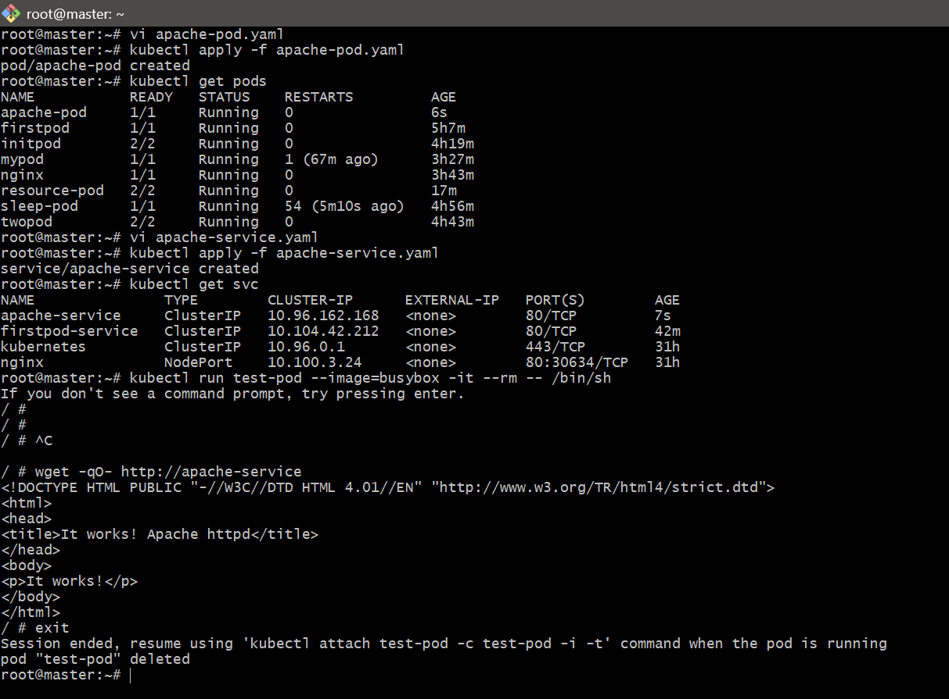

2. Expose an Nginx pod externally using a NodePort service.
Expose an Nginx Pod Externally Using NodePort Service
Objective
Expose an Nginx Pod to the outside world (browser access) using a NodePort Service in Kubernetes.

Step 1: Create Nginx Pod
Create a file:
vi nginx-pod.yaml
Add:
apiVersion: v1
kind: Pod
metadata:
name: nginx-pod
labels:
app: nginx
spec:
containers:
- name: nginx-container
image: nginx
ports:
- containerPort: 80

Step 2: Create the Pod
kubectl apply -f nginx-pod.yaml
Verify:
kubectl get pods

Step 3: Create NodePort Service
Create a file:
vi nginx-service.yaml
Add:
apiVersion: v1
kind: Service
metadata:
name: nginx-nodeport-service
spec:
type: NodePort
selector:
app: nginx
ports:
- protocol: TCP
port: 80
targetPort: 80
nodePort: 30007 # (optional: must be between 30000–32767)

Step 4: Apply Service
kubectl apply -f nginx-service.yaml

Step 5: Verify Service
kubectl get svc
Example output:
NAME TYPE CLUSTER-IP PORT(S)
nginx-nodeport-service NodePort 10.x.x.x 80:30007/TCP

Step 6: Access in Browser
If using AWS EC2
You must:
- Go to Security Group
- Add inbound rule:
  - Port: 30007
  - Source: 0.0.0.0/0
- Use Public IP:
http://<EC2-PUBLIC-IP>:30007
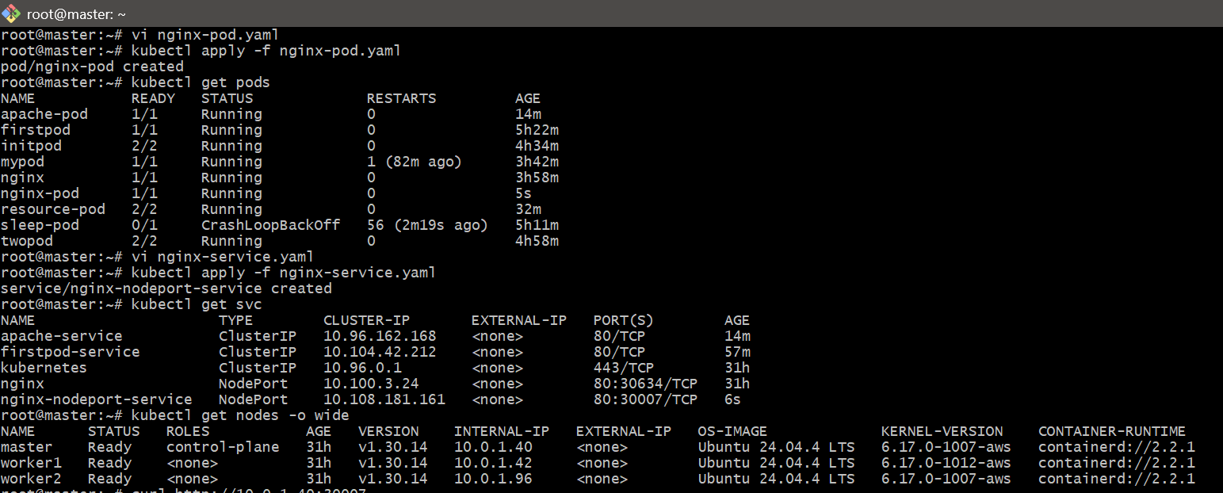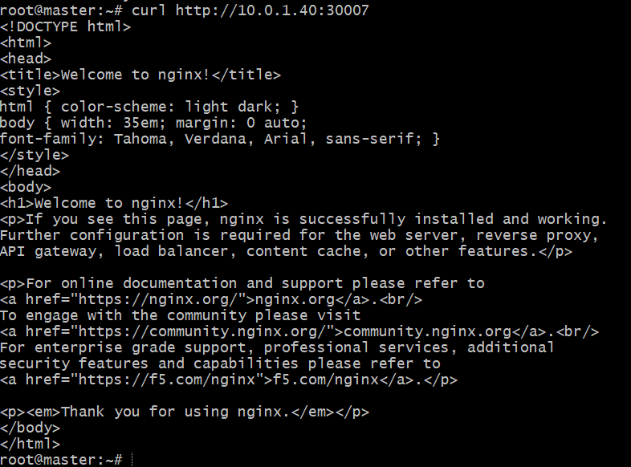

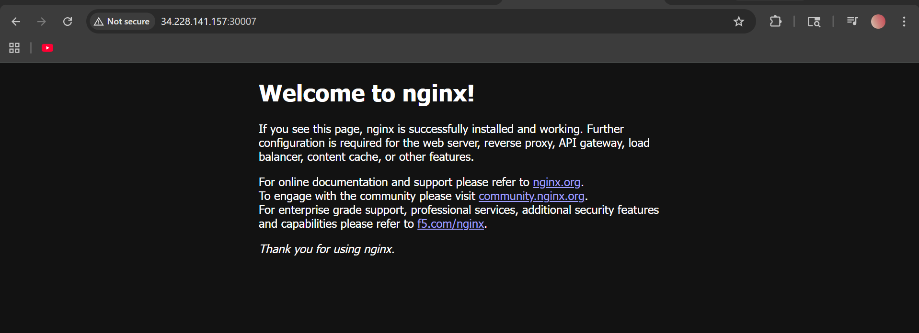

3. Deploy a ReplicationController to maintain 3 replicas of an Nginx pod.
Objective
Create a ReplicationController in Kubernetes to ensure that 3 Nginx pods are always running.

Step 1: Create the YAML file
Create a file named:
vi nginx-rc.yaml
Add this content:
apiVersion: v1
kind: ReplicationController
metadata:
name: nginx-rc
spec:
replicas: 3
selector:
app: nginx-rc
template:
metadata:
labels:
app: nginx-rc
spec:
containers:
- name: nginx-container
image: nginx
ports:
- containerPort: 80

Step 2: Apply the YAML file
Run:
kubectl apply -f nginx-rc.yaml
Expected output:
replicationcontroller/nginx-rc created

Step 3: Verify the ReplicationController
Check the RC:
kubectl get rc
You should see something like:
NAME DESIRED CURRENT READY AGE
nginx-rc 3 3 3 10s

Step 4: Verify the Pods
Run:
kubectl get pods
You should see 3 nginx pods created by the ReplicationController, with names similar to:
nginx-rc-4sb5k
nginx-rc-wh26x
nginx-rc-lklzm

Step 5: Describe the ReplicationController
To see full details:
kubectl describe rc nginx-rc
This shows:
- desired replicas
- current replicas
- pod template
- labels
- events

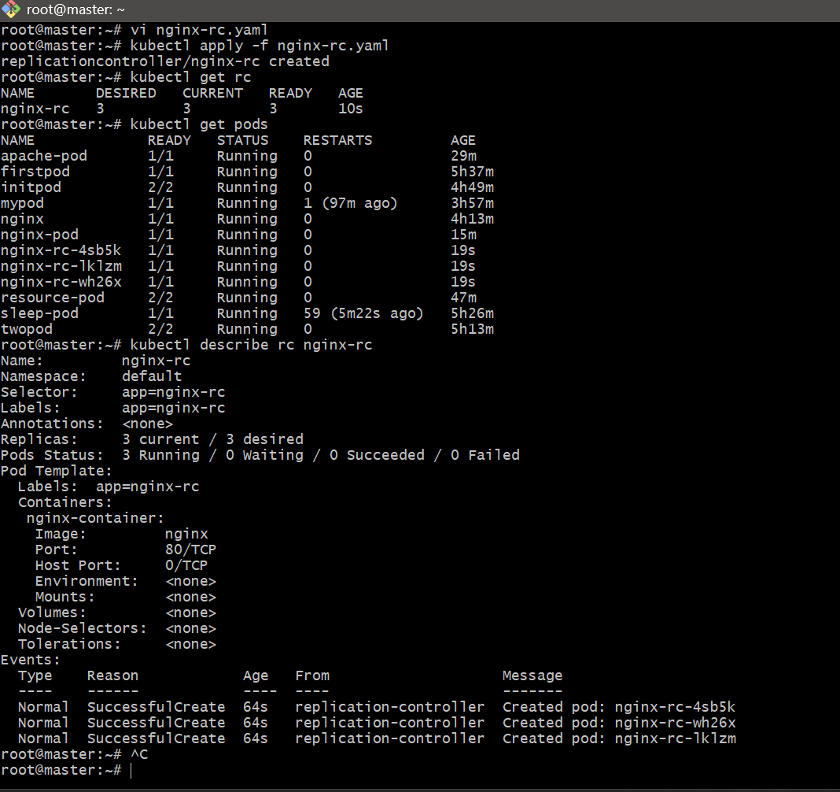

4. Scale the ReplicationController from 3 replicas to 5 replicas.
Scale ReplicationController from 3 to 5
🎯 Objective
Increase the number of running pods managed by the ReplicationController from 3 to 5.
Edit YAML (Manual Method)
Run:
kubectl edit rc nginx-rc
Find this line:
replicas: 3
Change to:
replicas: 5
Save and exit (:wq in vi)

🔍 Verify Again
kubectl get rc
kubectl get pods

What Happens Internally
- Kubernetes compares:
  - Desired replicas = 5
  - Current replicas = 3
- It automatically creates 2 new pods
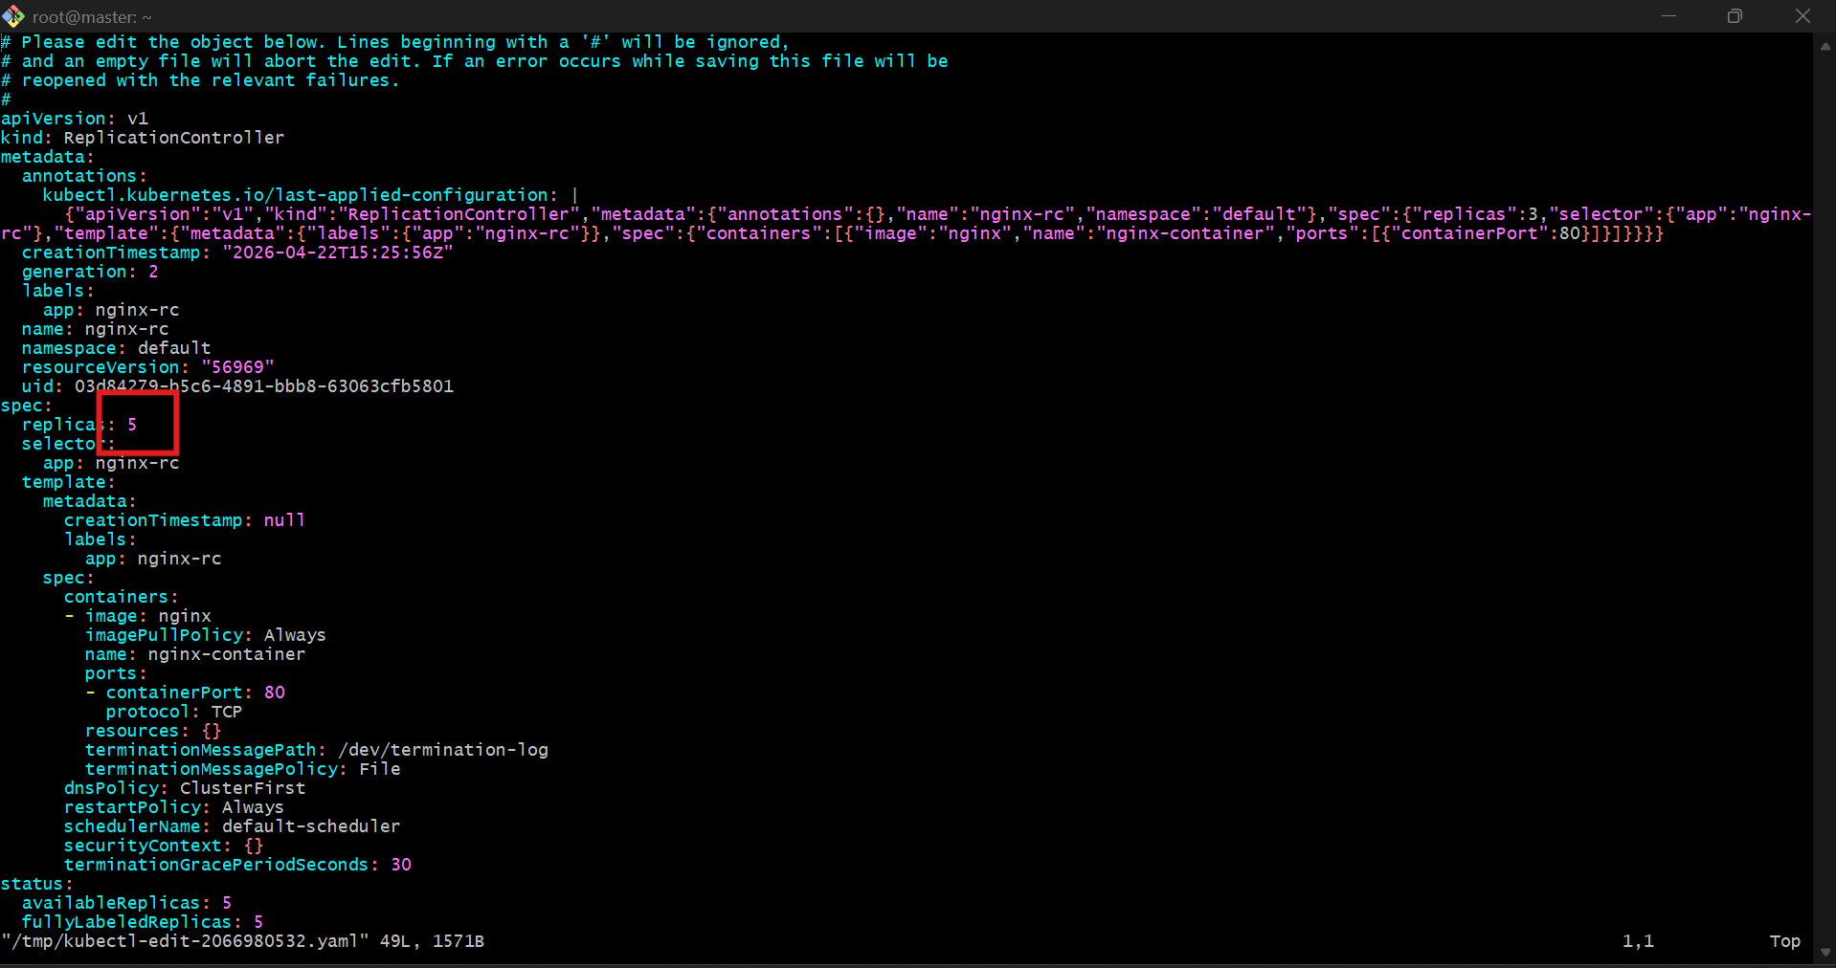

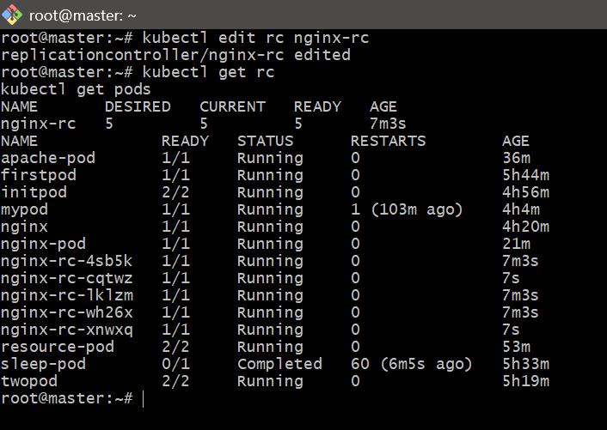

5.Create a ReplicaSet to manage pods based on multiple labels (prod and test).

Create a ReplicaSet Using Multiple Labels (prod & test)
🎯 Objective
Create a ReplicaSet that manages pods using multiple labels:
- env=prod
- tier=test
Step 1: Create YAML File
vi nginx-rs.yaml

YAML Configuration
apiVersion: apps/v1
kind: ReplicaSet
metadata:
name: nginx-rs
spec:
replicas: 3
selector:
matchLabels:
env: prod
tier: test
template:
metadata:
labels:
env: prod
tier: test
spec:
containers:
- name: nginx-container
image: nginx
ports:
- containerPort: 80

Step 2: Apply the ReplicaSet
kubectl apply -f nginx-rs.yaml
Step 3: Verify ReplicaSet
kubectl get rs
Expected output:
NAME DESIRED CURRENT READY
nginx-rs 3 3 3

Step 4: Verify Pods
kubectl get pods --show-labels
👉 You should see:
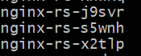

Step 5: Test Label Matching (Important)
Delete one pod:
kubectl delete pod <pod-name>
👉 ReplicaSet will automatically create a new pod with same labels.

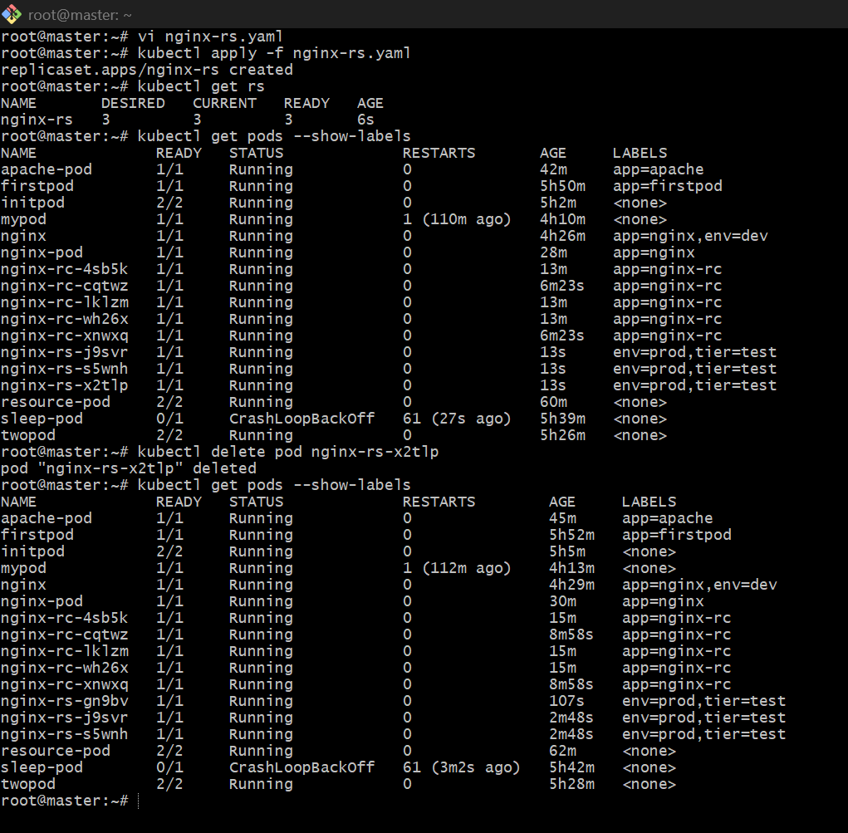

6. Deploy a ReplicaSet that excludes pods with the label backend.

Objective
Create a ReplicaSet that:
- Selects pods with a specific label (e.g., env=prod)
- Excludes pods that have label tier=backend
👉 This is done using matchExpressions with NotIn

Step 1: Create YAML File
vi nginx-rs-exclude.yaml

YAML Configuration
apiVersion: apps/v1
kind: ReplicaSet
metadata:
name: nginx-rs-exclude
spec:
replicas: 3
selector:
matchExpressions:
- key: env
operator: In
values:
- prod
- key: tier
operator: NotIn
values:
- backend
template:
metadata:
labels:
env: prod
tier: frontend # This ensures it is NOT backend
spec:
containers:
- name: nginx-container
image: nginx
ports:
- containerPort: 80

Step 2: Apply the ReplicaSet
kubectl apply -f nginx-rs-exclude.yaml

Step 3: Verify ReplicaSet
kubectl get rs
Expected:
NAME DESIRED CURRENT READY
nginx-rs-exclude 3 3 3

Step 4: Verify Pods & Labels
kubectl get pods --show-labels
👉 You will see:
nginx-rs-exclude-xxx env=prod,tier=frontend
✔ These pods:
- Match env=prod
- Do NOT have tier=backend

Step 5: Test Exclusion (Important)
Create a pod manually with tier=backend:
kubectl run test-backend --image=nginx --labels="env=prod,tier=backend"
Now check:
kubectl get pods --show-labels
👉 Observation:
- ReplicaSet will NOT manage this pod
- Because it is excluded by NotIn backend
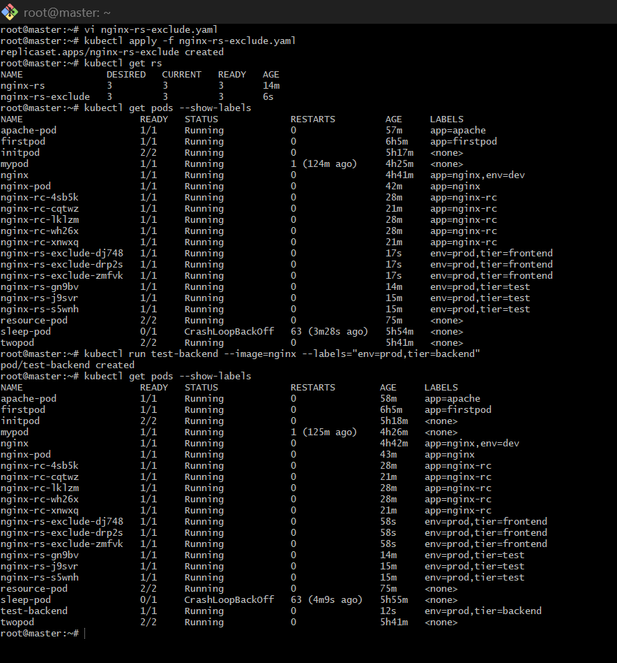
7.Test load balancing across multiple pods using a NodePort service.
Objective
Verify that a NodePort Service distributes traffic across multiple pods.

Step 1: Create a Deployment with Multiple Nginx Pods
Create a file:
vi nginx-deploy.yaml
Add:
apiVersion: apps/v1
kind: Deployment
metadata:
name: nginx-deploy
spec:
replicas: 3
selector:
matchLabels:
app: nginx-lb
template:
metadata:
labels:
app: nginx-lb
spec:
containers:
- name: nginx
image: nginx
ports:
- containerPort: 80
Apply it:
kubectl apply -f nginx-deploy.yaml
Check pods:
kubectl get pods -o wide

Step 2: Expose the Deployment Using NodePort Service
Create a file:
vi nginx-nodeport.yaml
Add:
apiVersion: v1
kind: Service
metadata:
name: nginx-lb-service
spec:
type: NodePort
selector:
app: nginx-lb
ports:
- port: 80
targetPort: 80
nodePort: 30008
Apply it:
kubectl apply -f nginx-nodeport.yaml
Verify:
kubectl get svc

Step 3: Confirm Endpoints
Run:
kubectl get endpoints nginx-lb-service
You should see 3 pod IPs. Example:
10.244.1.10:80,10.244.2.15:80,10.244.1.20:80
That means the service is connected to all 3 pods.

Step 4: Test the Service Repeatedly
From the master node, run:
curl http://10.0.1.40:30008
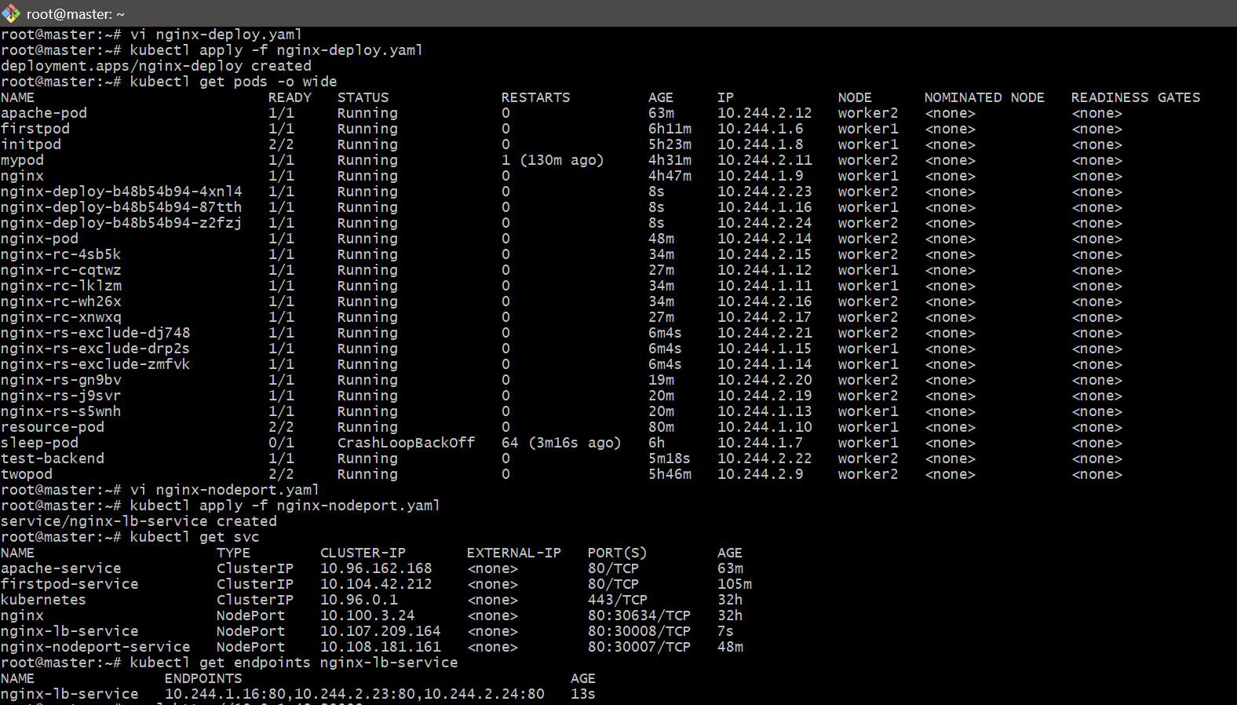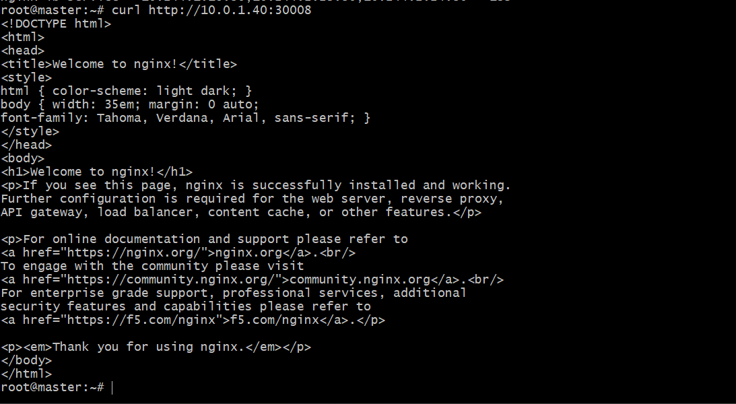

- Delete a ReplicationController without affecting the running pods.
Objective
Delete a ReplicationController (RC) while keeping its pods running.

Key Concept
Normally, when you delete an RC:
👉 Pods are also deleted ❌
But we can prevent this using:
--cascade=orphan
👉 This makes pods independent (orphaned) and keeps them running ✅

Step 1: Check Existing RC
kubectl get rc
Example:
nginx-rc 5 5 5

Step 2: Delete RC Without Deleting Pods
Run:
kubectl delete rc nginx-rc --cascade=orphan

Step 3: Verify RC is Deleted
kubectl get rc
👉 nginx-rc should NOT be listed

Step 4: Verify Pods Still Running
kubectl get pods
👉 You will still see:
nginx-rc-xxxxx Running
nginx-rc-yyyyy Running
nginx-rc-zzzzz Running

Step 5: Check Labels (Important)
kubectl get pods --show-labels
👉 Pods still have labels, but no controller managing them

