- Deploy an application using a Deployment with 3 replicas and a rolling update strategy.
Step 1: Create Deployment YAML
Create a file:
vi deployment.yaml
Paste this:
apiVersion: apps/v1
kind: Deployment
metadata:
name: my-app-deployment
labels:
app: my-app
spec:
replicas: 3
selector:
matchLabels:
app: my-app
strategy:
type: RollingUpdate
rollingUpdate:
maxUnavailable: 1 # max pods unavailable during update
maxSurge: 1 # extra pods created during update
template:
metadata:
labels:
app: my-app
spec:
containers:
- name: my-app-container
image: nginx:latest # replace with your app image
ports:
- containerPort: 80

Step 2: Apply the Deployment
kubectl apply -f deployment.yaml
step 3: Verify
kubectl get deployments
kubectl get pods
Key Points
- replicas: 3 → ensures high availability.
- RollingUpdate strategy → updates pods gradually without downtime.
- maxUnavailable: 1 → only 1 pod can go down during update.
- maxSurge: 1 → allows 1 extra pod during update for smoother rollout.
If you want, I can also show how to expose this deployment using a Service or perform a rolling update with a new image. 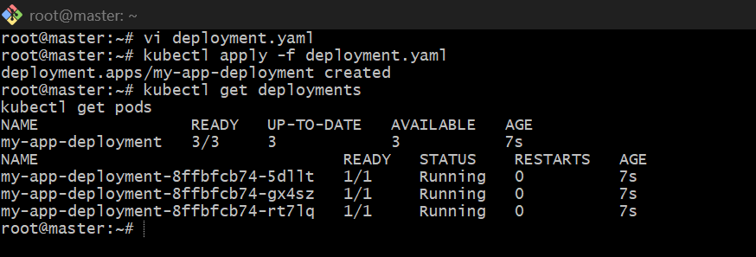

- Configure a Deployment with a Recreate strategy and observe the downtime.
What is Recreate strategy?
In Recreate strategy:
- Kubernetes first deletes all old pods
- Then it creates new pods
So during update, for some time no pod is running, and that is called downtime.
Step 1: Create Deployment YAML
Create a file:
vi recreate-deployment.yaml
Paste this:
apiVersion: apps/v1
kind: Deployment
metadata:
name: recreate-demo
spec:
replicas: 3
selector:
matchLabels:
app: recreate-app
strategy:
type: Recreate
template:
metadata:
labels:
app: recreate-app
spec:
containers:
- name: nginx-container
image: nginx:1.24
ports:
- containerPort: 80
Save and exit.

Step 2: Apply the Deployment
Run:
kubectl apply -f recreate-deployment.yaml
Expected output:
deployment.apps/recreate-demo created

Step 3: Check Deployment
Run:
kubectl get deployment
You should see something like:
NAME READY UP-TO-DATE AVAILABLE AGE
recreate-demo 3/3 3 3 10s

Step 4: Check Pods
Run:
kubectl get pods -o wide
You should see 3 running pods.

Step 5: Expose the Deployment using NodePort Service
Create another file:
vi recreate-service.yaml
Paste this:
apiVersion: v1
kind: Service
metadata:
name: recreate-service
spec:
type: NodePort
selector:
app: recreate-app
ports:
- port: 80
targetPort: 80
nodePort: 30008
Save and exit.
Apply it:
kubectl apply -f recreate-service.yaml
Check service:
kubectl get svc

Step 6: Find Node IP
Run:
kubectl get nodes -o wide
Use the public IP.
Example URL:
http://192.168.1.11:30008
Open this in browser.
You should see the nginx page. 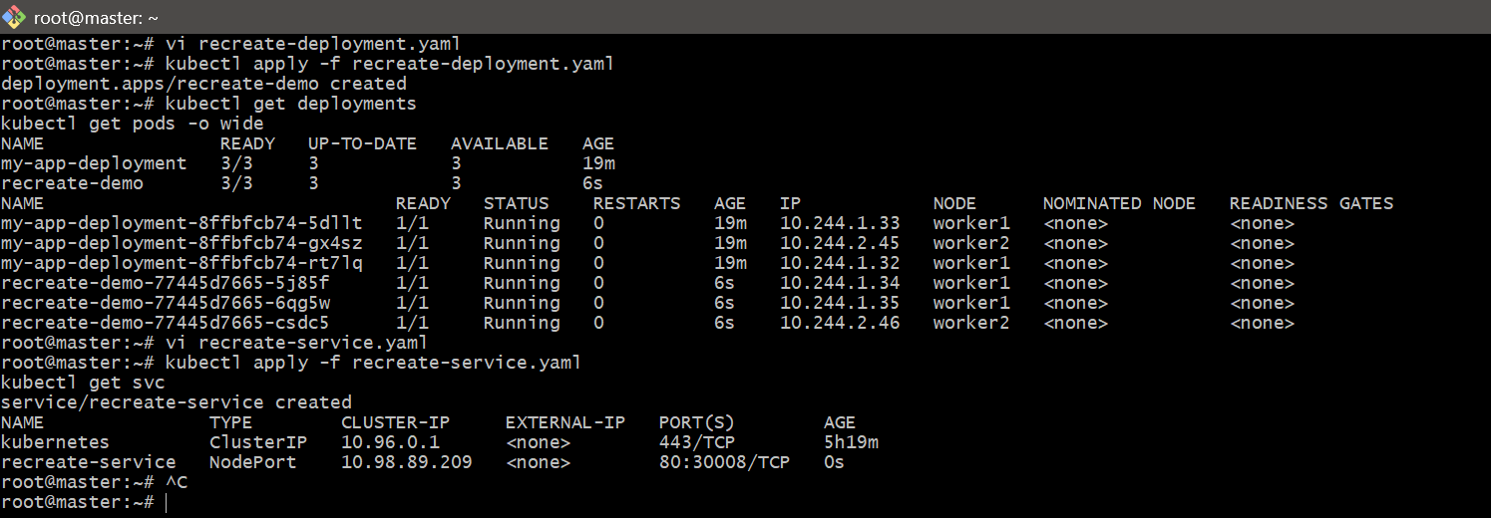
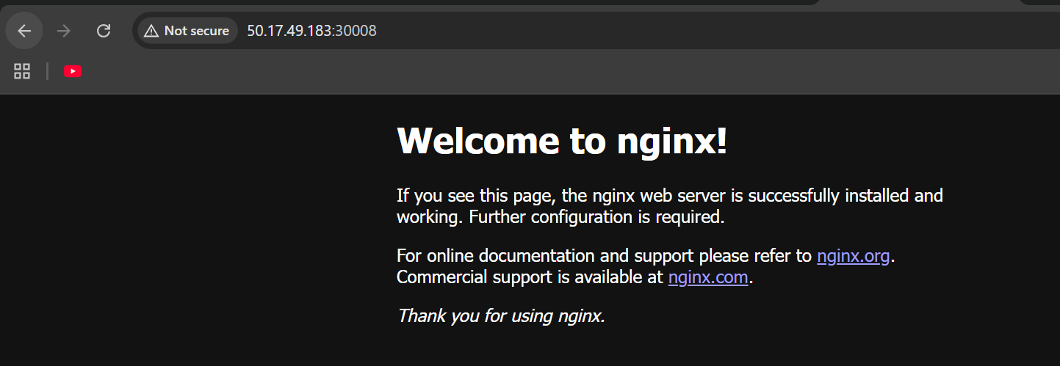

- Update an existing Deployment and perform a rollback to the previous version.
Task
🎯 Update a Deployment (change image) and then rollback to previous version if needed.

Step 1: Check existing Deployment
kubectl get deployments 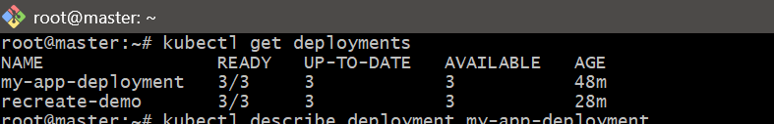

Step 2: Check current image
kubectl describe deployment my-app-deployment
Look for:
Image: nginx:latest 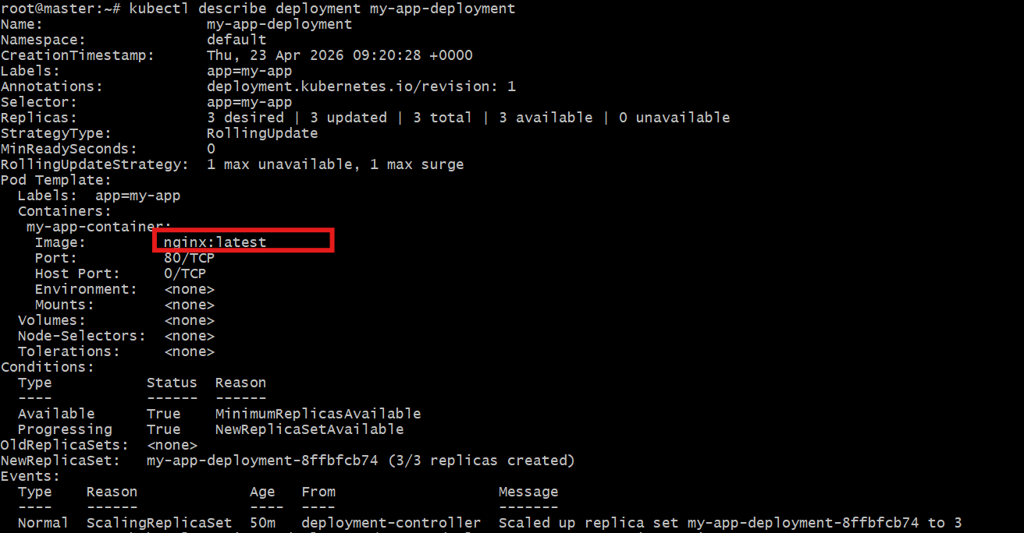

Step 3: Update the Deployment (Rolling Update)
Change the image:
kubectl set image deployment/my-app-deployment my-app-container=nginx:1.25
Output:
deployment.apps/my-app-deployment image updated

Step 4: Monitor rollout
kubectl rollout status deployment/my-app-deployment
Watch pods:
kubectl get pods -w
👉 You will see:
- Old pods terminating
- New pods creating

Step 5: Check rollout history
kubectl rollout history deployment/my-app-deployment
Example:
REVISION CHANGE-CAUSE
1 Initial deployment
2 Image updated to nginx:1.25

Step 6: Rollback to previous version
kubectl rollout undo deployment/my-app-deployment
Output:
deployment.apps/my-app-deployment rolled back

Step 7: Verify rollback
kubectl describe deployment my-app-deployment
Now image will be back to:
nginx:latest

Step 8: Check status again
kubectl rollout status deployment/my-app-deployment

🧠 What is happening internally?
- Kubernetes keeps Deployment revisions
- When you update → new revision is created
- Rollback → switches to old ReplicaSet

⚠️ When to use rollback?
- New version has bug ❌
- Application not working ❌
- Pods crashing ❌
- Health check failing ❌
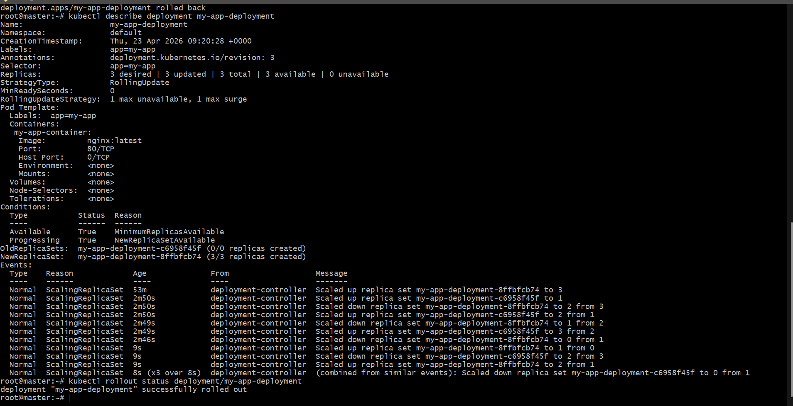

- Modify a Deployment to add resource requests and limits for CPU and memory.
🎯 Task
Add resource requests and limits to an existing Deployment.

🧠 What are requests & limits?
- requests → minimum resources guaranteed to container
- limits → maximum resources container can use
Example:
- CPU request: 100m (0.1 CPU)
- CPU limit: 500m (0.5 CPU)
- Memory request: 128Mi
- Memory limit: 256Mi

Step 1: Check existing Deployment
kubectl get deployments
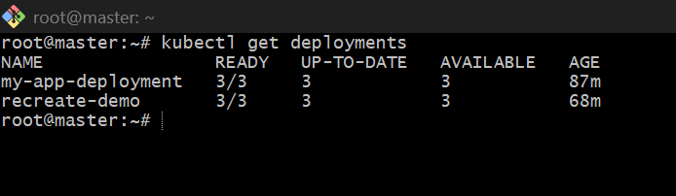

Step 2: Edit Deployment
kubectl edit deployment my-app-deployment

Step 3: Add resources section
Find this part:
containers:
- name: my-app-container
image: nginx:latest
Modify it like this 👇
containers:
- name: my-app-container
image: nginx:latest
resources:
requests:
cpu: "100m"
memory: "128Mi"
limits:
cpu: "500m"
memory: "256Mi"
Save and exit.
Step 4: Kubernetes will restart pods
Once you save:
- New pods will be created
- Old pods will be terminated (rolling update)
Step 5: Verify changes
kubectl describe deployment my-app-deployment
Look for:
Limits:
cpu: 500m
memory: 256Mi
Requests:
cpu: 100m
memory: 128Mi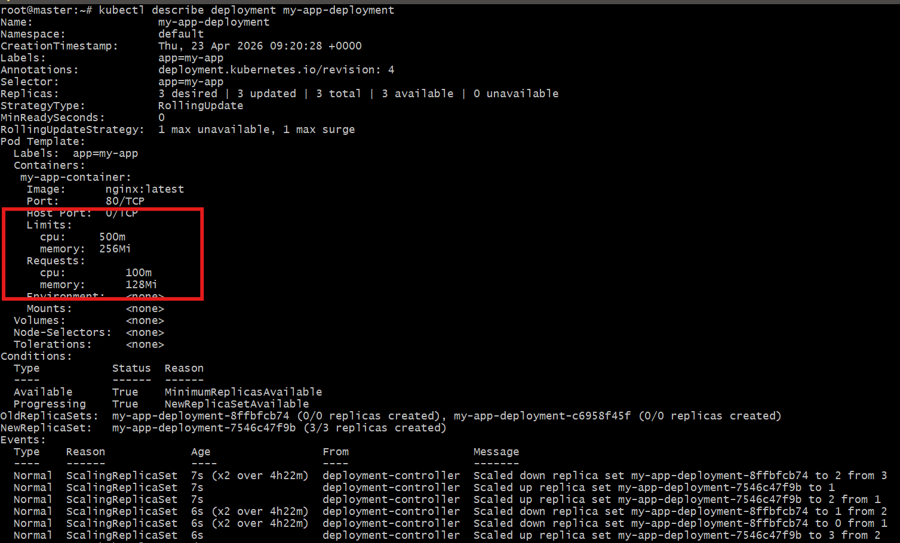

Step 6: Check pods
kubectl get pods
kubectl describe pod <pod-name>
Verify resource section is applied.
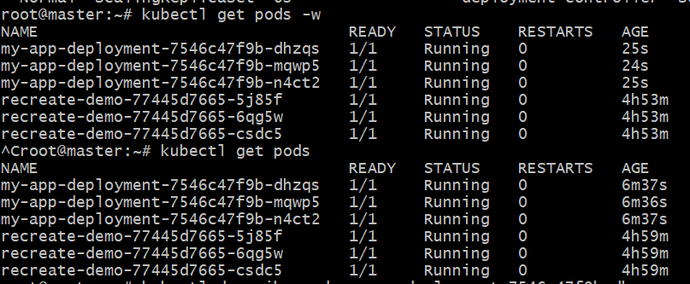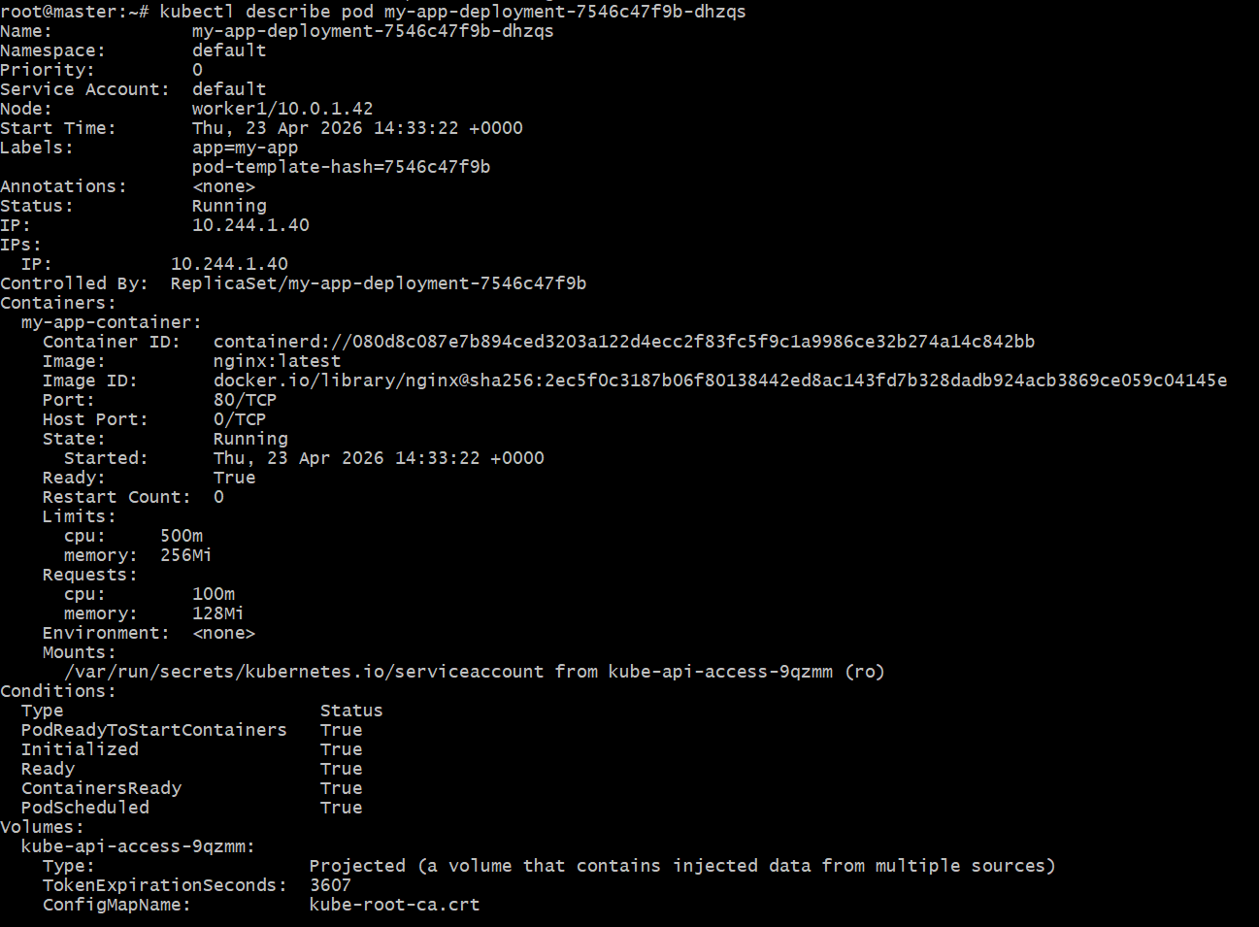

- Create a Deployment with MaxSurge and MaxUnavailable configurations.
🎯 Task
Create a Kubernetes Deployment that uses RollingUpdate strategy with:
- maxSurge → extra pods during update
- maxUnavailable → pods allowed to go down

🧠 Concept (Simple)
- maxSurge: 1 → can create 1 extra pod (total becomes 4 if replicas=3)
- maxUnavailable: 1 → only 1 pod can be unavailable during update
👉 Ensures zero/minimum downtime

Step 1: Create YAML file
vi surge-deployment.yaml

Step 2: Paste this YAML
apiVersion: apps/v1
kind: Deployment
metadata:
name: surge-demo
spec:
replicas: 3
selector:
matchLabels:
app: surge-app
strategy:
type: RollingUpdate
rollingUpdate:
maxSurge: 1
maxUnavailable: 1
template:
metadata:
labels:
app: surge-app
spec:
containers:
- name: nginx-container
image: nginx:1.24
ports:
- containerPort: 80

Step 3: Apply Deployment
kubectl apply -f surge-deployment.yaml
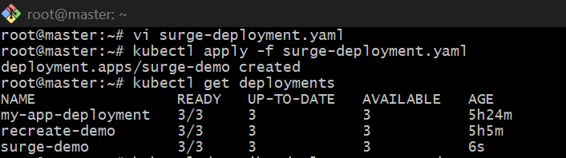

Step 4: Verify Deployment
kubectl get deployments


Step 5: Check strategy
kubectl describe deployment surge-demo
You should see:
StrategyType: RollingUpdate
RollingUpdateStrategy: 1 max unavailable, 1 max surge
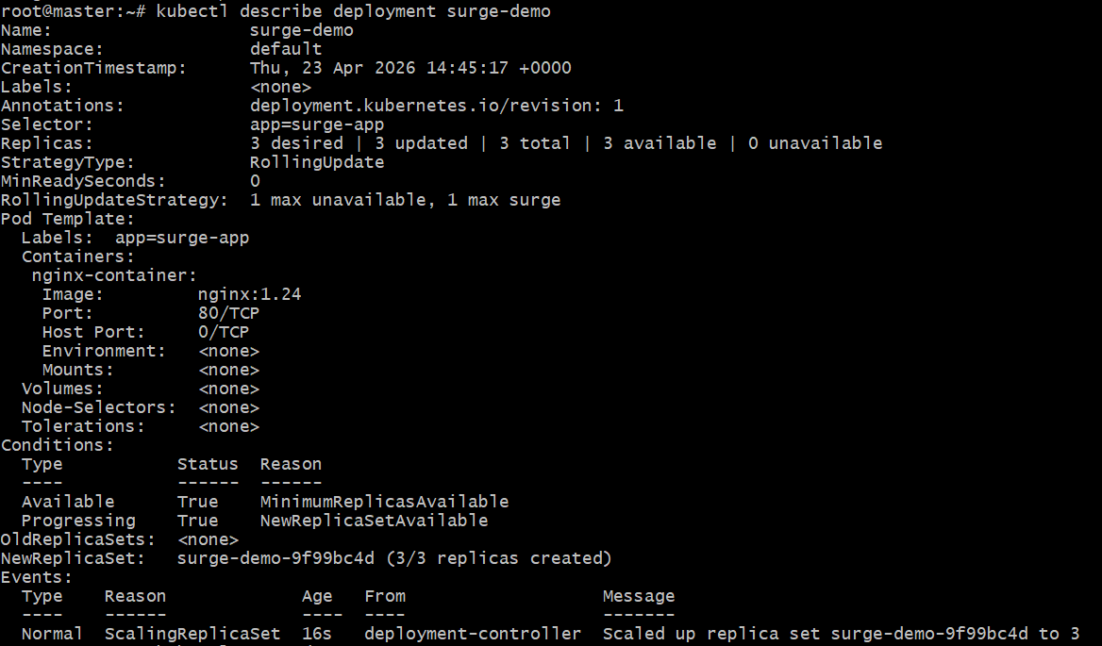

Step 6: Test Rolling Update
Open 2 terminals:
Terminal 1 (watch pods)
kubectl get pods -w
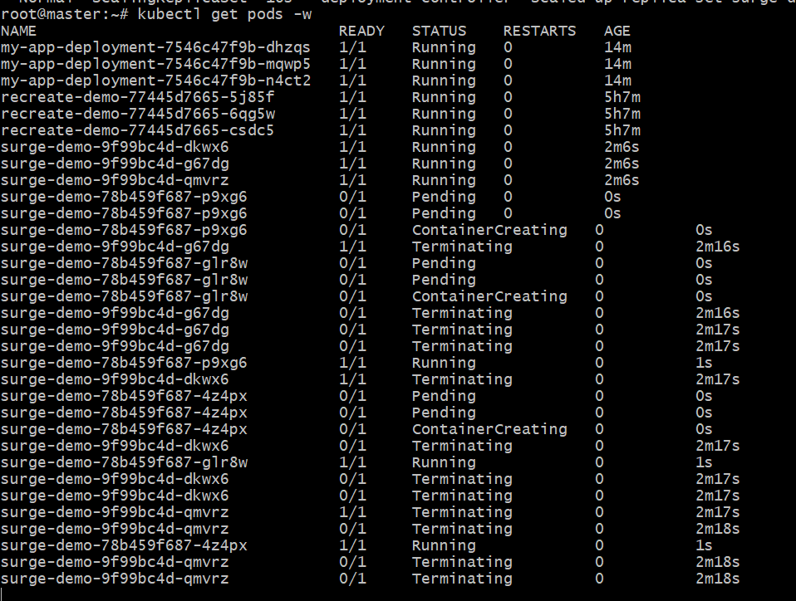
Terminal 2 (update image)
kubectl set image deployment/surge-demo nginx-container=nginx:1.25
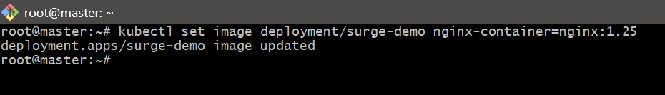

- Set up a Deployment with a custom revision history limit.
Task Objective
Create a Deployment and configure revisionHistoryLimit so Kubernetes keeps only a limited number of old versions for rollback.

What is revision history limit?
When you update a Deployment, Kubernetes creates a new ReplicaSet for the new version and keeps old ReplicaSets for rollback.
By default, Kubernetes keeps 10 old revisions.
If you set:
revisionHistoryLimit: 2
Kubernetes will keep only the last 2 old versions.

Step 1: Create the Deployment YAML file
Run:
vi revision-deployment.yaml
Paste this YAML:
apiVersion: apps/v1
kind: Deployment
metadata:
name: revision-demo
spec:
replicas: 3
revisionHistoryLimit: 2
selector:
matchLabels:
app: revision-app
template:
metadata:
labels:
app: revision-app
spec:
containers:
- name: nginx-container
image: nginx:1.24
ports:
- containerPort: 80
Save and exit.

Step 2: Apply the Deployment
Run:
kubectl apply -f revision-deployment.yaml
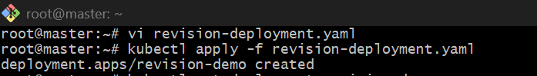If the

Step 3: Verify the Deployment
Run:
kubectl get deployment revision-demo 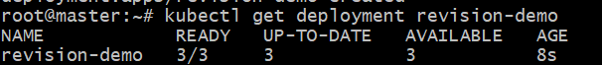
This means 3 pods are running.

Step 4: Check Deployment details
Run:
kubectl describe deployment revision-demo
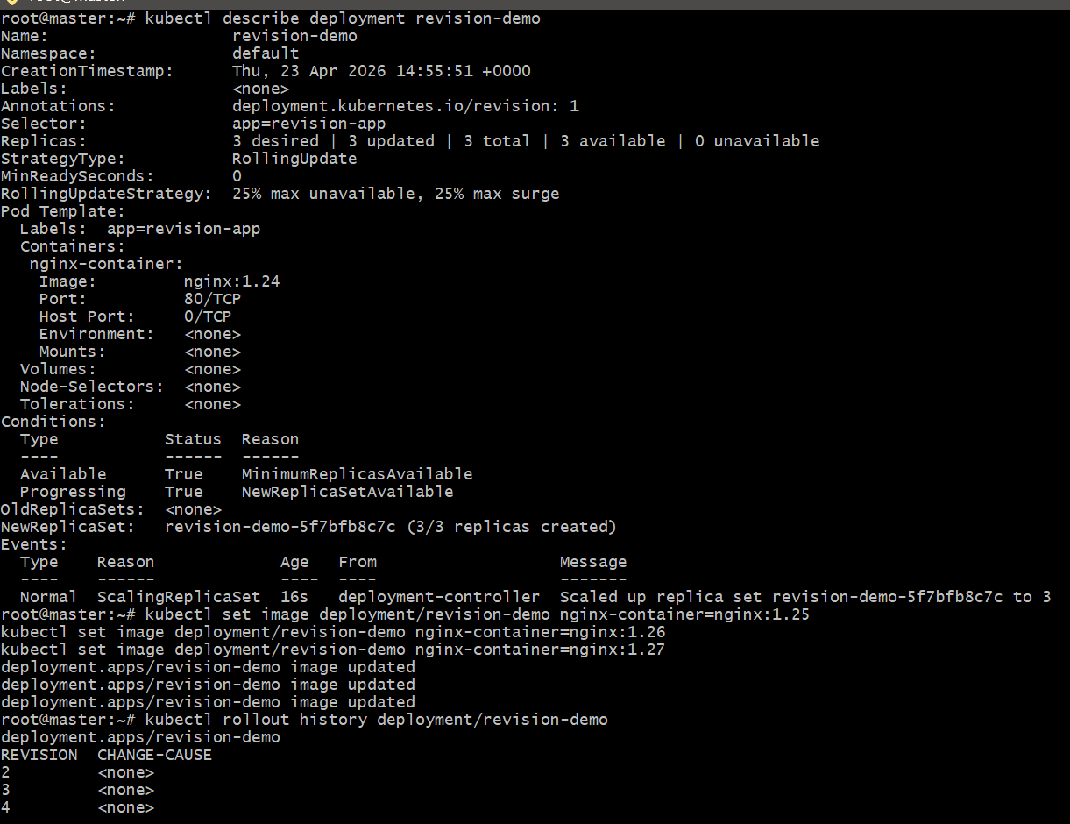

Step 5: Create multiple revisions
Now update the image multiple times so Kubernetes creates new revisions.
Run:
kubectl set image deployment/revision-demo nginx-container=nginx:1.25
kubectl set image deployment/revision-demo nginx-container=nginx:1.26
kubectl set image deployment/revision-demo nginx-container=nginx:1.27
Each command creates a new revision. 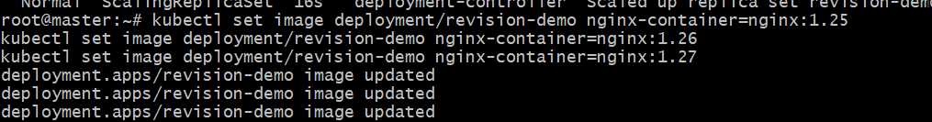

Step 6: Check rollout history
Run:
kubectl rollout history deployment revision-demo
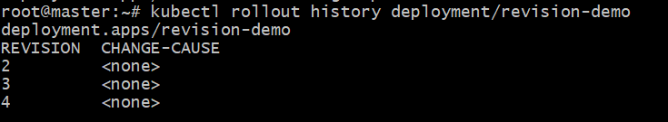
Step 7: Check ReplicaSets
Run:
kubectl get rs
Look for ReplicaSets related to revision-demo.
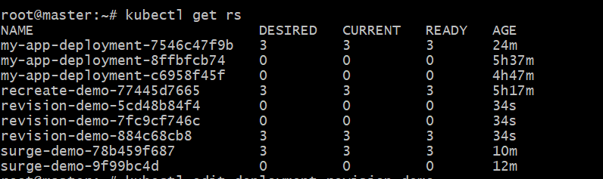Meaning:
- 1 ReplicaSet is current
- 2 ReplicaSets are old
This proves the custom revision history limit is working.

Step 8: Test again with one more update
Run one more image update:
kubectl set image deployment/revision-demo nginx-container=nginx:1.28
Now check ReplicaSets again:
kubectl get rs
What will happen:
- a new ReplicaSet is created
- the oldest old ReplicaSet is deleted
- only 2 old ReplicaSets are retained 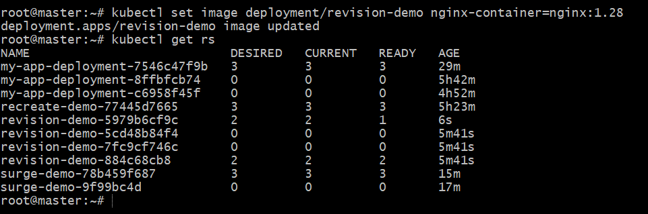

Step 9: Final verification
Run:
kubectl describe deployment revision-demo
and
kubectl get rs
If only 2 old ReplicaSets are retained, then your revisionHistoryLimit: 2 is working successfully.

Step 10: Delete the Deployment if needed
After completing the task, you can delete it using:
kubectl delete deployment revision-demo
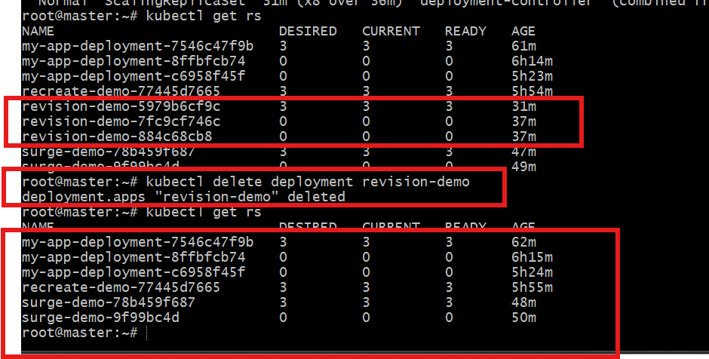

- Deployment during an update, and then resume it.
Task Objective
Pause a Deployment update, verify that the rollout is stopped, and then resume it.
This is useful when:
- you started an update
- you want to stop it temporarily
- you want to review changes before continuing

What does pause mean?
When a Deployment is paused:
- Kubernetes accepts changes to the Deployment
- but it does not continue the rollout
When you resume:
- Kubernetes continues the update process

Step 1: Check existing Deployment
Run:
kubectl get deployments
We will use my-app-deployment. 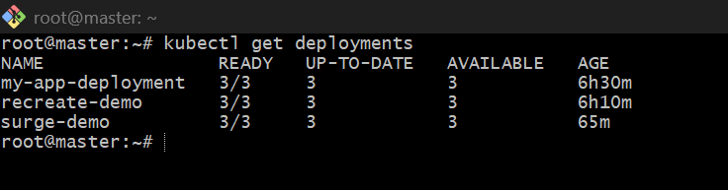

Step 2: Check current image
Run:
kubectl describe deployment my-app-deployment
Look for the current image, for example:
Image: nginx:latest
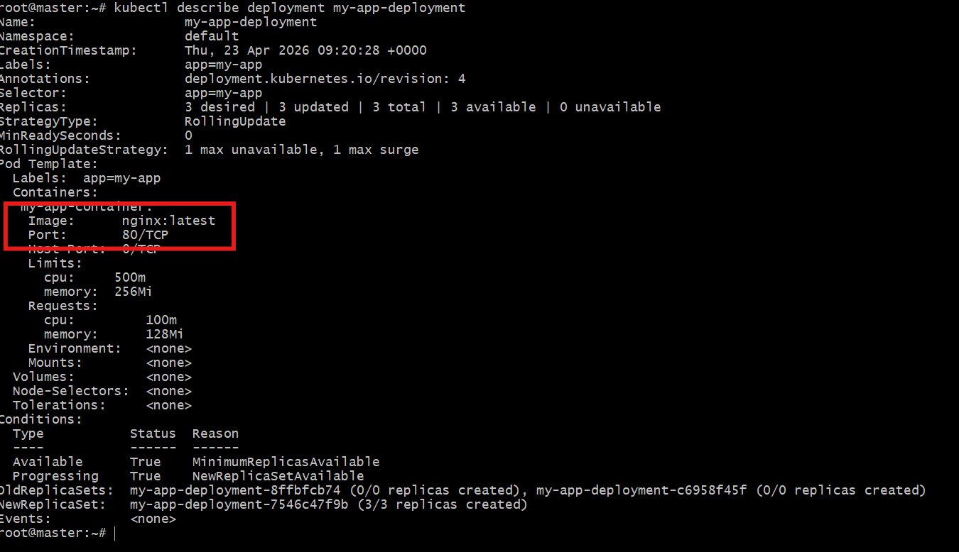

Step 3: Pause the Deployment
Run:
kubectl rollout pause deployment my-app-deployment
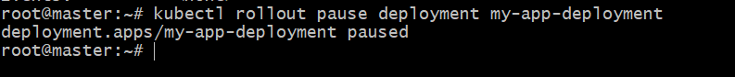
Step 4: Verify that Deployment is paused
Run:
kubectl describe deployment my-app-deployment
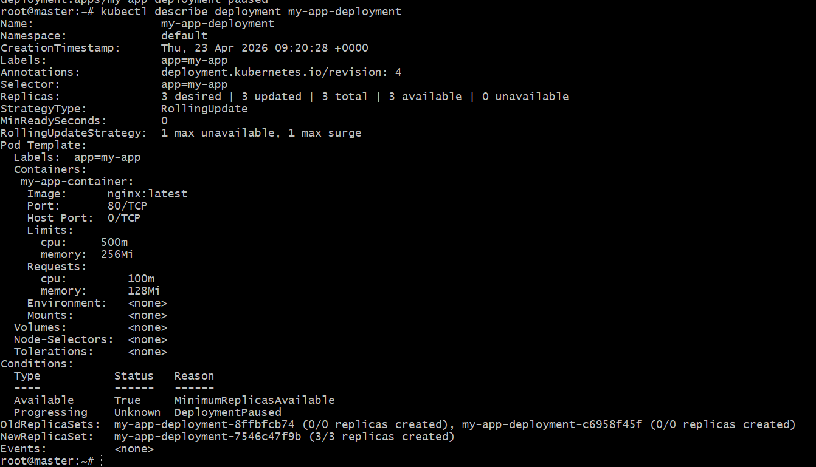
Step 5: Make an update while Deployment is paused
Now change the image:
kubectl set image deployment/my-app-deployment my-app-container=nginx:1.25

Step 6: Observe that rollout does not happen immediately
Run:
kubectl get pods 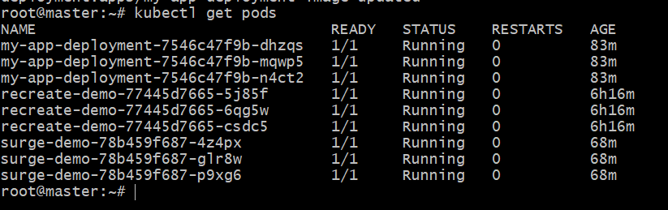
and
kubectl rollout status deployment my-app-deployment
Since the Deployment is paused:
- new rollout will not complete
- pods may not update immediately as normal rollout
You can also check:
kubectl describe deployment my-app-deployment

Step 7: Resume the Deployment
Run:
kubectl rollout resume deployment my-app-deployment
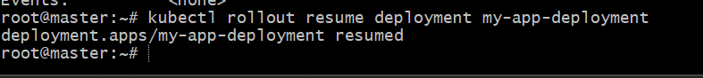
Step 8: Check rollout status
Run:
kubectl rollout status deployment my-app-deployment
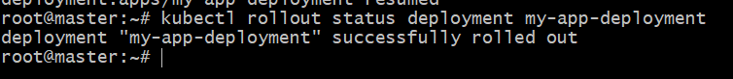

Step 9: Watch pods during resume
Run:
kubectl get pods -w
Now you will see:
- old pods terminating
- new pods creating
- rollout continuing normally 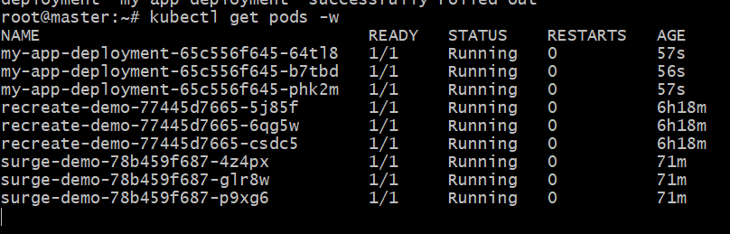

Step 10: Verify updated image
Run:
kubectl describe deployment my-app-deployment
Now the image should be updated to:
nginx:1.25
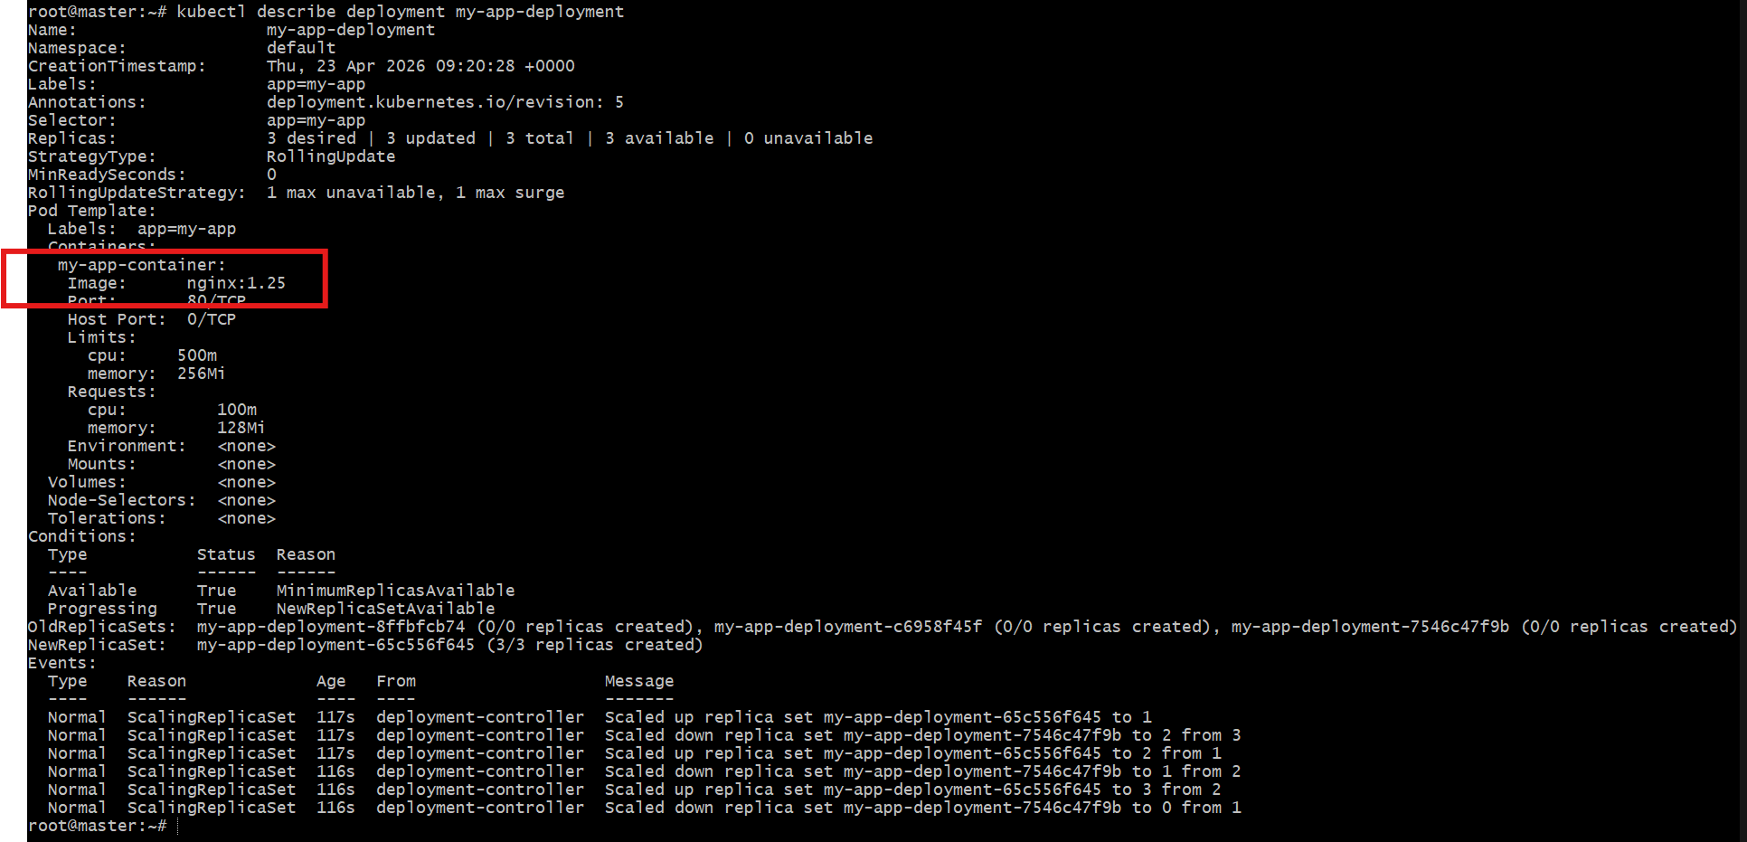

- Create a pod using resource requests for memory and CPU, and observe how the scheduler assigns it to a node.
🎯 Task Objective
- Create a Pod with CPU & Memory requests
- See which node Kubernetes scheduler assigns
- Understand why that node was chosen

🧠 Concept (Simple)
Kubernetes scheduler checks:
- Available CPU & Memory on nodes
- Pod requests
- Then assigns Pod to a suitable node
👉 If a node doesn’t have enough resources → Pod won’t schedule

Step 1: Create Pod YAML
vi resource-pod.yaml

Step 2: Paste this YAML
apiVersion: v1
kind: Pod
metadata:
name: resource-pod
spec:
containers:
- name: nginx-container
image: nginx
resources:
requests:
cpu: "200m"
memory: "128Mi"
limits:
cpu: "500m"
memory: "256Mi"

Step 3: Create the Pod
kubectl apply -f resource-pod.yaml
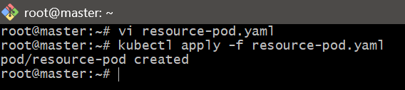
Step 4: Check Pod status
kubectl get pods -o wide
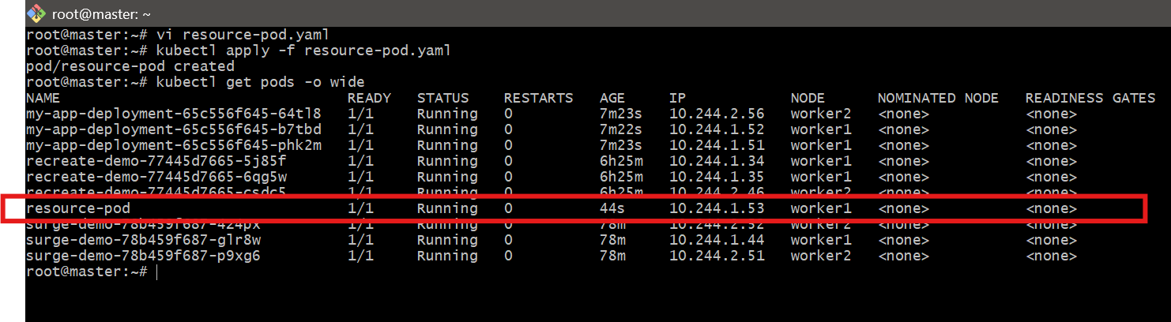
👉 NODE column shows where pod is scheduled

Step 5: Describe the Pod (IMPORTANT)
kubectl describe pod resource-pod
Look for:
Node: worker1/x.x.x.x
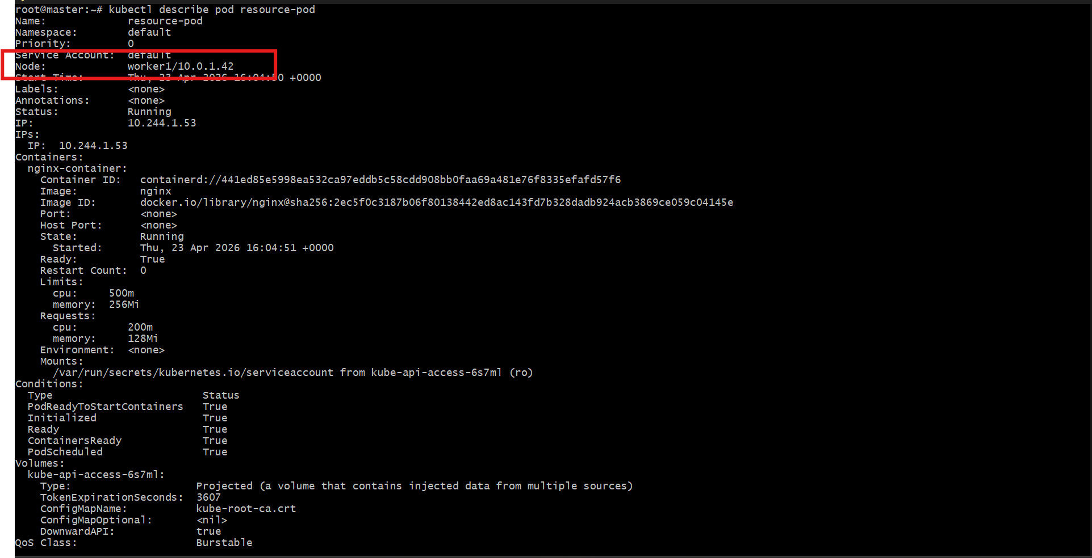
👉 This tells:
- Which node scheduler selected

Step 6: Check Node resources
kubectl describe node worker1
Look for:
Allocated resources:
CPU Requests
Memory Requests
👉 This shows:
- How much resource is already used
- Why this node was selected
