- Create a namespace dev-environment and apply a resource-based quota that restricts the number of pods to 3 and services to 2.
Step 1: Create Namespace
Run this command:
kubectl create namespace dev-environment
👉 Verify:
kubectl get namespaces
You should see:
dev-environment

Step 2: Create ResourceQuota YAML
Create a file:
vi resource-quota.yaml
Paste this:
apiVersion: v1
kind: ResourceQuota
metadata:
name: dev-quota
namespace: dev-environment
spec:
hard:
pods: "3"
services: "2"
👉 Explanation (simple):
- pods: "3" → Max 3 pods allowed
- services: "2" → Max 2 services allowed

Step 3: Apply the ResourceQuota
kubectl apply -f resource-quota.yaml

Step 4: Verify Quota
kubectl get resourcequota -n dev-environment
OR detailed view:
kubectl describe quota dev-quota -n dev-environment

Step 5: Test (VERY IMPORTANT for understanding)
▶ Create 3 pods (allowed)
kubectl run pod1 --image=nginx -n dev-environment
kubectl run pod2 --image=nginx -n dev-environment
kubectl run pod3 --image=nginx -n dev-environment
👉 Check:
kubectl get pods -n dev-environment
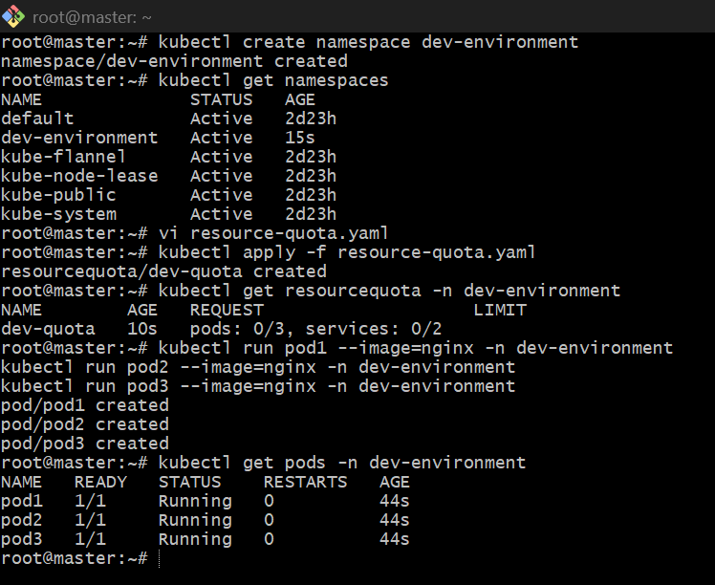

- Create a pod in the prod-environment namespace with 0.2 CPU and 200Mi memory requests, and 0.5 CPU and 500Mi memory limits.
Step 1: Create Namespace (prod-environment)
kubectl create namespace prod-environment
👉 Verify:
kubectl get ns

✅ Step 2: Create Pod YAML with Requests & Limits
Create file:
vi prod-pod.yaml
Paste this:
apiVersion: v1
kind: Pod
metadata:
name: prod-pod
namespace: prod-environment
spec:
containers:
- name: nginx-container
image: nginx
resources:
requests:
cpu: "200m"
memory: "200Mi"
limits:
cpu: "500m"
memory: "500Mi"

Step 3: Apply the Pod
kubectl apply -f prod-pod.yaml

Step 4: Verify Pod
kubectl get pods -n prod-environment

Step 5: Verify Resource Configuration (VERY IMPORTANT)
kubectl describe pod prod-pod -n prod-environment
👉 Check this section in output:
Requests:
cpu: 200m
memory: 200Mi
Limits:
cpu: 500m
memory: 500Mi
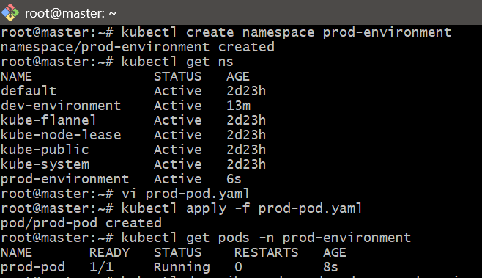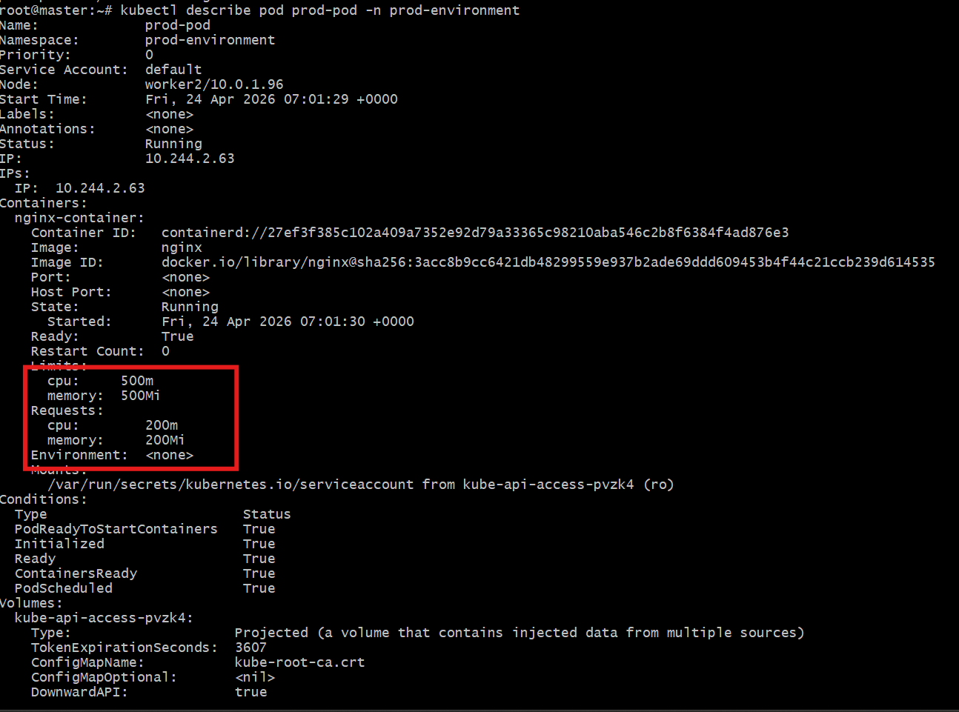

- In the staging-environment namespace, set a LimitRange that assigns default CPU and memory limits (300m CPU, 600Mi memory) and applies a minimum and maximum CPU.
Step 1: Create Namespace
kubectl create namespace staging-environment
Verify:
kubectl get ns
Step 2: Create LimitRange YAML
Create file:
vi limitrange.yaml
Paste this:
apiVersion: v1
kind: LimitRange
metadata:
name: staging-limits
namespace: staging-environment
spec:
limits:
- type: Container
default:
cpu: "300m"
memory: "600Mi"
defaultRequest:
cpu: "150m"
memory: "300Mi"
min:
cpu: "100m"
memory: "100Mi"
max:
cpu: "500m"
memory: "1Gi"

Step 3: Apply the LimitRange
kubectl apply -f limitrange.yaml
Step 4: Verify
kubectl get limitrange -n staging-environment
Detailed view:
kubectl describe limitrange staging-limits -n staging-environment
Step 5: Test (IMPORTANT)
Create a pod without specifying resources:
kubectl run test-pod --image=nginx -n staging-environment
Now check:
kubectl describe pod test-pod -n staging-environment
You will see automatically applied:
Limits:
cpu: 300m
memory: 600Mi
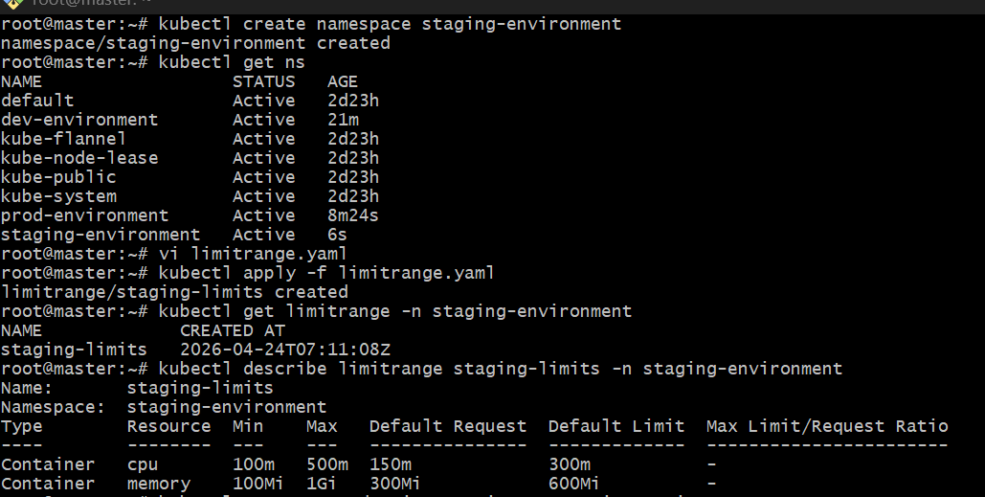
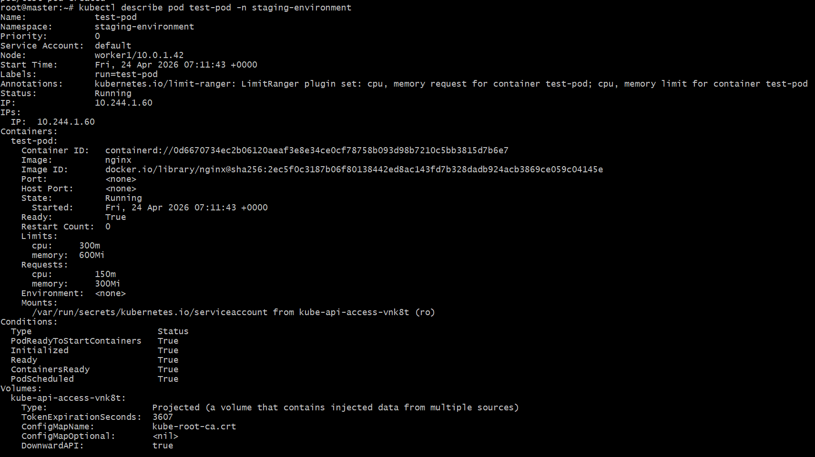

4. Create a pod and a NodePort service in the default namespace, then create another pod in the test namespace and communicate between them using Service DNS.
Step 1: Create Pod in default namespace
kubectl run nginx-pod --image=nginx --port=80
Verify:
kubectl get pods

Step 2: Create NodePort Service
kubectl expose pod nginx-pod --type=NodePort --port=80 --target-port=80 --name=nginx-service
Verify:
kubectl get svc

Step 3: Create test namespace
kubectl create namespace test

Step 4: Create another Pod in test namespace
Use busybox pod:
kubectl run test-pod --image=busybox -n test --restart=Never -- sleep 3600
Verify:
kubectl get pods -n test

Step 5: Communicate using Service DNS
From test-pod, access service in default namespace:
kubectl exec -it test-pod -n test -- wget -qO- nginx-service.default.svc.cluster.local
You should see Nginx HTML output:
Welcome to nginx!

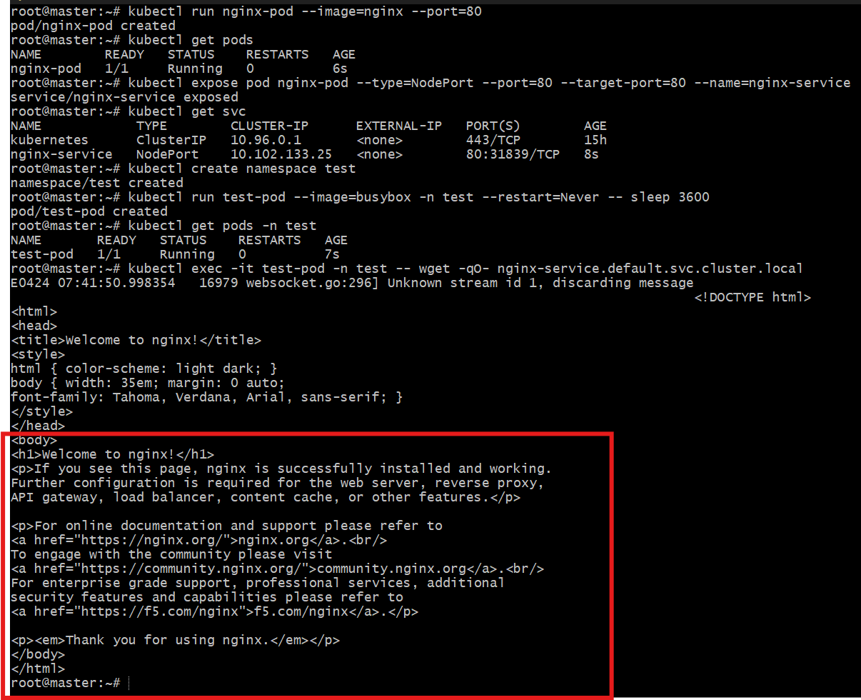

5. Apply a LimitRange with a max limit/request ratio of 2 for memory in the performance-environment namespace, and test by creating a pod with mismatched resource requests and limits.
Step 1: Create Namespace
kubectl create namespace performance-environment

Step 2: Create LimitRange (ratio = 2 for memory)
Create file:
vi limitrange-ratio.yaml
Paste this:
apiVersion: v1
kind: LimitRange
metadata:
name: memory-ratio-limit
namespace: performance-environment
spec:
limits:
- type: Container
maxLimitRequestRatio:
memory: "2"

Step 3: Apply LimitRange
kubectl apply -f limitrange-ratio.yaml
Verify:
kubectl describe limitrange memory-ratio-limit -n performance-environment

Step 4: Test with INVALID Pod (should FAIL)
Create file:
vi bad-pod.yaml
apiVersion: v1
kind: Pod
metadata:
name: bad-pod
namespace: performance-environment
spec:
containers:
- name: nginx
image: nginx
resources:
requests:
memory: "200Mi"
limits:
memory: "500Mi"
Apply:
kubectl apply -f bad-pod.yaml

Step 5: Test with VALID Pod (should WORK)
vi good-pod.yaml
paste this:
apiVersion: v1
kind: Pod
metadata:
name: good-pod
namespace: performance-environment
spec:
containers:
- name: nginx
image: nginx
resources:
requests:
memory: "200Mi"
limits:
memory: "400Mi"
Apply:
kubectl apply -f good-pod.yaml

