- Create a ConfigMap from a directory containing multiple files and inject the variables into a pod as environment variables.
steps
1. Create one directory
mkdir app-config
cd app-config
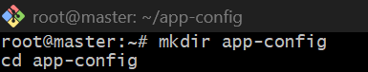
2. Create multiple files inside directory
echo "dev" > APP_ENV
echo "mysql-service" > DB_HOST
echo "3306" > DB_PORT
echo "abhinay" > USER_NAME
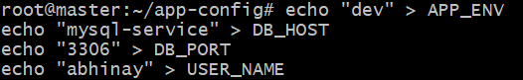
Check files:
ls
cat APP_ENV
cat DB_HOST
cat DB_PORT
cat USER_NAME
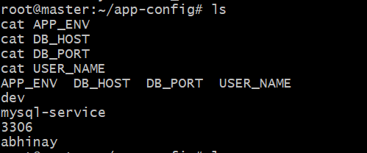

3. Create ConfigMap from directory
kubectl create configmap app-configmap --from-file=app-config
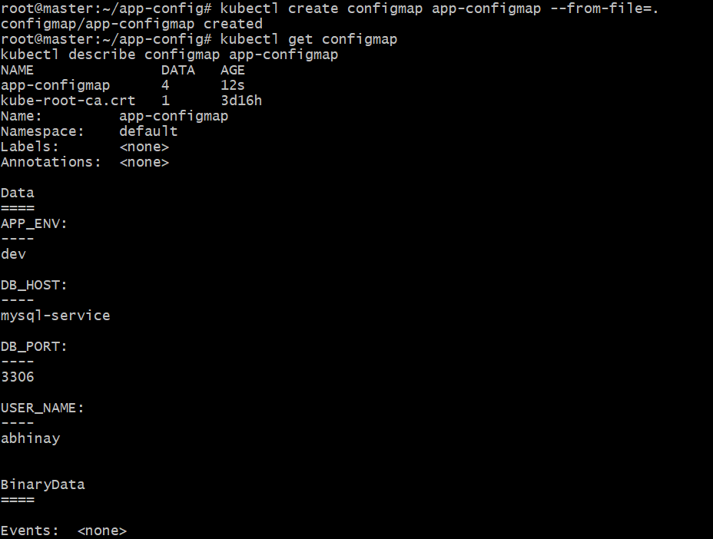
Verify:
kubectl get configmap
kubectl describe configmap app-configmap
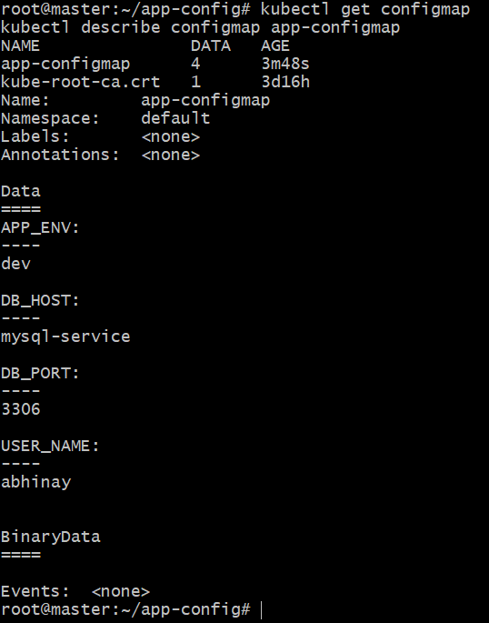

4. Create Pod YAML
vi configmap-env-pod.yaml
Paste this:
apiVersion: v1
kind: Pod
metadata:
name: configmap-env-pod
spec:
containers:
- name: nginx
image: nginx
envFrom:
- configMapRef:
name: app-configmap
Save and exit.
5. Apply Pod
kubectl apply -f configmap-env-pod.yaml
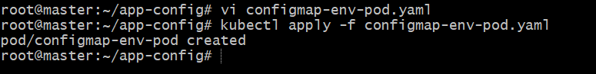
Check pod:
kubectl get pods
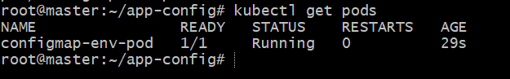

6. Verify environment variables inside Pod
kubectl exec -it configmap-env-pod -- env
You should see:
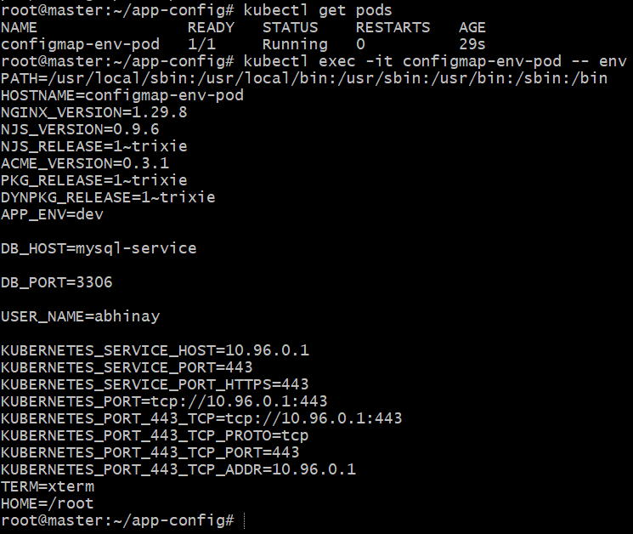

- Create a ConfigMap from a file and mount it as a volume inside a pod, ensuring the configuration data is available as files.

Step 1: Create a file
mkdir config-test
cd config-test
echo "DB_HOST=mysql-service" > app.properties
echo "DB_PORT=3306" >> app.properties
echo "APP_ENV=dev" >> app.properties
Check file:
cat app.properties
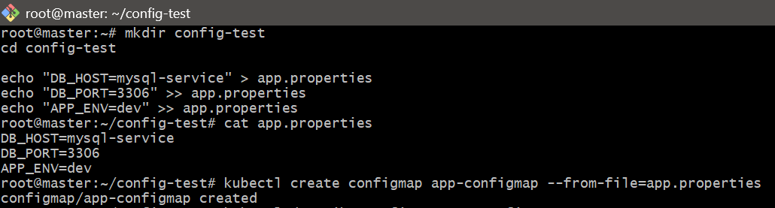

🔹 Step 2: Create ConfigMap from file
kubectl create configmap app-configmap --from-file=app.properties
👉 Verify:
kubectl describe configmap app-configmap
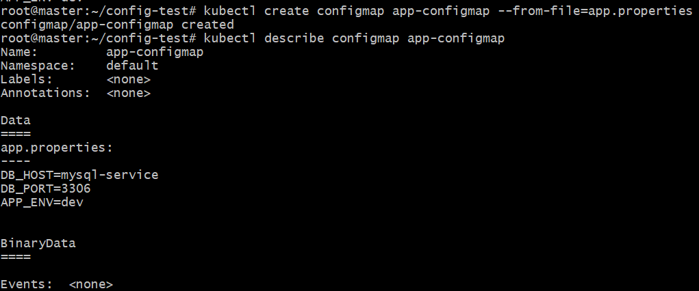

Step 3: Create Pod YAML
vi configmap-volume-pod.yaml
Paste this:
apiVersion: v1
kind: Pod
metadata:
name: configmap-volume-pod
spec:
containers:
- name: nginx
image: nginx
volumeMounts:
- name: config-volume
mountPath: /etc/config
volumes:
- name: config-volume
configMap:
name: app-configmap

Step 4: Apply Pod
kubectl apply -f configmap-volume-pod.yaml
Check:
kubectl get pods
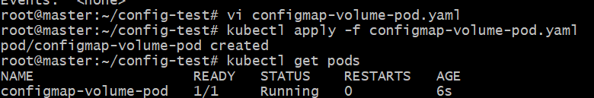

🔹 Step 5: Verify inside Pod
kubectl exec -it configmap-volume-pod -- /bin/bash
Inside pod:
cd /etc/config
ls
cat app.properties
👉 Output will be:
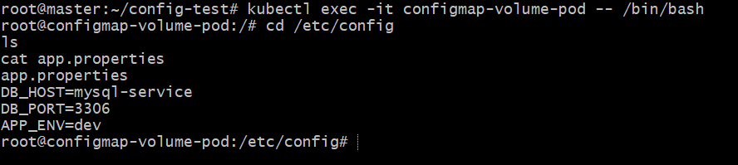

- Create a Secret with sensitive information (username and password) and inject it into a pod as environment variables.

Step 1: Create Secret (username & password)
kubectl create secret generic app-secret \
--from-literal=username=admin \
--from-literal=password=12345
👉 Verify:
kubectl get secret
kubectl describe secret app-secret
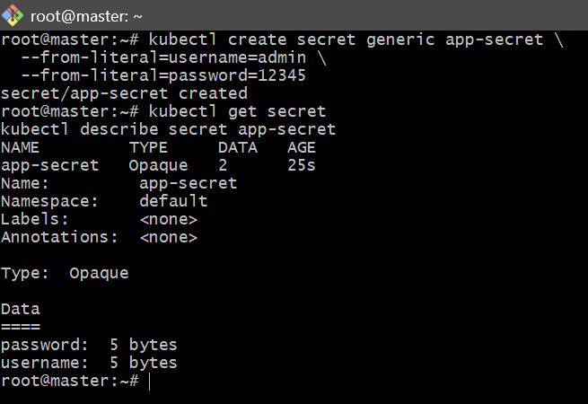

🔹 Step 2: Create Pod YAML
vi secret-env-pod.yaml
Paste this:
apiVersion: v1
kind: Pod
metadata:
name: secret-env-pod
spec:
containers:
- name: nginx
image: nginx
env:
- name: USERNAME
valueFrom:
secretKeyRef:
name: app-secret
key: username
- name: PASSWORD
valueFrom:
secretKeyRef:
name: app-secret
key: password

🔹 Step 3: Apply Pod
kubectl apply -f secret-env-pod.yaml
Check:
kubectl get pods
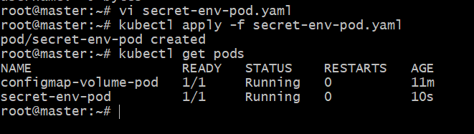

🔹 Step 4: Verify inside Pod
kubectl exec -it secret-env-pod -- env | grep USERNAME
kubectl exec -it secret-env-pod -- env | grep PASSWORD
👉 Output:
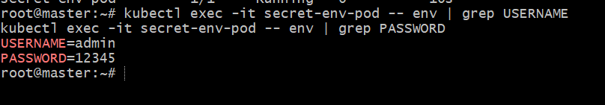

- Create a Secret using a YAML file, mount it as a volume in a pod, and verify the specific Secret values are available as files.

Step 1: Create Secret YAML
vi app-secret.yaml
Paste:
apiVersion: v1
kind: Secret
metadata:
name: app-secret
type: Opaque
stringData:
username: "abhinay"
password: "abhi"
Save and apply:
kubectl apply -f app-secret.yaml
Check:
kubectl get secret
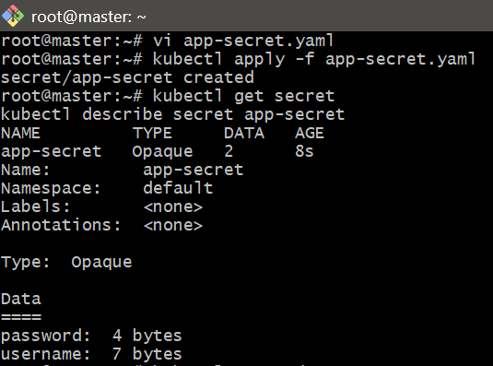

Step 2: Create Pod YAML
vi secret-volume-pod.yaml
Paste:
apiVersion: v1
kind: Pod
metadata:
name: secret-volume-pod
spec:
containers:
- name: nginx
image: nginx
volumeMounts:
- name: secret-volume
mountPath: /etc/secret-data
readOnly: true
volumes:
- name: secret-volume
secret:
secretName: app-secret
Save and apply:
kubectl apply -f secret-volume-pod.yaml
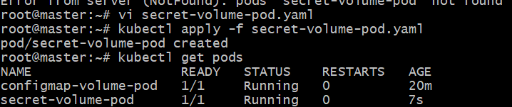

Step 3: Check Pod
kubectl get pods
Wait until:
secret-volume-pod 1/1 Running
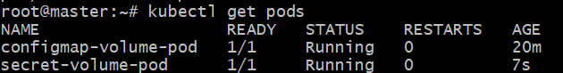

Step 4: Verify files inside Pod
kubectl exec -it secret-volume-pod -- ls /etc/secret-data
Output:
Step 5: Check Secret values
kubectl exec -it secret-volume-pod -- cat /etc/secret-data/username
Output:
abhinay
kubectl exec -it secret-volume-pod -- cat /etc/secret-data/password
Output:
Abhi
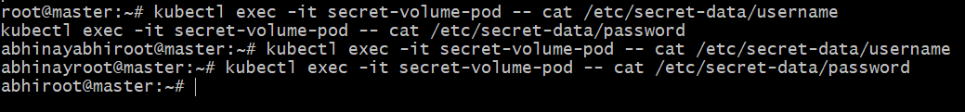

- Inject a ConfigMap as environment variables and a Secret as files into the same pod, ensuring both are accessible within the pod.

Step 1: Create ConfigMap
kubectl create configmap app-config \
--from-literal=APP_ENV=dev \
--from-literal=DB_HOST=mysql-service
Verify:
kubectl get configmap
kubectl describe configmap app-config
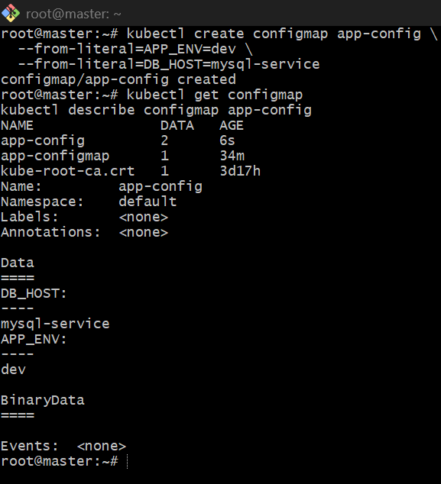

Step 2: Create Secret
kubectl create secret generic app-secret \
--from-literal=username=admin \
--from-literal=password=12345
Verify:
kubectl get secret
kubectl describe secret app-secret
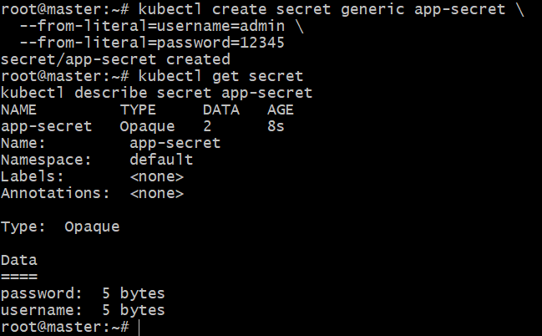

Step 3: Create Pod YAML
vi configmap-secret-pod.yaml
Paste:
apiVersion: v1
kind: Pod
metadata:
name: configmap-secret-pod
spec:
containers:
- name: nginx
image: nginx
envFrom:
- configMapRef:
name: app-config
volumeMounts:
- name: secret-volume
mountPath: /etc/secret-data
readOnly: true
volumes:
- name: secret-volume
secret:
secretName: app-secret
Apply:
kubectl apply -f configmap-secret-pod.yaml
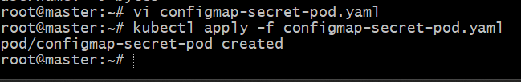

Step 4: Check Pod
kubectl get pods
Wait until:
configmap-secret-pod 1/1 Running
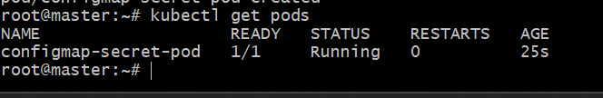

Step 5: Verify ConfigMap environment variables
kubectl exec -it configmap-secret-pod -- env | grep APP_ENV
kubectl exec -it configmap-secret-pod -- env | grep DB_HOST
Output:
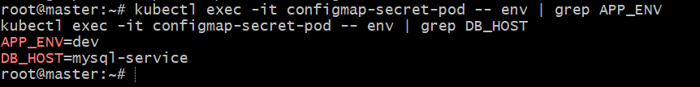
Step 6: Verify Secret files
kubectl exec -it configmap-secret-pod -- ls /etc/secret-data
Output:
password
username
Check values:
kubectl exec -it configmap-secret-pod -- cat /etc/secret-data/username
kubectl exec -it configmap-secret-pod -- cat /etc/secret-data/password
Output:
admin
12345

