Task 1: Execute all yaml files shown in video.
1. Check nodes
kubectl get nodes
Assume your nodes are:
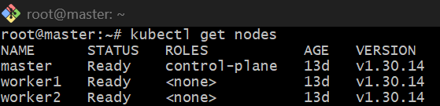
2. Add label to node
kubectl label node worker1 env=prod
kubectl label node worker2 env=test
kubectl get nodes --show-labels
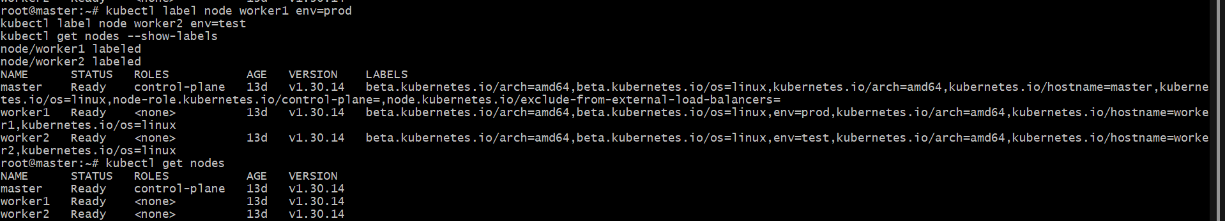
3. NodeSelector YAML
Create file:
vi nodeselector-pod.yaml
Paste:
apiVersion: v1
kind: Pod
metadata:
name: nodeselector-pod
spec:
containers:
- name: nginx
image: nginx
nodeSelector:
env: prod
Apply:
kubectl apply -f nodeselector-pod.yaml
kubectl get pods -o wide
This pod should run on worker1.
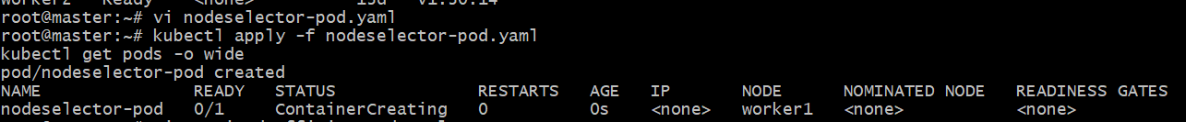
4. Preferred Node Affinity YAML
Create file:
vi preferred-affinity-pod.yaml
Paste:
apiVersion: v1
kind: Pod
metadata:
name: preferred-affinity-pod
spec:
containers:
- name: nginx
image: nginx
affinity:
nodeAffinity:
preferredDuringSchedulingIgnoredDuringExecution:
- weight: 1
preference:
matchExpressions:
- key: env
operator: In
values:
- test
Apply:
kubectl apply -f preferred-affinity-pod.yaml
kubectl get pods -o wide
This pod prefers worker2, but if not available, it can run on another node.

5. Required Node Affinity YAML
Create file:
vi required-affinity-pod.yaml
Paste:
apiVersion: v1
kind: Pod
metadata:
name: required-affinity-pod
spec:
containers:
- name: nginx
image: nginx
affinity:
nodeAffinity:
requiredDuringSchedulingIgnoredDuringExecution:
nodeSelectorTerms:
- matchExpressions:
- key: env
operator: In
values:
- test
Apply:
kubectl apply -f required-affinity-pod.yaml
kubectl get pods -o wide
This pod must run only on a node with env=test.
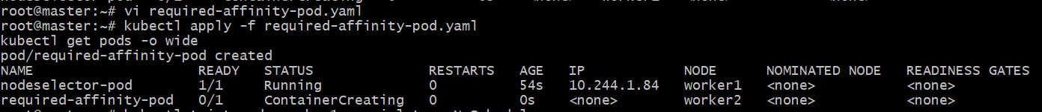
6. Taint node
kubectl taint node worker1 special=true:NoSchedule
kubectl describe node worker1 | grep -i taint
7. Pod without toleration
vi no-toleration-pod.yaml
apiVersion: v1
kind: Pod
metadata:
name: no-toleration-pod
spec:
containers:
- name: nginx
image: nginx
nodeSelector:
env: prod
Apply:
kubectl apply -f no-toleration-pod.yaml
kubectl get pods -o wide
kubectl describe pod no-toleration-pod
It may stay Pending because worker1 has a taint.

8. Pod with toleration
vi toleration-pod.yaml
apiVersion: v1
kind: Pod
metadata:
name: toleration-pod
spec:
containers:
- name: nginx
image: nginx
nodeSelector:
env: prod
tolerations:
- key: "special"
operator: "Equal"
value: "true"
effect: "NoSchedule"
Apply:
kubectl apply -f toleration-pod.yaml
kubectl get pods -o wide
Now pod should run on worker1.
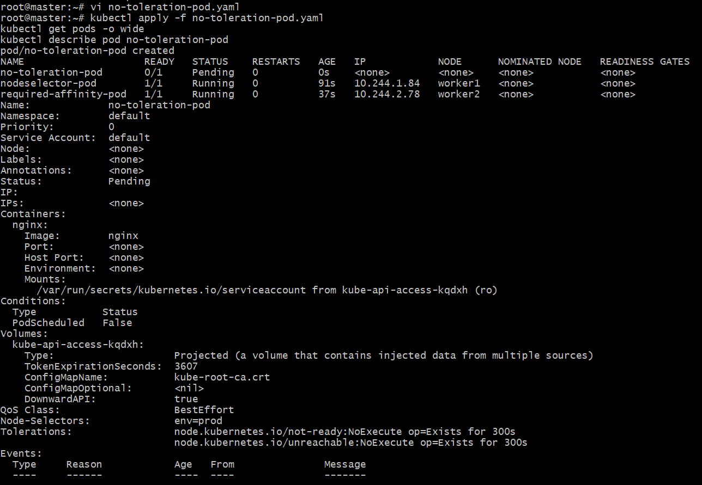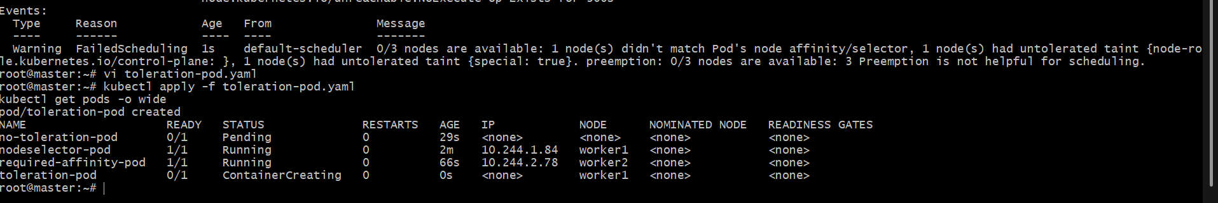
9. Remove taint and labels after task
kubectl taint node worker1 special=true:NoSchedule-
kubectl label node worker1 env-
kubectl label node worker2 env-
10. Delete all task pods
kubectl delete pod nodeselector-pod preferred-affinity-pod required-affinity-pod no-toleration-pod toleration-pod
Final check:
kubectl get pods
kubectl get nodes --show-labels

Task 2: Taint a Node and Schedule a Tolerant Pod Taint a node with special=true:NoSchedule. Create a pod with a toleration that matches the taint, allowing it to be scheduled on the tainted node.
🎯 Task Goal
👉 Taint a node → block pods
👉 Create pod with toleration → allow it

🧱 STEP 1: Check nodes
kubectl get nodes
Assume:
master
worker1
worker2

🧱 STEP 2: Add taint to node
👉 We will taint worker1
kubectl taint node worker1 special=true:NoSchedule
Verify:
kubectl describe node worker1 | grep -i taint
✅ Output should show:
special=true:NoSchedule

🧱 STEP 3: (Optional but recommended) Add label
kubectl label node worker1 env=prod

🧱 STEP 4: Create Pod WITHOUT toleration (to understand)
vi no-toleration.yaml
apiVersion: v1
kind: Pod
metadata:
name: no-toleration-pod
spec:
containers:
- name: nginx
image: nginx
nodeSelector:
env: prod
Apply:
kubectl apply -f no-toleration.yaml
kubectl get pods -o wide
👉 This pod will be Pending ❌
Reason → taint blocks it

🧱 STEP 5: Create Pod WITH toleration (MAIN TASK)
vi toleration-pod.yaml
apiVersion: v1
kind: Pod
metadata:
name: toleration-pod
spec:
containers:
- name: nginx
image: nginx
nodeSelector:
env: prod
tolerations:
- key: "special"
operator: "Equal"
value: "true"
effect: "NoSchedule"

🧱 STEP 6: Apply YAML
kubectl apply -f toleration-pod.yaml
Check:
kubectl get pods -o wide
✅ Expected:
toleration-pod Running worker1

🔍 STEP 7: Verify
kubectl describe pod toleration-pod
Check:
- Node → worker1 ✅
- Toleration applied ✅
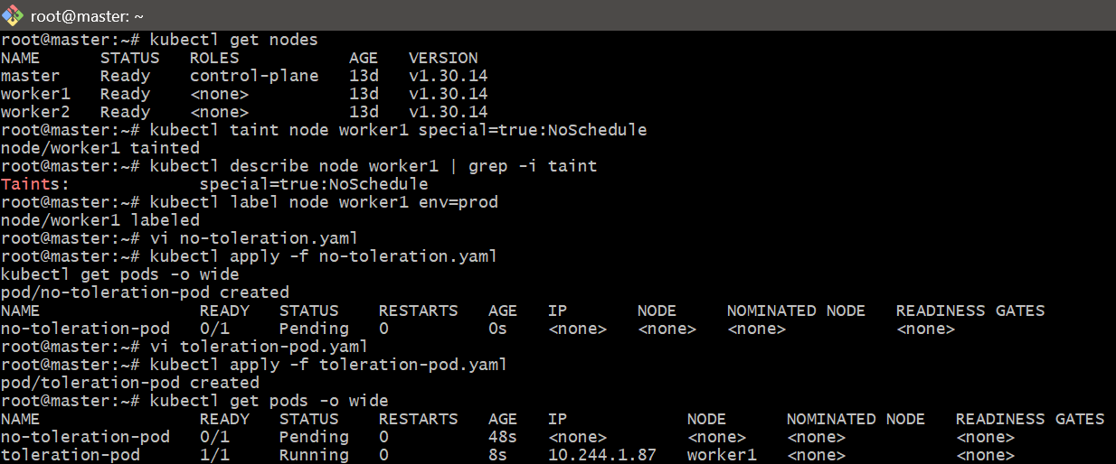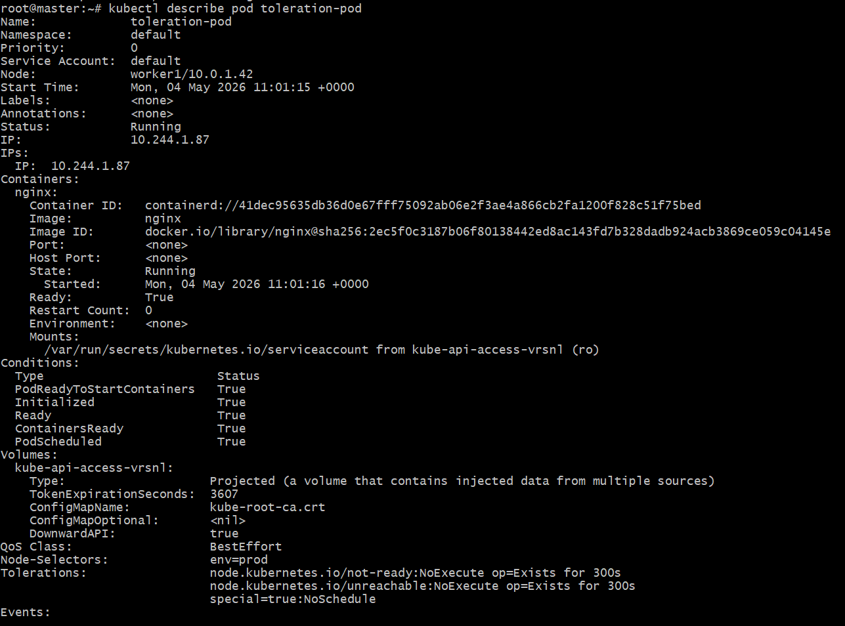

Task 3: Use NodeSelector to Schedule a Pod on a Specific Node Label a node with env=dev. Create a pod with a nodeSelector that schedules it only on the node labeled env=dev.

🎯 Task Goal
👉 Label a node → env=dev
👉 Create pod → should run only on that node

🧱 STEP 1: Check nodes
kubectl get nodes
Example:
master
worker1
worker2

🧱 STEP 2: Add label to node
👉 We will label worker2 as env=dev
kubectl label node worker2 env=dev
Verify:
kubectl get nodes --show-labels
✅ You should see:
worker2 ... env=dev

🧱 STEP 3: Create NodeSelector Pod YAML
vi nodeselector-dev.yaml
Paste this:
apiVersion: v1
kind: Pod
metadata:
name: dev-pod
spec:
containers:
- name: nginx
image: nginx
nodeSelector:
env: dev

🧱 STEP 4: Apply YAML
kubectl apply -f nodeselector-dev.yaml

🧱 STEP 5: Verify
kubectl get pods -o wide
✅ Expected output:
dev-pod Running worker2

🔍 STEP 6: Double verification
kubectl describe pod dev-pod
Check:
- Node → worker2 ✅
- NodeSelector → env=dev ✅
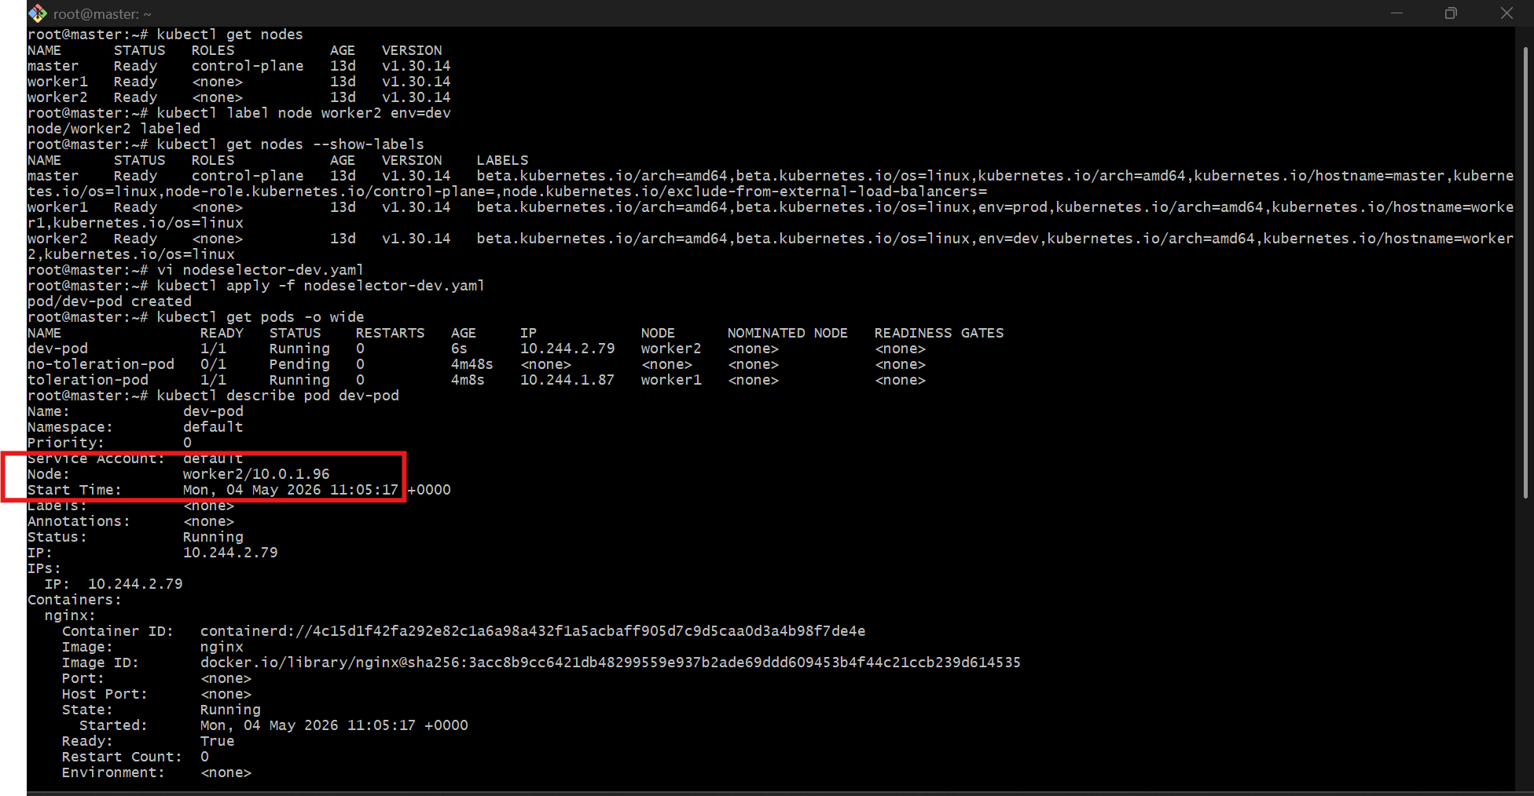

Task 4: Use Node Affinity with Soft Scheduling Label a node with env=test. Create a pod with PreferredDuringSchedulingIgnoredDuringExecution node affinity, preferring to schedule it on a node labeled env=test. Remove the label and verify the pod continues to run.

STEP 1: Label worker node
kubectl label node worker2 env=test
Verify:
kubectl get nodes --show-labels

STEP 2: Create YAML file
vi preferred-affinity-test.yaml
Paste:
apiVersion: v1
kind: Pod
metadata:
name: soft-affinity-pod
spec:
containers:
- name: nginx
image: nginx
affinity:
nodeAffinity:
preferredDuringSchedulingIgnoredDuringExecution:
- weight: 100
preference:
matchExpressions:
- key: env
operator: In
values:
- test

STEP 3: Apply YAML
kubectl apply -f preferred-affinity-test.yaml
Check pod:
kubectl get pods -o wide
Expected:
soft-affinity-pod Running worker2
Because worker2 has env=test.

STEP 4: Remove label
kubectl label node worker2 env-
Verify label removed:
kubectl get nodes --show-labels

STEP 5: Verify pod still running
kubectl get pods -o wide

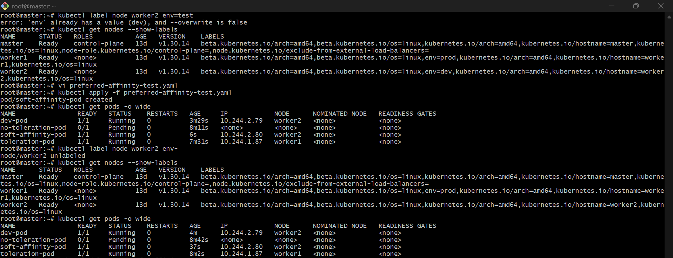
Task 5: Implement Node Affinity with Hard Scheduling Create a pod with RequiredDuringSchedulingIgnoredDuringExecution node affinity, ensuring it will only be scheduled on a node labeled env=prod. Verify the pod cannot be scheduled if no node has the env=prod label.

🎯 Task Goal
👉 Pod should run ONLY on node with env=prod
👉 If no node has that label → Pod should NOT schedule (Pending)

🧱 STEP 1: Make sure NO node has label (IMPORTANT)
kubectl get nodes --show-labels
👉 If you see env=prod, remove it:
kubectl label node worker1 env-
kubectl label node worker2 env-

🧱 STEP 2: Create YAML (Hard Affinity)
vi required-affinity.yaml
Paste:
apiVersion: v1
kind: Pod
metadata:
name: hard-affinity-pod
spec:
containers:
- name: nginx
image: nginx
affinity:
nodeAffinity:
requiredDuringSchedulingIgnoredDuringExecution:
nodeSelectorTerms:
- matchExpressions:
- key: env
operator: In
values:
- prod

🧱 STEP 3: Apply YAML
kubectl apply -f required-affinity.yaml

🧱 STEP 4: Verify (IMPORTANT)
kubectl get pods
👉 Expected:
hard-affinity-pod Pending

🔍 STEP 5: Check reason
kubectl describe pod hard-affinity-pod
👉 You will see:
0/3 nodes are available:
node(s) didn't match Pod's node affinity
✅ This proves:
👉 Hard affinity is strictly enforced

🧱 STEP 6: Now add label (to allow scheduling)
kubectl label node worker1 env=prod

🧱 STEP 7: Verify again
kubectl get pods -o wide
👉 Expected:
hard-affinity-pod Running worker1
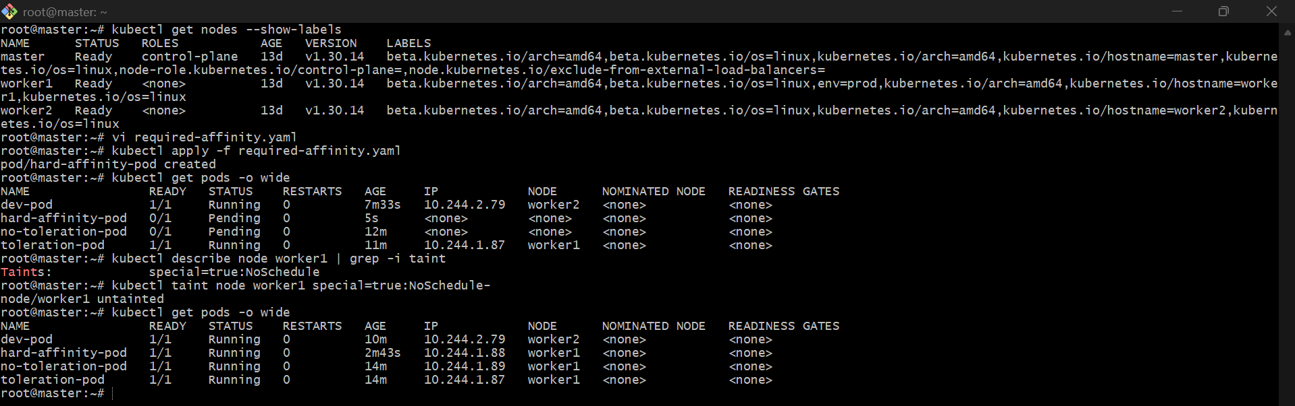

Task 6: Taint a Node and Use NoExecute with Toleration Seconds Taint a node with special=true:NoExecute. Create a pod with a tolerationSeconds field (e.g., 60 seconds) and observe it gets evicted after 60 seconds on the tainted node.

Step 1: Label worker1
kubectl label node worker1 env=noexecute --overwrite
Step 2: Create pod with 60 seconds toleration
vi noexecute-pod.yaml
Paste:
apiVersion: v1
kind: Pod
metadata:
name: noexecute-pod
spec:
nodeSelector:
env: noexecute
containers:
- name: nginx
image: nginx
tolerations:
- key: "special"
operator: "Equal"
value: "true"
effect: "NoExecute"
tolerationSeconds: 60
Apply:
kubectl apply -f noexecute-pod.yaml
Check pod:
kubectl get pods -o wide
Step 3: Taint worker1 with NoExecute
kubectl taint node worker1 special=true:NoExecute
Now watch pod:
kubectl get pods -w
Expected:
noexecute-pod Running
After around 60 seconds:
noexecute-pod Terminating
Then it will disappear.
Step 4: Verify eviction
kubectl get pods
You should not see noexecute-pod.
