- Create and Test a Kubernetes Pod with an EmptyDir Volume
Task: Create and Test a Kubernetes Pod with an EmptyDir Volume

🔹 What is emptyDir (Simple Understanding)
- emptyDir is a temporary storage volume
- Created when Pod starts
- Deleted when Pod is deleted
- Used to share data between containers in same Pod

🧩 Step 1: Create YAML File
Open file:
vi emptydir-pod.yaml
Paste this YAML:
apiVersion: v1
kind: Pod
metadata:
name: emptydir-pod
spec:
containers:
- name: container1
image: nginx
volumeMounts:
- name: shared-data
mountPath: /usr/share/nginx/html
- name: container2
image: busybox
command: ["/bin/sh", "-c"]
args:
- while true; do
echo "Hello from Container2" > /data/index.html;
sleep 5;
done
volumeMounts:
- name: shared-data
mountPath: /data
volumes:
- name: shared-data
emptyDir: {}
👉 Important Understanding
- container2 writes data
- container1 (nginx) serves that data
- Both share same emptyDir volume

🚀 Step 2: Apply the YAML
kubectl apply -f emptydir-pod.yaml

🔍 Step 3: Verify Pod
kubectl get pods
Check details:
kubectl describe pod emptydir-pod

🔧 Step 4: Test the Volume (VERY IMPORTANT)
👉 Check inside container2 (writer)
kubectl exec -it emptydir-pod -c container2 -- sh
Then:
cat /data/index.html
You should see:
Hello from Container2

👉 Check inside container1 (nginx)
kubectl exec -it emptydir-pod -c container1 -- sh
Then:
cat /usr/share/nginx/html/index.html
✅ Same output should appear → means volume is shared

🌐 Step 5: Test in Browser (Optional but Best)
Port forward:
kubectl port-forward emptydir-pod 8080:80
Open browser:
http://localhost:8080
👉 You will see:
Hello from Container2

🧹 Step 6: Cleanup
kubectl delete pod emptydir-pod
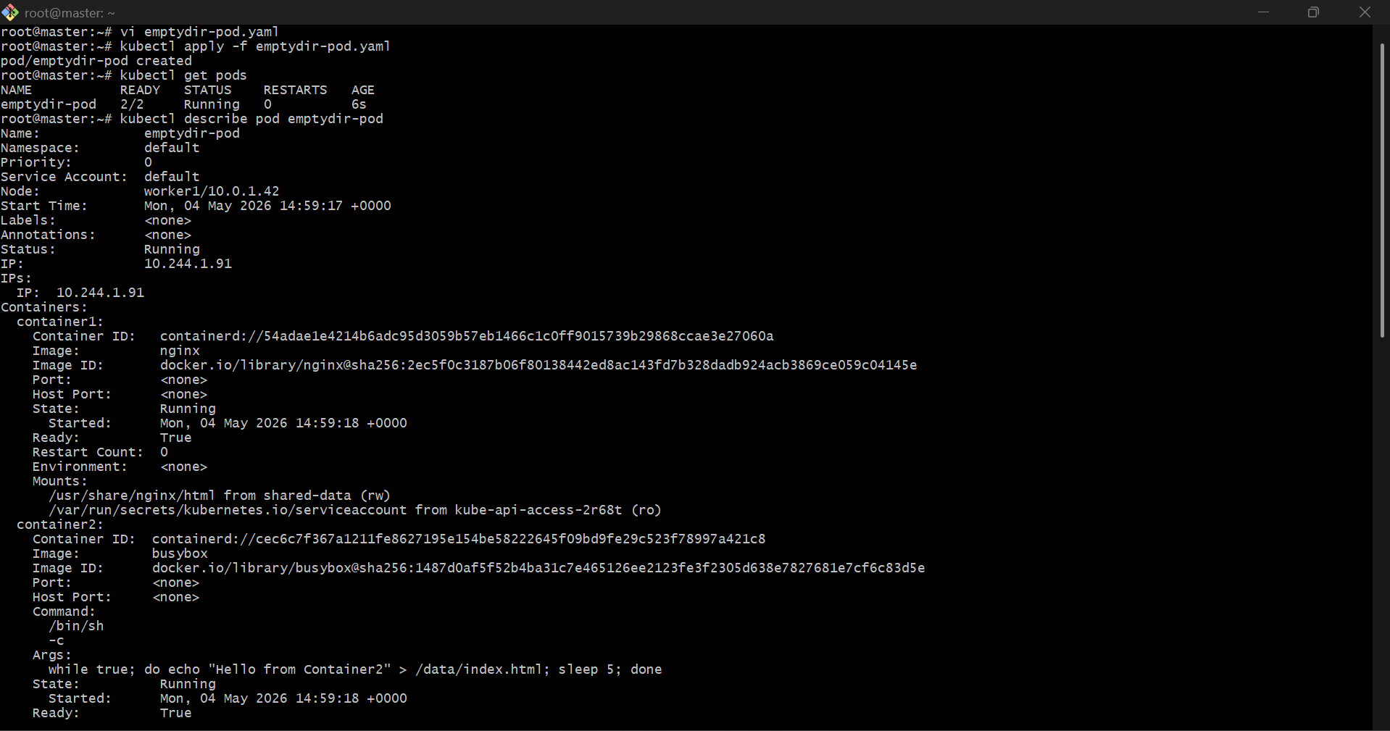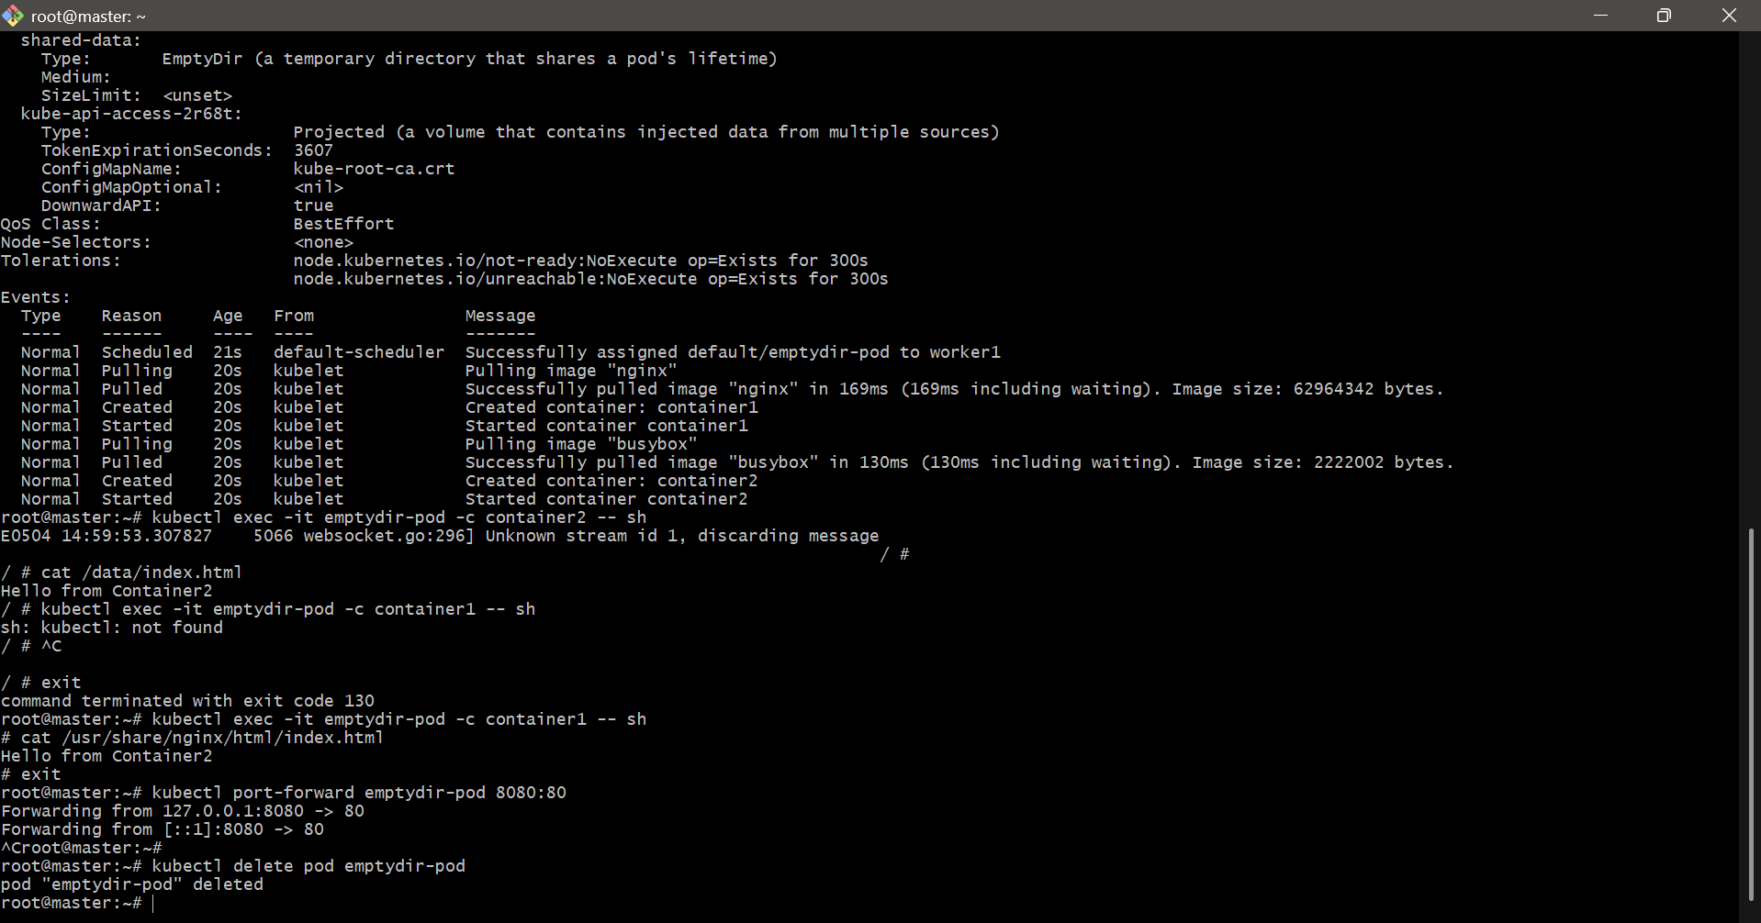

- Configure a HostPath Volume in Kubernetes and Validate Data Persistence

What is hostPath?
hostPath mounts a directory from the worker node filesystem into the Pod.
So data is stored on the Node, not only inside the Pod.

Step 1: Create Directory on Worker Node
First check where your Pod will run:
kubectl get nodes
Create folder on worker node:
mkdir -p /mnt/hostpath-data
chmod 777 /mnt/hostpath-data

Step 2: Create YAML File
vi hostpath-pod.yaml
Paste this:
apiVersion: v1
kind: Pod
metadata:
name: hostpath-pod
spec:
nodeName: worker1
containers:
- name: nginx-container
image: nginx
volumeMounts:
- name: host-volume
mountPath: /usr/share/nginx/html
volumes:
- name: host-volume
hostPath:
path: /mnt/hostpath-data
type: DirectoryOrCreate
If your worker node name is different, replace worker1.

Step 3: Apply YAML
kubectl apply -f hostpath-pod.yaml
Check Pod:
kubectl get pods -o wide

Step 4: Add Data Inside Pod
kubectl exec -it hostpath-pod -- bash
Inside Pod:
echo "Hello from HostPath Volume" > /usr/share/nginx/html/index.html
cat /usr/share/nginx/html/index.html
exit

Step 5: Validate Data on Worker Node
Go to worker1 server and run:
cat /mnt/hostpath-data/index.html
Output:
Hello from HostPath Volume

Step 6: Delete Pod and Recreate
kubectl delete pod hostpath-pod
kubectl apply -f hostpath-pod.yaml
Check again:
kubectl exec -it hostpath-pod -- cat /usr/share/nginx/html/index.html
Output should still be:
Hello from HostPath Volume
✅ This proves data persistence because data stayed on the worker node.

Cleanup
kubectl delete pod hostpath-pod
On worker node:
rm -rf /mnt/hostpath-data

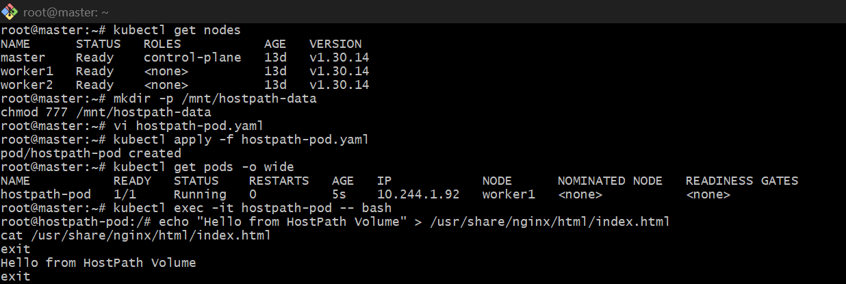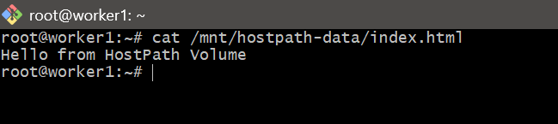

- Deploy an Amazon EBS Volume Using Persistent Volume and Persistent Volume Claim (PVC)

Important point
EBS volume and Kubernetes worker node must be in the same Availability Zone.
Check pod worker node:
kubectl get nodes -o wide
Assume pod runs on worker1.

Step 1: Create EBS Volume in AWS
In AWS Console:
EC2 → Volumes → Create Volume
Use:
Size: 5 GiB
Type: gp3
Availability Zone: same as worker node
After creating, copy the Volume ID:
vol-xxxxxxxxxxxxxxxxx

Step 2: Create Persistent Volume
vi ebs-pv.yaml
Paste:
apiVersion: v1
kind: PersistentVolume
metadata:
name: ebs-pv
spec:
capacity:
storage: 5Gi
accessModes:
- ReadWriteOnce
persistentVolumeReclaimPolicy: Retain
awsElasticBlockStore:
volumeID: vol-xxxxxxxxxxxxxxxxx
fsType: ext4
Replace:
vol-xxxxxxxxxxxxxxxxx
with your real EBS volume ID.
Apply:
kubectl apply -f ebs-pv.yaml
Check:
kubectl get pv

Step 3: Create Persistent Volume Claim
vi ebs-pvc.yaml
Paste:
apiVersion: v1
kind: PersistentVolumeClaim
metadata:
name: ebs-pvc
spec:
accessModes:
- ReadWriteOnce
resources:
requests:
storage: 5Gi
Apply:
kubectl apply -f ebs-pvc.yaml
Check:
kubectl get pvc
Expected:
ebs-pvc Bound

Step 4: Create Pod Using PVC
vi ebs-pod.yaml
Paste:
apiVersion: v1
kind: Pod
metadata:
name: ebs-pod
spec:
containers:
- name: app
image: nginx
volumeMounts:
- name: ebs-storage
mountPath: /usr/share/nginx/html
volumes:
- name: ebs-storage
persistentVolumeClaim:
claimName: ebs-pvc
Apply:
kubectl apply -f ebs-pod.yaml
Check:
kubectl get pods

Step 5: Verify Volume Inside Pod
kubectl exec -it ebs-pod -- /bin/bash
Inside pod:
echo "Hello from EBS Volume" > /usr/share/nginx/html/index.html
cat /usr/share/nginx/html/index.html
exit

Step 6: Test Persistence
Delete pod:
kubectl delete pod ebs-pod
Create pod again:
kubectl apply -f ebs-pod.yaml
Check data:
kubectl exec -it ebs-pod -- cat /usr/share/nginx/html/index.html
Expected output:
Hello from EBS Volume
That means your EBS volume is working with PV and PVC.

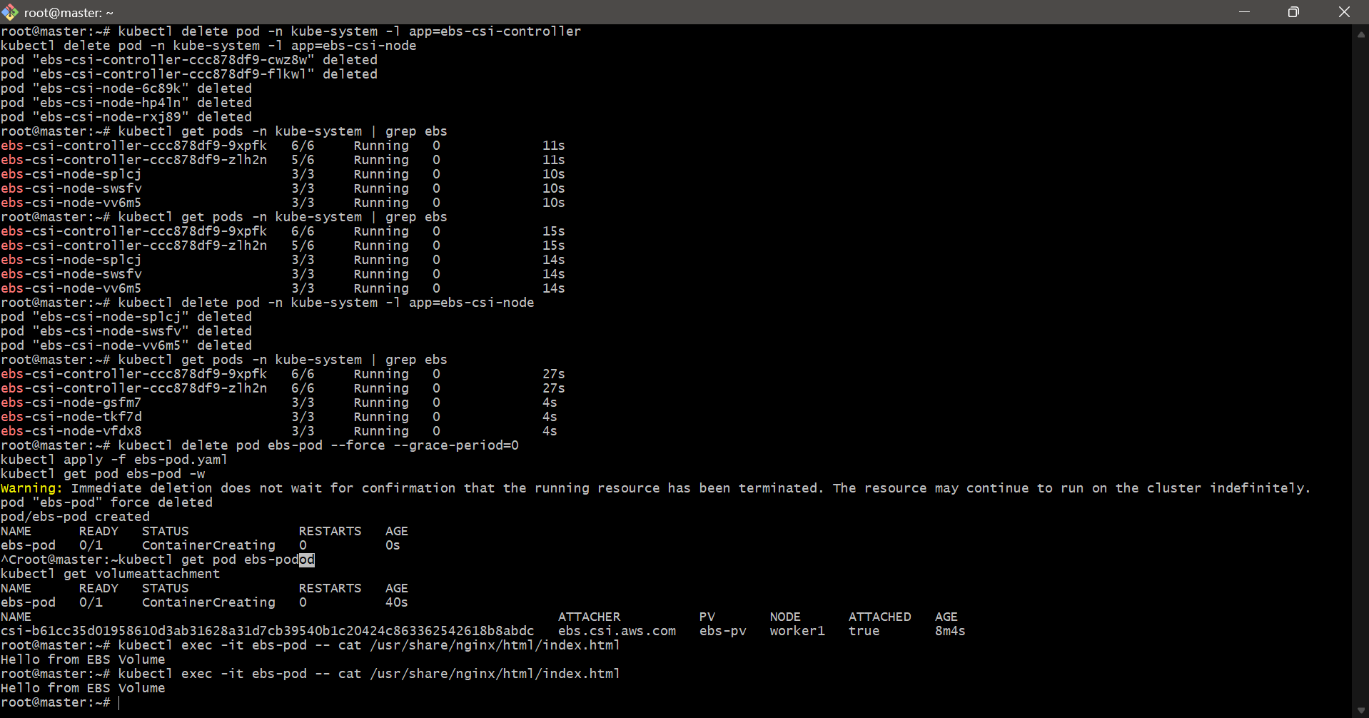

- Set Up an Amazon EFS Volume and Attach it to Multiple Pods

1. Create multi-pod YAML
vi efs-multi-pod.yaml
Paste this:
apiVersion: v1
kind: Pod
metadata:
name: efs-pod-1
spec:
containers:
- name: app
image: nginx
volumeMounts:
- name: efs-storage
mountPath: /usr/share/nginx/html
volumes:
- name: efs-storage
persistentVolumeClaim:
claimName: efs-pvc
---
apiVersion: v1
kind: Pod
metadata:
name: efs-pod-2
spec:
containers:
- name: app
image: nginx
volumeMounts:
- name: efs-storage
mountPath: /usr/share/nginx/html
volumes:
- name: efs-storage
persistentVolumeClaim:
claimName: efs-pvc
2. Apply the file
kubectl apply -f efs-multi-pod.yaml
kubectl get pods
3. Test shared EFS storage
Write from first pod:
kubectl exec -it efs-pod-1 -- bash
echo "Hello from Pod 1 using EFS" > /usr/share/nginx/html/index.html
exit
Read from second pod:
kubectl exec -it efs-pod-2 -- bash
cat /usr/share/nginx/html/index.html
exit
Expected output:
Hello from Pod 1 using EFS
4. Final verification
kubectl get pvc
kubectl get pv
kubectl describe pvc efs-pvc
If both pods become Running and Pod 2 can read Pod 1’s file, your task is completed ✅
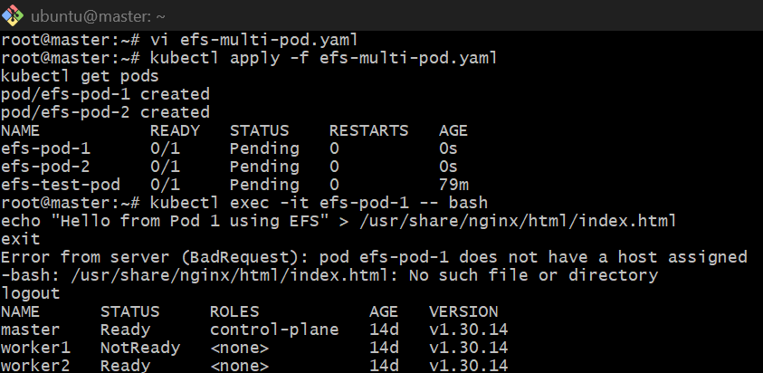
- Implement and Test Liveness and Readiness Probes in a Kubernetes Pod

1. Create YAML file
vi probe-pod.yaml
Paste this:
apiVersion: v1
kind: Pod
metadata:
name: probe-pod
labels:
app: probe-demo
spec:
containers:
- name: app
image: nginx
ports:
- containerPort: 80
readinessProbe:
httpGet:
path: /
port: 80
initialDelaySeconds: 5
periodSeconds: 5
livenessProbe:
httpGet:
path: /
port: 80
initialDelaySeconds: 10
periodSeconds: 10
2. Apply YAML
kubectl apply -f probe-pod.yaml
kubectl get pods
3. Verify probes
kubectl describe pod probe-pod
Check for:
Readiness: http-get http://:80/
Liveness: http-get http://:80/
4. Test readiness/liveness
kubectl exec -it probe-pod -- rm /usr/share/nginx/html/index.html
kubectl get pods
kubectl describe pod probe-pod
Because / fails, readiness may fail.
5. Restore file
kubectl exec -it probe-pod -- sh -c 'echo "Nginx is healthy" > /usr/share/nginx/html/index.html'
kubectl get pods
6. Delete task
kubectl delete -f probe-pod.yaml
