- Configure VPC peering in cross regions. 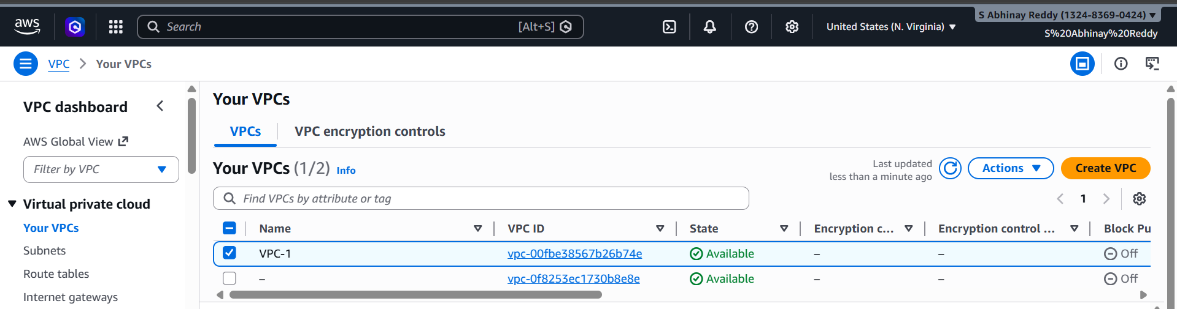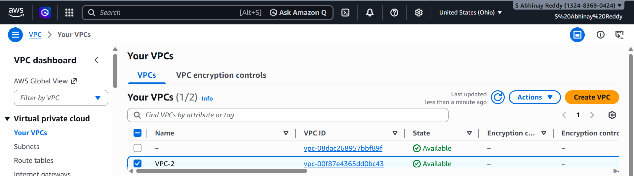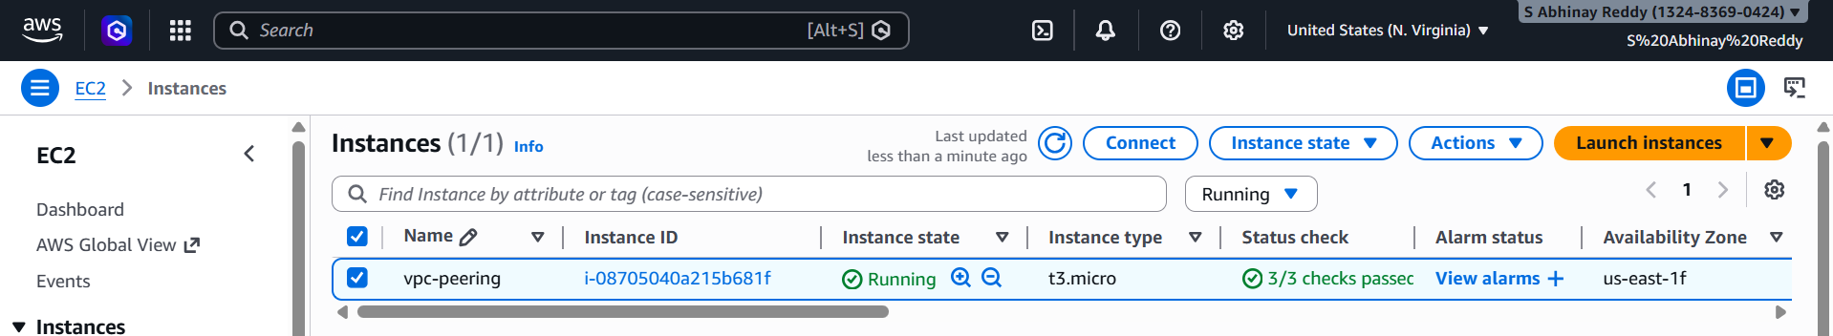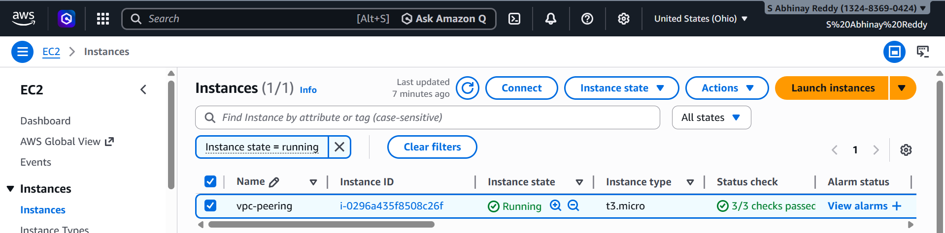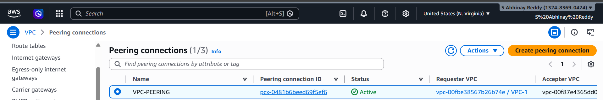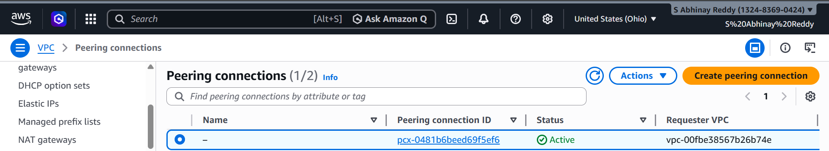
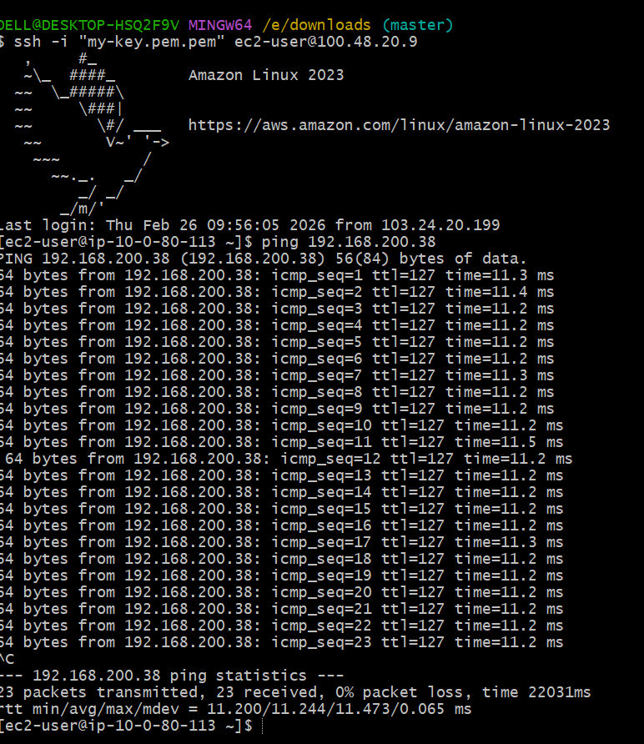
- Purchase one domain from GoDaddy. 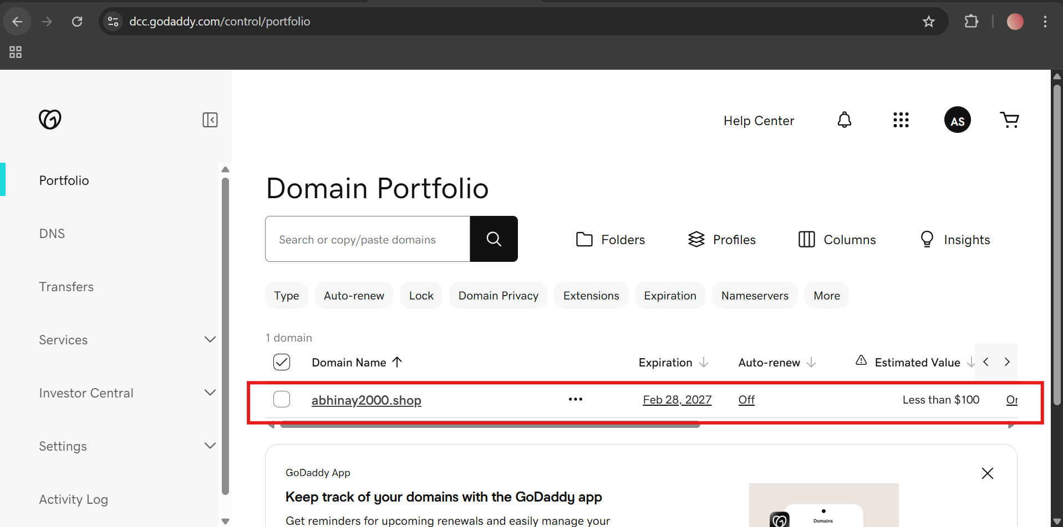

- Deploy static website in S3.
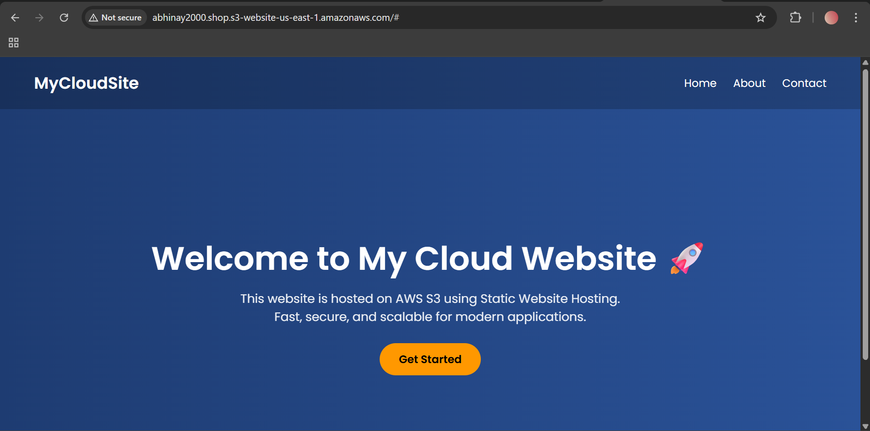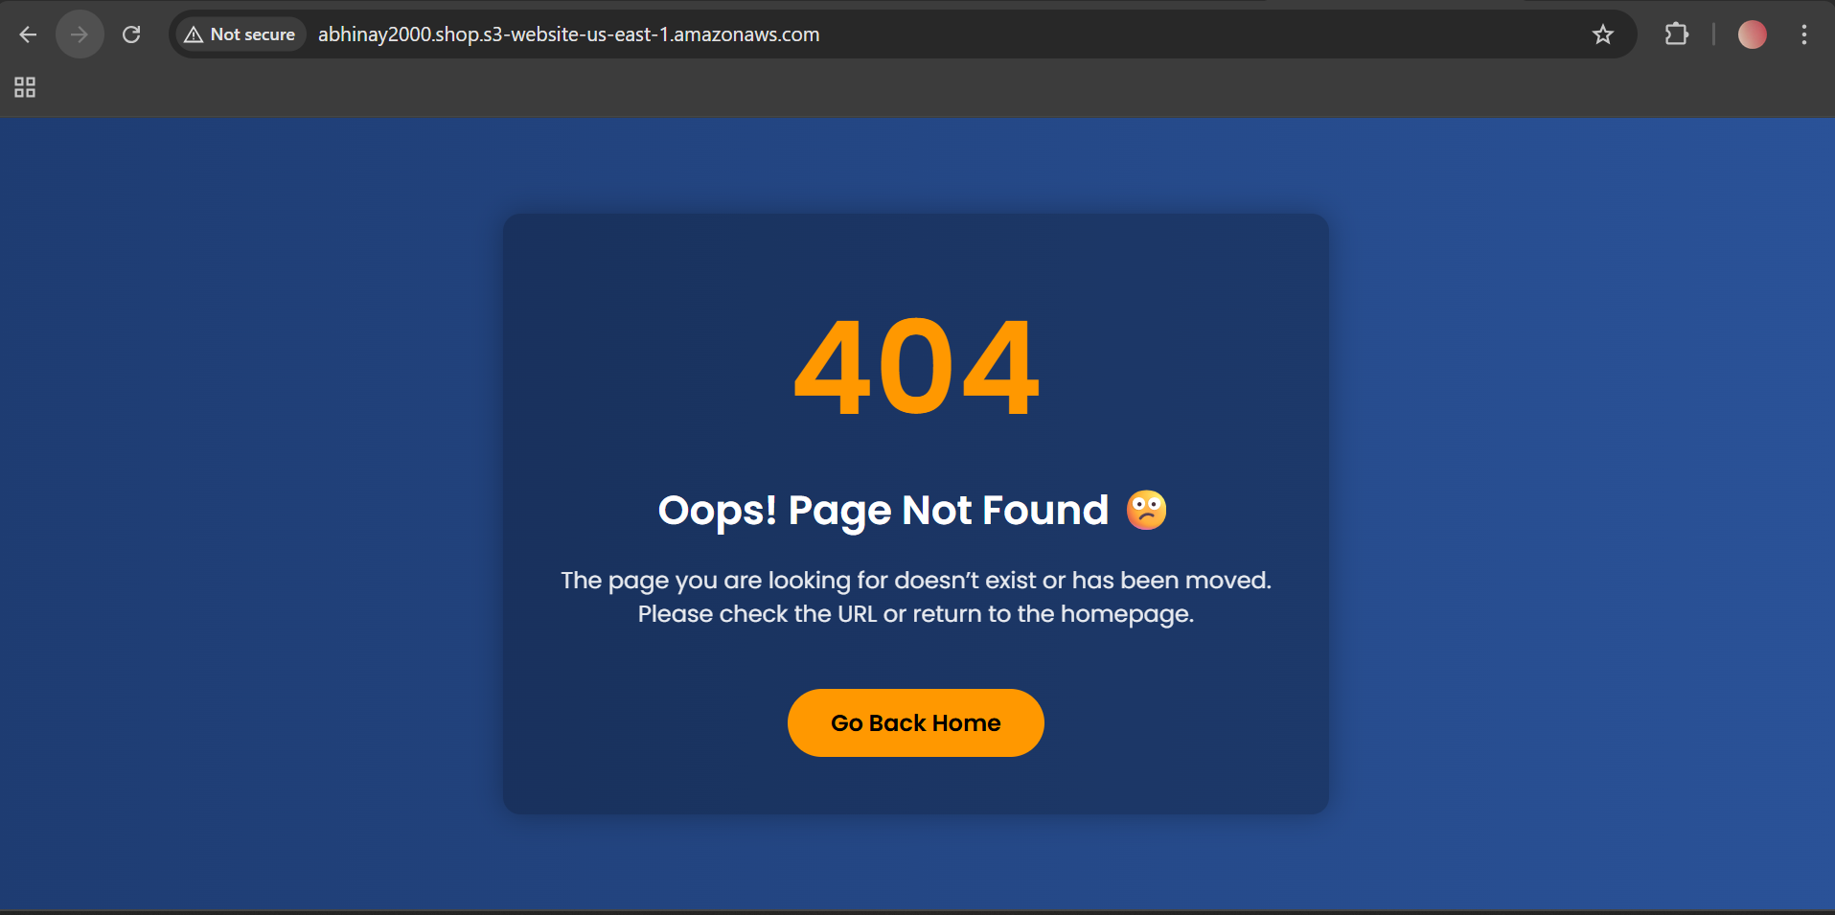

- Create a CDN and attach one SSL certificate.

Step 1: Request SSL Certificate (ACM) 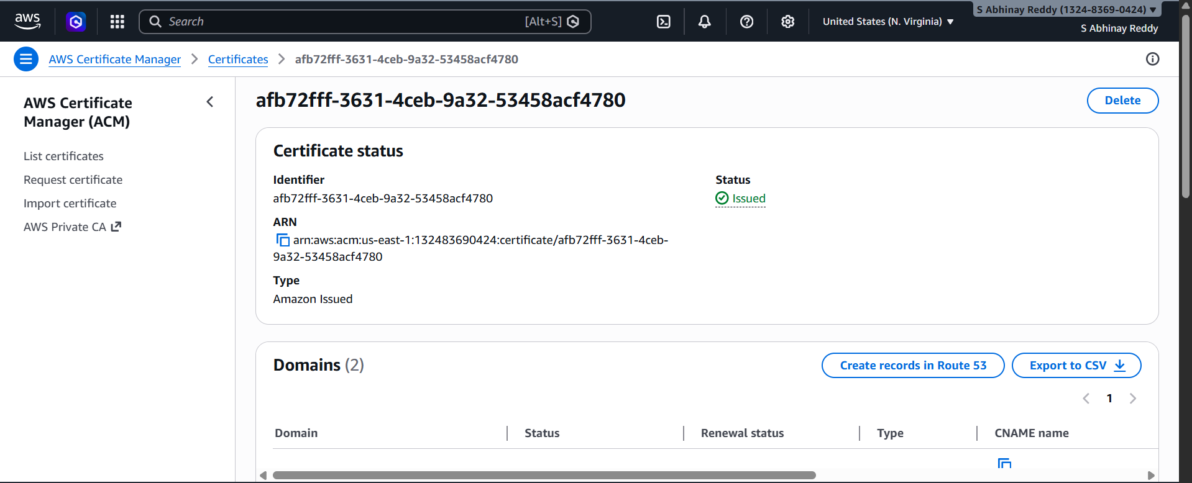
Step 2: Create CloudFront Distribution (CDN)
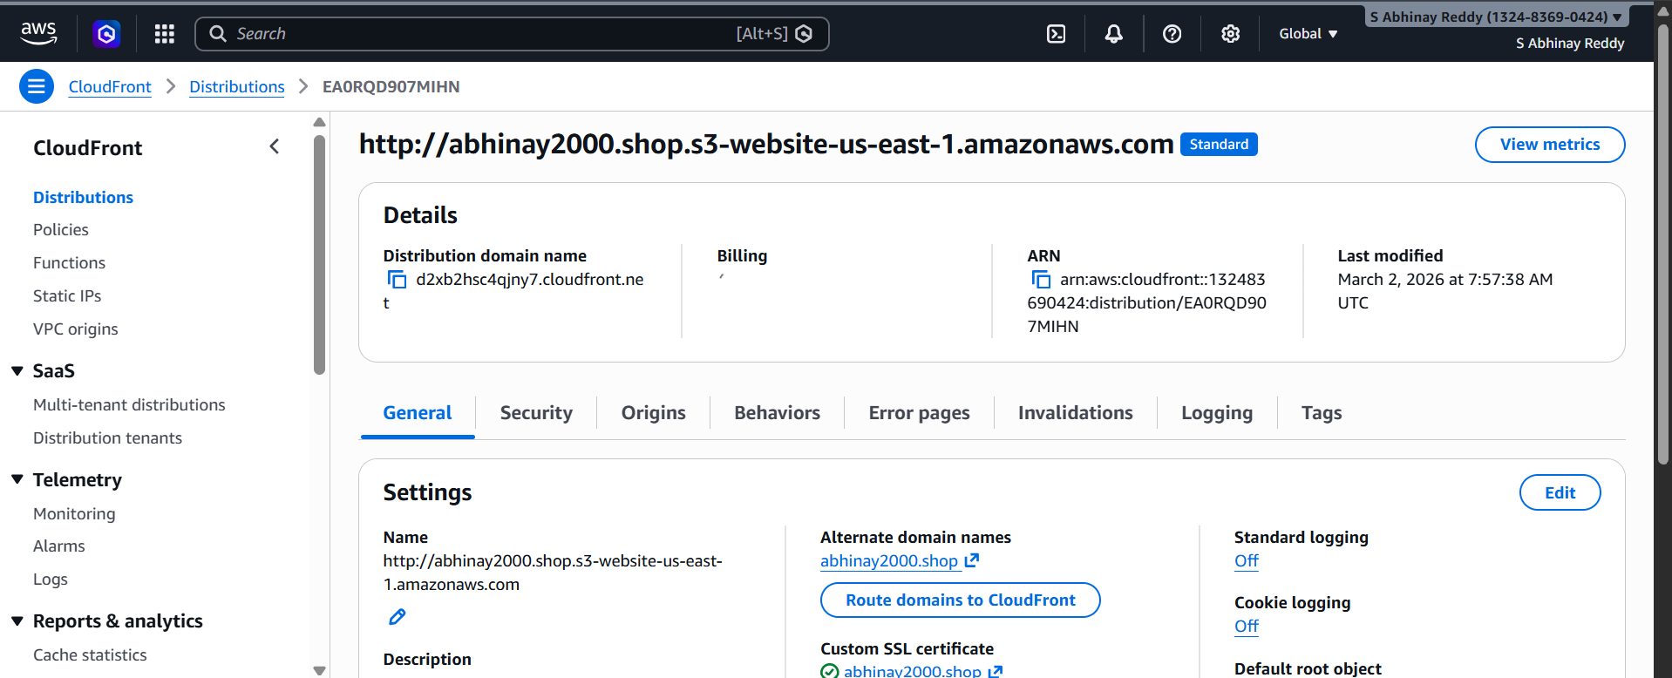Step 3: Connect Domain to CloudFront (DNS) 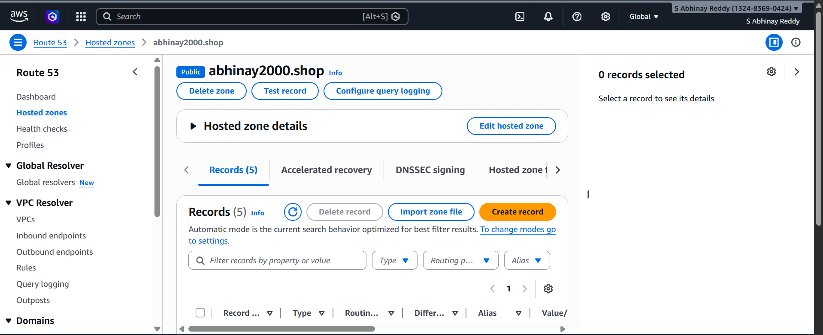
Step 4: Test HTTPS
Open browser
Type:
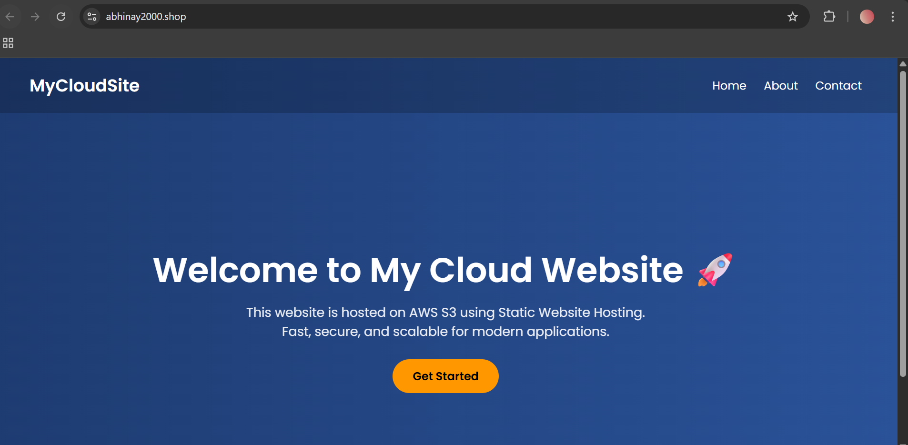 https://abhinay2000.shop

- Create a Route 53 hosted zone and map the domain with the CDN.
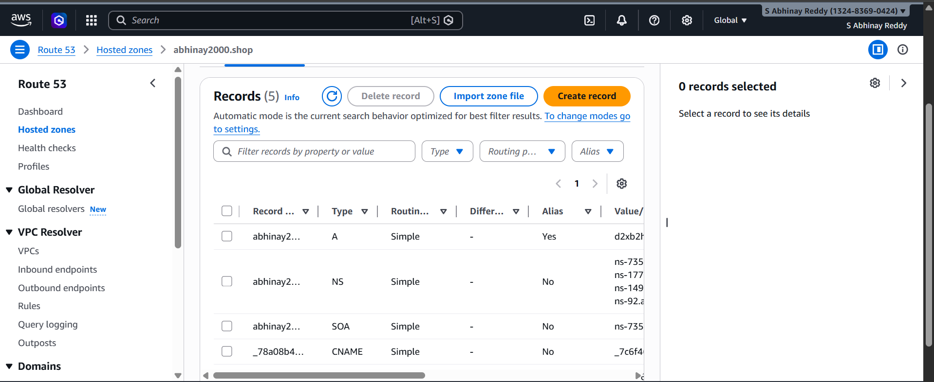
- Update the index.html in the S3 bucket and ensure the updated file is accessible using the domain name. 

- Share the domain name in Slack to test the connectivity.

https://abhinay2000.shop/

