1). Install Terraform on your PC
Task 1: Install Terraform on Your PC (Windows)
Step 1: Download Terraform
Open:
Terraform Download Page
Download:
- Windows AMD64 ZIP

Step 2: Extract ZIP File
After download:
- Go to Downloads
- Right click ZIP
- Click Extract All
- Extract to:
C:\terraform
You should see:
C:\terraform\terraform.exe

Step 3: Add Terraform to Environment Variables
Open Environment Variables
Press:
Windows + R
Type:
sysdm.cpl
Press Enter.

Go To
Advanced → Environment Variables
Under System Variables:
- Select Path
- Click Edit
- Click New
Add:
E:\Downloads\terraform_1.15.2_windows_amd64Click:
- OK
- OK
- OK

Step 4: Verify Terraform Installation
Open:
- PowerShell
OR
- CMD
Run:
terraform version
Expected output:
Terraform v1.x.x

Step 5: Check Terraform Help
Run:
terraform
You will see all Terraform commands.

Important Terraform Commands
Initialize Terraform
terraform init

Check Execution Plan
terraform plan

Apply Changes
terraform apply

Destroy Resources
terraform destroy

Verify Installation Path
Run:
where terraform
Expected:
E:\Downloads\terraform_1.15.2_windows_amd64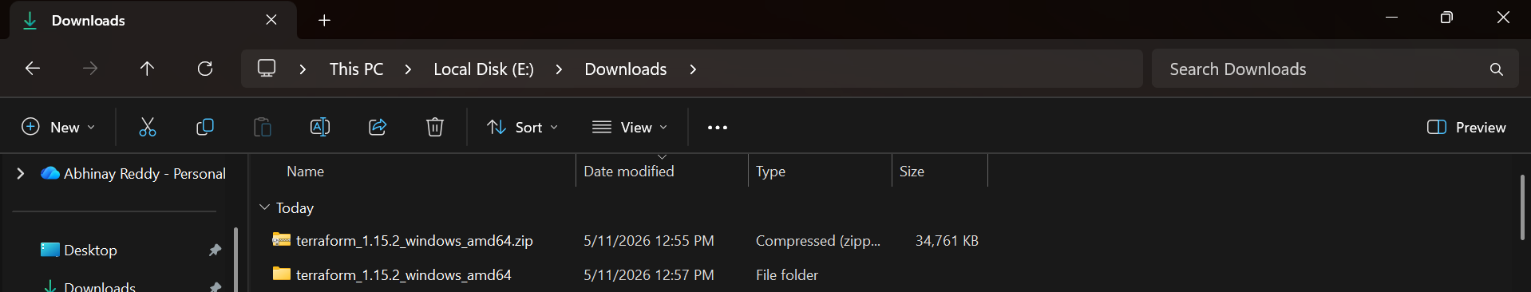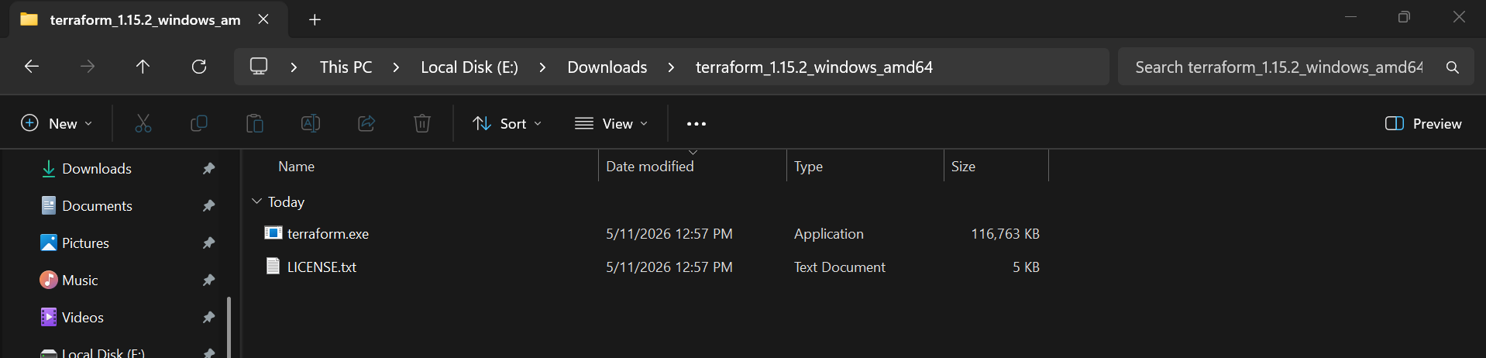
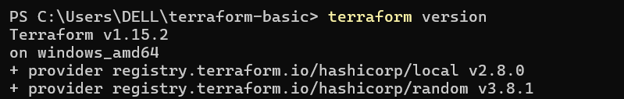

2). Execute all the templates shown in video.
Step 1: Create Project Folder
Run:
mkdir terraform-basic
cd terraform-basic
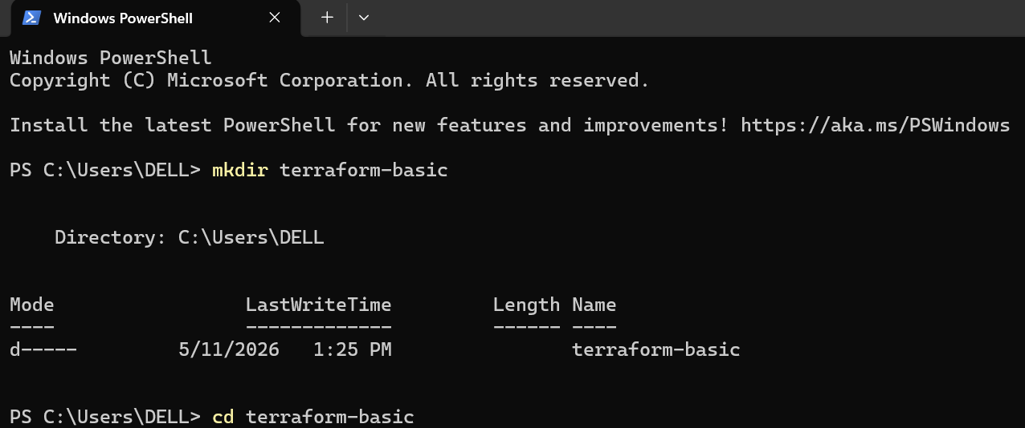

Step 2: Create Terraform File
Run:
notepad main.tf
Click:
Yes
when Notepad asks to create file.

Step 3: Paste This Terraform Code
resource "local_file" "my_pet" {
filename = "pets.txt"
content = "I love Terraform"
}
resource "random_pet" "mypet" {
prefix = "Mr"
separator = "-"
length = 1
}
Save and close Notepad.

Step 4: Initialize Terraform
Run:
terraform init
This downloads providers.
Expected:
Terraform has been successfully initialized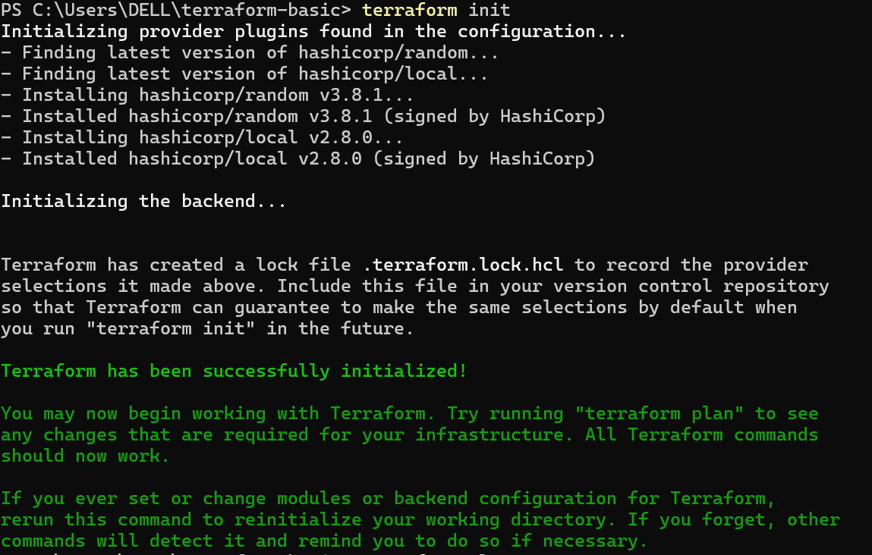

Step 5: Check Terraform Plan
Run:
terraform plan
This shows what Terraform will create.
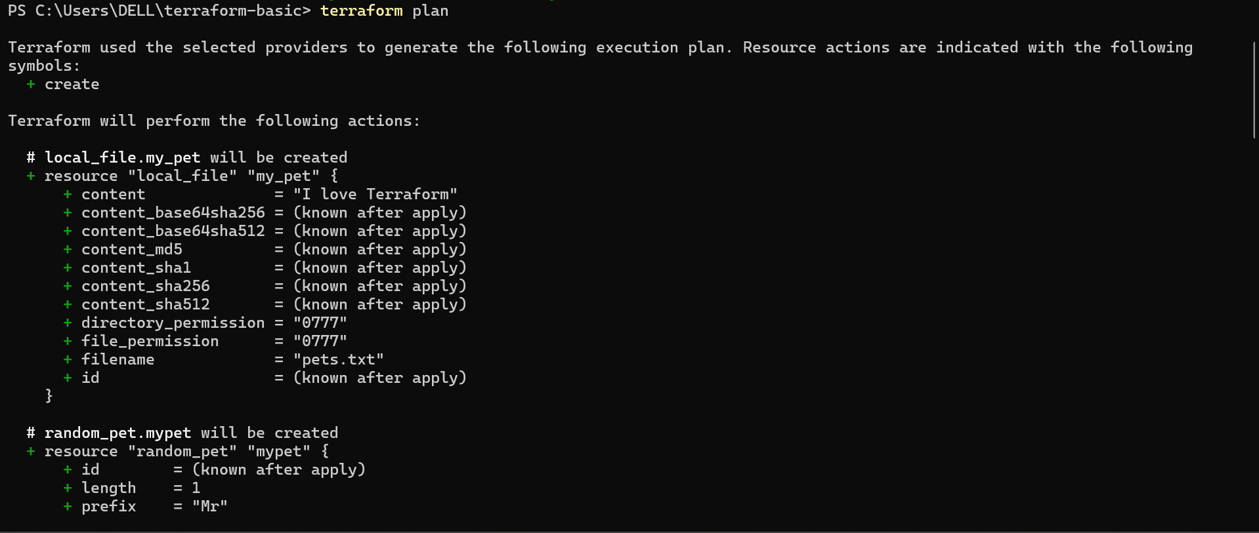

Step 6: Apply Terraform
Run:
terraform apply
Type:
yes
Press Enter.
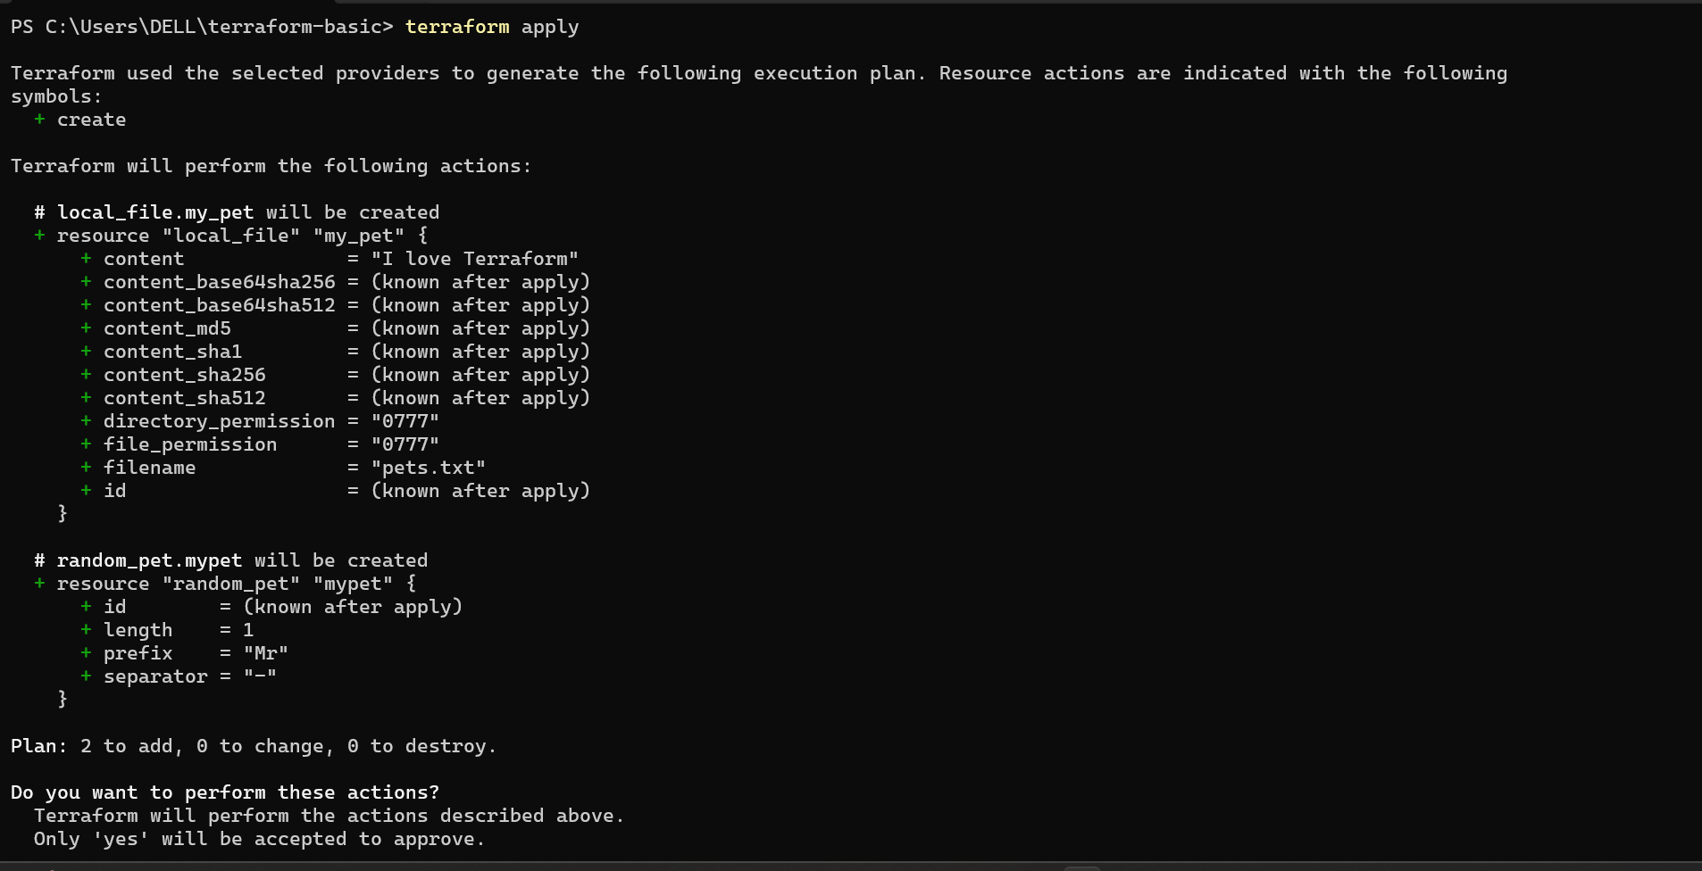

Step 7: Verify Output
Run:
dir
You should see:
pets.txt
terraform.tfstate
Read file:
cat pets.txt
Expected:
I love Terraform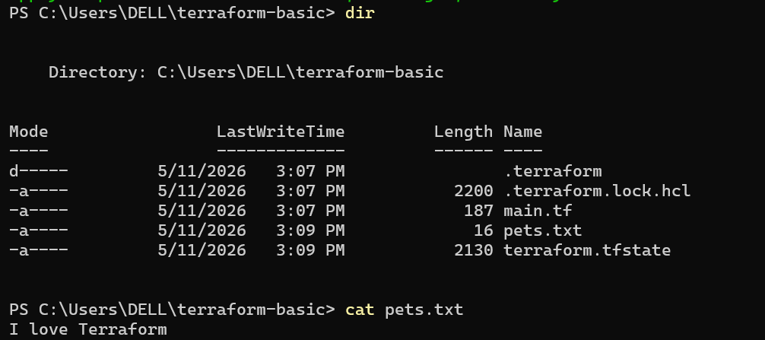

Step 8: Destroy Resources
Run:
terraform destroy
Type:
yes
This removes created resources. 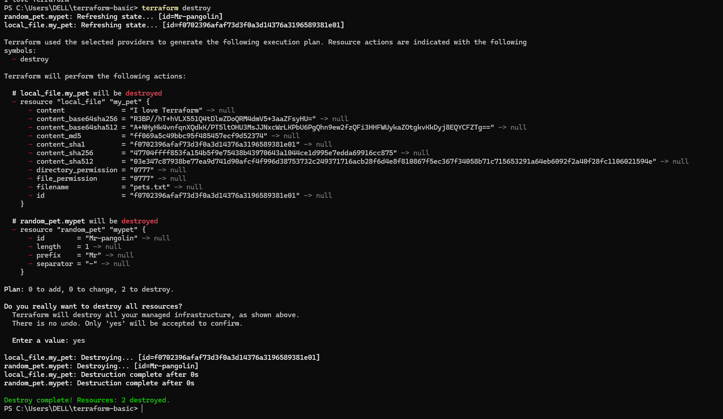

3). Note down below points, Terraform Init, Terraform Plan, Terraform Apply, Terraform Provider.
1. Terraform Init
Command
terraform init

Purpose
terraform init is used to initialize the Terraform working directory.
It prepares Terraform project for execution.

What Happens Internally
When this command runs:
- Downloads required providers
- Creates .terraform directory
- Creates .terraform.lock.hcl
- Initializes backend configuration

Example
terraform init

Expected Output
Terraform has been successfully initialized!

Important Point
This command must be executed first before:
- terraform plan
- terraform apply

2. Terraform Plan
Command
terraform plan

Purpose
terraform plan shows what Terraform is going to do.
It compares:
- Terraform configuration
WITH
- Current infrastructure state

What It Shows
- Resources to be created
- Resources to be modified
- Resources to be destroyed

Important Point
This command does NOT create anything.
It only displays execution preview.

Example Output
Plan: 2 to add, 0 to change, 0 to destroy

3. Terraform Apply
Command
terraform apply

Purpose
terraform apply executes the changes.
It creates infrastructure/resources defined in .tf files.

What Happens
Terraform:
- Reads configuration
- Generates execution plan
- Asks for approval
- Creates resources

Example
terraform apply
Then type:
yes

Example Output
Apply complete! Resources: 2 added, 0 changed, 0 destroyed.

4. Terraform Provider
Definition
Provider is a plugin used by Terraform to interact with platforms or services.
Terraform uses providers to create resources.

Examples of Providers
Provider | Purpose
AWS | Create AWS resources
Azure | Create Azure resources
Google | Create GCP resources
Local | Create local files
Random | Generate random values

Example from Task
resource "local_file" "my_pet" {
filename = "pets.txt"
content = "I love Terraform"
}
Uses:
- Local provider

Another Example
resource "random_pet" "mypet" {
prefix = "Mr"
separator = "-"
length = 1
}
Uses:
- Random provider

Summary Table
Command | Purpose
terraform init | Initialize Terraform project
terraform plan | Preview infrastructure changes
terraform apply | Create infrastructure/resources
Provider | Connect Terraform with platforms/services

4). Integrate a sample Terraform template in Jenkins.

Jenkins + Terraform Integration (Step-by-Step)
Objective
Integrate a sample Terraform template with Jenkins Pipeline.

Step 1: Login to Jenkins Server
ssh -i your-key.pem ubuntu@<SERVER-IP>
Switch to root user:
sudo -i

Step 2: Install Terraform
Update packages:
apt update -y
Install required packages:
apt install -y wget unzip
Download Terraform:
wget https://releases.hashicorp.com/terraform/1.15.2/terraform_1.15.2_linux_amd64.zip
Unzip Terraform:
unzip terraform_1.15.2_linux_amd64.zip
Move Terraform binary:
mv terraform /usr/local/bin/
Verify installation:
terraform version
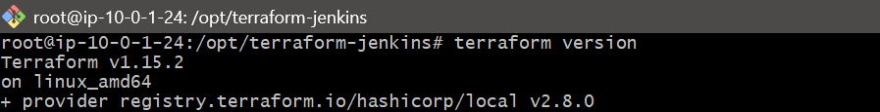

Step 3: Create Terraform Project Directory
mkdir -p /opt/terraform-jenkins
Move into directory:
cd /opt/terraform-jenkins

Step 4: Create Terraform File
Open file:
nano main.tf
Paste below content:
resource "local_file" "demo" {
filename = "/opt/terraform-jenkins/jenkins-terraform.txt"
content = "Terraform executed successfully from Jenkins"
}
Save file:
CTRL + O
Enter
CTRL + X

Step 5: Test Terraform Manually
Initialize Terraform:
terraform init
Run Terraform plan:
terraform plan
Apply configuration:
terraform apply -auto-approve
Verify output file:
cat /opt/terraform-jenkins/jenkins-terraform.txt
Expected output:
Terraform executed successfully from Jenkins 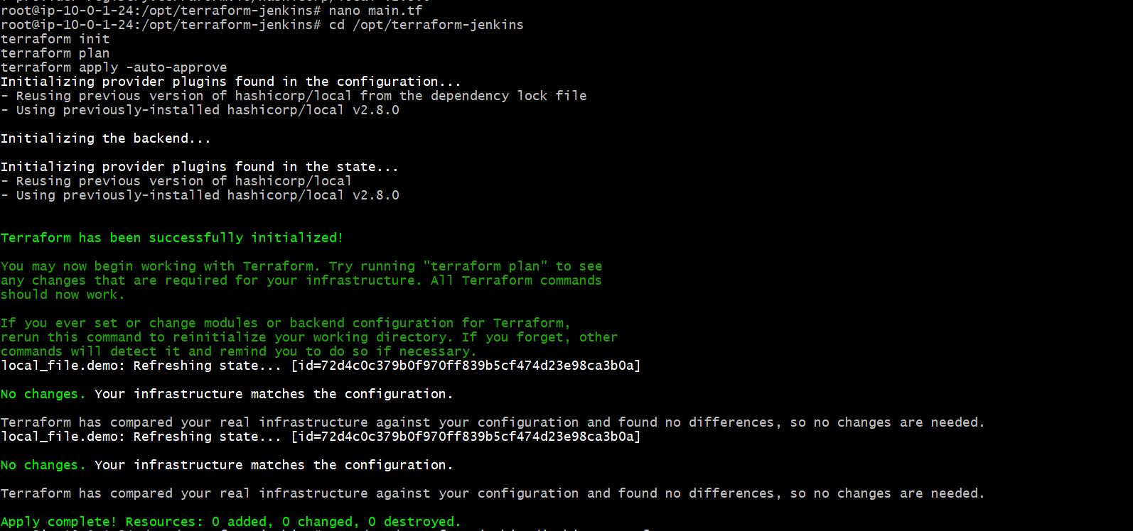

Step 6: Give Jenkins Permission
Run commands:
sudo chown -R jenkins:jenkins /opt/terraform-jenkins
sudo chmod -R 777 /opt/terraform-jenkins
Create temporary directory:
sudo mkdir -p /opt/terraform-jenkins@tmp
Give permissions:
sudo chown -R jenkins:jenkins /opt/terraform-jenkins@tmp
sudo chmod -R 777 /opt/terraform-jenkins@tmp
Restart Jenkins:
sudo systemctl restart jenkins 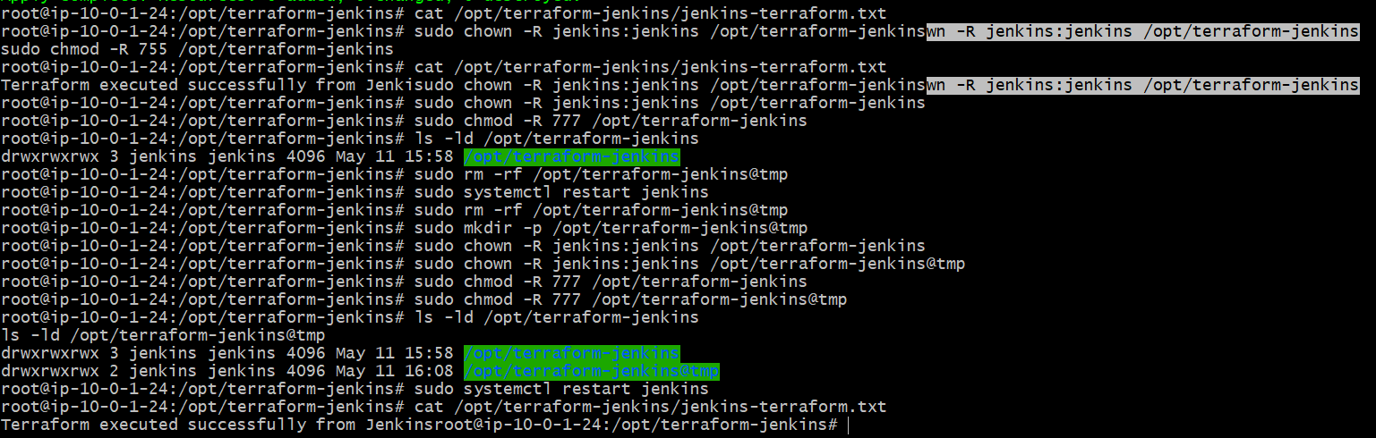

Step 7: Open Jenkins
Open browser:
http://<SERVER-IP>:8080

Step 8: Create Jenkins Pipeline Job
- Click New Item
- Enter job name:
terraform-demo
- Select:
Pipeline
- Click OK

Step 9: Configure Pipeline Script
Scroll to:
Pipeline
Select:
Pipeline Script
Paste below script:
pipeline {
agent any

stages {

stage('Terraform Version') {
steps {
sh 'terraform version'
}
}

stage('Terraform Init') {
steps {
dir('/opt/terraform-jenkins') {
sh 'terraform init'
}
}
}

stage('Terraform Plan') {
steps {
dir('/opt/terraform-jenkins') {
sh 'terraform plan'
}
}
}

stage('Terraform Apply') {
steps {
dir('/opt/terraform-jenkins') {
sh 'terraform apply -auto-approve'
}
}
}

stage('Verify Output') {
steps {
sh 'cat /opt/terraform-jenkins/jenkins-terraform.txt'
}
}
}
}
Click:
Save

Step 10: Bring Jenkins Node Online
Go to:
Manage Jenkins
→ Nodes
→ Built-In Node
Click:
Bring this node back online

Step 11: Configure Executors
Go to:
Built-In Node
→ Configure
Set:
Number of executors = 2
Click:
Save

Step 12: Run Pipeline
Go to:
terraform-demo
Click:
Build Now
Open:
Console Output
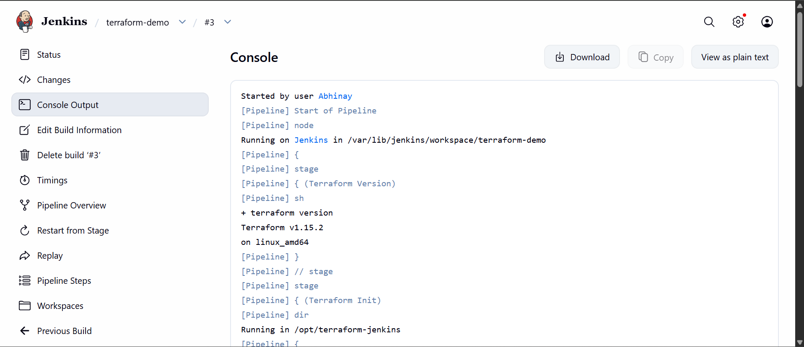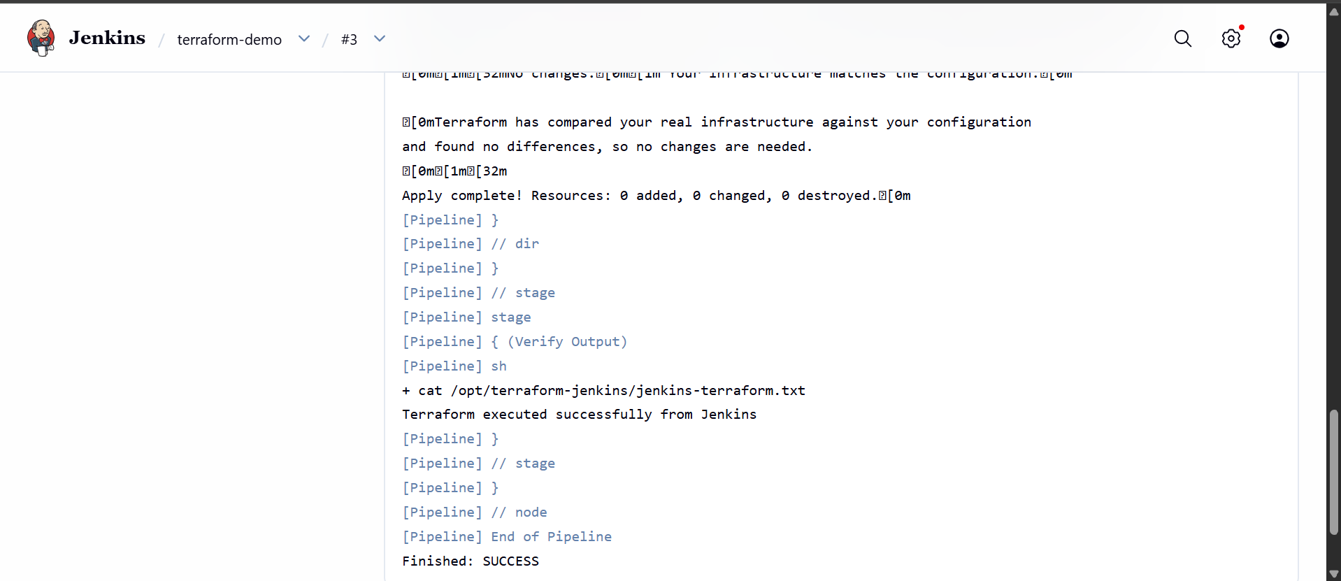

Step 13: Verify Final Output
Run on server:
cat /opt/terraform-jenkins/jenkins-terraform.txt
Expected output:
Terraform executed successfully from Jenkins

Final Result
Terraform successfully integrated with Jenkins Pipeline.

